Lessons from using Google Sheets and Zoom to provoke discussion about more flexible and sustainable Colorado River operations

David E. Rosenberg

Utah State University | [david.rosenberg@usu.edu](mailto:david.rosenberg@usu.edu) | @WaterModeler

May 10, 2022

Target: *Earth’s Future*

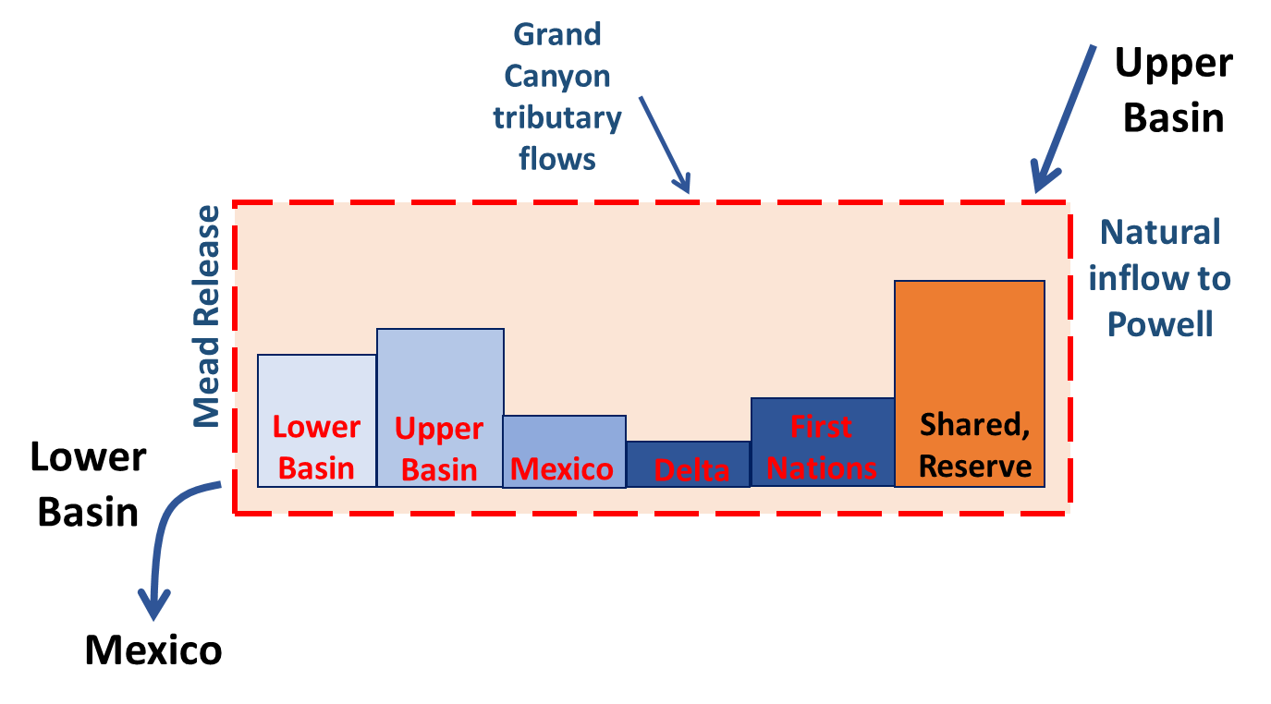

1. Colorado River basin account balances are the water stored in a combined Lake Powell-Lake Mead system.

**Key Points**

1. 26 Colorado River managers and experts used Google Sheets and Zoom to discuss more flexible and sustainable operations.
2. Participants consumed, saved, and traded water in 6 basin accounts, protected reservoirs, and sustained endangered, native fish.
3. Participants said share basin accounts with others and accounts were too far from current operations.
4. Synthesized 10 lessons to improve model process, increase operational flexibility, and build trust.
5. Engage multiple organizations simultaneously to generate more actionable suggestions for management.

**Keywords:** Participatory model, Aridification, Adapt, Available water, Trust, Conservation, Water trade.

# Introduction

This work had the purpose to provoke Colorado River managers and experts to discuss basin accounts as more flexible and sustainable than existing operations that equalize reservoirs and expire in 2026 (USBR, 2007). To provoke thought and discussion, I set up a Google Sheet with accounts for the Upper Basin, Lower Basin, Mexico, Colorado River Delta, and First Nations, plus a shared reserve that participants jointly managed (Figure 1). Between April and November 2021, I invited 32 Colorado River mangers and experts to 13 Zoom and 1 in-person sessions. During the sessions, 1 to 6 participants from the same organization (26 people total) choose Lake Powell natural inflow each year. Participants then consumed, saved, and traded water in their accounts, protected key Lake Powell and Lake Mead elevations, and sustained endangered, native fish of the Grand Canyon. At the end of each session, I asked participants what they liked and what to improve. This piece synthesizes lessons from the discussions to improve model process, increase operational flexibility, and build trust. The next section describes and differentiates the Zoom and Google Sheet sessions from prior studies of environmental water decision making (Horne et al., 2016) and participatory modeling (Bourget, 2011; Langsdale et al., 2013; Michaud, 2013; Van den Belt, 2004; Voinov et al., 2016; Wheeler et al., 2018) that did not include stakeholders, extracted data from participants, or built a model then presented findings at the project end. Section 3 describes the steps to step up and use basin accounts while section 4 compares basin accounts to existing operations. Sections 5 and 6 share lessons from the discussions and next steps to engage multiple organizations simultaneously. A final section concludes.

# Process to Provoke Discussion

Modeling with Google Sheets and Zoom is a form of participatory modeling (Bourget, 2011; Langsdale et al., 2013; Michaud, 2013; Van den Belt, 2004; Wheeler et al., 2018) that added role play during an online meeting with one or more participants. The sessions sought to provoke thought and discussion about current and future operations rather than forecast future conditions, simulate what if, identify what was best, or wait to the project end to present findings. Like serious games (Ewen and Seibert, 2016; Madani et al., 2017; Schulze et al., 2015; Seibert and Vis, 2012), the sessions were intended as an immersive experience. The sessions offered distinct benefits that differ from the use of expert models that stakeholders never saw (Horne et al., 2016), management models that were too big for participants to change, efforts that extracted data from participants (Voinov et al., 2016), or collaborative models that participants built together (Van den Belt, 2004).

The Colorado River managers and experts were employed by the Federal Government, Upper Colorado River Commission, state agencies, water districts, consulting firms, universities, a non-governmental organization, a foundation, and a First Nation. Three people participated in two sessions, three people started but did not complete a session, two people declined a request to participate, and one person never responded. During the same period, I also held or supervised Google Sheet and Zoom modeling sessions with 4 graduate students, 22 university colleagues, and 63 undergraduate students none of whom had expertise in the Colorado River basin. This piece focuses on feedback from the 26 Colorado River managers and experts who completed a session.

Sessions followed the general structure:

* Participants were solicited through email or by invite from a participant.
* Sessions were held with 1 to 6 participants from the same organization.
* Sessions lasted 1 to 3 hours.
* There were 5 individual roles. Each participant played one or more roles.
* There was 1 joint role that participants played together.
* In sessions with a small number of participants, I played one or more roles.
* Participants sometimes played their organization, sometimes not.
* After role play of 1 to 5 years, I asked participants what they liked and what to improve.

The model is available online as a workbook with help guide (Rosenberg, 2022). The initial workbook rows allowed participants to choose an account, enter a strategy, and register initial assumptions such as reservoir starting levels and protection elevations. Subsequent rows comprised the remaining components of the water balance for a combined Lake Powell-Lake Mead system. These components included inflow, reservoir evaporation, available water, consumptive use, conservation, trade, and Lake Powell release that split the combined storage between Lake Powell and Lake Mead. Columns represented years. Participants entered individual choices (strategy, consumption, and conservation) and joint choices (trades, split combined storage) into spreadsheet cells.

# Basin Account Setup and Use

The purpose of basin accounts were to give participants more flexibility to make water conservation and consumption decisions independent of other parties. The accounts exist within a region of combined management (Figure 1). The region stretched from the natural inflows to Lake Powell down to Lake Mead releases. The total of all account balances equaled the combined active storage in Lake Powell and Lake Mead. Participants completed 7 steps to step up and use accounts (Table 1).

1. Steps to setup and use basin water accounts.

|  |  |  |
| --- | --- | --- |
| Step | | Decision Type |
| 1. | Assigned accounts and defined strategies. | Individual |
| 2. | Assigned existing reservoir storage to accounts. | Joint |
| 3. | Selected year’s natural inflow to Lake Powell. | Watershed |
|  | + Assigned inflow to accounts. | Joint |
| 4. | Calculated each accounts available water. | Calculated |
| 5. | Participants conserved, consumed, and traded within their available water. | Individual |
| 6. | Assigned combined storage to Lake Powell and Lake Mead. | Joint |
| 7. | Continued to next year. | Calculated |

1. **Assigned accounts and defined strategies** for the next few years. Participants entered their name and strategy and affirmed their ability to interact with the Google Sheet. For example, an Upper Basin strategy might be to increase water use or deliver 1922 Compact volume to Lower Basin. If a participant wanted advice to formulate a strategy, they consulted the online model guide (Rosenberg, 2022).

The Upper Basin, Lower Basin, Mexico, Colorado River Delta, and First Nations accounts represented entities defined in the 1922 Colorado River Compact, 1948 Upper Colorado River Basin Compact, 1944 U.S-Mexico Treaty, Minutes 319 and 323, and pledges to include our First Nations (Carson et al., 1948; IBWC, 2021; Ten Tribes Partnership, 2018; USBR, 2020). The First Nations account allowed First Nations to manage their water independently from the Basin State in which the First Nation was located. This set up differed from current operations where Basin States administer water rights for the First Nations within their state boundaries.

The shared reserve was endowed with 11.6 million acre-feet (maf) of water that represented the protect volumes of 5.9 and 5.7 maf in Lake Powell and Lake Mead (elevations 3,525 and 1,020 feet) that are defined in the Upper and Lower Basin Drought Contingency Plans (USBR, 2019). The reserve prevented participants who drew down their account balance to zero from further drawing down reservoir storage. At the same time, the 11.6 maf in the reserve comprised 72% of the active storage in Lake Powell and Lake Mead. If all participants agreed, the reserve could transfer water to a participant in difficulty. When contemplating withdrawals from the shared reserve, consideration was given to the potential for reduced hydropower generation at one or both reservoirs and warmer Glen Canyon Dam release temperatures that threated the status quo for native, endangered fish of the Grand Canyon (Wheeler et al., 2021).

1. **Assigned all existing reservoir storage to accounts**. The participants jointly agreed on how to assign all active reservoir storage at the model start to the accounts. The start volume varied from 21 to 16.2 maf as the actual Lake Powell and Lake Mead volumes drew down over the time period of the Zoom sessions. Default assignments drew on existing agreements and operations. For example, participants assigned Mexico 0.17 maf that was the October 2020 balance in its Lake Mead conservation account (USBR, 2007; USBR, 2021). Participants assigned the Lower Basin the 2.8 maf balance in the Lake Mead conservation accounts for California, Arizona, and Nevada (USBR, 2007; USBR, 2021). Similarly, participants assigned the Upper Basin most of the Lake Powell storage that was not the protection volume. Participants assigned the shared reserve 11.6 maf as described in Step 1 (USBR, 2019). The assignments allowed the Lower Basin and Mexico to move their Lake Mead conservation account balances into a more flexible basin account. There were many ways to assign the reservoir storage to accounts.
2. **Selected year’s natural inflow and assigned to accounts**. Participants choose each year’s natural inflow to Lake Powell. Participants used historical data in the model guide. In many cases, participants chose values below the 2000 to 2020 average (Salehabadi et al., 2020) and below the Lake Powell release criteria of 8.23 maf per year (Figure 2). The Lake Powell natural flow represented the flow if users above Lake Powell did not store, divert, or consume water (Prairie, 2020; Wheeler et al., 2019). Crediting natural flow to the basin accounts allowed the Upper Basin and First Nations to divert and consume Colorado River water, deduct consumptive use from their account, then carry over the balance to the next year. This setup allowed the Upper Basin and First Nations located upstream of Lake Powell to store water in Lake Powell even though they did not physically withdraw water from Lake Powell. To the Lake Powell natural flow, the model added default inflows of 0.2 maf per year for Hoover to Imperial Dam intervening flow (Prairie, 2020) and 0.8 maf per year for intervening Grand Canyon flow (Rosenberg, 2021; Wang and Schmidt, 2020). The intervening Grand Canyon flow included the Paria, Little Colorado, and Virgin rivers plus Grand Canyon seeps from Glen Canyon Dam to Lake Mead. 0.6 maf per year of intervening Grand Canyon flow represented a 5-year sequence average for a dry period while 1.0 maf per year was the 30-year average.

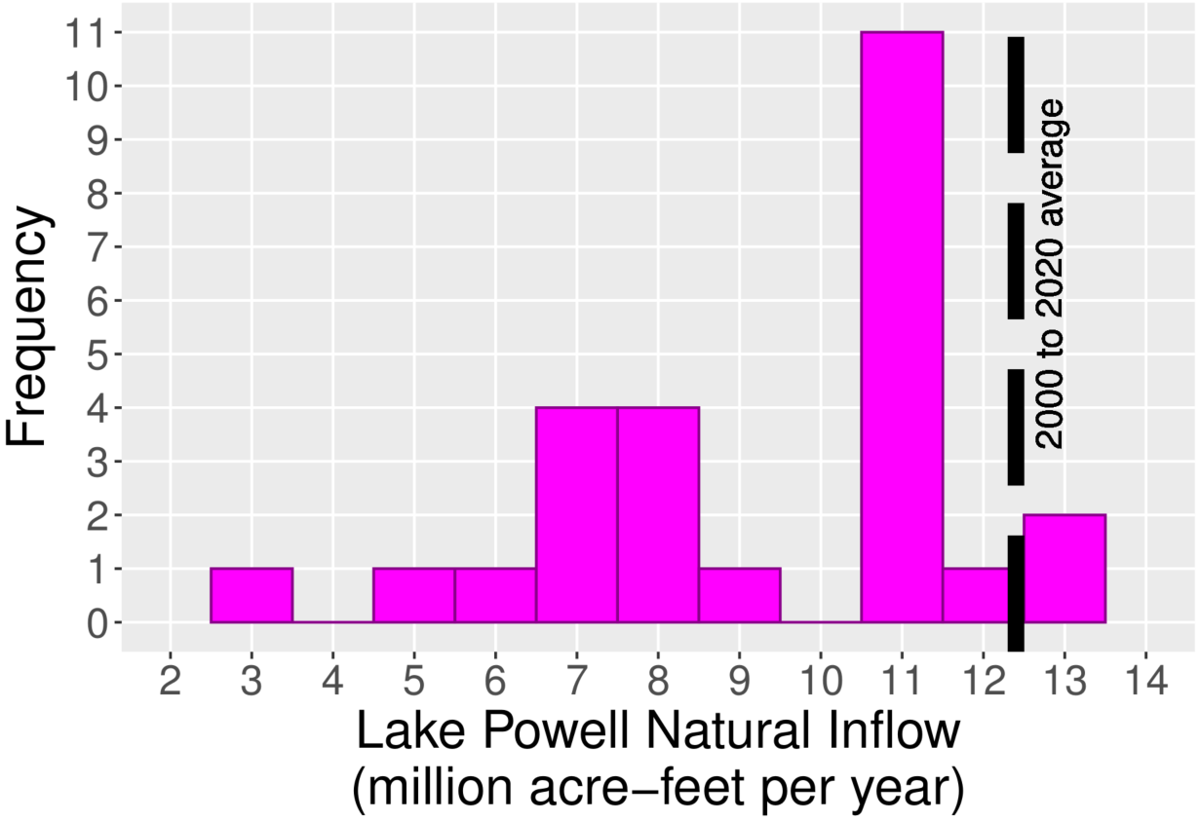

1. Participant choices for future Lake Powell natural inflow.

Participants also assigned inflows to the accounts. Default assignments followed the existing priority of operations with changes for the shared reserve, Lake Havasu / Lake Parker, and First Nations that are not in current operations (Figure 3).

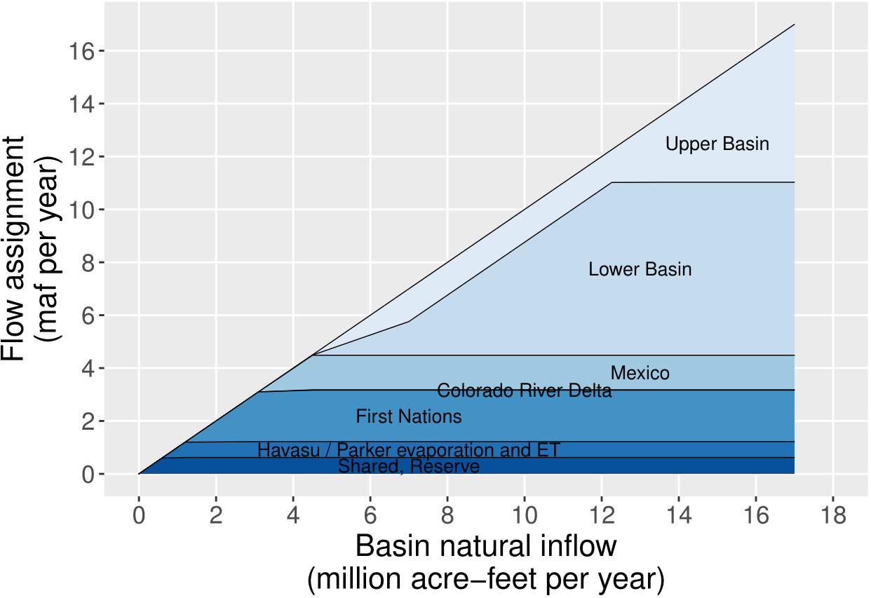

1. Assignment of basin natural inflow to accounts

1. Assigned the **shared reserve** inflow that equaled the account’s share of reservoir evaporation because reservoir evaporation depletes inflow before other activities. This assignment kept the shared reserve balance steady and helped protect levels in the Upper and Lower Basin DCPs (USBR, 2019).
2. Assigned inflow to equal Lake Havasu / Parker evaporation and evapotranspiration.
3. Assigned **First Nations** 1.94 maf per year of decreed water rights because the First Nations managed their water independently of the Basin States. The volume included 1.06 and 0.952 maf per year above and below Glen Canyon Dam (Ten Tribes Partnership, 2018) and deducted First Nations in the Lower Basin’s portion of Havasu / Parker losses. The volume excluded claimed amounts.
4. Assigned **Colorado River Delta** 0.016 maf per year because that volume was 67% of the 9-year, 0.21 maf volume the U.S. and Mexico pledged in Minute 323 (IBWC, 2021).
5. Assigned **Mexico** 1.5 maf per year (1944 U.S.-Mexico Treaty), minus the mandatory conservation volume specified in Minutes 319 and 323, minus Mexico contributions to the Colorado River Delta, and minus Mexico’s portion of Havasu / Parker losses because the U.S. must deliver Mexico water first (IBWC, 2021). The mandatory conservation volume increased as Lake Mead level declined.
6. Split the next 2.4 maf per year natural flow between the **Upper** and **Lower Basins** because the Upper and Lower Basins have 1.2 and 2.45 maf per year of pre-1922 water rights (Leeflang, 2021) after deducting First Nations use.
7. Assigned the **Lower Basin** the next 5.3 maf per year. 5.3 maf plus 1.2 maf pre-1922 use plus 0.95 maf of water for First Nations below Hoover dam (Ten Tribes Partnership, 2018) plus half the Mexico assignment resulted in 8.2 maf per year that is the Lake Powell objective release.
8. Assigned the **Upper Basin** any remaining Lake Powell natural flow.

There are many ways to assign basin inflow to the accounts.

1. **Calculated each account’s available water** as the account balance (Step 2), plus share of inflow (Step 3), and minus share of reservoir evaporation (Eq. 1; all units maf). An account’s share of reservoir evaporation was the combined annual Lake Powell and Lake Mead evaporation prorated by the account’s share of the combined storage. Optional purchases from other accounts increased available water while sales decreased an account’s available water. The optional trades built on a feature of the Lower Basin drought contingency plan that let Lower Basin parties transfer their Lake Mead conservation account balance to another party (USBR, 2019).

|  |  |
| --- | --- |
|  | (Eq. 1) |

1. **Parties conserved and consumed within their available water independent of other parties.** Consumptive use withdrew from a basin account. Conservation made water in the account available next year. Each party’s end-of-year account balance was their available water (Step 4) minus consumption. Account withdraws from Lower Basin, Mexico, Delta, and First Nations accounts implied a withdraw from Hoover dam or Lake Mead.
2. **Assigned the remaining combined storage to Lake Powell and Lake Mead.** The existing operations seek to equalize or split storage 50%/50% (USBR, 2007). This assignment was another joint (political) decision and gave parties flexibility to split in other amounts. Parties withdrew from their basin accounts whether water was physically stored in Lake Powell or Lake Mead. Two considerations to assign combined storage between Lake Powell and Lake Mead were:
   1. **Maintain the status quo for endangered, native fish of the Grand Canyon.** As Lake Powell draws down, the stored water heats (less stratification) and increases release water temperature through the hydropower turbines. Warmer releases advantage non-native fish who eat the young of native, endangered fish of the Grand Canyon (Figure 4). Outcomes for native fish become highly uncertain (Figure 4, red) when Lake Powell storage drops to 5.9 maf (3,525 feet), release temperatures exceed 18oC, and water continues to flow through the turbines (elevation 3,490 feet [4 maf]). Outcomes for native fish also become highly uncertain when Lake Powell storage drops to 1.4 maf (3,425 feet), release temperatures exceed 18oC, and water is released through the low elevation river outlets (elevation 3,370 feet; 0 maf). Options to improve outcomes for native fish were store more water in Lake Powell, forego hydropower generation, and/or release more water through the river outlets.
   2. **Stay above minimum power pools.** Reservoir drawdown reduced hydropower generation and sped the time to reach minimum power pools where reservoirs no longer generate energy (Lake Powell an Lake Mead elevations of 3,490 and 955 feet; 4.0 and 2.2 maf). During the April to November 2021 period, the Western Area Power Authority delivered less energy to its customers (Arellano, 2021). Customers purchased additional energy from more expensive sources.

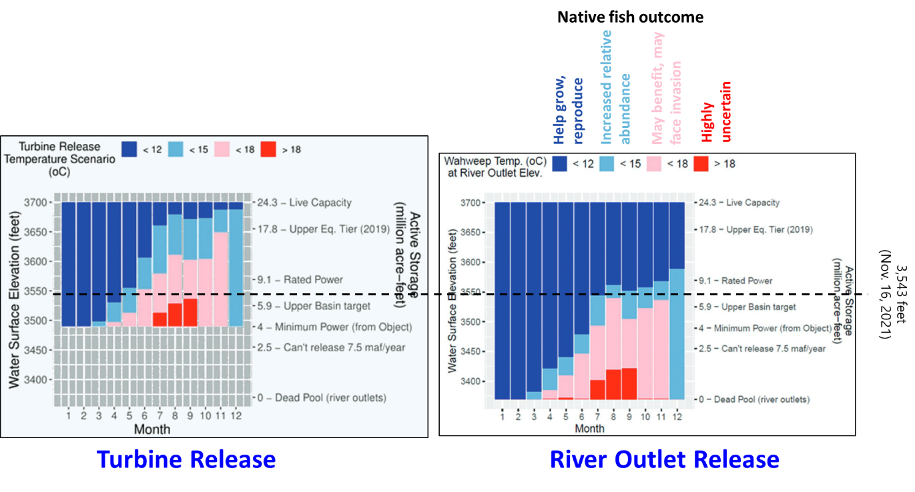

1. Releases through the Glen Canyon Dam turbines (left, 3,490 feet) require more stored water to sustain colder water releases for native fish of the Grand Canyon than releases through the river outlets (right, 3,370 feet) (adapted from Wheeler et al., 2021).
2. **Continued to next year.** All end of year account balances carried over to the beginning of the next year (Steps 3 to 6).

A spreadsheet implemented the 7 steps in 142 rows on 1 master worksheet, 4 data support worksheets, a ReadMe worksheet, and a Versions worksheet (Rosenberg, 2022). Each spreadsheet row on the master worksheet also linked to an online model guide.

# Compare to Existing Operations

Existing Colorado River operations comprise treaties, compacts, court cases, and agreements negotiated over 100 years (1922; Carson et al., 1948; IBWC, 2021; Ten Tribes Partnership, 2018; U.S. Bureau of Reclamation and National Park Service, 2016; USBR, 2007; USBR, 2019). These operations:

* Seek a Lake Powell release of 8.23 maf per year with allowances to equalize Lake Powell and Lake Mead storage (USBR, 2007).
* Aspire to protect elevations 3,525 and 1,020 feet in Lake Powell and Lake Mead that correspond to active storages of 5.9 and 5.7 maf (USBR, 2019).
* Reduce deliveries to the Lower Basin states and Mexico as Lake Mead draws down (IBWC, 2021; USBR, 2007; USBR, 2019).
* Allow the Lower Basin states and Mexico to store voluntary reductions from their historical allocations in Lake Mead accounts for later use (USBR, 2007).

Castle and Fleck (2019), Kuhn and Fleck (2019), MacDonnell et al. (1995), and USBR (2008) further describe the existing operations. The Colorado River Simulation System (CRSS) maintained by Reclamation encodes operations into 12 reservoirs, 29 flow gages, 520 water user objects, and 145 rules (Wheeler et al., 2019; Zagona et al., 2001).

Basin accounts and current operations share many features such as encourage conservation, plan for shortages, and closer coordinate Lake Powell and Lake Mead operations (USBR, 2020). They both seek to address future controversies through consultation and negotiation not litigation.

The major differences are:

* Created 6 accounts in the combined Lake Powell-Lake Mead system rather than Lake Mead conservation accounts only for Lower Basin and Mexico parties.
* Each participant managed all available water rather than only water in a Lake Mead conservation account.
* Participants managed available water in their account year-to-year rather than make new joint agreements for more conservation as conditions declined.
* Allowed sales and trades between accounts in the combined system rather than only between Lake Mead conservation accounts.
* Adapted releases to inflow and storage rather than only storage (Rosenberg, In press).
* Defined a shared reserve and allowed the reserve volume to vary over time rather than specify fixed protection elevations for Lake Powell and Lake Mead.
* Gave the Colorado River Delta and First Nations accounts in the combined system rather than require non-governmental organizations to secure water from the U.S. and Mexico for each pulse flow or administer First Nation’s water under state systems.
* Subtracted all Lake Mead and Lake Powell evaporation in proportion to the account balance rather than ignore ~500,000 acre-feet of Lake Mead evaporation and 160,000 to 230,000 acre-feet of Colorado River evapotranspiration prior to build Glen Canyon Dam (Fleck and Castle, 2022; Schmidt et al., 2016).
* Allowed parties more flexibility to split combined storage between Lake Powell and Lake Mead than equalize storage. More flexibility to store water in Lake Powell allowed colder releases to sustain native, endangered fish of the Grand Canyon.

# Lessons

This section identifies lessons to improve model process and increase operational flexibility.

**1. Listen**. The first participant said to continue to provoke thought and discussion. During sessions, I continued to listen to what participants said (Table 2).

1. Positive statements about synchronous modeling and flex account experience

|  |  |
| --- | --- |
| **Things to like** | **More things to like** |
| * I like it / It's neat / It's fun. * Interactive. I see the effect of choices. * See yourself in the model. * See effects on native fish. * Drive a conversation around conservation with bad hydrology. * Facilitates thought and conservation. | * More holistic approach to basin management. * Make me think about the equity issue. How to factor in equity. * I like the gaming. * What it means to have and use my own water account. |

One participant suggested:

Start asking people from different parties to participate in the same session.

And another participant later wrote:

I think others will find the same value in the exercise that I have seen…. its thought provoking.

Lots of participants also encouraged to share with others and suggested specific people.

**2. Solicit feedback early.** In the early weeks, I shared a first version for Lake Powell with students and a colleague. They suggested to reduce the number of years to 5. The next week, a Colorado River manager liked the exercise and asked for a more complete picture for Lake Mead and down to the Mexico border. This comment kicked off a serial process where I met with new participant(s), solicited feedback, used time between meetings to improve the Google Sheet, and met with new participants.

The serial process resulted in 36 changes recorded in the *Versions* worksheet (Rosenberg, 2022). I grouped player decisions into dashboards, allowed participants to withdraw water from the shared reserve, and redid the split of Lake Powell natural flow between the Upper Basin, Lower Basin, and Mexico multiple times. I also wrote a model guide and hyperlinked each spreadsheet row to a section in the guide (Rosenberg, 2022). There were many more improvements. Regular feedback let the Google Sheet evolve over time.

**3. Identify flashpoints.** Multiple participants raised the flashpoint to split Lake Powell natural inflow among the Upper and Lower Basins. Was the 75 maf each 10 years in Article III(d) of the 1922 Compact a delivery or non-deplete requirement (Beckstead and Hoerner, 2012)? Can the Upper Basin deliver less water in the 1st model year and store more to recoup an over-delivery by 4 maf in the prior 9 years? How to handle the 2.3 and 3.5 maf per year of pre-1922 water uses in the Upper and Lower Basins (Leeflang, 2021)? Can the Upper Basin store water in a basin account for future use if Article III(e) of the Compact does not allow the Upper Basin to withhold water? One participant described 4 or 5 or 6 maf per year of Lake Powell natural flow as unprecedented, never been done, and unclear what will happen. Participants voiced different views about the acceptability of basin accounts and existing operations.

These comments identified the split of Lake Powell natural inflow below 8.23 maf per year as a flashpoint, a win-lose conflict, or zero-sum game. The different splits of inflow gave one account more water and another account less. Flashpoints helped identify contentious model components that further changes may not improve.

**4. Provide options to resolve conflicts.** Similar to identify flashpoints (lesson #3), basin accounts engendered 5 other win-lose tradeoffs and conflicts:

1. Added a First Nations account.
2. Split existing reservoir storage among accounts.
3. Stored water in Lake Powell and Lake Mead.
4. Drew down shared reserve.
5. Charged reservoir evaporation to accounts.

It’s hard to know how or if parties will resolve these tradeoffs. There are many possibilities. Parties may stay stuck at the current point until a tradeoff is pushed outwards, pushed inwards, or linked to other conflicts. Thus, I turned many conflicts into participant choices. For example, participants could enable a First Nations account or revert to current operations where Basin States administer water rights for the First Nations within their state boundaries. The Google Sheet and Zoom sessions let participants think about and discuss the choices.

**5. Prorate reservoir evaporation by account balance.** Splitting reservoir evaporation among accounts was a win-lose conflict (lesson #5) because some or all of Lake Mead and Lake Powell evaporation is not counted in current operations (Fleck and Castle, 2022; Schmidt et al., 2016). Participants offered accolades and nods for the 7 spreadsheet rows that calculated the split. Prorating evaporation by account balance might be favorable because:

1. Each party was treated equitably. Parties with larger account balances shared more responsibility for reservoir evaporation.
2. The Upper and Lower Basins could shift some of their responsibility for evaporation onto other parties and the shared reserve.
3. In model year 1, the shared reserve had the largest account balance and was charged 72% of the combined reservoir evaporation.

Treating accounts equitably may help parties overcome a win-lose conflict.

**6. Many options to govern draw down below the combined protection volume of 11.6 maf.** One participant recommended to keep the shared reserve at 11.6 maf. Another participant noted that 11.6 maf is a lot of water and there may be reasons to draw down the shared reserve below the combined protection volume. A third participant suggested to trust a third party such as Reclamation to manage the shared reserve. There was also a suggestion to allow accounts to sell water to the shared reserve if no other party wanted to buy. These comments identified multiple options to drawdown Lake Powell and Lake Mead below 11.6 maf.

**7. Include money to increase management flexibility.** In the Google Sheet and Zoom sessions, participants voluntarily sold and purchased water. Many trades were for larger water volumes, more money, and involved more entities than California, Arizona, Nevada, and the Federal government promised in their recent $200 million plan to conserve 500,000 acre-feet each year for 2 years (Allhands, 2021). For example, some participants who role played Mexico sold water to build non-water infrastructure projects. Some participants who played the Upper Basin sold some water to get paid to conserve to prepare for mandatory cutbacks to meet the 10-year delivery requirement. Trades were possible because the basin account balances defined the water each participant had available to trade each year. Also, trades administratively transferred from one account to another within the combined Lake Powell-Lake Mead system without physical movement. While water was scarce, money gave participants more flexibility to acquire, consume, store, or sell water when their account balance was high or low.

**8. Combined management offered more flexibility.** Combined management offered participants more flexibility to store and access water in either Lake Powell or Lake Mead while sustaining the status quo of cold water releases from Lake Powell for native, endangered fish of the Grand Canyon. Combined management also let participants conserve and consume independent of other participants. Participants managed all available water in the combined system not just water in Lake Mead conservation accounts. Participants managed their available water rather than wait to negotiate larger reductions from historical allocations. Combined management helped shift Lake Powell and Lake Mead as Upper and Lower Basin reservoirs towards joint reservoirs. To give participants more flexibility to manage the combined water, I updated the Google Sheet, to offer more choices with fewer rules and spreadsheet formulas.

**9. Find common benefits such as more flexibility.** Lessons #5-8 combined to find common benefits for all participants as a way to escape win-lose conflicts. Each basin account enjoyed common benefits each year of more flexibility to consume and conserve water independent of other accounts (lesson #8) and trade water with other participants. These common benefits treated participants equitably (lesson #5).

**10. Recognize a model’s useful life.** Participants also said basin accounts were:

* Very different than current operations.
* “A huge leap from management today and, when we roll up our sleeves, fraught with implementation issues.”
* A heavy lift from existing management to whole basin management.
* A freak out to break the existing operations.
* “Easy to suggest. Harder to get adopted.”
* “I don’t know how you would ever do it. Hard to get traction on things that are less difficult than this.”

These comments discounted the model’s legitimacy and actionability (Van den Belt, 2004; Wheeler et al., 2018). Make the model more actionable by working with multiple organizations simultaneously. I did not have resources to support a multi-organization effort. After 13 sessions, I wrote up the lessons from the experience as this manuscript.

# Broader Meaning

This work used Google Sheets and Zoom to engage 26 Colorado River managers and experts to model and discuss Colorado River basin accounts as an alternative to reservoir equalization operations that expire in 2026. The engagement contrasted with no/little stakeholder interaction for 42 studies of environmental water decisions (Horne et al., 2016) and many participatory model efforts that extracted data from participants (Voinov et al., 2016). The sequential process of meet, solicit feedback, improve, and meet with new participants differed from the build-translate approach most researchers use to build a model on their own then present findings at their project end.

The use of basin accounts provoked multiple discussion threads such as this is fun, I see effects on native fish, I see myself in the model, think about equity, the 8.23 maf Lake Powell release criteria is a flash point and win-lose conflict, give parties common benefits like more flexibility, share the work with others, and basin accounts strayed too far from current operations. The later comment raised issues of legitimacy and actionability. To increase model legitimacy and actionability, ask participants to:

* Define, construct, modify, test, and validate their own model rather than choose within an existing model (Voinov et al., 2016).
* Engage with people from multiple organizations rather than a single organization.
* Screen multiple possible options rather than experiment with one option.

The Google Sheet let participants collaborate via the web on the same workbook in real time. Participants made individual and group decisions and viewed outputs. That collaboration is not possible with CRSS (Zagona et al., 2001), Water Evaluation and Planning (Yates et al., 2005), R, R Shiney, Python, or cloud notebooks (Abdallah et al., 2022). Like other spreadsheet programs, Google Sheets made difficult version control, organize an intuitive interface, validate user input, and automate tasks.

As the Colorado River basin becomes more arid, an important next step is to organize efforts where creative, productive, and connected participants can together generate, test, and validate innovative ideas for new management. Participants can learn together, build trust, generate more innovative and actionable insights, and share findings with their communities (Van den Belt, 2004; Voinov et al., 2016). People intending to lead or join such efforts are challenged to assemble a team with basin, modeling, discipline, integration, facilitation, guiding, communication, interpersonal, and political skills. Leaders are challenged to find money and time to support the team. And the team has to convince potential participants to invest their time because group work can generate more innovative and actionable products than if people and organizations work solo.

# Conclusions

This work had the purpose to provoke discussion about Colorado River basin accounts as more flexible sustainable than existing reservoir equalization operations that expire in 2026. To provoke discussion, a Google Sheet was set up with accounts for the Upper Basin, Lower Basin, Mexico, Colorado River Delta, and First Nations, plus a shared reserve account that participants jointly managed. During 14 Google Sheet and Zoom sessions, 26 Colorado River managers and experts choose Lake Powell natural inflow each year. Participants then consumed, saved, and traded water in the accounts while protecting key reservoir elevations and sustaining endangered, native fish of the Grand Canyon. This setup differed from prior studies that excluded stakeholders, extracted data from participants, or built a model then presented findings at the project end. Participants said the activity was fun, I see effects on native fish, I see myself in the model, think about equity, share the work with others, and basin accounts strayed too far from current operations. Lessons from the sessions include to listen, solicit feedback early, identify flash points and options to resolve them, prorate reservoir evaporation by account balance, allow trades to increase manager flexibility, find common benefits such as more flexibility for all participants, and recognize a model’s useful life. Next steps are to engage multiple organizations simultaneously to generate more innovative and actionable insights for management.

# Data, Model, and Code Availability

The data, model, code, and directions are available at Rosenberg (2022). The data and code to generate Figures 2 to 4 are available at Rosenberg (2022). and Rosenberg (2020).

# Acknowledgements

I appreciate the time, engagement, and discussion that the 26 Colorado River managers and experts contributed. This work benefited from a $50 donation from a private individual. The donation was used to purchase software to generate the online model guide. 5 individuals gave feedback that improved this manuscript. Some of those people participated in a Google Sheet and Zoom session. This work represents the views of the author not Utah State University.

# Requested Citation

David E. Rosenberg (2022). “Lessons from using Google Sheets and Zoom to provoke discussion about more flexible and sustainable Colorado River operations.” Utah State University, Logan, Utah.

# References

(1922). "Colorado River Compact." <https://www.usbr.gov/lc/region/pao/pdfiles/crcompct.pdf>. [Accessed on: October 5, 2021].

Abdallah, A. M., Rheinheimer, D. E., Rosenberg, D. E., Knox, S., and Harou, J. J. (2022). "An interoperable software ecosystem to store, visualize, and publish water resources systems modelling data." *Environmental Modelling & Software*, 151, 105371. <https://www.sciencedirect.com/science/article/pii/S1364815222000779>.

Allhands, J. (2021). "It could take at least 500,000 acre-feet of water a year to keep Lake Mead from tanking." *Arizona Republic*, November 8, 2021.

Arellano, A. (2021). *Colorado River Water Users Association*, Las Vegas, NV.

Beckstead, B., and Hoerner, C. (2012). "Does the Upper Basin have a Delivery Obligation or an Obligation Not to Deplete the Flow of the Colorado River at Lee Ferry?", Colorado River Governance Initiative. <http://www.waterpolicy.info/wp-content/uploads/2015/09/Delivery-Obligation-memo.pdf>.

Bourget, L. (2011). "Converging Waters: Integrating collaborative modeling with participatory processes to make water resources decisions." Mass-White, U.S. Army Corps of Engineers, Institute for Water Resources, Washington, D.C., 218.

Carson, C. A., Stone, C. H., Wilson, F. E., Watson, E. H., and Bishop, L. C. (1948). "Upper Colorado River Basin Compact." U.S. Bureau of Reclamation. <https://www.usbr.gov/lc/region/g1000/pdfiles/ucbsnact.pdf>. [Accessed on: September 7, 2021].

Castle, A., and Fleck, J. (2019). "The Risk of Curtailment under the Colorado River Compact." <http://dx.doi.org/10.2139/ssrn.3483654>.

Ewen, T., and Seibert, J. (2016). "Learning about water resource sharing through game play." *Hydrol. Earth Syst. Sci.*, 20(10), 4079-4091. <https://www.hydrol-earth-syst-sci.net/20/4079/2016/>.

Fleck, J., and Castle, A. (2022). "Green Light for Adaptive Policies on the Colorado River." *Water*, 14(1), 2. <https://www.mdpi.com/2073-4441/14/1/2>.

Horne, A., Szemis, J. M., Kaur, S., Webb, J. A., Stewardson, M. J., Costa, A., and Boland, N. (2016). "Optimization tools for environmental water decisions: A review of strengths, weaknesses, and opportunities to improve adoption." *Environmental Modelling & Software*, 84, 326-338. <http://www.sciencedirect.com/science/article/pii/S1364815216302936>.

IBWC. (2021). "Minutes between the United States and Mexican Sections of the IBWC." United States Section. <https://www.ibwc.gov/Treaties_Minutes/Minutes.html>. [Accessed on: July 22, 2021].

Kuhn, E., and Fleck, J. (2019). *Science Be Dammed: How Ignoring Inconvenient Science Drained the Colorado River*, University of Arizona Press.

Langsdale, S., Beall, A., Bourget, E., Hagen, E., Kudlas, S., Palmer, R., Tate, D., and Werick, W. (2013). "Collaborative Modeling for Decision Support in Water Resources: Principles and Best Practices." *Journal of the American Water Resources Association*, 49(3), 629-638. <http://dx.doi.org/10.1111/jawr.12065>.

(Leeflang, B.). (2021). "Colorado River Coding: Pre 1922 Compact Water Use." <https://github.com/dzeke/ColoradoRiverCoding/tree/main/Pre1922CompactWaterUse>.

MacDonnell, L. J., Getches, D. H., and Hugenberg, W. C. (1995). "The Law of the Colorado River: Coping with severe sustained drought." *JAWRA Journal of the American Water Resources Association*, 31(5), 825-836. <http://dx.doi.org/10.1111/j.1752-1688.1995.tb03404.x>.

Madani, K., Pierce, T. W., and Mirchi, A. (2017). "Serious games on environmental management." *Sustainable Cities and Society*, 29, 1-11. <http://www.sciencedirect.com/science/article/pii/S2210670716301834>.

Michaud, W. R. (2013). "Evaluating the Outcomes of Collaborative Modeling for Decision Support." *Journal of the American Water Resources Association*, 49(3), 693-699. <http://dx.doi.org/10.1111/jawr.12066>.

Prairie, J. (2020). "Colorado River Basin Natural Flow and Salt Data." U.S. Bureau of Reclamation. <https://www.usbr.gov/lc/region/g4000/NaturalFlow/current.html>.

Rosenberg, D. E. (2020). "How does Lake Powell water storage influence release temperatures and Grand Canyon fishes?", Utah State University. <https://doi.org/10.5281/zenodo.4345405>.

Rosenberg, D. E. (2021). "Colorado River Coding: Grand Canyon Intervening Flow." GrandCanyonInterveningFlow folder. <https://doi.org/10.5281/zenodo.5501466>.

Rosenberg, D. E. (2022). "Colorado River Basin Accounts: Provoke discussion about more flexible and sustainable operations, HydroShare,." Hydroshare.org. <https://doi.org/10.4211/hs.57ad7df425b84da2874e9c19e7b34aad>. [Accessed on: May 11, 2022].

Rosenberg, D. E. (In press). "Adapt Lake Mead releases to inflow to give managers more flexibility to slow reservoir draw down." *Journal of Water Resources Planning and Management*, 10. <https://digitalcommons.usu.edu/water_pubs/170/>.

Salehabadi, H., Tarboton, D., Kuhn, E., Udall, B., Wheeler, K., E.Rosenberg, D., Goeking, S., and Schmidt, J. C. (2020). "Stream flow and Losses of the Colorado River in the Southern Colorado Plateau." Center for Colorado River Studies, Utah State University, Logan, Utah. <https://qcnr.usu.edu/coloradoriver/files/WhitePaper4.pdf>.

Schmidt, J. C., Kraft, M., Tuzlak, D., and Walker, A. (2016). "Fill Mead First: a technical assessment." Utah State University, Logan, Utah. <https://qcnr.usu.edu/wats/colorado_river_studies/files/documents/Fill_Mead_First_Analysis.pdf>.

Schulze, J., Martin, R., Finger, A., Henzen, C., Lindner, M., Pietzsch, K., Werntze, A., Zander, U., and Seppelt, R. (2015). "Design, implementation and test of a serious online game for exploring complex relationships of sustainable land management and human well-being." *Environmental Modelling & Software*, 65(0), 58-66. <http://www.sciencedirect.com/science/article/pii/S1364815214003557>.

Seibert, J., and Vis, M. J. P. (2012). "Irrigania – a web-based game about sharing water resources." *Hydrol. Earth Syst. Sci.*, 16(8), 2523-2530. <http://www.hydrol-earth-syst-sci.net/16/2523/2012/>.

Ten Tribes Partnership. (2018). "Colorado River Basin Ten Tribes Partnership Tribal Water Study." U.S. Department of the Interior, Bureau of Reclamation, Ten Tribes Partnership. <https://www.usbr.gov/lc/region/programs/crbstudy/tws/finalreport.html>.

U.S. Bureau of Reclamation, and National Park Service. (2016). "Glen Canyon Dam Long-Term Experimental and Management Plan Final Environmental Impact Statement." <http://ltempeis.anl.gov/documents/final-eis/>.

USBR. (2007). "Record of Decision: Colorado River Interim Guidelines for Lower Basin Shortages and Coordinated Operations for Lakes Powell and Mead." U.S. Bureau of Reclamation. <https://www.usbr.gov/lc/region/programs/strategies/RecordofDecision.pdf>.

USBR. (2008). "Law of the River." Bureau of Reclamation. <https://www.usbr.gov/lc/region/g1000/lawofrvr.html>. [Accessed on: Dec. 8, 2021].

USBR. (2019). "Agreement Concerning Colorado River Drought Contingency Management and Operations." U.S. Bureau of Reclamation, Washington, DC. <https://www.usbr.gov/dcp/finaldocs.html>.

USBR. (2020). "Review of the Colorado River Interim Guidelines for Lower Basin Shortages and Coordinated Operations for Lake Powell and Lake Mead." U.S. Bureau of Reclamation, U.S. Department of Interior. <https://www.usbr.gov/ColoradoRiverBasin/documents/7.D.Review_FinalReport_12-18-2020.pdf>.

USBR. (2021). "Boulder Canyon Operations Office - Program and Activities: Water Accounting Reports." U.S. Bureau of Reclamation. <https://www.usbr.gov/lc/region/g4000/wtracct.html>.

Van den Belt, M. (2004). *Mediated modeling: A systems dynamics approach to environmental consensus building*, Island Press, Washington. <https://islandpress.org/books/mediated-modeling>.

Voinov, A., Kolagani, N., McCall, M. K., Glynn, P. D., Kragt, M. E., Ostermann, F. O., Pierce, S. A., and Ramu, P. (2016). "Modelling with stakeholders – Next generation." *Environmental Modelling & Software*, 77, 196-220. <http://www.sciencedirect.com/science/article/pii/S1364815215301055>.

Wang, J., and Schmidt, J. C. (2020). "Stream flow and Losses of the Colorado River in the Southern Colorado Plateau." Center for Colorado River Studies, Utah State University, Logan, Utah. <https://qcnr.usu.edu/coloradoriver/files/WhitePaper5.pdf>.

Wheeler, K., Kuhn, E., Bruckerhoff, L., Udall, B., Wang, J., Gilbert, L., Goeking, S., Kasprak, A., Mihalevich, B., Neilson, B., Salehabadi, H., and Schmidt, J. C. (2021). "Alternative Management Paradigms for the Future of the Colorado and Green Rivers." Center for Colorado River Studies, Utah State University, Logan, Utah. <https://qcnr.usu.edu/coloradoriver/files/WhitePaper_6.pdf>.

Wheeler, K. G., Robinson, C. J., and Bark, R. H. (2018). "Modelling to bridge many boundaries: the Colorado and Murray-Darling River basins." *Regional Environmental Change*, 18(6), 1607-1619. <https://doi.org/10.1007/s10113-018-1304-z>.

Wheeler, K. G., Schmidt, J. C., and Rosenberg, D. E. (2019). "Water Resource Modelling of the Colorado River – Present and Future Strategies." Center for Colorado River Studies, Utah State University, Logan, Utah. <https://qcnr.usu.edu/coloradoriver/files/WhitePaper2.pdf>.

Yates, D., Sieber, J., Purkey, D., and Huber-Lee, A. (2005). "WEAP21 - A demand-, priority-, and preference-driven water planning model Part 1: Model characteristics." *Water International*, 30(4), 487-500. <Go to ISI>://000234619500008.

Zagona, E. A., Fulp, T. J., Shane, R., Magee, T., and Goranflo, H. M. (2001). "Riverware: A Generalized Tool for Complex Reservoir System Modeling." *JAWRA Journal of the American Water Resources Association*, 37(4), 913-929. <https://onlinelibrary.wiley.com/doi/abs/10.1111/j.1752-1688.2001.tb05522.x>.