**Adapting to low Colorado River flows and storage: lessons from 3 computer exercises**

David E. Rosenberg

Utah State University | [david.rosenberg@usu.edu](mailto:david.rosenberg@usu.edu) | @WaterModeler July 27, 2022

As Colorado River flows and reservoir levels decline, discussion is ramping up about adapting operations to low flow and storage because existing operations adapt only to storage. This post reviews three recent computer exercises that adapted Colorado River operations to low flow and low storage. Three final paragraphs synthesize lessons to build towards more equitable and sustainable operations.

# Live within our means (Wang and Rosenberg, Submitted)([free link](https://digitalcommons.usu.edu/water_pubs/171/)). This effort defined a new rule that adapted basin depletions to equal average flow over the prior 10 years. The rule triggered when Lake Mead drew down below 1,060 feet—a level that at the time was below the actual level. The new rule was tested in a new open-source exploratory model that had Upper Basin, Lower Basin, Mexico, Lake Powell, and Lake Mead objects. First, a base case of existing operations was validated against Colorado River Simulation System (CRSS) output. Then the adaptive rule was simulated for the worst natural flows at Lee Ferry down to 5 million acre-feet (maf) derived from tree rings back to 1416 AD. Existing operations drew down Lake Powell and Lake Mead to critical levels in a few years whereas the adaptive rule sustained both reservoirs above their critical levels for long periods of time (Figure 1). The exploratory model split reductions among parties as percentages.

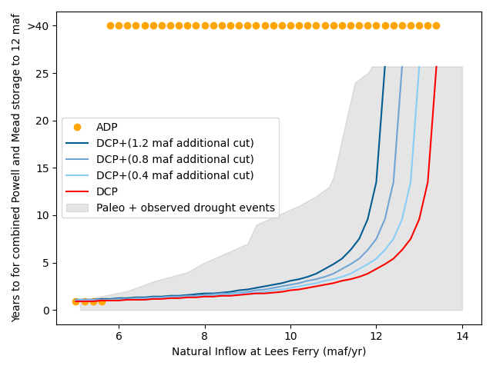

**Figure 1. Years (y-axis) until combined Lake Powell and Lake Mead storage drops to 12 maf.** ADP = adaptive rule. DCP = existing rules.

1. **Adapt Lake Mead Releases to Flows to Slow Drawdown** (Rosenberg, In press)([**free link**](https://digitalcommons.usu.edu/water_pubs/170/)). This piece focused on Lake Mead. A chart identified the consumption to stabilize Lake Mead level for different water elevations and reservoir inflows down to 7 maf per year (Figure 2, thick dashed blue line). Combinations of reservoir inflow and consumption below the dashed line in the blue fill area will raise Lake Mead’s level while combinations above the line in the pink and red areas will lower Lake Mead’s level. For example, to stabilize Lake Mead at its current elevation of 1,041 feet with 8 maf of reservoir inflow—corresponding to a Lake Powell release of 7 to 7.4 maf —parties conserve more than the current Interim Guidelines (USBR, 2007), Drought Contingency Plan (USBR, 2019), and 500 Plus Plan (Hager, 2021). The work suggested two methods to split reductions among parties: a) parties negotiate, or b) convert historical allocations and mandatory reductions into percent shares similar to how the Upper Basin states split flow by their compact (Carson et al., 1948).

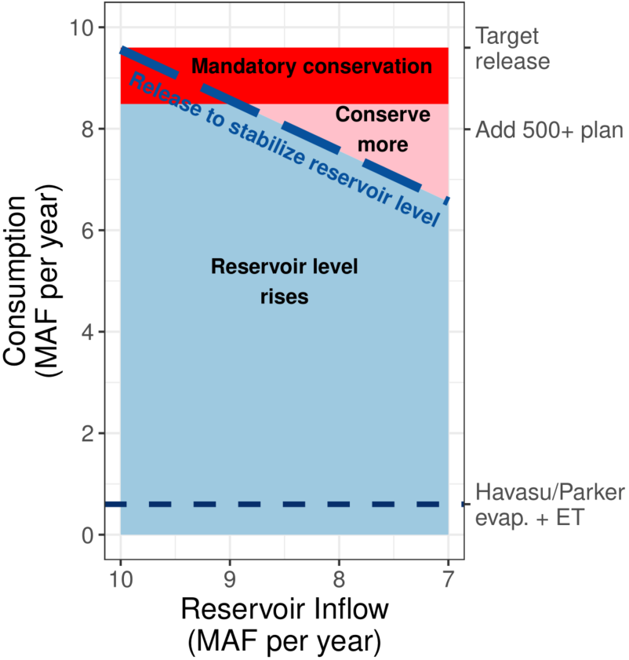

**Figure 2. Consumption to stabilize Lake Mead at elevation 1,041 feet for different reservoir inflows.**

1. **Colorado River Basin Accounts** (Rosenberg, 2022)([**free link to exercise**](https://doi.org/10.4211/hs.9402805ae48245b7b0474c7d32440cd7) **on HydroShare**). In this exercise, 26 Colorado River managers and experts chose the Lake Powell natural inflow each year (Figure 3). A Google Sheet divided the inflow into accounts within a combined Lake Powell-Lake Mead system by following existing operations as best as possible. There were accounts for the Upper Basin, Lower Basin, Mexico, Colorado River Delta, First Nations, and a shared reserve. The shared reserve started with all combined active storage below Lake Powell and Lake Mead critical elevations of 3,525 and 1,020 feet. Next, participants entered how much water to consume, save, or trade that year. The Google Sheet updated account balances. Then, participants split the remaining combined storage between Lake Powell and Lake Mead by observing cells that reported reservoir elevations, Lake Powell release temperature, and suitability for endangered, native fish of the Grand Canyon. As context, existing operations seek a 50%/50% split (equalization). Participants carried account balances to the next year. At the end, participants shared what they liked and what to improve.

The activity was completed in 14 sessions from April to November, 2021. Feedback included “I see myself in the model,” “Fun”, “Made me think about equity,” “Share with others,” and “A huge leap from management today.” Discussions generated lots of talk about equity, sustainability, hydropower generation, water prices, protecting endangered, native fish, and other issues. **I invite you to virtually manage a Colorado River basin account.** Open the [repository](https://doi.org/10.4211/hs.e0cbe52ad4524c07bb5b7ff8c373a343), download the Excel file, move into Google Sheets, and invite people to start.

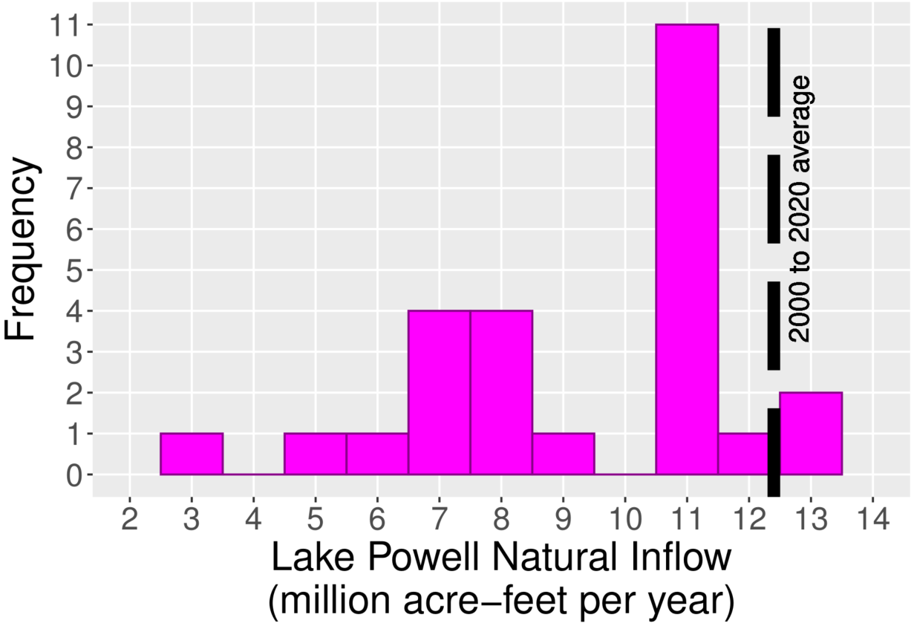

**Figure 3. Participant choices for flow in basin accounts** **activity**

There are many ways to represent adaptive operations such as a rule, chart, or interactive sheet. A common benefit of the three approaches was to define a goal of how much additional water for parties to conserve. Define the goal is also an important first step to motivate and sustain conservation behavior (Aveek, 2022).

One common challenge to adapt to flows was how low a flow to consider? A second challenge was how to divide the sometimes large cutbacks among parties? A third and fourth challenge were how to turn the annual analyses into monthly operations and how to adapt when flow forecasts overestimate actual flow?

There are many more potential adaptive operations with different flow triggers, cutback strategies, temporal, and spatial scopes. Before exploring those aspects further, I suggest to consider a larger set of operations and values such as equity, sustainability, First Nations participate as sovereigns, joint learning, affordable energy for rural communities, protect native fish, and manage with uncertainty.

# Acknowledgements

Hadia Akbar, Jian Wang, and Micah Saftsten provided suggestions that improved this piece.

# References

Aveek, M. R. (2022). "Sustain Water Conservation Behaviors Using Nonparametric Ranking and Social Marketing," Utah State University, Logan, Utah. <https://digitalcommons.usu.edu/cgi/viewcontent.cgi?article=9674&context=etd>.

Carson, C. A., Stone, C. H., Wilson, F. E., Watson, E. H., and Bishop, L. C. (1948). "Upper Colorado River Basin Compact." U.S. Bureau of Reclamation. <https://www.usbr.gov/lc/region/g1000/pdfiles/ucbsnact.pdf>. [Accessed on: September 7, 2021].

Hager, A. (2021). "Lower basin states sign deal to put water back in Lake Mead amid dropping levels." *KUNC*. <https://www.kunc.org/environment/2021-12-15/lower-basin-states-sign-deal-to-put-water-back-in-lake-mead-amid-dropping-levels>.

Rosenberg, D. E. (2022). "Colorado River Basin Accounts: Provoke discussion about more adaptive operations." Hydroshare.org. <https://doi.org/10.4211/hs.e0cbe52ad4524c07bb5b7ff8c373a343>.

Rosenberg, D. E. (In press). "Adapt Lake Mead releases to flow to give managers more flexibility to slow reservoir draw down." *Journal of Water Resources Planning and Management*, 10. <https://digitalcommons.usu.edu/water_pubs/170/>.

USBR. (2007). "Record of Decision: Colorado River Interim Guidelines for Lower Basin Shortages and Coordinated Operations for Lakes Powell and Mead." U.S. Bureau of Reclamation. <https://www.usbr.gov/lc/region/programs/strategies/RecordofDecision.pdf>.

USBR. (2019). "Agreement Concerning Colorado River Drought Contingency Management and Operations." U.S. Bureau of Reclamation, Washington, DC. <https://www.usbr.gov/dcp/finaldocs.html>.

Wang, J., and Rosenberg, D. E. (Submitted). "Living within our Means: Adapting Colorado River Basin depletions to available water." *Submitted to Journal of Water Resources Planning and Management*. <https://digitalcommons.usu.edu/water_pubs/171/>.