**Living within our Means: Adapting Colorado River Basin depletions to available water**

Jian Wang and David E. Rosenberg

Utah Water Research Laboratory

Utah State University

**Abstract:**

Over any time period, the inflows to minus the depletions from any controlled area must equal the change of storage. When users' aspirations to deplete water exceed inflows, water managers must either a) draw down reservoir storage to meet some or all of users’ demands, or b) cut back customary deliveries to adapt to inflows and stabilize reservoir storage. We use a new open-source, Python reservoir model for the Colorado River Basin to simulate new demonstrative adaptive reservoir operations across many short-duration, severe flow sequences observed or reconstructed between 1416 and 2020. Results show: 1) the existing rules to operate Lake Powell and Lake Mead will draw down both reservoirs to their critical storages of 6.0 million acre-feet (3,525 and 1,025 feet) in 3 to 5 years. 2) Triggering the new rule at a Lake Mead elevation of 1,060 feet to adapt basin wide depletions to inflow can sustain both reservoirs above their critical levels for long periods of time. The new rule asks or requires Lower and Upper Basin users to conserve from 0.5 maf per year less to 1.0 maf per year more water than the largest mandatory cutback of 1.375 maf per year. To adopt these adaptive operations, the parties will need to creatively combine five water conservation principles to convert win-lose or lose-lose tradeoffs into win-win opportunities.

1. **Introduction**

Colorado River managers face an uncertain future. The river supplies the two largest reservoirs in the country and flows through iconic landscapes such as the Grand Canyon and other national park units. Management of the river is governed by a bi-national treaty, two interstate compacts, Supreme Court decisions, laws and administrative rules, and numerous inter-party agreements collectively called the Law of the River. The Law of the River began to be codified in the 1920s, when the Colorado River Compact was negotiated (Hundley, 1975; Kuhn and Fleck, 2019) and the compact intends to provide certainty about the volume of water that basin states and users can divert. Today, basin runoff is decreasing (Woodhouse et al, 2016; Udall and Overpeck, 2017; Xiao et al., 2018; Hoerling et al., 2019; Milly and Dunne, 2020; Williams et al., 2020), which has renewed concerns about how to allocate a diminishing and uncertain supply. Future consumptive water uses are uncertain and outcomes for river and reservoir ecosystems are not well predicted. Basin managers, stakeholders and others need tools to help them develop win-win arrangements that are more adaptive, flexible, and transparent across numerous uncertain scenarios.

Three major types of models are currently used for reservoir management: optimization, simulation-based optimization, and simulation/rule-based simulation. A reservoir optimization model searches for reservoir releases and reservoir elevations that maximize benefits (e.g., hydropower generation revenue) or minimize cost (e.g., water supply cost) given a set of constraints (e.g., water balance equations). These models can help identify optimal or near optimal solutions, especially when system objectives are clear. Draper et al. (2003) developed CALVIN (CALifornia Value Integrated Network) to help identify statewide reservoir storage, releases, and flows to minimize California's water supply cost. In this model, inflow was assumed to be perfectly known, and the HEC-PRM software, which solves linear programs with a network structure, was adopted to solve the model. Dogan et al. (2018) introduced the python-based CALVIN model, which is coupled to multiple linear programming solvers. This open source model provides more flexibility by investigating limited forecast optimization and comparing runtime benchmarks for different linear solvers.

In a simulation-based optimization model, operating policies are tested in a simulation model first and then adjusted by optimization techniques in each iteration to improve system productivity, increase efficiency, or reduce system cost. Knox et al. (2018) proposed a Python Network Simulation (Pynsim) framework for multi-agent simulation of networked resource systems. This model enables users to connect to other models and incorporates an example coupling with multi-objective evolutionary algorithms to explore Pareto optimal solutions among different objectives.

Rule-based simulation models simulate system performance with predefined operating policies. They allow users to define and test multiple different operating policies among many different hydrologic and demand scenarios. The U.S. Army Corps of Engineers Hydrologic Engineering Center developed HEC-ResSim to simulate reservoir operations for flood control, water supply, and other purposes (Klipsch and Evans, 2006). Riverware is another widely used proprietary rule-based simulation software in which a river basin’s network of dams and diversions could be represented and edited using a Graphical User Interface (Zagona et al 2001). In the Colorado River, the Bureau of Reclamation maintains the Riverware Colorado River Simulation System (CRSS), which represents the water supply and river network with 12 reservoirs, 29 inflow nodes, 520 water user objects, and 178 primary rules (Wheeler et al. 2019). Stakeholders with substantial technical expertise and budget resources use CRSS to explore alternative long-range strategies to manage water supplies and demands. However, testing different alternative management policies with CRSS is challenging work because many policies in CRSS are closely related, and one must be careful to make the right changes to the policies.

Adaptive reservoir management policies adapt policies or decisions over time as conditions change and information improves (Haasnoot et al., 2013, Herman et al. 2020, Wang et al. 2020, Yang et al. 2021). Signposts usually represent the undesirable system conditions or expiration date and are often used to determine when and under what conditions to adapt operations. In the Colorado River, the Lower Basin’s Drought Contingency Plan (DCP) has two adaptive features: 1) mandatory conservation targets increase as Lake Mead elevation drops, and 2) managers must stabilize lake level when Lake Mead elevation is projected to fall to 1,025 feet (6.0 maf). Similarly, the Upper Basin DCP pledges to protect Lake Powell’s elevation of 3,525 feet (5.9 maf). Within these operations, the Lower Basin DCP adapts Lake Mead releases to elevations not reservoir inflow.

Therefore, we present a rule that adapts basin depletions to inflows (ADP). The rule triggers at a higher Lake Mead elevation of 1,060 feet (8.4 maf) and dynamically sets system depletions equal to inflows. To help evaluate this policy, we built an open source exploratory model for the Colorado River basin. We used this model to perform sensitivity analysis to evaluate under what conditions the system is vulnerable. We also used this model to test the performance of adaptive policies and existing policies. This paper contributes an:

* Adaptive policy that adapts basin depletions to streamflows.
* Open source python model for the Colorado River system.
* Exploration of Colorado River system vulnerabilities under different hydrologic conditions.
* Evaluation of the performance of ADP and DCP under severe drought conditions.
* Strategies for users to conserve larger water volumes identified by the adaptive policy.

Section 2 of the paper introduces the exploratory model. Section 3 provides a Colorado River case study introducing details of the reservoir simulation model, a reservoir-release temperature model, and adaptive policies designed for the Colorado River. Section 4 shares example results for model validation, sensitivity analysis, and reservoir simulations under adaptive policies across different hydrologic traces. Section 5 discusses how to encourage users to conserve larger water volumes identified by the adaptive policy. A final section summarizes the model contributions to manage for an uncertain future and future work.

1. **Open-source exploratory model description**

An open-source exploratory model provides data, model, code, and directions to use in a public repository without promise or budget for ongoing support. This contrasts with a paid, proprietary model such as RiverWare/CRSS, where payment also grants the user access to technical support. The open-source exploratory model in this research uses object-oriented programming to classify different kinds of objects, such as reservoirs, users, and rivers. The model is also equipped with different modules for different analyses and simulations. These modules communicate with each other within the exploratory model. Python was selected as the programming language because (1) more and more water resource scientists are using Python (Knox et al., 2018; Smith et al., 2018; Díaz-González et al., 2021), (2) it enables object-oriented programming, and (3) it supports a large number of data processing and plotting libraries.

**2.1 Basic setup and running a simulation**

Step 1: Develop a water resources system network by creating instances of reservoirs, users, and rivers classes. The exploratory model structures the system as a network, which consists of nodes and links. A node can represent a reservoir or a user. The “Reservoir” node class is the parent class for all reservoirs, and it includes basic properties such as elevation, storage, inflow, outflow, spill, etc. This class also provides some basic functions, such as converting from storage to elevation. The “User” class has a demand property to represent how much water is required in each time step. Failure to meet this demand is defined as water shortage. A link connects two different nodes. The “River” class links two nodes from upstream to downstream. More specific reservoir, user, and river classes can be defined and inherit properties from the three base classes.

Step 2: Specify input parameters and scenarios. Similar to many other rule-based simulation models, the exploratory model requires input of basic reservoir parameters, inflow scenarios for each reservoir, and demand scenarios for each water user. The exploratory model provides tools to import data and export results.

Step 3: Develop operating rules to specify when and how much water to release from each reservoir. In the exploratory model, all operating rules are defined in “ReleaseFunction.py,” and their active states are controlled in the “policyControl.py” script. Users are allowed to develop their own operating rules by expanding the “ReleaseFunction.py” script.

Step 4: Simulate scenarios and output results. Simulations start by running the “start.py” script in the “simulation” folder. The model will then use the defined rules to simulate the system from the beginning to the end of the planning horizon from upstream reservoirs to downstream reservoirs across specified hydrologic and demand scenarios. After simulation, the exploratory model exports reservoir inflows, elevations, storages, releases, user demands, and shortages. Users are allowed to change the default export setting and customize results to export.

**2.2 Sensitivity analysis and adaptive management**

Multidimensional uncertainty analysis can reveal the effects of multiple uncertain factors on the activity or system of interest. It was used in Brown et al. (2012) to help understand how decisions are sensitive to uncertain changing precipitation, temperature, and other factors. The exploratory model provides such a tool to help identify the combinations of future streamflow, user demands, and operating policies that push the system into vulnerable or undesirable states. The insights from sensitivity analysis can help guide when/how to adapt operating policies to avoid system failure. In the exploratory model, adaptive operating rules can be defined in the “ReleaseFunction.py” script as other operating rules. Since all reservoir simulation data and results are assigned and calculated within the network object introduced in section 2.1, the adaptive rules can use the latest system information to determine how much water users should conserve and how much water to release from reservoirs.

**2.3 Linking in additional models**

In modern water resources planning and management, reservoir release decisions also affect other aspects of the system, such as hydropower generation and river ecosystems. No one model does all these things well. Instead, couple to other models that are more capable in those areas. As an example, the current version of the exploratory model is coupled with a release temperature and reservoir water surface elevation model to help predict the temperature of water released from Glen Canyon Dam (Section 5.2, Wheeler et al., 2021). In the Grand Canyon below Lake Powell, release temperature is a key factor that effects downstream river temperature. Downstream river temperature is a fundamental driver of ecosystem structure because river temperature creates habitats suitable for different native and invasive fish species.

1. **Case Study: Colorado River Basin**

The Colorado River Basin encompasses approximately 8% of the continental United States and provides water supply, irrigation water, and hydroelectricity to 40 million people in the United States and Mexico. River management in the early and mid-20th century focused on water supply and hydroelectricity production whereas modern management also considers ecosystem services provided by the river, native and endemic species that are endangered or threatened, and protection and enhancement of national park system units. Many factors will affect the future management of the Colorado River, including increasing air temperature, decreasing watershed runoff, population growth, changing patterns of consumptive use, preferential filling of some reservoirs, changes in the temperature of water released from reservoirs, changes in river ecosystems (especially fish communities), changing societal values, evolving water allocation policies, and the location and extent of water conservation efforts. Many of these factors are difficult to predict, especially for several decades in the future.

**3.1 Reservoir simulation model (structure and data)**

In our exploratory model for the Colorado River Basin, there are two reservoirs, Lake Powell and Lake Mead, that account for approximately 83% of the entire basin storage volume. There are two aggregated users, the Upper Basin and Lower Basin + Mexico (Figure 3.1). In this example, three upper basin tributaries (Upper Colorado River, Green River, and San Juan River) were aggregated into one tributary to Lake Powell and three tributaries (Paria River, Little Colorado River, and Virgin River) were aggregated into one tributary to Lake Mead. All individual Upper Basin users were combined as one Upper Basin user (UB), and all Lower Basin and Mexico users were combined as one Lower Basin user (LB and Mexico). We assume the combined Upper Basin user consumes water above Lake Powell and the combined Lower Basin user consumes water below Lake Mead.

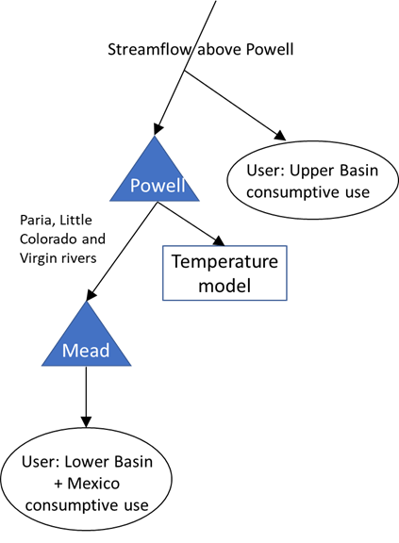

**Figure 3.1. Schematic map of the Colorado River Basin in the exploratory model.**

The exploratory model simulates reservoirs from upstream to downstream. For each reservoir, the water balance equation – inflows minus releases minus evaporation equals change in storage -- is applied to simulate the changes in reservoir storages based on different operating rules. In the exploratory model, all basic parameters for Lake Powell and Lake Mead are obtained from the CRSS Aug 2020 version. Note that in CRSS, evaporation for Lake Powell is calculated with a Periodic Net Evaporation method (RiverWare Manual. 2020) and Lake Mead evaporation is the product of reservoir surface area and evaporation rates. To be consistent with CRSS, we used the same method in the exploratory model.

The Direct Natural Flow (1906 to 2018) scenario has been incorporated into the exploratory model. This scenario includes the mid-20th century drought (1953 to 1977) and the Millennium Drought (2000 to 2018). In this scenario, the index sequential method (Kendall and Dracup, 1991; Ouarda et al., 1997) is applied to generate 113 hydrologic traces. This scenario is provided by the US Bureau of Reclamation and is used in CRSS (Aug, 2020 version). In addition, short duration and more intense Lees Ferry natural flow that range from 5 to 12 million acre-feet per year based on the tree-ring reconstructed flow from 1416 to 2015 (Salehabadi et al., 2021) are selected for sensitivity analysis. Also, average intervening inflow to the system is assumed to be 0.9 maf per year (Wang and Schmidt, 2021), which includes tributaries within the Grand Canyon and streamflow from the Virgin River.

We use an increasing UB demand scenario (from 5.026 maf in 2020 to 5.523 maf in 2060) projected by the Upper Colorado River Commission (UCRC, 2007) that is also the default demand schedule in CRSS (Aug, 2020 version). In addition to the LB and Mexico demand schedule, Lake Mead also needs to release water to meet natural vegetation and phreatophyte user demands, as well as LB gains and losses (including inflow below Lake Mead, changes to Lake Mohave and Lake Havasu storage, and evaporation losses). These data varied among different streamflow traces, and all of these data are obtained from CRSS (Aug, 2020 version) and are used in the current version of the exploratory model. In sensitivity analysis, average UB demand is assumed to be 5.35 maf per year (UCRC, 2007, schedule B), and average LB and Mexico demand is assumed to be 9.6 maf per year (Fleck, 2020).

**3.2 Adaptive management (ADP) and drought contingency plan operating rules (DCP and DCP+) policies**

In the current version of exploratory model, we replicate seven important CRSS Lake Powell operating rules such as equalize Lake Powell and Lake Mead storages under different elevation tiers defined in the 2007 Interim Guidelines. In addition to these rules, the exploratory model also provides a simple version of the equalization rule that uses fewer parameters than the replicated rules. In this rule, Lake Powell releases are iterated to balance Lake Powell and Lake Mead. The 2007 Interim Guidelines (USBR, 2007a), Drought Contingency Plan (DCP, 2019), Minute 319 (Minute 319, 2012), and Minute 323 (Minute 323, 2017) determine LB and Mexico contributions (or cutbacks) under different Lake Mead elevations; the lower the elevation, the larger the cutback. In the exploratory model, a nested if-else statement is used to return increasing cutback values as Lake Mead elevation falls from 1,090 to 1,025 feet. A new DCP+1.2 rule returns cutbacks 1.2 million acre-feet per year larger than DCP for the same elevation tier.

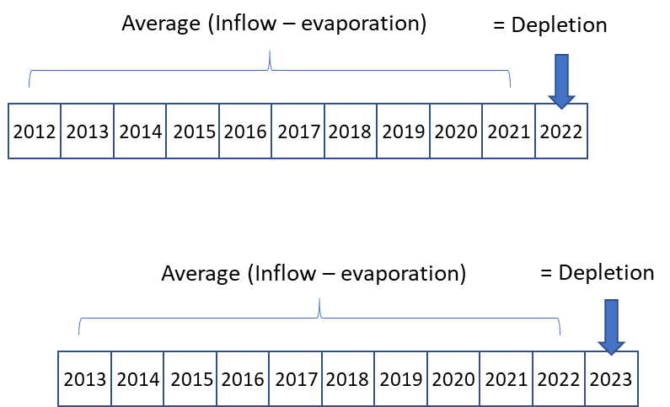

**Figure 3.2. Schematic of adaptive management strategy in this research**

The adaptive policy (hereafter, ADP) in this research is defined as adapting depletion to the average past 10-years of system gain (Figure 3.2). Gain is the difference between inflow and reservoir evaporation. The ADP policy uses the most recent hydrologic information every year to assist with the next year’s decision-making regarding depletions and reservoir storage. The benefits to use hydrologic information from several past years include: (1) users only use the available water coming into the system; (2) dynamically balance basin depletion and water system gains; (3) capture recent hydrologic changes; (4) use the most recent data; and (5) prevent severe reservoir drawdown during one or more low inflow years. Water conserved in reservoirs still belongs to users and can be used when severe drought occurs. Equation (1) assumes next-year depletion for the entire basin is equal to the average past gains to the system.

(1)

where is total water depletion in year *y*, represents inflow in the past year *t*, represents evaporation in the past year *t*, *N* is the total years to look backward, and *y* - *N* to *y* – 1 is the lookback period. Another variation of the ADP strategy is to incorporate 1 or 2 years of reliable future inflow predictions in calculating the average inflow to the system. We don’t use future forecast information in this research.

Water shortages in the coming year are calculated by subtracting the total system depletion determined in equation (1) from original basin demand schedule. Many strategies exist to allocate entire basin shortages to UB or LB and Mexico. We tested different strategies ranging from the UB bears all shortages to the UB bears no shortages. In this research, we simulated the ADP strategy along with the equalization policy (to determine where to store water) across all historical streamflow records (1906–2018). The ADP strategy is assumed to start in January 2021 and will only be triggered when Lake Mead elevation is less than 1,060 feet and the average system gain over the past 10 years is smaller than the next year's demand schedule. When Lake Mead elevation is above 1,060 feet, LB and Mexico contributions are calculated by the DCP operation. The 1,060 feet trigger is 35 feet and 2.4 maf higher than the 1,025 feet trigger in the Lower Basin DCP.

**3.3 Reservoir release temperature model**

To help evaluate downstream river ecosystem response to different management strategies explored by CRSS, we developed and applied a monthly dam-release temperature model. The temperature of water passed through Glen Canyon Dam penstock intakes reflects the quality of water in a withdrawal zone. The thickness of this withdrawal zone is determined by stratification in the reservoir, ambient reservoir currents, forebay bathymetry, intake geometry, and the amount of water drawn through the intakes. The withdrawal zone tends to be higher than the penstock intake centerline elevation. For example, measurements made during a High Flow Experiment in 2008, when the reservoir was at 3,590 ft, suggests this value is about 15 ft (Vermeyen, 2011). For this reason, the water temperature being passed through the penstock intakes may be closer to water temperatures located at shallower depths in a temperature profile measured at some distance from the intakes. The reservoir release temperature model assumes that the average water temperature within the withdrawal zone can be approximated for a given month and surface lake elevation by using a monthly average reservoir temperature profile and a constant that represents the difference between the depth of the penstock intakes and the depth in the profile that best represents the withdrawal zone (Wheeler, et al., 2021). To construct the model, we first developed monthly reservoir temperature profiles by averaging all reservoir temperature profiles reported by Vernieu (2015) for a given month. We then calculated the depth of the water withdrawal based on the difference between surface elevation and the elevation of the penstocks. For each month, we utilized a constant offset (15 ft) to add to the penstock depth to better represent the withdrawal zone. This model allowed us to quickly predict release water temperature for each month and surface elevation from CRSS. Unlike other process-based models (e.g., CE-QUAL W2), the model used here does not capture the variability associated with tributary inflow and temperature or weather conditions.

1. **Example results**

**4.1 Model validation**

To validate the exploratory model, we compare Lake Powell and Lake Mead inflow, storage, and outflow results from the exploratory model against CRSS results for the same basic parameters (section 3.1), 113 direct natural flow traces, demands, and operating rules. Results for one hydrologic trace that repeats a mid-20th century drought show that Lake Powell and Lake Mead storage, inflow and outflow simulation results from the exploratory model are very close to those of CRSS (Figure 1). Validation results for other hydrologic traces are also similar (Appendix A, Figure A.1.) The computational time for each hydrologic trace in the exploratory model was about 0.35 seconds, which is 50 times faster than the CRSS single-trace run time of about 20s. Minor differences between the exploratory model results and CRSS results can be explained by the exploratory model replicating many important policies in CRSS, but not all of them. These validation results demonstrate the capability of the exploratory model to correctly simulate the two largest reservoirs in the Colorado River system.

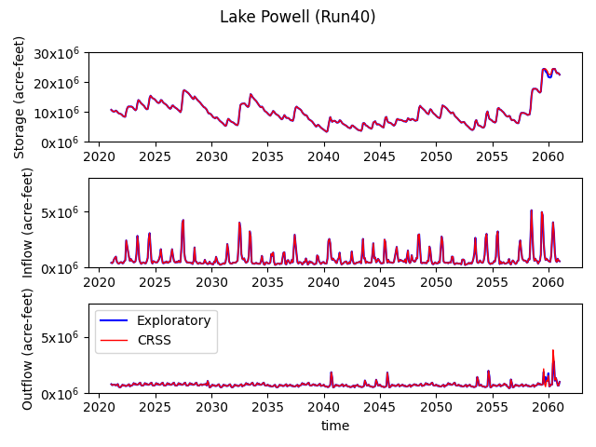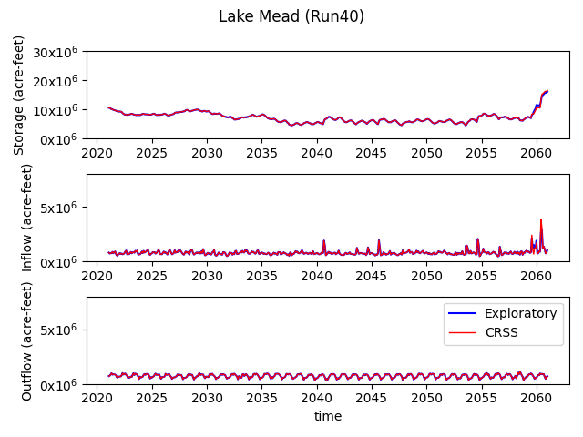

**Figure 4.1 Comparison between Lake Powell and Lake Mead results from the exploratory model and CRSS.**

**4.2 Multidimensional sensitivity analysis**

We use sensitivity analysis tool introduced in section 2.2 to analyze system performance under different natural flows at Lees Ferry, user demands, and release policies. Under many scenarios of Lee Ferry natural flow that range from 5 to 12 million acre-feet (maf) every year, the existing Lower Basin DCP operations will draw the combined storage of Lake Powell and Lake Mead down to 12 maf in less than 4 years (Figure 4.2). With 12 maf of natural flow at Lee Ferry every year, increasing the largest DCP cutback by 1.2 maf per year over the existing cutback pushes the drawdown time to 10 years. However, with 10 maf or lower of natural flow at Lee Ferry every year, all versions of the DCP drawdown combined reservoir storage to 12 maf in about three years or shorter. The grey background in Figure 4.2 shows the numerous combinations of drought duration and natural flow at Lee Ferry that have occurred in the observed and paleo records (Salehabadi et al. 2021, Figure 14). These numerous hydrologic scenarios are possible and can quickly drawdown reservoir storage to critical levels. The red and blue lines in the grey shaded area indicate that DCP and DCP+ will not get the LB, Mexico, or UB through many intense, short duration droughts in the observed and paleo records.

In contrast, the ADP keeps combined reservoir storage above 12 maf for 40 years or longer for Lee Ferry natural flows above 5 maf per year each year. For Lee Ferry natural flow around 5 maf per year, the ADP does not maintain combined storage above 12 maf because the reservoir storage falls below 12 maf before the ADP rule can trigger. The ADP rule sustains reservoir levels through much longer droughts than the current DCP operations. The ADP rule sustains reservoir levels because the ADP rule adapts and cuts back allowed depletions to the available gains to the system – the inflow minus evaporation. In contrast, the DCP operations and variants cut back depletions according to a lower fixed lake level schedule that does not consider annual reservoir inflow. In short, the ADP requires users to conserve more water than the DCP. When UB demands are reduced to 4.5 maf per year, it can delay the time that combined reservoir storage draws down to 12 maf (Appendix A, Figure A.2).

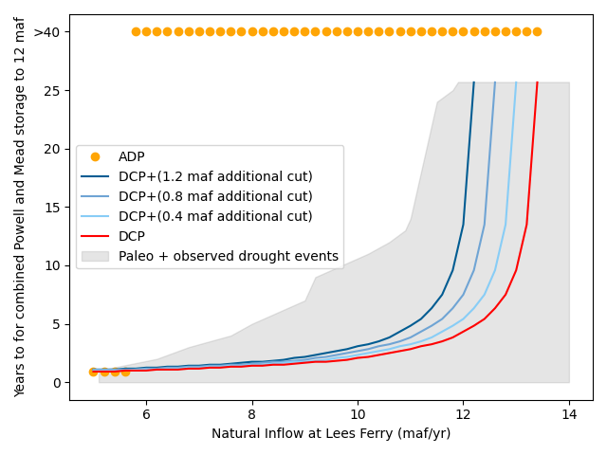

**Figure 4.2. Years (y-axis) until combined Lake Powell and Lake Mead storage will go to 12 maf for different steady year-to-year inflows (x-axis) under different policies (red and blue lines; when average UB demand = 5.35 maf/yr)**

Figure 4.3 shows trade-offs between combined reservoir storage volume at the end of the simulation and steady-state basin depletion. The larger the end of planning horizon combined storage (affected by different policies, indicated by different point shapes), the smaller the steady state total depletions under the same amount of natural flow at Lees Ferry (indicated by color schemes). Among the three tested policies, DCP empties reservoir storage first; however, steady-state basin depletion is the largest because reservoir evaporation is no longer a factor after Lake Powell and Lake Mead become run-of-river reservoirs. DCP+ preserves more water than DCP, but only avoids emptying reservoir storage when natural flows are not low. ADP can always keep the combined reservoir storage higher than 12 maf at the expense of having the lowest steady state depletion among these policies. However, when combined reservoir storage reaches steady state, only minimal additional cutbacks from ADP are required to keep the reservoirs running above 12 maf compared to DCP or DCP+.

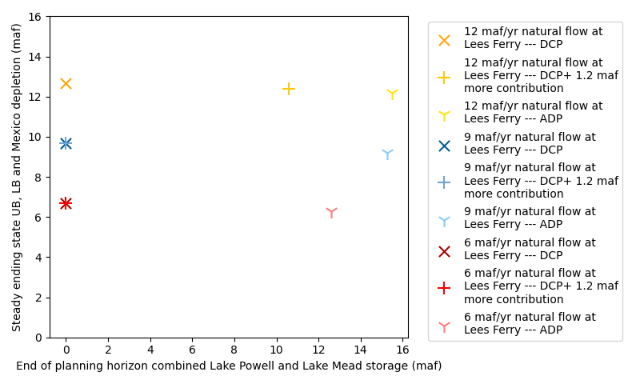

**Figure 4.3. Trade-off between end-of-planning-horizon combined storage for Lake Powell and Lake Mead and static state total depletions (when average UB demand = 5.35 maf/yr)**

Figure 4.4 shows Lake Powell summer release temperatures under the different operations policies for different natural flows at Lees Ferry. Compared with DCP, ADP can always keep release temperatures at or below 20 °C, and more importantly, operators can lower release temperature by mixing water from penstock and river outlets. These features provide the downstream river ecosystem a relatively more stable temperature pattern. As for DCP, reservoir release temperatures in the first several years range from a low of 10 °C to a high of 25 °C. This is because Lake Powell elevation is higher than the penstock elevation (3,470 feet) in those years, and thus water can be released from both the penstock and the river outlet (3,370 feet). Since the reservoir is thermally stratified, water released from river outlets is usually cooler than water released from the penstock. When reservoir elevation drops below penstock elevation, Lake Powell release temperature converges, which also means operators cannot control release temperature by mixing water released from the penstock and river outlets. In Figure 4.4, with 12 maf per year of natural flow at Lees Ferry, Lake Powell release temperatures will gradually increase to 25 °C after 2035 with DCP, and lower natural flows at Lees Ferry will accelerate this process. A water temperature of 25°C exceeds the highest historical records (around 15°C) since Lake Powell was filled and will create large uncertainties for the Grand Canyon river ecosystem.

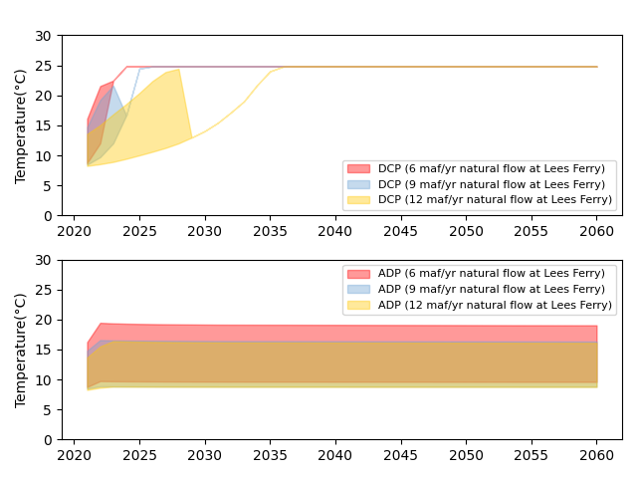

**Figure 4.4. Lake Powell summer release temperatures for different steady year-to-year inflows under DCP (top) and ADP (bottom) policies (when average UB demand = 5.35 maf/yr)**

Previous analysis shows that inflow is one dominant factor in declining reservoir storage. Therefore, in addition to reservoir elevation/storage, operating rules for the Colorado River should also consider inflow information because it is the combined effect of inflow and releases that contributes to the changes in reservoir storage. This means managers must also adapt Upper and Lower Basin demands to unregulated inflow to prevent Lake Powell and Lake Mead levels from dropping below 3,525 and 1,025 feet.

**4.3 Sharing shortages**

In Figure 4.5, the first two subplots compare Lake Powell and Lake Mead elevations for the ADP and DCP policies under Millennium Drought hydrology (average Lee Ferry natural flow of 12.4 maf per year). The ADP policy keeps Lake Powell above 3,490 feet (Lake Powell minimum power pool) and Lake Mead above 1,025 feet for most of the time, but at the sacrifice of experiencing large water shortages (3rd and 4th subplots). The additional water saved by ADP in earlier years is not wasted; instead, some of it is stored in both Lake Powell and Lake Mead, thus leaving more water for future use. These results demonstrate the value of water conservation. Users conserve 0 to 1.0 maf per year (bottom right figure) more than the current DCP to get through a continuation of the Millennium Drought. Water conserved in reservoirs is saved for future water uses. Results for Mid-20th century drought (Appendix A, Figures A.5 and A.6) show similar results and also highlight the value of water conservation.

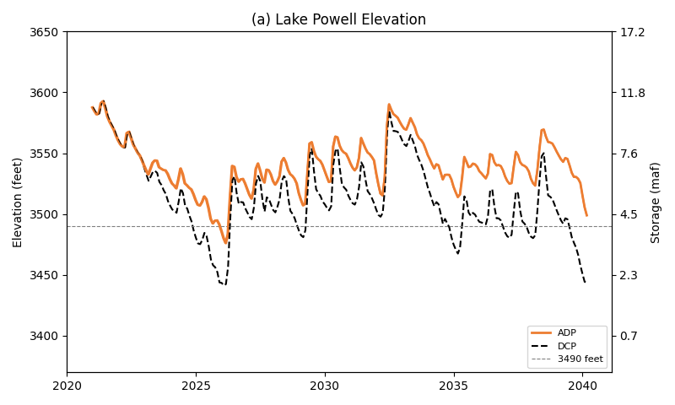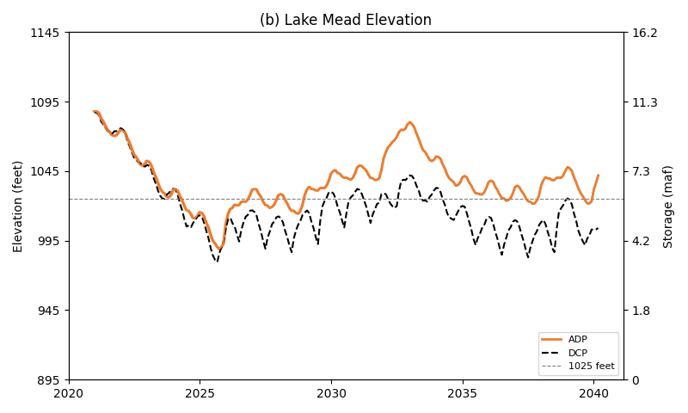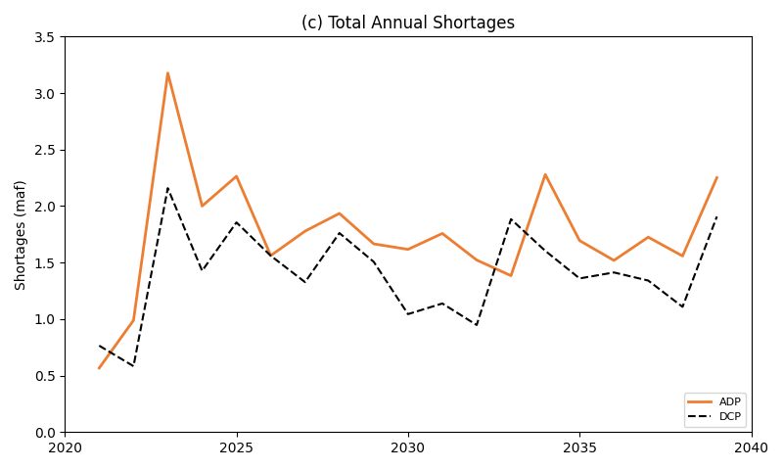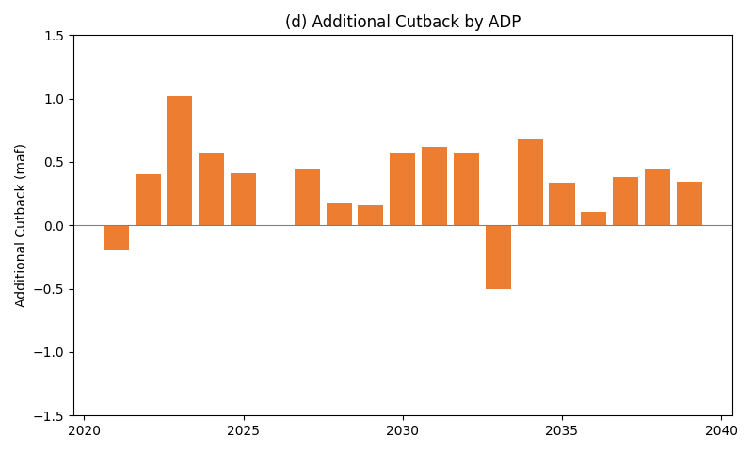

**Figure 4.5. Lake Powell and Lake Mead elevation and total system shortages under Millennium Drought (2000–2018)**

Besides distributing shortages proportionally to UB, LB, and Mexico, we also simulated different allocations of new shortages by the UB, LB, and Mexico and found a quasi-linear and win-lose tradeoff (Figure 6). In Figure 4.6, yellow circle represents the complete fulfillment of all demands over the next 19 years. Clearly, the entire basin will not have enough water to satisfy all UB and LB and Mexico demand if the millennium drought continues. The win-lose tradeoff also suggests that Mexico and the Upper and Lower Basins will have difficulty to negotiate a split of the new shortages. This is the same difficulty that the Lower Basin states have to negotiate increased cutbacks above the current mandatory cutbacks. The parties will have difficulty to transition to an ADP policy. There will need to be some other (unmodeled) benefits to motivate adoption of the ADP policy.

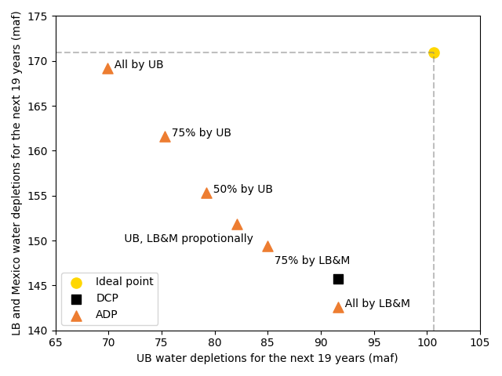

**Figure 4.6. Depletion trade-offs between UB and LB and Mexico under the Millennium drought (2000–2018)**

1. **Creative Conservation**

Under continued Millennium drought hydrology of 12.4 million acre-feet per year average natural flow to Lee Ferry, the adapting depletion to inflow policy keeps Lake Powell level above 3,495 feet and Lake Mead above 1,025 feet (6 million acre-feet). The ADP maintains these levels by requiring basin water users to conserve up to 1 million acre-feet per year more than currently mandated by the Lower Basin drought contingency plan (Figure 4.5). The Upper and Lower Basins and Mexico will find it difficult to split these additional cutbacks among themselves (lose-lose tradeoff).

Implementing an adaptive depletion or similar policy will need creative efforts to turn a lose-lose policy into a win-win. We believe the parties can find win-win alternatives by creatively combining five principles to help parties collaboratively conserve more water, money, and time.

1. **Promote voluntary conservation with compensation**. Voluntary, compensated, and temporary conservation is now the motto for the Upper Basin (UCRC 2019). Other examples of voluntary, compensated conservation are the Quantification Settlement Agreement of 2003 and urban water conservation programs. For example, Metropolitan Water District (MWD) of Southern California, San Diego Water Authority (SDWA), and Southern Nevada Water Authority (SNWA) offered their customers rebates to replace old toilets, showerheads, laundry machines, and other appliances with WaterWise and Energy Star labeled appliances that use less water per flush, minute, and cycle. SNWA bought turf back from users (cash for grass). In contrast, mandated conservation, such as the Lower Basin’s drought contingency plan, forced users to make rapid, large, and painful cutbacks beyond what they have historically conserved.
2. **Conserve sooner rather than later.** Voluntary water conservation programs for Lake Mead allow Mexico, the Lower Basin states, and contractors to store water they conserve in Lake Mead, get credit, and later withdraw the conserved water subject to restrictions on lake elevation and maximum annual withdrawal amounts (USBR, 2007b, IBWC, 2021). Presently, Lower Basin conservation accounts hold 2.8 maf of water—23% of current Lake Mead active storage—and have exceeded the 2.7 maf program cap (USBR 2020). In recent years, annual conservation efforts are close to 0.625 maf per year program cap on annual deposits and delayed the onset of mandatory conservation efforts. In contrast, the 2007 Interim Guideline operation to equalize storage in Lakes Powell and Mead (USBR, 2007) discouraged the Upper Basin from storing water in Lake Powell. Water the Upper Basin stored in Lake Powell was released by the equalization rule downstream to the Lower Basin. In the 2012 to 2021 period, Lake Powell released 4 maf more than required by the 1922 Compact and 1944 United States-Mexico treaty.
3. **Make conservation a habit.** Many conservation actions like retrofitting household water appliances, lining canals, or installing center pivots will save water year after year after year compared to a no-action alternative. Other short-term drought conservation efforts like encouraging shorter showers or limiting the allowed days/times for landscape irrigation quickly revert after the triggering drought conditions lift.
4. **Save water, money, and time.** For urban water providers such as MWD, SDCWA, and SNWA, it is less expensive to encourage customers to conserve than to build expensive and contentious new dams, pipelines, or other infrastructure with uncertain lead times or permitting processes. Installing center pivots, automating canal operations, and installing automatic dishwashers each save water. More valuable than the water, these conservation actions save customers time.
5. **Give parties more flexibility** to conserve and consume water independent of other parties. For example, give each party an individual flex account in the combined Lake Powell-Lake Mead system. Together, the account balances total all active storage which presently is larger than Lake Mead conservation account balances. Then each year, the party’s available water is the party’s account balance, plus share of combined natural flow, minus the party’s share of reservoir evaporation. Each party individually consumes and conserves within their available water independent of other parties. This setup transitions the current hybrid system of private Lake Mead conservation accounts and a public pool into individual flex accounts (Figure 5.1; Rosenberg 2021a). By giving parties more flexibility in their consumption and conservation decisions, parties can set their risk and reward tolerances. This set up can also help counter a negative feedback where Lake Mead draws down then parties withdraw water from their conservation accounts to use that water before they lose it. Conservation account withdrawals accelerate Lake Mead draw down.

|  |  |
| --- | --- |
|  |  |
| **Figure 5.1. Convert conservation accounts and a public pool (left, current operations) into individual accounts that give parties more flexibility to conserve and consume independent of other parties (right).** | |

Combining the conservation principles of temporary, compensated, sooner, make a habit, save money, and save time can create a win-win opportunity when an urban user approaches an upstream agricultural user to lease water during a low flow period. The urban user requires the agricultural user to invest some of the payments to improve farm water conservation (Rosenberg, 2021b). This requirement keeps payments in the local community, spurs growth of local agri-businesses, and makes more water available for lease in future years. The temporary lease and required investment keep the agricultural user in operation and curtail the reviled buy-and-dry transaction where a permanent purchase permanently dries the agricultural land. In the win-win transaction, 1) an urban user gets temporary access to some more water during a critical dry period while an agricultural community is compensated, 2) the agricultural users starts conserving sooner than they otherwise would, 3) the agricultural user develops a conservation habit through repeated leases, 4) the parties together save water, money, and time, and 5) the parties sustain and grow the agricultural community.

Combining the conservation principles of temporary, compensated, and more flexibility can create win-win opportunities for parties to sell some of their available water to other users or purchase available water from other users. These compensated transactions move water from one account to another account in the combined reservoir storage system and do not require wheeling. With this combination, a party can sell some water and get compensated to initiate conservation ahead of an anticipated future mandatory shortage. Another party can purchase water to help make a mandatory conservation target that year. Still another party may prefer to buy water than conserve. Try out these and other collaborative conservation strategies with the pilot flex accounting tool at Rosenberg (2021c). These collaborative conservation strategies turn win-lose or lose-lose mandatory cutbacks into win-win opportunities for voluntary, compensated agreements or more flexibility to conserve.

1. **Limitations and Future works**

There are numerous adaptive policies for reservoir operation. These policies can be triggered by different reservoir storage, inflow, climate, or combinatory triggers. A combined Lake Powell and Lake Mead storage volume could also trigger an adaptive policy. Numerous political choices also shape the selection of a policy and triggers. Here, we simulated one policy that adapted basin depletions to inflows when Lake Mead’s level fell below 1,060 feet.

The ADP strategy considers past hydrologic information, but does not make use of forecasting information. Individual parties can forecast future inflow, the model does not have forecast.

While we simulated reservoir release temperature, we do not consider downstream river drivers such as air temperature, sediment, and interactions between different fish species. Future work may incorporate these factors into the exploratory model.

We simulated basin management at monthly time steps, which may not be able to capture important finer time-scale river ecosystem responses to daily or hourly streamflow variation. Future work may cross more time scales and consider tradeoffs between water volume, hydropower revenue, and ecosystem benefits.

Managers must plan for many possible hydrologic and operational scenarios (Wang et al, 2020). Thus, we made our modeling materials open-source so that managers can explore and adjust the model assumptions to see what conservation efforts are required under different hydrologic or operational scenarios.

1. **Conclusion**

We developed an open-source exploratory model to help simulate adaptive operating rules for the Colorado River Basin. The exploratory model complements existing simulation models by offering greater flexibility and speed when setting up scenarios for uncertain future conditions and adaptive policies. We found that the exploratory model results for Lake Powell and Lake Mead validated against CRSS results at 1/50 of the CRSS running time. We tested the conditions under which the system will be in a vulnerable state in the next year. Results reveal that many intense, short duration droughts from the observed and paleo records will draw down Lake Powell and Lake Mead storage to 12 maf in a few short years. Finally, we developed and tested an adapting-depletion-to-inflow policy (ADP) using the most severe droughts observed in history (Millennium Drought and Mid-20th century drought). This policy used recent inflow information that goes unused by the existing Law of the River operations. Release decisions from this policy adapt to inflows and kept depletion and inflow dynamically balanced. This adaptive policy helped Lake Powell and Lake Mead stay at relatively higher elevations (Lake Powel 3,490 feet, Lake Mead 1,125 feet) at the expense of 0.5 maf per year less to 1.0 maf per year larger mandatory cutback than the existing rules of 1.375 maf per year. To conserve at those higher levels, the parties will need to creatively combine five water conservation principles to transform win-lose or lose-lose results into win-win opportunities.

**Acknowledgements**

This material is based upon work supported by the U.S. Geological Survey under Grant/Cooperative Agreement No. G16AP00086 Project ID 2020UT303b, the Center for Colorado River Studies at Utah State University, the Catena Foundation, and the Walton Family Foundation. This work benefited from discussions with one Upper and one Lower Basin manager. We also thank Carri Richards for her editing assistance.

**Data Availability Statement**

All data, codes, and models used in this study are available on the [Wang](https://github.com/JianWangUSU/Future_of_the_Colorado_River_Project/tree/master/ExploratoryModel) (2021) and Rosenberg (2021d).

**Reproducible Results**

Mahmudur Rahman Aveek (Utah State University) downloaded, installed, and ran the exploratory model and reproduced results in all figures.

**Reference**

Brown, C., Ghile, Y., Laverty, M., & Li, K. (2012). Decision scaling: Linking bottom‐up vulnerability analysis with climate projections in the water sector. Water Resources Research, 48(9).

Dogan, M. S., Fefer, M. A., Herman, J. D., Hart, Q. J., Merz, J. R., Medellín-Azuara, J., & Lund, J. R. (2018). An open-source Python implementation of California's hydroeconomic optimization model. Environmental Modelling & Software, 108, 8–13.

DCP, (2019), Colorado River Basin Drought Contingency Plans (DCP). <https://www.usbr.gov/dcp/finaldocs.html>

Díaz-González, L., Uscanga-Junco, O. A., & Rosales-Rivera, M. (2021). Development and comparison of machine learning models for water multidimensional classification. Journal of Hydrology, 598, 126234.

Draper, A.J., Jenkins, M.W., Kirby, K.W., Lund, J.R., Howitt, R.E., 2003. Economic-engineering optimization for California water management. J. Water Resour. Plann. Manag. 129, 155–164. <https://doi.org/10.1061/(ASCE)0733-9496(2003)> 129:3(155).

Draper, A. J., and Lund, J. R. (2004). Optimal hedging and carryover storage value. Journal of water resources planning and management, 130(1), 83–87.

Fleck, John (2020). How big was Lake Mead’s “structural deficit” in 2019? Link: <http://www.inkstain.net/fleck/2020/01/how-big-was-lake-meads-structural-deficit-in-2019/>

Haasnoot, M., Kwakkel, J. H., Walker, W. E., and ter Maat, J. (2013). Dynamic Adaptive Policy Pathways: A Method for Crafting Robust Decisions for a Deeply Uncertain World. Global Environmental Change, 23(2), 485–498.

Herman, J. D., Quinn, J. D., Steinschneider, S., Giuliani, M., & Fletcher, S. (2020). Climate adaptation as a control problem: Review and perspectives on dynamic water resources planning under uncertainty. Water Resources Research, 56(2), e24389.

Hundley, N., Jr. (1975), Water and the West: The Colorado River Compact and the Politics of Water in the American West. Berkeley, University of California Press. Kendall, D. R. and J. A. Dracup, (1991), "A Comparison of Index-Sequential and AR(1) Generated Hydrologic Sequences," Journal of Hydrology, 122(1): 335–352, <https://doi.org/10.1016/0022-1694(91)90187-M>.

IBWC. (2021). "Minutes between the United States and Mexican Sections of the IBWC." United States Section. <https://www.ibwc.gov/Treaties_Minutes/Minutes.html>.

Klipsch, J. D., and Evans, T. A. (2006, April). Reservoir operations modeling with HEC-ResSim. In Proceedings of the 3rd Federal Interagency Hydrologic Modeling Conference, Reno, NV, USA (Vol. 3).

Knox, S., Meier, P., Yoon, J., and Harou, J. J. (2018). A python framework for multi-agent simulation of networked resource systems. Environmental Modelling & Software, 103, 16–28.

Kuhn, E. and J. Fleck, (2019), Science Be Dammed: How Ignoring Inconvenient Science Drained the Colorado River, University of Arizona Press, <https://uapress.arizona.edu/book/science-be-dammed>.

Minute 319, (2012), "Minute No. 319; Interim International Cooperative Measures in the Colorado River Basin through 2017 and Extension of Minute 318 Cooperative Measures to Address the Continued Effects of the April 2010 Earthquake in the Mexicali Valley, Baja California," International Boundary and Water Commission, Available online at: https://www.ibwc.gov/Files/Minutes/Minute_319.pdf.

Minute 323, (2017), "Minute No. 323, Extension of Cooperative Measures and Adoption of a Binational Water Scarcity Contingency Plan in the Colorado River Basin dated September 21, 2017," International Boundary and Water Commission, Available online at: https://www.ibwc.gov/Files/Minutes/Min323.pdf.

Ouarda, T. B. M. J., J. W. Labadie and D. G. Fontane, (1997), "Indexed Sequential Hydrologic Modeling for Hydropower Capacity Estimation," JAWRA Journal of the American Water Resources Association, 33(6): 1337–1349, <https://doi.org/10.1111/j.1752-1688.1997.tb03557.x>.

Rosenberg, D. E. (2021a). "Combined Lake Powell-Lake Mead plots." <https://github.com/dzeke/ColoradoRiverCoding/tree/main/CombinedPowellMead>.

Rosenberg, D. E. (2021b). "Invest in Farm Water Conservation to Curtail Buy and Dry." Inkstain. <http://www.inkstain.net/fleck/2021/06/invest-in-farm-water-conservation-to-curtail-buy-and-dry/>.

Rosenberg, D. E. (2021c). "Pilot flex accounting to encourage more water conservation in a combined Lake Powell-Lake Mead system." <https://github.com/dzeke/ColoradoRiverCoding/tree/main/ModelMusings>.

Rosenberg, D. E. (2021d). "Combined Lake Powell-Lake Mead plots." Utah State University. Logan, Utah. <https://github.com/dzeke/ColoradoRiverCoding/tree/main/CombinedPowellMead>.

Salehabadi, H., D. G. Tarboton, E. Kuhn, B. Udall, K. G. Wheeler, D. E. Rosenberg, S. A. Goeking and J. C. Schmidt, (2020), "The Future Hydrology of the Colorado River Basin," White Paper 4, Future of the Colorado River Project, Center for Colorado River Studies, Utah State University, 71 p., <https://qcnr.usu.edu/coloradoriver/files/WhitePaper4.pdf>.

Smith, J. A., Cox, A. A., Baeck, M. L., Yang, L., and Bates, P. (2018). Strange floods: The upper tail of flood peaks in the United States. Water Resources Research, 54(9), 6510-6542.

Xiao, M., Udall, B., & Lettenmaier, D. P. (2018). On the causes of declining Colorado River streamflows. Water Resources Research, 54(9), 6739–6756.

Udall, B., and Overpeck, J. (2017). The twenty‐first century Colorado River hot drought and implications for the future. Water Resources Research, 53(3), 2404–2418.

Upper Colorado River Commission, (2007), "Upper Colorado River Division States, Current and Future Depletion Demand Schedule," Available online at: <https://qcnr.usu.edu/coloradoriver/blog/overestim_2.pdf>.

Upper Colorado River Commission. (2019). "Request for Qualification-Based Proposals for Professional Services." RFP #2019-01-UCRC.

USBR, (2007a), "Colorado River Interim Guidelines for Lower Basin Shortages and the Coordinated Operations for Lake Powell and Lake Mead - Final Environmental Impact Statement," U.S. Bureau of Reclamation, <https://www.usbr.gov/lc/region/programs/strategies/FEIS/index.html>.

USBR. (2007b). "Record of Decision: Colorado River Interim Guidelines for Lower Basin Shortages and Coordinated Operations for Lakes Powell and Mead." U.S. Bureau of Reclamation. <https://www.usbr.gov/lc/region/programs/strategies/RecordofDecision.pdf>.

USBR. (2021). "Water Operations: Historic Data, Upper Colorado River Division." Upper Colorado River Division, U.S. Buruea of Reclamation. <https://www.usbr.gov/rsvrWater/HistoricalApp.html>.

Vermeyen, T. B., (2011), "Glen Canyon Dam Penstock Withdrawal Characteristics, 2007-2008," Hydraulic Laboratory Report HL-2011-02 U.S. Department of the Interior, Bureau of Reclamation, Technical Service Center, Hydraulic Investigations and Laboratory Services Group, Denver, Colorado <https://www.usbr.gov/tsc/techreferences/hydraulics_lab/pubs/HL/HL-2011-02.pdf>.

Vernieu, W. S., (2015), "Historical Physical and Chemical Data for Water in Lake Powell and from Glen Canyon Dam Releases, Utah-Arizona, 1964–2013," Data Series 471, Version 3.0, U.S. Department of the Interior, U.S. Geological Survey, <https://pubs.usgs.gov/ds/471/pdf/> ds471.pdf.

Wang, J., D. E. Rosenberg, K. G. Wheeler and J. C. Schmidt, (2020), "Managing the Colorado River for an Uncertain Future," White Paper 3, Future of the Colorado River Project, Center for Colorado River Studies, Utah State University, 30 p., <https://qcnr.usu.edu/coloradoriver/files/CCRS_White_Paper_3.pdf>.

Wang, J. and Schmidt, J. C., (2020), "Stream flow and Losses of the Colorado River in the Southern Colorado Plateau," White Paper 5, Future of the Colorado River Project, Center for Colorado River Studies, Utah State University, 26 p., <https://qcnr.usu.edu/coloradoriver/files/WhitePaper5.pdf>.

Wang, J. (2021). " Living within our Means: Adapting Colorado River Basin depletions to the available water." Utah State University. Logan, Utah. <https://github.com/JianWangUSU/Future_of_the_Colorado_River_Project/tree/master/ExploratoryModel>

Wheeler, K. G., Rosenberg, D. E., and Schmidt, J. C., (2019), "Water Resource Modeling of the Colorado River: Present and Future Strategies," White Paper 2, Future of the Colorado River Project, Center for Colorado River Studies, Utah State University, 47 p., <https://qcnr.usu.edu/coloradoriver/files/WhitePaper2.pdf>.

Wheeler, K. G., Kuhn, E., Bruckerhoff, L., Udall, B., Wang, J., Gilbert, Lael., Goeking, Sara., Kasprak, A., Mihalevich, B., Neilson, B., Salehabadi, H., and Schmidt, J. C. (2021), " Alternative Management Paradigms for the Future of the Colorado and Green Rivers," White Paper 6, Future of the Colorado River Project, Center for Colorado River Studies, Utah State University, 91 p., <https://qcnr.usu.edu/coloradoriver/files/WhitePaper6.pdf>.

Woodhouse, C. A., Pederson, G. T., Morino, K., McAfee, S. A., and McCabe, G. J. (2016). Increasing influence of air temperature on upper Colorado River streamflow. Geophysical Research Letters, 43, 2174–2181. https://doi.org/10.1002/2015GL067613

Yang, G., Zaitchik, B., Badr, H., and Block, P. (2021). A Bayesian adaptive reservoir operation framework incorporating streamflow non-stationarity. Journal of Hydrology, 594, 125959.

Zagona, E. A., Fulp, T. J., Shane, R., Magee, T., and Goranflo, H. M. (2001). Riverware: A generalized tool for complex reservoir system modeling 1. JAWRA Journal of the American Water Resources Association, 37(4), 913–929.

**Appendix A**

In Figure A.1, we present three typical traces to show system performance in comparing between the exploratory model and CRSS. Results demonstrate the capability of the exploratory model to correctly simulate the two largest reservoirs in the Colorado River system. Besides using the UCRC UB demand schedule, we also use another relatively smaller UB demand schedule for multi-dimensional sensitivity analysis, and present the results in Figures A.2, A.3, and A.4. Comparing the results in Figures 4.2, 4.3, and 4.4 indicates that lowering UB demand will delay the reservoir reaching severe conditions, increase end-of-planning horizon storage, and decrease reservoir release temperature. In addition, in this appendix, we also show how adaptive policy performs under another severe sustained drought (the Mid-20th century drought) in Figures A.5 and A.6. Results demonstrate that the ADP is capable of keeping reservoirs running at relatively higher elevations without users losing much water.

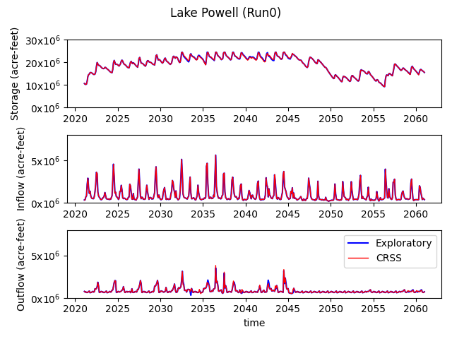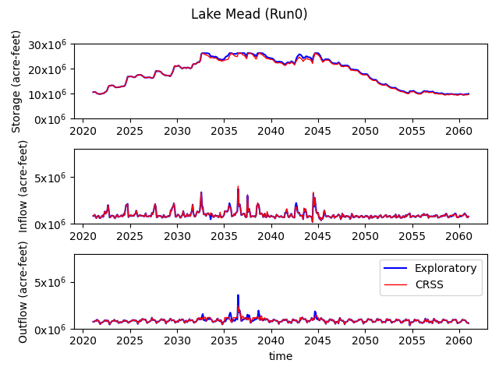

* 1. **Hydrologic trace 0 indicates historical hydrology (1906-1945)**

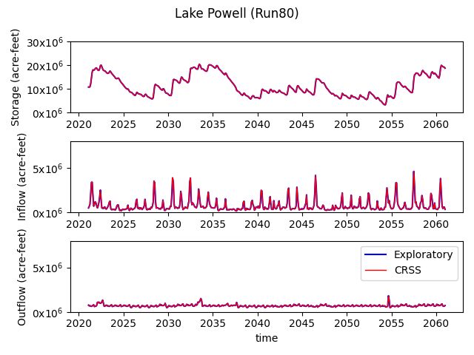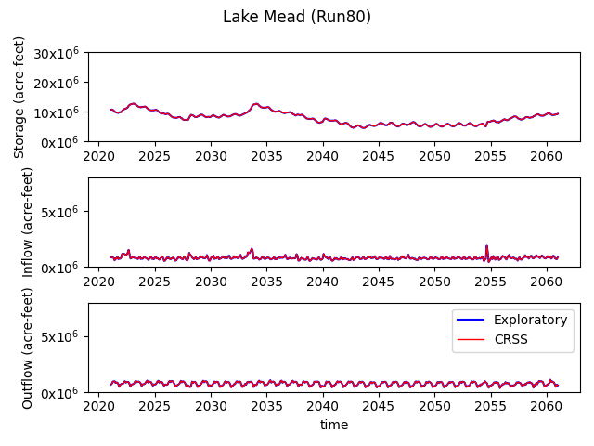

* 1. **Hydrologic trace 80 indicates historical hydrology (1986-2018, 1906-1912)**

**Figure A.1. Lake Powell and Lake Mead results from comparison between the exploratory model and CRSS under different hydrologic traces.**

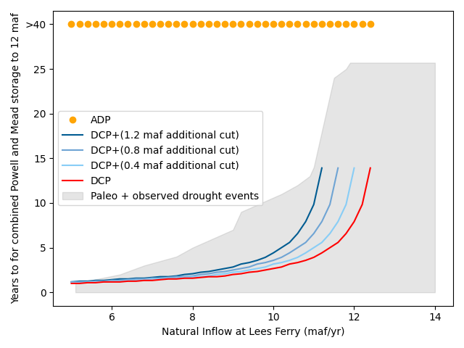

**Figure A.2. Years (y-axis) until combined Lake Powell and Lake Mead storage will go to 12 maf for different steady year-to-year inflows under different policies (when average UB demand = 4.5 maf/yr).**

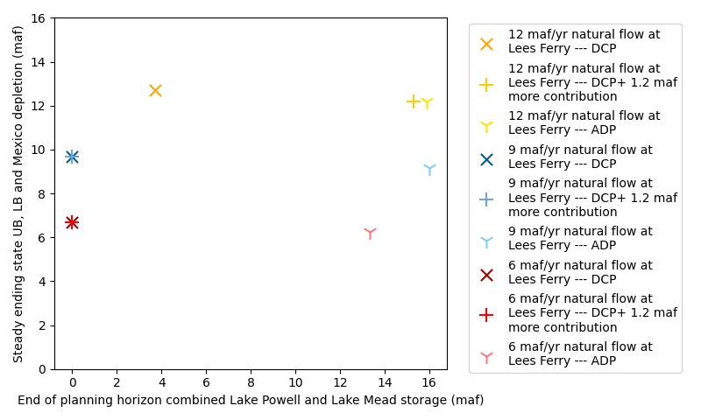

**Figure A.3. Trade-off between end-of-planning horizon combined storage for Lake Powell and Lake Mead and UB and LB and Mexico static state delivery (when average UB demand = 4.5 maf/yr).**

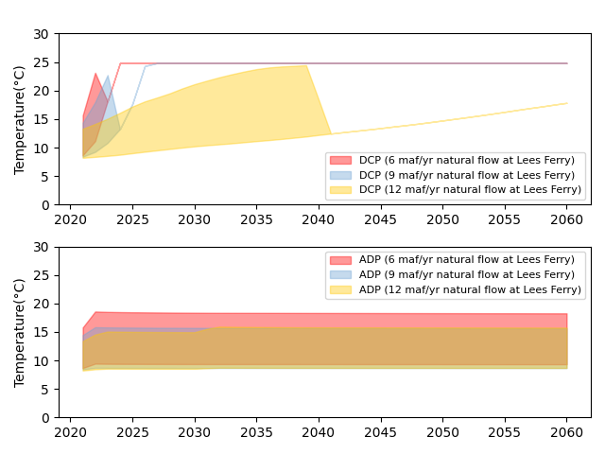

**Figure A.4. Lake Powell summer release temperature for different steady year-to-year inflows under different policies (when average UB demand = 4.5 maf/yr).**

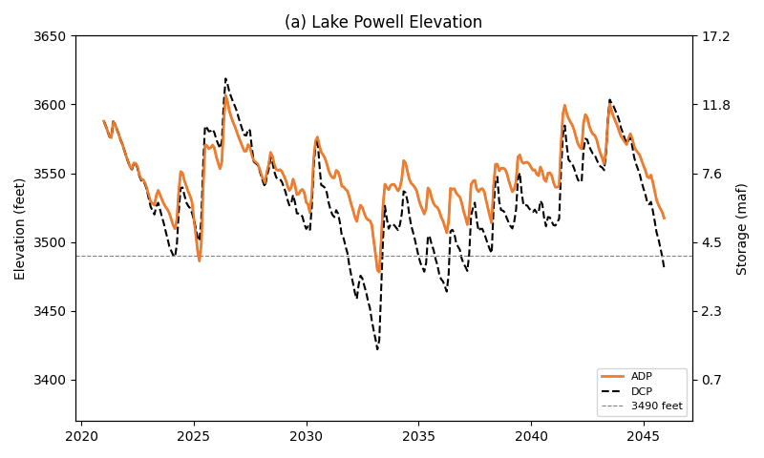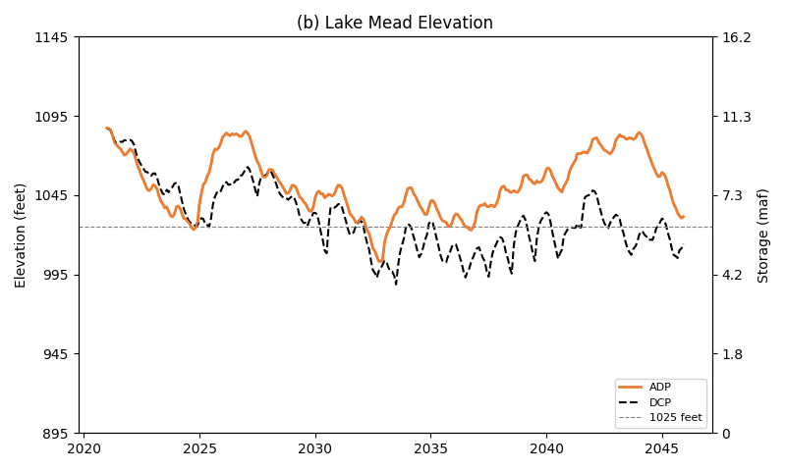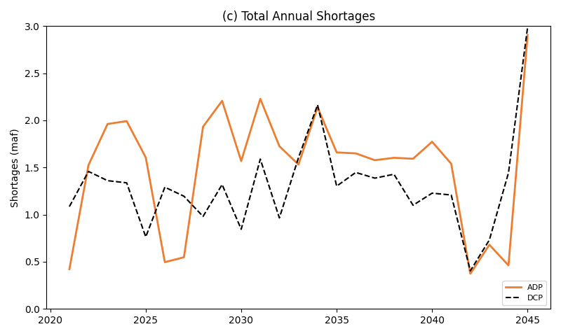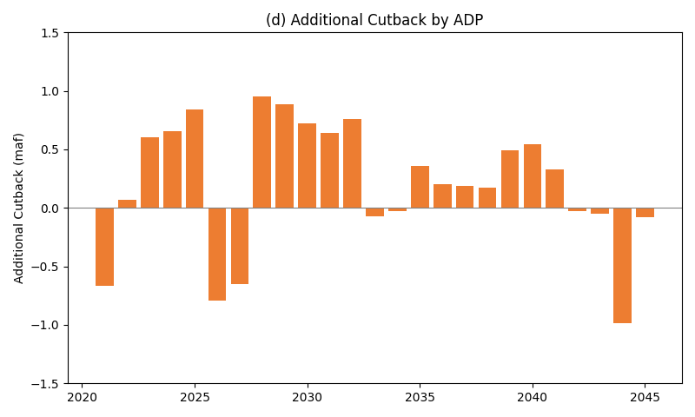

**Figure A.5. Lake Powell and Lake Mead elevation and total system shortages under Mid-20th century drought (1953–1977)**

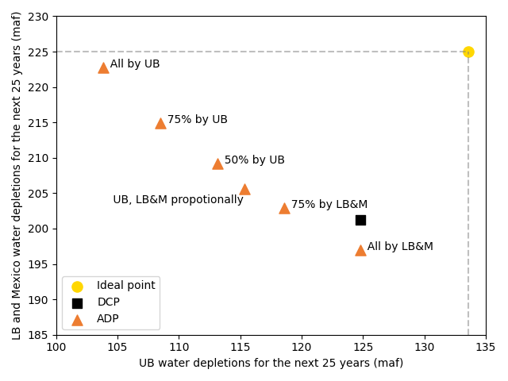

**Figure A.6. Depletion trade-offs between UB and LB and Mexico under Mid-20th century drought (1953–1977)**