How much water to store in Lake Powell to benefit native fish of the Grand Canyon?

David E. Rosenberg

November 21, 2020

## Overview

This is an R Markdown document. This document identifies Lake Powell water surface elevations for release temperature scenarios. Elevation ranges are estimated for release through the turbine (elevation 3490 feet) and release through the river outlets (3370 feet). Ranges for each outlet are plotted as stacked bar graphs. Ranges of water surface elevations are estimated using three data sets: Lake Powell turbine release temperature, water surface elevation, and temperature profiles. Four release temperature scenarios are temperatures less than 12oC, less than 15oC, less than 18oC, and above 18oC. Scenarios with release temperatures:

1. below 12oC year round are conditions where native fish persisted, but likely only because of the existence of warmer tribs to spawn in.
2. below 15oC represents conditions of thriving populations for many warm-water native fish (except razorback sucker).
3. below 18oC represents conditions that have not occurred in many decades, and which may benefit native fish, but may also harm them by facilitating invasion by warm water non-natives.
4. above 18oC represents conditions that have not occurred in many decades, for which predictions are highly uncertain, and for which the potential for negative consequences for native species increases dramatically.

This effort attempts to describe, visualize, and translate uncertainties in reservoir release temperatures into the language of reservoir elevations which are the mainstay of other Lake Powell operations such as equalization and Upper Basin drought contingency plan.

## Citation

Rosenberg, D. (2020). Colorado River Fitures - Code Projects: How much water to store in Lake Powell to benefit native fish of the Grand Canyon? Utah State University. Logan, Utah. <https://github.com/dzeke/ColoradoRiverFutures/tree/master/LakePowellTemperatureScenarios>.

## Contents

Figure 1 - Temperature suitability for cold-water non-native, water-water native, and warm-water nonnative fish. Not very belieable data. Need to update.

Figure 2 - Water Surface Elevation vs. Turbine release temperatures by month which is the Dibble et al (unpublished) spreadsheet model output. One of my main takeaways from Dibble et al (unpublished) model is that the data can be sliced by month.

Figure 3 - Figure 2 plus adds observed water surface elevations vs. turbine release temperature. The observed data is plotted as a range of daily min and max temperatures.

Figure 4 - Figure 3 plus adds transformed lake temperature profile data at the Wahweap station.

Figure 5 - Stacked bar plot shows ranges and uncertainty in water surface elevations by month for different scenarios of release temperatures. These ranges and errors are tabulated from the water surface elevation and release temperature data shown in Figure 4. The plot visualizes the reservoir surface elevations needed to achieve different turbine release temperature scenarios. The plot provides a way to describe, visualize, and translate uncertainties in reservoir release temperatures into the language of reservoir elevations which are the mainstay of other Lake Powell operations. The ranges in water surface elevation are large.

Figure 6 - Observed and transformed water temperature profile data at Wahweap at river outlet evlevation (3,370 feet). Similar to Figure 4 but for lower river outlet release elevation.

Figure 7 - Lake Powell water surface elevations for river outlet release temperature scenarios. Same as Figure 5 but for lower river outlet release elevation.

## Data sources

1. Fish temperature suitability - Table 2 from Valdez, R. A., Speas, D. W., and Kubly, D. M. (2013). "Benefits and Risks of Temperature Modification at Glen Canyon Dam to Aquatic Resources of the Colorado River in the Grand Canyon." U.S. Bureau of Reclamation, Salt Lake City, UT. <https://gcdamp.com/images_gcdamp_com/b/bf/GCD-Temp_Mod-Valdez_%26_Speas_9-17-2013.pdf>. FishTemperatureRequirements.xlsx
2. Dibble et al (unpublished) Spreadsheet model of monthly release temperature as a function fo surface water elevation. TemperatureModel_GrandCanyonStorage.xlsx (unpublished)
3. Time series of Glen Canyon Dam release temperature provided by Bryce M. 15-minute time step. GCD_release_water_temp.csv
4. Time series of daily Glen Canyon Dam elevation - USBR (2020). Water Operations: Historic Data, Upper Colorado River Division, U.S. Buruea of Reclamation. <https://www.usbr.gov/rsvrWater/HistoricalApp.html>. LAKEPOWELL06-16-2020T16.32.29.csv.
5. Lake Powell Temperature Profiles. Vernieu, W. S. (2015). "Historical Physical and Chemical Data for Water in Lake Powell and from Glen Canyon Dam Releases, Utah-Arizona, 1964 –2013." Data Series 471, Version 3.0. <https://pubs.usgs.gov/ds/471/pdf/ds471.pdf>. 'qryProfiles at Primary Stations.csv'.

## Results

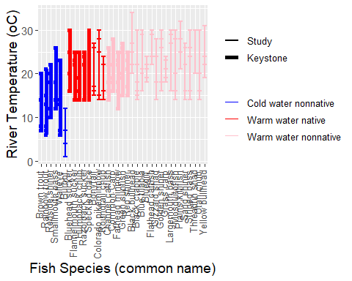

## Figure 1. Grand Canyon fish temperature suitability: growth, incubation, and ovulation stages (Valdex et al, 2013). Not very belieable data. Need to update.

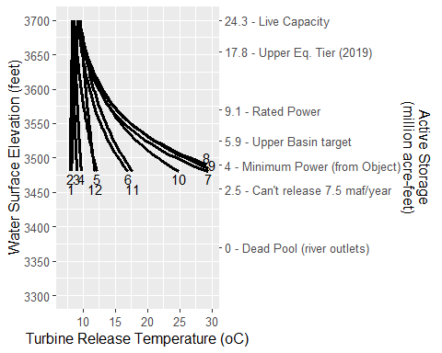

## Figure 2. Dibble et al (unpublished) spreadsheet model: turbine release temperature vs. water surface elevation by month

One main take away is that the water surface-release temperature data can be sliced by month.

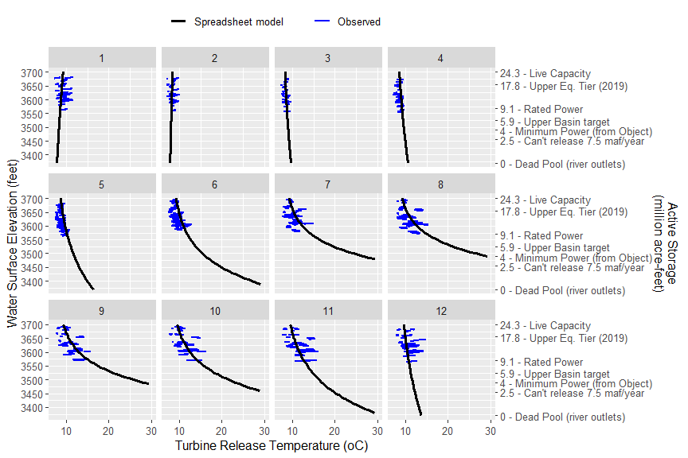

## Figure 3. Compare spreadsheet model to observed penstock release temperature. Horizonal blue bars indicate daily min/max temperature.

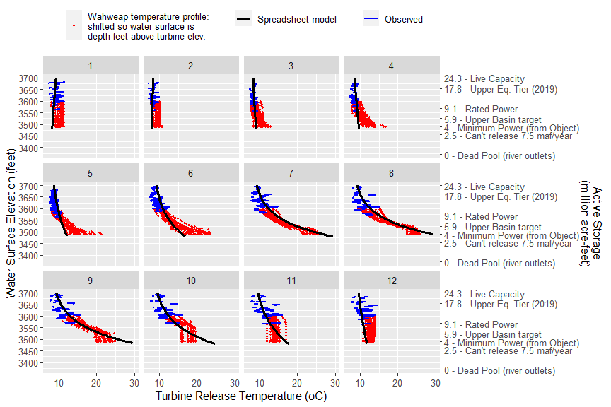

## Figure 4. Compare spreadsheet model, observed penstock release temperature, and temperature profile data.

Profile data was transformed twice.

1. Lower water surface elevation so depth reading is at the penstock elevation of 3490 feet. Two translation is used to plot the profile data at a lower water surface elevations. For example, a temperature profile point of 18oC 10 feet below (depth = 10 feet) an observed water surface elevation of 3610 feet is translated down to a water surface elevation of 3500 feet. 10 feet below the new water surface elevation fo 3500 feet is the turbine release elevation of 3490 feet and a temperature of 18oC. Similarly, a temperature profile point of 15oC measured 20 feet below an oserved water surface level of 3610 feet is translated down to a water water surface elevation of 3510 feet and turbine release temperature of 15oC (20 feet above the turbine elevation of 3490 feet). These translations assume that solar radiation is the primary driver of temperature in the reservoir epilimium and that water temperatures at shallow depths will be similar regardless of whether the water surface elevation is 3490, 3500, 3520, etc. feet.
2. For Wahweap temperatures at turbine elevation above 11, 13, and 15oC, decrease the turbine release temperature by 0.5, 1, and 2oC. Comparing turbine release temperatures to temperatures at Wahweap at 3,390 feet shows the later is 1 to 2 oC cooler than the Wahweap temperature.

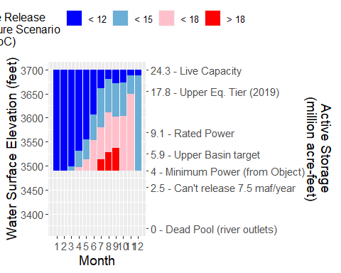

## Figure 5. Lake Powell water surface elevations for turbine release temperature scenarios. Elevation ranges consider uncertainty in observed and water profile data.

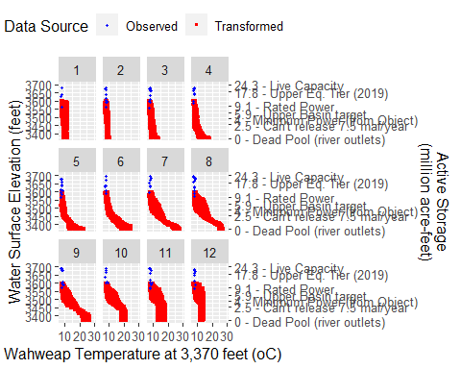

## Figure 6. Observed and transformed water temperature profile data at Wahweap at river outlet evlevation (3,370 feet).

Profile data were transformed to lower the water surface elevation so depth reading is at the river outlet elevation of 3,370 feet.

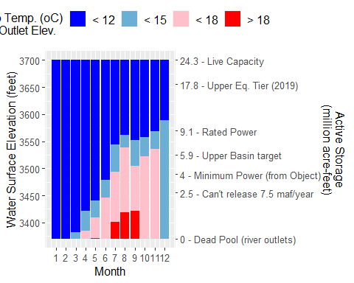

## Figure 7. Lake Powell water surface elevations for river outlet release temperature scenarios. Elevation ranges consider uncertainty in observed and water profile data.