**Sidebar: How does Lake Powell water storage influence release temperatures and Grand Canyon fishes?**

Glen Canyon dam release temperature is a key driver for fish of the Grand Canyon. Predicting fish responses to changes in reservoir release temperatures is also challenging. Thus, we use Lake Powell release temperature and depth-temperature profile data to identify ranges of monthly reservoir water surface elevations to achieve four ecologically-relevant, temperature scenarios (Figure X). Water levels in August, September, and October above 3,675 feet will give cold releases less than 12oC that are within the range observed historically (dark blue bars). These water surface levels likely force native fish to spawn in tributaries to the Grand Canyon (dark blue bars). Summer water levels between 3,600 and 3,675 feet will keep release temperatures below 15oC (light blue bars). These temperatures have become more common in recent years and may contribute to increased abundance of native fish in western Grand Canyon. August to October water levels below 3,600 feet will warm releases up to 18oC (pink bars). Here, outcomes are very uncertain for native fish as these temperatures have not been observed since dam construction. Native fish may benefit, but they may also face invasion and competition by warm water non-natives from Lake Mead. Lastly, July to August water levels below 3,525 feet will warm releases above 18oC (red bars). Outcomes for native fish for these temperatures are highly uncertain. Sustained temperatures above 19oC also threaten the tailwater trout fishery. Summertime temperatures above 18oC would be reached even if the Upper Basin states maintain their drought contingency plan target of 3,525 feet. If managers forego turbine releases and release water through the river outlets, a similar stacked bar plot can be constructed that shifts water surface elevations down by 100 to 125 feet.

These results can help construct Fill Mead First and Fill Powell First alternative management paradigms (AMPs) that improve temperatures for the native fish of the Grand Canyon. For example, use the elevations of 3,600 and 3,675 feet (light blue bars) to set the Powell-Low and Powell-High parameters so release temperature more frequently stays below 15oC. Additionally, define AMP elevation targets seasonally or monthly rather than annually to focus on summer months when release temperatures are generally warmest and most threaten native fish. See Rosenberg (2020) for data, code, and further information.

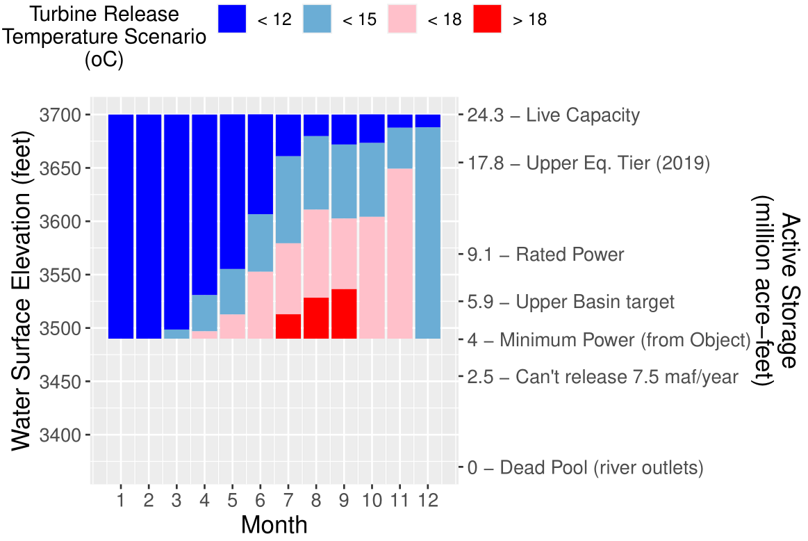

Figure X. Lake Powell water levels for turbine release temperature scenarios. Elevation ranges consider uncertainty in observed release and water profile data.

**Appendix X. How does Lake Powell water storage influence release temperatures and Grand Canyon fishes?**

# Introduction

Current Lake Powell reservoir operations for equalization and the Upper Basin drought contingency plan are articulated as target reservoir surface elevations and storage volumes. This analysis asks and answers the question how does water storage in Lake Powell influence release temperatures and Grand Canyon fishes?

# Prior Work

Reservoir release temperature is a key driver for fish of the Grand Canyon (Figure 1)(Dibble et al., 2020). During summer months, reservoir release water warms as it travels downstream to Lake Mead. Prior efforts have used process- and empirically-based models to relate reservoir water surface elevations to release temperature and release temperature to downstream temperatures (Dibble et al., 2020; Mihalevich et al.; USBR, 2007, Appendix F; Wright et al., 2009). These models require the user to specify difficult to predict inputs such as incoming solar radiation and air temperature.

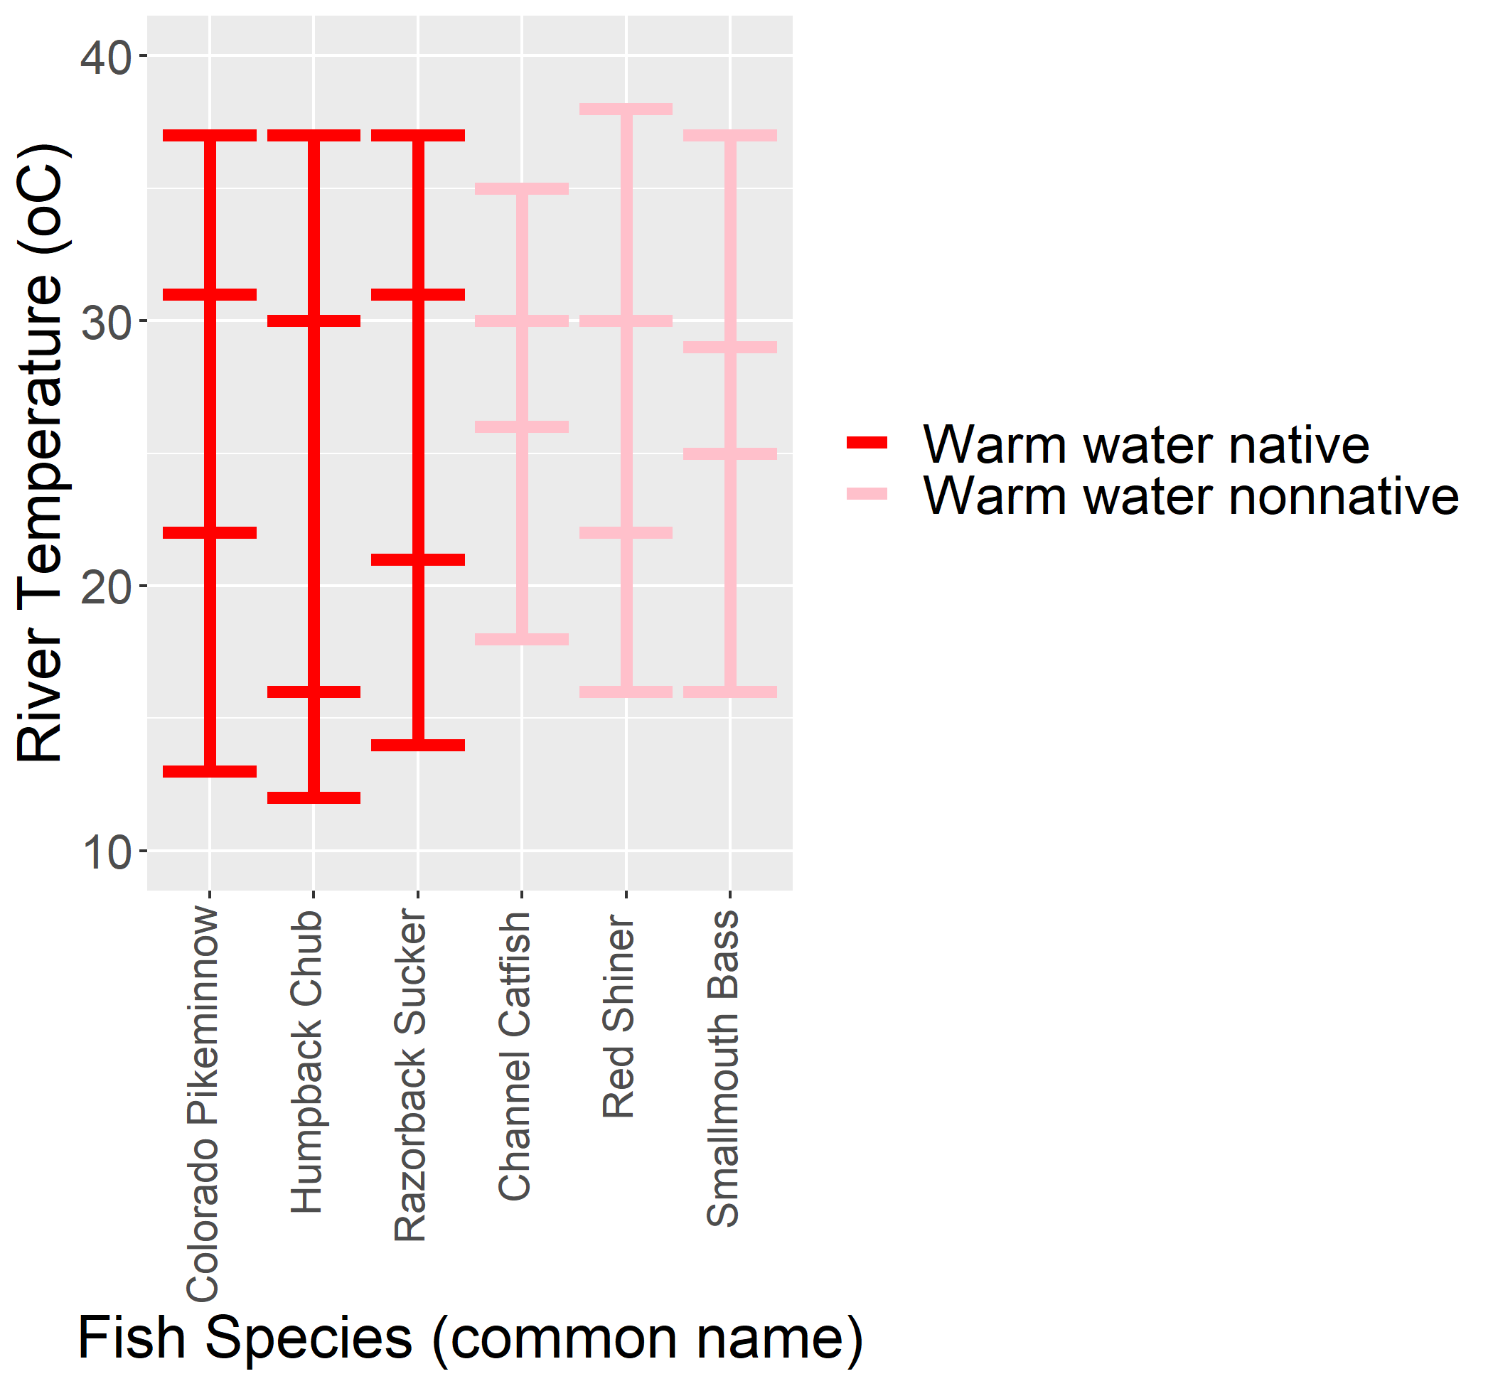

Figure 1. Minimum, minimum optimal, maximum optimal, and maximum temperature suitability (horizontal bars) for select native (red) and nonnative (pink) warm-water fish species of the Grand Canyon. Data from (Dibble et al., 2020).

As an alternative, here we use, link, and characterize uncertainties in the primary reservoir water level (USBR, 2020), release temperature (GCMRC, 2020), and depth-temperature profile (Vernieu, 2015) data. We then define ecologically-relevant release temperature scenarios that span different outcomes for native and non-native fish of the Grand Canyon. We visualize the reservoir elevation zones that correspond to each release temperature scenario.

# Methods

First, use date and time information to link the primary observed reservoir water level (USBR, 2020), release temperature (GCMRC, 2020), and depth-temperature profile (Vernieu, 2015) data sets.

Second, define ecologically-relevant release temperature scenarios with different impacts on native and non-native fishes in Grand Canyon (Table 1). The scenarios for <12oC and <15oC reflect that native, warm-water fish have slightly lower minimum and minimum optimal temperature thresholds than non-native fish (Figure 1).

**Table 1. Reservoir release temperature scenarios**

|  |  |  |
| --- | --- | --- |
| **Scenario (oC)** | **Ecological Meaning** | **Years Observed** |
| < 12 | Year-round release temperatures where native fish persisted, but likely rely on warmer tributaries for reproduction and growth. | Consistently before 2003 |
| < 15 | These summer correspond with increased relative abundance of native fish downstream. Other factors, such as predation by nonnatives, may contribute as well. | More frequently after 2003 |
| < 18 | Uncertain outcome. May benefit native fish, but may also harm them by facilitating invasion and competition by warm water non-natives. | Not since 1973 |
| > 18 | Outcome highly uncertain for native fish. Tailwater trout fishery unlikely to persist. | Not since 1973 |

Third, plot the daily range of observed release temperature data (GCMRC, 2020) for different water surface elevations (Figure 2, blue).

Fourth, translate the depth-temperature profile data (Vernieu, 2015) at the Wahweap station to show anticipated release temperatures at water surface elevations *below* historically observed elevations (Figure 2, red). The translation assumes that solar radiation is the primary driver of temperature in the reservoir epilimnion and that water temperatures at shallow depths below the water surface will be similar regardless if water surface elevation is 3490, 3500, 3600, 3610, etc. feet.

* For example, translate a temperature profile measurement of 18oC 10 feet below (depth = 10 feet) an observed water surface elevation of 3,610 feet down to a water surface elevation of 3,500 feet. 10 feet below the new water surface elevation of 3,500 feet will give a release temperature of 18oC at the turbine release elevation of 3,490 feet.
* Additionally, decrease the turbine release temperature by 0.5, 1, or 2oC for Wahweap profile temperatures greater than 11, 13, and 15 oC. This adjustment adjusts for differences between Wahweap and release temperatures due to turbine entrainment and other factors (Figure 3).

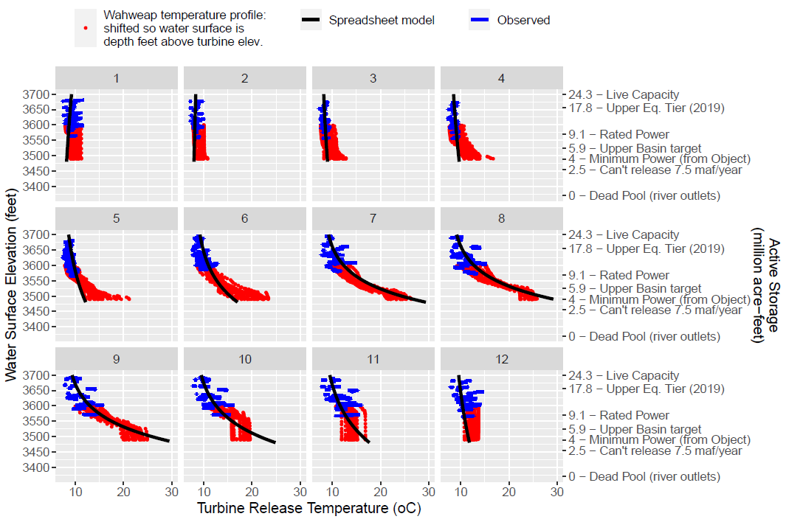

Figure 2. Compare observed penstock release temperature (blue) and translated depth-temperature profile data (red). Black lines show estimated release by an empirical spreadsheet model (Dibble et al., 2020)

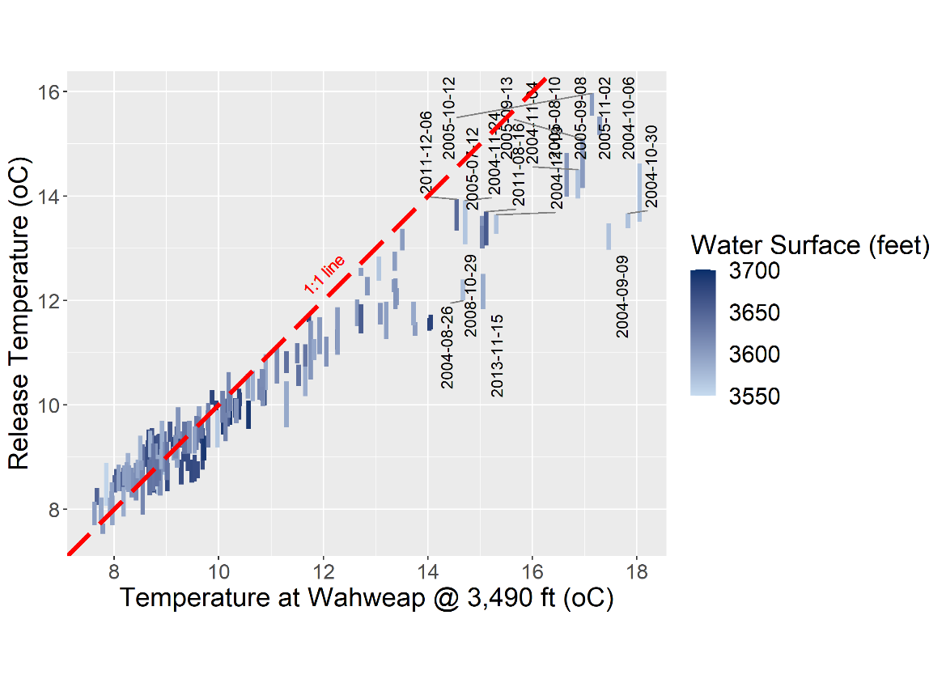

Figure 3. Comparison of turbine release and Wahweap profile temperatures at the turbine elevation of 3,490 feet.

Fifth, identify the range of reservoir water surface elevations for each release temperature scenario. For example, in August, we might see a 15oC release through the turbine for reservoir elevations between 3,525 and 3,610 feet.

Finally, stack into bars the reservoir elevation ranges for each release temperature scenario (Figure 4).

# Results

Examination of the stacked bars in Figure 4 shows:

* Water levels above 3,675 feet will cool releases below 12oC (dark blue bars). Native fish may persist with these year-round release temperatures but likely rely on warmer tributaries for reproduction and growth.
* Elevation ranges of 3,600 to 3675 feet in August, September, and October will keep release temperatures below 15oC (light blue bars). These release temperatures may see increased relative abundance of native fish downstream but other factors, such as predation by nonnatives, may contribute.
* August to October water levels below 3,600 feet will warm releases (<18oC) so that outcomes are uncertain for native fish (pink bars). Native fish may face invasion and predation by non-native warmwater fish.
* Water levels below 3,525 feet will further warm releases above 18oC (red bars). Impacts for native fish are very uncertain. Also, the tailwater trout fishery may perish.



Figure 4. Lake Powell water surface elevations to maintain release temperature scenarios through the turbines. Elevation ranges consider uncertainty in observed and water profile data.

If Glen Canyon Dam managers forgo penstock releases and release water through the river outlets, the same release temperatures can be achieved with reservoir water surface elevations that are 100 to 125 feet lower (Figure 5). For example, 15oC releases can be maintained through September, October, and November with reservoir elevations down to 3,500 feet (compared to 3,600 feet if releasing all water through the penstocks). If managers release water through both the penstocks and river outlets, managers can maintain release temperatures at water surface levels below levels shown in Figure 4 and above levels shown in Figure 5.

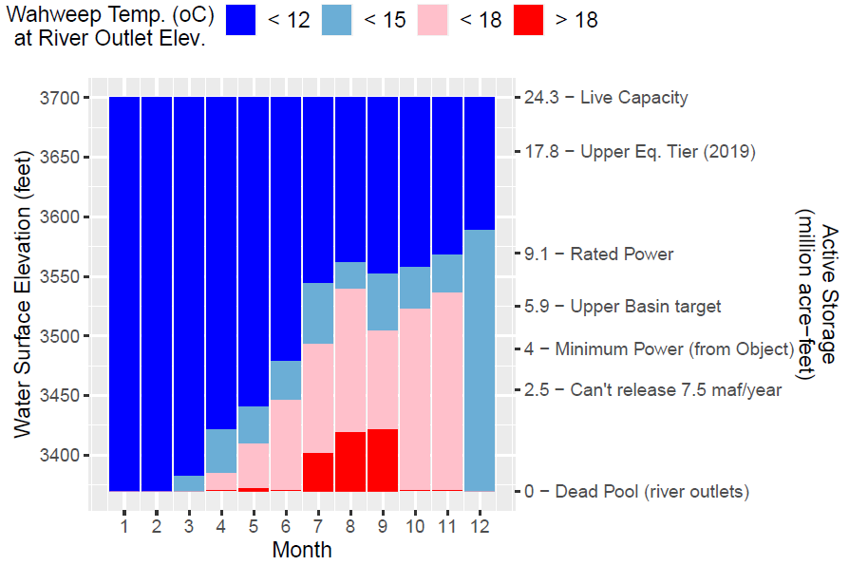

**Figure 5. Lake Powell water surface elevations to maintain temperature scenarios through the river outlets. Elevation ranges consider uncertainty in observed and water profile data.**

# Limitations

This analysis assumes:

1. Future relationships between reservoir release temperatures and reservoir water surface elevations will resemble the historical data.
2. The future relationship between reservoir release temperature and temperature at Wahweap at the turbine elevation will resemble the historical data.
3. Ignores flow dynamics, entrainment, and mixing of different temperature water from elevations near the intakes of the penstocks and river outlets.
4. The future timing and magnitude of annual reservoir turnover will resemble historical turnover.

# Wrap Up

The reservoir water surface elevations in Figures 4 or 5 can help modify the Fill Mead First and Fill Powell First alternative management paradigms (AMPs) to benefit native fish of the Grand Canyon. For example, set the Powell-Low and Powell High parameters to 3,600 and 3,675 feet (range for light blue bars) so that Powell release temperatures are more frequently less than 15oC. The analysis also shows potential to define summer or monthly reservoir targets and better align operations with key periods important to native fish when reservoir releases are warmest.

# Data, Model, and Code Availability

The data, models, and code that support this analysis are available at Rosenberg (2020).

# References

Dibble, K., Yackulic, C., Kennedy, T., Bestgen, K., and Schmidt, J. J. (2020). "Water storage decisions will determine the distribution and persistence of imperiled river fishes." *Ecological Applications*, EAP20-0706.

GCMRC. (2020). "Glen Canyon Dam near Page, AZ." Grand Canyon Monitoring and Research Center, U.S. Geological Survey. <https://www.gcmrc.gov/discharge_qw_sediment/station/GCDAMP/09379901#>.

Mihalevich, B. A., Neilson, B. T., Buahin, C. A., Yackulic, C. B., and Schmidt, J. C. "Water temperature controls for regulated canyon-bound rivers." *Water Resources Research*, n/a(n/a), e2020WR027566. <https://agupubs.onlinelibrary.wiley.com/doi/abs/10.1029/2020WR027566>.

Rosenberg, D. E. (2020). "How does Lake Powell water storage influence release temperatures and Grand Canyon fishes?", Utah State University. <https://10.5281/zenodo.4345405>.

USBR. (2007). "Colorado River Interim Guidelines for Lower Basin Shortages and Coordinated Operations for Lake Powell and Lake Mead – Final Environmental Impact Statement." U.S. Bureau of Reclamation. <http://www.usbr.gov/lc/region/programs/strategies/FEIS/index.html>.

USBR. (2020). "Water Operations: Historic Data, Upper Colorado River Division." Upper Colorado River Division, U.S. Buruea of Reclamation. <https://www.usbr.gov/rsvrWater/HistoricalApp.html>. [Accessed on: June 16, 2020].

Vernieu, W. S. (2015). "Historical Physical and Chemical Data for Water in Lake Powell and from Glen Canyon Dam Releases, Utah-Arizona, 1964 –2013." *Data Series 471, Version 3.0*. <https://pubs.usgs.gov/ds/471/pdf/ds471.pdf>.

Wright, S. A., Anderson, C. R., and Voichick, N. (2009). "A simplified water temperature model for the Colorado River below Glen Canyon Dam." *River Research and Applications*, 25(6), 675-686. <https://onlinelibrary.wiley.com/doi/abs/10.1002/rra.1179>.