# Synchronous Model Guide

## Flex Accounting for a Combined Lake Powell-Lake Mead System

David E. Rosenberg | Utah State University | [david.rosenberg@usu.edu](mailto:david.rosenberg@usu.edu) | @WaterModeler

October 15, 2021

# I**ntroduction**

This document supports participants to use the synchronous model for a combined Lake Powell-Lake Mead system (Rosenberg, 2021d). Synchronous means multiple participants connect to the same cloud model and enter individual water conservation and consumption choices and group decisions as model time progresses year-by-year. This document provides context information for each individual and group choice and explains how choices build on existing Colorado River management (Appendix A). The document also suggest potential values to enter.

Find quick links to support information (the sections of this document) in the Model file, *Master* worksheet, Column N.

# Get Started

Follow the Setup and Play instructions in Box 1. The rest of the document provides guidance on the steps to play.

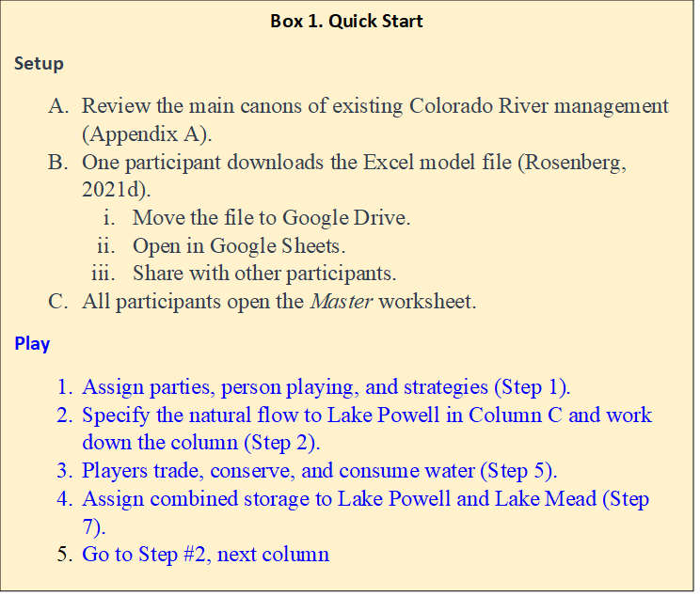

## Types of Use

The synchronous model can be used in two modes:

1. Synchronously by multiple people where each person plays one or more parties (in Google Drive).
2. By a single person (plays all parties).

Players can explore:

* Water conservation and consumptive use strategies.
* Scenarios of natural flow.
* Joint (political) decisions such as:
  + Include more parties or stakeholders.
  + Split existing reservoir storage among parties.
  + Split future inflows among parties.
  + Split the combined reservoir storage among reservoirs.

# Step 1. Assign Parties, Person playing, and Strategies

Five parties and one shared, reserve account derive standing from the 1922 Colorado River Compact, 1944 U.S.-Mexico Treaty, subsequent Minutes 319 and 323, Upper and Lower Basin drought contingency plans, and desire to include more parties (Table 1)(1922; IBWC, 2021; USBR, 2019; USBR, 2020).

**Table 1. Parties, Reason(s) to include in model, and Potential Strategies**

| **Party** | Reason(s) to Include | **Potential Strategy(s)** |
| --- | --- | --- |
| Upper Basin | Article II(c to g) of the Colorado River Compact (1922). | * Continue to consume ~ 4.0 maf/year (historical consumptive use). 4.0 maf includes 1.1 maf of use by First Nations in the Upper Basin. * Increase consumptive use above 4.0 maf/year to fulfil aspirations to further develop. * Sell some water, get paid to conserve, and prepare for shortage and curtailment (Rosenberg, 2021e). |
| Lower Basin | Article II(c to g) of the Colorado River Compact (1922). | * Continue mandatory conservation and cutback from 7.5 maf per year as Lake Mead level declines (USBR, 2019). See cutback schedule in *MandatoryConservation* sheet. 7.5 maf includes 0.95 maf of use by First Nations in the Lower Basin. * Buy water to reduce mandatory conservation. * Save some water for future years. |
| Mexico | 1944 U.S.-Mexico Treaty and subsequent Minutes | * Continue mandatory conservation and cutback from 1.5 maf per year as Lake Mead levels decline (IBWC, 2021). See *MandatoryConservation* sheet. * Conserve more water beyond mandatory targets. * Sell some water to other parties to gain money to build non-water projects. |
| Colorado River Delta | Section VIII of Minute 323 (IBWC, 2021) | * Save until have enough water for a 0.06 maf pulse flood every few years. * Save until have enough water for a longer duration 0.08 maf pulse flood. Scientists are still figuring our the ecological and other benefits of 0.08 or 0.06 maf pulse floods. * Buy water and make more frequent pulse floods. |
| First Nations | * Include more parties (USBR, 2020) * Tribal water study (Ten Tribes Partnership, 2018) | * Develop and use 2.0 maf per year of rights. 1.1 maf of use by First Nations in the Upper Basin and 0.95 maf by First Nations in the Lower Basin. * Lease undeveloped water. * Save water for future use. |
| Shared, Reserve | Protect Lake Powell and Lake Mead elevations of 3,525 and 1,020 feet (USBR, 2019) | * Maintain combined protection volume (11.6 maf). * Account managed by consensus of all parties. * Assume parties do not agree on releases, so no releases, steady account balance. * Transfer some water without payment to party in need. |

Each participant can play one or more roles.

Representatives of individual states — e.g., Utah, Wyoming, Colorado, and New Mexico in the Upper Basin — can team up to role play a party like the Upper Basin. When teaming, draw on prior water sharing agreements such as an Upper Basin Compact where parties share water in specified percentages (Carson et al., 1948).

## 1A. Explain cell types

Four model cell types are defined by fill color (Table 2).

**Table 2. Model Cell Types**

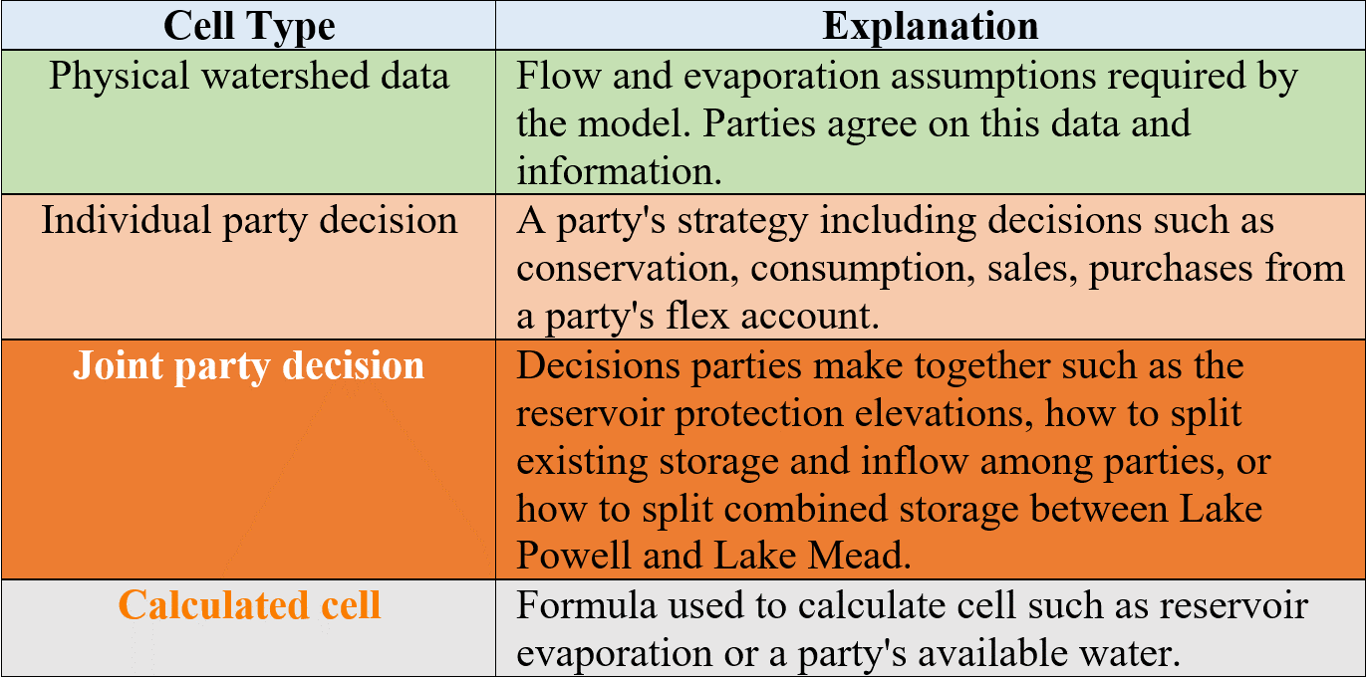

## 1B. Make Assumptions

### **(i) Evaporation rates**

Evaporation rates for Lake Powell and Lake Mead are taken as the midpoint within reported ranges of measurements (Table 3)(Schmidt et al., 2016). Evaporation rates for Lake Mead are presently measured and more reliable than Lake Powell. Lake Powell evaporation rates have not been measured in decades. A sensitivity analysis found that the lower and upper bounds on Lake Mead evaporation rates for a five year study for Lake Mead draw down saw variations of 0.25 maf or less in Lake Mead storage volume (Rosenberg, 2021a).

**Table 3. Reservoir evaporation rates (feet per year)**

|  |  |  |
| --- | --- | --- |
| **Reservoir** | **Midpoint** | **Range** |
| Powell | 5.7 | 4.9 – 6.5 |
| Mead | 6.0 | 5.5 – 6.4 |

### (ii) Start storage

Reservoir start storage is taken from data portals (USBR, 2021b; USBR, 2021c). Text in Column D lists the date.

### (iii) Protection elevations

The reservoir protection elevations of 3,525 feet for Lake Powell and 1,020 feet for Lake Mead are defined in the Upper and Lower Basin Drought Contingency Plans (USBR, 2019). As the reservoirs approach the protection levels, the plans state the parties will consult with the Federal Government to stabilize and prevent the reservoirs from falling below these levels. To stabilize, the parties will need to make reservoir releases plus evaporation less than inflow (Rosenberg, 2021a).

### (iv) The protection volumes

The reservoir protection volumes associated with the Lake Powell and Lake Mead protection elevations become the starting balance for the shared, reserve account. These volumes are calculated from the Elevation-Area-Volume curve for the reservoir. See worksheets *Powell-Elevation-Area* and *Mead-Elevation-Area*.

Participants can enter lower protection levels and volumes than the default values. Lowering will reduce hydropower generation at Glen Canyon Dam and Hoover Dam. Lowering will also raise the temperature of water in Lake Powell, raise Glen Canyon Dam release water temperature, and pressure the native, endangered fish populations of the Grand Canyon. With warmer release water temperatures, non-native fish outcompete the native fish. Colorado River managers recommend to keep the default protection levels for now. Participants can also jointly lower the protection volume later during each year of model time.

### (v) Prior 9-year Lake Powell release

Prior 9-year Lake Powell releaseis 78.1 maf and is the release measured through Glen Canyon Dam from 2012 to 2021 (Figure 1).

### **(vi)** **Prior 9-year Paria River flow**

Prior 9-year Paria River flow is 0.17 maf and measured just before the confluence with the Colorado River at Lee Ferry. We care about the 9-year Lake Powel release and Paria River flow because these volumes tell us how much the Upper Basin must deliver in the next 10th year (1st year of the model) to meet its 10-year delivery requirement of 82.5 maf each decade to the Lower Basin and Mexico via article III(d) of the 1922 Colorado River Compact and 1944 US-Mexico Treaty. Here,

82.5 maf = (7.5)(10) + (1.5/2)(10)

Where 7.5 maf is the Upper Basin’s annual delivery responsibility to the Lower Basin, (1.5/2) is the Upper Basin’s half share of the U.S. responsibility to Mexico, and 10 is a consecutive 10 year period.

### (vii) Delivery to meet 10-year requirement

Upper Basin delivery to meet 10-year requirement is the 82.5 maf requirement minus the Lake Powell Release minus the Paria flow. The Upper Basin must deliver 4.2 maf to the Lower Basin next year at Lee Ferry. The Upper Basin can keep all Lake Powell natural flow above 4.2 maf.

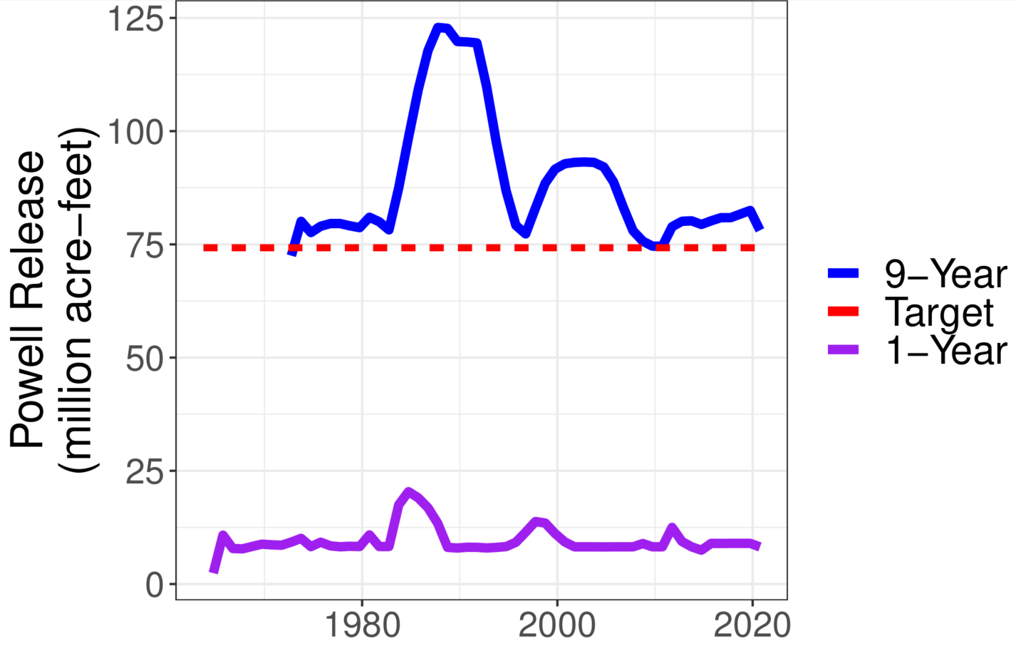

**Figure 1. Lake Powell Releases**

### Upper Basin pre-1922 water rights

Upper Basin water rights in million acre-feet per year prior to 1922 when the Colorado River Compact was signed (Table 4). These water rights have a seniority date prior to the compact. In the assignment of inflow (see Step 2), these rights are filled first ahead of the Lower Basin’s right to 75 million acre-feet every consecutive 10-years by Article III(d) of the Compact. Presently, pre 1922 water rights for New Mexico are unknown.

The 1.9 maf per year value in the model is the 2.7 maf per year total in Table 3, plus an assumed 0.3 maf per year for New Mexico, minus 1.06 maf per year for First Nations in the Upper Basin. This assignment assumes Upper Basin First Nations water rights all have a priority before 1922.

**Table 4. Upper Basin pre-compact water rights (million acre-feet per year)**

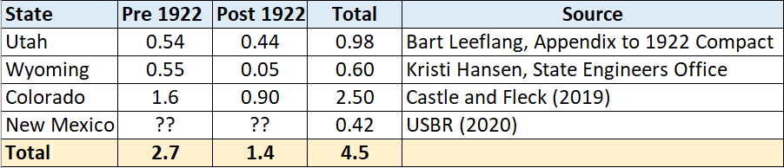

# Step 2. Specify natural inflow to Lake Powell

Specify natural inflow to Lake Powell as the water in the Green, San Juan, mainstem Colorado, and other tributaries that would flow into Lake Powell if there were no upstream human consumptive use or reservoirs. Once a Lake Powell natural flow is specified, the rows below populate with data.

Because future flows are uncertain, we can only specify natural inflow to Lake Powell as a scenario of possible future flows. Develop a scenario from:

1. The most recent 22 years, where estimated natural inflow to Lake Powell varied from 6 to 20 maf per year (Figure 2).
2. Flow values reconstructed from the historical (1905 to 2015) or paleo (1416 to 2015) periods (Meko et al., 2017; Prairie, 2020). See workbook tab *HydrologicScenarios* for some flow scenarios from these periods.
3. The mean natural flow of low-flow sequences in the paleo reconstructed or recent observed periods (Figure 3). For example, a 5-year drought that started in 1580 AD had a reconstructed average flow of 9 maf per year.
4. Devise a time series of flows on your own or adapt values year-to-year as model time progresses.
5. Optionally, refer to unregulated inflows from 1960 to 1999 (USBR, 2021d)(Figure 4) and add ~3 maf to get a natural flow. The addition represents non-reservoir consumptive use in the Upper Basin. Figure 5 shows how to conserve from unregulated to natural flow.

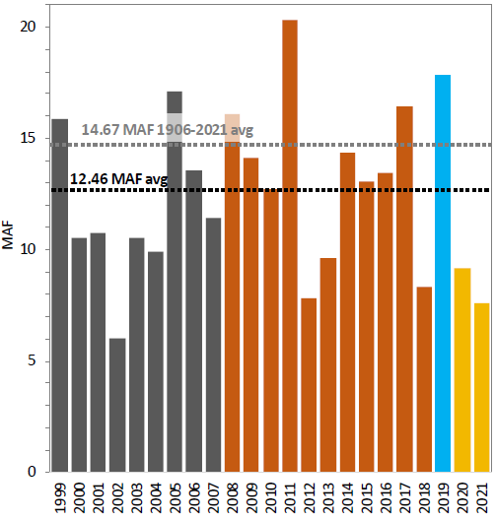

**Figure 2. Estimated natural inflow to Lake Powell {USBR, 2021 #2836}**

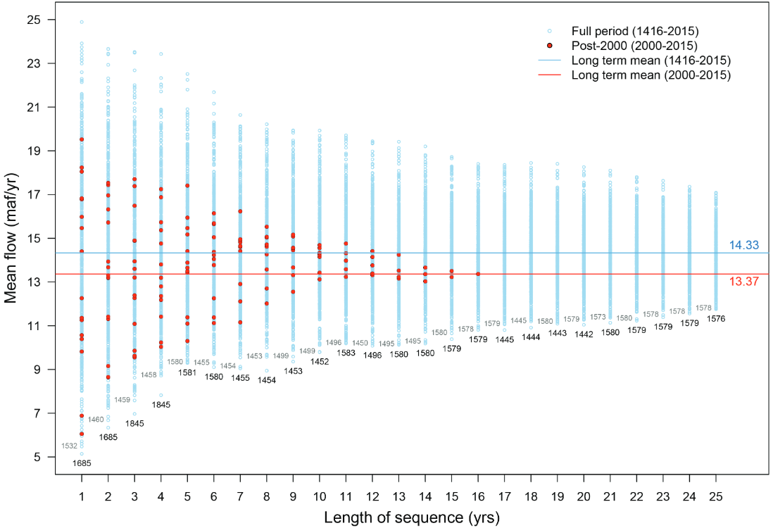

**Figure 3. Sequence-average plot of the tree-ring reconstructed flow of the Colorado River at Lees Ferry (Salehabadi et al., 2020).**

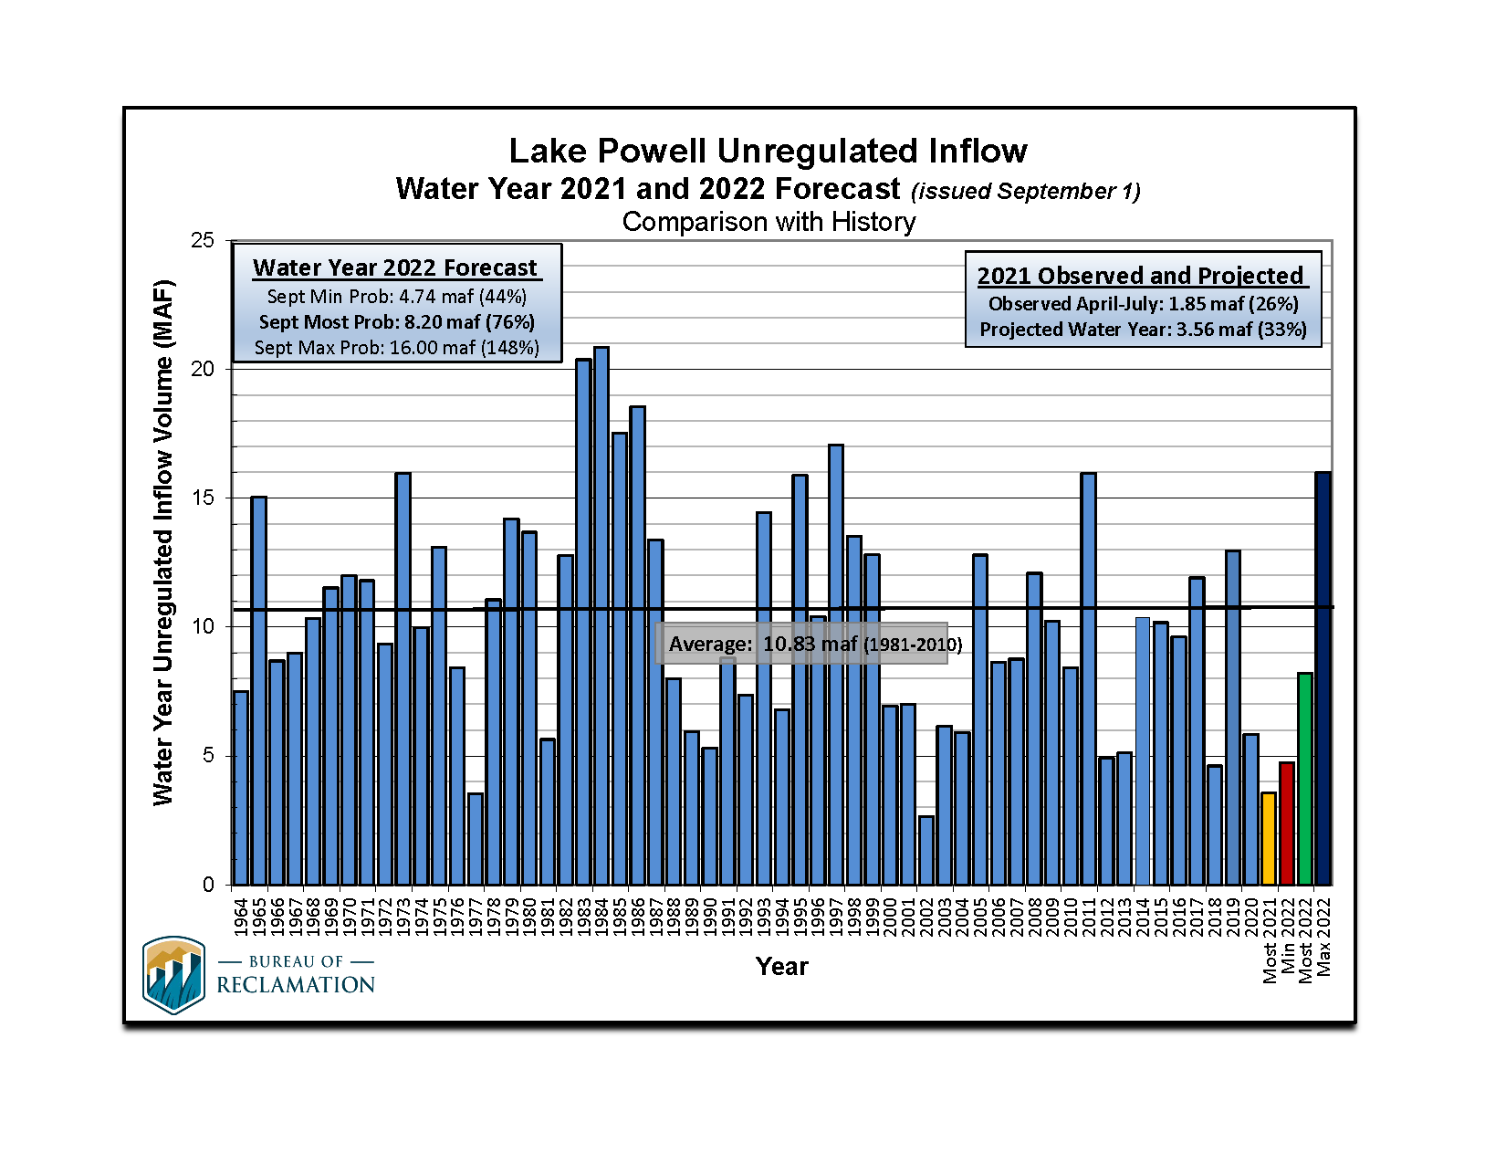

**Figure 4. Unregulated flow to Lake Powell (USBR, 2021d). Add ~ 3 maf for natural flow.**

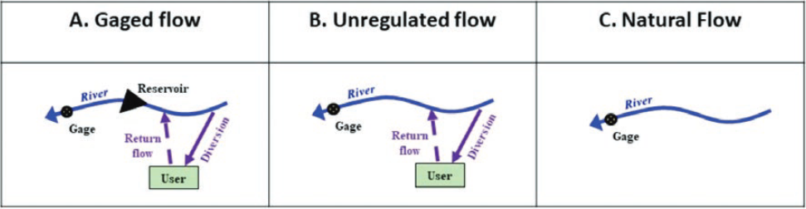

**Figure 5. Process to go from gaged (measured) flow to natural flow (Wheeler et al., 2019).**

Alternatively,

The model uses natural flow as in input because the model first credits a share of the year’s natural flow to each party’s flex account. Then parties consume and conserve water. Consumed water is subtracted from the account balance to obtain the end-of-year reservoir storage.

## 2A. Intervening Grand Canyon Flow

Enter the intervening flow from the Paria, Little Colorado, and Virgin rivers plus seeps on the Grand Canyon from Glen Canyon Dam to Lake Mead. This intervening flow excludes Lake Powell release or other upstream consumptive use on the rivers. A compilation of USGS gaged data from 1990 to 2020 show a mean intervening Grand Canyon flow of 0.9 maf per year with 5-year sequences below 0.75 maf (Figure 5)(Rosenberg, 2021b). By default, the model uses an intervening Grad Canyon flow of 0.8 maf per year.

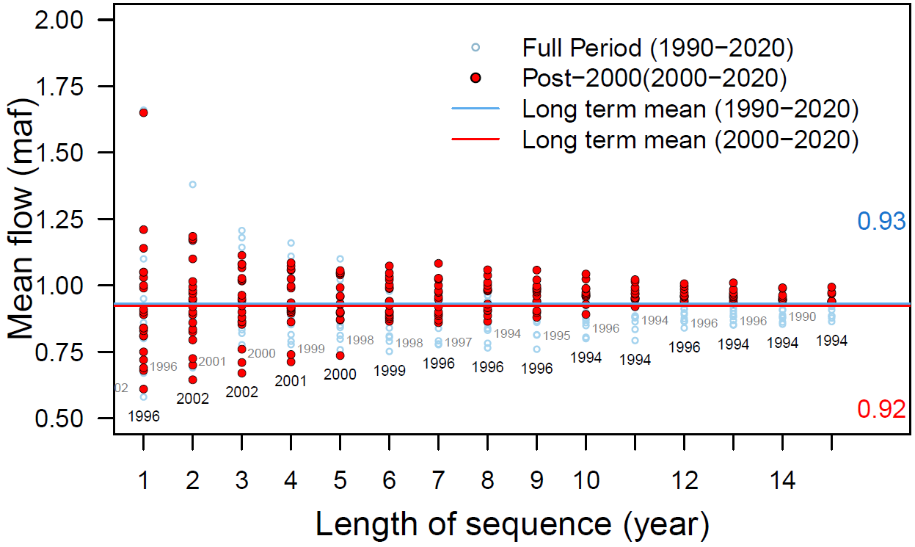

**Figure 5. Mean Grand Canyon tributary flow (Glen Canyon Dam to Lake Mead) for different sequence lengths.**

## 2B. Mead to Imperial Dam intervening flow

Enter the intervening flow from Hoover Dam to Imperial dam. By default, this intervening flow is 0.2 maf per year and was estimated from the natural flow data set below Hoover Dam (Prairie, 2020).

## 2C. Havasu/Parker evaporation and evapotranspiration

This value results evaporation from Lakes Havasu and Parker and the evapotranspiration of riverbank vegetation from Hoover Dam down to Lake Havasu. A default value of 0.6 maf per year is used and represents the value used in Lake Mead accounting. Find annual estimates of the Havasu/Parker evaporations and evapotranspiration from 1995 to 2014 at USBR (2021a).

# Step 3. Split existing reservoir storage among parties (year 1 only)

Split the starting combined reservoir storage (Figure 6) entered in Section 1B among the parties. These assignments are joint party (political) decisions. There are many possibilities. Here, the default values in Column B apply Interim Guidelines Intentionally Created Surplus (ICS) accounts, the Lower and Upper Basin drought contingency plans and the Minute 323 to the U.S.-Mexico Treaty (IBWC, 2021; USBR, 2019).

* Assign the 11.6 maf protection volume to the shared, reserve account. 11.6 maf is the sum of 5.9 maf protection volume for Lake Powell plus 5.7 maf protection volume for Lake Mead (USBR, 2019).
* Assign the 0.17 maf in Mexico’s Lake Mead conservation account to Mexico (USBR, 2021a).
* Assign the 2.8 maf balance in Lower Basin Lake Mead conservation (ICS) accounts to the Lower Basin.
* Assign the remaining Lake Mead storage to the Lower Basin.
* Assign the remaining storage in Lake Powell to the Upper Basin.
* In these assignments, the Colorado River Delta and First Nations do not get any storage.

In actuality, the parties will negotiate over a share of the existing reservoir storage. This negotiation should be more positive for parties. Parties will get the same or more storage water as they get with current operations. In the current operations there are no Lake Powell storage accounts and only Lake Mead conservation accounts for Lower Basin and Mexico.

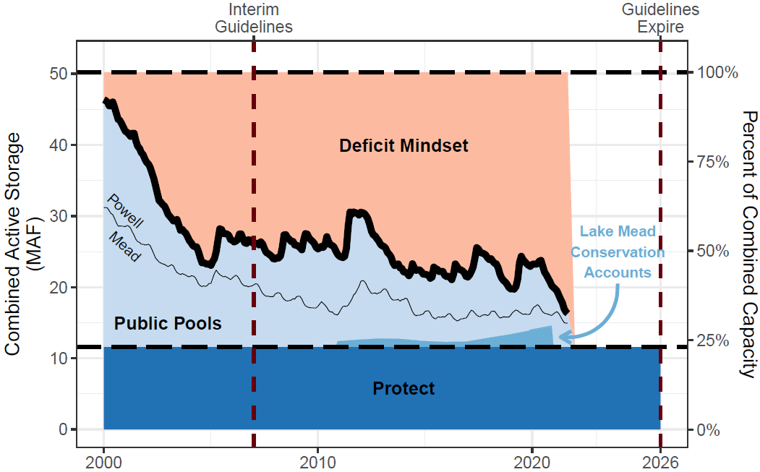

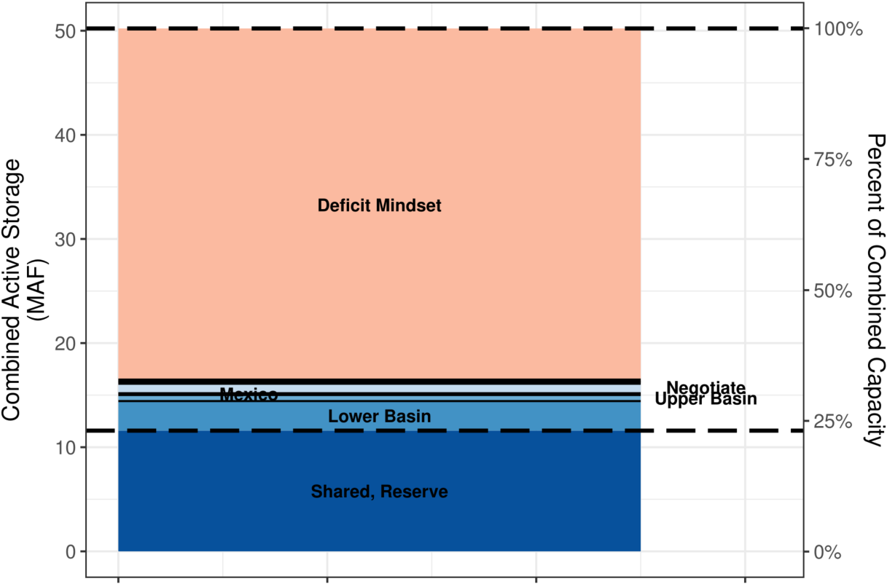

**Figure 6. Assign combined Lake Powell and Lake Mead storage (top) to flex accounts (bottom).**

## 3A. Begin of year reservoir storage

In Year 1 (Column C), beginning of year reservoir storage is the Lake Powell and Lake Mead volumes specified in Section 1B.

In subsequent years (Columns D, E, …), the Lake Powell and Lake Mead storage volumes are the volumes decided by parties at the end of the prior year.

## 3B. Calculate Powell + Mead Evaporation

Reservoir evaporation volume is the product of (i) annual evaporation rate (see Section 1B), and the lake surface areas associated with the current reservoir volumes. Find the Elevation-Storage-Area relationships on the *Powell-Elevation-Area* and *Mead-Elevation-Area* worksheets (far right). Data were download from the Colorado River Simulation System (CRSS) model (Wheeler et al., 2019; Zagona et al., 2001).

The combined reservoir evaporation is divided among flex accounts in proportion to the flex account balance (Equation 1, evaporation terms in maf per year, balance and storage terms in maf).

 Equation 1

For example, if the combined evaporation is 1.0 maf and Upper Basin has 10% of the combined storage, then the Upper Basin is assigned 10% of the combined evaporation or 0.1 maf that year.

## 3C. Calculate Mexico Water Allocation

Mexico’s water allocation is its 1.5 maf per year treaty amount minus mandatory conservation volumes specified in Minutes 319 and 323 for declining Lake Mead levels (Table 5)(IBWC, 2021). The *MandatoryConservation* sheet shows the Mexico and Lower Basin conservation schedules.

**Table 5. Mexico Mandatory Conservation under Minutes 319 and 323**

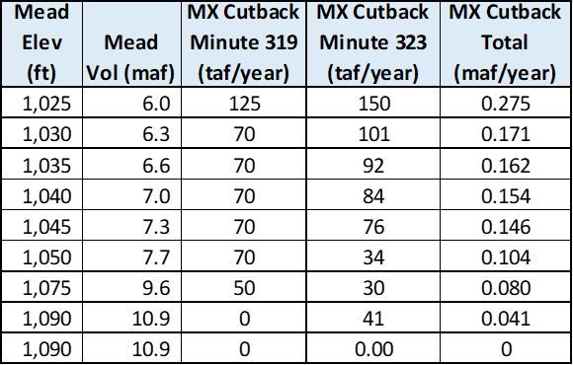

# Split combined natural inflow among parties

Split the combined natural inflow – natural inflow to Lake Powell, plus intervening Grand Canyon inflow, plus Mead to Imperial Dam intervening inflow, minus Havasu / Parker evaporation and ET (see Sections 2A-C) – among accounts. This split is a joint party (political) decision. There are lots of ways to split. Table 6 shows one way to split that draws on existing operations. In these operations, first assign volumes to the Shared water reserve, Delta, Mexico, and First Nations accounts (Lake Powell Natural flow up to 3.5 maf per year). Assign the next 1.9 maf per year of Lake Powell Natural flow to Upper Basin pre-1922 water rights (pre Compact). Assign the next 5.8 maf of Lake Powell Natural Inflow to the Lower Basin (reduced from 7.5 maf because First Nations already assigned 0.95 maf for uses below Glen Canyon Dam and carriage losses for Lake Mohave/Lake Parker evaporation and evapotranspiration. Last, assign any remaining Lake Powell natural flow to the Upper Basin.

**Table 6. Assign inflow to parties**

|  |  |  |  |
| --- | --- | --- | --- |
| **Party** | **Volume (MCM)** | **Event** | **Existing Operations** |
| Shared, Reserve | Varies by Evap. | Assign share of inflow that offsets the evaporation volume for the shared, reserve account. This assignment keeps the account balance steady year to year. | Drought Contingency Plans (USBR, 2019) |
| Colorado River Delta | 0.016 | 0.016 maf is 67% of the 9-year, 0.21 maf volume pledged by the U.S. and Mexico. | Minute 323 (IBWC, 2021) |
| Mexico | 1.5 minus mandatory conservation minus carriage loss | Mandatory conservation volumes increase as Lake Mead level’s decreases (see Section 3C). Carriage loss is Mexico’s share of Havasu/Parker Evaporation and Evapotranspiration (1.5/8.7 = 17.2%) | 1944 Treaty, Minutes 319 and 323 (IBWC, 2021) |
| First Nations | 2.01 minus Lower Basin carriage loss | Rights of 1.06 and 0.952 maf in the Upper and Lower Basins. Excludes claimed amounts. Lower Basin carriage loss is share of Havasu/Parker Evaporation and ET in the Lower Basin (0.95/8.7 = 11%). | Tribal Water Study (Ten Tribes Partnership, 2018). |
| Lower Basin | 7.5 minus 0.95 minus carriage loss | Quantified rights of 7.5 maf minus rights of First Nations in the Lower Basin minus share of Havasu/Parker Evaporation and ET ([7.5 – 0.95]/8.7 = 75.3%). | 1922 Compact Article III(d) |
| Upper Basin | 1.9 + Remain | Pre-compact rights plus any remaining Lake Powell natural flow. | 1922 Compact Article III(d) |

The volumes in Table 6 draw from the inflow sources in different amounts (Table 7). I expect it easier to assign each year’s inflow than negotiate ever larger mandatory conservation targets.

Table 7. Assign inflow sources to parties

|  |  |  |
| --- | --- | --- |
| **Party** | **Lake Powell Natural Flow** | **Grand Canyon Intervening + Mead to Imperial** |
| Shared, Reserve | 50% | 50% |
| Colorado River Delta | 50% | 50% |
| Mexico | 50% | 50% |
| First Nations | 1.06 maf | 0.95 maf |
| Upper Basin (pre-1922 rights) | min(1.9, Remain) | -- |
| Lower Basin | min(5.8, Remain) | Remain |
| Upper Basin (post 1922) | Remain | -- |
| Havasu/Parker Evap. and ET | -- | 100% |

The volumes in Table 6 differ from the customary accounting of first 8.23 maf of Lake Powell Natural flow to Lower Basin plus Mexico and remaining amount to the Upper Basin. The difference arises because:

* Mexico, First Nations, Colorado River Delta, and Havasu/Parker evaporation and evapotranspiration are accounted for separately in Flex accounting.
* Mexico’s amount is reduced by conservation under Minutes 319 and 323.
* The Shared, Reserve account is charged a share of the combined reservoir evaporation.
* Lower Basin, Mexico, and First Nations in the Lower Basin are charged carriage loss (Havasu/Parker evaporation and evapotranspiration).
* 1922 Pre-Compact Upper Basin water rights are given priority over the Lower Basin.

The present configuration is valid for Lake Powell Natural flows down to 3.7 maf per year. Below that value, I am unclear whether to assign natural flow to First Nations or Mexico first or to share the assignment.

# Step 5. Player Dashboards – Conserve, Consume, and Trade

Each player has a dashboard where they can trade, conserve, and consume their available water (Figure 7). 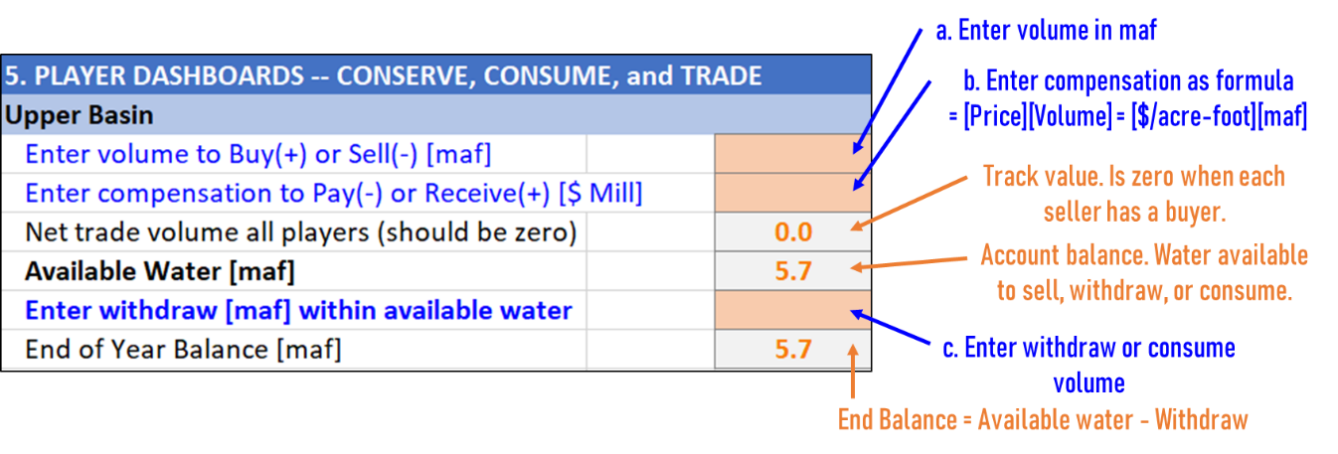

**Figure 7. Upper Basin Dashboard annotated. A Lake Powell natural flow of 9 maf gives the Upper Basin 5.7 maf of available water to sell or consume. No trades or withdraws have been entered.**

### (i) Buy or sell water from other player(s)

Enter buy amounts as positive (+) and sell amounts negative (-). These are additions and subtractions to the party’s available water. Enter all amounts in maf. If multiple transactions – e.g, buy 0.5 maf from Lower Basin and 0.2 maf from Mexico -- enter as a formula: = 0.5 + 0.2

**These transactions are all temporary – for one year!**

When a buying party requires a selling party to invest financial proceeds in new farm or urban water conservation efforts, the money stays in the local community and the seller can make more water available in future years (Rosenberg, 2021e).

### (ii) Compensation

Enter compensation – payments for buying, receipts for sales – in $ millions. Enter as a formula. Multiple the sale price in $/acre-foot by the buy or sell volume in maf. Table 8 shows rough Colorado River water prices. Table 9 shows example compensation for different water prices and target water volumes.

* For example, a purchase of 0.5 maf at $500 per acre-foot is (0.5)(500) = $250 million.
* If a party buys 0.5 maf at $500 per acre-foot from one party and 0.2 maf at $1,200 per acre-foot from a second party, the compensation formula is:

Compensation = (0.5)(500) + (0.2)(1,200) = $850 million.

The recently proposed 500-Plus plan seeks to reduce Lower Basin water use by 0.5 maf per year (Allhands, 2021). Potential compensation amounts are shown in green fill in Table 9.

**Table 8. Rough Colorado River water prices**

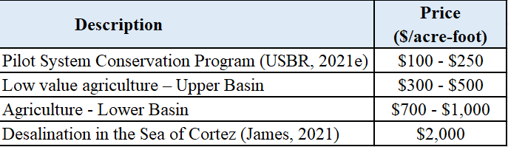

**Table 9. Compensation ($ million) at different water prices ($/acre-foot)to purchase different target water volumes (maf)**

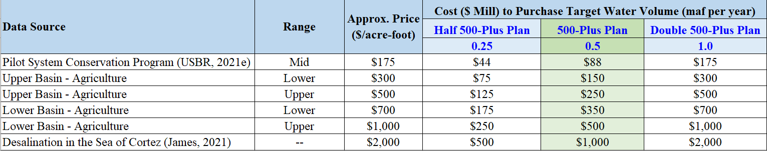

### (iii) Net Trade Volume all Players

Confirm the net trade volume for all players is zero. A zero balance indicates there is a buyer for every seller.

### (iv) Available Water

Available water is the water available to a party to consume, conserve, or sell to another party. Purchases can increase available water (Eq. 2).

|  |  |
| --- | --- |
|  | (Eq. 2) |

### (v) Enter Withdraw within Available Water

Flex account withdraws are a party’s consumptive use. This consumptive use occurs by parties physically withdrawing from the combined Lake Powell-Lake Mead system at Hoover dam (Lower Basin, Mexico, or Delta), or diverting instream flow before that flow enters the combined system (Upper Basin). In the later case, the Upper Basin diverts the water and its flex account is deducted the corresponding consumptive use.

Enter withdraws and consumptive use according to the strategy identified in Step 1 or modifications to that strategy based on current conditions.

The withdraw cell fill will turn red when the withdraw exceeds the available water. No withdrawing more money than is in your bank account!

### (vi) End of Year Balance

The party’s flex account balance at the end of the year after deducting withdraws and consumptive use. End of Year balance = Available Water – Withdraw.

## 5A. Shared, Reserve Dashboard

The dashboard for the shared, reserve account is orange fill – all parties must agree to a purchase or sale (Figure 8).

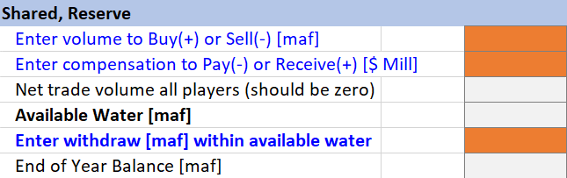

**Figure 8. Shared, Reserve account choices are a joint decision by all parties.**

The current recommendation is keep the shared, reserve account balance steady – no sales or gifts to parties in distress.

Selling or gifting water from the shared, reserve account to other parties will lower Lake Powell and/or Lake Mead levels:

* Reduce storage in Lake Powell, heat the water temperature of Lake Powell storage (less stratification), increase the release water temperature, and push native, endangered fish of the Grand Canyon into unchartered territory -- more susceptible to prey by non-native fish. Higher Lake Powell levels and colder releases maintain the status quo for endangered fish. The worksheet *PowellReleaseTemperature* provides a table and figure of the impacts on fish of less water storage in Lake Powell.
* Reduce the head available for hydropower generation, and speed the time that reservoirs reach their minimum power pools (where they can no longer generate energy). When energy generation declines, Lake Powell and Lake Mead energy producers must go on the spot energy market to purchase the energy shortfall. The synchronous model does not quantify the impacts of reduced hydropower generation.

Both impacts will depend on how combined storage is split between Lake Powell and Lake Mead (see next section).

# Step 6. Summary of Player Actions

Shows player actions grouped by Purchases and Sales, Account Withdraws, and Account end-of-year balances. These groupings can help see whether sales balanced purchases and also overall water consumption for the year.

## 6A. Combined Storage – End of Year

The combined storage – end of the year is the combined storage in Lake Powell and Lake Mead at the end of the year after all account withdraws and consumptive use. This volume is the sum of the end-of-year- balances in all accounts.

# Step 7. Assign Combined Storage to Powell and Mead

Assign the end-of-year combined storage to Lake Powell and Lake Mead. Enter as percent where 50% splits the combined storage equally between the two reservoirs and 75% places more storage in Lake Powell.

After entering a percent split, the following items will calculate:

### (i) Powell and Mead storage volumes and levels

The model uses the elevation-area-volume relationships for the reservoirs to calculate storage level from volume. See the left and right hand side of Figure 10 for critical levels and volumes such as dead pool (0 maf storage) and minimum power pool (penstock elevations) to avoid.

### (ii) Lake Powell release to achieve Powell and Mead storage volumes

This is the annual release from Lake Powell to achieve the specified storage volumes in Lake Powell and Lake Mead. Compare to numbers such as 7 to 9 maf per year that are the target of equalization releases (Figure 12)(USBR, 2007). Note that as combined storage declines, it will become harder to achieve the 7-9 maf targets. This Powell release is calculated as (all terms maf):

Powell Release = -[Powell end storage] + [Powell start storage] + [Powell Natural Inflow] – [Upper Basin Consume] – [Powell Evaporation] (Equation 3)

A negative release is infeasible and means too much water is already in Lake Mead. Specify a lower percentage in Step 7 – lower Powell end storage.

### (iii) Turbine release water temperature

The temperature of water released through the Lake Powell penstocks to generate hydropower. This data is pulled from observations of water temperature (Wheeler et al., 2021, Appendix 1).

### (iv) Suitability for native, endangered fish of the Grand Canyon

As release water temperature rises, push the native, endangered fish of the Grand Canyon into unchartered territory -- become more susceptible to competition and prey by introduced non-native fish. Colder releases preserve the status quo. Table 10 shows the breakpoints of temperature suitability for native fish (Wheeler et al., 2021, Appendix 1).

### (v) Suitability for tailwater trout

The tailwater trout are an introduced species, require colder water, and live in the Colorado River reach from Glen Canyon Dam to Lee Ferry (and possibly below). Table 10 shows the breakpoints of temperature suitability for tailwater trout (Wheeler et al., 2021, Appendix 1).

Box 2 shows an example of the impacts of 13.8 maf of combined storage if assign 65% of that storage to lake Powell.

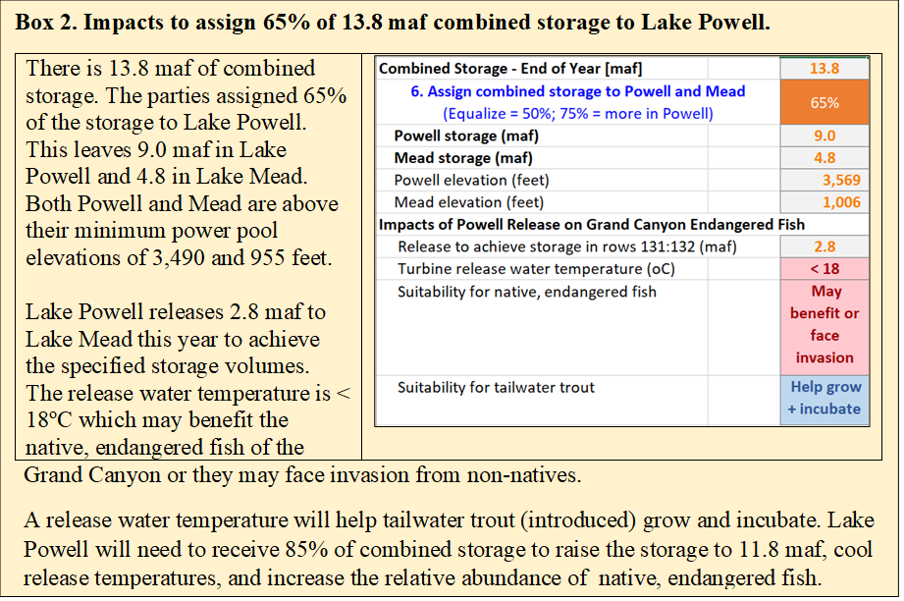

## 7A. Consider four issues to split the combined storage between the two reservoirs:

### (i) Preserve status quo for endangered, native fish of the Grand Canyon

As Lake Powell water storage drops to the turbine release elevation of 3,490 feet (4 maf), the water stored in Lake Powell heats (less stratification), increases release water temperature through the hydropower turbines, and pushes native, endangered fish of the Grand Canyon into unchartered territory -- more susceptible to prey by non-native fish (Figure 9, left). Higher Lake Powell levels and colder water releases preserve the status quo. Table 10 summarizes the important Lake Powell elevation break points for fish. To delay these negative impacts on fish, managers can forego release and hydropower generation through the turbines and instead release water through the low elevation river outlets (elevation 3,370 feet; 0 maf; Figure 10). For example, an 18oC release through the river outlets requires 5.9 maf less storage than an 18oC release through hydropower turbines (elevation 3,600 feet on Figure 10 left plot compared to 3,525 feet on right plot). This information is also presented on the *PowellReleaseTemperature* worksheet.

|  |  |
| --- | --- |
|  |  |

**Figure 9. Lake Powell release water temperatures through the hydropower turbines (elevation 3,490 feet; left) and river outlets (elevation 3,370 feet; right) for different water surface elevations (Wheeler et al., 2021).**

**Table 10. Effects of Summer Lake Powell Elevation on Fish**

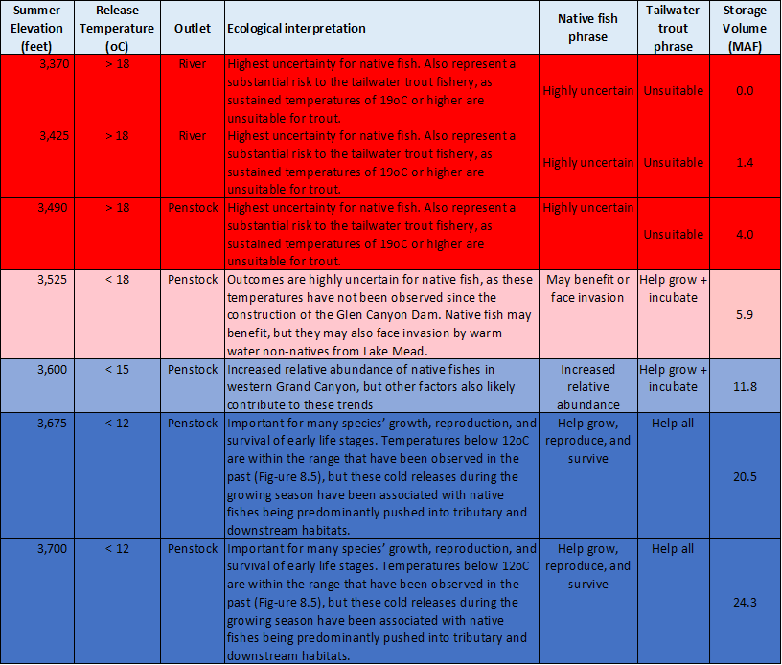

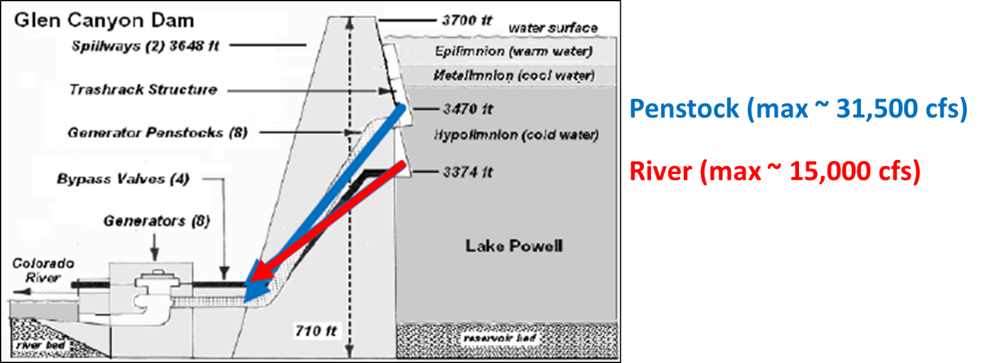

Figure 10. Glen Canyon Dam river outlets (red) are ~ 100 feet below the penstocks (blue)

### (ii) Reduce Hydropower Generation

Reduced water surface elevation reduces hydropower generation and speeds the time that reservoirs reach their minimum power pools (elevations 3,490 and 955 feet in Lake Powell and Lake Mead) where the reservoirs can no longer generate energy. When energy generation declines, Lake Powell and Lake Mead energy producers must go on the spot energy market to purchase the energy shortfall. The synchronous model does not quantify the impacts of reduced hydropower generation.

### (iii) Reduce evaporation loss

The combined evaporated volume changes less than 0.12 maf to preferentially store water in Lake Mead or Lake Powell (Figure 11, red numbers). These volumes are inside the margin of error of the evaporated volumes (Figure 11, black bars) calculated from the evaporation rates (Section 1Bi). This analysis suggests there is no water supply or evaporation benefit to preferentially store combined storage in Lake Powell or Lake Mead.

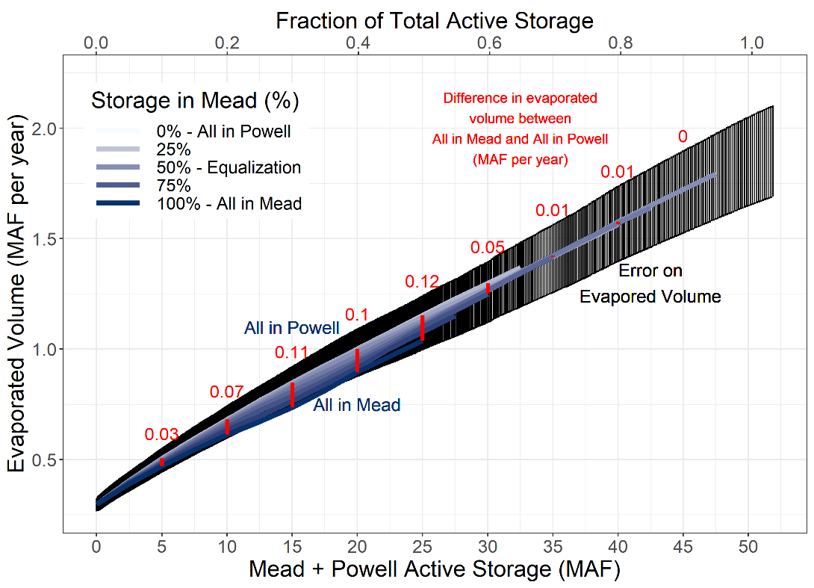

**Figure 11. Combined evaporated volume changes little (red numbers) to preferentially store water in Lake Mead or Lake Powell.**

### (iv) Current operations

Since 2007, the current operations sought to equalize storage in Lake Powell and Lake Mead (enter 50%)(USBR, 2007). Prior to 2007, managers kept more storage in Lake Mead (Figure 12).

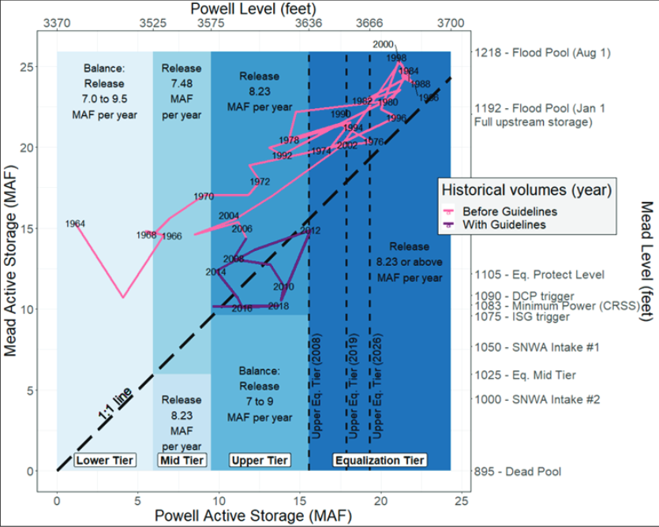

**Figure 12. Lake Powell-Lake Mead coordination rules (blue fill) and historical lake levels before and after the 2007 interim guidelines (pink and purple lines)(Wheeler et al., 2019).**

# Step 8. Move to next year

Move to next year. Move to Step 2 Specify natural inflow to Lake Powell in the next year (next column). Repeat Steps 2 to 7 for each year.

The purpose of synchronous model is to provoke thought and discussion about renegotiation of Lake Powell and Lake Mead operations. So continue to play years so long as the discussion provokes new insights.

# Step 9. Finish

Congratulations. You finished! If you wish to provide feedback – things you liked, things to improve – please send an email to david.rosenberg@usu.edu.

# Data, Model, and Code Availability

The data, code, and directions to generate figures in this post are available on Github.com at Rosenberg (2021c).

# Requested Citation

David E. Rosenberg (2021). " Synchronous Model Guidance: Flex Accounting for a Combined Lake Powell-Lake Mead System." Utah State University. <https://github.com/dzeke/ColoradoRiverCoding/tree/main/ModelMusings>.

# Appendix 1. Summary of Current Colorado River Operations

The Colorado River basin has a long history. The parties do not get along. There is much written material. This appendix summarizes key pieces and provides links to the actual documents:

1. [**Map**](https://www.usbr.gov/lc/images/maps/CRBSmap.jpg) shows Upper Basin, Lower Basin, Glen Canyon Dam/Lake Powell, Hoover Dam/Lake Mead, and diversions inside and outside the hydrologic basin (USBR, 2012).
2. **Compacts, treaties, and agreements** in 1922, 1928, 1944, 1956, 1964, and 1968 -- <https://www.usbr.gov/lc/region/g1000/lawofrvr.html>.
3. **2007 Interim Guidelines**. Lower Basin states increase mandatory conservation as Lake Mead level falls from 1,075 to 1,025 feet; Intentionally created surplus (aka conservation) accounts in Lake Mead for Lower Basin states (Section 3); Equalize storage in Lake Powell and Lake Mead (Section 6). <https://www.usbr.gov/lc/region/programs/strategies/RecordofDecision.pdf>.
4. **2012 and 2017. Minutes 319 and 323 to the 1944 US-Mexico Treaty**. Mexico increases mandatory conservation as Lake Mead’s level falls from 1,090 to 1,025 feet. <https://www.ibwc.gov/Treaties_Minutes/Minutes.html>.
5. **2018 Ten Tribes Partnership Water Study.** Quantified 2.0 million acre-feet (maf) rights in Upper and Lower Basins and 0.8 maf claims. https://www.usbr.gov/lc/region/programs/crbstudy/tws/finalreport.html.
6. **2019 Upper Basin Drought Contingency Plan.** Protect Lake Powell elevation of 3,525 feet (5.9 maf). Prevent Lake Powell to fall to minimum power pool elevation of 3,490 feet (4.0 maf). https://www.usbr.gov/dcp/finaldocs.html.
7. **2019 Lower Basin Drought Contingency Plan.** Increase mandatory conservation targets as Lake Mead’s level falls from 1,090 feet to 1,025 feet. See current mandatory conservation schedule in (Castle and Fleck, 2019). Protect Lake Mead from falling below elevation 1,020 feet. https://www.usbr.gov/dcp/finaldocs.html.
8. **2026.** **Interim Guidelines and Drought Contingency Plans expire.**
9. **Castle and Fleck (2019)**:
   1. Summarize current Colorado River operations in slightly more detail than Box 1.
   2. Describe what happens when the Upper Basin is unable to deliver 8.23 million acre-feet (maf) of water per year to Lower Basin as required in the 1922 Compact and 1944 US-Mexico Treaty.
10. **Kuhn and Fleck (2019)** give a well written history of Colorado River management. Read this piece for fun or to go in depth on a particular piece of management.

# References

(1922). "Colorado River Compact." <https://www.usbr.gov/lc/region/pao/pdfiles/crcompct.pdf>. [Accessed on: October 5, 2021].

Allhands, J. (2021). "It could take at least 500,000 acre-feet of water a year to keep Lake Mead from tanking." *Arizona Republic*, November 8, 2021.

Carson, C. A., Stone, C. H., Wilson, F. E., Watson, E. H., and Bishop, L. C. (1948). "Upper Colorado River Basin Compact." U.S. Bureau of Reclamation. <https://www.usbr.gov/lc/region/g1000/pdfiles/ucbsnact.pdf>. [Accessed on: September 7, 2021].

Castle, A., and Fleck, J. (2019). "The Risk of Curtailment under the Colorado River Compact." <http://dx.doi.org/10.2139/ssrn.3483654>.

IBWC. (2021). "Minutes between the United States and Mexican Sections of the IBWC." United States Section. <https://www.ibwc.gov/Treaties_Minutes/Minutes.html>. [Accessed on: July 22, 2021].

Kuhn, E., and Fleck, J. (2019). *Science Be Dammed: How Ignoring Inconvenient Science Drained the Colorado River*, University of Arizona Press.

Meko, D., Bigio, E., and Woodhouse, C. A. (2017). "Colorado River at Lees Ferry, CO River (Updated Skill)." *Treeflow*. <https://www.treeflow.info/content/upper-colorado#field-ms-calibration-validation>.

Prairie, J. (2020). "Colorado River Basin Natural Flow and Salt Data." U.S. Bureau of Reclamation. <https://www.usbr.gov/lc/region/g4000/NaturalFlow/current.html>.

Rosenberg, D. E. (2021a). "Adapt Lake Mead releases to inflow to give managers more flexibility to slow reservoir draw down." Utah State University, Logan, Utah. <https://digitalcommons.usu.edu/water_pubs/170/>.

Rosenberg, D. E. (2021b). "Colorado River Coding: Grand Canyon Intervening Flow." GrandCanyonInterveningFlow folder. <https://doi.org/10.5281/zenodo.5522835>.

Rosenberg, D. E. (2021c). "Colorado River Coding: Intentionally Created Surplus for Lake Mead: Current Accounts and Next Steps." ICS folder. <https://doi.org/10.5281/zenodo.5522835>.

Rosenberg, D. E. (2021d). "Colorado River Coding: Pilot flex accounting to encourage more water conservation in a combined Lake Powell-Lake Mead system." ModelMusings folder. <https://doi.org/10.5281/zenodo.5522835>.

Rosenberg, D. E. (2021e). "Invest in Farm Water Conservation to Curtail Buy and Dry." *169*, Utah State University, Logan, Utah. <https://digitalcommons.usu.edu/water_pubs/169/>.

Salehabadi, H., Tarboton, D., Kuhn, E., Udall, B., Wheeler, K., E.Rosenberg, D., Goeking, S., and Schmidt, J. C. (2020). "Stream flow and Losses of the Colorado River in the Southern Colorado Plateau." Center for Colorado River Studies, Utah State University, Logan, Utah. <https://qcnr.usu.edu/coloradoriver/files/WhitePaper4.pdf>.

Schmidt, J. C., Kraft, M., Tuzlak, D., and Walker, A. (2016). "Fill Mead First: a technical assessment." Utah State University, Logan, Utah. <https://qcnr.usu.edu/wats/colorado_river_studies/files/documents/Fill_Mead_First_Analysis.pdf>.

Ten Tribes Partnership. (2018). "Colorado River Basin Ten Tribes Partnership Tribal Water Study." U.S. Department of the Interior, Bureau of Reclamation, Ten Tribes Partnership. <https://www.usbr.gov/lc/region/programs/crbstudy/tws/finalreport.html>.

USBR. (2007). "Record of Decision: Colorado River Interim Guidelines for Lower Basin Shortages and Coordinated Operations for Lakes Powell and Mead." U.S. Bureau of Reclamation. <https://www.usbr.gov/lc/region/programs/strategies/RecordofDecision.pdf>.

USBR. (2012). "Colorado River Basin Water Supply and Demand Study." U.S. Department of Interior, Bureau of Reclamation, Washington, D.C. <https://www.usbr.gov/lc/region/programs/crbstudy.html>.

USBR. (2019). "Agreement Concerning Colorado River Drought Contingency Management and Operations." U.S. Bureau of Reclamation, Washington, DC. <https://www.usbr.gov/dcp/finaldocs.html>.

USBR. (2020). "Review of the Colorado River Interim Guidelines for Lower Basin Shortages and Coordinated Operations for Lake Powell and Lake Mead." U.S. Bureau of Reclamation, U.S. Department of Interior. <https://www.usbr.gov/ColoradoRiverBasin/documents/7.D.Review_FinalReport_12-18-2020.pdf>.

USBR. (2021a). "Boulder Canyon Operations Office - Program and Activities: Water Accounting Reports." U.S. Bureau of Reclamation. <https://www.usbr.gov/lc/region/g4000/wtracct.html>.

USBR. (2021b). "Glen Canyon Dam, Current Status, Lake Powell Inflow Forecast." U.S. Bureau of Reclamation. <https://www.usbr.gov/uc/water/crsp/cs/gcd.html>.

USBR. (2021c). "Lake Mead at Hoover Dam, End of Month Elevation." Lower Colorado River Operations, U.S. Buruea of Reclamation. <https://www.usbr.gov/lc/region/g4000/hourly/mead-elv.html>. [Accessed on: October 5, 2021].

USBR. (2021d). "Lake Powell Unregulated Inflow." <https://www.usbr.gov/uc/water/crsp/studies/images/PowellForecast.png>. [Accessed on: September 28, 2021].

Wheeler, K., Kuhn, E., Bruckerhoff, L., Udall, B., Wang, J., Gilbert, L., Goeking, S., Kasprak, A., Mihalevich, B., Neilson, B., Salehabadi, H., and Schmidt, J. C. (2021). "Alternative Management Paradigms for the Future of the Colorado and Green Rivers." Center for Colorado River Studies, Utah State University, Logan, Utah. <https://qcnr.usu.edu/coloradoriver/files/WhitePaper6.pdf>.

Wheeler, K. G., Schmidt, J. C., and Rosenberg, D. E. (2019). "Water Resource Modelling of the Colorado River – Present and Future Strategies." Center for Colorado River Studies, Utah State University, Logan, Utah. <https://qcnr.usu.edu/coloradoriver/files/WhitePaper2.pdf>.

Zagona, E. A., Fulp, T. J., Shane, R., Magee, T., and Goranflo, H. M. (2001). "Riverware: A Generalized Tool for Complex Reservoir System Modeling." *JAWRA Journal of the American Water Resources Association*, 37(4), 913-929. <https://onlinelibrary.wiley.com/doi/abs/10.1111/j.1752-1688.2001.tb05522.x>.