# Model Guide

## Lake Mead Water Bank based on the Principle of Divide Reservoir Inflow

David E. Rosenberg | Utah State University | [david.rosenberg@usu.edu](mailto:david.rosenberg@usu.edu)

| <http://rosenberg.usu.edu>

November 25, 2024

# I**ntroduction**

The purpose of this tool is to give users the opportunity to immerse in water user roles and experiment with a Lake Mead Water Bank. The Bank works on the principles of **A) Divide reservoir inflow**, **B) Subtract evaporation**, and **C) Users withdraw and conserve within their available water**, others choices, and real-time discussion of choices. We see uses of the tool for two purposes:. We see use of the tool for two purposes:

* As researchers we want to learn *Why* basin partners choose assumptions and *how* extreme; *Why* and *how* basin partners articulate their risk of uncertain future water supply and manage their vulnerability; and *Which* new insights they take from a model session.
* Provoke discussion about new alternatives for Colorado River management post 2026 and their possible benefits to:
  + Stabilize and recover reservoir storage under conditions of low storage *and* low inflow, and
  + Give users more autonomy to manage their vulnerability to water shortages.

This document provides context information for each individual and group choice within the immersive model. The document also explains how choices build on existing Colorado River management (Appendix A). The document also suggest potential values to enter for user choices.

Find quick links to this support information -- the sections and subsections of this document -- in the Model file, *Master* worksheet, Column N.

Requirements

* **Session Guide**: 1 person to setup in Google Sheets (see Setup below), invite participants, and organize play.
* **Number of People**: 2 or more (Session Guide may also participate).
* **Time**: 1 to 3 hours.
* **Software**: Session Guide has a Google Account.

# Instructions to Guide a Model Session

Review the main canons of existing Colorado River management (Appendix A; persons not familiar with current Colorado River operations).

Follow the setup and play instructions (Box 1). The rest of the document provides guidance on each step.

**Box 1. Steps to Guide a Model Session**

**Setup**

1. Identify a Session Guide (may also participate).
2. Download the file [**LakeMeadWaterBankDivideInflow.xlsx**](https://github.com/dzeke/ColoradoRiverCollaborate/raw/refs/heads/main/LakeMeadWaterBankDivideInflow/LakeMeadWaterBankDivideInflow.xlsx) to your computer.
3. Move the Excel file to your Google Drive. Open as a Google Sheet.
4. Open the **Versions** Worksheet to see updates.
5. Duplicate the **Master** Worksheet to save a blank version for later use.
6. Invite 1 or more participant(s) to join the Google Sheet.
   1. In the upper right of the Google Sheet, click the **Share** button.
   2. Add emails, and set permissions so participants can access the Google Sheet. Or copy and share the sheet's URL.

**Play**

1. On the **Master** Worksheet, scroll down Column A. Participants enter values in row blocks with **Blue Text**.
   1. For example, in Rows 4-10, participants select a **User,**  articulate the User's **vulnerability to water shortages**, and define a **strategy to manage vulnerability. If fewer than 6 participants, participants select multiple users**.
   2. Enter the Lake Mead starting storage in **Cell B19**.
   3. On **Row 20, Column B**, the Reclamation user sets the elevation for the protection zone - Lake Mead will never fall below this level.
   4. In **Cell B21**, enter the total Water Conservation Account (Intentionally Created Surplus) Balance. This value includes California, Arizona, Nevada, and Mexico.
   5. Enter the Lake Mead Inflow for Year 1 in **Cell C28**. Cells below will populate.
   6. Participants continue to enter values in Year 1 (Column C) down to **Row 109** in row blocks with **Blue Text**.
2. Move to Year 2 (Column D). Enter a new Lake Mead Inflow in **Cell D28**.
3. Find linked help for each row in **Column N**.

ions (Law of River).

1. See **ReadMe-Directions** Worksheet for these directions and descriptions of all worksheets in the Workbook.

## Types of Use

The model can be used in two modes:

1. Synchronously by multiple participant where each participant manages one or more accounts (in Google Drive).
2. By a single participant (manages all accounts).

Participants can explore:

* Water conservation and consumptive use strategies.
* Scenarios of Lake Mead inflow.
* Joint (political) decisions such as:
  + Split existing reservoir storage among accounts.
  + Split future inflows among accounts.

# Step 1. Assign Accounts, Articulate Vulnerabilities, and Strategies to Manage Vulnerability

The Reclamation, California, Arizona, Nevada, and Mexico accounts represent entities defined in the 1922 Colorado River Compact, US-Mexico Treaty of 1948, subsequent Minutes 319 and 323, Lower Basin drought contingency plans, and pledges to include more accounts (Table 1)(1922; IBWC, 2021; USBR, 2019; USBR, 2020). The Tribal Nations of the Lower Basin users represents Tribal Nations and their settled water rights (Ten Tribes Partnership, 2018).

**Maps of water user areas**

* [Upper Basin, Lower Basin, Mexico](https://www.usbr.gov/lc/images/maps/CRBSmap.jpg) (USGS, 2016)
* [First Nations](http://www.naturalresourcespolicy.org/images/col-river-basin/map-tribes-crb.jpg) (Ten Tribes Partnership, 2018)

**Table 1. Accounts, Reason(s) to include in model, and Potential Strategies**

| **Account** | Reason(s) to Include | **Potential Strategy(s)** |
| --- | --- | --- |
| Reclamation | Article II(c to g) of the Colorado River Compact (1922). Lower Basin Drought Contingency Plan (USBR, 2019). | * Set Lake Mead Protection Elevation of 1,020 feet as defined in the Lower Basin Drought Contingency Plan (USBR, 2019). Lake Mead will not fall below this level. * Lower the protection elevation to allocate more active storage to other users |
| California | Article II(c to g) of the Colorado River Compact (1922). | * Continue mandatory conservation and cutback from 4.4 maf per year as Lake Mead level declines from 1,090 to 1,025 feet (USBR, 2019). See cutback schedule in *MandatoryConservation* sheet. These values exclude 0.95 maf per year of use by First Nations in the Lower Basin. * Cut back an addition amount per year to represent the 500-Plus Plan (Allhands, 2021). * Buy water to reduce mandatory conservation. * Save some water for future years. |
| Arizona | Article II(c to g) of the Colorado River Compact (1922). | * Continue mandatory conservation and cutback from 2.8 maf per year as Lake Mead level declines from 1,090 to 1,025 feet (USBR, 2019). See cutback schedule in *MandatoryConservation* sheet. These values exclude 0.95 maf per year of use by First Nations in the Lower Basin. * Cut back an addition amount per year to represent the 500-Plus Plan (Allhands, 2021). * Buy water to reduce mandatory conservation. * Save some water for future years. |
| Nevada | Article II(c to g) of the Colorado River Compact (1922). | * Continue mandatory conservation and cutback from 0.3 maf per year as Lake Mead level declines from 1,090 to 1,025 feet (USBR, 2019). See cutback schedule in *MandatoryConservation* sheet. These values exclude 0.95 maf per year of use by First Nations in the Lower Basin. * Cut back an addition amount per year to represent the 500-Plus Plan (Allhands, 2021). * Buy water to reduce mandatory conservation. * Save some water for future years. |
| Mexico | 1944 U.S.-Mexico Treaty and subsequent Minutes | * Continue mandatory conservation and cutback from 1.5 maf per year as Lake Mead levels decline (IBWC, 2021). See *MandatoryConservation* sheet. * Conserve more water beyond mandatory targets. * Lease water to get money for non-water projects. |
| Tribal Nations of the Lower Basin | * Include more accounts (USBR, 2020) * Tribal water study (Ten Tribes Partnership, 2018) | * Develop and use 0.95 maf of settled water rights by Tribal Nations in the Lower Basin. * Lease settled, undeveloped water to other users to acquire capital to build new projects. * Save water for future use. |

A participant can play one or more accounts.

The First Nations account allows First Nations of the Lower Basin to manage their water independently from the Basin State in which the First Nation was located. This set up differed from current operations where Basin States administer water rights for the First Nations within their state boundaries.

Delete the entry in Cell A10 to remove the Tribal Nations of the Lower Basin

user. Removing will reallocate 0.95 maf of settled water rights – add 0.48 maf

to the Arizona and 0.48 maf to California.

## 1A. Explain cell types

Four model cell types are defined by fill color (Table 2).

**Table 2. Model Cell Types**

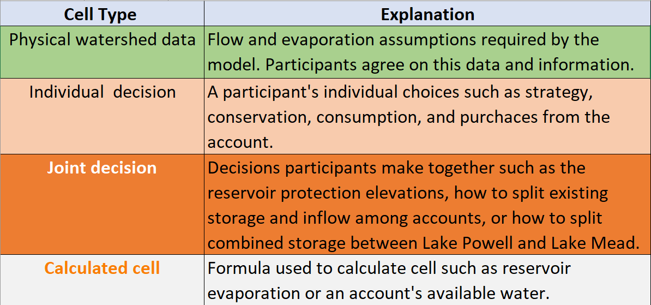

## 1B. Make Assumptions

### **(i) Evaporation rates**

Evaporation rates for Lake Mead are taken as the midpoint within reported ranges of measurements (Table 3)(Schmidt et al., 2016). Evaporation rates for Lake Mead are presently measured using eddy-covariance however there is a several year delay in reporting values (Moreo, 2015). A sensitivity analysis found that the lower and upper bounds on Lake Mead evaporation rates for a five year study for Lake Mead draw down saw variations of 0.25 maf or less in Lake Mead storage volume.

**Table 3. Reservoir evaporation rates (feet per year)**

|  |  |  |
| --- | --- | --- |
| **Reservoir** | **Midpoint** | **Range** |
| Mead | 6.0 | 5.5 – 6.4 |

### (ii) Start storage

Reservoir start storage is taken from data portals (USBR, 2021c; USBR, 2021d). Text in Column D lists the date.

### (iii) Protection elevations

These Lake Powell and Lake Mead elevations inform the start storage for the shared reserve account. The reservoir protection elevations of 3,525 feet for Lake Powell and 1,020 feet for Lake Mead are defined in the Upper and Lower Basin Drought Contingency Plans (USBR, 2019). As the reservoirs approach the protection levels, the plans state the accounts will consult with the Federal Government to stabilize and prevent the reservoirs from falling below these levels. To stabilize, participants will need to make reservoir releases plus evaporation less than inflow (Rosenberg, In press).

### (iv) The protection volumes

The reservoir protection volumes associated with the Lake Powell and Lake Mead protection elevations (item iii). These volumes become the starting balance for the shared, reserve account. These volumes are calculated from the Elevation-Area-Volume curve for the reservoir. See worksheets *Powell-Elevation-Area* and *Mead-Elevation-Area*.

Participants can enter lower protection levels and volumes than the default values. Lowering will reduce hydropower generation at Glen Canyon Dam and Hoover Dam. Lowering will also raise the temperature of water in Lake Powell, raise Glen Canyon Dam release water temperature, and pressure the native, endangered fish populations of the Grand Canyon. With warmer release water temperatures, non-native fish outcompete the native fish. Colorado River managers recommend to keep the default protection levels for now. Participants can also jointly lower the protection volume later during each year of model time.

### (v) Prior 9-year Lake Powell release

This setting is no longer active. Prior 9-year Lake Powell releaseis 78.1 maf and is the release measured through Glen Canyon Dam from 2012 to 2021 (Figure 1).

### **(vi)** **Prior 9-year Paria River flow**

This setting is not active. Prior 9-year Paria River flow is 0.17 maf and measured just before the confluence with the Colorado River at Lee Ferry. We care about the 9-year Lake Powel release and Paria River flow because these volumes tell us how much the Upper Basin must deliver in the next 10th year (1st year of the model) to meet its 10-year delivery requirement of 82.5 maf each decade to the Lower Basin and Mexico via article III(d) of the 1922 Colorado River Compact and 1944 US-Mexico Treaty. Here,

82.5 maf = (7.5)(10) + (1.5/2)(10)

Where 7.5 maf is the Upper Basin’s annual delivery responsibility to the Lower Basin, (1.5/2) is the Upper Basin’s half share of the U.S. responsibility to Mexico, and 10 is a consecutive 10 year period.

### (vii) Delivery to meet 10-year requirement

This setting is no longer active. Upper Basin delivery to meet 10-year requirement is the 82.5 maf requirement minus the Lake Powell Release minus the Paria flow. The Upper Basin must deliver 4.2 maf to the Lower Basin next year at Lee Ferry. The Upper Basin can keep all Lake Powell natural flow above 4.2 maf.

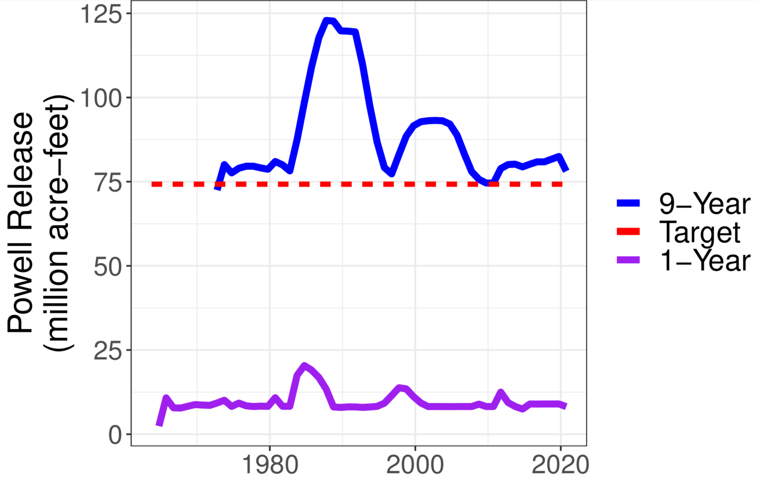

**Figure 1. Lake Powell Releases**

### Upper Basin pre-1922 water rights

Upper Basin water rights in million acre-feet per year prior to 1922 when the Colorado River Compact was signed (Table 4). These pre-1922 water rights have a seniority date prior to the compact. In the assignment of inflow (see Step 2), these rights are filled concurrent to Lower Basin pre-1922 water rights.

The 1.2 maf per year value in the model is the 2.3 maf per year total in Table 4, minus 1.06 maf per year for First Nations in the Upper Basin. This assignment assumes Upper Basin First Nations water rights all have a priority before 1922.

**Table 4. Pre-compact water rights (million acre-feet per year)(Leeflang, 2021)**



# Step 2. Specify natural inflow to Lake Powell

Participants together choose a natural inflow to Lake Powell as the water in the Green, San Juan, mainstem Colorado, and other tributaries that would flow into Lake Powell if there were no upstream human consumptive use or reservoirs. Once a Lake Powell natural flow is specified, the rows below populate with data.

Because future flows are uncertain, specify natural inflow to Lake Powell as a scenario of possible future flows. Develop a scenario from:

1. The most recent 22 years, where estimated natural inflow to Lake Powell varied from 6 to 20 maf per year (Figure 2).
2. Flow values reconstructed from the historical (1905 to 2015) or paleo (1416 to 2015) periods (Meko et al., 2017; Prairie, 2020). See workbook tab *HydrologicScenarios* for some flow scenarios from these periods.
3. The mean natural flow of low-flow sequences in the paleo reconstructed or recent observed periods (Figure 3). For example, the 5-year drought that started in 1580 AD had the lowest reconstructed 5-year average flow: 9 maf per year.
4. Devise a time series of flows on your own or adapt values year-to-year as model time progresses.
5. Optionally, refer to unregulated inflows from 1960 to 1999 (USBR, 2021e)(Figure 4) and add ~3 maf to get a natural flow. The addition represents non-reservoir consumptive use in the Upper Basin. Figure 5 shows how to convert from unregulated to natural flow.

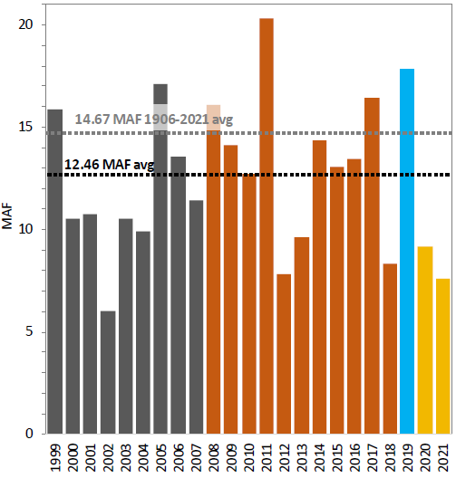

**Figure 2. Estimated natural inflow to Lake Powell (USBR, 2021a)**

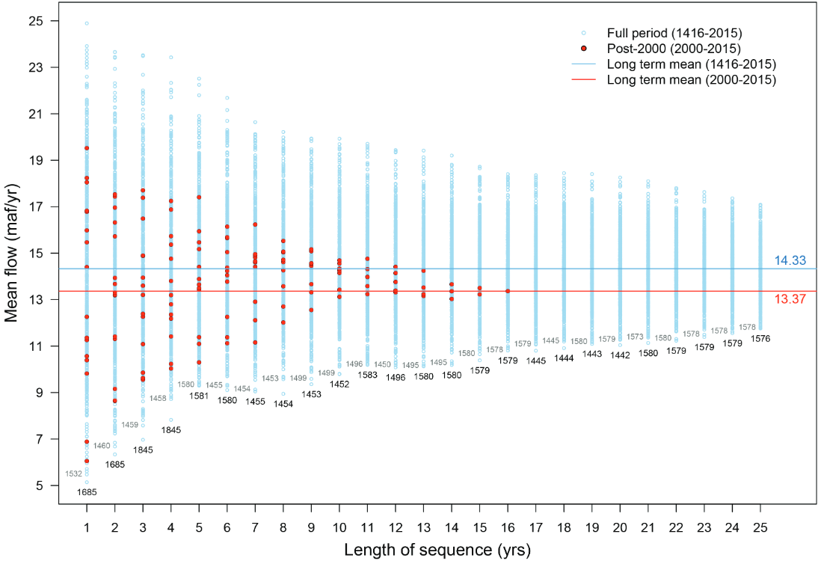

**Figure 3. Sequence-average plot of the tree-ring reconstructed flow of the Colorado River at Lees Ferry (Salehabadi et al., 2020).**

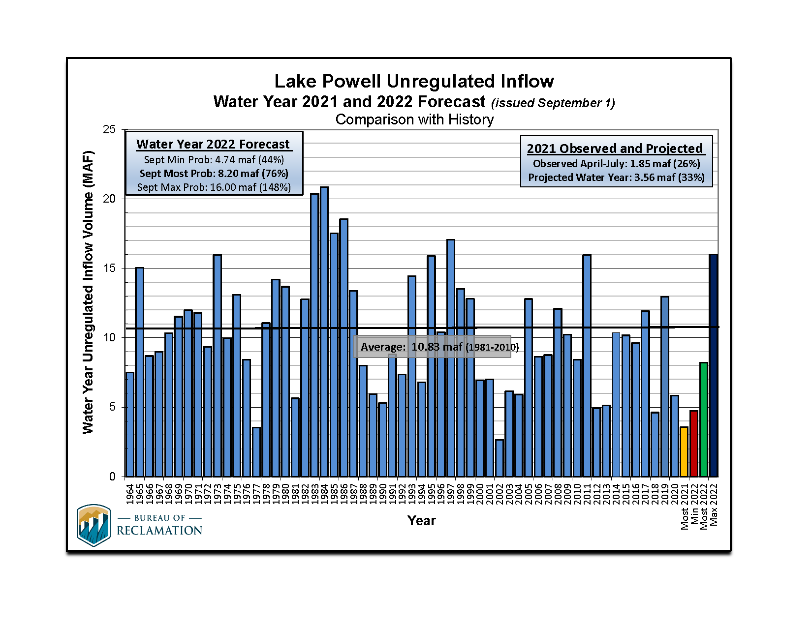

**Figure 4. Unregulated flow to Lake Powell (USBR, 2021e). Add ~ 3 maf for natural flow.**

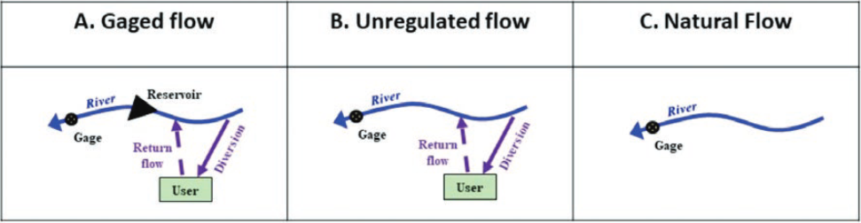

**Figure 5. Process to go from gaged (measured) flow to natural flow (Wheeler et al., 2019).**

The model uses natural flow as in input because the model first credits a share of the year’s natural flow to each basin account. Then participants consume and conserve water. Consumed water is subtracted from the account balance to obtain the end-of-year reservoir storage.

## 2A. Intervening Grand Canyon Flow

Enter the intervening flow from the Paria, Little Colorado, and Virgin rivers plus seeps on the Grand Canyon from Glen Canyon Dam to Lake Mead. By default, the model uses an intervening Grad Canyon flow of 0.8 maf per year. This intervening flow excludes Lake Powell release or other upstream consumptive use on the rivers. A compilation of USGS gaged data from 1990 to 2020 show a mean intervening Grand Canyon flow of 0.9 maf per year with 5-year sequences below 0.75 maf (Figure 5)(Rosenberg, 2021a).

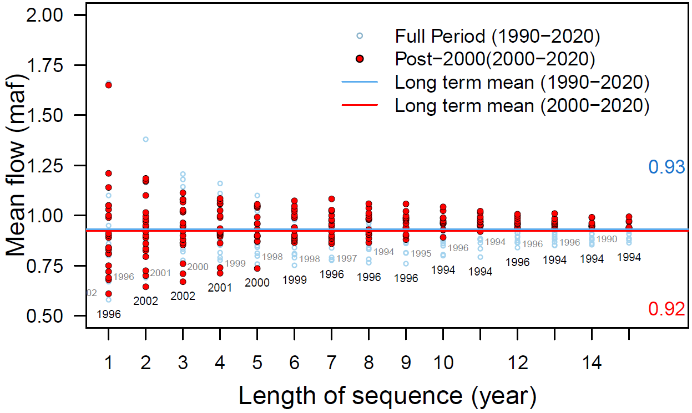

**Figure 5. Mean Grand Canyon tributary flow (Glen Canyon Dam to Lake Mead) for different sequence lengths.**

## 2B. Mead to Imperial Dam intervening flow

Enter the intervening flow from Hoover Dam to Imperial dam. By default, this intervening flow is 0.2 maf per year and was estimated from the natural flow data set below Hoover Dam (Prairie, 2020).

## 2C. Havasu/Parker evaporation and evapotranspiration

This value represents evaporation from Lakes Havasu and Parker and the evapotranspiration of riverbank vegetation from Hoover Dam down to Lake Havasu. A default value of 0.6 maf per year is used and represents the value used in Lake Mead accounting. Find annual estimates of the Havasu/Parker evaporations and evapotranspiration from 1995 to 2014 at USBR (2021b).

# Step 3. Split existing reservoir storage among accounts (year 1 only)

Participants split the starting combined reservoir storage (Figure 6) entered in Section 1B among the basin accounts. There are many possibilities. Here, the default values in Column B apply Interim Guidelines Intentionally Created Surplus (ICS) accounts, the Lower and Upper Basin drought contingency plans and the Minute 323 to the U.S.-Mexico Treaty (IBWC, 2021; USBR, 2019).

* Assign the 11.6 maf protection volume to the shared, reserve account. 11.6 maf is the sum of 5.9 maf protection volume for Lake Powell plus 5.7 maf protection volume for Lake Mead (USBR, 2019).
* Assign the 0.17 maf in Mexico’s Lake Mead conservation account to Mexico (USBR, 2021b).
* Assign the 2.8 maf balance in Lower Basin Lake Mead conservation (ICS) accounts to the Lower Basin.
* Assign the remaining Lake Mead storage to the Lower Basin.
* Assign the remaining storage in Lake Powell to the Upper Basin.
* In these assignments, the Colorado River Delta and First Nations do not get any storage.

In actuality, the participants will negotiate over a share of the existing reservoir storage. In these negotiations, participants will get the same or more storage water as they get with current operations. In the current operations there are no Lake Powell storage accounts and only Lake Mead conservation accounts for Lower Basin and Mexico.

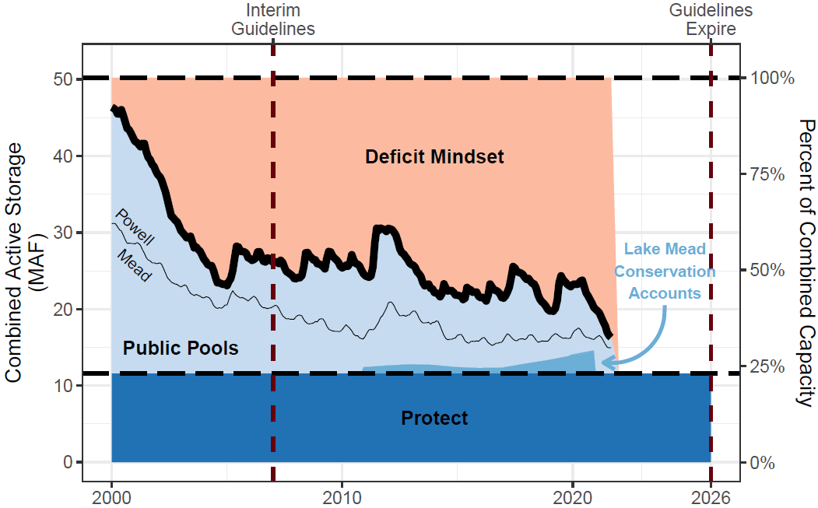

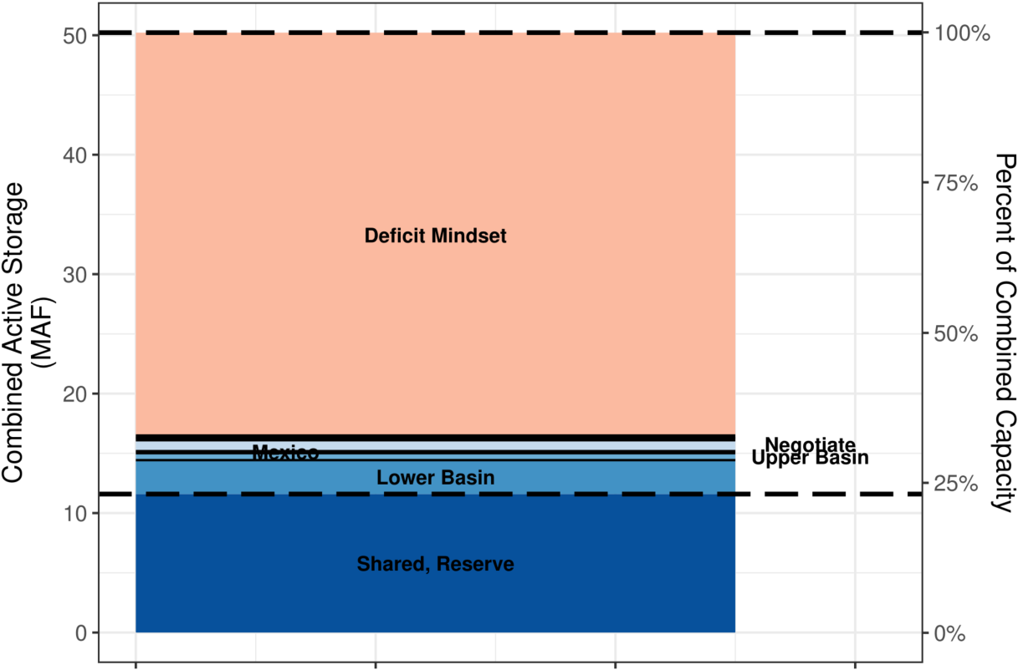

**Figure 6. Assign combined Lake Powell and Lake Mead storage (top) to basin accounts (bottom).**

## 3A. Begin of year reservoir storage

In Year 1 (Column C), beginning of year reservoir storage is the Lake Powell and Lake Mead volumes specified in Section 1B.

In subsequent years (Columns D, E, …), the Lake Powell and Lake Mead storage volumes are the volumes decided by accounts at the end of the prior year.

## 3B. Calculate Powell + Mead Evaporation

Reservoir evaporation volume is the product of (i) annual evaporation rate (see Section 1B), and the lake surface areas associated with the current reservoir volumes. Find the Elevation-Storage-Area relationships on the *Powell-Elevation-Area* and *Mead-Elevation-Area* worksheets (far right). Data were download from the Colorado River Simulation System (CRSS) model (Wheeler et al., 2019; Zagona et al., 2001).

The combined reservoir evaporation is divided among basin accounts in proportion to the account balance (Equation 1, evaporation terms in maf per year, balance and storage terms in maf).

 Equation 1

For example, if the combined evaporation is 1.0 maf and Upper Basin has 10% of the combined storage, then the Upper Basin is assigned 10% of the combined evaporation or 0.1 maf that year.

## 3C. Calculate Mexico Water Allocation

Mexico’s water allocation is its 1.5 maf per year treaty amount, minus mandatory conservation volumes specified in Minutes 319 and 323 for declining Lake Mead levels(Table 5), minus Mexico’s contribution to the Colorado River Delta listed in Minute 323 (IBWC, 2021), minus Mexcio’s portion of the Lake Havasu / Parker evaporation and evapotranspiration. The *MandatoryConservation* sheet shows the Mexico and Lower Basin conservation schedules.

**Table 5. Mexico Mandatory Conservation under Minutes 319 and 323**

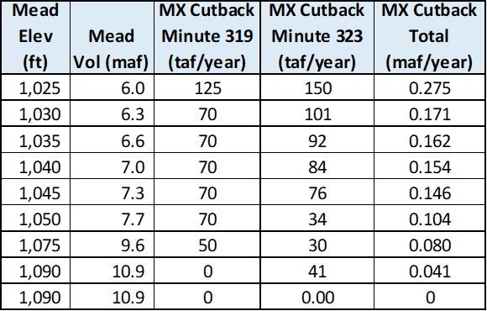

# Split combined natural inflow among accounts

Participants split the basin natural inflow among accounts (Figure 7). Basin natural inflows include natural inflow to Lake Powell, plus intervening Grand Canyon inflow, plus Mead to Imperial Dam intervening inflow (see Sections 2A-C).

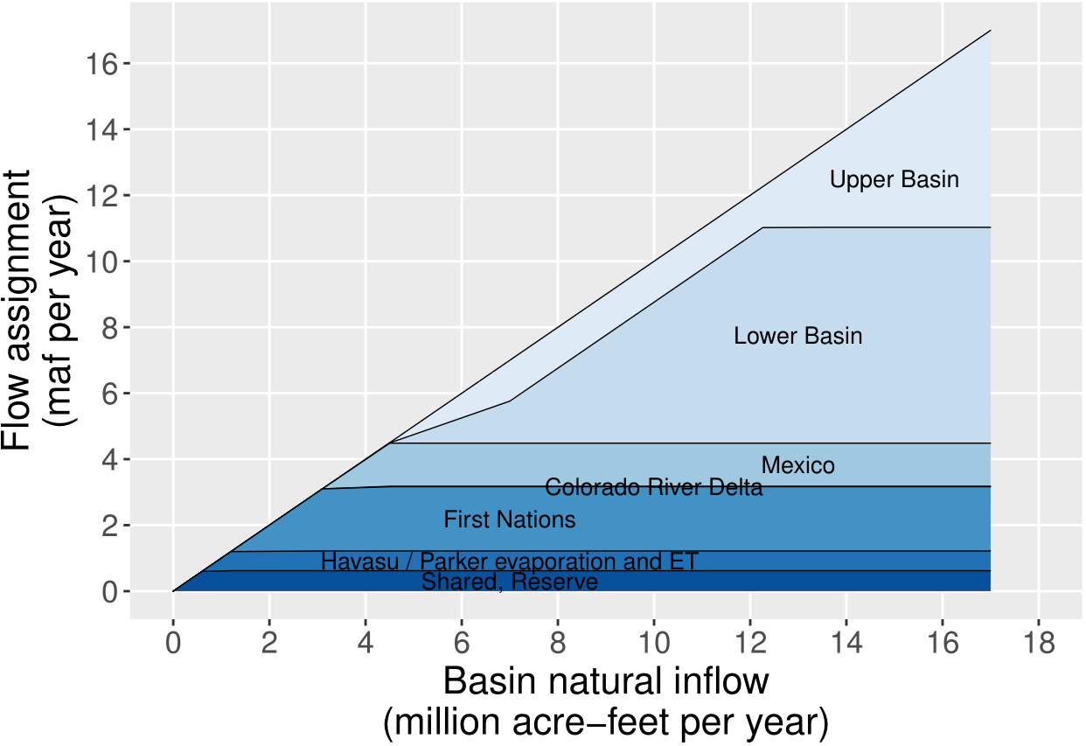

**Figure 7. Split natural flow among Colorado River basin accounts.**

There are lots of ways to split inflow among the basin accounts. Table 6 justifies the default splits shown in Figure 7 that draw on existing operations.

**Table 6. Assign inflow to accounts**

|  |  |  |
| --- | --- | --- |
|  | **Step** | **Existing Operations** |
| 1. | Assign the **shared, reserve account** the *first block of inflow* to exactly offset the evaporation volume of the account. This assignment keeps the shared, reserve balance steady year to year. Volume depends on reservoir storage. | Drought Contingency Plans (USBR, 2019) |
| 2. | Assigned inflow to equal Lake Havasu / Parker evaporation and evapotranspiration. This assignment is drawn from inflow assignments to Mexico, Lower Basin, and First Nations in the Lower Basin. | None. Existing operations do not discus these losses. |
| 3. | Assigned **First Nations** the next *1.94 maf* per year of decreed water rights because First Nations managed their water independently of Basin States. The volume is 1.06 plus 0.952 maf in the Upper and Lower Basins minus First Nations in the Lower Basin’s share of Havasu/Parker losses. The amount excludes claimed amounts. | Tribal Water Study (Ten Tribes Partnership, 2018). |
| 4. | Assigned the **Colorado River Delta** the next *0.016 maf* of inflow. This volume is 67% of the 9-year, 0.21 maf volume pledged by the U.S. and Mexico. | Minute 323 (IBWC, 2021) |
| 5. | Assigned **Mexico** the next *1.5 maf* of inflow *minus mandatory conservation minus Mexico’s portion* of Havasu/Parker losses. Mandatory conservation volumes increase as Lake Mead level’s decreases (see Section 3C). | 1944 Treaty, Minutes 319 and 323 (IBWC, 2021) |
| 6. | Split the next 2.4 maf per year natural flow between the **Upper** and **Lower Basins** because the Basins have 1.2 and 2.45 maf per year of pre-1922 water rights after deducting use by First Nations. | (Leeflang, 2021; Ten Tribes Partnership, 2018) |
| 7. | Assign the **Lower Basin** the next 5.3 *maf* of natural flow. 5.2 maf plus 1.2 maf pre-1922 use plus 0.95 maf of First Nations use below Hoover dam plus half of Mexico’s assignment resulted in 8.2 maf per year that is the Lake Powell objective release. | 1922 Compact Article III(d) |
| 7. | Assign the **Upper Basin** *all remaining* Lake Powell natural flow. | 1922 Compact Article III(d) |

Figure 7 and Table 6 are one way to assign natural inflow to the basin accounts. Other methods may prioritize the Colorado River Delta, First Nations, and Mexico differently.

# Step 5. Participant Dashboards – Conserve, Consume, and Trade

Each participant has a dashboard where they can trade, conserve, and consume their available water (Figure 8). 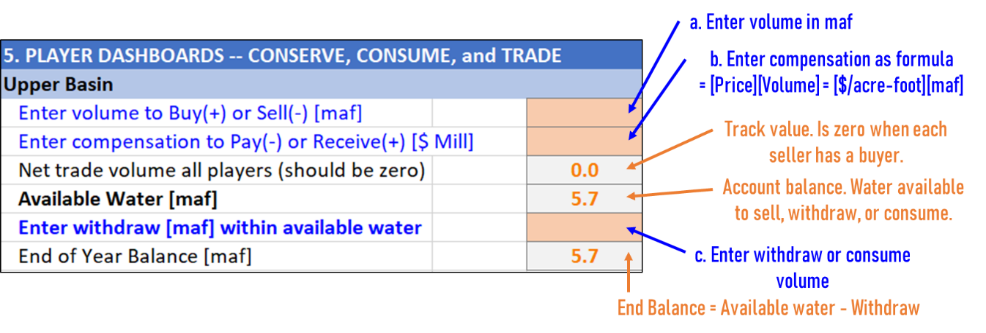

**Figure 8. Upper Basin Dashboard annotated. A Lake Powell natural flow of 9 maf gives the Upper Basin 5.7 maf of available water to sell or consume. No trades or withdraws have been entered.**

### (i) Buy or sell water from other participants(s)

Enter buy amounts as positive (+) and sell amounts negative (-). These are additions and subtractions to the account’s available water. Enter all amounts in maf. If multiple transactions – e.g, buy 0.5 maf from Lower Basin and 0.2 maf from Mexico -- enter as a formula: = 0.5 + 0.2

**These transactions are all temporary – for one year!**

When a buying account requires a selling account to invest financial proceeds in new farm or urban water conservation efforts, the money stays in the local community and the seller can make more water available in future years (Rosenberg, 2021c).

### (ii) Compensation

Enter compensation – payments for buying, receipts for sales – in $ millions. Enter as a formula. Multiply the sale price in $/acre-foot by the buy or sell volume in maf. Table 7 shows rough Colorado River water prices. Table 8 shows example compensation for different water prices and target water volumes.

* For example, a purchase of 0.5 maf at $500 per acre-foot is (0.5)(500) = $250 million.
* If a participant buys 0.5 maf at $500 per acre-foot from one participant and 0.2 maf at $1,200 per acre-foot from a second participant, the compensation formula is:

Compensation = (0.5)(500) + (0.2)(1,200) = $850 million.

The recently proposed 500-Plus plan seeks to reduce Lower Basin water use by 0.5 maf per year (Allhands, 2021). Potential compensation amounts are shown in green fill in Table 8.

**Table 7. Approximate Colorado River water prices**

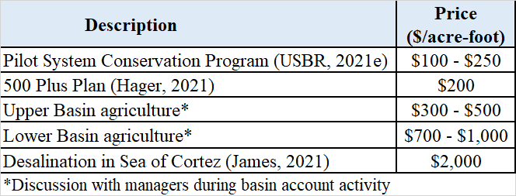

**Table 8. Compensation at different water prices to purchase different target water volumes ($ billion)**

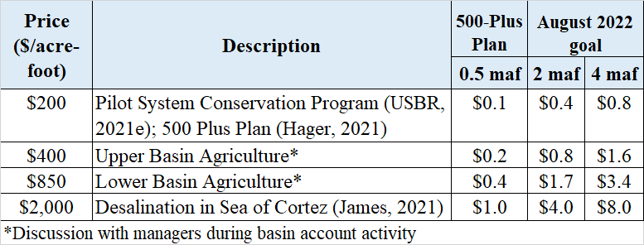

### (iii) Net Trade Volume all Participants

Confirm the net trade volume for all participants is zero. A zero balance indicates there is a buyer for every seller.

### (iv) Available Water

Available water is the water available to a participant to consume, conserve, or sell to another account. Sales decrease and purchases increase available water (Eq. 2).

|  |  |
| --- | --- |
|  | (Eq. 2) |

### (v) Enter Withdraw within Available Water

Account withdraws are consumptive use. This consumptive use occurs by a participant physically withdrawing from the combined Lake Powell-Lake Mead system at Hoover dam (Lower Basin, Mexico, or Delta). Consumptive use can also occur by diverting instream flow before that flow enters the combined system (Upper Basin). In the later case, the Upper Basin diverts the water and its basin account is deducted the corresponding consumptive use.

Enter withdraws and consumptive use according to the strategy identified in Step 1 or modifications to that strategy based on current conditions.

Check that other participants do not withdraw more water than is available to them!

### (vi) End of Year Balance

The account balance at the end of the year after deducting withdraws and consumptive use. End of Year balance = Available Water – Withdraw.

## 5A. Shared, Reserve Dashboard

The dashboard for the shared, reserve account is orange fill – all accounts must agree to a purchase or sale (Figure 9).

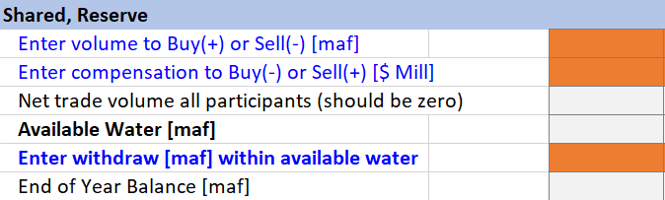

**Figure 9. Shared, Reserve account choices are a joint decision by all participants.**

The current recommendation is keep the shared, reserve account balance steady – no sales or gifts to participants in distress.

Selling or gifting water from the shared, reserve account to other accounts will lower Lake Powell and/or Lake Mead levels:

* Reduce storage in Lake Powell, heat the water temperature of Lake Powell storage (less stratification), increase the release water temperature, and push native, endangered fish of the Grand Canyon into unchartered territory -- more susceptible to prey by non-native fish. Higher Lake Powell levels and colder releases maintain the status quo for endangered fish. The worksheet *PowellReleaseTemperature* provides a table and figure of the impacts on fish of less water storage in Lake Powell.
* Reduce the head available for hydropower generation, and speed the time that reservoirs reach their minimum power pools (where they can no longer generate energy). When energy generation declines, power customers must go on the spot energy market to purchase the energy shortfall. The model of Colorado River basin accounts not quantify the impacts of reduced hydropower generation.

Both impacts will depend on how combined storage is split between Lake Powell and Lake Mead (see next section).

# Step 6. Summary of Participant Actions

Shows participant actions grouped by Purchases and Sales, Account Withdraws, and Account end-of-year balances. These groupings can help see whether sales balanced purchases and also overall water consumption for the year.

## 6A. Combined Storage – End of Year

The combined storage – end of the year is the combined storage in Lake Powell and Lake Mead at the end of the year after all account withdraws and consumptive use. This volume is the sum of the end-of-year- balances in all accounts.

# Step 7. Assign Combined Storage to Powell and Mead

All participants together assign the end-of-year combined storage to Lake Powell and Lake Mead. Enter as percent where 50% splits the combined storage equally between the two reservoirs and 75% places more storage in Lake Powell.

After entering a percent split, the following items will calculate:

### (i) Powell and Mead storage volumes and levels

The model uses the elevation-area-volume relationships for the reservoirs to calculate storage level from volume. See the left and right hand side of Figure 11 for critical levels and volumes such as dead pool (0 maf storage) and minimum power pool (penstock elevations) to avoid.

### (ii) Lake Powell release to achieve Powell and Mead storage volumes

This is the annual release from Lake Powell to achieve the specified storage volumes in Lake Powell and Lake Mead. Compare to numbers such as 7 to 9 maf per year that are the target of equalization releases (Figure 13)(USBR, 2007). Note that as combined storage declines, it will become harder to achieve the 7-9 maf targets. This Powell release is calculated as (all terms maf):

Powell Release = -[Powell end storage] + [Powell start storage] + [Powell natural inflow] – [Upper Basin consume] – [Powell evaporation] (Equation 3)

A negative release is infeasible and means too much water is already in Lake Mead. Specify a lower percentage in Step 7 – lower Powell end storage.

### (iii) Turbine release water temperature

The temperature of water released through the Lake Powell penstocks to generate hydropower. This data is pulled from observations of release water temperature and temperature profiles at Wahweap (Wheeler et al., 2021, Appendix 1).

### (iv) Suitability for native, endangered fish of the Grand Canyon

As Lake Powell release water temperature rises, outcomes become more uncertain for endangered, native fish of the Grand Canyon. The endangered, native fish become more susceptible to competition and prey by introduced non-native fish. Colder releases preserve the status quo. Table 9 shows the breakpoints of temperature suitability for native fish (Wheeler et al., 2021, Appendix 1).

### (v) Suitability for tailwater trout

The tailwater trout are an introduced species, require colder water, and live in the Colorado River reach from Glen Canyon Dam to Lee Ferry (and possibly below). Table 9 shows the breakpoints of temperature suitability for tailwater trout (Wheeler et al., 2021, Appendix 1).

Box 2 shows an example of the impacts of 13.8 maf of combined storage if assign 65% of that storage to Lake Powell.

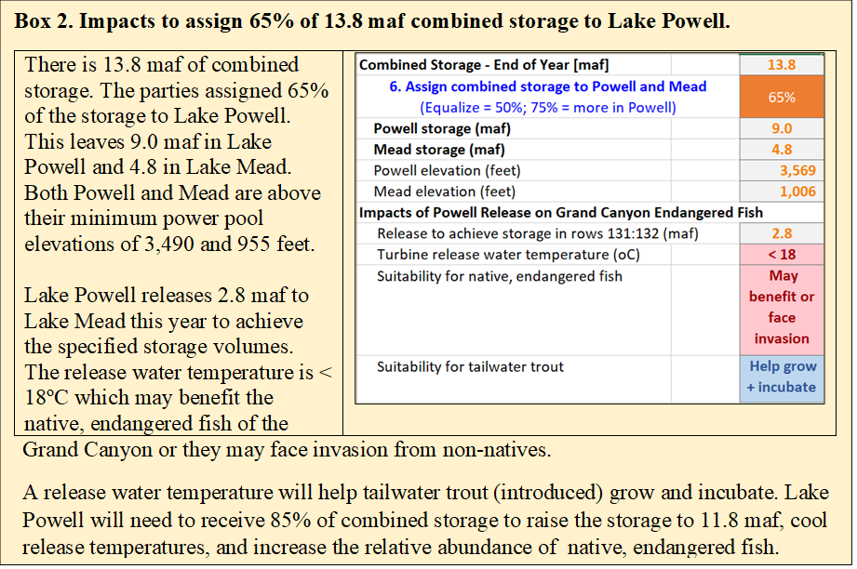

## 7A. Consider four issues to split the combined storage between the two reservoirs:

### (i) Preserve status quo for endangered, native fish of the Grand Canyon

As Lake Powell water storage drops to the turbine release elevation of 3,490 feet (4 maf), the water stored in Lake Powell heats (less stratification), increases release water temperature through the hydropower turbines, and increases uncertainty in outcome for endangered, native fish of the Grand Canyon. The endangered, native fish become more susceptible to prey by non-native fish (Figure 10, left). Higher Lake Powell levels and colder water releases preserve the status quo. Table 9 summarizes the important Lake Powell elevation break points for fish. To delay these negative impacts on fish, managers can forego release and hydropower generation through the turbines and instead release water through the low elevation river outlets (elevation 3,370 feet; 0 maf; Figure 11). For example, an 18oC release through the river outlets requires 5.9 maf less storage than an 18oC release through hydropower turbines (elevation 3,600 feet on Figure 11 left plot compared to 3,525 feet on right plot). This information is also presented on the *PowellReleaseTemperature* worksheet.

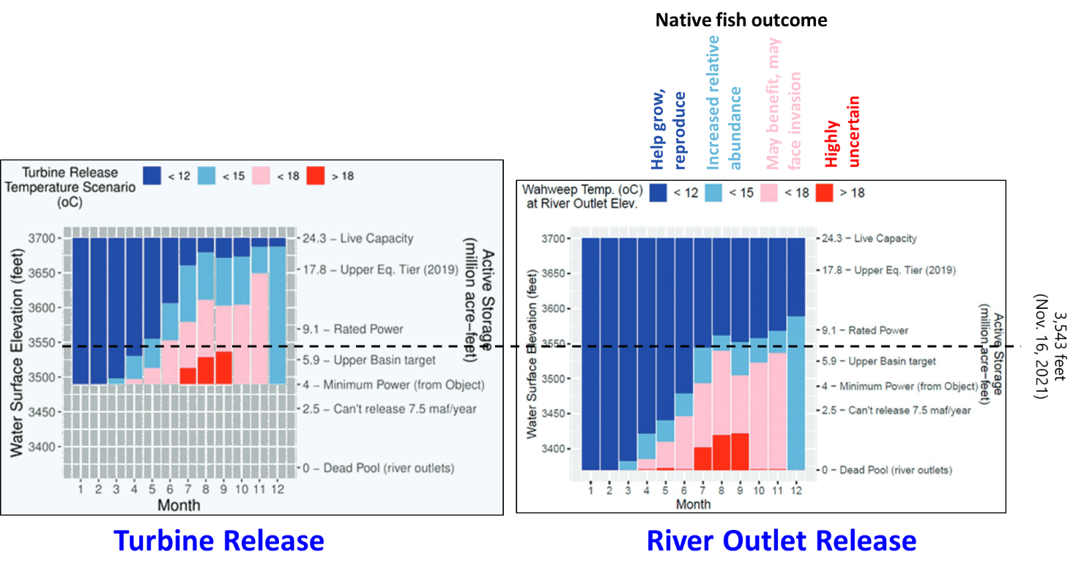

**Figure 10. Lake Powell release water temperatures through the hydropower turbines (elevation 3,490 feet; left) and river outlets (elevation 3,370 feet; right) for different water surface elevations (Wheeler et al., 2021). Dashed black line represents Nov 16, 2021 storage.**

**Table 9. Effects of Summer Lake Powell Elevation on Fish**

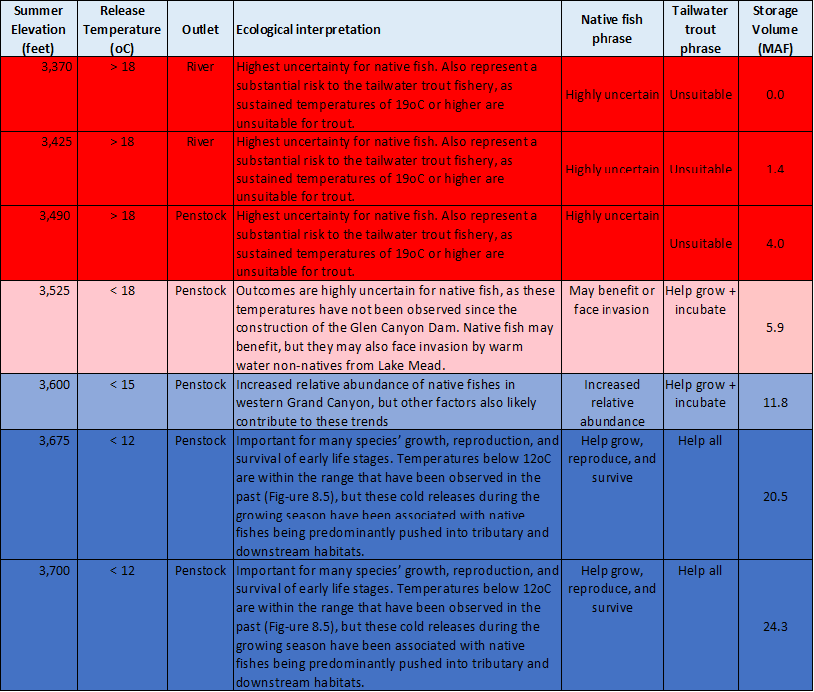

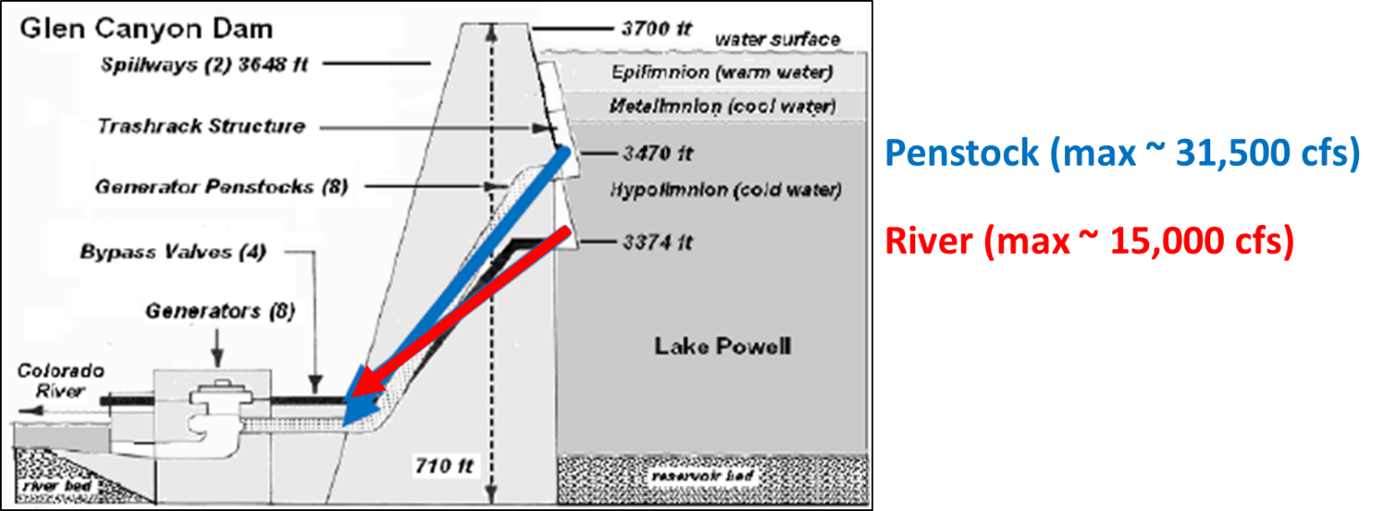

Figure 11. Glen Canyon Dam river outlets (red) are ~ 100 feet below the penstocks (blue)

### (ii) Reduce Hydropower Generation

Reduced water surface elevation reduces hydropower generation and speeds the time that reservoirs reach their minimum power pools (elevations 3,490 and 955 feet in Lake Powell and Lake Mead) where the reservoirs can no longer generate energy. When energy generation declines, Lake Powell and Lake Mead energy customers must go on the spot energy market to purchase the energy shortfall. The model of Colorado River basin accounts does not quantify the impacts of reduced hydropower generation.

### (iii) Reduce evaporation loss

The combined evaporated volume changes less than 0.12 maf to preferentially store water in Lake Mead or Lake Powell (Figure 12, red numbers). These volumes are inside the margin of error of the evaporated volumes (Figure 12, black bars) calculated from the evaporation rates (Section 1Bi). This analysis suggests there is no water supply or evaporation benefit to preferentially store combined storage in Lake Powell or Lake Mead.

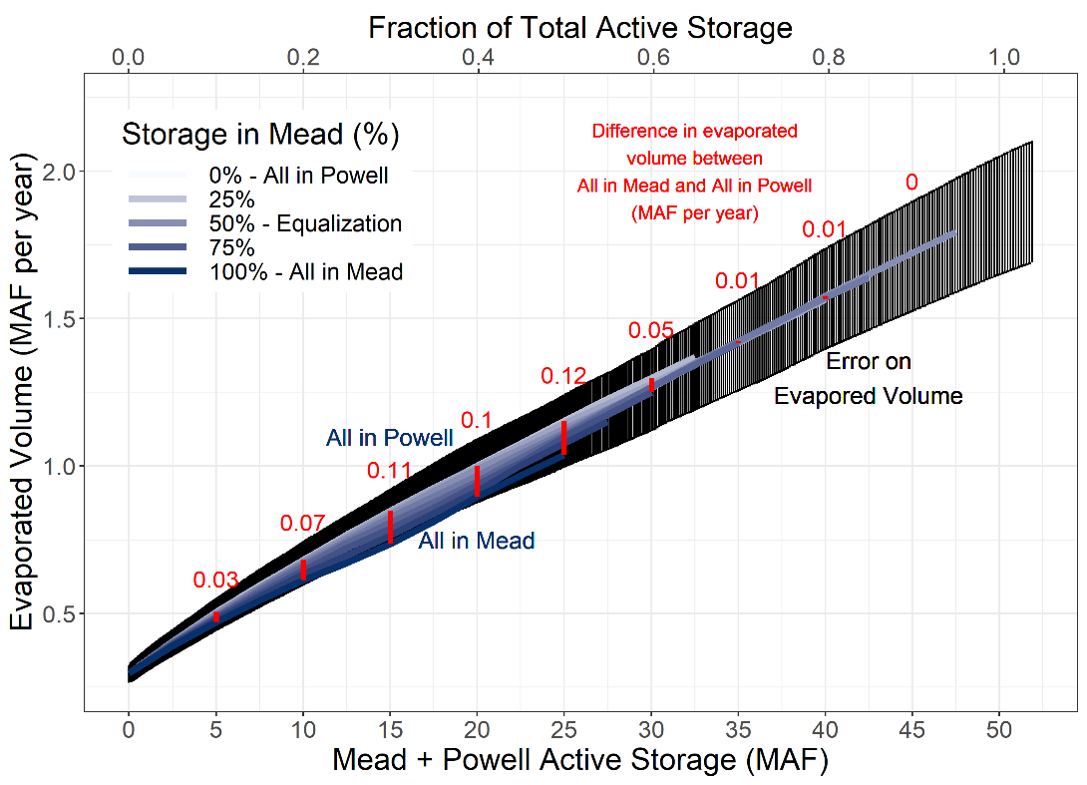

**Figure 12. Combined evaporated volume changes little (red numbers) to preferentially store water in Lake Mead or Lake Powell.**

### (iv) Current operations

Since 2007, the current operations sought to equalize storage in Lake Powell and Lake Mead (enter 50%)(USBR, 2007). Prior to 2007, managers kept more storage in Lake Mead (Figure 13).

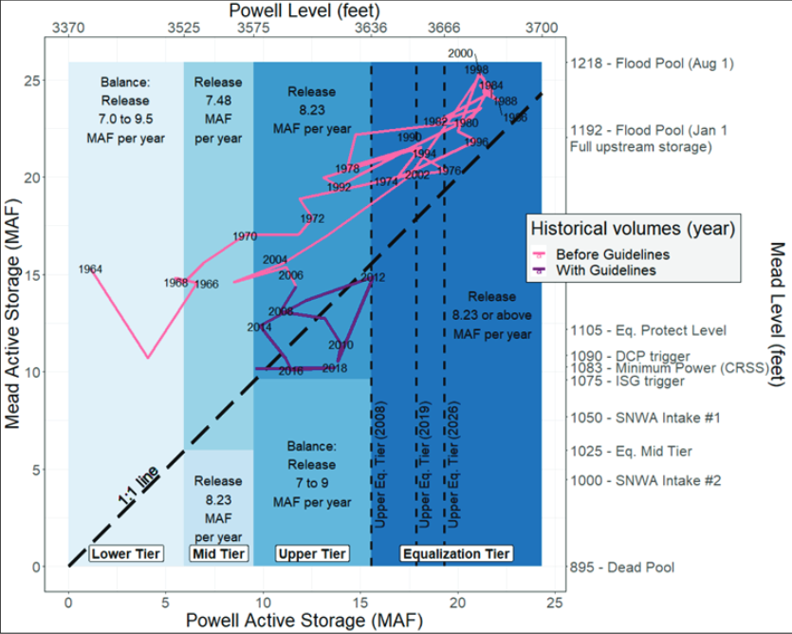

**Figure 13. Lake Powell-Lake Mead coordination rules (blue fill) and historical lake levels before and after the 2007 interim guidelines (pink and purple lines)(Wheeler et al., 2019).**

# Step 8. Move to next year

Move to next year. Move to Step 2 Specify natural inflow to Lake Powell in the next year (next column). Repeat Steps 2 to 7 for each year.

The purpose of the Colorado River basin accounts activity is to provoke thought and discussion about new Lake Powell and Lake Mead operations. So continue to play years so long as the discussion provokes new insights.

# Step 9. Finish

Congratulations. You finished! If you wish to provide feedback – things you liked, things to improve – please send an email to david.rosenberg@usu.edu.

# Data, Model, and Code Availability

The data, code, and directions to generate figures in this post are available on Github.com at Rosenberg (2021b).

# Requested Citation

David E. Rosenberg (2021). "Model Guide: Colorado River Basin Accounts." Utah State University. <https://github.com/dzeke/ColoradoRiverCoding/tree/main/ModelMusings>.

# Appendix 1. Summary of Current Colorado River Operations

The Colorado River basin has a long history. The parties do not get along. There is much written material. This appendix summarizes key pieces and provides links to the actual documents:

1. [**Map**](https://www.usbr.gov/lc/images/maps/CRBSmap.jpg) shows Upper Basin, Lower Basin, Glen Canyon Dam/Lake Powell, Hoover Dam/Lake Mead, and diversions inside and outside the hydrologic basin (USBR, 2012).
2. **Compacts, treaties, and agreements** in 1922, 1928, 1944, 1956, 1964, and 1968 -- <https://www.usbr.gov/lc/region/g1000/lawofrvr.html>.
3. **2007 Interim Guidelines**. Lower Basin states increase mandatory conservation as Lake Mead level falls from 1,075 to 1,025 feet; Intentionally created surplus (aka conservation) accounts in Lake Mead for Lower Basin states (Section 3); Equalize storage in Lake Powell and Lake Mead (Section 6). <https://www.usbr.gov/lc/region/programs/strategies/RecordofDecision.pdf>.
4. **2012 and 2017. Minutes 319 and 323 to the 1944 US-Mexico Treaty**. Mexico increases mandatory conservation as Lake Mead’s level falls from 1,090 to 1,025 feet. <https://www.ibwc.gov/Treaties_Minutes/Minutes.html>.
5. **2018 Ten Tribes Partnership Water Study.** Quantified 2.0 million acre-feet (maf) rights in Upper and Lower Basins and 0.8 maf claims. https://www.usbr.gov/lc/region/programs/crbstudy/tws/finalreport.html.
6. **2019 Upper Basin Drought Contingency Plan.** Protect Lake Powell elevation of 3,525 feet (5.9 maf). Prevent Lake Powell to fall to minimum power pool elevation of 3,490 feet (4.0 maf). https://www.usbr.gov/dcp/finaldocs.html.
7. **2019 Lower Basin Drought Contingency Plan.** Increase mandatory conservation targets as Lake Mead’s level falls from 1,090 feet to 1,025 feet. See current mandatory conservation schedule in (Castle and Fleck, 2019). Protect Lake Mead from falling below elevation 1,020 feet. <https://www.usbr.gov/dcp/finaldocs.html>.
8. **2021 Lower Basin 500 Plus Plan.** The Lower Basin states and Federal government agree to pay $200 million to conserve 0.5 maf each year for two years (Allhands, 2021).
9. **2026.** **Interim Guidelines and Drought Contingency Plans expire.**
10. **Castle and Fleck (2019)**:
    1. Summarize current Colorado River operations in more detail than Items #1-9.
    2. Describe what happens when the Upper Basin is unable to deliver 8.23 million acre-feet (maf) of water per year to Lower Basin as required in the 1922 Compact and 1944 US-Mexico Treaty.
11. **Kuhn and Fleck (2019)** give a well written history of Colorado River management. Read this piece for fun or to go in depth on a particular piece of management.

# References

Allhands, J. (2021). "It could take at least 500,000 acre-feet of water a year to keep Lake Mead from tanking." *Arizona Republic*, November 8, 2021. <https://www.azcentral.com/story/opinion/op-ed/joannaallhands/2021/11/08/lake-mead-could-get-extra-water-from-lower-basin-annually/6306601001/>.

Castle, A., and Fleck, J. (2019). "The Risk of Curtailment under the Colorado River Compact." *SSRN eLibrary*. <http://dx.doi.org/10.2139/ssrn.3483654>.

Colorado River Compact. (1922). <https://www.usbr.gov/lc/region/pao/pdfiles/crcompct.pdf> [Accessed on: October 5, 2021].

IBWC. (2021). "Minutes between the United States and Mexican Sections of the IBWC." United States Section, <https://www.ibwc.gov/Treaties_Minutes/Minutes.html> [Accessed on: July 22, 2021].

Kuhn, E., and Fleck, J. (2019). *Science Be Dammed: How Ignoring Inconvenient Science Drained the Colorado River*, University of Arizona Press.

Leeflang, B. (2021). "Colorado River Coding: Pre 1922 Compact Water Use." <https://doi.org/10.5281/zenodo.5501466>.

Meko, D., Bigio, E., and Woodhouse, C. A. (2017). "Colorado River at Lees Ferry, CO River (Updated Skill)." *Treeflow*. <https://www.treeflow.info/content/upper-colorado#field-ms-calibration-validation>.

Moreo, M. T. (2015). "Evaporation data from Lake Mead and Lake Mohave, Nevada and Arizona, March 2010 through April 2015." U.S. Geological Survey Data Release. <http://dx.doi.org/10.5066/F79C6VG3>.

Prairie, J. (2020). "Colorado River Basin Natural Flow and Salt Data." U.S. Bureau of Reclamation. <https://www.usbr.gov/lc/region/g4000/NaturalFlow/current.html>.

Rosenberg, D. E. (2021a). "Colorado River Coding: Grand Canyon Intervening Flow." GrandCanyonInterveningFlow folder, <https://doi.org/10.5281/zenodo.5501466>.

Rosenberg, D. E. (2021b). "Colorado River Coding: Intentionally Created Surplus for Lake Mead: Current Accounts and Next Steps." ICS folder, <https://doi.org/10.5281/zenodo.5501466>.

Rosenberg, D. E. (2021c). "Invest in Farm Water Conservation to Curtail Buy and Dry." *Submitted to Journal of Water Resources Planning and Management*, 3. <https://digitalcommons.usu.edu/water_pubs/169/>.

Rosenberg, D. E. (In press). "Adapt Lake Mead releases to inflow to give managers more flexibility to slow reservoir draw down." *Journal of Water Resources Planning and Management*, 10. <https://digitalcommons.usu.edu/water_pubs/170/>.

Salehabadi, H., Tarboton, D., Kuhn, E., Udall, B., Wheeler, K., E.Rosenberg, D., Goeking, S., and Schmidt, J. C. (2020). "Stream flow and Losses of the Colorado River in the Southern Colorado Plateau." Center for Colorado River Studies, Utah State University, Logan, Utah. <https://qcnr.usu.edu/coloradoriver/files/WhitePaper4.pdf>.

Schmidt, J. C., Kraft, M., Tuzlak, D., and Walker, A. (2016). "Fill Mead First: a technical assessment." Utah State University, Logan, Utah. <https://qcnr.usu.edu/wats/colorado_river_studies/files/documents/Fill_Mead_First_Analysis.pdf>.

Ten Tribes Partnership. (2018). "Colorado River Basin Ten Tribes Partnership Tribal Water Study." U.S. Department of the Interior, Bureau of Reclamation, Ten Tribes Partnership. <https://www.usbr.gov/lc/region/programs/crbstudy/tws/finalreport.html>.

USBR. (2007). "Record of Decision: Colorado River Interim Guidelines for Lower Basin Shortages and Coordinated Operations for Lakes Powell and Mead." U.S. Bureau of Reclamation. <https://www.usbr.gov/lc/region/programs/strategies/RecordofDecision.pdf>.

USBR. (2012). "Colorado River Basin Water Supply and Demand Study." U.S. Department of Interior, Bureau of Reclamation, Washington, D.C., <https://www.usbr.gov/lc/region/programs/crbstudy.html>.

USBR. (2019). "Agreement Concerning Colorado River Drought Contingency Management and Operations." U.S. Bureau of Reclamation, Washington, DC. <https://www.usbr.gov/ColoradoRiverBasin/dcp/index.html>.

USBR. (2020). "Review of the Colorado River Interim Guidelines for Lower Basin Shortages and Coordinated Operations for Lake Powell and Lake Mead." U.S. Bureau of Reclamation, U.S. Department of Interior. <https://www.usbr.gov/ColoradoRiverBasin/documents/7.D.Review_FinalReport_12-18-2020.pdf>.

USBR. (2021a). "21st Century Colorado River: Hydrology and Risk of Lake Mead Reaching Critically Low Elevations." U.S. Bureau of Reclamation. <https://github.com/dzeke/ColoradoRiverCoding/raw/main/500PlusPlan/MeadRisk-LBActionsWebianr11-5-21.pdf>.

USBR. (2021b). "Boulder Canyon Operations Office - Program and Activities: Water Accounting Reports." U.S. Bureau of Reclamation. <https://www.usbr.gov/lc/region/g4000/wtracct.html>.

USBR. (2021c). "Glen Canyon Dam, Current Status, Lake Powell Inflow Forecast." U.S. Bureau of Reclamation. <https://www.usbr.gov/uc/water/crsp/cs/gcd.html>.

USBR. (2021d). "Lake Mead at Hoover Dam, End of Month Elevation." Lower Colorado River Operations, U.S. Buruea of Reclamation, <https://www.usbr.gov/lc/region/g4000/hourly/mead-elv.html> [Accessed on: October 5, 2021].

USBR. (2021e). "Lake Powell Unregulated Inflow." <https://www.usbr.gov/uc/water/crsp/studies/images/PowellForecast.png> [Accessed on: September 28, 2021].

USGS. (2016). "Colorado River Basin map." U.S. Geological Survey. <https://www.usgs.gov/media/images/colorado-river-basin-map>.

Wheeler, K., Kuhn, E., Bruckerhoff, L., Udall, B., Wang, J., Gilbert, L., Goeking, S., Kasprak, A., Mihalevich, B., Neilson, B., Salehabadi, H., and Schmidt, J. C. (2021). "Alternative Management Paradigms for the Future of the Colorado and Green Rivers." Center for Colorado River Studies, Utah State University, Logan, Utah. <https://qcnr.usu.edu/coloradoriver/files/WhitePaper_6.pdf>.

Wheeler, K. G., Schmidt, J. C., and Rosenberg, D. E. (2019). "Water Resource Modelling of the Colorado River – Present and Future Strategies." Center for Colorado River Studies, Utah State University, Logan, Utah. <https://qcnr.usu.edu/coloradoriver/files/news/White-Paper-2.pdf>.

Zagona, E. A., Fulp, T. J., Shane, R., Magee, T., and Goranflo, H. M. (2001). "Riverware: A Generalized Tool for Complex Reservoir System Modeling." *JAWRA Journal of the American Water Resources Association*, 37(4), 913-929. <https://doi.org/10.1111/j.1752-1688.2001.tb05522.x>.