The Lake Mead Water Conservation Program: Managing Risks of Declining Flows Through Autonomy and Adaptation.

David Rosenberg, Brittany Fager, Erik Porse
May 22, 2026

Summary
The Lake Mead water conservation program has successfully reduced Colorado River water use since its inception in 2007. Yet, the system is largely based on a promise of future deliveries when storage increases. How can the program stabilize and recover reservoir storage under conditions of low storage and low inflow that may persist for extended periods with the basin becoming more arid. Both suggestions switch accounting from reductions of historical entitlements to allocations aligned with annual available water. Our analysis shows that such changes could stabilize and potentially recover Lake Mead storage under conditions of low storage and low inflow, while also increasing the autonomy of water users to manage risks of water shortages.

Introduction
Drawdown of reservoirs across the western United States and uncertainty in future water supply put agricultural users, urban users, Tribal Nations, and ecosystems at risk of water shortages (Jasechko and Perrone, 2021). Communities with varied access to water supply sources, capital, and information face different levels of vulnerability to shortages(Allaire and Acquah, 2022; Cutter et al., 2003; Cutter et al., 2000; Meehan et al., 2020; Mileti, 1999; Pace et al., 2022; Thomas et al., 2019; Wakhungu et al., 2021). Goals of systemwide managers to protect critical reservoir elevations can conflict with goals of users to sustain continued deliveries. User, Tribal, and ecosystem goals can also conflict, especially in times of water scarcity (Hecht et al., 2020; Hegwood et al., 2022; Rosenberg, 2024). In river basins facing future increases in aridity, water managers are challenged to increase user autonomy to manage their risk of water shortages. One user strategy to increase autonomy is to conserve water in reservoirs and allow users to later withdraw their water when flows may be lower.
Within the Colorado River Basin, the voluntary Lake Mead water conservation program is the most successful and adaptive component of present Colorado River operations. The existing program allows Arizona, California, and Nevada water users to voluntarily reduce consumption from their legal entitlements, keep the conserved water in Lake Mead, and withdraw conserved water at a future point in time subject to some constraints. The program was created as part of the 2007 Interim Guidelines (e.g., USBR, 2007b) and expanded in the 2019 Lower Basin Drought Contingency Plan (USBR, 2019). The program is typically called Intentionally Created Surplus (ICS). In addition to ICS, due to continued reservoir declines, additional Lake Mead water use reduction program requires Arizona, Nevada, and California to receive deliveries lower than historical entitlements as Lake Mead draws down (Kuhn and Fleck, 2019; USBR, 2007a; USBR, 2019). Minutes 319 and 323 to the 1944 United States - Mexico treaty set up similar voluntary water conservation mandatory shortage programs for Mexico (IBWC, 2021).
Grant (2007) wrote that the Lake Mead water conservation program was the “most imaginative” part of the 2007 Interim Guidelines and that the program will increase water supply or make supply more productive. Program participation amended the operating principle of "use it or lose it" common to laws that govern water use in many western states. Such practices do not incentivize conservation. If a contractor uses less than their legal entitlement of water deliveries, the state could potentially reclaim the allocation and assign the water right to a different use.
The ICS program had modest activities through 2015. New strategies to promote higher levels of engagement and conservation have been proposed to raise caps on credits and debits Robison (2017) Fleck and Castle (2022). Stelter (2022) suggested Utah adopt the same voluntary water conservation program using Flaming Gorge as the reservoir. Colby et al. (2025) suggested to assign up to 50% of conserved water to remain in Lake Mead as system water to create a balance of individual and collective resiliency. Huizar et al. (2023) reported difficulty to predict and model state’s water conservation choices. Rosenberg (2024) proposed and tested water accounts in a combined Lake Powell-Lake Mead system. Recently, the U.S. Bureau of Reclamation (Reclamation) proposed several ways to improve the program (now called Storage and Delivery) beginning in 2027 (USBR, 2026). One option is to remove gaming between the voluntary water conservation and mandatory water shortage programs by tying mandatory shortages to the anticipated Lake Mead level if there was no voluntary activity (colloquially called “operational neutrality”). A second suggestion can move voluntarily conserved water upstream to Lake Powell to increase operational flexibility.
The voluntary Lake Mead water conservation program operates with the assumption that the annual Lake Mead inflow minus reservoir evaporation—the annual physically available water—exceeds legal entitlements. This assumption is challenged as the Colorado River Basin becomes more arid (Salehabadi et al., 2022; Salehabadi et al., 2024; Udall and Overpeck, 2017). At the 20th anniversary of the creation of the Lake Mead Water Conservation Program and ICS, there is a need to ask if the program’s underlying assumptions are valid and sustainable. To address this knowledge gap, in this analysis, we ask and answer the following questions:
- How much water has the program conserved since its inception and how much as remained in Lake Mead?
- What, if any other successes are associated with the program?
- What challenges does the program face as the Colorado River Basin becomes more arid?
- Can policies promote actions by users to conserve water and what is the role of user autonomy in managing and mitigating potential conflicting risks of water shortages?
This article provides an overview of the program and analyzes its operations to date and capacity for future success. The analysis is broken into four sections. First, we provide definitions and examples of Lake Mead water conservation program activities (Section 2). Next, we share program successes and challenges (Sections 3 and 4). Finally, we share strategies to increase user autonomy to manage risk with declining flows (Section 5). The strategies switch basin wide accounting structures for tracking water from reductions of historical entitlements to allocations based on reservoir inflow. These changes can help stabilize and potentially recover Lake Mead storage under conditions of low storage and low inflow.

Definitions and Example Program Activities
Box 1. Definitions
Legal entitlements - The 4.4, 2.8, 0.3, and 1.5 million acre-feet per year volumes of water allocated to California, Arizona, Nevada, and Mexico under current Colorado River operations.
Water conservation - The voluntary and temporary reduction in water use from a historical allocation at one place at one point in time coupled with an increase in water use at the same place at a future point in time (or another location at the same or future point in time).
Water conservation account credit - The volume of water conserved and left in Lake Mead.
Water conservation account debit - The volume of water withdrawn, diverted, and consumed above a legal entitlement.
Water conservation account balance - The sum of all credits minus all debits from 2007 to present.
Reservoir protection level - The reservoir active storage volume (or elevation) set to provide a buffer against reservoir drawdown to the minimum power pool. The present Lake Mead protection elevation is 1,020 feet which is 5.9 million acre-feet of active storage above the minimum power pool elevation of 955 feet.
Prohibition on program debits - The reservoir volume or elevation trigger below which water conservation program debits are prohibited. This trigger elevation has the purpose to prevent reservoir drawdown below the protection elevation. Presently, the trigger elevation is 1,025 feet.
Mandatory water use reduction – The volume of water a Lower Basin user or Mexico must reduce use below their historical entitlement. This volume is also referred to as a shortage. Shortages increase as Lake Mead draws down from elevation 1,090 feet towards 1,020 feet.
The existing voluntary Lake Mead water conservation program activities can be considered as reservoir withdraws below or above historical allocations (credits and debits; Box 1; Examples 1 and 2). A water user (i) has an annual account credit (A_{i}) of:
$A_{i}=max\left(E_{i}- D_{i}, 0\right), ∀i$ [Eq. 1]
Where E_{i} and D_{i} are user i’s annual legal entitlement and consumptive use (maf).
Example 1. Water conservation account credit. At the beginning of 2018, Arizona had a water conservation account balance of 126,800 acre-feet. In 2018, Arizona withdrew, diverted, and consumed 2.484 million acre-feet—216,000 acre-feet less than its historical allocation of 2.8 million acre-feet. As a result, Arizona's water conservation account was credited 216,000 acre-feet. At the end of 2018, Arizona's conservation account balance was 343,000 acre-feet (126,800 + 216,000 acre-feet). Arizona’s water conservation action raised Lake Mead's volume 216,000 acre-feet above the anticipated volume—the surplus in "Intentionally Created Surplus"—had Arizona withdrawn, diverted and consumed its historical allocation.
Example 2. Water conservation account debit. At the beginning of 2022, California had a water conservation account balance of 1.36 million acre-feet. In 2022, California withdrew, diverted, and consumed 4.51 million acre-feet of water—111,000 acre-feet of water above its historical allocation. At the end of 2022, California had a water account balance of 1.245 million acre-feet (1.36 – 0.111 million acre-feet). Lake Mead's storage reduced 111,000 acre-feet from the anticipated volume had California withdrawn its historical allocation.
Program structure. The program limits credits and debits each year. The program also set maximum water conservation account balances for the three Lower Basin states. The program also prohibits debits—withdraw above legal entitlements—when Lake Mead storage is at or below 6.0 million acre-feet (reservoir elevation of 1,025 feet). The program assesses a 5% reduction in the first year to cover increased reservoir evaporation associated with a higher Lake Mead level and surface area. The program assesses a 3% reduction in subsequent years.
Interactions with the mandatory Lake Mead water shortage program. Introduced in the Interim Guidelines and expanded in the Lower Basin Drought Contingency Plan, mandatory water shortages increase as Lake Mead’s level declines from an elevation of 1,090 to 1,020 feet (Kuhn and Fleck, 2019; USBR, 2007a; USBR, 2019). Nonetheless, the 2019 DCP allows states and contractors to debit their voluntary water conservation account balances to meet their mandatory reductions in water use. This transfer is an administrative action and does not change Lake Mead level. Recently, the USBR (2026) proposed to exclude mandatory reductions (M_{i} [million acre-feet per year]) from the calculation of voluntary credits (Eq. 2).
$A_{i}=max\left(E_{i}-M_{i}- D_{i}, 0\right), ∀i$ [Eq. 2]
Here, A, E, and D are defined previously in Eq. 1.
We draw and report annual data on water conservation account balances, credits, and debits from Reclamation’s water accounting reports {USBR, 2026 #2772}. The data span the period 2007 to 2025.

Program Successes
- Since 2007, the Lower Basin states have collectively conserved and credited 4.4 million acre-feet of water (Figure 1).
- Of those credits, 3.6 million acre-feet of water remain in Lake Mead (Figure 2).
- Each state holds account balances of between 0.7 (Arizona) to 1.7 (California) million acre-feet (Figure 2).
- Account balances are often significant by comparison to consumptive use. For example, Nevada's 2024 water conservation account balance of 954,000 acre-feet is almost 5 times its recent consumptive use of near 200,000 acre-feet per year.
- Total conserved water has grown since 2016 (Figure 2).
- Participation has exceeded the upper limits for credits allowed by the Interim Guidelines (Figure 2). This excess shows the program has grown beyond the expectations of the designers of the program.
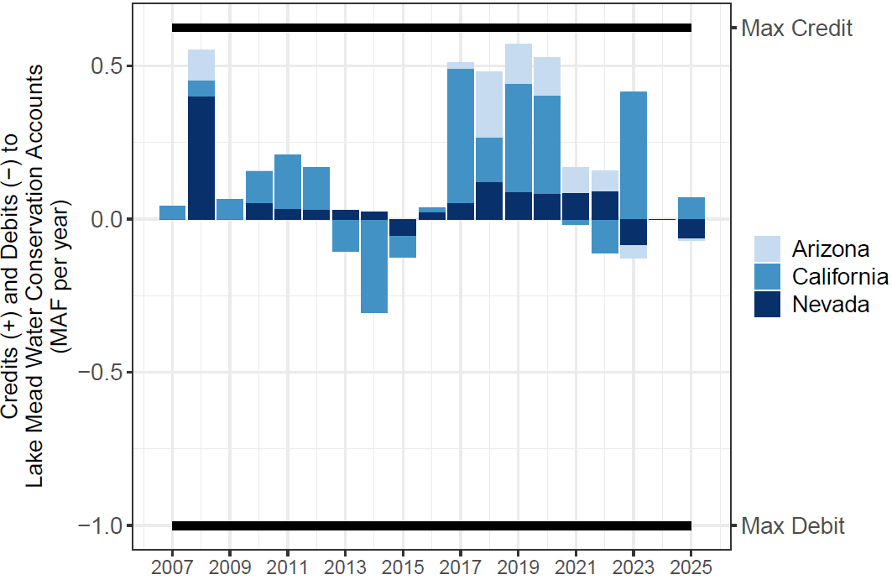
Figure 1. Lake Mead water conservation account annual credits and debits.

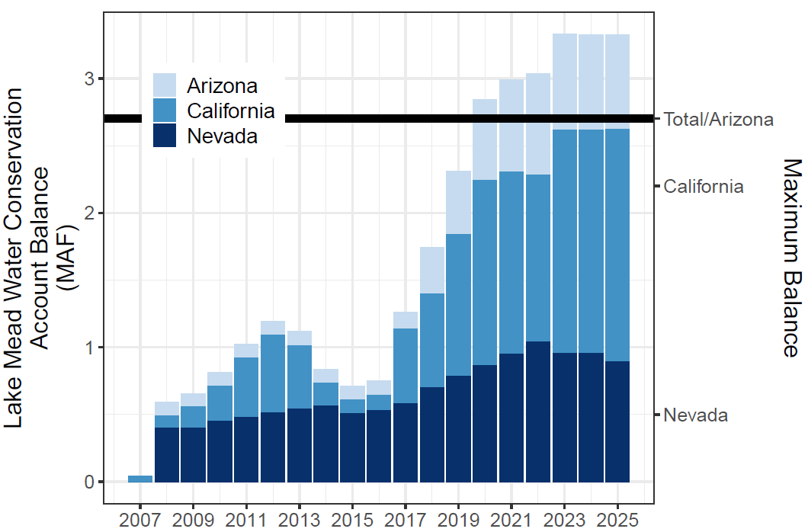
Figure 2. Lake Mead water conservation account balances.

- Mexico has conserved and credited 0.3 million acre-feet of water of which 0.24 million acre-feet remain in Lake Mead.
- The program has conserved more water than other voluntary, compensated, or mandatory Colorado River Basin water conservation program (Table 1; Allhands, 2021; UCRC, 2018; UCRC, 2024; USBR, 2021a; USBR, 2021b)

Table 1. Colorado River Basin water conservation programs and accomplishments.
- States have some additional autonomy for reservoir withdraws and to manage vulnerability independent of other states activities. This autonomy reduces conflict.
- Since 2022, the water conservation program has kept Lake Mead’s storage above the 5.9 million-acre feet protection volume (elevation 1,020 feet) defined in the Lower Basin Drought Contingency Plan (Figure 3).

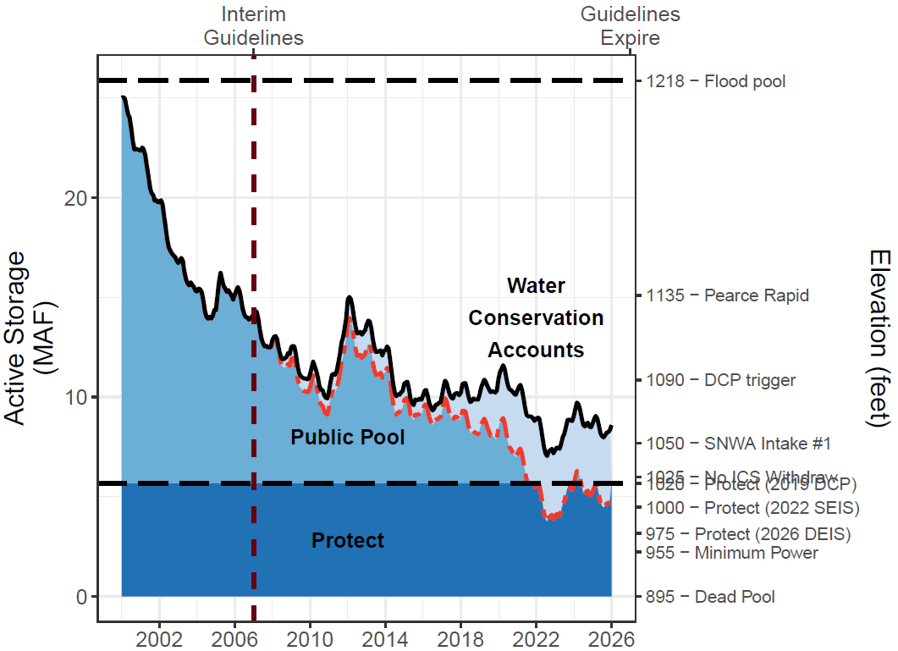
Figure 3. Lake Mead storage (solid black line), water conservation account balances (light blue fill), and anticipated lake volume absent the water conservation program (dashed red line). Since 2022, the conservation program has kept Lake Mead level above elevation 1,020 feet (5.9 million acre-feet).

Program Challenges
Despite successes, there are challenges to motivating users to continue to conserve water and leave that water in Lake Mead, as well as with accessing conserved water as inflow and reservoir storage decline.
Reservoirs can draw down quickly. States and contractors conserved water with the understanding that this water would be accessible for withdrawal in the future. With multiple years of debits, Lake Mead can drawdown close to the protection elevation in a few years. Within the current conservation framework, Lower Basin states and Mexico loaned the Colorado River system 3.6 million acre-feet of water, which some or all they may want to recover in the future. Once the users perceive that Lake Mead will drawdown close to the protection volume, they may race to debit their water conservation account balances to access their conserved water in the absence of systemwide goals.
Motivating additional voluntary water conservation is challenging. As reservoir storage draws down to the protection volume, states and contractors face increasing difficulty to access and debit their conserved water. Their prior conserved water becomes a stranded asset. This challenge can also spur conflicts if:

  - Multiple states simultaneously withdraw conserved storage, which results in Lake Mead dropping below its protection elevation. States would need to agree on lower debits that keep Lake Mead at or above the protection elevation.
  - One state seeks to pull storage from the reservoir that creates a debit on their account and decreases Lake Mead storage towards the protection volume. This activity prevents other states in future years from drawing on water in their accounts.
  - Other states and users take counter measures to increase their ability to access conserved water with the undesired effect to further draw down Laken Mead.

Tribal, environmental, and municipal water needs are not explicitly included. The Lake Mead water conservation program is built on legal entitlements to states, which were developed at a time that did not include key water needs that we recognize in the 21st Century. These needs include water for Tribal Nations, aquatic, and wetland habitat. Counter-intuitively, Lake Mead storage above an elevation of 1,135 feet, will submerge the Pearce Rapid and allow invasive fish in the reservoir to swim upstream to the detriment of native fish in Grand Canyon. There is ongoing debate about what is the minimum volume of supply for municipal use, health, and safety.
Reservoir inflows are not considered in conservation accounting. The voluntary water conservation program functions under the assumption that the annual Lake Mead inflow minus evaporation—the annual physically available water—exceeds the sum of legal entitlements of 9.0 million acre-feet per year. When this assumption is false, Lake Mead will draw down even as states credit their water conservation accounts. Essentially, states got credit for water conservation activity even though the physical water never entered the reservoir. There are two cases when the assumption is valid and invalid (Figure 4).

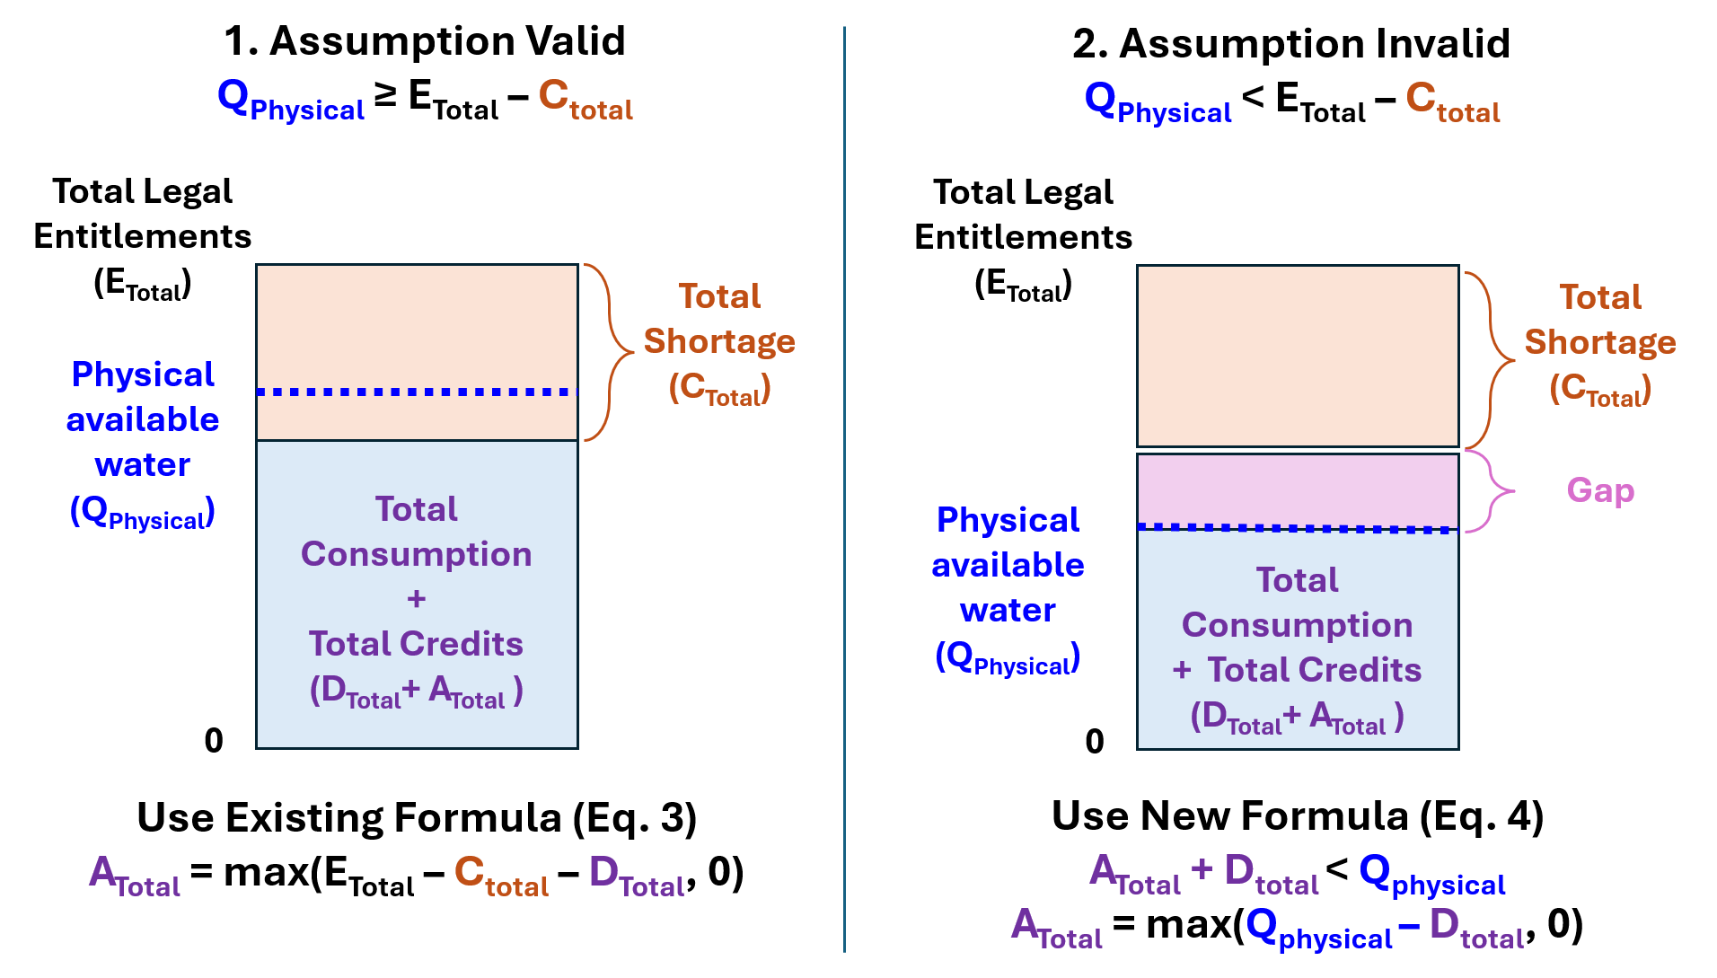
Figure 4. Conceptual models showing when the assumption that Physically Available Water (Q_{physical}) exceeds Total Legal Entitlements minus Total Shortage (E_{Total} – C_{Total}) is valid (Case 1, left) or invalid (Case 2, right). In Case #2, there is a gap between Total Legal Entitlements and the Physical Available Water that the Total Shortage does not fill.

The two cases can also be more precisely described mathematically. Summing Eq. 2 over all users gives:
$A_{Total}=max\left(E_{Total}-M_{Total}- D_{Total}, 0\right)$ [Eq. 3]

In case 1, the annual Physically Available Water (Q_{Physical} [million acre-feet per year]) exceeds Total Legal Entitlements minus Total Mandatory Shortages (Q_{Physical} ≥ E_{Total} $-$ M_{Total}). In this case [E_{Total} $-$ M_{Total} $-$ D_{Total}] is positive and max([a positive number], 0) is that positive number. Thus, full credits A_{Total} are correctly awarded (Eq 3; Fig. 4, Case #1).

However, in a Case #2 when the annual Physically Available Water is less than the Total Legal Entitlements minus Total Mandatory Cuts (Q_{Physical} < E_{Total} $-$ C_{Total}), there is a gap between the Total Legal Entitlements and Physically Available Water that the Total Mandatory Cuts do not fill (Figure 4, Case #2). In this case, Eq. 3 will incorrectly award credits A_{Total} because there was insufficient reservoir inflow.

We estimate that 0.8 million acre-feet of the total 4.4 million acre-feet of voluntary Lake Mead water conservation program activity through 2024 were credited even though sufficient water did not flow into Lake Mead (Figure 5).
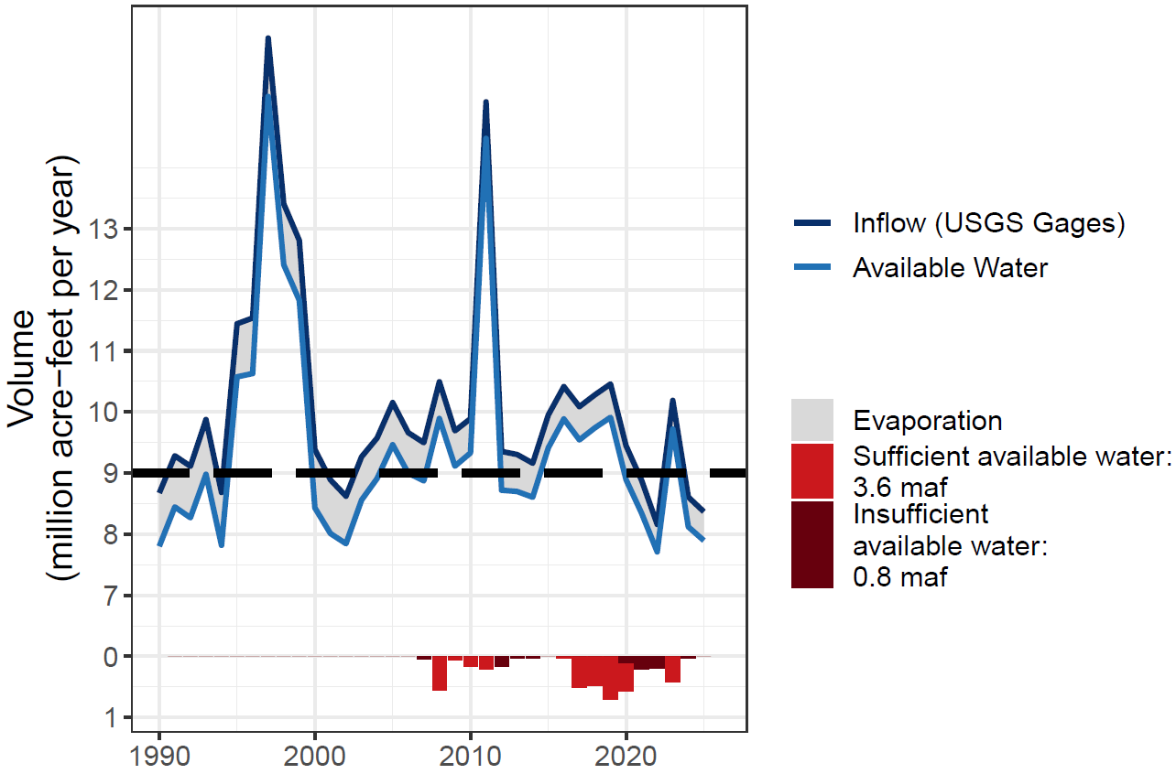
Figure 5. Annual Lake Mead inflow, evaporation, physically available water, and conservation credits in relation to total legal entitlements of 9.0 million acre-feet.

Conditions where the physically available water is less that total legal entitlements will increasingly occur as future Colorado River flows become more volatile and risk of reservoir level declines increase (Table 2). For example, with a Lake Powell release of 7.0 million acre-feet per year, mandatory shortages must exceed 1.5 maf per year for there to be sufficient physically available water to award all requested credits. When the Lake Powell release is 6 million acre-feet as in Water Year 2025-2026, mandatory shortages must exceed 2.6 maf per year.

Table 2. Conditions of Lake Powell releases and Lower Basin shortages where there is sufficient physically available water to award all requested credits. When there is insufficient water, the gap is calculated. All columns million acre-feet per year.

Strategies to Motivate Conservation and Increase Autonomy of Users
There are numerous ways to structure factors that drive long-term stable reservoir levels and hydrologic balances within a water allocation program to promote conservation. Accurately representing the potential futures of reservoir inflow, evaporation, current storage, withdraws, prohibitions on debits, and protected storage volume is critical to managing future risks. There are numerous ways to design and motivate voluntary, uncompensated water conservation. First, USBR can raise the elevation trigger that prohibits debits on water conservation accounts. This would preserve more water in storage by preventing deliveries of unavailable water. Second, USBR can set a storage trigger that requires mandatory water use reductions to the anticipated Lake Mead storage volume if there was no voluntary water conservation activity (i.e., the dashed red line in Figure 4)(City of Phoenix, 2024; Pitt et al., 2024; USBR, 2026). Third, updated policies can allow Tribal users to participate. Finally, new operational policies that split conserved water between Lake Powell and Lake Mead can provide more flexibility in operations to sustain ecosystems in Grand Canyon, or create a system pool to be managed by Reclamation (Rosenberg, 2023; Rosenberg, 2024; USBR, 2026).
Here we describe two novel program improvements that motivate water conservation behavior while give users more autonomy to manage their risks of water shortages in the face of aridity. Both strategies switch the conservation accounting from reductions from historical entitlements to reductions from the annual physically available water.
Proportional Scaling. In this strategy, we only credit water that physically flowed into the reservoir and can be stored for later release. Never allow total annual assigned credits (Atotal) and consumptive use to exceed total annual physically available water (Eq 4):

$\sum_{i}{\left(D_{i}+A_{i}\right)} ≤Q_{Physical}$ or $A_{Total}=max\left(Q_{Physical}- D_{Total}, 0\right)$ [Eq. 4]
This strategy uses a proportional scaling factor to assign each user’s credits within the physically available water (Eq. 5):

$A_{i}=max\left({E_{i}-M}_{i}- D_{Total}, 0\right)∙min\left(1, \frac{Q_{Physical}}{D_{Total}+A_{Total}}\right), ∀i$ [Eq. 5]
If total claims D_{Total} + A_{Total} ≤ Q_{Physical}, there is sufficient physically available water, the multiplier is 1, and everyone receives their full requested credits (A_{i}). If total claims exceed the physically available water, the multiplier is $\frac{Q_{Physical}}{D_{Total}+A_{Total}}$ < 1, which reduces all requested credits by a proportion. Reducing credits in this way would encourage water conservation at larger Lake Powell releases and higher Lake Mead storage (lower storages).

Water Accounting. Water accounting can… In this framework, USBR would set the protection volume in Lake Mead during time period 0 to stabilize reservoir storage (PV₀ [million acre-feet), as implemented in published studies (Myers et al., 2025). This volume defines a Reclamation water account balance. Then in each year, the Reclamation water account takes a first share of the Lake Mead inflow equal to the annual reservoir evaporation. This action sustains the protection account balance over time (Eq 6).
${PV}_{t+1}={PV}_{t}-{Evaporation}_{t}+ {Share of Inflow}_{t}$ [Eq. 6]
Lower Basin and Mexico users then divide the remaining reservoir inflow (Share of Inflow_{i} [million acre-feet per year]). Each user i consumes (and conserves) within their water account balance in each time period t (B_{i,t} [million acre-feet]); Eq. 7).
$B_{i,t+1}=B_{i,t}+ {Share of Inflow}_{i,t}-D_{i,t}, ∀i$ [Eq. 7]
Such that all account balances must be 0 or positive ($B_{i,t+1}≥0$). Users carry over any positive end-of-year account balances to the next year.

There are several additional benefits and motivators for a Lake Mead water accounting program.
- Water accounts can be created for any users or uses such as Tribal Nations or endangered species conservation programs.
- All users can withdraw some up to all of their account balance at any time and at any Lake Mead storage volume. Because each user must maintain a zero or positive account balance, the stable protection account volume prevents further draw down to critical elevations. Thus, there is no elevation trigger that prohibits debits.
- Current water conservation account balances can be rolled over to be the Year 0 water account balance. Thus, the existing Lake Mead water conservation program can be sunset.
- Water accounting gives Reclamation and water users more autonomy and flexibility to manage their differing interests and risks. For Reclamation, this is where to set the reservoir protection elevation. Reclamation does not need to consult with the other users. The other water users can more independently adapt their decisions to consume water, conserve water for future use, and trade in response to their account balances, others choices, the discussion of choices, and their perceptions—or fears—of future low flow. There can also be discussion of the (a) volumes, and (b) prices for Reclamation to purchase water from other users to raise the Lake Mead elevation—purchase volumes and prices that may change from year to year as water becomes more scarce or available.
- Sunset the existing mandatory water shortage program and water shortages tied to declining Lake Mead. If all users consume and draw down their water account balances, the protection account prevents further draw down to critical levels. Users who maintain positive account balances will keep Lake Mead storage above the protection volume.
- Without a mandatory water shortage program, there is also no need for shortage operations contingent on the anticipated reservoir level had users not conserved water (operational neutrality). Water accounting more transparently and flexibly allows use within the physically available water—reservoir inflow minus the evaporation.
- Prioritize reservoir evaporation as the highest consumptive use by allocating a first share of Lake Mead inflow to the reservoir protection account to offset reservoir evaporation. This prioritization corrects a shortfall of existing Colorado River operations that ignore reservoir evaporation.
- Water accounting can be coordinated with other proposals for Lake Powell releases. A Lake Powell release plus gains through Grand Canyon become the inflow to Lake Mead. Reclamation can then take the first share of inflow equal to Lake Mead evaporation to sustain the Lake Mead protection account balance.
There are at least 2 sticky points that come with water accounting.
- Tradeoffs. The selection of a Lake Mead protection volume creates a tradeoff between the protection account volume managed by Reclamation and the remaining reservoir storage available to other users. When a water accounting program starts, setting a lower protection volume increases the storage for other users. Setting a higher protection volume reduces the starting storage available to other users, potentially limiting the roll over of existing water conservation account balances. For example, if the accounting program started on May 16, 2026 (Lake Mead elevation 1,052.5 feet; 7.9 million acre-feet active storage) and Reclamation selected a Lake Mead protection elevation of 1,000 feet (4.5 million acre-feet of active storage), then users could only roll over 3.4 of the existing 3.6 million acre-feet in the water conservation program. Setting a protection elevation of 975 feet (3.2 maf of active storage) would allow the complete roll over of all existing conserved water with 1.1 maf of unassigned storage. This storage could be assigned to users such as Tribal Nations, who were previously excluded from participation.
- Division of Lake Mead inflow. Water accounting is neutral to if or how the Lower Basin states, Tribal Nations of the Lower Basin, and Mexico apportion the Lake Mead inflow after Reclamation takes the first share to offset reservoir evaporation. Apportionment can be done by priority, pro rata, a combination, percentage splits of shortages in the Lower Basin Alternative (Buschatzke et al., 2024), or another method. In the 4th method, a user’s share of the reservoir inflow is their historical allocation minus the agreed-on shortage volume (Appendix A). Difficult decisions about apportionment of reservoir inflow are best for negotiations as they are ultimately political choices for where, when, how much, and for which purposes to consumptively use Colorado River water. Until users reach agreement, we suggest to allocate more reservoir inflow to increase the Lake Mead protection account balance. This set up may encourage users to reach agreement so they can access water.

Conclusions
Within the Colorado River Basin, the voluntary Lake Mead water conservation programs offer users more autonomy to manage their different and sometimes conflicting risks of water shortages. In one sentence—Arizona, California, Nevada, and Mexico can voluntarily reduce use from their legal entitlements, keep the conserved water in Lake Mead, and withdraw conserved water at a future point in time subject to some constraints. Since the program inception in 2007, Lower Basin users have conserved 4.4 million acre-feet of water with 3.6 million acre-feet presently remaining in Lake Mead. These efforts kept Lake Mead storage above the protection volume through the recent (and ongoing) critically dry period. The program works on the assumption that the annual physically available water―reservoir inflow minus evaporation―exceeds legal entitlements. This assumption is challenged as the Colorado River Basin becomes more arid. As reservoir storage draws down, there is also a challenge to motivate voluntary water conservation because users face increasing difficulty to access and debit their conserved water. We describe two novel program improvements that switch the conservation accounting from reductions from historical entitlements to reductions from the annual physically available water. One strategy proportionally reduces credits. A second strategy converts to water accounting. Both strategies have additional benefits such as ______________ . [[Final Sentence]].

Data Availability
The data, models, and code used to generate tables and figures in this manuscript are available for download at https://github.com/dzeke/ColoradoRiverCollaborate/tree/main/LakeMeadWaterConservationProgramAnalysis.

Appendix A. Estimate Shares of Annual Lake Mead Inflow from Prior Agreed Apportionment of Shortages.
This appendix demonstrates a method to estimate Mexico’s and each Lower Basin state’s share of the annual Lake Mead inflow from prior agreed upon apportionment of shortages. A user’s legal entitlement minus their prior agreed-on water shortage volume (Buschatzke et al., 2024; Table A1) becomes the share of reservoir inflow (Table A2).
Table A1. Prior agreed Lower Basin shortages and shares of shortages (Buschatzke et al., 2024).

Table A2. Share of Lake Mead inflow by volume and percentage.
Example calculations of share of Lake Mead inflow by volume and percentage (Table A2) are:
- Total Lake Mead inflow [B] = 9.0 ─ Total Shortage [A].
  - For example, a total shortage of 0.4 maf yields a Lake Mead inflow of 9.0 ─ 0.4 = 8.6 maf per year.

- Share of Reservoir Inflow:
  - Arizona [C] = 2.8 ─ Share of Shortage as Volume in Table A1.
    - For example, at 8.6 maf of reservoir inflow, Arizona’s share is 2.8 ─ 0.28 = 2.52 maf.
  - Nevada [D] = 0.3 ─ Share of Shortage as Volume in Table A1.
    - For example, at 8.0 maf of reservoir inflow, Nevada’s share is 0. 3 ─ 0.03 = 0.27 maf.
  - California [E] = 4.4 ─ Share of Shortage as Volume in Table A1.
    - For example, at 7.5 maf of reservoir inflow, California’s share is 4.4 ─ 0.44 = 3.96 maf.
  - Mexico [F] = 1.5 ─ Share of Shortage as Volume in Table A1.
    - For example, at 7.5 maf of reservoir inflow, Mexico’s share is 1.5 ─ 0.25 = 1.25 maf.

- Total Reservoir Inflow [G] = [C] + [D] + [E] + [F]

- A user’s Percent of Reservoir Inflow is their share by volume divided by the total volume.

  - Arizona [H] = [C] / [G]
  - Nevada [I] = [D] / [G]
  - And so forth.

- Total Percentage of Reservoir Inflow [L] = [H] + [I] + [J] + [K] = 100%.

References
Allaire, M., and Acquah, S. (2022). "Disparities in drinking water compliance: Implications for incorporating equity into regulatory practices." AWWA Water Science, 4(2), e1274. https://doi.org/10.1002/aws2.1274.
Allhands, J. (2021). "It could take at least 500,000 acre-feet of water a year to keep Lake Mead from tanking." Arizona Republic, November 8, 2021. https://www.azcentral.com/story/opinion/op-ed/joannaallhands/2021/11/08/lake-mead-could-get-extra-water-from-lower-basin-annually/6306601001/.
Buschatzke, T., Hamby, J. B., and Entsminger, J. (2024). "Lower Basin Alternative for the Post-2026 Coordinated Operation of the Colorado River Basin." https://www.snwa.com/assets/pdf/lower-basin-alternative-letter-march2024.pdf [Accessed on: August 14, 2024].
City of Phoenix. (2024). "Additional concepts for consideration - City of Phoenix." https://www.usbr.gov/ColoradoRiverBasin/documents/post2026/alternatives/2024-05-08_Additional_Concepts_for_Consideration_City_of_Phoenix_508.pdf.
Colby, B., Hansen, K., and Sorensen, K. (2025). "Policy Nook — Policy Note: Tough Tradeoffs in the Colorado River Basin." Water Economics and Policy, 11(04), 2471002. 10.1142/s2382624x24710024.
Cutter, S. L., Boruff, B. J., and Shirley, W. L. (2003). "Social Vulnerability to Environmental Hazards*." Social Science Quarterly, 84(2), 242-261. https://doi.org/10.1111/1540-6237.8402002.
Cutter, S. L., Mitchell, J. T., and Scott, M. S. (2000). "Revealing the Vulnerability of People and Places: A Case Study of Georgetown County, South Carolina." Annals of the Association of American Geographers, 90(4), 713-737. https://doi.org/10.1111/0004-5608.00219.
Fleck, J., and Castle, A. (2022). "Green Light for Adaptive Policies on the Colorado River." Water, 14(1), 2. https://www.mdpi.com/2073-4441/14/1/2.
Grant, D. L. (2007). "Collaborative Solutions to Colorado River Water Shortages: The Basin States' Proposal and Beyond." Nevada Law Journal, 8, 964
https://heinonline.org/HOL/Page?handle=hein.journals/nevlj8&id=980&collection=journals&index=.
Hecht, J. S., Vogel, R. M., McManamay, R. A., Kroll, C. N., and Reed, J. M. (2020). "Decision Trees for Incorporating Hypothesis Tests of Hydrologic Alteration into Hydropower&#x2013;Ecosystem Tradeoffs." Journal of Water Resources Planning and Management, 146(5), 04020017. https://doi.org/10.1061/(ASCE)WR.1943-5452.0001184.
Hegwood, M., Langendorf, R. E., and Burgess, M. G. (2022). "Why win–wins are rare in complex environmental management." Nature Sustainability. https://doi.org/10.1038/s41893-022-00866-z.
Huizar, L., Díaz, S., Lansey, K., and Arnold, R. (2023). "Water Supply in the Lower Colorado River Basin: Effectiveness of the 2019 Drought Contingency Plan." Journal of Environmental Engineering, 149(10), 04023058. doi:10.1061/JOEEDU.EEENG-7324.
IBWC. (2021). "Minutes between the United States and Mexican Sections of the IBWC." United States Section, https://www.ibwc.gov/Treaties_Minutes/Minutes.html [Accessed on: July 22, 2021].
Jasechko, S., and Perrone, D. (2021). "Global groundwater wells at risk of running dry." Science, 372(6540), 418-421. https://doi.org/10.1126/science.abc2755.
Kuhn, E., and Fleck, J. (2019). Science Be Dammed: How Ignoring Inconvenient Science Drained the Colorado River, University of Arizona Press.
Meehan, K., Jepson, W., Harris, L. M., Wutich, A., Beresford, M., Fencl, A., London, J., Pierce, G., Radonic, L., Wells, C., Wilson, N. J., Adams, E. A., Arsenault, R., Brewis, A., Harrington, V., Lambrinidou, Y., McGregor, D., Patrick, R., Pauli, B., Pearson, A. L., Shah, S., Splichalova, D., Workman, C., and Young, S. (2020). "Exposing the myths of household water insecurity in the global north: A critical review." WIREs Water, 7(6), e1486. https://doi.org/10.1002/wat2.1486.
Mileti, D. S. (1999). Disasters by Design: A Reassessment of Natural Hazards in the United States, Joseph Henry Press, Washington, D.C.
Myers, A., Rosenberg, D., Akbar, H., and Porse, E. (2025). "Immersive Model for Lake Mead Based on the Principle of Divide Reservoir Inflow." Hydroshare. http://www.hydroshare.org/resource/23bf9eb290ce4c6a8290c214e6b04da4.
Pace, C., Fencl, A., Baehner, L., Lukacs, H., Cushing, L. J., and Morello-Frosch, R. (2022). "The Drinking Water Tool: A Community-Driven Data Visualization Tool for Policy Implementation." International Journal of Environmental Research and Public Health, 19(3), 1419. https://www.mdpi.com/1660-4601/19/3/1419.
Pitt, J., Miller, B., Funk, A., Rice, M., Hawes, T., Moran, K., and Porterfield, S. (2024). "Conservation Groups’ Cooperative Conservation Alternative for Post-2026 Colorado River Guidelines Operations and Strategies." Reclamation. https://www.usbr.gov/ColoradoRiverBasin/documents/post2026/alternatives/2024-03-29_Final_Letter_re_Cooperative_Conservation_508.pdf.
Robison, J. A. (2017). "The Colorado River Revisited." University of Colorado Law Review, 88(3). https://heinonline.org/HOL/Page?handle=hein.journals/ucollr88&id=511&collection=journals&index=.
Rosenberg, D. E. (2023). "Colorado River Basin Water Accounts: Provoke discussion about more adaptive reservoir operations." Hydroshare.org. https://doi.org/10.4211/hs.090be1e69e734c8991a1c4d8f9b9e21c.
Rosenberg, D. E. (2024). "Lessons from immersive online collaborative modeling to discuss more adaptive reservoir operations." Journal of Water Resources Planning and Management, 150(7). https://doi.org/10.1061/JWRMD5.WRENG-5893.
Salehabadi, H., Tarboton, D. G., Udall, B., Wheeler, K. G., and Schmidt, J. C. (2022). "An Assessment of Potential Severe Droughts in the Colorado River Basin." JAWRA Journal of the American Water Resources Association, 58(6), 1053-1075. https://doi.org/10.1111/1752-1688.13061.
Salehabadi, H., Tarboton, D. G., Wheeler, K. G., Smith, R., and Baker, S. (2024). "Quantifying and Classifying Streamflow Ensembles Using a Broad Range of Metrics for an Evidence-Based Analysis: Colorado River Case Study." Water Resources Research, 60(7), e2024WR037225. https://doi.org/10.1029/2024WR037225.
Stelter, D. (2022). "Towards a Utah Intentionally Created Surplus Program." Sustainable Development Law and Policy, 22(2), 4-21. https://heinonline.org/HOL/Page?collection=journals&handle=hein.journals/sdlp22&id=44&men_tab=srchresults.
Thomas, K., Hardy, R. D., Lazrus, H., Mendez, M., Orlove, B., Rivera-Collazo, I., Roberts, J. T., Rockman, M., Warner, B. P., and Winthrop, R. (2019). "Explaining differential vulnerability to climate change: A social science review." WIREs Climate Change, 10(2), e565. https://doi.org/10.1002/wcc.565.
UCRC. (2018). "Colorado River System Conservation Pilot Program in the Upper Colorado River Basin." Upper Colorado River Commission. http://www.ucrcommission.com/RepDoc/SCPPDocuments/2018__SCPP_FUBRD.pdf.
UCRC. (2024). "Colorado River System Conservation Pilot Program in the Upper Colorado River Basin." Upper Colorado River Commission. http://www.ucrcommission.com/wp-content/uploads/2024/06/2023_SCPP_Report_June2024.pdf.
Udall, B., and Overpeck, J. (2017). "The twenty‐first century Colorado River hot drought and implications for the future." Water Resources Research, 53(3), 2404-2418. https://doi.org/10.1002/2016WR019638.
USBR. (2007a). "Colorado River Interim Guidelines for Lower Basin Shortages and Coordinated Operations for Lakes Powell and Mead: Final Environmental Impact Statement." U.S. Bureau of Reclamation, Washington, D.C., https://www.usbr.gov/lc/region/programs/strategies/FEIS/index.html.
USBR. (2007b). "Record of Decision: Colorado River Interim Guidelines for Lower Basin Shortages and Coordinated Operations for Lakes Powell and Mead." U.S. Bureau of Reclamation. https://www.usbr.gov/lc/region/programs/strategies/RecordofDecision.pdf.
USBR. (2019). "Agreement Concerning Colorado River Drought Contingency Management and Operations." U.S. Bureau of Reclamation, Washington, DC. https://www.usbr.gov/ColoradoRiverBasin/dcp/index.html.
USBR. (2021a). "Boulder Canyon Operations Office - Program and Activities: Water Accounting Reports." U.S. Bureau of Reclamation. https://www.usbr.gov/lc/region/g4000/wtracct.html.
USBR. (2021b). "Pilot System Conservation Program." U.S. Bureau of Reclamation, https://www.usbr.gov/lc/region/programs/PilotSysConsProg/pilotsystem.html [Accessed on: October 14, 2021].
USBR. (2026). "Post-2026 Operational Guidelines and Strategies for Lake Powell and Lake Mead – Draft Environmental Impact Statement." U.S. Bureau of Reclamation. https://www.usbr.gov/ColoradoRiverBasin/post2026/draft-eis/.
Wakhungu, M. J., Abdel-Mottaleb, N., Wells, E. C., and Zhang, Q. (2021). "Geospatial Vulnerability Framework for Identifying Water Infrastructure Inequalities." Journal of Environmental Engineering, 147(9), 04021034. https://doi.org/10.1061/(ASCE)EE.1943-7870.0001903.

