Lake Mead Water Conservation Program: Successes, Challenges, and Suggestions to Increase Sustainability and User Autonomy.

David Rosenberg, Brittany Fager, Erik Porse
April 8, 2026

Summary
The Lake Mead water conservation program has successfully reduced Colorado River water use since its inception in 2007. Yet, the system is largely based on a promise of future deliveries when storage increases. How can the program stabilize and recover reservoir storage under conditions of low storage and low inflow that may persist for extended periods with the basin becoming more arid. Additionally, can innovative programs increaseautonomy of water users to manage water shortage vulnerabilities and decrease conflicts? Here, we explore opportunities for water banking, based on the principles of matching river inflows with user withdrawls and accounting for systemwide evapotranspiration.

Introduction
This study suggests new Lake Mead water accounting, which uses a water balancing approach where consumption and conservation targets are based on reservoir inflow, and users can manage their storage accounts independently. The Lake Mead water conservation program is the most successful and adaptive component of present Colorado River operations. In one sentence—the existing program allows Lower Basin users to voluntarily reduce use from their legal entitlements, keep the conserved water in Lake Mead, and withdraw the conserved water at a future point in time subject to some constraints. The program was created as part of the 2007 Interim Guidelines (e.g., USBR, 2007) and expanded in the 2019 Lower Basin Drought Contingency Plan (USBR, 2019). The Guidelines and Colorado River experts refer to the program as Intentionally Created Surplus (ICS). Minutes 319 and 323 to the 1944 United States - Mexico treaty set up a similar water conservation program for Mexico (IBWC, 2021). The water conservation program was set up and operates with the assumption that annual Lake Mead inflow minus evaporation—the annual available water—exceed legal entitlements. This assumption is challenged as the Colorado River Basin becomes more arid. Here, we, seek to improve and adapt it, and underlying river operations, to 21st Century climate conditions. The next section reviews prior scholarship on managing vulnerability to water shortages both outside and within the basin. In section 3, we offer examples of existing program operations, including their effect on Lake Mead storage. Subsequent sections share 10 program successes and 3 challenges. Finally, we share 2 suggestions to stabilize and recover Lake Mead storage for conditions of low reservoir storage and inflow. The suggestion also increases water user autonomy to manage their vulnerability to water shortages more independently of other users while leverage prior negotiations and decrease conflicts post 2026. We suggest switching to water accounting based on the principles of division of reservoir inflow, subtract evaporation, and users consume and conserve within their available water. The framework moves the concept of entitlement to water towards one that recognizes environmental limits on resource availability. Such a program would stabilize and potentially recover Lake Mead storage under conditions of low storage and low inflow while increasing user autonomy mean fewer negotiations and less stress for basin partners both now and in the future.

Literature Review
Drawdown of Colorado River reservoirs and uncertainty in future water supply put agricultural users, urban users, Tribal Nations, and ecosystems at risk of water shortages (Jasechko and Perrone, 2021). Communities are differently vulnerable and have differing ability/inability to act due to inequitable access to water infrastructure and information (Allaire and Acquah, 2022; Cutter et al., 2003; Cutter et al., 2000; Meehan et al., 2020; Mileti, 1999; Pace et al., 2022; Thomas et al., 2019; Wakhungu et al., 2021). System goals to protect critical reservoir elevations conflict with user goals to sustain deliveries. User, Tribal, and ecosystem goals also conflict with each other (Hecht et al., 2020; Hegwood et al., 2022; Rosenberg, 2024).
Grant (2007) described the Lake Mead water conservation program and innovations. He wrote that the program was the “most imaginative” part of the 2007 Interim Guidelines and that the program will increase water supply or make supply more productive. Kuhn and Fleck (2019) described the mandatory water conservation in the Interim Guidelines tied to declining Lake Mead storage (USBR, 2007; USBR, 2019). Stelter (2022) suggested Utah adopt the same water conservation program using Flaming Gorge as the reservoir. Various agency webpages overview the existing program (e.g., CAP, 2022). In January 2026, Reclamation shared several ways they propose to improve the program for new operations beginning in 2027:

Current Program Examples
Box 1. Definitions
Legal entitlements - The 4.4, 2.7, 0.3, and 1.5 million acre-feet per year volumes of water allocated to California, Arizona, Nevada, and Mexico under current Colorado River operations.
Water conservation - The voluntary and temporary reduction in water use from a historical allocation at one place at one point in time coupled with an increase in water use at the same place at a future point in time (or another location at the same or future point in time).
Water conservation account credit - The volume of water conserved and left in Lake Mead.
Water conservation account debit - The volume of water withdrawn, diverted, and consumed above a legal entitlement.
Water conservation account balance - The sum of all credits minus all debits from 2007 to present.
Reservoir protection level - The reservoir active storage volume (or elevation) set to provide a buffer against reservoir drawdown to the minimum power pool. The present Lake Mead protection elevation is 1,020 feet which is 5.9 million acre-feet of active storage above the minimum power pool elevation of 955 feet.
Prohibition on program debits - The reservoir volume or elevation trigger below which water conservation program debits are prohibited. This trigger elevation has the purpose to prevent reservoir drawdown below the protection elevation. Presently, the trigger elevation is 1,025 feet.
This section defines existing Lake Mead water conservation program activities as reservoir withdraws below or above historical allocations (credits and debits; Box 1; Examples 1 and 2). The section also lists program constraints and shows activity from 2007 to 2023.
Example 1. Water conservation account credit. At the beginning of 2018, Arizona had a water conservation account balance of 126,800 acre-feet. In 2018, Arizona withdrew, diverted, and consumed 2.484 million acre-feet—216,000 acre-feet less than its 2.7 million acre-foot historical allocation. Arizona's water conservation account was credited 216,000 acre-feet. At the end of 2018, Arizona's conservation account balance was 343,000 acre-feet (126,800 + 216,000 acre-feet). Arizona’s water conservation action raised Lake Mead's volume 216,000 acre-feet above the anticipated volume—the surplus in "Intentionally Created Surplus"—had Arizona withdrawn, diverted and consumed its historical allocation.
Example 2. Water conservation account debit. At the beginning of 2022, California had a water conservation account balance of 1.36 million acre-feet. In 2022, California withdrew, diverted, and consumed 4.51 million acre-feet of water -- 111,000 acre-feet of water above its historical allocation. At the end of 2022, California had a water account balance of 1.245 million acre-feet. Lake Mead's storage reduced 111,000 acre-feet from the anticipated volume had California withdrawn its historical allocation.
Program constraints. The program limits credits and debits each year. The program set maximum water conservation account balances for the three Lower Basin states. The program also prohibits debits—withdraw above historical allocations—when Lake Mead storage is at or below 6.0 million acre-feet (elevation 1025 feet). The program assesses a 5% reduction in the first year to cover increased reservoir evaporation associated with a higher Lake Mead level and surface area. The program assesses a 3% reduction in subsequent years.
Interactions with mandatory water conservation program are complex. The 2007 Interim Guidelines and 2019 Drought Contingency Plan specify increasing volumes of mandatory reductions in reservoir withdraws as Lake Mead level declines towards 1,020 feet (USBR, 2007; USBR, 2019). The 2019 DCP allows states and contractors to debit their water conservation account balance to meet their mandatory reductions in water use. This transfer is an administrative action and does not change Lake Mead level. It is unclear whether states and contractors can recover those transfers at a future period.
The water conservation program functions under the assumption that annual Lake Mead inflow minus evaporation—the annual available water—exceeds the sum of the historical allocations of 9.0 million acre-feet per year. The U.S. Bureau of Reclamation (USBR) reports annually water conservation account credits, debits, and balances (USBR, 2021a). At the end of 2023, the Lower Basin States collectively conserved and credited 4.1 million acre feet of water while debiting 790,000 acre-feet (Figure 1). Present account balances are 3.3 million acre-feet (Figure 2). USBR’s reports show no reductions for evaporation.
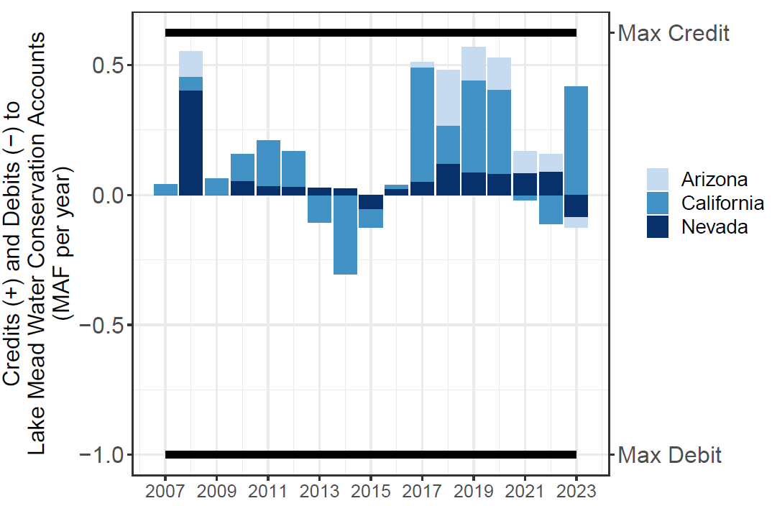  Figure 1. Lake Mead water conservation account annual credits and debits. | 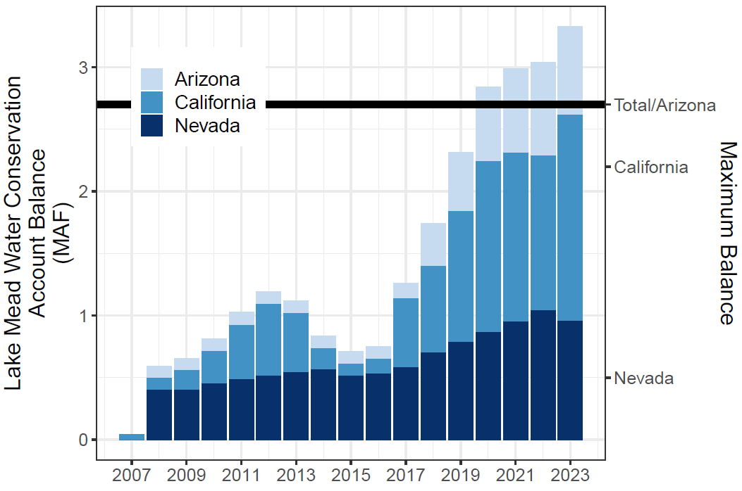  Figure 2. Lake Mead Water Conservation Account Balances.

Program Successes
- Since 2007, the Lower Basin states have collectively conserved and credited 4.1 million acre-feet of water (Figure 1).
- The Lower Basin states have presently conserved and left in Lake Mead 3.3 million acre-feet of water (Figure 2).
- Each state has participated at levels above or near 1 million acre-feet (Figure 2).
- For example, Nevada's 2023 water conservation account balance of 955,000 acre-feet is almost 5 times its recent consumptive use of near 200,000 acre-feet per year.
- Program participation has grown in recent years (Figure 2).
- Participation has exceeded the upper limits for credits allowed by the Interim Guidelines (Figure 2). This excess shows the program has grown beyond the expectations of the designers of the program.
- The program has conserved more water than other voluntary, compensated, or mandatory Colorado River Basin water conservation program (Table 3; Allhands, 2021; UCRC, 2018; UCRC, 2024; USBR, 2021a; USBR, 2021b)
Table 3. Colorado River Basin water conservation programs and accomplishments.
- States have some additional autonomy for reservoir withdraws and to manage vulnerability independent of other states activities. This autonomy reduces conflict.
- The water conservation program was part of a set of long-term and emergency actions that kept Lake Mead’s storage above the 5.9 million-acre feet protection volume (elevation 1,020 feet) during a critical drawdown period in 2022 (Figure 3).
- Program participation jettisoned the principle of "use it or lose it" common to laws that govern water use in many western states, including California, Arizona, and Nevada. Use it or lose it practices fail to incentivize conservation because if a contractor uses less than their historical allocation over a number of years, the state can reclaim the allocation and assign the water right to a different user.

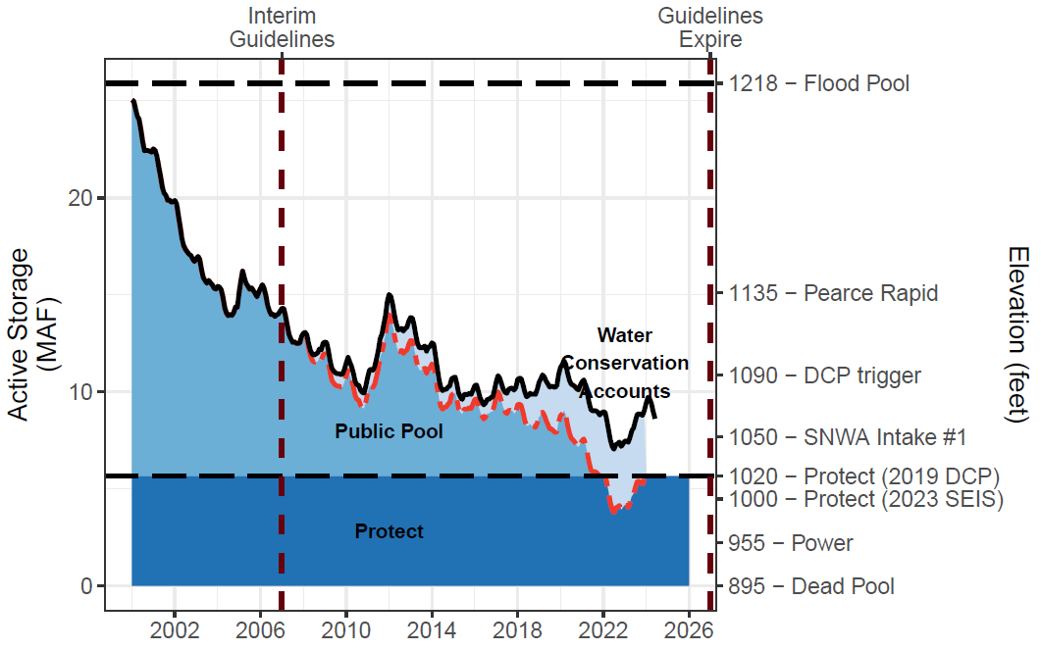
Figure 3. Lake Mead Storage (solid black line), Water Conservation Account Balances (light blue fill), and anticipated lake volume absent the water conservation program (dashed red line). The conservation program kept Lake Mead level above elevation 1,020 feet (5.9 million acre-feet) during low lake levels in 2022. (Source: XXX)

Program Challenges
There are four core challenges that must be addressed by current and future programs to promote water conservation in the Colorado River Basin:
- Reservoirs can draw down quickly. States and contractors conserved water with the understanding that this water would be available for withdrawal in the future. With multiple years of debits, Lake Mead can drawdown close to the protection elevation in a few years. Within the current conservation framework, Lower Basin states loaned the Colorado River system 3.3 million acre-feet of water, which some or all may want to recover at a future point. Once the users perceive Lake Mead will drawdown close to the protection volume, they may race to debit their water conservation account balances to access their conserved water in the absence of systemwide goals

- Motivating additional voluntary water conservation is challenging. As reservoir storage draws down to the protection volume, states and contractors face increasing difficulty to access and debit their water conservation account balances. Their prior conserved water becomes a stranded asset. This challenge can also spur conflicts if:

  - Multiple states withdraw conserved storage, which results in Lake Mead dropping below its protection elevation. States would need to find lower debits that keep Lake Mead at or above the protection elevation.
  - A state seeks to pull storage from the reservoir that creates a debit on their account and decreases Lake Mead storage towards the protection volume. This activity prevents other states in future years from drawing on water in their accounts.
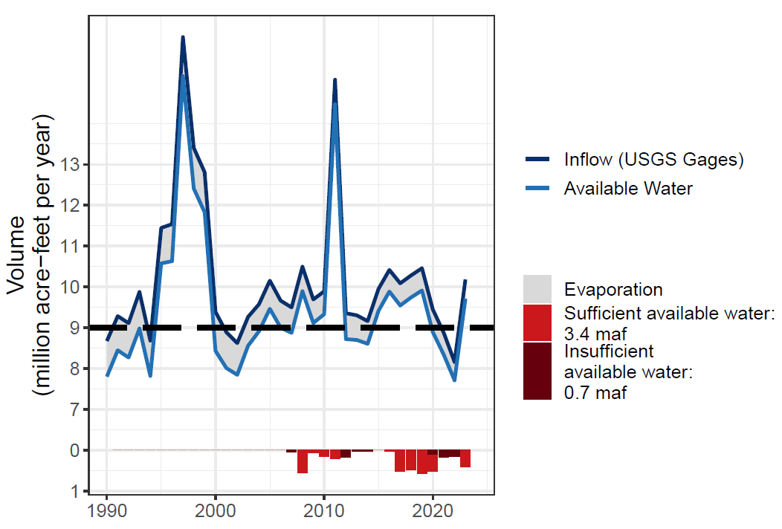
Figure 4. Lake Mead Inflow, Evaporation, Available Water, and Conservation Credits with and without sufficient available water.

  - Other states and users take counter measures to increase their ability to access conserved water with the undesired effect to lower Laken Mead storage.

- Reservoir inflows are not considered in conservation accounting. When a key component that defines the water available for release―reservoir inflow―is not included in the design of a water conservation program, overdraft can occur despite large systemwide storage capacity. In this scenario, Lake Mead would draw down even as states credit their water conservation accounts. This situation occurred over the past decade. This happened when the balance of Lake Mead inflows and evaporation were less than historical allocations (Figure 4). Essentially, states got credit for voluntary water conservation activity even though the physical water never entered the reservoir. It is estimated that 0.7 million acre-feet of the total 4.1 million acre-feet of program conservation efforts were credited even though sufficient water did not flow into Lake Mead (Figure 4).
- Environmental and minimum household water needs are not explicitly included in the current framework. The interim guidelines are built on historical water allocations to states, which were developed at a time that did not include key water needs that we recognize in the 21st Century, including environmental water flows and aquatic habitat and tribal water rights. Additionally, some areas of the basin recognize that households should be able to access a minimum level of water supply for health and safety.

Water Accounts: Promoting Lake Mead Storage during Conditions of Low Storage and Inflow while Increasing User Autonomy to Manage Vulnerability
There are numerous ways to structure the key factors in a hydrologic balance―including reservoir inflow, evaporation, current storage, prohibitions on debits, and protected storage volume―within a water conservation program with reservoir storage. Thus, there are numerous ways to design a voluntary, uncompensated program. One option is to raise the elevation trigger that prohibits debits on water conservation accounts. Another option is to set the storage trigger that requires mandatory water conservation to the anticipated Lake Mead storage volume had the voluntary water conservation program not existed (City of Phoenix, 2024; Pitt et al., 2024 ).
We suggest to switch from the current model of water conservation accounting to water accounts. In each year, basin users would divide each year’s reservoir inflow, subtract evaporation, and users consume and conserve within their available water (account balance). Users carry over end-of-year account balances to the next year. Additionally, USBR sets the protection volume to stabilize and recover Lake Mead storage. Lake Mead active storage becomes the protection volume plus the sum of all water user account balances. The proposed accounting procedure has 9 steps (Box 2).
Box 2. Steps for a Lake Mead Water Accounting Program.
- Set the reservoir protection volume. Reservoir storage will always stay above this amount because account balances must always be positive. Present conversations suggest setting the Lake Mead protection volume between 4.0 and 5.7 million acre-feet of active storage (elevations 1,000 to 1,020 feet).
- Divide the present active storage above the protection volume among the user accounts. One intuitive division is by user's current water conservation account balances (rollover; Figure 2). Allocate additional active storage (public pool in Figure 3) to accounts for Tribal Nations, the Colorado River Delta, and/or other users.
- Estimate the year's reservoir inflow. Inflow is the annual Lake Powell release plus 600,000 to 1 million acre-feet of gains along Grand Canyon (Rosenberg, 2022; Wang and Schmidt, 2020; Figure 4). Since 1990, annual Lake Mead inflow varied from 8 to 16 million acre-feet.
- Divide the year's reservoir inflow among the water accounts. Here, share of reservoir inflow is a historical allocation minus a user’s agreed on shortage volume (Appendix A).
- Subtract reservoir evaporation in proportion to each water account balance.
- Calculate the new water account balance as beginning-of-year account balance, plus share of available water (Step D), minus share of evaporation (Step E).
- Each user withdraws and conserves within their account balance. Users independently manage their climate vulnerability.
- Subtract the withdraw amount (Step G) from the water account balance (Step F) to specify the new account balance at the beginning of the next year.
- Return to Step C for the next year.
In water accounting, users can access all their prior conserved water (rollover) and current account balance at any time because the protection volume ensures a minimum storage volume and account balances must always stay zero or positive. With water accounts, there is no trigger to prohibit debits. With water account, there is also no mandatory conservation because, again, the protection volume stabilizes reservoir storage.
Water accounts leverage prior shortage sharing agreements, including the recent Lower Basin Alternative (Buschatzke et al., 2024). A user’s share of the reservoir inflow is their historical allocation minus the agreed-on shortage volume (Appendix A). Program designers can also create accounts for communities excluded from river management such as Tribal Nations and Colorado River Delta.
Lake Mead water accounts also preserve flexibility to operate Lake Powell to benefit Grand Canyon ecosystems, sustain hydropower generation, and/or stabilize and recover Powell storage under low storage and low inflow conditions, because it allows for some decoupling of Lake Powell and Lake Mead operations that introduce operational flexibility.. Instead, Lake Powell releases specify when Lake Powell water becomes available to Lake Mead and Lower Basin users. This introduces more certainty to operations. Water accounts for Lake Mead diverters allow users to adapt their decisions to consume and conserve water within their available water. Thus, Lake Mead water accounting gives users more autonomy to manage their vulnerability to water shortages independent of other users.

Conclusions and Next Steps
The Lake Mead water conservation program is the most successful Colorado River basin conservation program to date. Since 2007, Lower Basin users have conserved 4.1 million acre-feet of water with 3.3 million acre-feet presently remaining in Lake Mead. These efforts have kept Lake Mead storage above the protection volume. The program works on the assumption that the annual available water―reservoir inflow minus evaporation―exceeds historical allocations. This assumption is challenged as the Colorado River Basin becomes more arid. There is also a challenge to motivate voluntary water conservation as reservoir storage draws down to the protection volume because states and contractors face increasing difficulty to access and debit their conserved water. How to (i) improve the existing program, (ii) stabilize and recover reservoir storage under low storage and inflow conditions, (iii) jetson the need for mandatory Lower Basin conservation tied to declining system storage, while (iv) increase user autonomy to manage their conflicting vulnerability to water shortages, and (v) leverage prior negotiations and decrease conflict? One suggestion—switch to water accounting based the principles of divide reservoir inflow, subtract evaporation, and users consume and conserve within their available water.
Do the above benefits of a Lake Mead water accounting program sound too good to be true? We intend to build an immersive online collaborative model (Rosenberg, 2024) to allow basin partners to explore Lake Mead water accounting while observe partners’ choices to manage their vulnerabilities to water shortages. During a model session, collaborators make extreme assumptions for hydrology, ecosystem responses, and starting reservoir storage. Collaborators then immerse in water user roles. They decide how much water to release and conserve in response to their available water, other’s choices, and real-time discussion of choices. As researchers, we want to learn:
- Why basin partners choose assumptions and how extreme.
- Why and how basin partners manage their risk of uncertain future water supply.
- Which new insights they take from a model session.
We believe these discussions can help inform how to simulate impacts of Lake Mead water accounting and reduce conflicting system, user, Tribal, and ecosystem vulnerabilities to water shortages. Reach out by email to david.rosenberg@usu.edu if you have read this far and want to join a collaborative model session.

Data Availability
The data, models, and code used to generate tables and figures in this manuscript are available for download at https://github.com/dzeke/ColoradoRiverCollaborate/tree/main/LakeMeadWaterConservationProgramAnalysis.

Appendix A. Estimate Shares of Annual Lake Mead Inflow.
This appendix estimates Mexico’s and each Lower Basin state’s share of the annual Lake Mead inflow. A user’s historical allocation minus their prior agreed-on water shortage volume (Buschatzke et al., 2024; Table A1) becomes the share of reservoir inflow (Table A2).
Table A1. Prior agreed Lower Basin shortages and shares of shortages (Buschatzke et al., 2024).

Table A2. Share of Lake Mead inflow by volume and percentage.
Example calculations of share of Lake Mead inflow by volume and percentage (Table A2) are:
- Total Lake Mead inflow [B] = 9.0 ─ Total Shortage [A].
  - For example, a total shortage of 0.4 maf yields a Lake Mead inflow of 9.0 ─ 0.4 = 8.6 maf per year.

- Share of Reservoir Inflow:
  - Arizona [C] = 2.8 ─ Share of Shortage as Volume in Table A1.
    - For example, at 8.6 maf of reservoir inflow, Arizona’s share is 2.8 ─ 0.28 = 2.52 maf.
  - Nevada [D] = 0.3 ─ Share of Shortage as Volume in Table A1.
    - For example, at 8.0 maf of reservoir inflow, Nevada’s share is 0. 3 ─ 0.03 = 0.27 maf.
  - California [E] = 4.4 ─ Share of Shortage as Volume in Table A1.
    - For example, at 7.5 maf of reservoir inflow, California’s share is 4.4 ─ 0.44 = 3.96 maf.
  - Mexico [F] = 1.5 ─ Share of Shortage as Volume in Table A1.
    - For example, at 7.5 maf of reservoir inflow, Mexico’s share is 1.5 ─ 0.25 = 1.25 maf.

- Total Reservoir Inflow [G] = [C] + [D] + [E] + [F]

- A user’s Percent of Reservoir Inflow is their share by volume divided by the total volume.

  - Arizona [H] = [C] / [G]
  - Nevada [I] = [D] / [G]
  - And so forth.

- Total Percentage of Reservoir Inflow [L] = [H] + [I] + [J] + [K] = 100%.
Observations
- Nevada and Mexico’s percent shares of the reservoir inflow remain constant at 3.3% and 16.67%, respectively. These percentage shares are the same share of their historical allocations.
- Arizona’s percentage share of Lake Mead inflow decreases as the inflow decreases whereas California’s share of Lake Mead inflow increases.

References
Allaire, M., and Acquah, S. (2022). "Disparities in drinking water compliance: Implications for incorporating equity into regulatory practices." AWWA Water Science, 4(2), e1274. https://doi.org/10.1002/aws2.1274.
Allhands, J. (2021). "It could take at least 500,000 acre-feet of water a year to keep Lake Mead from tanking." Arizona Republic, November 8, 2021. https://www.azcentral.com/story/opinion/op-ed/joannaallhands/2021/11/08/lake-mead-could-get-extra-water-from-lower-basin-annually/6306601001/.
Buschatzke, T., Hamby, J. B., and Entsminger, J. (2024). "Lower Basin Alternative for the Post-2026 Coordinated Operation of the Colorado River Basin." https://www.snwa.com/assets/pdf/lower-basin-alternative-letter-march2024.pdf [Accessed on: August 14, 2024].
CAP. (2022). "ICS – Three little letters that signify big contributions and new flexibility." Central Arizona Project, https://knowyourwaternews.com/ics-three-little-letters-that-signify-big-contributions-and-new-flexibility/ [Accessed on: August 13, 2024].
City of Phoenix. (2024). "Additional concepts for consideration - City of Phoenix." https://www.usbr.gov/ColoradoRiverBasin/documents/post2026/alternatives/2024-05-08_Additional_Concepts_for_Consideration_City_of_Phoenix_508.pdf.
Cutter, S. L., Boruff, B. J., and Shirley, W. L. (2003). "Social Vulnerability to Environmental Hazards*." Social Science Quarterly, 84(2), 242-261. https://doi.org/10.1111/1540-6237.8402002.
Cutter, S. L., Mitchell, J. T., and Scott, M. S. (2000). "Revealing the Vulnerability of People and Places: A Case Study of Georgetown County, South Carolina." Annals of the Association of American Geographers, 90(4), 713-737. https://doi.org/10.1111/0004-5608.00219.
Grant, D. L. (2007). "Collaborative Solutions to Colorado River Water Shortages: The Basin States' Proposal and Beyond." Nevada Law Journal, 8, 964
https://heinonline.org/HOL/Page?handle=hein.journals/nevlj8&id=980&collection=journals&index=.
Harou, J., Pulido-Velazquez, M., Rosenberg, D. E., Josue Medellin-Azuara, Lund, J. R., and Howitt, R. E. (2009). "Hydro-economic Models: Concepts, Design, Applications, and Future Prospects." Journal of Hydrology, 375(3-4), 627-643. https://doi.org/10.1016/j.jhydrol.2009.06.037.
Hecht, J. S., Vogel, R. M., McManamay, R. A., Kroll, C. N., and Reed, J. M. (2020). "Decision Trees for Incorporating Hypothesis Tests of Hydrologic Alteration into Hydropower&#x2013;Ecosystem Tradeoffs." Journal of Water Resources Planning and Management, 146(5), 04020017. https://doi.org/10.1061/(ASCE)WR.1943-5452.0001184.
Hegwood, M., Langendorf, R. E., and Burgess, M. G. (2022). "Why win–wins are rare in complex environmental management." Nature Sustainability. https://doi.org/10.1038/s41893-022-00866-z.
IBWC. (2021). "Minutes between the United States and Mexican Sections of the IBWC." United States Section, https://www.ibwc.gov/Treaties_Minutes/Minutes.html [Accessed on: July 22, 2021].
Jasechko, S., and Perrone, D. (2021). "Global groundwater wells at risk of running dry." Science, 372(6540), 418-421. https://doi.org/10.1126/science.abc2755.
Kasprzyk, J. R., Nataraj, S., Reed, P. M., and Lempert, R. J. (2013). "Many objective robust decision making for complex environmental systems undergoing change." Environmental Modelling & Software, 42(0), 55-71. http://dx.doi.org/10.1016/j.envsoft.2012.12.007.
Kuhn, E., and Fleck, J. (2019). Science Be Dammed: How Ignoring Inconvenient Science Drained the Colorado River, University of Arizona Press.
Meehan, K., Jepson, W., Harris, L. M., Wutich, A., Beresford, M., Fencl, A., London, J., Pierce, G., Radonic, L., Wells, C., Wilson, N. J., Adams, E. A., Arsenault, R., Brewis, A., Harrington, V., Lambrinidou, Y., McGregor, D., Patrick, R., Pauli, B., Pearson, A. L., Shah, S., Splichalova, D., Workman, C., and Young, S. (2020). "Exposing the myths of household water insecurity in the global north: A critical review." WIREs Water, 7(6), e1486. https://doi.org/10.1002/wat2.1486.
Mileti, D. S. (1999). Disasters by Design: A Reassessment of Natural Hazards in the United States, Joseph Henry Press, Washington, D.C.
Mitchell, R., Shawcroft, G., Lopez, E., and Gebhart, B. (2024). "Upper Division States Alternative." http://www.ucrcommission.com/wp-content/uploads/2024/03/UDS-Alternative-Submittal-March-5-2024.pdf [Accessed on: August 14, 2024].
Pace, C., Fencl, A., Baehner, L., Lukacs, H., Cushing, L. J., and Morello-Frosch, R. (2022). "The Drinking Water Tool: A Community-Driven Data Visualization Tool for Policy Implementation." International Journal of Environmental Research and Public Health, 19(3), 1419. https://www.mdpi.com/1660-4601/19/3/1419.
Pitt, J., Miller, B., Funk, A., Rice, M., Hawes, T., Moran, K., and Porterfield, S. (2024 ). "Conservation Groups’ Cooperative Conservation Alternative for Post-2026 Colorado River Guidelines Operations and Strategies." Reclamation. https://www.usbr.gov/ColoradoRiverBasin/documents/post2026/alternatives/2024-03-29_Final_Letter_re_Cooperative_Conservation_508.pdf.
Porse, E. C., Sandoval-Solis, S., and Lane, B. A. (2015). "Integrating Environmental Flows into Multi-Objective Reservoir Management for a Transboundary, Water-Scarce River Basin: Rio Grande/Bravo." Water Resources Management, 29(8), 2471-2484. https://doi.org/10.1007/s11269-015-0952-8.
Rosenberg, D. E. (2022). "Adapt Lake Mead Releases to Inflow to Give Managers More Flexibility to Slow Reservoir Drawdown." Journal of Water Resources Planning and Management, 148(10), 02522006. https://doi.org/10.1061/(ASCE)WR.1943-5452.0001592.
Rosenberg, D. E. (2024). "Lessons from immersive online collaborative modeling to discuss more adaptive reservoir operations." Journal of Water Resources Planning and Management, 150(7). https://doi.org/10.1061/JWRMD5.WRENG-5893.
Stelter, D. (2022). "Towards a Utah Intentionally Created Surplus Program." Sustainable Development Law and Policy, 22(2), 4-21. https://heinonline.org/HOL/Page?collection=journals&handle=hein.journals/sdlp22&id=44&men_tab=srchresults.
Thomas, K., Hardy, R. D., Lazrus, H., Mendez, M., Orlove, B., Rivera-Collazo, I., Roberts, J. T., Rockman, M., Warner, B. P., and Winthrop, R. (2019). "Explaining differential vulnerability to climate change: A social science review." WIREs Climate Change, 10(2), e565. https://doi.org/10.1002/wcc.565.
UCRC. (2018). "Colorado River System Conservation Pilot Program in the Upper Colorado River Basin." Upper Colorado River Commission. http://www.ucrcommission.com/RepDoc/SCPPDocuments/2018__SCPP_FUBRD.pdf.
UCRC. (2024). "Colorado River System Conservation Pilot Program in the Upper Colorado River Basin." Upper Colorado River Commission. http://www.ucrcommission.com/wp-content/uploads/2024/06/2023_SCPP_Report_June2024.pdf.
USBR. (2007). "Record of Decision: Colorado River Interim Guidelines for Lower Basin Shortages and Coordinated Operations for Lakes Powell and Mead." U.S. Bureau of Reclamation. https://www.usbr.gov/lc/region/programs/strategies/RecordofDecision.pdf.
USBR. (2019). "Agreement Concerning Colorado River Drought Contingency Management and Operations." U.S. Bureau of Reclamation, Washington, DC. https://www.usbr.gov/ColoradoRiverBasin/dcp/index.html.
USBR. (2021a). "Boulder Canyon Operations Office - Program and Activities: Water Accounting Reports." U.S. Bureau of Reclamation. https://www.usbr.gov/lc/region/g4000/wtracct.html.
USBR. (2021b). "Pilot System Conservation Program." U.S. Bureau of Reclamation, https://www.usbr.gov/lc/region/programs/PilotSysConsProg/pilotsystem.html [Accessed on: October 14, 2021].
Wakhungu, M. J., Abdel-Mottaleb, N., Wells, E. C., and Zhang, Q. (2021). "Geospatial Vulnerability Framework for Identifying Water Infrastructure Inequalities." Journal of Environmental Engineering, 147(9), 04021034. https://doi.org/10.1061/(ASCE)EE.1943-7870.0001903.
Wang, J., and Schmidt, J. C. (2020). "Stream flow and Losses of the Colorado River in the Southern Colorado Plateau." Center for Colorado River Studies, Utah State University, Logan, Utah. https://qcnr.usu.edu/coloradoriver/files/WhitePaper5.pdf.
Yates, D., Sieber, J., Purkey, D., and Huber-Lee, A. (2005). "WEAP21 - A demand-, priority-, and preference-driven water planning model Part 1: Model characteristics." Water International, 30(4), 487-500. https://doi.org/10.1080/02508060508691893.
Zagona, E. A., Fulp, T. J., Shane, R., Magee, T., and Goranflo, H. M. (2001). "Riverware: A Generalized Tool for Complex Reservoir System Modeling." JAWRA Journal of the American Water Resources Association, 37(4), 913-929. https://doi.org/10.1111/j.1752-1688.2001.tb05522.x.

