Give Lake Mead managers more flexibility to conserve to stop draw down to the dead pool
David E. Rosenberg | Utah State University | david.rosenberg@usu.edu | @WaterModeler
June 3, 2021
This post is the third in a series titled Encouraging more Water Conservation in the Colorado River Basin.
- Part I is “Invest in Farm Water Conservation to Curtail Buy and Dry” (on Inkstain).
- Part II is “Add reservoir inflow as new criteria to recover Lake Mead from shortage”

Introduction
Over the last two decades of drought, Lake Mead’s storage has dropped from 25 to 10 million acre-feet (maf). In their new drought operations, the Lower Colorado River Basin states and contractors individually and collectively committed to prevent Lake Mead from declining below 5.7 maf of active storage (1,020 feet) (USBR, 2019a). For many reservoir inflows, stabilizing Lake Mead’s storage will require the parties to conserve above their mandatory conservation targets. As Lake Mead draws down to 5.7 maf of storage, will the parties lower the stabilization level and delay additional conservation efforts? How to stop Lake Mead’s drawdown towards the dead pool (0 acre feet or active storage)?
This blog post reviews the existing voluntary and mandatory water conservation programs for Lake Mead. The review focuses on how the programs divide reservoir storage between private conservation accounts and a public shared pool. The division encourages reservoir draw down towards the dead pool because the parties first tap the public pool and afterwards their private accounts. To stop draw down, the post proposes individualized accounts to track available water – each party’s share of reservoir storage plus inflow. A new configuration ensures parties release from their individual accounts before the public pool. Accounting based on available water gives each party a larger account balance than a conservation account and more flexibility to make individual decisions on release and conservation independent of other parties. With water availability accounts, the parties can also jointly agree to lower the stabilization level below 5.7 maf without fear to draw down Lake Mead all the way to dead pool. A next post proposes water availability accounts for a combined Lake Powell-Lake Mead system.

Existing Conservation Programs
A voluntary water conservation program allows Lower Basin states and contractors to store water they conserve in Lake Mead, get credit, and later withdraw the conserved water subject to restrictions on lake elevation and maximum annual withdrawal amounts (USBR, 2007). Presently, the conservation accounts hold 2.8 maf of water—23% of current Lake Mead active storage—and have exceeded the 2.7 maf program cap (Figure 1; USBR, 2020). In recent years, annual conservation efforts are close to 0.625 maf per year program cap on annual deposits (Figure 2).
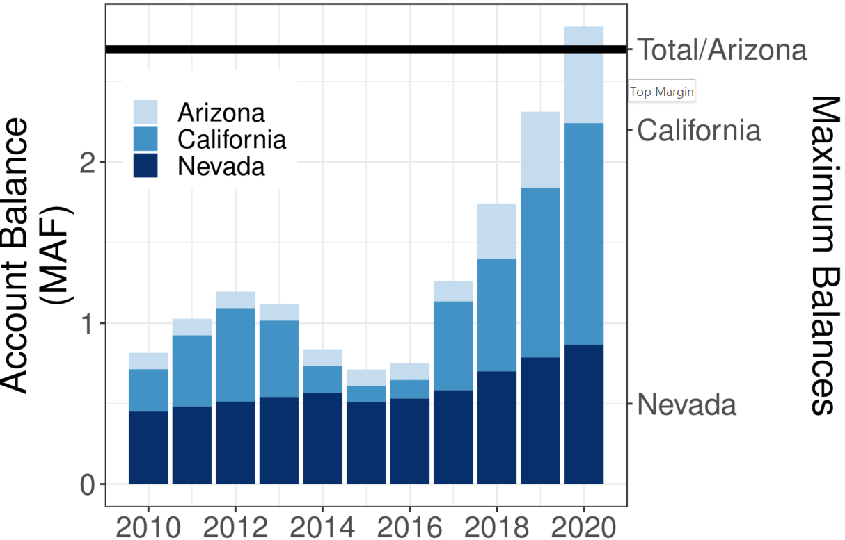  Figure 1. Conservation account balances (USBR, 2019b) | 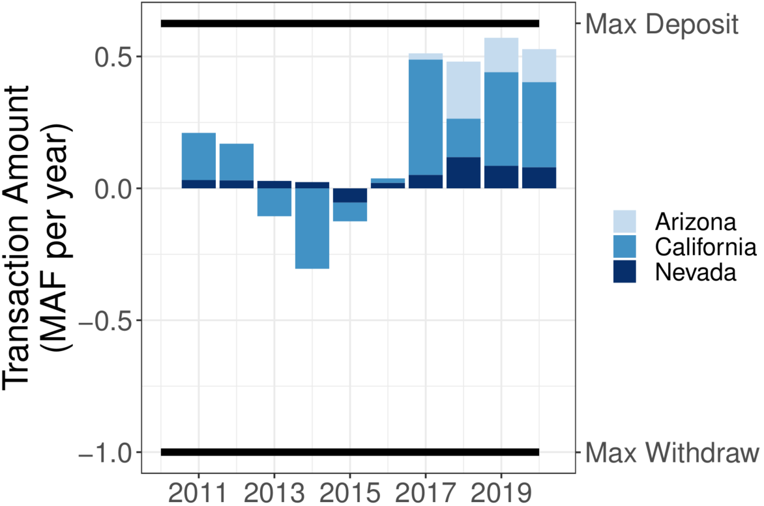  Figure 2. Deposits (+) and withdrawals (-) from conservation accounts (USBR, 2019b)

As Lake Mead falls from 9.9 to 6.0 maf of storage (1,090 to 1,025 feet), the Lower Basin states, their contractors, and Mexico must meet mandatory water conservation targets that grow from 0.24 to 1.35 maf per year USBR (2019a). Within these mandatory targets, any party can still withdraw water from a conservation account or convert and use water in a conservation account to meet a mandatory conservation target. Withdraws and conversions from a conservation account increase reservoir releases and draw down Lake Mead faster than if a party met their mandatory target by new conservation efforts that year. In 2020, California withdrew from its conservation account to substitute for low water availability in the Sierras while Arizona and Nevada converted. Together, the states conserved 43,000 acre-feet less in 2020 than in 2019. As a result, Lake Mead is 43,000 acre-feet lower than had the states sustained their prior conservation efforts.
Comparing each Lower Basin state’s 2020 conservation account balance to its mandatory conservation target shows the states have differing abilities to delay new conservation efforts (Figure 3). These differing abilities suggest the states may also have differing desires to lower the Lake Mead level where they increase conservation efforts to stabilize the reservoir.

Division of Reservoir Storage
The Lake Mead conservation accounts are private pools of stored water while the remaining active storage is a shared, public pool (Figure 4A). A state draws on the public pool first as other states do. As reservoir storage draws down, states withdraw from their private water conservation account to supplement limited withdraws allowed by the mandatory conservation targets. The withdraws from conservation accounts trigger a negative feedback that accelerates reservoir withdraw and further withdraws from conservation accounts.
As reservoir storage draws down towards the total balance in all conservation accounts, the states face increased pressure to withdraw from their conservation accounts. They face increased pressure because once physical reservoir storage falls below the total balance of all conservation accounts, the conservation credits become unredeemable. Bill Hasencamp from the Metropolitan
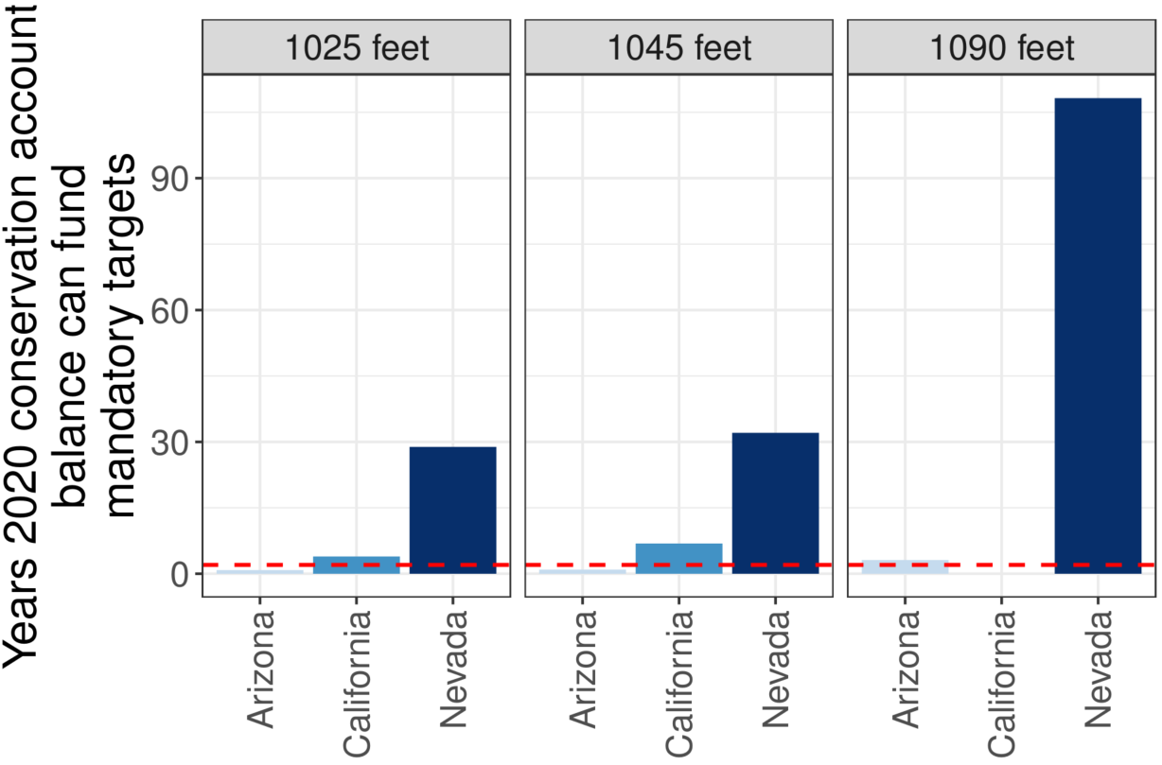
Figure 3. Years 2020 conservation account balance can convert to meet mandatory targets and delay new conservation efforts. Dashed red line indicates 2 years.
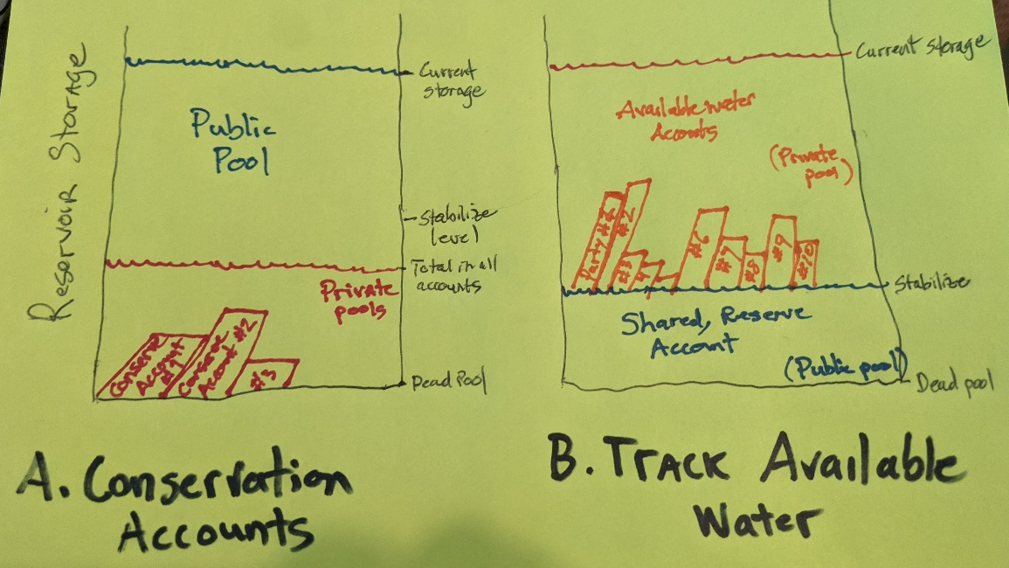
Figure 4. Division of reservoir storage with current Lake Mead conservation accounts (A) and proposed accounts that track available water (B).
Water District (MWD) of Southern California recently floated the idea that MWD might be ok to conserve a large volume and only recover a portion (Walton, 2021). That strategy works when all parties are on board. If not, there will be a conflict about who recovers their conserved water and who does not.
Similarly, once Lake Mead draws down towards 5.7 maf of storage, one party can likely persuade the other parties to lower the level rather than enact additional conservation efforts to stabilize the reservoir. Parties that were ok to undertake large additional conservation efforts will not increase their conservation efforts if one party continues their use. And if one or more parties continue their use, the remaining parties must conserve more than if all parties shared in the additional conservation. These disincentives encourage continued reservoir draw down.
Ironically and paradoxically, draw-down will accelerate as parties empty their conservation accounts. This situation is a tragedy of the commons (Hardin, 1968) with a twist and complication of private water conservation accounts that comprise a small portion of the total reservoir storage.
How to maneuver out of this mess?

Proposal: Give managers more flexibility to conserve
This section proposes new accounts to track available water – reservoir storage plus each year’s inflow – as a fix to continued reservoir draw down. Setting up and using the accounts will require the parties to make some hard political choices. The reward for those choices is a reservoir that never draws down to dead pool, each party gets flexibility to manage their withdraw and conservation decisions independent of other users, an opportunity to manage all water rather than only prior conserved water, plus the opportunity to include some more stakeholders in Colorado River management. The steps to set up and use available water accounts are:
- Give an account to each party. Who gets an account is a first set of political decisions. Obviously give each Lower Basin state contractor an individual account. Then there is an opportunity to follow through on recent pledges to include more stakeholders in management. For example, give an account to the U.S. and Mexican groups that secure water for the Colorado River Delta. Give the First Nations one or multiple accounts. Give the Salton Sea managers an account. Maybe others too. And to these accounts add two more. Create a “Havasu/Parker Evaporation and Evapotranspiration” account to ensure the instream uses downstream of Lake Mead are provided for. And create a “shared, reserve” account that is jointly managed by consensus by all parties.

- Divide the existing storage in Lake Mead among the user accounts. This division is a another set of political decisions. An easy division is to give each Lower Basin contractor the current balance in their Lake Mead water conservation account. Then retire the pilot water conservation accounting program. Scale up the popular, well used, and successful program to manage all the water in Lake Mead. A next harder decision is how much of the remaining storage to give the “shared, reserve” account. This volume might be the current stabilization volume of 5.3 maf or lower. How low? I do not know. But the value could go lower than 2.0 maf (minimum power pool at elevation 950 feet) or lower if the account holders compensate Reclamation for the opportunity cost of lost hydropower generation. The “shared, reserve” account volume will be lowest volume Lake Mead draws down to because the assumption is the account managers – all parties – will never all consent to a release and thus the water will stay parked in the account and in the reservoir. Finally, divide the remaining active storage (current storage minus conservation account balances minus “shared, reserve” volume) among the users. I don’t have useful suggestions here. Maybe the Lower Basin contractors get all the remaining storage and new users have the opportunity to conserve and build their account balances over time. Maybe there is a formula to split the remaining storage among the parties. Regardless, I expect it will be easier to divide the remaining reservoir storage among parties (expanding pie) than negotiate ever larger cutbacks and mandatory conservation targets (shrinking pie).
- Divide each year’s reservoir inflow among the user accounts. This division is a another set of political decisions and there are many possibilities. Easier choices here are 0.6 and 0.016 maf per year to Havasu/Parker and the Colorado River Delta per existing operations and the environmental provision of Minute 323. By giving the “shared, reserve” account a share of inflow that offsets the account’s prorated share of reservoir evaporation, the account balance will stay steady from year to year. More difficult will be dividing each year’s reservoir inflow among the Lower Basin states. The current mandatory conservation targets differ from prior agreements and vary by reservoir elevations. When tracking and managing for available water, reservoir elevations will vary as parties make individual decisions independent of other parties. If the Lower Basin states have difficulty dividing the reservoir inflow, they might try splitting the reservoir inflow into two parts. One part is assigned by a priority system while the second part is split based on percentages. This bicameral system would correspond to how the framers of the U.S. Constitution split representation in the U.S. Congress. The split would ensure all states get a share of the inflow. I do not have good suggestions for the portion of inflow that First Nations or Salton Sea mangers should seek. But I welcome further discussion from knowledge persons. In all cases, the division of reservoir inflow must allow that inflow varies year to year. And like for reservoir storage, it should be easier to divide each year’s inflow among the parties than negotiate ever larger cutbacks and mandatory conservation targets.
- Then each year: (a) observe the reservoir inflow (either prior year or forecast), (b) split the inflow among the parties, (c) estimate each party’s share of the reservoir evaporation proportional to their account balance, and (d) calculate each party’s available water as their beginning of year account balance plus share of inflow minus share of evaporation. Next (e) parties decide the volume they will consumptive use or conserve/store, (f) calculate an end-of-year account balance, and (g) transfer the balance to the beginning of the next year.
This accounting by available water flips the ordering of the shared, reserve (public) and private pools in Lake Mead (Figure 4B). Even if all parties draw down their private accounts to zero, Lake Mead will only draw down to the storage of the shared, reserve account. Each party should find accounting by available water – the reservoir storage plus inflow -- attractive because they get more flexibility to make individual decisions on release and conservation independent of other parties and independent of the reservoir level. Additionally, each party gets the opportunity to manage a larger account balance than their present conservation account. To realize these benefits, the parties must conclude new negotiations for which parties to give available water accounts, and how to divide the existing Lake Mead storage and future inflows among parties. I hope the parties will prefer these one-time expanding pie negotiations to recurring negotiations for increasing water cutbacks and mandatory conservation should the parties keep their existing conservation accounts.
I encourage readers interested to further explore accounting by available water to download a prototype tool for Lake Mead. Pop the Excel workbook into a Google sheet and invite 2 or more friends to role play different parties. Role play with different number of parties, divisions of existing reservoir storage or inflows, reservoir inflow scenarios, and individual release and water conservation strategies. Email feedback – things you like and things to improve – to david.rosenberg@usu.edu.
A next post proposes water availability accounts for a combined Lake Powell-Lake Mead system.

Data, Model, and Code Availability
The data, code, and directions to generate figures in this post are available on Github.com at Rosenberg (2021).

Acknowledgements
This work is unfunded. Eric Kuhn and Jennifer Pitt made comments to improve earlier drafts.

References
Hardin, G. (1968). "The Tragedy of the Commons." Science, 162(3859), 1243-1248. https://science.sciencemag.org/content/sci/162/3859/1243.full.pdf.
Rosenberg, D. E. (2021). "Intentionally Created Surplus for Lake Mead: Current Accounts and Next Steps." https://github.com/dzeke/ColoradoRiverFutures/tree/master/ICS.
USBR. (2007). "Record of Decision: Colorado River Interim Guidelines for Lower Basin Shortages and Coordinated Operations for Lakes Powell and Mead." U.S. Bureau of Reclamation. https://www.usbr.gov/lc/region/programs/strategies/RecordofDecision.pdf.
USBR. (2019a). "Agreement Concerning Colorado River Drought Contingency Management and Operations." U.S. Bureau of Reclamation, Washington, DC. https://www.usbr.gov/dcp/finaldocs.html.
USBR. (2019b). "Boulder Canyon Operations Office - Program and Activities: Water Accounting Reports." U.S. Bureau of Reclamation. https://www.usbr.gov/lc/region/g4000/wtracct.html.
USBR. (2020). "Water Operations: Historic Data, Upper Colorado River Division." Upper Colorado River Division, U.S. Buruea of Reclamation. https://www.usbr.gov/rsvrWater/HistoricalApp.html. [Accessed on: June 16, 2020].
Walton, B. (2021). "Amid Dire Colorado River Outlook, States Plan to Tap Their Lake Mead Savings Accounts." Circle of Blue. https://www.circleofblue.org/2021/world/amid-dire-colorado-river-outlook-states-plan-to-tap-their-lake-mead-savings-accounts/. [Accessed on: June 19, 2021].

