Convert prior conservation credits to delay new mandatory Lower Colorado River shortages
David E. Rosenberg | Utah State University | david.rosenberg@usu.edu | @WaterModeler
June 3, 2021
This post is the second in a series titled Encouraging more Water Conservation in the Colorado River Basin. Part I is “Invest in Farm Water Conservation to Curtail Buy and Dry”

Introduction
As Lake Mead’s water level falls from 1,090 feet (9.9 million acre-feet active storage) to 1,025 feet (6.0 million acre-feet), the Lower Colorado River basin states of Arizona, Nevada, and California must reduce their customary diversions and meet mandatory water conservation targets that grow from 0.3 to 1.1 million acre-feet per year (USBR, 2019a). How will the Lower Basin States meet the conservation targets in their 2019 Drought Contingency Plan (DCP)?
To answer the question, this blog post compares the Lower Basin states’ past voluntary water conservation actions for the Intentionally Created Surplus (ICS) program for Lake Mead to the mandatory conservation targets. The ICS program for Lake Mead allows Lower Basin states and contractors to voluntarily conserve water, store the water in Lake Mead, get credit, and later withdraw conserved water subject to restrictions on lake elevation and maximum annual withdrawal amounts (USBR, 2007). These prior conservation efforts exceed 2.3 million acre-feet—23% of current Lake Mead active storage—and are approaching the 2.7 million acre-feet program cap (Figure 1; USBR, 2020). The largest annual conservation efforts are close to 0.625 million acre-feet per year program cap on annual deposits (Figure 2).
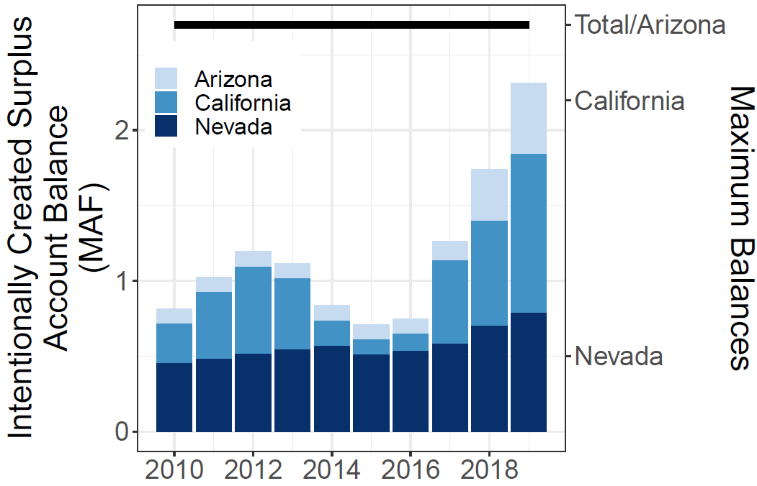  Figure 1. Balances in ICS accounts (USBR, 2019b) | 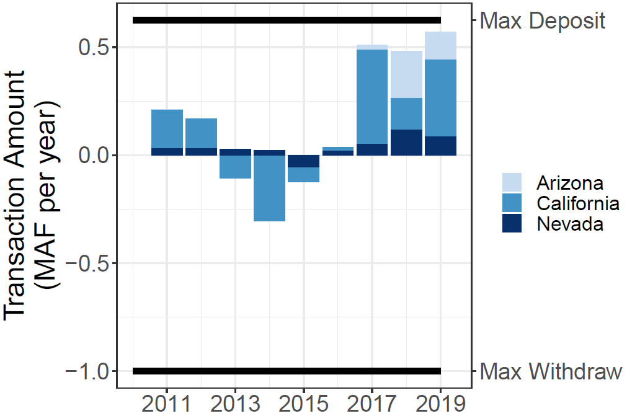  Figure 2. Deposits (+) and withdrawals (-) from ICS accounts (USBR, 2019b)

Demonstrated Capacity to Conserve
California and Nevada’s prior annual voluntary conservation efforts and credits to their ICS accounts already exceed their DCP conservation targets at all Lake Mead levels (Figure 3). In contrast, Arizona’s largest prior voluntary conservation effort of 216,000 acre-feet just exceeded it’s 192,000 acre-feet DCP conservation target for Lake Mead levels between 1,075 and 1,090 feet. To meet mandatory DCP targets below 1,045 feet, Arizona must triple its largest, prior annual voluntary conservation effort. Hopefully, Arizona’s plans to ramp up its mandatory conservation efforts will work (James, 2021).
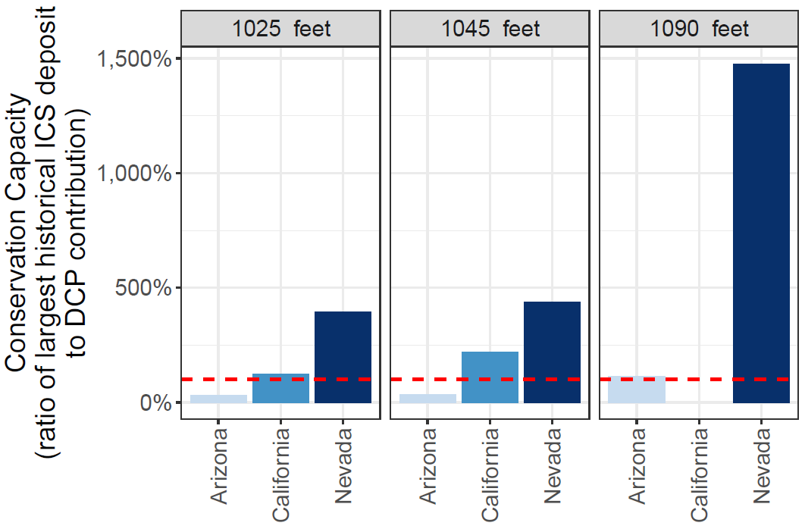
Figure 3. Ratio of largest prior voluntary conservation effort to mandatory DCP target. Dashed red line at 100% indicates the largest prior effort will meet the DCP target.

Number of Years to Delay new Mandatory Conservation Efforts
Within the Lower Basin DCP operations, states and contractors can also convert previously-conserved ICS water and use to meet a DCP conservation target. Divide a state’s ICS account balance by its annual DCP target to identify the number of years to convert and delay the onset of new conservation efforts.
The Lower Basin states have differing abilities to delay new conservation efforts (Figure 4). Nevada can delay for at least 25 years. California can convert ICS water and delay new conservation efforts for 5 or 2.5 years once it’s DCP target triggers at 1,045 or 1,025 feet. Arizona’s can delay new conservation efforts for 2.5 years when Lake Mead is between 1,070 and 1,090 feet and less than one year below 1,070 feet. These timings suggest Arizona will start new mandatory conservation efforts one or two years after Lake Mead falls below 1,090 feet while California will start 2 to 5 years after Lake Mead falls below 1,050 feet. This schedule will shorten if reservoir inflows decline, Lake Mead falls to 1,030 feet sooner than 2026, or the states renegotiate their DCP operations for higher conservation volumes. We will have to see whether a stick point for the renegotiations is transitioning from water conservation that is creditable and recoverable to unrecoverable.
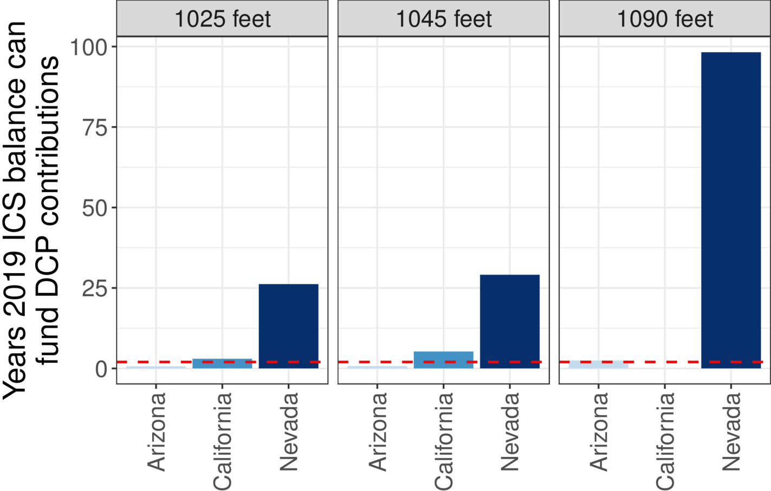
Figure 4. Years 2019 ICS balance can convert to meet DCP targets and delay new conservation efforts. Dashed red line indicates 2 years.
Raising the cap on ICS accounts may encourage states and contractors to undertake more voluntarily conservation efforts each year, deposit to their ICS account, then convert and use their ICS water to meet their DCP targets. But rising ICS account balances may exceed the physical and active water storage in Lake Mead. Once balances exceed the water storage, account water is no longer physically recoverable. The incentive to participate in the ICS program diminishes or evaporates. Presently, the 2.7 million acre-feet cap on accounts is small compared to Mead’s active storage of 10.9 million acre-feet. Rising account balances and declining reservoir storage will narrow the gap. How and where to set the program caps?

Alternatives to Convert and Delay
The current Lower Basin DCP operations encourage and incentivize the states and contractors to convert and use prior ICS conservation efforts to meet future DCP targets. This conversion will delay the onset of new water conservation measures and continue reservoir draw-down. How to encourage more water conservation sooner?
Since the states have differing abilities to convert their ICS water, the states may benefit from voluntary, temporary, and compensated trades or leases. The current ICS and DCP programs allow exchanges of previously conserved water. Exchanges will increase flexibility to locate new conservation effects above DCP targets. Exchanges should require compensation recipients to invest some of the compensation in farm water conservation. This investment will keep money in the local community, allow recipients to offer more water in future years, help grow a conservation ethic, and avoid buy-and-dry (Rosenberg, 2021b).
The Lower Basin DCP operations can also add reservoir inflow as a criteria for decisions about reservoir releases, conservation, and DCP targets. Adding a criteria of inflow would shift decision making away from users’ aspirations for customary deliveries and towards the available water – reservoir storage plus inflow. The next post in this series presents the benefits and drawbacks to add inflow as a new criteria in DCP operations.
A follow-on post proposes an accounting system that uses available water and is individualized so each user can make their own decisions regarding reservoir releases, water conservation, financial compensation, risk, and reward independent of the other users.

Data, Model, and Code Availability
The data, code, and directions to generate figures in this post are available on Github.com at Rosenberg (2021a).

Acknowledgements
This work is unfunded. Eric Kuhn and Jennifer Pitt made comments to improve this piece.

References
James, I. (2021). "Southwest braces for water cutbacks as drought deepens along the Colorado River." Arizona Republic.
Rosenberg, D. E. (2021a). "Intentionally Created Surplus for Lake Mead: Current Accounts and Next Steps." https://github.com/dzeke/ColoradoRiverFutures/tree/master/ICS.
Rosenberg, D. E. (2021b). "Invest in Farm Water Conservation to Curtail Buy and Dry." Inkstain. https://github.com/dzeke/ColoradoRiverFutures/blob/master/BlogDrafts/InvestInFarmWaterConservationToStopBuyAndDry.docx.
USBR. (2007). "Record of Decision: Colorado River Interim Guidelines for Lower Basin Shortages and Coordinated Operations for Lakes Powell and Mead." U.S. Bureau of Reclamation. https://www.usbr.gov/lc/region/programs/strategies/RecordofDecision.pdf.
USBR. (2019a). "Agreement Concerning Colorado River Drought Contingency Management and Operations." U.S. Bureau of Reclamation, Washington, DC. https://www.usbr.gov/dcp/finaldocs.html.
USBR. (2019b). "Boulder Canyon Operations Office - Program and Activities: Water Accounting Reports." U.S. Bureau of Reclamation. https://www.usbr.gov/lc/region/g4000/wtracct.html.
USBR. (2020). "Water Operations: Historic Data, Upper Colorado River Division." Upper Colorado River Division, U.S. Buruea of Reclamation. https://www.usbr.gov/rsvrWater/HistoricalApp.html. [Accessed on: June 16, 2020].

