How will the Lower Colorado River Basin states meet their mandatory water conservation targets?
David E. Rosenberg | Utah State University | david.rosenberg@usu.edu | @WaterModeler
June 3, 2021
This post is the second in a series titled Encouraging more Water Conservation in the Colorado River Basin. Part I is “Invest in Farm Water Conservation to Curtail Buy and Dry”

Introduction
As Lake Mead’s water level falls from 1,090 feet (9.9 million acre-feet active storage) to 1,025 feet (6.0 million acre-feet), the Lower Colorado River Basin states of Arizona, Nevada, and California must meet mandatory water conservation targets that grow from 0.3 to 1.1 million acre-feet per (USBR, 2019a). How will the Lower Basin States meet the conservation targets of their Drought Contingency Plan (DCP)?
To answer the question, this blog compares the Lower Basin states’ past voluntary water conservation actions for the Intentionally Created Surplus (ICS) program for Lake Mead to the mandatory conservation targets. The ICS program for Lake Mead allows Lower Basin states and contractors to voluntarily conserve water, store the water in Lake Mead, get credit, and later withdraw conserved water subject to restrictions on lake elevation and maximum annual withdrawal amount (USBR, 2007). Total ICS account balances exceed 2.3 million acre-feet—23% of current Lake Mead active storage—but are approaching the 2.7 million acre-feet administrative cap (Figure 1; USBR, 2020). Recently, users voluntarily conserved and credited close to 0.625 million acre-feet per year—also close to the cap on annual deposits (Figure 2).

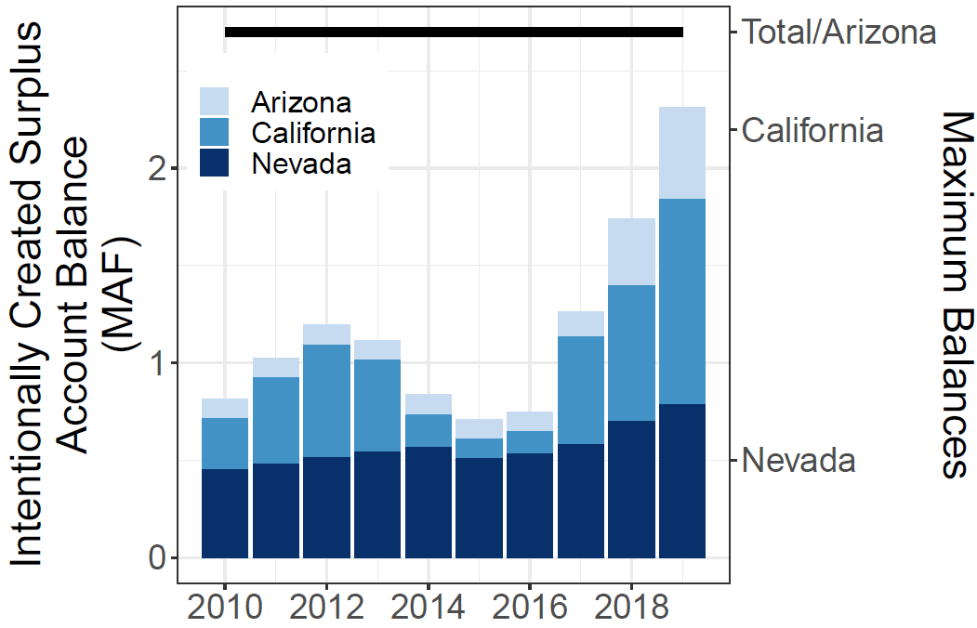  Figure 1. Balances in ICS accounts (USBR, 2019b) | 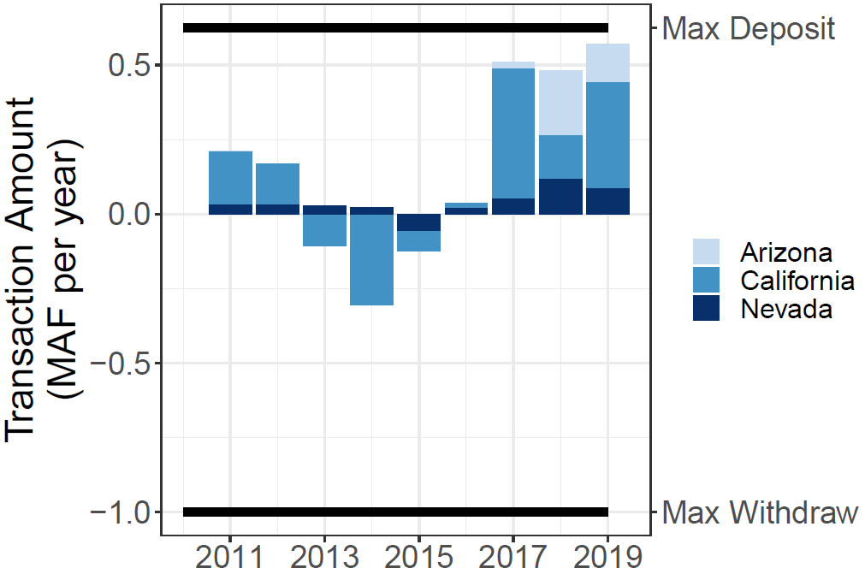  Figure 2. Deposits (+) and withdrawals (-) from ICS accounts (USBR, 2019b)

Compare largest annual ICS deposit to DCP targets
California and Nevada’s annual voluntary conservation efforts and credits to their ICS accounts already exceed their DCP conservation targets at all Lake Mead levels (Figure 3). These states demonstrated their conservation capacity. In contrast, Arizona’s largest voluntary conservation effort of 216,000 acre-feet in 2018 just exceeded it’s 192,000 acre-feet DCP conservation target when Lake Mead’s level is between 1,075 and 1,090 feet. Arizona’s largest voluntary conservation effort will need to triple to meet the state’s mandatory DCP targets at Lake Mead levels below 1,045 feet. Hopefully, Arizona’s plans to ramp up its mandatory conservation efforts will work (James, 2021).
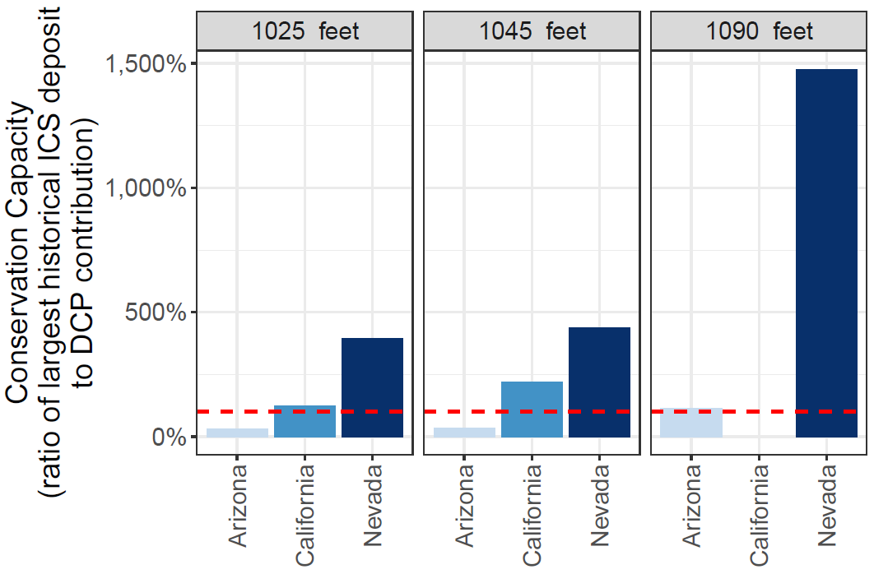
Figure 3. Ratio of largest prior voluntary conservation effort to mandatory DCP target. Dashed red line at 100% indicates the largest historical effort met the DCP target.

Compare ICS balance to DCP target
Within the Lower Basin DCP, a new account type called DCP ICS —yes, a compound acronym—allows states and contractors to covert ICS water to meet a state’s or contractor’s DCP conservation target. The total cap on all ICS and DCP ICS account balances stays at 2.7 million acre-feet but states.
Across all Lake Mead elevations, Nevada can convert and use its ICS water to meet its DCP targets for at least 25 years (Figure 4). California can convert and use its ICS balance to meet its DCP targets for 5 years at a Mead water level of 1,045 feet. Arizona’s ICS balance will only convert and meet 2.5 years of DCP targets at a Lake Mead elevation of 1,090 feet.
States and contractors will convert and use their ICS water to meet DCP targets because the Lower Basin DCP also allows users to fully recover their DCP ICS water once Lake Mead’s level recovers to 1,110 feet (12.6 million acre-feet storage). With constant or declining reservoir inflows, the ICS conversions will delay new mandatory conservation efforts and further decline Lake Mead’s level. States’ alternative to convert ICS waters is to start new mandatory conservation efforts, directly apply them to meet the DCP target, and permanently lose the conserved water.
To reduce or avoid the lake level decline, one may suggest to increase the cap on all ICS and DCP ICS accounts. By raising the cap, states and contractors may undertake new voluntarily conservation efforts each year, deposit to their ICS account, then convert and use their ICS water to meet their DCP target. Raising the cap would encourage new water conservation each year and DCP ICS accounts will grow over time. Raising the cap on ICS and DCP ICS accounts also increases the risk that the account balances will exceed the physical and active water storage in Lake Mead. Once the account balances exceed the physical water storage, the ICS water is no longer recoverable. The incentive to participate in the ICS program evaporates. Presently, the 2.7 million acre-feet cap on ICS and DCP ICS accounts seems small compared to Mead’s active storage or 10.9 million acre-feet. With declining reservoir storage and rising account balances, at what storage volume to cap the conservation accounts?

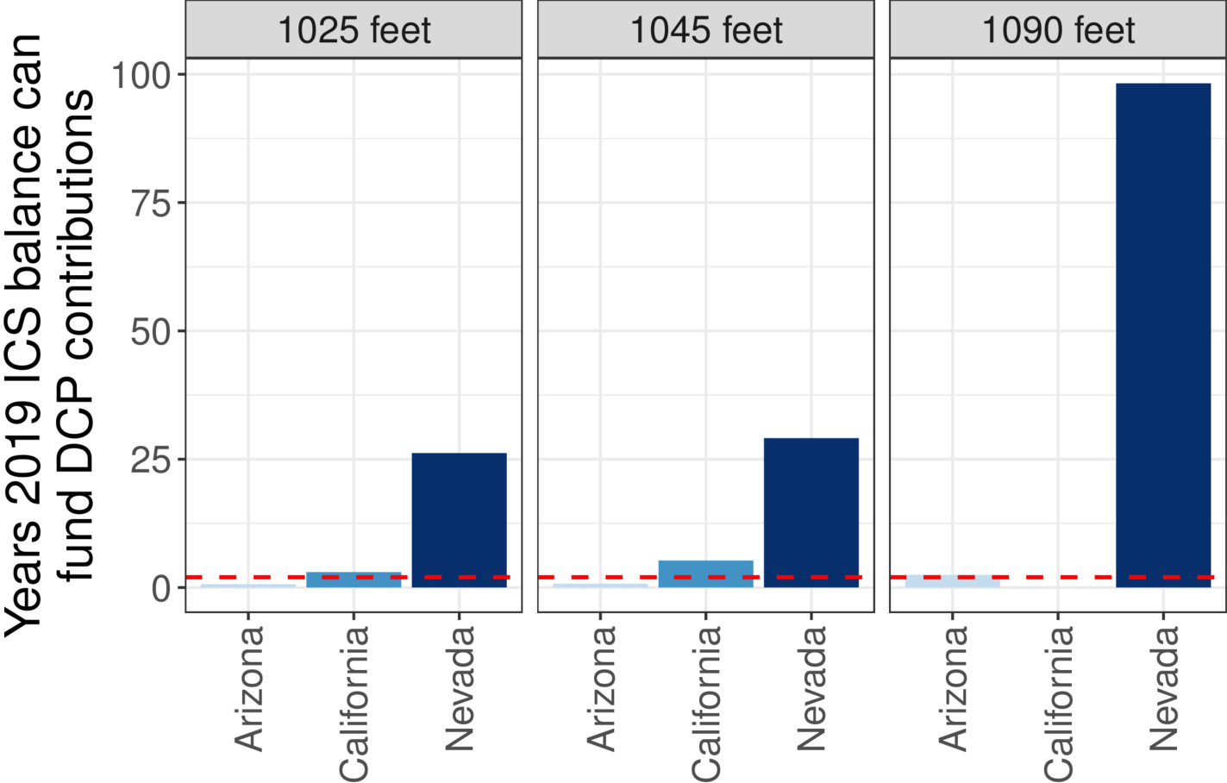
Figure 4. Years 2019 ICS balance can meet DCP targets. Dashed red line indicates 2 years.

Concluding Observations
Under the current Lower Basin DCP rules, the states and contractors should convert and use their ICS balances to meet their DCP targets. Depending on the state, the conversions can continue for several years. The conversions will simultaneously delay the onset of additional conservation measures and continue reservoir draw-down. This answer generates several follow-up questions:
- Will the Lower Basin states convert all their ICS water before they start additional voluntary or mandatory water conservation without credit or recovery?
- To what critical lake level will the states let Lake Mead decline before they start conserving water at the volumes needed to stabilize or recover the reservoir?
- How will reservoir inflows – that are not mentioned in the current DCP agreement (Wang et al., 2020) – affect drawdown and recovery?
- What can outsiders do to encourage the Lower Basin states and contractors to start additional mandatory and voluntary conservation efforts sooner?

The next posts in the this series Encouraging more water conservation in the Colorado River basin tackle these questions.

Data, Model, and Code Availability
The data, code, and directions to generate figures in this post are available on Github.com at (Rosenberg, 2021).

Acknowledgements
This work is unfunded. Eric Kuhn and Jennifer Pitt made comments to improve this piece.

References
James, I. (2021). "Southwest braces for water cutbacks as drought deepens along the Colorado River." Arizona Republic.
Rosenberg, D. E. (2021). "Intentionally Created Surplus for Lake Mead: Current Accounts and Next Steps." https://github.com/dzeke/ColoradoRiverFutures/tree/master/ICS.
USBR. (2007). "Record of Decision: Colorado River Interim Guidelines for Lower Basin Shortages and Coordinated Operations for Lakes Powell and Mead." U.S. Bureau of Reclamation. https://www.usbr.gov/lc/region/programs/strategies/RecordofDecision.pdf.
USBR. (2019a). "Agreement Concerning Colorado River Drought Contingency Management and Operations." U.S. Bureau of Reclamation, Washington, DC. https://www.usbr.gov/dcp/finaldocs.html.
USBR. (2019b). "Boulder Canyon Operations Office - Program and Activities: Water Accounting Reports." U.S. Bureau of Reclamation. https://www.usbr.gov/lc/region/g4000/wtracct.html.
USBR. (2020). "Water Operations: Historic Data, Upper Colorado River Division." Upper Colorado River Division, U.S. Buruea of Reclamation. https://www.usbr.gov/rsvrWater/HistoricalApp.html. [Accessed on: June 16, 2020].
Wang, J., Rosenberg, D. E., Schmidt, J. C., and Wheeler, K. G. (2020). "Managing the Colorado River for an Uncertain Future." Center for Colorado River Studies, Utah State University, Logan, Utah. http://qcnr.usu.edu/coloradoriver/files/CCRS_White_Paper_3.pdf.

