Sidebar: How much water to store in Lake Powell to benefit native fish of the Grand Canyon?
A tack-on analysis of the Lake Powell release temperature and depth-temperature profile data identifies ranges of reservoir water surface elevations to achieve four ecologically-relevant, temperature scenarios (Figure X). Water levels in August, September, and October above 3,675 feet will give cold releases less than 12ºC that force native fish to spawn in tributaries to the Grand Canyon (dark blue bars). Summer water levels between 3,600 and 3,675 feet will keep release temperatures below 15ºC that historically have been suitable for most native fish except razorback sucker (light blue bars). August to October water levels below 3,600 feet will warm releases up to 18ºC (pink bars). Here, outcomes are uncertain for native fish. Native fish may benefit, but they may also face invasion by warm water non-natives. Lastly, July to August water levels below 3,525 feet will warm releases above 18ºC and dramatically increase the potential for negative consequences for native species (red bars). Native fish of the Grand Canyon may face negative consequences even if the Upper Basin states maintain their drought contingency plan target of 3,525 feet. If managers forego turbine releases and release water through the river outlets, a similar stacked bar plot can be constructed that shifts water surface elevations down by 100 to 125 feet.
These results can help construct Fill Mead First and Fill Powell First alternative management paradigms (AMPs) that improve conditions for the native fish of the Grand Canyon. For example, use the elevations 3,600 and 3,675 feel (light blue bars) to set the Powell-Low and Powell-High parameters so release temperature more frequently stays below 15ºC. Additionally, define AMP elevation targets seasonally or monthly rather than annually to focus on summer months when releases are warmest and most threaten native fish. See Rosenberg (2020) for data, code, and further information.
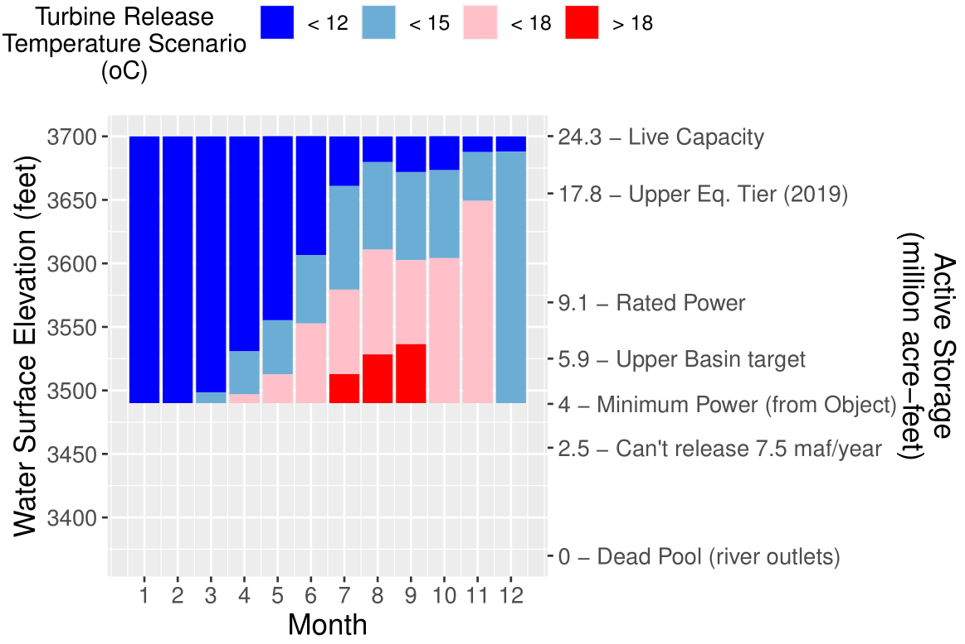
Figure X. Lake Powell water levels for turbine release temperature scenarios. Elevation ranges consider uncertainty in observed release and water profile data.

Appendix X. How much water to store in Lake Powell to benefit native fish of the Grand Canyon?

Introduction
Current Lake Powell reservoir operations for equalization and the Upper Basin drought contingency plan are articulated as target reservoir surface elevations and storage volumes. This short analysis asks and answers the question what Lake Powell water surface elevations will benefit native, warm-water fish of the Grand Canyon?

Prior Work
Reservoir release temperature is a key driver for fish of the Grand Canyon (Figure 1)(Dibble et al., 2020). During summer months, reservoir release water warms as it travels downstream to Lake Mead. Prior efforts have used process- and empirically-based models to relate reservoir water surface elevations to release temperature and release temperature to downstream temperatures (Dibble et al., 2020; Mihalevich et al.; USBR, 2007, Appendix F; Wright et al., 2009). These models require the user to specify difficult to predict inputs such as incoming solar radiation and air temperature.
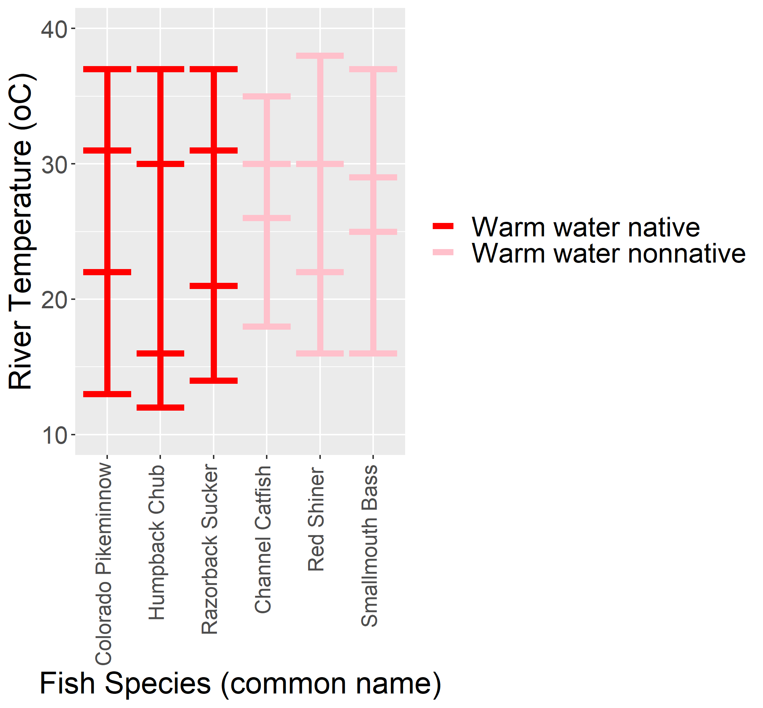
Figure 1. Minimum, minimum optimal, maximum optimal, and maximum temperature suitability (horizontal bars) for select native (red) and nonnative (pink) warm-water fish species of the Grand Canyon. Data from (Dibble et al., 2020).
As an alternative, here we use, link, and characterize uncertainties in the primary reservoir water level (USBR, 2020), release temperature (GCMRC, 2020), and depth-temperature profile (Vernieu, 2015) data. We then define ecologically-relevant release temperature scenarios that are favorable for native, warm-water fish of the Grand Canyon and visualize the reservoir elevation zones that correspond to each release temperature scenario.

Methods
First, use date and time information to link the primary observed reservoir water level (USBR, 2020), release temperature (GCMRC, 2020), and depth-temperature profile (Vernieu, 2015) data sets.
Second, define ecologically-relevant release temperature scenarios that are favorable for native, warm-water fish of the Grand Canyon (Table 1). The scenarios for <12ºC and <15ºC reflect that native, warm-water fish have slightly lower minimum and minimum optimal temperature thresholds than non-native fish (Figure 1).
Table 1. Reservoir release temperature scenarios
Scenario (ºC) | Ecological Meaning
< 12 | Year-round temperatures where native fish persisted, but likely only because they spawn in warmer tributaries.
< 15 | Thriving populations for many warm-water native fish except razorback sucker.
< 18 | Uncertain outcome. May benefit native fish, but may also harm them by facilitating invasion by warm water non-natives. Conditions have not existed for decades.
> 18 | Predictions are highly uncertain, and for which the potential for negative consequences for native species increases dramatically. Conditions have not occurred in many decades

Third, plot the daily range of observed release temperature data (GCMRC, 2020) for different water surface elevations (Figure 2, blue).
Fourth, translate the depth-temperature profile data (Vernieu, 2015) at the Wahweap station to show anticipated release temperatures at water surface elevations below historically observed elevations (Figure 2, red). The translation assumes that solar radiation is the primary driver of temperature in the reservoir epilimnion and that water temperatures at shallow depths below the water surface will be similar regardless if water surface elevation is 3490, 3500, 3600, 3610, etc. feet.
- For example, translate a temperature profile measurement of 18ºC 10 feet below (depth = 10 feet) an observed water surface elevation of 3,610 feet down to a water surface elevation of 3,500 feet. 10 feet below the new water surface elevation of 3,500 feet will give a release temperature of 18ºC at the turbine release elevation of 3,490 feet.
- Additionally, decrease the turbine release temperature by 0.5, 1, or 2ºC for Wahweap profile temperatures greater than 11, 13, and 15 ºC. This adjustment adjusts for differences between Wahweap and release temperatures due to turbine entrainment and other factors (Figure 3).
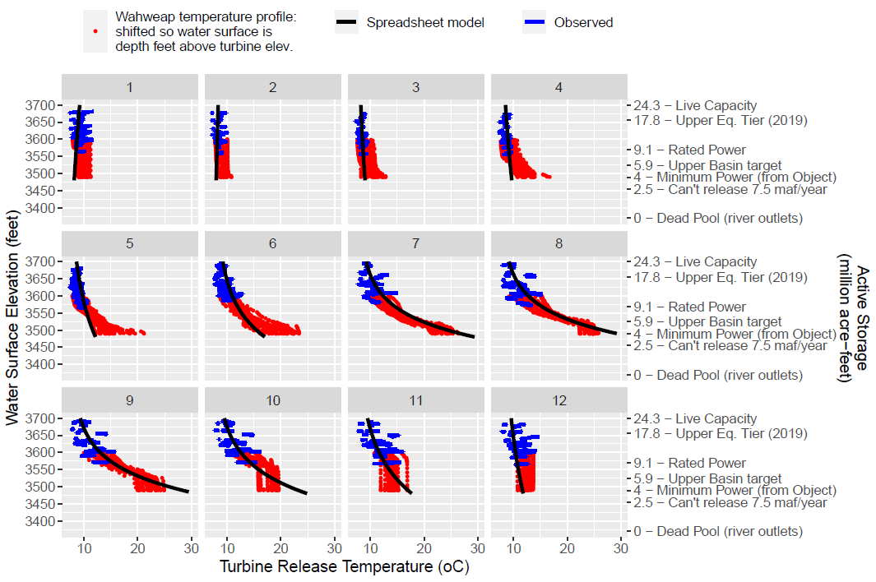
Figure 2. Compare observed penstock release temperature (blue) and translated depth-temperature profile data (red). Black lines show estimated release by an empirical spreadsheet model (Dibble et al., 2020)

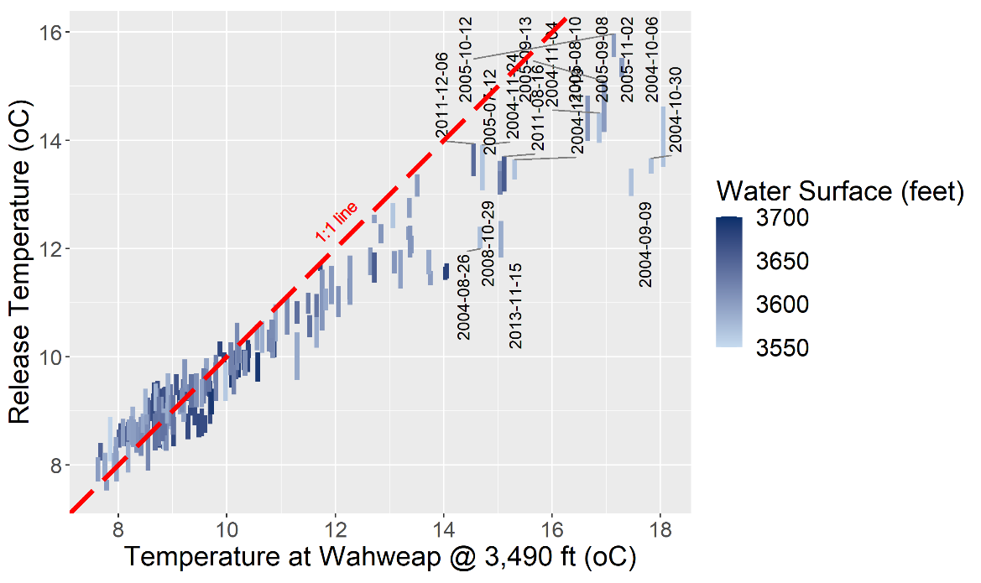
Figure 3. Comparison of turbine release and Wahweap profile temperatures at the turbine elevation of 3,490 feet.
Fifth, identify the range of reservoir water surface elevations for each release temperature scenario. For example, in August, we might see a 15ºC release through the turbine for reservoir elevations between 3,525 and 3,610 feet.
Finally, stack into bars the reservoir elevation ranges for each release temperature scenario (Figure 4).

Results
Examination of the stacked bars in Figure 4 shows:
- Elevation ranges of 3,600 to 3675 feet in August, September, and October will keep release temperatures below 15ºC and suitable for most warm-water native fish (light blue bars).
- Water levels above 3,675 feet will cool releases (< 12ºC) and force native fish to spawn in tributaries (dark blue bars).
- August to October water levels below 3,600 feet will warm releases (<18ºC) so that outcomes are uncertain for native, warm-water fish (pink bars) while water levels below 3,525 feet will further warm releases (> 18ºC) that dramatically increase the potential for negative consequences for native species (red bars).
Figure 4. Lake Powell water surface elevations to maintain release temperature scenarios through the turbines. Elevation ranges consider uncertainty in observed and water profile data.

If Glen Canyon Dam managers forgo penstock releases and release water through the river outlets, the same release temperatures can be achieved with reservoir water surface elevations that are 100 to 125 feet lower (Figure 5). For example, 15ºC releases can be maintained through September, October, and November with reservoir elevations down to 3,500 feet (compared to 3,600 feet if releasing all water through the penstocks). If managers release water through both the penstocks and river outlets, managers can maintain release temperatures at water surface levels below levels shown in Figure 4 and above levels shown in Figure 5.
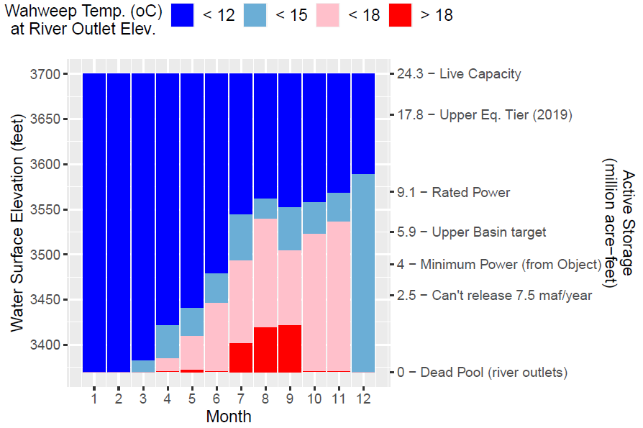
Figure 5. Lake Powell water surface elevations to maintain temperature scenarios through the river outlets. Elevation ranges consider uncertainty in observed and water profile data.

Limitations
This analysis assumes:
- Future relationships between reservoir release temperatures and reservoir water surface elevations will resemble the historical data.
- Similarly, the future relationship between reservoir release temperature and temperature at Wahweap at the turbine elevation will resemble the historical data.
- The future timing and magnitude of annual reservoir turnover will resemble historical turnover.
- Food and habitat will not limit native, warm-water fish of the Grand Canyon when release temperatures stay below 15ºC.

Wrap Up
The reservoir water surface elevations in Figures 4 or 5 can help specify reservoir water levels for Fill Mead First and Fill Powell First alternative management paradigms (AMPs) that benefit native fish of the Grand Canyon. For example, set the Powell-Low and Powell High parameters to 3,600 and 3,675 feet (range for light blue bars). The analysis also shows potential to define summer or monthly reservoir targets and better align operations with key periods important to native fish when reservoir releases are warmest.

Data, Model, and Code Availability
The data, models, and code that support this analysis are available at Rosenberg (2020).

References
Dibble, K., Yackulic, C., Kennedy, T., Bestgen, K., and Schmidt, J. J. (2020). "Water storage decisions will determine the distribution and persistence of imperiled river fishes." Ecological Applications, EAP20-0706.
GCMRC. (2020). "Glen Canyon Dam near Page, AZ." Grand Canyon Monitoring and Research Center, U.S. Geological Survey. https://www.gcmrc.gov/discharge_qw_sediment/station/GCDAMP/09379901#.
Mihalevich, B. A., Neilson, B. T., Buahin, C. A., Yackulic, C. B., and Schmidt, J. C. "Water temperature controls for regulated canyon-bound rivers." Water Resources Research, n/a(n/a), e2020WR027566. https://agupubs.onlinelibrary.wiley.com/doi/abs/10.1029/2020WR027566.
Rosenberg, D. E. (2020). "Colorado River Futures - Code Projects: Lake Powell Water Surface Elevations for Release Temperature Scenarios." Utah State University. https://github.com/dzeke/ColoradoRiverFutures/tree/master/LakePowellTemperatureScenarios.
USBR. (2007). "Colorado River Interim Guidelines for Lower Basin Shortages and Coordinated Operations for Lake Powell and Lake Mead – Final Environmental Impact Statement." U.S. Bureau of Reclamation. http://www.usbr.gov/lc/region/programs/strategies/FEIS/index.html.
USBR. (2020). "Water Operations: Historic Data, Upper Colorado River Division." Upper Colorado River Division, U.S. Buruea of Reclamation. https://www.usbr.gov/rsvrWater/HistoricalApp.html. [Accessed on: June 16, 2020].
Vernieu, W. S. (2015). "Historical Physical and Chemical Data for Water in Lake Powell and from Glen Canyon Dam Releases, Utah-Arizona, 1964 –2013." Data Series 471, Version 3.0. https://pubs.usgs.gov/ds/471/pdf/ds471.pdf.
Wright, S. A., Anderson, C. R., and Voichick, N. (2009). "A simplified water temperature model for the Colorado River below Glen Canyon Dam." River Research and Applications, 25(6), 675-686. https://onlinelibrary.wiley.com/doi/abs/10.1002/rra.1179.

