Logan, Utah Experiment with Leading Digits

David E. Rosenberg

June 14, 2020

## R Markdown

This is an R Markdown document to test the leading digits principle (numbers disproportionately have leading digits of 1) on smart meter data for a manufacturing user in Logan, Utah.

This code is accessible at: Rosenberg (2020). <https://github.com/dzeke/leading-digits>. It is forked from code by Sowby (2020) <https://github.com/rsowby/leading-digits>.

For more on the claims of leading digits and water use, see Sowby, R. B. (2018). “Conformance of Public Water Use Data to Benford’s Law.” Journal - AWWA, 110(12), E52-E59. <https://awwa.onlinelibrary.wiley.com/doi/abs/10.1002/awwa.1161>.

## Loading required package: readxl

## Loading required package: dplyr

## Warning: package 'dplyr' was built under R version 3.5.3

##   
## Attaching package: 'dplyr'

## The following objects are masked from 'package:stats':  
##   
## filter, lag

## The following objects are masked from 'package:base':  
##   
## intersect, setdiff, setequal, union

## [1] "Process started at 2020-06-14 21:52:48"

## [1] "Dataset2.csv"  
## [1] "mydata is now 879419 records"  
## [1] "mydatahourly is now 622 records"  
## [1] "mydatahourly is now 550 records"

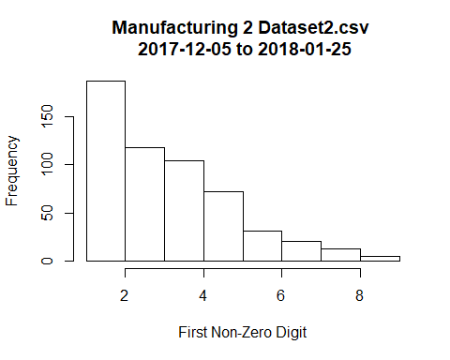

## [1] "Dataset3.csv"  
## [1] "mydata is now 523775 records"  
## [1] "mydatahourly is now 372 records"  
## [1] "mydatahourly is now 317 records"

