SOFTWARE REQUIREMENTS SPECIFICATION
Project Title: PSU AI.D: AI-Powered Student ID System for Pangasinan State University

General Description
A next-generation ID processing system for Pangasinan State University that leverages Artificial Intelligence to automate photo validation, enable instant digital payments, provide temporary digital IDs, and streamline batch processing and printing. PSU AI.D addresses long delays, rejected applications, and manual errors by offering students and administrators a faster, smarter, and more reliable ID issuance experience.

Functional Requirements
- Secure Student Login
- Students can log in using their official PSU credentials, ensuring only authorized users can access the system.
- AI-Powered Photo Validation
- The system uses AI to automatically check uploaded photos against requirements (white shirt, white background, clear face, uncovered ears).
- Instant Feedback on Invalid Photos
- If a student’s photo fails validation, the system instantly rejects it and provides clear feedback so corrections can be made right away.

- 24/7 Online Application Submission
- Students can apply for their ID anytime through the web-based portal, without waiting for manual announcements from the registrar.
- Integrated Digital Payment
- Students can pay ID fees directly within the system using GCash, PayMaya, or other PSU-approved payment gateways.
- Temporary Digital ID Generation
- Upon successful submission and payment, the system generates a digital ID that students can use immediately while waiting for their physical ID.
- Real-Time Application Status Updates
- Students are automatically notified of their application status (accepted, rejected, payment pending, ready for pickup) through the system.
- Batch Processing for Instructors/Admins
- Administrators can process multiple ID applications at once, saving time and reducing repetitive manual tasks.
- Payment Validation Dashboard
- Admins can view and verify payment records in real time, ensuring that only students with confirmed payments proceed to ID issuance.

Non-Functional Requirements
- Performance – The system must handle up to 100 student submissions simultaneously without lag.
- Security – All student photos, payments, and records must be encrypted; access restricted by user roles.
- Usability – Simple interface with clear upload instructions and visual guides for students.
- Reliability – AI photo validation and payment verification must provide accurate and consistent results.
- Maintainability – Code should be modular (separate modules for AI validation, payments, notifications, and printing).
- Compatibility – Must work on desktops, laptops, and mobile devices (responsive design).
- Availability – System should be online 24/7 with scheduled maintenance only during off-peak hours.
- Scalability – Designed to support future features (e.g., alumni ID requests, RFID integration).

IV. Prototype/GUI Screen Prints/Drawing
PLATE 1. Login Page
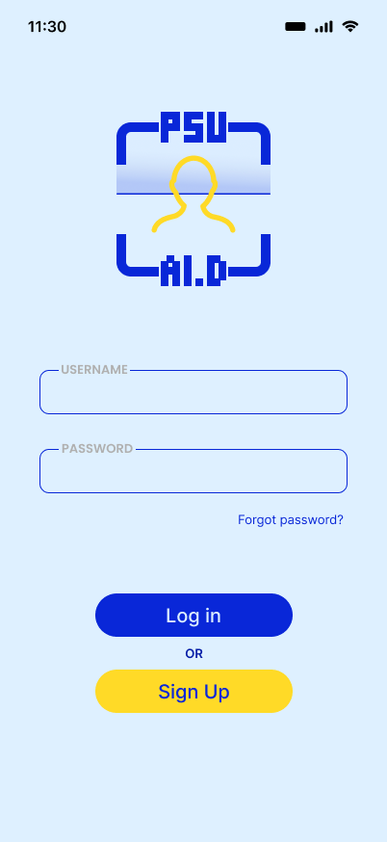
Plate 1 displays the PSU-A.I.D. application's login page user interface with input for a Username and Password below the clear application logo. The layout presents both "Sign Up" and "Log in" options allowing users neat access to either existing or new accounts.

PLATE 2. Student Dashboard
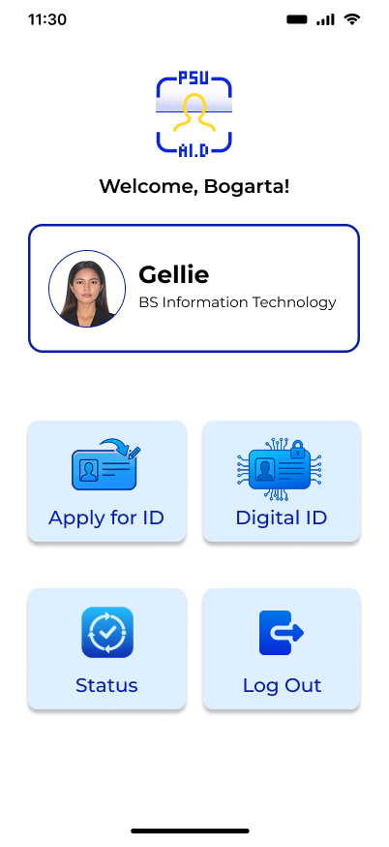
Plate 2 shows the user's dashboard, which immediately welcomes the user. It clearly displays his profile information and gives him four simple options for his ID needs: Apply, Digital ID, Status, and Log Out.

PLATE 3. Student Apply for ID
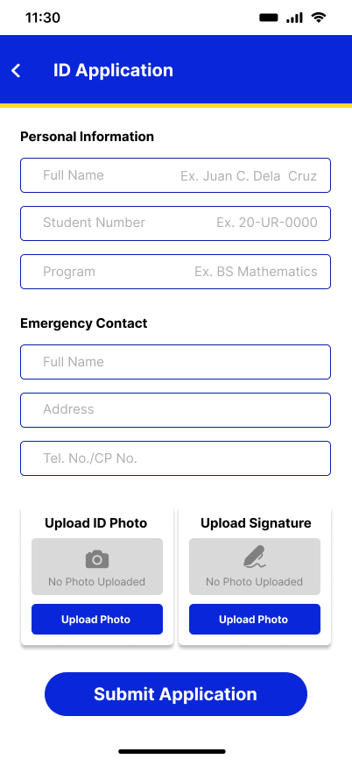
Plate 3 shows the ID Application screen, where the student fills in their personal and emergency contact details. The final step is they upload a photo and signature before clicking the "Submit Application" button.

PLATE 4. Photo Validation
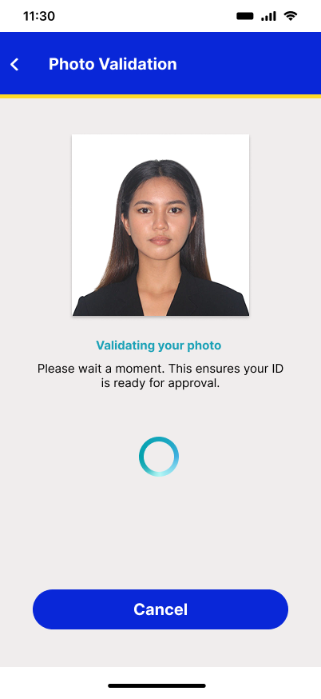
Plate 4 the Photo Validation screen, which pops up while the system checks the quality of the uploaded photo. The message simply asks you to wait a moment while your picture is processed before the application moves to the approval stage

PLATE 5. Student ID Status
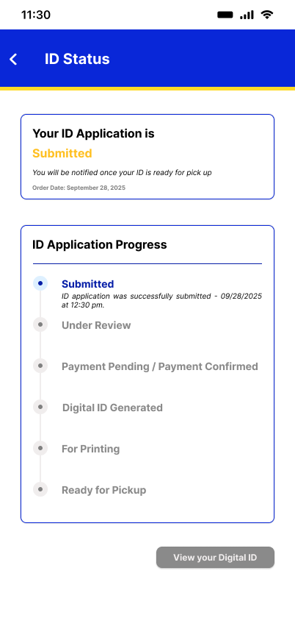
Plate 5 shows the Student ID Status page, which immediately tells the user their application is Submitted. It also includes a clear timeline of all the steps from Under Review to Ready for Pickup so they know exactly what's next.

PLATE 6. Student Digital ID
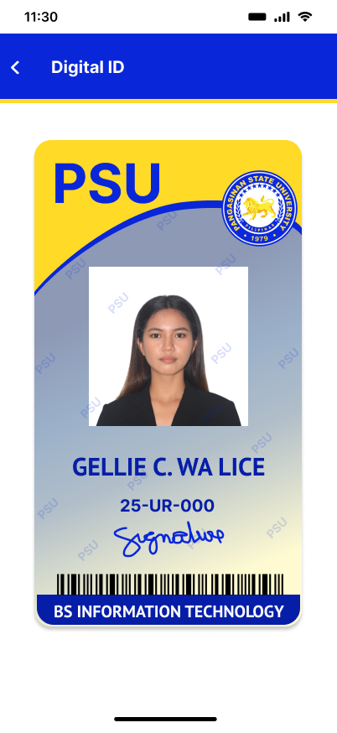
Plate 6, the Digital ID screen, which shows the student a complete, virtual version of their school ID card. It clearly displays the student's photo, name, program, and signature for easy verification while waiting for their physical ID.

PLATE 7. Admin Dashboard
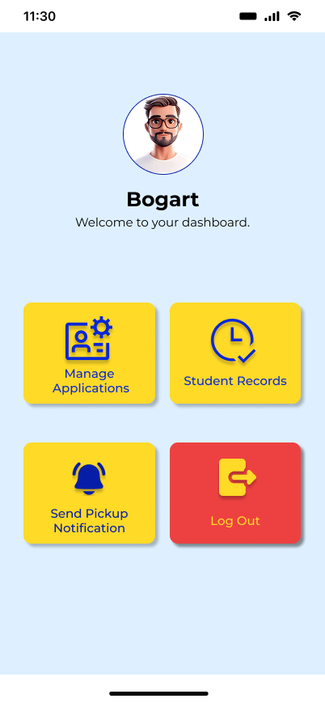
Plate 7 shows the Admin Dashboard, which welcomes the admin, to the system management interface. He has four clear options to run the ID process: Manage Applications, Student Records, Notify for Pickup, and Log Out.

PLATE 8. Admin Manage Applications
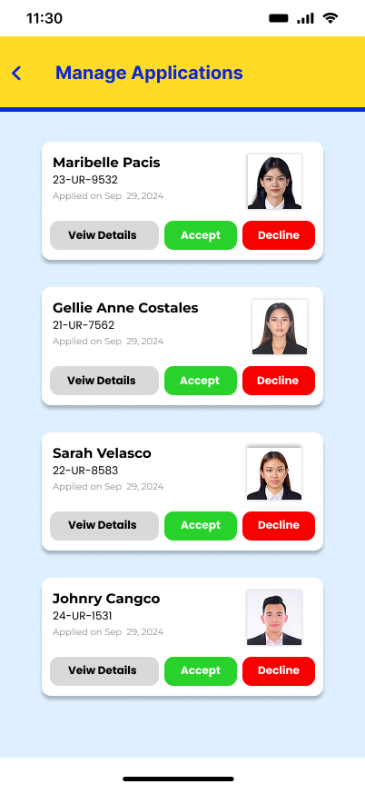
Plate 8 shows the Admin's application review screen, showing a list of students waiting for ID approval. The admin has clear options to View Details for a closer look, then immediately Accept or Decline the request.

PLATE 9. Admin Student Records
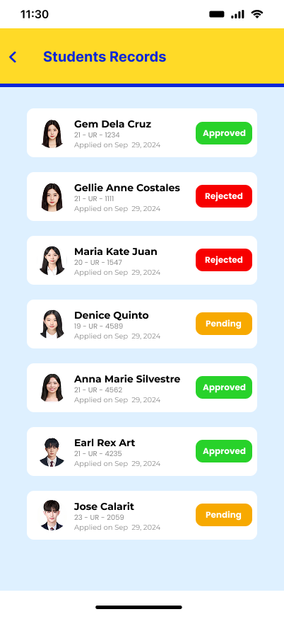
Plate 9, the Student Records screen, which shows the admin a list of all ID applications records. The status is clear for every student, quickly showing if they are Approved (green), Rejected (red), or Pending (orange).

PLATE 10. Admin Send Pickup Notification
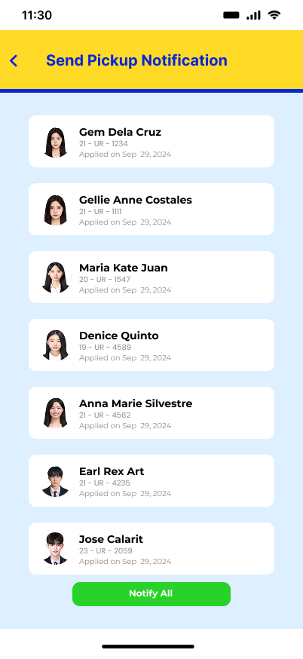
Plate 10, the Send Pickup Notification screen, showing a list of students whose IDs are ready for them. The admin just needs to hit the green "Notify All" button at the bottom to send the message to everyone.

V. Modules of the App with Descriptions
Login Module
- This module allows both students and administrators to securely access the system using their official PSU credentials. It ensures that only authorized users can access their respective dashboards and features.
Data Required:
- Username / PSU Email
- Password
Student Module
- This module enables students to apply for their ID online through the PSU AI.D web portal. Students can upload their ID photo, check for validation results, complete payment, and track their application status in real time.
Sub-Modules:
- Photo Upload and Validation – AI automatically checks if the uploaded photo meets PSU standards (white background, white shirt, clear face, uncovered ears).
- Payment Submission – Students can pay directly via integrated gateways such as GCash, PayMaya, or other PSU-approved options.
- Digital ID Access – Upon approval and payment confirmation, the system generates a temporary digital ID.
- Status Tracking – Provides real-time updates (Pending, Rejected, Payment Verified, Ready for Pickup).
AI Validation Module
- The core AI-powered feature of the system that validates student ID photos. It analyzes facial clarity, background color, dress code, and other requirements to ensure compliance with PSU ID standards.
Data Processed:
  - Uploaded Photo
  - Validation Results (Pass/Fail with Reasons)
Payment Module
- This module handles all digital transactions related to ID fees. It integrates with secure payment gateways, automatically records payment confirmations, and links them to corresponding student applications.
Sub-Modules:
  - Payment Verification – Confirms the transaction via the gateway’s API.
  - Receipt Generation – Issues a digital payment receipt viewable by students and admins.
  - Refund Management (optional) – For handling failed or duplicate transactions.
Digital ID Module
- Once an application is approved and payment is verified, this module automatically generates a temporary digital ID that students can use while waiting for their physical card.
Data Included:
  - Student Name
  - Student Number
  - Course & Department
  - QR Code for Verification

Admin Module
- This module gives administrators and registrar staff full control over the ID application process. They can view, approve, reject, or edit applications, verify payments, and manage system data.
Sub-Modules:
- Dashboard Overview – Displays total applicants, pending IDs, rejected photos, and payment summaries.
- Batch Processing – Allows admins to process multiple ID applications simultaneously.
- Payment Validation Dashboard – Lists confirmed and pending payments for cross-checking.
- Report Generation – Exports reports for record-keeping and audit purposes.

Notification Module
- Sends real-time notifications to students about their ID application status. Notifications appear within the web app or via email.
Triggers:
  - Photo Rejected
  - Payment Confirmed
  - ID Approved / Ready for Pickup

Security and Access Control Module
- Ensures data confidentiality and system integrity by implementing PSU’s authentication policies and encryption standards.
Functions:
  - Secure Login (HTTPS, token-based authentication)
  - Role-based Access (Student, Admin)
  - Data Encryption for personal and financial data

VI. ERD & System Flowchart
ENTITY RELATIONSHIP DIAGRAM
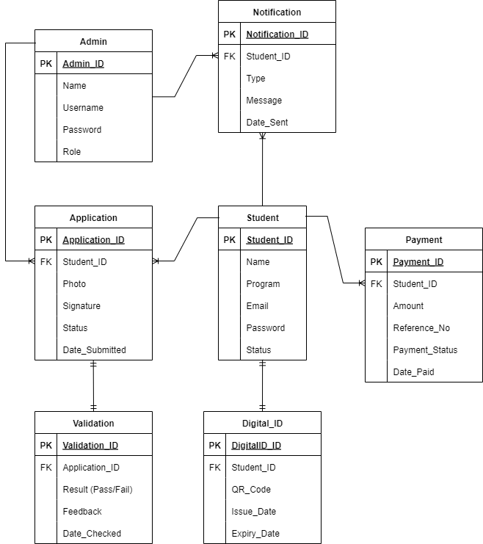

SYSTEM FLOW CHART (Student)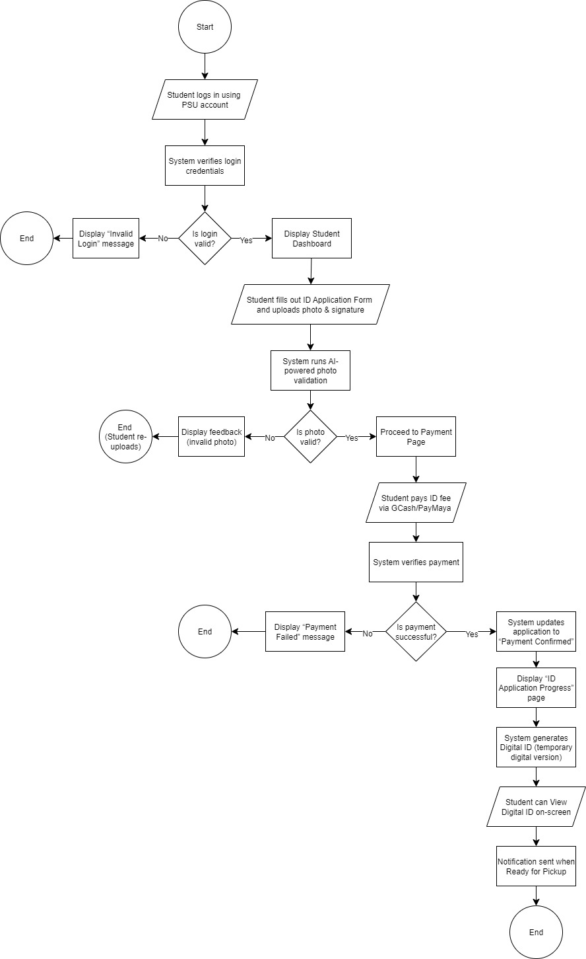
SYSTEM FLOW CHART (Admin)
