 

INSTRUCTION rOR PAYMENT IN EUR CURRENCY

Pihak pay 0s per instructions given below:

56A: Interm ediary Inst itut ion’: BltAUATWW‘ fUNlCREDlT BANK AUSTRIA);

OR

KTAGOEFF (KT BANK AG, GERMANY)

OR

PBZGHR2X {PRIVREDNA BANEA OD CROATtA);

S7A: Account with institution:

59A: Benefidary customer.

IBAN/Account number

70: }iemIttance Information: Note-

oaum:26.02.t02009:J0:02

BBIBBA22XXX

BOSNA BANK INTE RNATIONAL DD SARAJEVO SARAJEVO, BOSNIA AND fIfR\*FGOVINA

MEOZLIS ISLAMSXE ZAJEDNICE BANJA LUKA

KRAMA PETRA I KRAOOROEVICA 46 8ANJA LUKA

BOSNA I HERC£GOVINA BA39141555541f t00288

Purpose of payment

Usage of the Welds S6A, S7A, S9A and ’7O is mandatory.

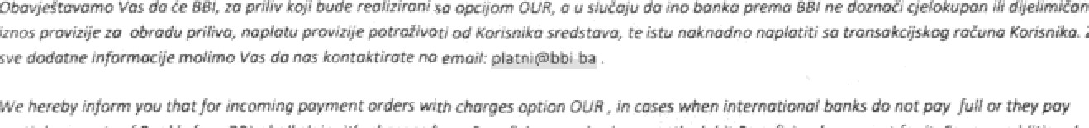

\* You can uwwe of che fol rgcorrespor\*dent banks m nder zo mv parents in Eur w favour of account witr OBE