**SETUP GUIDE**

Book store test

Requirement and Assumption

* Apache 2
* Php 7.2
* Composer

Assuming have a knowledge on setting up a simple server and having basic CLI knowledge.

1. **Get files**

Extract from Zip file or clone using Git

git clone <https://github.com/dzero1/99xt_test.git> book_store

cd book_store

1. **Composer install**

composer install

1. **Run using symfony CLI**

symfony server:start

**Or using WAMP/LAMP/XAMP/MAMP**

Make a symbolic link for “Public” folder on “www” folder. Edit the .htaccess file inside the public folder accordingly.

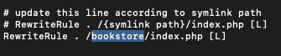

1. **Create database schema**

Make a schema as “99xt_store_system”.

Make sure to change user, password and host from **.env** file, according to your system.



1. **Run migration**

php bin/console doctrine:migrations:migrate

1. **Add default data**

php bin/console app:default-data

After run above command and you will see the auto generated coupon codes

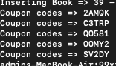

That’s it. If you used symfony CLI browse to <http://127.0.0.1:8000> or follow the localhost path

To run Unit testing use following commands

To test web routers:

php bin/phpunit tests/Controllers/WebsiteTest.php

Test for discount:

php bin/phpunit tests/Controllers/DiscountTest.php