COMP 7300/7306 Advanced Computer Architecture

Homework 2: Exercises (Individual, 100 pts)

IMPORTANT:
A late submission will get a 50% penalty if submitted after 9:00pm on the due day. After 9:00pm the next day, the submission will be worthless. Penalty will be 75% if submission is made between 9:01 and 10:00pm.

Exercises to work out and turn in INDIVIDUALLY:

Grading Guidelines:
A perfect answer is a self-contained: it includes rules/relations from the courses, the data from the exercise and a clear right answer that is the result of a logical reasoning.
A right answer will get full credit when:
- It is right (worth 25%)
- It is right AND neatly presented making it easy and pleasant to read. (another 25%)
- There is an obvious and clear link between 1) the information provided in the exercise and in class and 2) the final answer. A clear link is built by properly writing, justifying, and documenting an answer (another 50%).
Calculation mistakes will be minimally penalized (2 to 5% of full credit) while errors on units will be more heavily penalized.
You are welcome/encouraged to discuss exercises with other students, the TA, or the instructor. But, ultimately, personal writing is expected.
Remember, the weight of these exercises is very low relatively to tests. But, these exercises will have a decisive impact on your performance in tests.

USE THIS FILE AS THE STARTING DOCUMENT YOU WILL TURN IN. KEEP THE QUESTIONS AND INSERT YOUR ANSWERS.

IF USING HAND WRITING (STRONGLY DISCOURAGED), REWRITE THE QUESTIONS.

Blue Questions (No Need to turn in)
1) Choose three out of the six basic optimizations, and discuss in your own words their impact on hit time, bandwidth, miss penalty, miss rate, power consumption, and hardware cost/complexity.
2) (Choose FOUR out of the 10 optimizations, and discuss in your own words their impact on hit time, bandwidth, miss penalty, miss rate, power consumption, and hardware cost/complexity.

Exercise 1 (30 points) We assume that the cache size is 4 KB (data). We assume that M[i][j] is adjacent to M[i][j+1] in the memory and that the cache is fully associative using LRU replacing. We assume that an integer takes 4 bytes. Consider the following code that doubles a matrix in place:
int A[n][n];
int i,j;
for (j = 0; j < n; j++){
for (i = 0; i < n; i++)
A[i][j] = 2 * A[i]j]
}
- Suppose that n = 64 and the block size is 128 bytes.
  - How many blocks does the cache contain?
Since the block size is 128 bytes and the cache size is 4KB, the # of blocks would be 32.
  - How many blocks are needed to store one line?
Since the block size is 128 bytes and an integer takes 4 byte, so one block can store 32 integers. Because there are 64 integers in one line, 2 blocks are needed to store one line.
  - How many blocks are needed to store the full matrix?
2 blocks are needed to store one line and there are 64 lines in total, so 128 blocks are needed to store whole matrix
  - How many compulsory, capacity, and conflict misses will we have? Can we decrease any of the above misses using loop interchange or blocking? If yes, show how and tell the decrease in the number of misses for each category.
There are 128 compulsory misses because there are 128 blocks are needed in matrix, every time a new block in those128 blocks for matrix in cache, that would be a compulsory miss. There are 64*64-128 capacity misses, because besides those 128 blocks, every time a new block stored in cache, it would find out there is no place in cache. There is no conflict miss, because in full associative cache there is no certain place for a block. Yes, we can decrease the missed. Instead of doing columnwise, we can do this matrix double in rowwise. By doing this in rowwise, when a block is brought up in cache, the next 31 integers are also brought in cache, because M[i][j] is adjacent to M[i][j+1]. In this way, there would be 128 compulsory misses and no capacity misses.
- Redo a) with n = 64, and the block size is 256 bytes
1. Since the block size is 256 bytes and the cache size is 4KB, the # of blocks would be 16.
2. Since the block size is 256 bytes and an integer takes 4 byte, so one block can store 64 integers. Because there are 64 integers in one line, 1 blocks are needed to store one line.
3. 1 blocks are needed to store one line and there are 64 lines in total, so 64 blocks are needed to store whole matrix
4. There are 64 compulsory misses because there are 64 blocks in matrix, every time a block in 64 blocks in matrix stored in cache, that would be a compulsory miss. There are 64*64-64 capacity misses, because beside the 64 matrix blocks are stored, every time a new block are stored in cache, there is no place in cache. There is no conflict miss, because in full associative cache there is no certain place for a block. Yes, we can decrease the missed. Instead of doing columnwise, we can do this matrix double in rowwise. By doing this in rowwise, when a block is brought up in cache, the next 63 integers are also brought in cache, because M[i][j] is adjacent to M[i][j+1]. In this way, there would be 64 compulsory misses and no capacity misses.
- Redo a) with n = 64, and the block size is 512 bytes
1. Since the block size is 512 bytes and the cache size is 4KB, the # of blocks would be 8.
2. Since the block size is 512 bytes and an integer takes 4 byte, so one block can store 128 integers. Because there are 64 integers in one line, a half of blocks are needed to store one line.
3. a half of blocks are needed to store one line and there are 64 lines in total, so 32 blocks are needed to store whole matrix
4. There are 32 compulsory misses because there are 32 blocks in matrix, every time a block in 32 matrix block stored in cache, that would be a compulsory miss. There are 64*64/2-32 capacity misses, because after the 32 matrix blocks are stored, every time a new block are stored in cache, there is no place in cache. There is no conflict miss, because in full associative cache there is no certain place for a block. Yes, we can decrease the missed. Instead of doing columnwise, we can do this matrix double in rowwise. By doing this in rowwise, when a block is brought up in cache, the next 127 integers are also brought in cache, because M[i][j] is adjacent to M[i][j+1]. In this way, there would be 32 compulsory misses and no capacity misses.
Exercise 2: Virtual memory
We consider a 32 bit address bus and a 512 KB physical memory. Page size is 32 KB.
- Assuming a validity bit, a dirty bit, and two reference bits, what is the size of the page table? Show the different steps to determine the page table size.
Because the address bus has 32 bit, there are 2^32 virtual addresses. Page size is 32KB means physical address and virtual address offset both have 15 bits. 512KB physical memory and 32 KB page size means there would be 2^4=16 frames in physical memory. The physical address has a validity bit, a dirty bit, two reference bits and 4 frame address bit= 1+1+2+4=8 bits. The # of entry in page table is 2^32/2^15=2^17, so the size of page table is 2^17*8=2^20.
- Suppose that Entry n in the page table contains the value floor(n/2^{^10}). What is the physical address associated with virtual address (0x10002400)?
0x10002400 in hexadecimal is 0001 0000 0000 0000 0010 0100 0000 0000
There are 15 bits offsets, there are 17 bits left. 2^17/2^10=2^7, so the physical address is combined by first 14 bits and last 7 bits.
Physical address: 0001000010010000000000

Exercise 3: Deriving the pipeline speed up
Consider a monocycle CPU with 5 "operations". We assume that all instructions need the 5 operations (stages). Four of these stages take 100 ps each and the last stage takes 200ps.
1) What is the latency of one instruction on the monocycle CPU?
Because the CPU is monocycle, every instruction has to experience these five stages. So, 600ps.
2) What should be the clock frequency for the monocycle CPU?
The time consumed on an instruction is 600ps=6*10^-10, so the clock frequency is 1/600ps=1.67GHz.
3) What is the throughput (bandwidth) of the monocycle CPU?
Every instruction takes 600ps, so in 1 second there would be 1.67*10^9 instructions are taken care of.
4) Consider a program P with n instructions. What is the execution time for Program P (expression as a function of n)?
That would be n*600ps.
5) We want to pipeline the CPU above with one stage per operation. We neglect the buffer time between stages. All the questions below apply to the pipeline .
a) What is the latency for one instruction for the pipelined CPU?
The instructions are operating in different stages at same time, and they can transferred to next stage at the minimum operating time among all stage times. So the latency would be 1000ps.
b) What should be the clock frequency for the pipelined CPU?
Every 200ps=2*10^-10 an instruction can finish their work in CPU, so the clock frequency is 1/200ps=5GHz
c) What is the throughput (bandwidth) of the pipelined CPU?
Every second there are 5*10^9 instructions can finish their job in CPU.
d) Consider a program P with n instruction. What is the execution time for Program P?
The first instruction takes 1000ps to be processed, and every instruction after it would finish their job 200ps later, so (n-1)*200ps+1000ps.
(Make sure to take into account the phase to fill up the pipeline and wind it up)
6) What is the expression of the speed up (monocycle versus pipelined)? If n tends to infinity, what is the speed up?
Speedup=(n*600)/((n-1)*200+1000),when n tend to infinity, speedup would be 3.

Exercise 4
Consider the datapath on this figure:
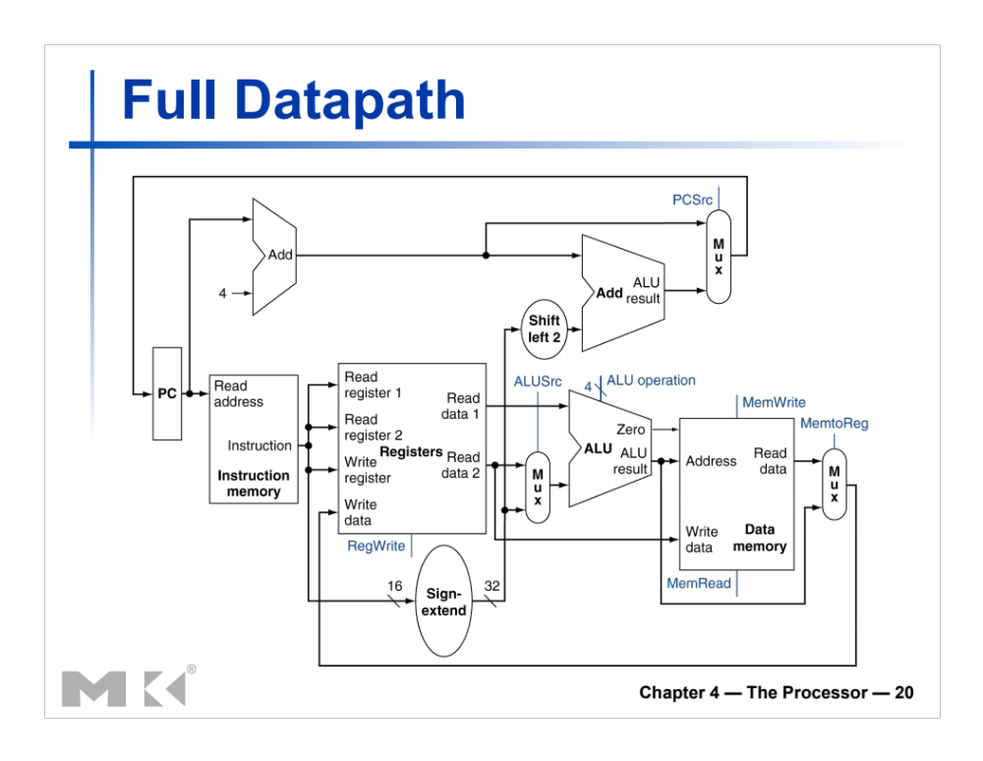
- Does this datapath support the following instruction:
lwr $r1, $r2($r3)? $r1 <- Mem[$r2 + $r3]
Example: if $r2 = 8 and $r3 = 120, the CPU will load the content of Mem[8+120] into register $r1.
Yes.
- If the answer is no,
  - Propose an instruction code for lwr (consistent with the instruction defined so far. This means that the first most significant bits should be reserved for the opcode)
Opcode(6bits) | Rs(5bits) | Rt(5bits) | Rd(5bits) | Shamt(5bits) | Funct(6bits)
000000 | 00010 | 01000 | 00101 | 00000 | 100000

  - Based on your instruction code, draw/add the datapath needed to support the lwr instruction.

  - After you draw the datapath, label the relevant buses with size and the content for the instruction lwr $1, $4($17). Assume that $1 = 32, $4 = 80, $17 = 40, and Mem[120] = 4321.

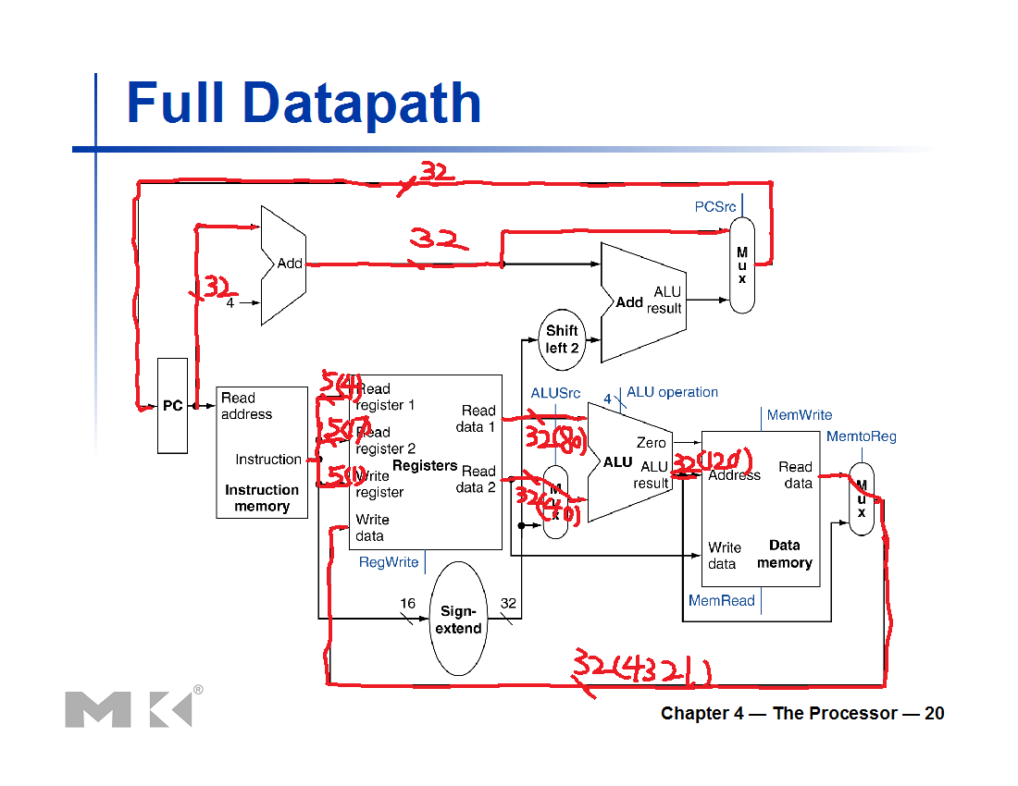

Based on progress, additional exercises may be added.
What to turn in INDIVIDUALLY?
Electronic copy of your exercises. Use Microsoft Word or PDF.

IMPORTANT:
A late submission will get a 50% penalty if submitted after 9:00pm on the due day. After 9:00pm the next day, the submission will be worthless.

