COMP 7300/7306 Advanced Computer Architecture

Homework 3: Exercises (Individual, 100 pts)

IMPORTANT:
A late submission will get a 50% penalty if submitted after 9:00pm on the due day. After 9:00pm the next day, the submission will be worthless. Penalty will be 75% if submission is made between 9:01 and 10:00pm.

Exercises to work out and turn in INDIVIDUALLY:

Grading Guidelines:
A perfect answer is a self-contained: it includes rules/relations from the courses, the data from the exercise and a clear right answer that is the result of a logical reasoning.
A right answer will get full credit when:
- It is right (worth 25%)
- It is right AND neatly presented making it easy and pleasant to read. (another 25%)
- There is an obvious and clear link between 1) the information provided in the exercise and in class and 2) the final answer. A clear link is built by properly writing, justifying, and documenting an answer (another 50%).
Calculation mistakes will be minimally penalized (2 to 5% of full credit) while errors on units will be more heavily penalized.
You are welcome/encouraged to discuss exercises with other students, the TA, or the instructor. But, ultimately, personal writing is expected.
Remember, the weight of these exercises is very low relatively to tests. But, these exercises will have a decisive impact on your performance in tests.

USE THIS FILE AS THE STARTING DOCUMENT YOU WILL TURN IN. KEEP THE QUESTIONS AND INSERT YOUR ANSWERS.

IF USING HAND WRITING (STRONGLY DISCOURAGED), REWRITE THE QUESTIONS.

Questions (10 points) : The following questions are related to instruction-level parallelism (pipelining). For this discussion, consider a pipeline with 6 stages. The latency of the stages varies from 100ps to 400ps.
- What is the maximal expected speedup that we can expect from this pipeline versus the same CPU if it was implemented as a monocycle (one stage) CPU?
We assume a program has n instructions. If the CPU use pipeline technique, the time it spent is 400*(n+5); if the CPU use monocycle technique, the longest time it may spend is 400*6*n. So the maximal speedup is 6.
- Is this maximal expected speedup achieved in practice? If no, explain ALL obstacles that decrease the expected speedup.
No. First of all, this speedup is based on the condition that the instruction of the program is infinity which is impossible. Secondly, when the latencies of stages are balanced, the speedup is 6, but when staged is not balance, it would decrease.

Exercise 1: (25 points) We assume that the data cache size is 1 KB (data) and the block size is 16 bytes. We assume that M[i][j] is adjacent to M[i][j+1] in the memory and that the cache is fully associative using LRU replacing. Consider the following code:
char A[64][64];
int i,j;
for (j = 0; j < 32; j++){
for (i = 0; i < 64; i++){
A[i][j] = A[i][j] ^ A[i][n-1-j];
A[i][n-1-j] = A[i][j] ^ A[i][n-1-j];
A[i][j] = A[i][j] ^ A[i][n-1-j];
}
}
This code performs a SPECIAL column-wise transpose. As indicated on Figure 2, the transposition is performed as follows: the first column(j=0) and the last column (j=63) are swapped, the second column (j=1) and the column (j = 62) are swapped, and so on…

Figure 2
We assume that the code is in a separate instruction cache and the variables i and j are in registers.
- Recall that this matrix contains characters (1 byte per character). How many blocks are needed to store one line of the matrix?
One block has 16 bytes, one line has 64 bytes, so 4 blocks are needed to store one line.
- How many blocks are needed to store the full matrix?
There are 64 lines in matrix, so 4*64=256 blocks are needed to store whole matrix.
- How many blocks does the cache contain?
Cache size is 1KB, so 1KB/16B=64blocks in cache.
- How many compulsory misses occur?
Because 256 blocks are needed to store full matrix, compulsory miss is 256.
- How many capacity misses occur?
To implement this loop, the block in memory would be taken into cache 64*64 times. 256 times of them are compulsory miss, so the capacity miss is 64*64-256.
- How many conflict misses occur?
Because the cache uses full associative technique, there would be no conflict miss.
- Would a loop interchange decrease the number of capacity misses? If yes, rewrite the loops with the loop interchange (no need to repeat the swapping instructions) and provide the new number of capacity misses.
Yes.
char A[64][64];
int i,j;
for (i = 0; i < 32; i++){
for (j = 0; j < 64; j++){
………
}
}
Because the loop goes rowwise and M[i][j] is adjacent to M[i][j+1], when a block is stored in cache, next 15 character will be hits not miss. So the capacity miss is 0.

- What would be the number of compulsory misses with a loop interchange?
Still 256 compulsory miss, because compulsory miss is irreducible.
- What should be the minimal size of the cache if we wanted to use blocking?
Because the loop is using two blocks simultaneously, the cache should be able to contain two blocks. 16B*2=32B

Exercise 2: (25 points) Consider the datapath on this figure:
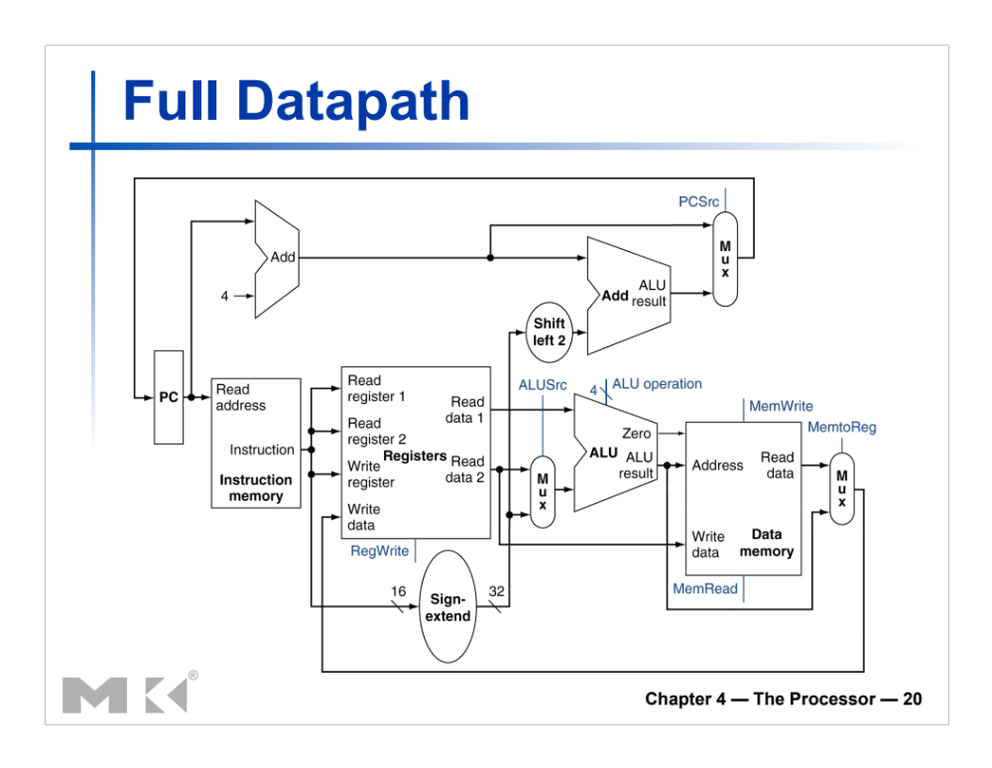
- Does this datapath support the following instruction:
BEQR $r₁, $r₂, $r_{a}
The above instruction executes this:
if ($r₁ == $r₂) then branch to address in register $r_{a}
else execute next instruction
Example 1: if $r₁= 8, $r₂ = 120, and $ra = 1000, the CPU will execute the next instruction.
Example 2: if $r₁= 17, $r₂ = 17, and $ra = 1000, the CPU will branch to Address 1000.

No.
- (7 points) If the answer is no, then add all resources (lines, muxes, components).
- (3 points) Propose an instruction code for lwr (consistent with the instruction defined so far. This means that the first six most significant bits should be reserved for the opcode)
Opcode | Rs | Rt | Rd | Shamt | funct
6 bits | 5bits | 5bits | 5bits | 5bits | 6bits

- (5 points)Based on your instruction code, draw/add the datapath needed to support the lwr instruction.
- (10 points)After you draw the datapath, show the values on the control inputs, and label the relevant buses with size and the content for the instruction BEQR $17,$1,$4. Assume that $1 = 10, $4 = 10, and $17 = 400.

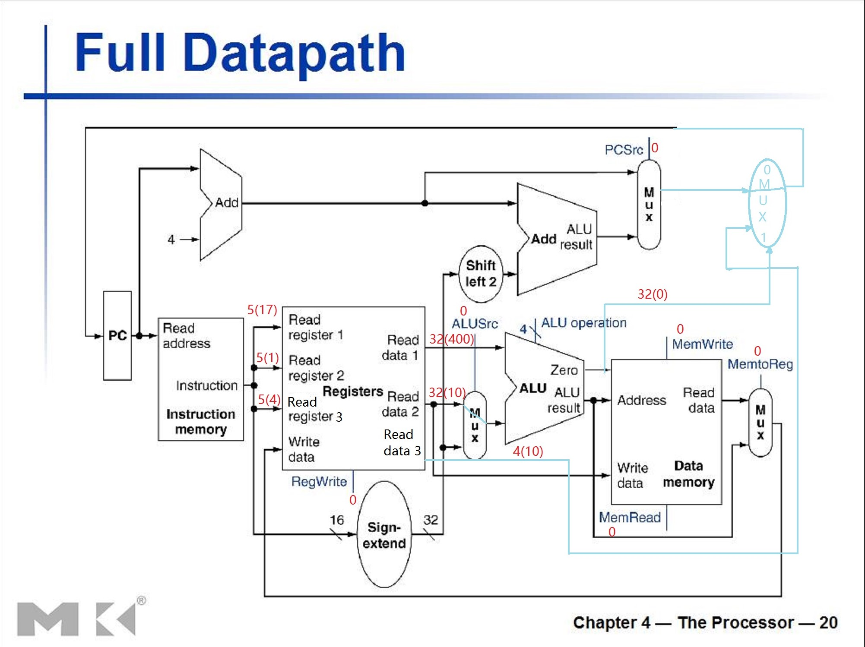

Exercise 3: (40 points)
Consider computing the vector Y = a * X + Y. Vectors X and Y contain 96 double floats each and are stored at addresses Rx and Ry, respectively. A double float takes 8 bytes (64 bits). We assume that registers can contain 64 bits and that the CPU can load/store a double float by generating only one address (reference). This exercise has three parts: Part A, B, and C.

Below is the code to compute the vector Y = a * X + Y on a MIPS machine. However, the code below works for vectors with 64 elements only.

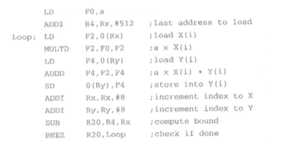

Part A:
- First, modify the code above to handle vectors with 96 elements
At the 2nd line, change 512 to 768
ADDI R4,Rx,#512
- How many data references are generated by the CPU to execute the modified code ?
In every loop the CUP would generate three references, and a at first time. So, the CUP would generate 1+96*3=289 references in total.
- How many instructions references are generated by the CPU to execute the modified code ?
There are 9 instruction in every loop and 2 in first run. So, 9*96+2=866

Part B:
The VMIPS CPU support vector operations for vectors of up to 64 elements. The VMIPS contains only one pipeline (lane). Therefore, whenever a vector instruction is executed on a vector containing n components, the pipeline simply makes n executions, i.e., one execution (of the SAME instruction) per component.

Below is the vector code to compute a vector Y = a * X + Y. The code below would work only for vectors with 64 elements.

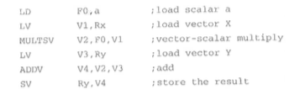
- First, modify the code above to handle vectors with 96 elements. Your code must be vectorized.
- How many data references are generated by the CPU to execute the modified code ?
- How many instructions references are generated by the CPU to execute the modified code ?

Part C: Evaluate the percentage of decrease from MIPS to VMIPS for each of the following address references: data, instructions, and total (both data and instruction).

Based on progress, additional exercises may be added.
What to turn in INDIVIDUALLY?
Electronic copy of your exercises. Use Microsoft Word or PDF.

IMPORTANT:
A late submission will get a 50% penalty if submitted after 9:00pm on the due day. After 9:00pm the next day, the submission will be worthless.

