Blue Questions (No Need to turn in)
1) Train yourself to convert quickly binary numbers to/from hexadecimal.
2) Can you state/use De Morgan Laws?

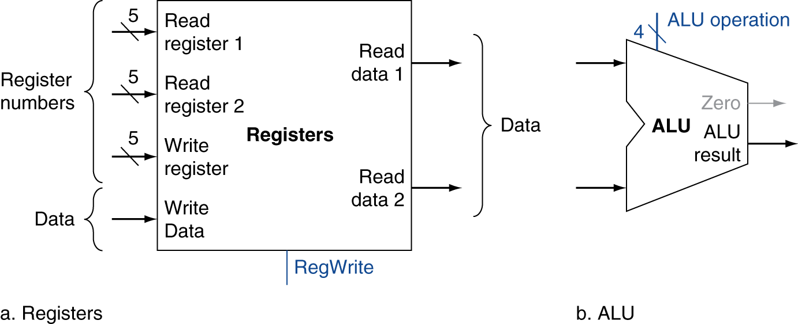
Figure 1 : MIPS Registers and ALU

Exercise 1 (12 points)
Consider the instruction OR $3, $16, $24. All questions in this exercise are related to this instruction. Assume that 1) $3 = 0x45454545, $16 = 0xAAAAAAAA, and $24 = 0x55555555, and 2) this instruction is at Address 0xA0002000. We assume a monocycle CPU.
- What does this instruction achieve? Which register(s) will be modified? If modified, what are their new values?
Achieve OR operation between the values of register $16 and $24 then store the result 0xFFFFFFFF to register $3.
$3 and $pc will be modified.
$3: 0xFFFFFFFF $PC: 0xA0002004

- What is the machine code of this instruction?
000000 10000 11000 00011 00000 100101

- When this instruction is being executed, what are the values of the registers PC, $16, and $24?
$PC: 0xA0002004
$16: 0xAAAAAAAA
$24: 0x55555555

- Referring to Figure 1, what are the values of the inputs [Read register 1], [Read register 2], [Write register], and [Write Data] while the instruction is being executed?
[Read register 1]: 16
[Read register 2]: 24
[Write register]: 3
[Write Data]: 0xFFFFFFFF

- Referring to Figure 1, what are the values of the outputs [Read data 1] and [Read data 2], while the instruction is being executed?
[Read data 1]: 0xAAAAAAAA
[Read data 2]: 0x55555555

- Referring to Figure 1, what are the values of the control signal [ALU operation] while the instruction is being executed? (Hint: Slide 5-23)
0001

- Referring to Figure 1, what are the values of the inputs of the ALU (top and bottom) while the instruction is being executed?
top: 0xAAAAAAAA
bottom: 0x55555555

- Referring to Figure 1, what are the values of the outputs [Zero] and [ALU Result] while the instruction is being executed?
[Zero]: 0
[ALU Result]: 0xFFFFFFFF

- What are the values of the control signals RegWrite, ALUSrc, MemWrite, ALUOp, MemToReg, MemRead, Branch, and RegDst? For the sake of the TA, express them as 9 bit number and in hexadecimal. RegWrite will be the most significant bit. For the sake of the TA, express them as 9 bit number and in hexadecimal. RegWrite will be the most significant bit.
100100001
0x121

Exercise 2 (12 points)
Consider the instruction beq $3, $16, 0x201. All questions in this exercise are related to this instruction. Assume that 1) $3 = 0x45454545, $16 = 0x45454545, and $24 = 0x55555555, and 2) this instruction is at Address 0xA0002000. We assume a monocycle CPU.
- What does this instruction achieve? Which register(s) will be modified? If modified, what are their new values?
Compare the values of $3 and $16, if they are equal, branch to address: PC+4 + 0x201*4 = 0xA0002808
$PC will be modified to 0xA0002808

- What is the machine code of this instruction?
000100 00011 10000 0000 0010 0000 0001

- When this instruction is being executed, what are the values of the registers PC, $16, and $24?
$PC: 0xA0002004
$16: 0x45454545
$24: 0x55555555

- Referring to Figure 1, what are the values of the inputs [Read register 1], [Read register 2], [Write register], and [Write Data] while the instruction is being executed?
[Read register 1]: 3
[Read register 2]: 16
[Write register]: Undetermined
[Write Data]: Undetermined

- Referring to Figure 1, what are the values of the outputs [Read data 1] and [Read data 2], while the instruction is being executed?
[Read data 1]: 0x45454545
[Read data 2]: 0x45454545

- Referring to Figure 1, what are the values of the control signal [ALU operation] while the instruction is being executed? (Hint: Slide 5-23)
0110

- Referring to Figure 1, what are the values of the inputs of the ALU (top and bottom) while the instruction is being executed?
top: 0x45454545
bottom: 0x45454545

- Referring to Figure 1, what are the values of the outputs [Zero] and [ALU Result] while the instruction is being executed?
[Zero]: 1
[ALU Result]: 0

- What are the values of the control signals RegWrite, ALUSrc, MemWrite, ALUOp, MemToReg, MemRead, Branch, and RegDst? For the sake of the TA, express them as 9 bit number and in hexadecimal. RegWrite will be the most significant bit.
00001X01X 0x12 or 0x13 or 0x1B or 0x1A

Exercise 3 (11 points)
Consider the instruction j 0x100. All questions in this exercise are related to this instruction. Assume that 1) $3 = 0x45454545, $16 = 0x45454545, and $24 = 0x55555555, and 2) this instruction is at Address 0xA0002000. We assume a monocycle CPU.
- What does this instruction achieve? Which register(s) will be modified? If modified, what are their new values?
Jump to address 0xA0000100.
$PC will be modified to 0xA0000100.
0x100已经是machine code里面地址✖4的结果，所以不用在乘，但是branch 的地址要乘4
- What is the machine code of this instruction?
000010 000000 0000 0000 0001 0000 0000

- When this instruction is completed, what are the values of the registers PC, $16, and $24?
$PC:0xA0000100
$16: 0x45454545
$24: 0x55555555

- Referring to Figure 1, what are the values of the inputs [Read register 1], [Read register 2], [Write register], and [Write Data] while the instruction is being executed?
[Read register 1]: 0
[Read register 2]: 0
[Write register]: 0
[Write Data]: Undetermined

- Referring to Figure 1, what are the values of the outputs [Read data 1] and [Read data 2], while the instruction is being executed?
[Read data 1]: 0
[Read data 2]: 0

- Referring to Figure 1, what are the values of the control signal [ALU operation] while the instruction is being executed? (Hint: Slide 5-23)
Undetermined

- Referring to Figure 1, what are the values of the inputs of the ALU (top and bottom) while the instruction is being executed?
top: 0
bottom: Undetermined

- Referring to Figure 1, what are the values of the outputs [Zero] and [ALU Result] while the instruction is being executed?
[Zero]: Undetermined
[ALU Result]: Undetermined

- What are the values of the control signals RegWrite, ALUSrc, MemWrite, ALUOp, MemToReg, MemRead, Branch, and RegDst?
0X0XXX0XX

Exercise 4 (25 points): Deriving the pipeline speed up
Consider a monocycle CPU with 5 "operations". We assume that all instructions need the 5 operations (stages). Four of these stages take 80 ps each and the last stage takes 240ps.
1) (1 point) What is the latency of one instruction on the monocycle CPU?
4*80ps + 240ps = 560 ps

2) (1 point) What should be the clock frequency for the monocycle CPU?
The period of the frequency must be equal to the latency of one instruction.
Frequency = 1/period = 1/560ps = 1/560*10⁻¹² s ≈ 1.79*10⁹ Hz = 1.79 GHz.

3) (2 points) What is the throughput (bandwidth) of the monocycle CPU?
This CPU delivers one instruction every 560ps, then the throughput
= number of instructions executed in one second
= 1 instruction/560*10⁻¹² s = 1.79*10⁹ instruction /second

4) (2 points) Consider a program P with n instructions. What is the execution time for Program P (expression as a function of n)?
Each instruction takes 560 ps, then n instructions will take 560n ps

5) We want to pipeline the CPU above with one stage per operation. We neglect the buffer time between stages. All the questions below apply to the pipeline .
a) (3 points) What is the latency for one instruction for the pipelined CPU?
The latency will not change, the CPU must still perform all operation for each instruction.
Therefore, the latency of one instruction = sum of all stages/operations = 560ps

Should be 1200 = 240*5

b) (3 points) What should be the clock frequency for the pipelined CPU?
The frequency of the clock must be set such that the period is at least the latency of the slowest operation. The slowest operation takes 240ps, then the frequency = 1/240ps = 1/0.24 ns = 4.2GHz.

c) (3 points) What is the throughput (bandwidth) of the pipelined CPU?
Since the CPU is pipelined, it will execute one instruction every 240 ps, the throughput
= number of instructions executed in one second
= 1 instruction/240*10⁻¹²s = 4.2*10⁹ instruction per second.

d) (4 points) Consider a program P with n instruction. What is the execution time for Program P? (Make sure to take into account the phase to fill up the pipeline and wind it up)
n instructions will take the time to fill up the pipeline (4 cc) and n cc to to produce the n instructions. Execution time = (5+n-1) cc = (n + 4) * 240 ps = 0.24 (n +4) ns

6) (2 points) What is the expression of the speed up (monocycle versus pipelined)? If n tends to infinity, what is the speed up?
Speed up = Time of Slowest Execution/ Time of fastest Execution = 0.56n /0.24(n+4)
When n tends to infinity, speed up will reach 0.56/0.24=2.33

7) (4 points) Propose changes you would make to this CPU to increase the speed-up. Justify
We could add more stages or decrease the duration of the stage to increase the speed-up. If it is possible, slowest operation would be divided to three parts which would have the same duration equal to 80 ps. That means the time of clock cycle would be decrease to 80 ps. It apparently increases the speed-up in terms of the equation.

Exercise 5 (40 points)
Consider the data path on this figure:
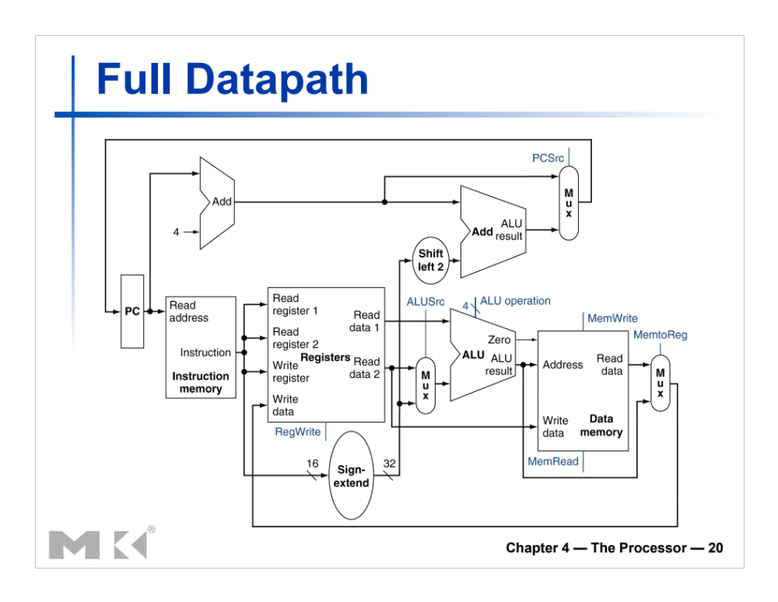
- (2 points) Does this datapath support the following instruction:
swr Immediate, $r1($r2) Mem[$r1 + $r2] ← Immediate (signed 16 bits value)
Example: if $r1 = 0x2300, $r2 = 0x1400, and Immediate = 0x1200, the CPU will store the signed extended vale $0x1200 in the memory at Address 0x3700 (Mem[0x2300+0x1400]).

No. There is not a datapath to write the immediate into data memory.

- If the answer is no, then add all resources (lines, muxes, components).
- (3 points) Propose an instruction code for swr (consistent with all instructions in the subset studied so far).
opcode | rs | rt | Constant or address
31-26 | 25-21 | 20-16 | 15-0
101100 | rs | rt | immediate

- (5 points) Based on your instruction code, draw/add the datapath needed to support the swr instruction.
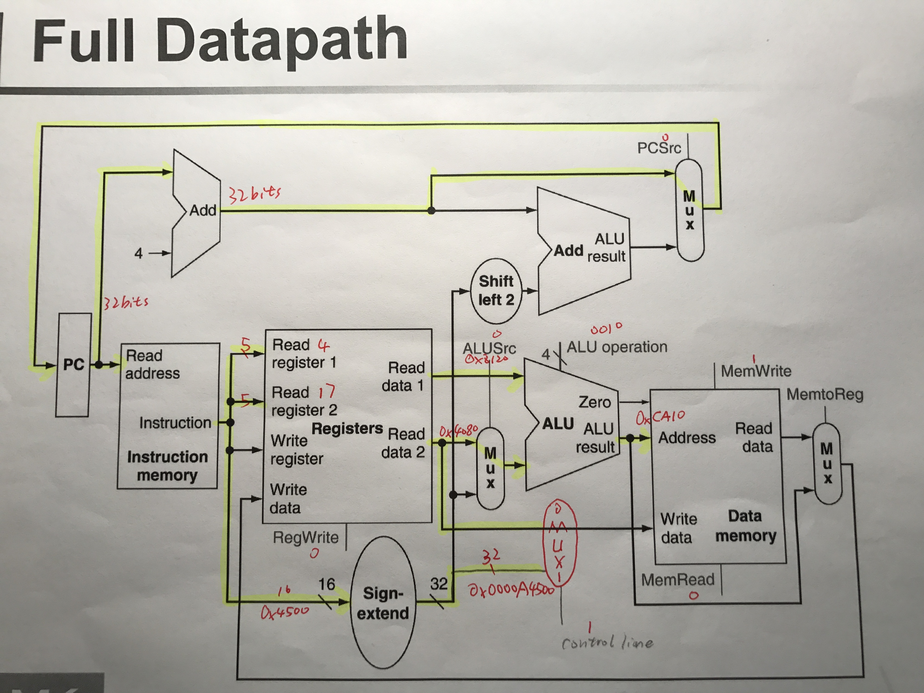

- (9 points)After you draw the datapath, label the relevant buses with size and the content for the instruction swr 0x4500, $4($17). Assume that $4 = 0x8120, $17 = 0x4080.

$r1 + $r2 = 0x8120 + 0x4080 = 0xC1A0 Mem[0xC1A0] = 0x4500
It is shown in the image at question 4)

- (1 point) Indicate all registers or memory locations that will be modified by this instruction
PC = PC + 4
MEM[0xC1A0] = 0x00004500

Based on progress, additional exercises may be added.
What to turn in INDIVIDUALLY?
Electronic copy of your exercises. Use Microsoft Word or PDF.

