COMP 7300/7306 Advanced Computer Architecture

Homework 3: Exercises (Individual, 100 pts)

IMPORTANT:
A late submission will get a 50% penalty if submitted after the deadline on the due day. . Penalty will be 75% if submission is made within one hour after the deadline. One day after deadline, you cannot submit the lab: it is worthless

Exercises to work out and turn in INDIVIDUALLY:

Grading Guidelines:
A right answer will get full credit when:
- It is right (worth 25%)
- It is right AND neatly presented making it easy and pleasant to read. (15%)
- There is an obvious and clear link between 1) the information provided in the exercise and in class and 2) the final answer. A clear link is built by properly writing, justifying, and documenting an answer (worth 60%).
Calculation mistakes will be minimally penalized (2 to 5% of full credit) while errors on units will be more heavily penalized.

You are welcome/encouraged to discuss exercises with other students, the TA, or the instructor. But, ultimately, personal writing is expected.
Remember, the weight of these exercises is very low relatively to tests. But, these exercises will have a decisive impact on your performance in tests.

Short Questions
- We want to evaluate the overhead storage in a cache.
  - Assuming 32-bit addresses, how many total bits are required for a direct-mapped cache with 64 KB of data and 32-word blocks? What is the percentage of overhead storage versus the data storage? (2 points)

Answer : since the address is 32 bit ,so we know tag should be (32-offset-index)
Total data size is 64KB= 2¹⁶ byte , and block size is 32 word = 32*4 = 2⁷ byte, and offset is 7 bit , so the number of block is 2¹⁶/2⁷ = 2⁹, so the index is 9 bit. So tag is 32-7-9 = 16 bit . so total overhead bit of cache is 16+1 (one is value bit ) = 17 bit. So total bits is 17*2⁹+64KB
The percentage is (17*2⁹ )/ (64KB) = 1.66%
*** remember 64KB is 2¹⁶ byte ,so I need to translate it into bit to know what the storage, because 17*2⁹ is bit

  - Does the percentage change if the cache is 4-way associative? (2 points)

Answer: Yes , the tag will be 18 bits , that make overhead 19 bits . so each set we have overhead 19*4(since this is 4 way associative ), so total overhead bit is 19*4*2⁷, so ,( 19*4*2⁷) bit /64KB = 1.85%

2) Consider a cache with 32 blocks and a block size of 8 bytes. To what block address does byte address 800 map to? (1 point)
Answer: Block address = byte address/ block size = 800/8 = 100

For bonus points index 100 % 32 = 4

Exercise 1 (30 points)
Consider the following 32-bit memory references: 5, 182, 47, 1, 197, 92, 182, 18, 189, 48, 176, 247

a) Direct-mapped with 16 one-word blocks
For each of the above references, identify the binary address, the tag, and the index. List whether each reference is a miss or a hit.

(assume all the references are byte address, so when we convert it into )

References(byte address) | Binary address | Tag | Index | Miss/hit
5 | 00000101 | 0000 | 0001 | Miss
182 | 10110110 | 0010 | 1101 | Miss
47 | 00101111 | 0000 | 1011 | Miss
1 | 00000001 | 0000 | 0000 | Miss
197 | 11000101 | 0011 | 0001 | Miss
92 | 01011010 | 0001 | 0110 | Miss
182 | 10110110 | 0010 | 1101 | Hit
18 | 00010010 | 0000 | 0100 | Miss
189 | 10111101 | 0010 | 1111 | Miss
48 | 00110000 | 0000 | 1100 | Miss
176 | 10110000 | 0010 | 1100 | Miss
247 | 11110111 | 0011 | 1101 | Miss

Since 16 one word blocks, block size is one word = 4bytes = 2² bytes , so the last 2 digits are offsets.
16 = 2⁴, so the index is the 4 digits adjacent to offsets of byte address
so the tag is 32 – (2+4) = 26 bits

b) Direct-mapped with 8 two-word blocks
For each of the above references, identify the binary address (already done), the tag, and the index. List whether each reference is a miss or a hit.

References(byte address ) | Binary address | Tag | Index | Miss/hit
5 | 101 | 0 | 000 | Miss
182 | 10110110 | 10 | 110 | Miss
47 | 101111 | 0 | 101 | Miss
1 | 1 | 0 | 000 | Hit
197 | 11000101 | 11 | 000 | Miss
92 | 1011010 | 1 | 011 | Miss
182 | 10110110 | 10 | 110 | Hit
18 | 10010 | 0 | 010 | Miss
189 | 10111101 | 10 | 111 | Miss
48 | 110000 | 0 | 110 | Miss
176 | 10110000 | 10 | 110 | Miss
247 | 11110111 | 11 | 110 | Miss

Offset: block size = two word = 8 byte = 2³ byte, so the last 3 digits are offset
8 = 2³ so the index is 3 adjacent digits next to offset
So tag is 32-(3+3) = 26

c) 2 way associative cache with 16 one-word blocks.
For each of the above references, identify the binary address, the tag, and the index. List whether each reference is a miss or a hit.

References | Binary address | Tag | Index | Miss/hit
5 | 101 | 0 | 1 | Miss
182 | 10110110 | 101 | 101 | Miss
47 | 101111 | 10 | 11 | Miss
1 | 1 | 0 | 0 | Miss
197 | 11000101 | 110 | 1 | Miss
92 | 1011010 | 10 | 110 | Miss
182 | 10110110 | 101 | 101 | Hit
18 | 10010 | 0 | 100 | Miss
189 | 10111101 | 101 | 111 | Miss
48 | 110000 | 1 | 100 | Miss
176 | 10110000 | 101 | 100 | Miss
247 | 11110111 | 111 | 101 | Miss

Since 16 blocks, the number of sets is 16blocks/2(ways) = 8 = 2³ , so index should be 3 digits.
Block size is one word (32bits ) = 4 byte = 2² byte. Offset = 2 digits So tag = 32-(3+2)= 28bits

d) Fully associative cache with 16 one-word blocks.
For each of the above references, identify the binary address, the tag, and the index. List whether each reference is a miss or a hit.

References | Binary address | Tag | Index | Miss/hit
5 | 101 | 1 | N/A | Miss
182 | 10110110 | 101101 | N/A | Miss
47 | 101111 | 1011 | N/A | Miss
1 | 1 | 0 | N/A | Miss
197 | 11000101 | 110001 | N/A | Miss
92 | 1011010 | 10110 | N/A | Miss
182 | 10110110 | 101101 | N/A | Hit
18 | 10010 | 100 | N/A | Miss
189 | 10111101 | 101111 | N/A | Miss
48 | 110000 | 1100 | N/A | Miss
176 | 10110000 | 101100 | N/A | Miss
247 | 11110111 | 111101 | N/A | Miss

Since this is fully associative cache , the number of set is 1, so the index is 2⁰, we do not need index. Block size is one word (2² byte), so offset = 2, so tag = 32-2=30

Exercise 2 (10 points)
Assume the miss rate of an instruction cache is 1% and the miss rate of the data cache is 2%. If the processor takes 2 clock cycles per instruction (CPI = 2) without any memory stall and the miss penalty is 100 cycles for all misses, determine how much faster a processor would run with a perfect cache that never missed. We assume that the frequency of loads and stores is 25% (in other words, 25% of all instructions are memory accesses).

Answer:
Instruction miss cycles: I * 0.01 * 100 = I ( I is the # of instructions)
Data miss cycles: I * 0.02 * 0.25*100 = 0.5I
Total memory stall cycle = I+0.5I = 1.5I
CPI_{stall} = 1.5 + 2 = 3.5
(CPU time with stall) / (CPU time with perfect cache ) = (I * CPI_{stall} *clock cycle ) / (I * CPI_{perfect} * clock cycle ) = 3.5/2 = 1.75
Average access time to instruction = hit time + mr* penalty = 2 +0.01*100 = 3 cycles
For 100 instructions = 100*3

For the data, average access time = hit time + mr* penalty = 2+0.02*100 =4 cycles
Average access to data = 0.25 *100 * 4 cc
Total time to exe my program = access to instructions + access to data = 3*100+0.25*100*4
The ideal system is faster by = time of the slowest/ time of the fastest = 100*(3+0.25*4)/2*100=2

Exercise 3 (5 points)
Find the average memory access time of a processor with a 1 ns clock cycle time, a miss penalty of 30 clock cycles, a miss rate of 0.05 misses per instruction, and a cache access time (including hit detection) of 1 clock cycle. Assume that the read and write miss penalties are the same and ignore write stalls.
Answer : average memory access time (AMAT) =Hit time + Miss rate * Miss penalty
= 1ns + 0.05*30cycle* 1ns = 2.5ns

Exercise 4 Caches Misses (10 points)
Examine the program InitializeMatrix.asm (posted on Canvas with the homework). The objective is to determine the number of data cache misses m and the data cache hit ratio hr. We assume a 256 byte direct-mapped cache and LRU as a block replacement policy.
- If the block size is 4 words per block, determine m and hr.
Answer: m = 64 hr = 192/256= 75%
In code line ‘sw $t2, data($s2)’, the CPU is trying to store a word into a memory address. Since the block size is 16 bytes, there will be 16 blocks in cache. So every 4 words can be stored in one block. The first one will always be miss, but rest 3 will be hit. So, the hit ratio is 12/16=75%. There are 256 words to be stored, so the number of miss is 64.

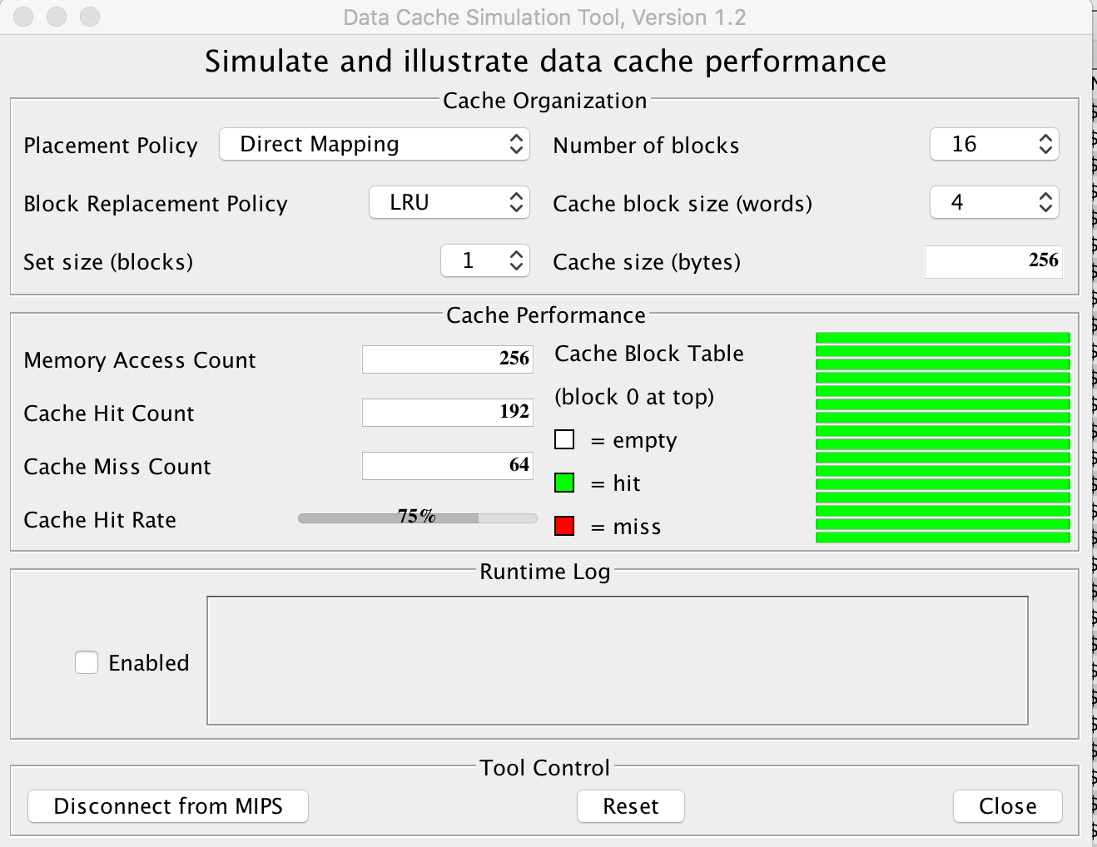

- If the block size is 8 words per block, determine m and hr.
Answer: m = 32 hr = 87.5%
Since the block size is 32 bytes, there will be 8 blocks. Every 8 words can be stored in one block, and every first word will be miss. So the hit ratio is 56/64 = 88%, the number of miss is 32.

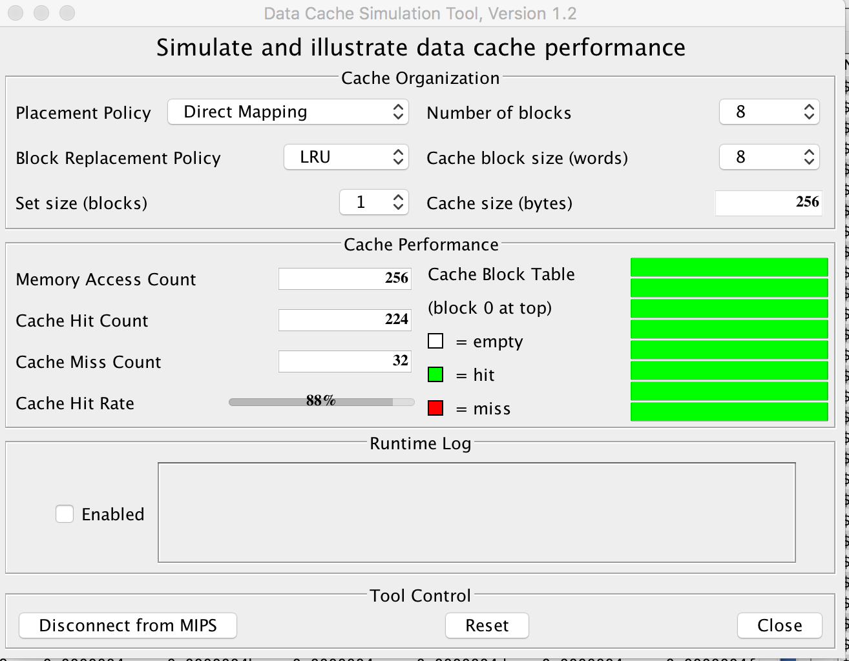

- Would the results change if the cache is 2 way associative?
Answer: No it would not change . it is same just like direct-mapped

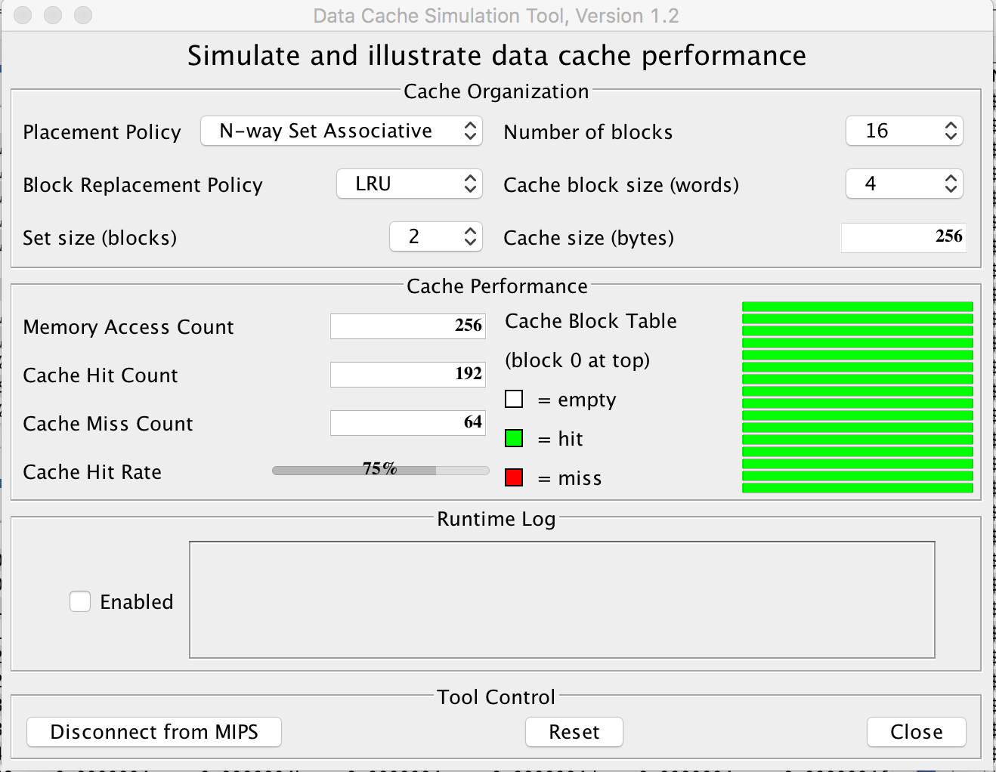

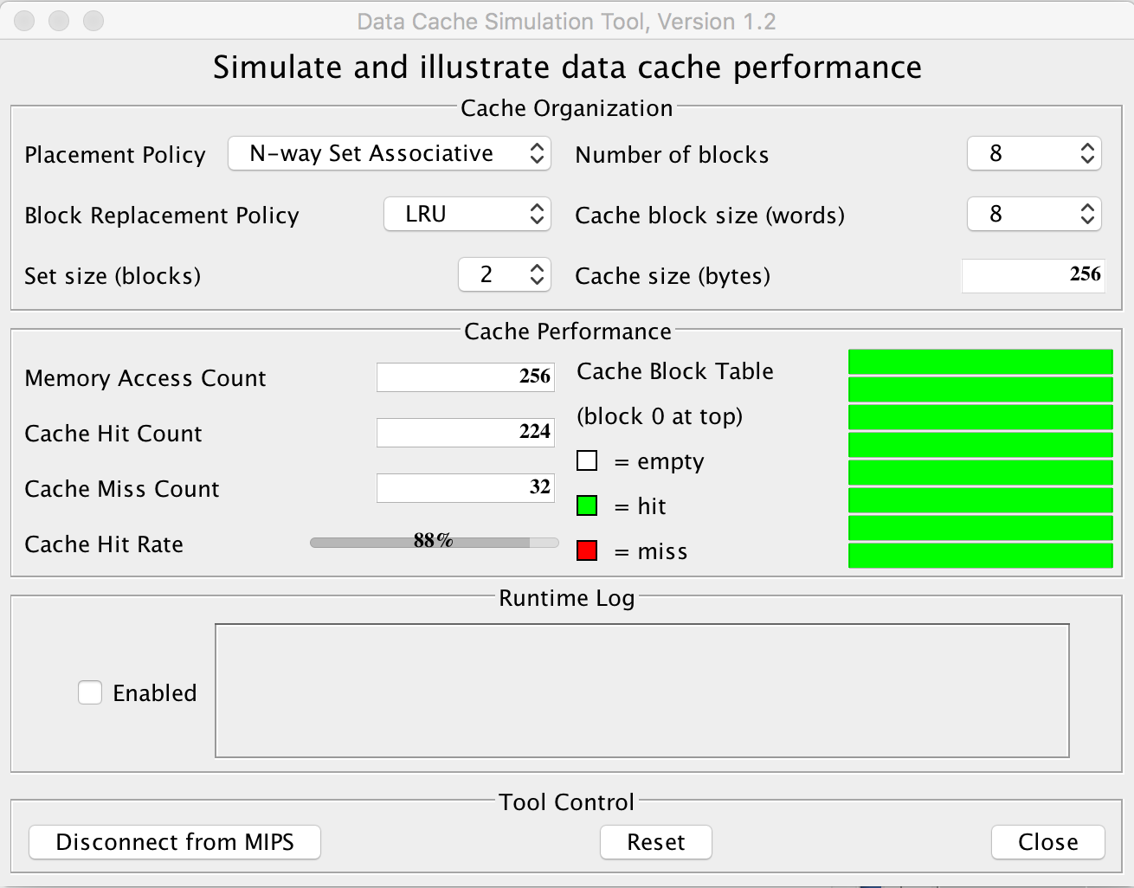

- Check your results using the MARS Tools→Data Cache Simulator.
Should be the same

Exercise 5: (30 points) We assume that the data cache size is 1 KB (data) and the block size is 16 bytes. We assume that M[i][j] is adjacent to M[i][j+1] in the memory and that the cache is fully associative using LRU replacing. Consider the following code:
char A[64][64];
int i,j;
for (j = 0; j < 32; j++){
for (i = 0; i < 64; i++){
A[i][j] = A[i][j] ^ A[i][n-1-j];
A[i][n-1-j] = A[i][j] ^ A[i][n-1-j];
A[i][j] = A[i][j] ^ A[i][n-1-j];
}
}
This code performs a SPECIAL column-wise transpose. As indicated on Figure 2, the transposition is performed as follows: the first column(j=0) and the last column (j=63) are swapped, the second column (j=1) and the column (j = 62) are swapped, and so on…

Figure 2
We assume that the code is in a separate instruction cache and the variables i and j are in registers.
- Recall that this matrix contains characters (1 byte per character). How many blocks are needed to store one line of the matrix?
Answer: There are 64 columns, means each line has 64 characters, means need 64bytes, one block is 16 bytes, so total need 64/16 = 4 blocks per line

- How many blocks are needed to store the full matrix?
Answer there are 64 lines , each lines need 4 blocks , so total need 64*4 = 256 blocks

- How many blocks does the cache contain?
Answer: Blocks =1KB / 16bytes = 2⁶ blocks

- How many compulsory misses occur?
One blocks will occur compulsory misses , since total 256 blocks , so will have 256 misses

- How many capacity misses occur?
Answer: 64*64 -256 = 3840

- How many conflict misses occur?
Answer : because this is full associative , has no conflict misses

- Would a loop interchange decrease the number of capacity misses? If yes, rewrite the loops with the loop interchange (no need to repeat the swapping instructions) and provide the new number of capacity misses.
Char A[64][64];
Int i.j;
for (i = 0; i <64; i++){
{
for (j = 0;j<32; j++){
…
}
}

Answer: Yes, because the loop goes rowwise and M[i][j] is adjacent to M[i][j+1], when a block is stored in cache, next characters will be hit ,so capacity miss is 0 .

- What would be the number of compulsory misses with a loop interchange?
Answer: 256, because one block will occur one miss

- What should be the minimal size of the cache if we wanted to use blocking?
Answer: Because the loop is using 2 blocks ,so it must at least contain 2 blocks

Exercise 6 (10 points): Virtual memory
We consider a 32 bit address bus and a 512 KB physical memory. Page size is 32 KB. (VM block is called a page )
- Assuming a validity bit, a dirty bit, and two reference bits, what is the size of the page table? Show the different steps to determine the page table size.
Page table size = number of entries * size of one entry
Number of entries = Number of pages in virtual space = Virtual space size / page size =
2³²/32*2¹⁰ = 2¹⁷
The number of frames = (physical)Total size / size of one frame = 512KB / 32KB = 16 = 2⁴ frames , therefor, the size of page table has 1 validity bit, 1 dirty bit, 2 reference bits and 4 bits for frames
Page table size is 2¹⁷ *(1+1+2+4)= 2²⁰

- Suppose that Entry n in the page table contains the value floor(n/2^{^10}). What is the physical address associated with virtual address (0x10002400)?
Answer:
Page number = address/ page size = 0x10002400 / 32KB = 0x10002400 / 2¹⁵ = (1 0000 0000 0000 0)₂
The page table entry pg indicate by the page number contains n/2^11, the the frame number is equal to (1 0000 0000 0000 0)₂ ^11 = (1 00)₂
The offset of virtual address is equal to virtual address % page size = (0x10002400)%32K = 0x2400
Concatenate the offset and frame number will have physical address = 0x22400

Another method :
Virtual address 0x10002400 = 0001 0000 0000 0000 0010 0100 0000 0000
So the offset = the 15(page size = 32K = 2¹⁵) least significant bit of above address
= 010 0100 0000 0000
page # = virtual address with the offset token off from the address = 0001 0000 0000 0000 0
frame # = content of the entry = page number >>11 = 0001 00
physical address = concatenate the offset and frame number = 0x22400

10 0010 0100 0000 0000

This exercise will be assigned only if vector CPUs

Additional Exercise : (XX points)
Consider computing the vector Y = a * X + Y. Vectors X and Y contain 96 double floats each and are stored at addresses Rx and Ry, respectively. A double float takes 8 bytes (64 bits). We assume that registers can contain 64 bits and that the CPU can load/store a double float by generating only one address (reference). This exercise has three parts: Part A, B, and C.

Below is the code to compute the vector Y = a * X + Y on a MIPS machine. However, the code below works for vectors with 64 elements only.

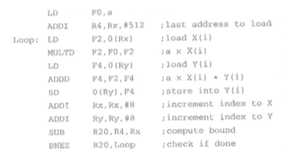

Part A:
- First, modify the code above to handle vectors with 96 elements
Answer: change 512 into 768
- How many data references are generated by the CPU to execute the modified code ?
Answer: In every loop the CPU would generate 3 references and 1 at first time , so total generate 1+96*3 = 289

- How many instructions references are generated by the CPU to execute the modified code ?
Answer: There are 9 instructions in every loop and 2 in first run, so total 2+96*9 = 866

Part B:
The VMIPS CPU support vector operations for vectors of up to 64 elements. The VMIPS contains only one pipeline (lane). Therefore, whenever a vector instruction is executed on a vector containing n components, the pipeline simply makes n executions, i.e., one execution (of the SAME instruction) per component.

Below is the vector code to compute a vector Y = a * X + Y. The code below would work only for vectors with 64 elements.

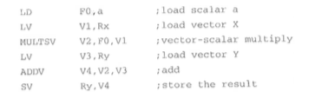
- First, modify the code above to handle vectors with 96 elements. Your code must be vectorized
LD | F0, a
LV | V1, Rx
MULTSV | V2, F0, V1
LV | V3, Ry
ADDV | V4, V2, V3
SV | Ry, V4
ADDI | Rx, Rx, #512
ADDI | Ry, Ry, #512
SUBI | VL, VL, #32
LV | V1, Rx
MULTSV | V2, F0, V1
LV | V3, Ry
ADDV | V4, V2, V3
SV | Ry, V4
ADDI | VL, VL, #32

- How many data references are generated by the CPU to execute the modified code . There is 1 scalar load operation, and for each element (first 64 elements, then 32 elements) there are 3 data references. So, there are total 1+3*96=289 data references.

- How many instructions references are generated by the CPU to execute the modified code ?
There 15 lines of code, each line of code is equal to one instruction reference. So, there are total 15 instruction references.

Part C: Evaluate the percentage of decrease (in the number of address references) from MIPS to VMIPS for each of the following address references: data, instructions, and total (both data and instruction).

The number of data references for MIPS and VMIPS are both 289. So, there is no decrease from MIPS to VMIPS in terms of data references.
The number of instruction reference for MIPS and VMIPS are 866 and 15, respectively. So, percentage of decrease from MIPS to VMIPS in terms of instruction reference is (866-15)/866=98.3%.
The total number of references for MIPS and VMIPS are (289+866) and (289+15), i.e. 1155 and 304, respectively. Therefore, the percentage of decrease for total references is (1155-304)/1155=73.7%

Based on progress, additional exercises may be added.
What to turn in INDIVIDUALLY?
Electronic copy of your exercises. Use Microsoft Word or PDF.

IMPORTANT:
A late submission will get a 50% penalty if submitted after 9:00pm on the due day. After 9:00pm the next day, the submission will be worthless.

