COMP 7300/7306 Advanced Computer Architecture

Homework 1: Exercises (Individual, 100 pts)

Exercises to work out and turn in:

Grading Guidelines:
A right answer will get full credit when:
- It is right (worth 25%)
- It is right AND neatly presented making it easy and pleasant to read. (15%)
- There is an obvious and clear link between 1) the information provided in the exercise and in class and 2) the final answer. A clear link is built by properly writing, justifying, and documenting an answer (worth 60%).
Calculation mistakes will be minimally penalized (2 to 5% of full credit) while errors on units will be more heavily penalized.

You are welcome/encouraged to discuss exercises with other students, the TA, or the instructor. But, ultimately, personal writing is expected.
Remember, the weight of these exercises is very low relatively to tests. But, these exercises will have a decisive impact on your performance in tests.

(45 points) Basics (You are strongly encouraged to use results from previous questions to avoid redoing work.)
- Represent in binary, octal and hexadecimal the number (3576)₁₀ in base 10.
Binary: 1101 1111 1000 octal: 6770 hexadecimal: 0xDF8

- Provide a method to divide a binary number n by a number m = 2^{p}. Use only binary operations. Do not use division (too costly). Use your method to compute n/m when n = 0xDF8 and m = (512)₁₀

Method: (Suppose n > m) First, we convert the number n from hexadecimal to binary. Since m could be represented as 2^{p}. Then we shift the number n to the right by p position then delete it after each iteration, the number still left is what we want.
0xDF8 = (110111111000)₂, since (512)₁₀ = 2⁹ Then shift the number to right 9 times, after that we have (110)₂ = (6)₁₀

- Provide a method to compute n % m when n is a binary number and m is a power of 2 (m= 2^{p}). Use only binary operations. Do not use division (too costly). Recall that n % m = n modulo m (remainder of the integer division of n by m). Use your method to compute n % m when n = 0xDF8 and m = (512)₁₀

Method: we can do “bitwise AND operation”: x % 2^{n} == x & (2^{n} - 1).
So n %m = n&(2⁹-1)= (1101 1111 1000)₂ & (01 1111 1111)₂ = (1 1111 1000)₂
So the answer should be (111111000)₂ = (504)₁₀

- What is hexadecimal representation of (-3576)₁₀ as a 16 bit two’s complement?
(3576)₁₀ = (0000 1101 1111 1000)₂
one’s complement of this number is (1111 0010 0000 0111)₂
(1111 0010 0000 0111)₂ +1 = (1111 0010 0000 1000)₂
(1111 0010 0000 1000)₂ = 0xF208

- Express in hexadecimal of (-3576) ₁₀ as a 32-bit number.
Use the result of last question we can know that the answer should be 0xFFFFF208

- Translate 0x4321A in decimal
0x4321A = 10*16⁰+1*16¹+2*16²+3*16³+4*16⁴ = (274970)₁₀

- Show how the value 0x1234AB56 would be arranged in memory of a) a little-endian and b) a big-endian machine. Assume that the base address is 0x1000.

Little –Endian Big-Endian
0x1000 0x56 0x12
0x1001 0xAB 0x34
0x1002 0x34 0xAB
0x1003 0x12 0x56

- Consider the address 0xDF8 in a 64 KB memory organized in blocks of 512 bytes. If the blocks are numbered starting at 0, what the number of the block that contains Address 0xDF8?
0xDF8 = (3576)₁₀ 3576/512 = 6, so the number 6 block will
contain the address 0xDF8
0000
- Consider the address 0xDF8 in a 64 KB memory organized in blocks of 512 bytes. If the offset of the first byte in a block is 0, what is the offset of the byte at Address 0xDF8? (Offset is the position of the byte inside the block).
From the question 3 we can know that remainder of 3576 % 512 = 504
So the offset is 504

- Compute and express in hexadecimal the -0.3125 as an IEEE 754 floating number in simple precision.
(-0.3125)₁₀ = -(5/16) = -(5/2⁴) = -1.01*2⁻²
general representation for single precision number is (-1)^{s} * (1+ Fraction) * 2^{(Exponent -127)}
subtracting the bias 127 from the exponent of -1.01*2⁻² yields:
(-1)¹ *(1+.0100 0000 0000 0000 0000 000_{two}) * 2⁽¹²⁵⁻¹²⁷⁾
so the single precision binary representation of -0.3125₁₀ is then:
(10111110101000000000000000000000)₂
so the hexadecimal is 0xBEA00000

- Compute and express in hexadecimal the -0.3125 as an IEEE 754 floating number in double precision.
According the last question
subtracting the bias 1023 from the exponent of -1.01*2⁻² yields
(-1)¹*(1+.0100 0000 0000 0000 0000 0000 0000 0000 0000 0000 0000 0000 0000_{two})*2⁽¹⁰²¹⁻¹⁰²³⁾
so the double precision binary representation of -0.3125₁₀ is then :
(1011111111010100000000000000000000000000000000000000000000000000)
so the hexadecimal is 0xBFD4 0000 0000 0000

- Consider a microprocessor with a 16-bit address bus. What is the size of the address space? (How many different addresses can this microprocessor generate?)

According the purpose of question, address bus is 16-bit,we can know it can generate 2¹⁶ addresses

- Consider a microprocessor with a 16-bit address bus. Assuming that each address refers one byte, what is the maximal size of the memory.
According last question, the size is 2¹⁶ bits = 64KB

- Consider two binary input x and y. Implement (with NAND gates only) the function f(x,y) that is set to 1 when x and y are different. Draw the circuit (you can draw it by hand, take a picture and insert it in this file).

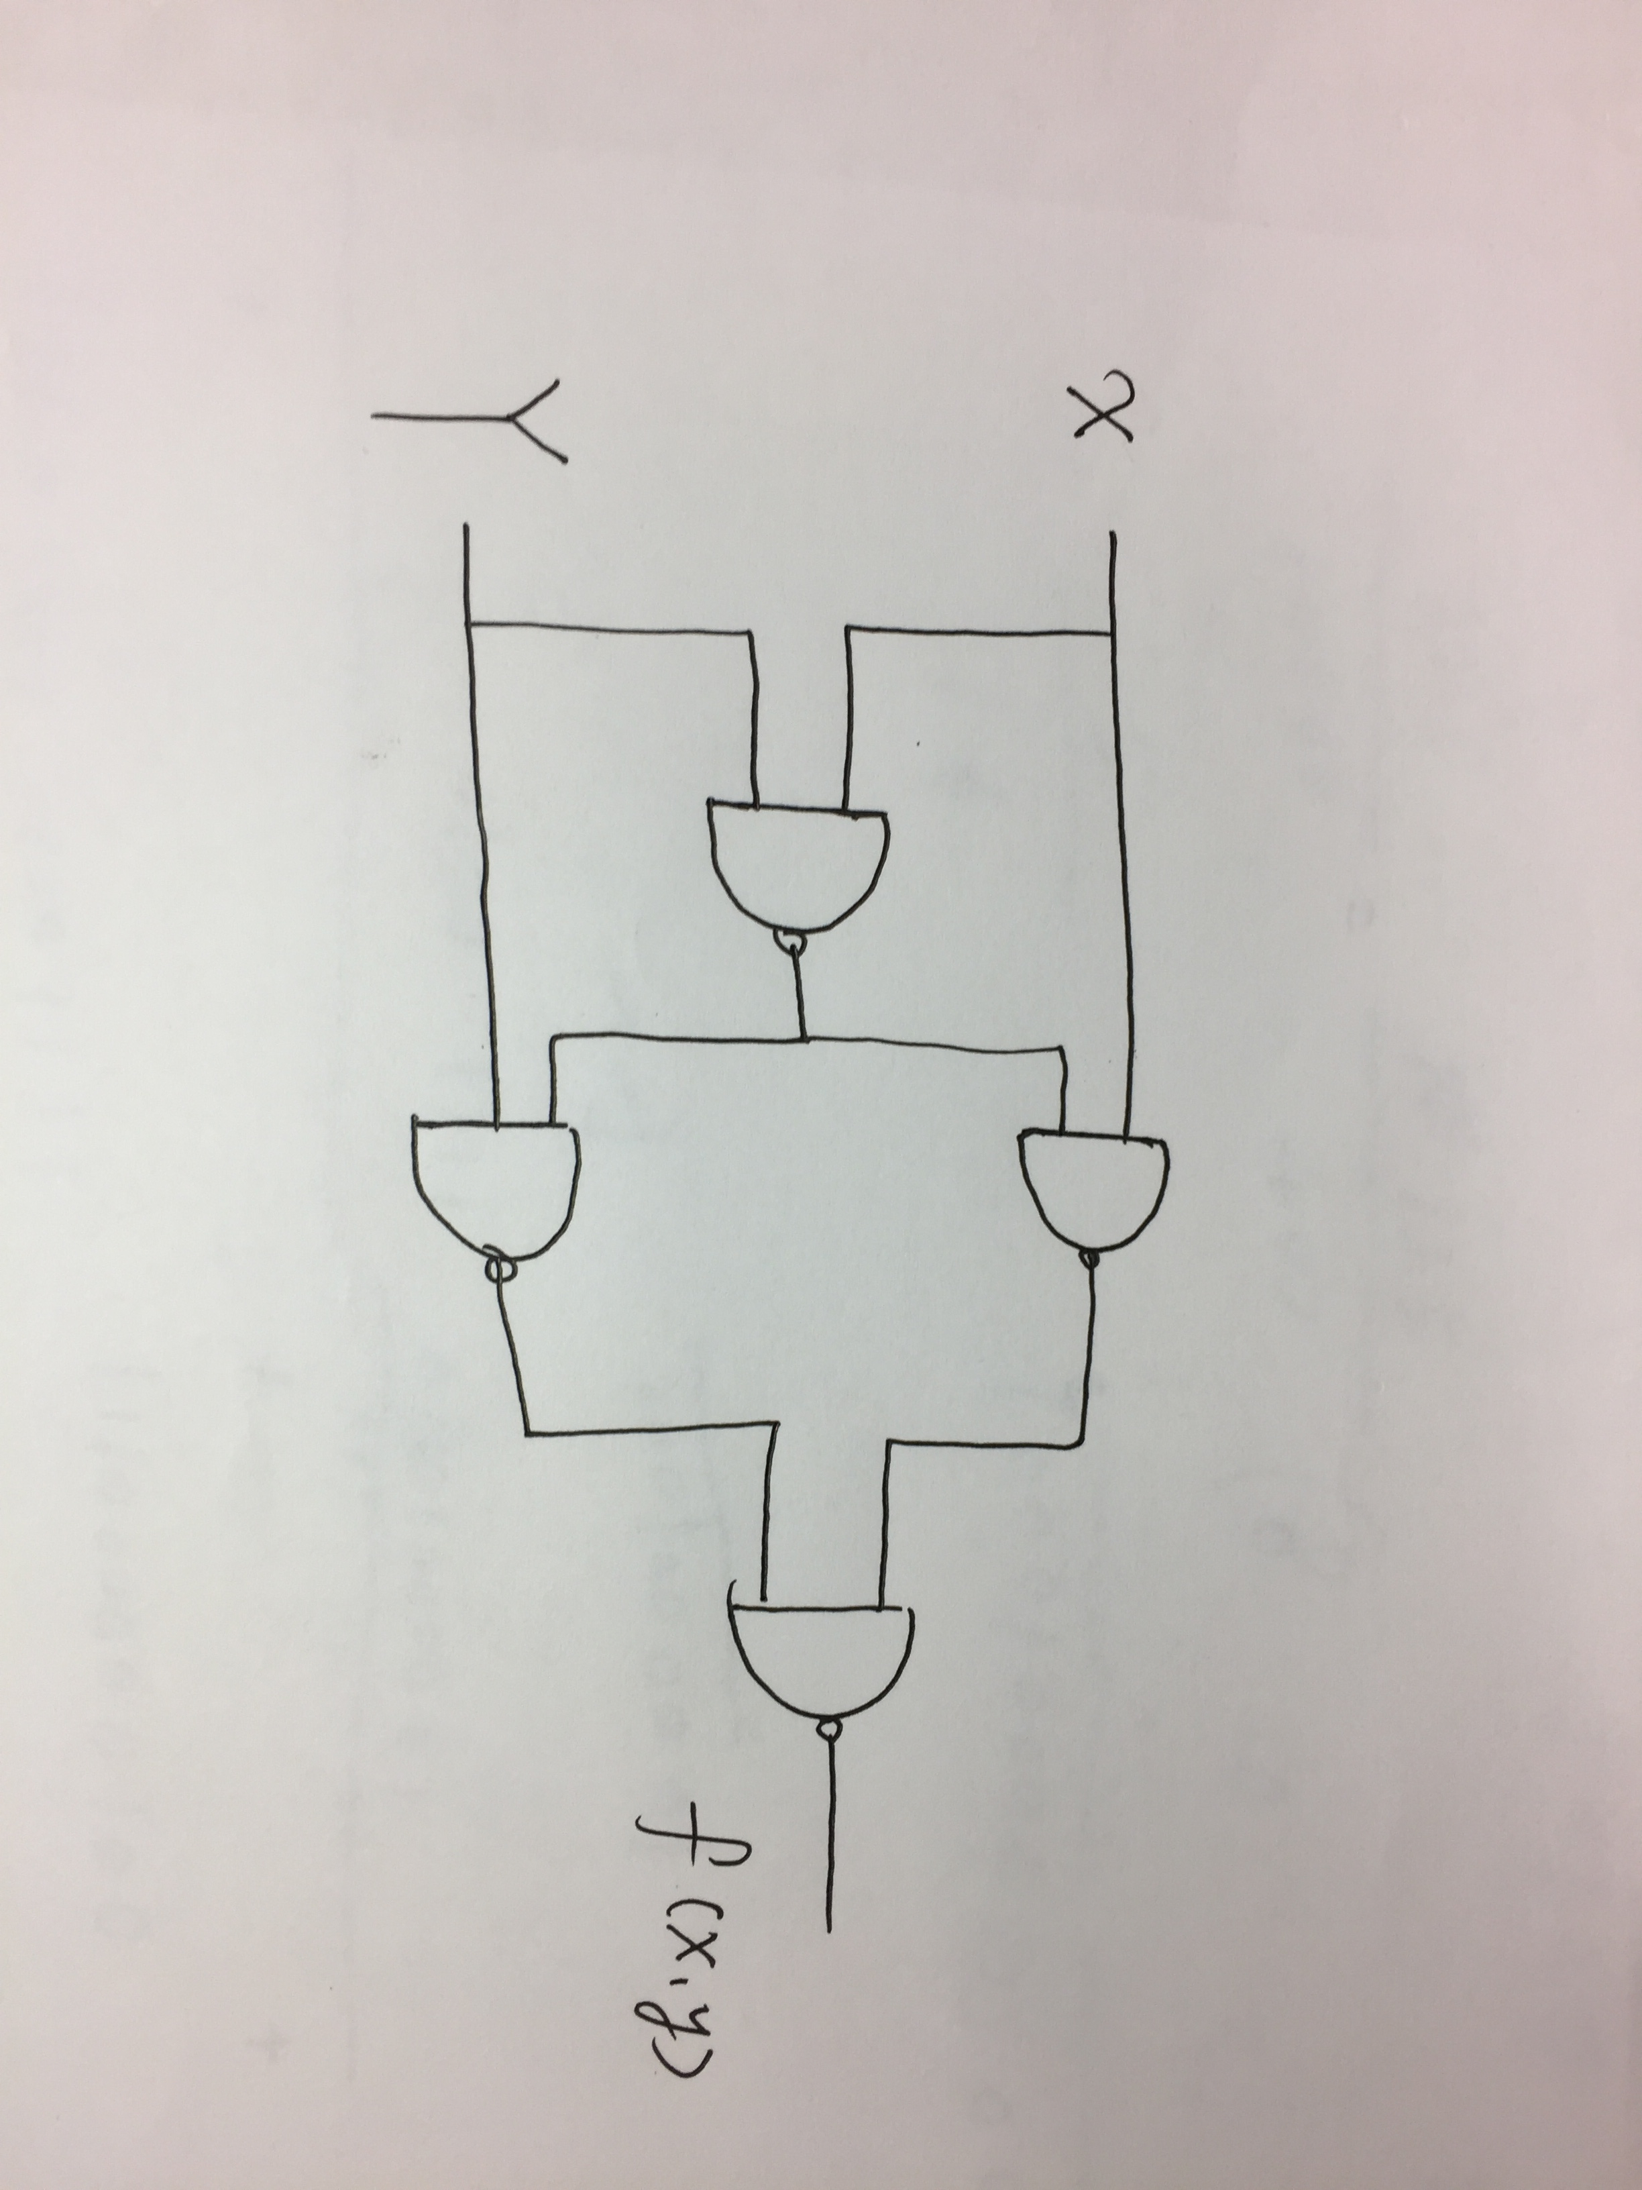

- Suppose that the cost is not an issue. Would the memory be hierarchical?
I think the memory should still be hierarchical for the situation that it is volatile memory. Since it require power to maintain the stored information, we need to consider how to keep data when power is down. However, there is no need to be hierarchical if memory is non-volatile, since without cost, we can select the faster one.

Exercise 1 (15 points)
Consider the following MIPS code. Translate it in C. Assume that the variables a, b, c, I and j are assigned to Registers $s0, $s1, $s2, $s3, and $s4, respectively. Assume that the base address of the arrays A and B are in Registers $s6 and $s7, respectively.

addi $t0, $s6, 4 $ t0 = $s6 +4
add $t1, $s6, $0 $t1 = $s6
sw $t1, 0($t0) store value of $t1 into the address $t0(0)
lw $t0, 0($t0) get value in the $t0 to and give it to $t0.
add $s0, $t1, $t0

answer addi $t0, $s6, 4 #t0 = &A[1]
add $t1, $s6, $0 #t1 = &A[0]
sw $t1, 0($t0) #A[1]= &A[0]
lw $t0, 0($t0) #t0 = &A[0]
add $s0, $t1, $t0 #a= &A[0] +&A[0]
& 取地址符号

c code :
A[1] = A;
a = 2*A

how many memory access = read the instruction + write in the memory.

Exercise 2 (20 points) Decoding instructions (binary ←→ assembly)
- Provide the type and assembly language instruction for the following binary value:
0000 0010 0001 0000 1000 0000 0010 0000
op = (000000)₂, rs = (10000)₂, rt = (10000)₂, rd = (10000)₂, shamt = (00000)₂,
funct = (100000)₂
R type : add $s0, $s0, $s0

- Provide the type and the hexadecimal representation of the following instruction:
lw $t1, 32($t2)

lw:(35)10 in op, $t2:(10)10 in rs, $t1:(9)10 in rt, (32)10 in address
I type binary representation is (100011 01010 01001 0000 0000 0010 0000)₂ = 0x8d490020

- Provide the type, assembly language instruction, and binary representation of the instruction described by the following MIPS fields:
op = 0, rs = 3, rt = 2, rd = 3, shamt, and funct = 34.

Since the funct=34,op=0 this is R type and sub function
Sub $v1, $v1,$v0
(000000 00011 00010 00011 00000 100010)₂

- Provide the type, assembly language instruction, and binary representation of the instruction described by the following MIPS fields:
op = 0x23, rs = 1, rt = 2, and const = 0x4
I type lw $v0,4($at)
(010011 00001 00010 0000 0000 0000 0100)₂

Exercise 3 (10 points)
Assume that we would like to expand the MIPS register file to 64 registers and expand the instruction set to contain twice as many instructions.
- How would this affect the size of each of the bit fields in the R-type instructions?

Since we expand the MIPS register file to 64 registers and expand the instruction set to contain twice as many instructions, we could get Log₂(64) = 6

Opcode = 6+1 = 7
rs = 5+1 =6bits rt = 5+1 = 6bits rd= 5+1 = 6bits funct =6+1 = 7
And opcode + rs + rt + rd + shamt + funct = 32 bits, we could get that shamt = 0 bit.

- How would this affect the size of each of the bit fields of the I-type instructions?

Since we expand the MIPS register file to 64 registers and expand the instruction set to contain twice as many instructions, we could get Log₂(64) = 6
Opcode = 6+1 = 7bits
rs = 5+1 = 6 bits rt = 5+1 = 6 bits
opcode + rs + rt +address = 32, so address = 13bits

Exercise 4 (10 points)
Write a MIPS code with the smallest number of MIPS instruction to store in Register $t1 the value ~$t1 (the bit-wise ones complement of $t1)
nor $t1, $t1, $zero

What to turn in?
- Electronic copy of your homework (individual).
Writing your answers is critical for your grade.

Grading Guidelines:
A right answer will get full credit when:
- It is right (worth 25%)
- It is right AND neatly presented making it easy and pleasant to read. (15%)
- There is an obvious and clear link between 1) the information provided in the exercise and in class and 2) the final answer. A clear link is built by properly writing, justifying, and documenting an answer (worth 60%).
Calculation mistakes will be minimally penalized (2 to 5% of full credit) while errors on units will be more heavily penalized.

You are welcome/encouraged to discuss exercises with other students, the TA, or the instructor. But, ultimately, personal writing is expected.
Remember, the weight of these exercises is very low relatively to tests. But, these exercises will have a decisive impact on your performance in tests.

