COMP 7300/7306 Advanced Computer Architecture

Homework 3: Exercises (Individual, 100 pts)

IMPORTANT:
A late submission will get a 50% penalty if submitted after the deadline on the due day. . Penalty will be 75% if submission is made within one hour after the deadline. One day after deadline, you cannot submit the lab: it is worthless

Exercises to work out and turn in INDIVIDUALLY:

Grading Guidelines:
A right answer will get full credit when:
- It is right (worth 25%)
- It is right AND neatly presented making it easy and pleasant to read. (15%)
- There is an obvious and clear link between 1) the information provided in the exercise and in class and 2) the final answer. A clear link is built by properly writing, justifying, and documenting an answer (worth 60%).
Calculation mistakes will be minimally penalized (2 to 5% of full credit) while errors on units will be more heavily penalized.

You are welcome/encouraged to discuss exercises with other students, the TA, or the instructor. But, ultimately, personal writing is expected.
Remember, the weight of these exercises is very low relatively to tests. But, these exercises will have a decisive impact on your performance in tests.

USE THIS FILE AS THE STARTING DOCUMENT YOU WILL TURN IN. KEEP THE QUESTIONS AND INSERT YOUR ANSWERS.

IF USING HAND WRITING (STRONGLY DISCOURAGED), REWRITE THE QUESTIONS.

Short Questions
- We want to evaluate the overhead storage in a cache.
  - Assuming 32-bit addresses, how many total bits are required for a direct-mapped cache with 64 KB of data and 32-word blocks? What is the percentage of overhead storage versus the data storage? (2 points)
    - word=4bytes.
To calculate the total bits, total bits=(valid bit + tag)*number of blocks+data.
We already know: valid bit=1 bit, data=32bits
Since, 1 block=32words=32*4 bytes=32*4 B,
number of data blocks=64KB/(32*4B)=2⁹
Number of blocks in the cache is 2⁹, so index=9bits
Block size=32*4B=2⁷B, so offset=7bits
So, tag=32-7-9=16bits.
So, total bits=(1bit +16bit)*2⁹+64*1024B*8bit/byte=49*512bit=532,992bit
% of overhead storage vs data storage=100%* [(1+16)*2⁹] / [64*1024*8]=1.7%
  - Does the percentage change if the cache is 4-way associative? (2 points)
Yes, it does.
The offset=7bit, is not changing since the size of a block is not changing.
However, the index is changed, since index is now the number of sets in cache.
Number of sets in cache=(number of blocks)/4=2⁹/2²=2⁷
So, index=7bit.
Tag=32bit-index-offset=32bit-7bit-7bit=18bit.
% of overhead storage vs data storage=100%*[(1+18)*2⁹]/[64*1024*8]=1.9%, so the percentage increased.

- Consider a cache with 32 blocks and a block size of 8 bytes. To what block address does byte address 800 map to? (1 point)
Block Address=800/8=100
So, it maps to block address 100.

Exercise 1 (30 points)
Consider the following 32-bit memory references: 5, 182, 47, 1, 197, 92, 182, 18, 189, 48, 176, 247
a) Direct-mapped with 16 one-word blocks
For each of the above references, identify the binary address, the tag, and the index. List whether each reference is a miss or a hit.
For a 32-bit processor, 1 word=4bytes.
We already know, number of blocks=16, 1 block=1 word=4 byte.
Since, block size=4bytes=2² byte, so, offset=2bit.
Since, there are 16 blocks in the cache, 16=2⁴, so, index=4 bit.
Tag=32bit - 2bit – 4bit=26bit.
- Memory address 5:
5=1*2⁰ + 1*2²
Binary address= 00….000 _{(number of “0” is 29)} 101
Offset=01, index=0001, tag=000…000_{(number of “0” is 26)}
Since, at first cache is empty, so this reference is a “miss”.
- Memory address 182:
182=1*2⁷+ 1*2⁵+ 1*2⁴+ 1*2²+1*2¹
Binary address= 00…000_{(number of “0” is 24)} 1011 0110
Offset=10, index=1101, tag=00…000_{(number of “0” is 24)} 10
Index=1101 has never been visited, so, it’s a “miss”.
- Memory address 47:
47=2⁵+ 2³+ 2²+2¹+2⁰
Binary address=00…000_{(number of “0” is 26)} 10 1111
Offset=11, index=1011, tag=00…000_{(number of “0” is 26)}
Index 1011 has never been visited, so, it’s a “miss”.
- Memory address 1:
1=2⁰
Binary address=00…000_{(number of “0” is 31)} 1
Offset=01, index=0000, tag=00…000_{(number of “0” is 26)}
Index 0000 has never been visited, so it’s a “miss”.
- Memory address 197:
197=2⁷+ 2⁶+ 2²+ 2⁰
Binary address=00…000_{(number of “0” is 24)} 1100 0101
Offset=01, index=0001, tag=00…000_{(number of “0” is 24)} 11
Index 0001 has been visited, but with different tag, so it’s a “miss”.
- Memory address 92:
92=2⁶+ 2⁴+ 2³+ 2²
Binary address=00…000_{(number of “0” is 25)} 101 1100
Offset=00, index=0111, tag=00…000_{(number of “0” is 25)} 1
Index 0111 has never been visited, so it’s a “miss”.
- Memory address 182:
182=2⁷+ 2⁵+ 2⁴+ 2²+ 2¹
Binary address=00…000_{(number of “0” is 24)} 1011 0110
Offset=10, index=1101, tag=00…000_{(number of “0” is 24)} 10
Index 1101 with tag 00…000_{(number of “0” is 24)} 10 has been visited, so it’s a “hit”.
- Memory address 18:
18=2⁴+ 2¹
Binary address=00…000_{(number of “0” is 27)} 1 0010
Offset=10, index=0100, tag= 00…000_{(number of “0” is 26)}
Index 0100 has never been visited, so it’s a “miss”.
- Memory address 189:
189=2⁷+ 2⁵+ 2⁴+ 2³+ 2²+ 2⁰
Binary address=00…000_{(number of “0” is 24)} 1011 1101
Offset=01, index=1111, tag=00…000_{(number of “0” is 24)} 10
Index 1111 has never been visited, so it’s a “miss”.
- Memory address 48:
48=2⁵+ 2⁴
Binary address=00…000_{(number of “0” is 26)} 11 0000
Offset=00, index=1100, tag=00…000_{(number of “0” is 26)}
Index 1100 has never been visited, so it’s a “miss”.
- Memory address 176:
176=2⁷+ 2⁵+ 2⁴
Binary address=00…000_{(number of “0” is 24)} 1011 0000
Offset=00, index=1100, tag=00…000_{(number of “0” is 24)} 10
Index 1100 has been visited, but with a different tag. So, it’s a “miss”.
- Memory address 247:
247=2⁷+ 2⁶+ 2⁵+ 2⁴+ 2²+ 2¹+ 2⁰
Binary address=00…000_{(number of “0” is 24)} 1111 0111
Offset=11, index=1101, tag=00…000_{(number of “0” is 24)} 11
Index 1101 has been visited, but with a different tag. So, it’s a “miss”.

reference | Binary address | tag | index | Miss or hit
5 | 00….000 _{(number of “0” is 29)} 101 | 00….000 _{(number of “0” is 26)} | 0001 | Miss
182 | 00…000_{(number of “0” is 24)} 1011 0110 | 00…000_{(number of “0” is 24)} 10 | 1101 | Miss
47 | 00…000_{(number of “0” is 26)} 10 1111 | 00…000_{(number of “0” is 26)} | 1011 | Miss
1 | 00…000_{(number of “0” is 31)} 1 | 00….000 _{(number of “0” is 26)} | 0000 | Miss
197 | 00…000_{(number of “0” is 24)} 1100 0101 | 00….000 _{(number of “0” is 24)} 11 | 0001 | Miss
92 | 00…000_{(number of “0” is 25)} 101 1100 | 00….000 _{(number of “0” is 25)} 1 | 0111 | Miss
182 | 00…000_{(number of “0” is 24)} 1011 0110 | 00….000 _{(number of “0” is 24)} 10 | 1101 | Hit
18 | 00…000_{(number of “0” is 27)} 1 0010 | 00….000 _{(number of “0” is 26)} | 0100 | Miss
189 | 00…000_{(number of “0” is 24)} 1011 1101 | 00….000 _{(number of “0” is 24)} 10 | 1111 | Miss
48 | 00…000_{(number of “0” is 26)} 11 0000 | 00….000 _{(number of “0” is 26)} | 1100 | Miss
176 | 00…000_{(number of “0” is 24)} 1011 0000 | 00….000 _{(number of “0” is 24)} 10 | 1100 | Miss
247 | 00…000_{(number of “0” is 24)} 1111 0111 | 00….000 _{(number of “0” is 24)} 11 | 1101 | Miss

b) Direct-mapped with 8 two-word blocks
For each of the above references, identify the binary address (already done), the tag, and the index. List whether each reference is a miss or a hit.
There are 8 blocks in the cache, each block 1block=2 word=2*4byte=8byte.
Block size=2³byte => offset=3bit
Number of blocks in cache=2³ => index=3bit
So, tag=32bit - 3bit – 3bit=26bit
- Memory address 5:
Binary address= 00….000 _{(number of “0” is 29)} 101
Offset=101, index=000, tag=00…000_{(number of “0” is 26)}
Since initially the cache is empty, so it’s a “miss”.
- Memory address 182:
Binary address= 00…000_{(number of “0” is 24)} 1011 0110
Offset=110, index=110, tag=00…000_{(number of “0” is 24)} 10
Index 110 has never been visited, so it’s a “miss”.
- Memory address 47:
Binary address=00…000_{(number of “0” is 26)} 10 1111
Offset=111, index=101, tag=00…000_{(number of “0” is 26)}
Index 101 has never been visited, so it’s a “miss”.
- Memory address 1:
Binary address=00…000_{(number of “0” is 31)} 1
Offset=001, index=000, tag=00…000_{(number of “0” is 26)}
Index 000 with the same tag has been visited, so it’s a “hit”.
- Memory address 197:
Binary address=00…000_{(number of “0” is 24)} 1100 0101
Offset=101, index=000, tag=00…000_{(number of “0” is 24)} 11
Index 000 has been visited but with a different tag, so it’s a “miss”.
- Memory address 92:
Binary address=00…000_{(number of “0” is 25)} 101 1100
Offset=100, index=011, tag=00…000_{(number of “0” is 25)} 1
Index 011 has never been visited, so it’s a “miss”.
- Memory address 182:
Binary address=00…000_{(number of “0” is 24)} 1011 0110
Offset=110, index=110, tag=00…000_{(number of “0” is 24)} 10
Index 110 with the same tag has been visited, so it’s a “hit”.
- Memory address 18:
Binary address=00…000_{(number of “0” is 27)} 1 0010
Offset=010, index=010, tag=00…000_{(number of “0” is 26)}
Index 010 has never been visited, so it’s a “miss”.
- Memory address 189:
Binary address=00…000_{(number of “0” is 24)} 1011 1101
Offset=101, index=111, tag=00…000_{(number of “0” is 24)} 10
Index 111 has never been visited, so it’s a “miss”.
- Memory address 48:
Binary address=00…000_{(number of “0” is 26)} 11 0000
Offset=000, index=110, tag=00…000_{(number of “0” is 26)}
Index 110 has been visited, but last time is with a different tag, so it’s a “miss”.
- Memory address 176:
Binary address=00…000_{(number of “0” is 24)} 1011 0000
Offset=000, index=110, tag=00…000_{(number of “0” is 24)} 10
Index 110 has been visited, but last time is with a different tag. So, it’s a “miss”.
- Memory address 247:
Binary address=00…000_{(number of “0” is 24)} 1111 0111
Offset=111, index=110, tag=00…000_{(number of “0” is 24)} 11
Index 110 has been visited, but last time is with a different tag. So, it’s a “miss”.

reference | Binary address | tag | index | Miss or hit
5 | 00….000 _{(number of “0” is 29)} 101 | 00….000 _{(number of “0” is 26)} | 000 | Miss
182 | 00…000_{(number of “0” is 24)} 1011 0110 | 00…000_{(number of “0” is 24)} 10 | 110 | Miss
47 | 00…000_{(number of “0” is 26)} 10 1111 | 00…000_{(number of “0” is 26)} | 101 | Miss
1 | 00…000_{(number of “0” is 31)} 1 | 00….000 _{(number of “0” is 26)} | 000 | Hit
197 | 00…000_{(number of “0” is 24)} 1100 0101 | 00….000 _{(number of “0” is 24)} 11 | 000 | Miss
92 | 00…000_{(number of “0” is 25)} 101 1100 | 00….000 _{(number of “0” is 25)} 1 | 011 | Miss
182 | 00…000_{(number of “0” is 24)} 1011 0110 | 00….000 _{(number of “0” is 24)} 10 | 110 | Hit
18 | 00…000_{(number of “0” is 27)} 1 0010 | 00….000 _{(number of “0” is 26)} | 010 | Miss
189 | 00…000_{(number of “0” is 24)} 1011 1101 | 00….000 _{(number of “0” is 24)} 10 | 111 | Miss
48 | 00…000_{(number of “0” is 26)} 11 0000 | 00….000 _{(number of “0” is 26)} | 110 | Miss
176 | 00…000_{(number of “0” is 24)} 1011 0000 | 00….000 _{(number of “0” is 24)} 10 | 110 | Miss
247 | 00…000_{(number of “0” is 24)} 1111 0111 | 00….000 _{(number of “0” is 24)} 11 | 110 | Miss

c) 2 way associative cache with 16 one-word blocks.
For each of the above references, identify the binary address, the tag, and the index. List whether each reference is a miss or a hit.
For each of the above references, identify the binary address, the tag, and the index. List whether each reference is a miss or a hit.
[Solution]
There are 16 blocks in the cache, each block 1block=1 word=4byte.
Block size=2²byte => offset=2bit
Number of sets in cache=16/2=8=2³ => index=3bit
So, tag=32bit - 2bit – 3bit=27bit

reference | Binary address | tag | index | Miss or hit
5 | 00….000 _{(number of “0” is 29)} 101 | 00….000 _{(number of “0” is 27)} | 001 | Miss
182 | 00…000_{(number of “0” is 24)} 1011 0110 | 00…000_{(number of “0” is 24)} 101 | 101 | Miss
47 | 00…000_{(number of “0” is 26)} 10 1111 | 00…000_{(number of “0” is 26)} 1 | 011 | Miss
1 | 00…000_{(number of “0” is 31)} 1 | 00….000 _{(number of “0” is 27)} | 000 | Miss
197 | 00…000_{(number of “0” is 24)} 1100 0101 | 00….000 _{(number of “0” is 24)} 110 | 001 | Miss
92 | 00…000_{(number of “0” is 25)} 101 1100 | 00….000 _{(number of “0” is 25)} 10 | 111 | Miss
182 | 00…000_{(number of “0” is 24)} 1011 0110 | 00….000 _{(number of “0” is 24)} 101 | 101 | Hit
18 | 00…000_{(number of “0” is 27)} 1 0010 | 00….000 _{(number of “0” is 27)} | 100 | Miss
189 | 00…000_{(number of “0” is 24)} 1011 1101 | 00….000 _{(number of “0” is 24)} 101 | 111 | Miss
48 | 00…000_{(number of “0” is 26)} 11 0000 | 00….000 _{(number of “0” is 26)} 1 | 100 | Miss
176 | 00…000_{(number of “0” is 24)} 1011 0000 | 00….000 _{(number of “0” is 24)} 101 | 100 | Miss
247 | 00…000_{(number of “0” is 24)} 1111 0111 | 00….000 _{(number of “0” is 24)} 111 | 101 | Miss

d) Fully associative cache with 16 one-word blocks.
For each of the above references, identify the binary address, the tag, and the index. List whether each reference is a miss or a hit.
There are 16 blocks in the cache, each block 1block=1 word=4byte.
Block size=2²byte => offset=2bit
Because, it’s fully associative cache, number of sets in cache=1=2⁰ => index=0bit =>no index
So, tag=32bit - 2bit =30bit

reference | Binary address | tag | Miss or hit
5 | 00….000 _{(number of “0” is 29)} 101 | 00….000 _{(number of “0” is 27)} 1 | Miss
182 | 00…000_{(number of “0” is 24)} 1011 0110 | 00…000_{(number of “0” is 24)} 1011 01 | Miss
47 | 00…000_{(number of “0” is 26)} 10 1111 | 00…000_{(number of “0” is 26)} 1011 | Miss
1 | 00…000_{(number of “0” is 31)} 1 | 00….000 _{(number of “0” is 30)} | Miss
197 | 00…000_{(number of “0” is 24)} 1100 0101 | 00….000 _{(number of “0” is 24)} 1100 01 | Miss
92 | 00…000_{(number of “0” is 25)} 101 1100 | 00….000 _{(number of “0” is 25)} 101 11 | Miss
182 | 00…000_{(number of “0” is 24)} 1011 0110 | 00….000 _{(number of “0” is 24)} 1011 01 | Hit
18 | 00…000_{(number of “0” is 27)} 1 0010 | 00….000 _{(number of “0” is 27)} 1 00 | Miss
189 | 00…000_{(number of “0” is 24)} 1011 1101 | 00….000 _{(number of “0” is 24)} 1011 11 | Miss
48 | 00…000_{(number of “0” is 26)} 11 0000 | 00….000 _{(number of “0” is 26)} 11 00 | Miss
176 | 00…000_{(number of “0” is 24)} 1011 0000 | 00….000 _{(number of “0” is 24)} 1011 00 | Miss
247 | 00…000_{(number of “0” is 24)} 1111 0111 | 00….000 _{(number of “0” is 24)} 1111 01 | Miss

Exercise 2 (10 points)
Assume the miss rate of an instruction cache is 1% and the miss rate of the data cache is 2%. If the processor takes 2 clock cycles per instruction (CPI = 2) without any memory stall and the miss penalty is 100 cycles for all misses, determine how much faster a processor would run with a perfect cache that never missed. We assume that the frequency of loads and stores is 25% (in other words, 25% of all instructions are memory accesses).
I-cache miss rate=1%
D-cache miss rate=2%
Miss penalty=100 cycles
Load & stores are 25% of instructions
Miss cycles per instruction:
I-cache=1%*100=1
D-cache=2%*100*25%=0.5
Ideal cache=2+1+0.5=3.5 cycles/instruction
So, a processor with a perfect cache run 3.5/2=1.75 times faster.

Exercise 3 (5 points)
Find the average memory access time of a processor with a 1 ns clock cycle time, a miss penalty of 30 clock cycles, a miss rate of 0.05 misses per instruction, and a cache access time (including hit detection) of 1 clock cycle. Assume that the read and write miss penalties are the same and ignore write stalls.
Clock cycle time=1ns
Miss penalty=30 cycles
Miss rate=0.05
Cache access time=1 cycle

Average memory access time(AMAT)=Hit time+ Miss rate*Miss penalty
=(1cycle + 0.05*30 cycle)*1ns/cycle
=2.5ns

Exercise 4 Caches Misses (10 points)
Examine the program InitializeMatrix.asm (posted on Canvas with the homework). The objective is to determine the number of data cache misses m and the data cache hit ratio hr. We assume a 256 byte direct-mapped cache and LRU as a block replacement policy.
- If the block size is 4 words per block, determine m and hr.
Since the matrix is 16*16=256words, so there are 256 references, word by word.
Number of blocks in cache=256byte/4*4byte=16blocks
Number of data blocks=256words/(4word/block)=64blocks
For each block being referenced, the first word is a miss, and the remaining 3 words are hit,
So, m=1*64=64 misses.
hr=[(3hit/block)*64blocks] /256access =75%

- If the block size is 8 words per block, determine m and hr.
Since the matrix is 16*16=256words, so there are 256 references, word by word.
Number of blocks in cache=256byte/8*4byte=8blocks
Number of data blocks=256words/(8word/block)=32blocks
For each block being referenced, the first word is a miss, and the remaining 7 words are hit, So, m=1*32=32 misses.
hr=[(7hit/block)*32blocks] /256access =87.5%
- Would the results change if the cache is 2 way associative?
It won’t change.
Because the Matrix program has good spatial locality, it reference the blocks in the row by row order in Matrix. So, after it reference a block, it will never retrieve it again, and will reference the following the same way. So, all the misses are compulsory misses, and 2-way associative won’t change the result.
- Check your results using the MARS Tools→Data Cache Simulator.
simulating result for direct-mapped cache, 4 words per block:
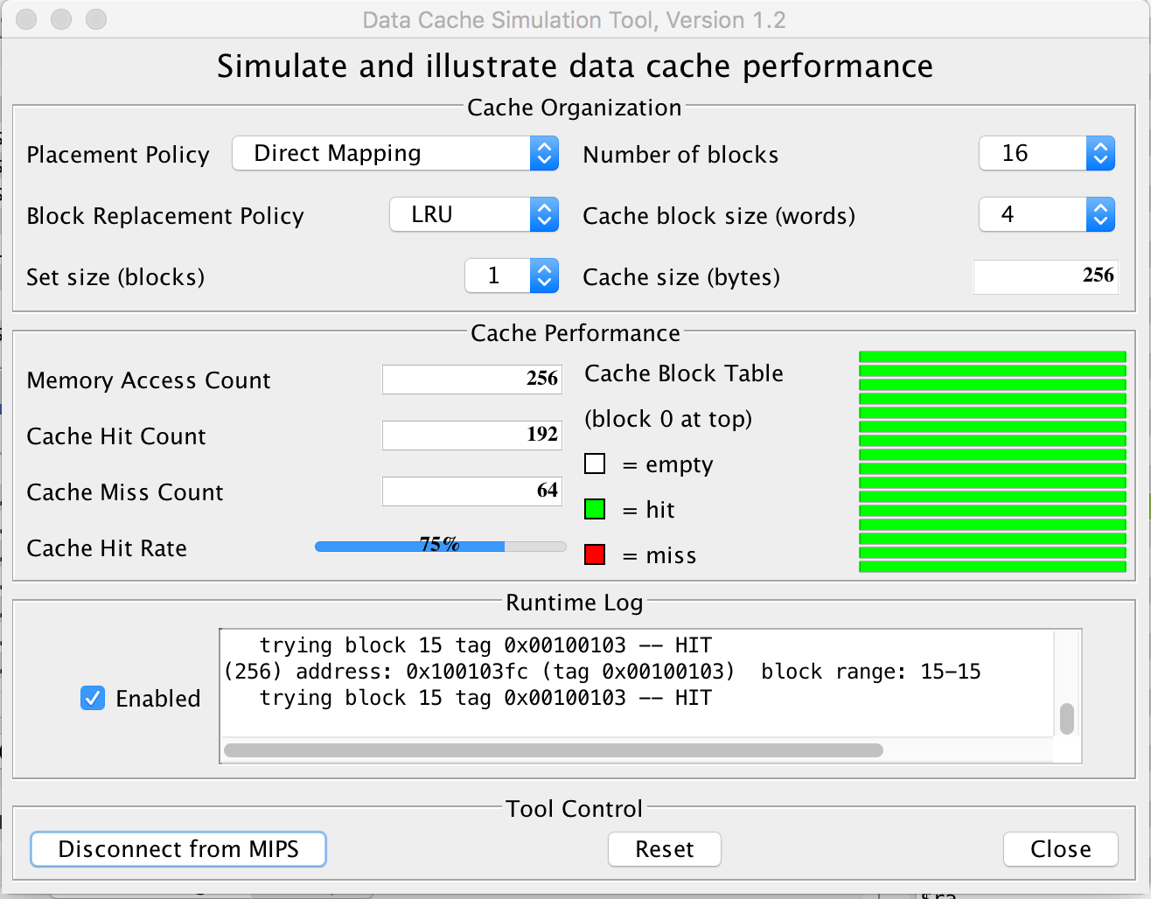
simulating result for direct-mapped cache, 8 words per block:

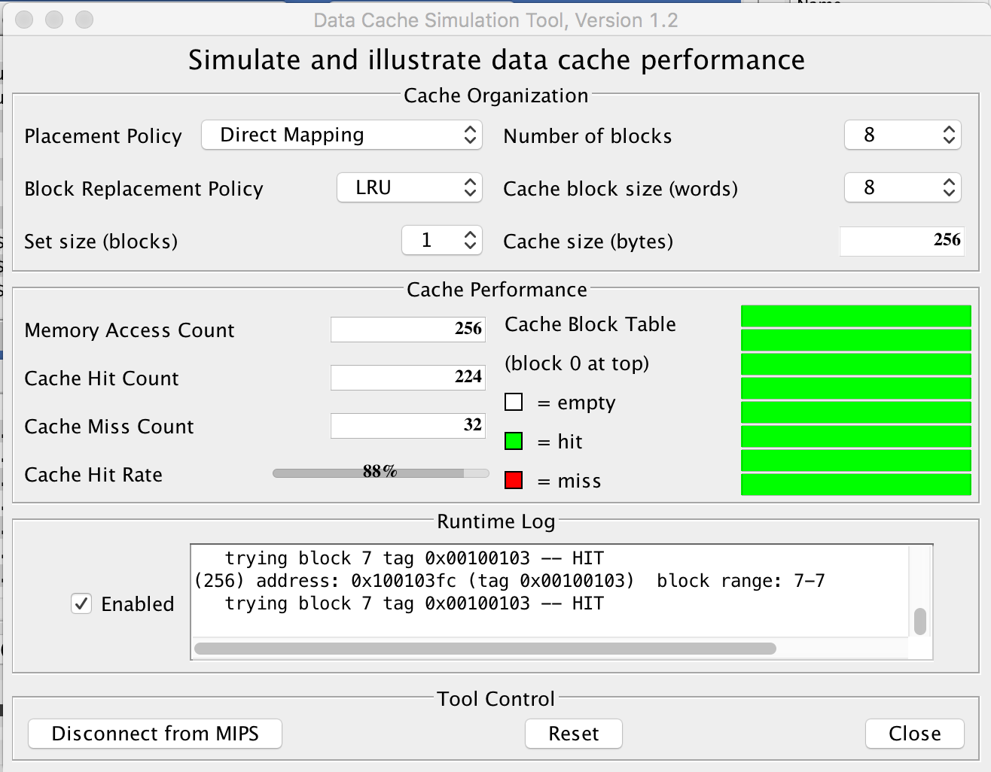
simulating result for 2-way associative cache, 4 words per block:
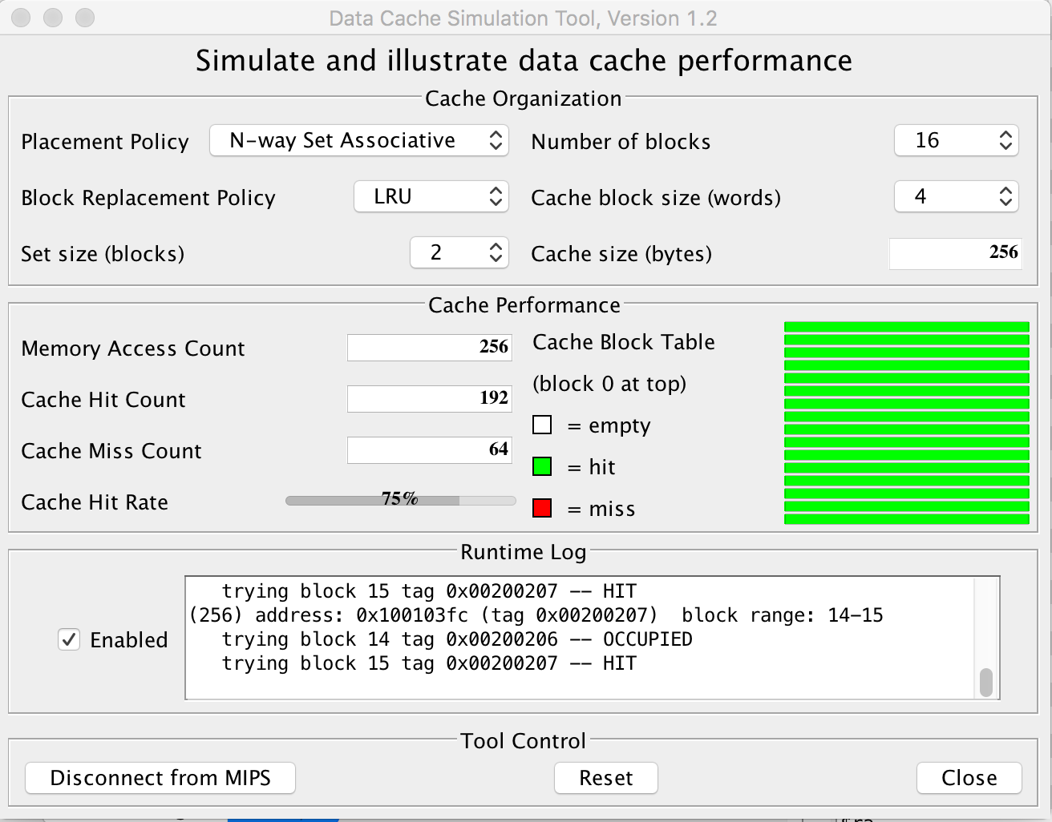
simulating result for 2-way associative cache, 8 words per block:
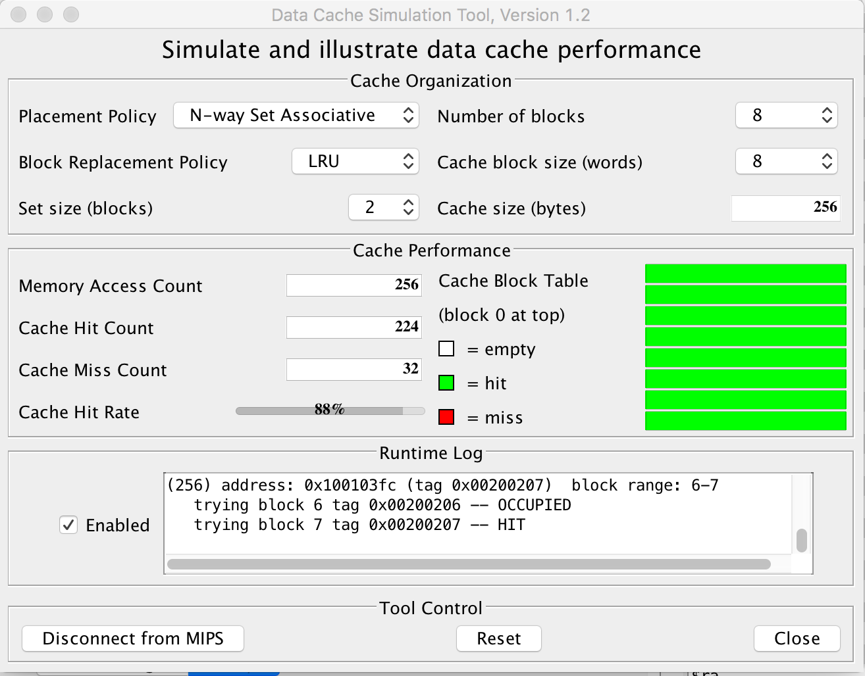

Exercise 5: (30 points) We assume that the data cache size is 1 KB (data) and the block size is 16 bytes. We assume that M[i][j] is adjacent to M[i][j+1] in the memory and that the cache is fully associative using LRU replacing. Consider the following code:
char A[64][64];
int i,j;
for (j = 0; j < 32; j++){
for (i = 0; i < 64; i++){
A[i][j] = A[i][j] ^ A[i][n-1-j];
A[i][n-1-j] = A[i][j] ^ A[i][n-1-j];
A[i][j] = A[i][j] ^ A[i][n-1-j];
}
}
This code performs a SPECIAL column-wise transpose. As indicated on Figure 2, the transposition is performed as follows: the first column(j=0) and the last column (j=63) are swapped, the second column (j=1) and the column (j = 62) are swapped, and so on…

Figure 2
We assume that the code is in a separate instruction cache and the variables i and j are in registers.
- Recall that this matrix contains characters (1 byte per character). How many blocks are needed to store one line of the matrix?
One line of Matrix has 64 “Char”=64*1B=64B
Block Size=16B
So, one line of Matrix need 64B/16B=4 blocks to store.
- How many blocks are needed to store the full matrix?
The Matrix has 64 lines, so 64*4=256 blocks are needed to store the full matrix.
- How many blocks does the cache contain?
cache size=1KB, block size=16B
# of blocks in cache=1KB/16B=(2^10)/(2^4)=2^6=64
- How many compulsory misses occur?
Compulsory miss occurs when a block is first brought into the cache. Since the matrix need 256 blocks, there will be 256 compulsory misses.
- How many capacity misses occur?
Each block has 16 “char”= 16 references.
For each block, the first reference is a compulsory miss, the other 15 references are capacity misses. Totally, there are 256 blocks. So, totally there are 256*15=3840 capacity misses.
- How many conflict misses occur?
Because the cache is fully associative, so, there is no conflict misses.
- Would a loop interchange decrease the number of capacity misses? If yes, rewrite the loops with the loop interchange (no need to repeat the swapping instructions) and provide the new number of capacity misses.
Yes.
for (i = 0; i < 64; i++){
for (j = 0; j < 32; j++){

}
}
In this way, there would be no capacity misses. Because after each block is first brought into the cache, it is fully used and never accessed again.
- What would be the number of compulsory misses with a loop interchange?
The compulsory misses would be still the same, 256 compulsory misses. Because this 256 blocks still need to be brought into the cache for the first time.
- What should be the minimal size of the cache if we wanted to use blocking?
Minimal size of the cache should be 2 blocks=2*16B=32B.
Because each time we need to reference data in two blocks at the same time to get
the “swap” operation done. So minimal size of cache should be 2 blocks of data.

Exercise 6 (10 points): Virtual memory
We consider a 32 bit address bus and a 512 KB physical memory. Page size is 32 KB.
- Assuming a validity bit, a dirty bit, and two reference bits, what is the size of the page table? Show the different steps to determine the page table size.
Page table size= # of page entries * page table entry(PTE) size
Page offset=log₂(page size in bytes)=log₂(32KB)=log₂(32*1024B)=15bits
Physical page number = physical memory size/page size=512KB/32KB=16=2⁴ =4bits
Page table entry size=1bit (validity bit) + 1bit (dirty bit) + 2bit (two reference bits) + 4bit (physical page number size) = 8bits
# of page entries= 2^{(virtual address –page offset)} =2⁽³²⁻¹⁵⁾=2¹⁷
So, page table size=2¹⁷*8bits=2¹⁷*2³=2²⁰ bits

- Suppose that Entry n in the page table contains the value floor(n/2^{^10}). What is the physical address associated with virtual address (0x10002400)?
0x10002400=0001,0000,0000,0000,0010,0100,0000,0000
Page offset=15bits
Page offset is (010,0100,0000,0000)₂
Virtual Address:
Virtual page number | Page offset

So, virtual page number (index for the page table) is 0001, 0000,0000,0000,0
n=(0001,0000,0000,0)₂
Physical page number=floor(n/2^10)=(1000)₂
Physical Address:
physical page number | Page offset

So, physical address is (100,0010,0100,0000,0000)₂ =0x42400

This exercise will be assigned only if vector CPUs

Additional Exercise : (XX points)
Consider computing the vector Y = a * X + Y. Vectors X and Y contain 96 double floats each and are stored at addresses Rx and Ry, respectively. A double float takes 8 bytes (64 bits). We assume that registers can contain 64 bits and that the CPU can load/store a double float by generating only one address (reference). This exercise has three parts: Part A, B, and C.

Below is the code to compute the vector Y = a * X + Y on a MIPS machine. However, the code below works for vectors with 64 elements only.

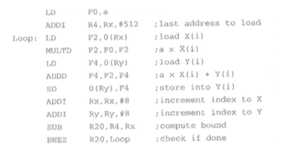

Part A:
- First, modify the code above to handle vectors with 96 elements
 | LD | F0, a
 | ADDI | R4, Rx, #768
Loop: | LD | F2, 0 (Rx)
 | MULTD | F2, F0, F2
 | LD | F4, 0 (Ry)
 | ADDD | F4, F2, F4
 | SD | 0 (Ry), F4
 | ADDI | Rx, Rx, #8
 | ADDI | Ry, Ry, #8
 | SUB | R20, R4, Rx
 | BNEZ | R20, Loop

Since (96 elements)*(8byte)=768, so, last address to load is #768.
- How many data references are generated by the CPU to execute the modified code ?
 | LD | F0, a
 | ADDI | R4, Rx, #768
Loop: | LD | F2, 0 (Rx)
 | MULTD | F2, F0, F2
 | LD | F4, 0 (Ry)
 | ADDD | F4, F2, F4
 | SD | 0 (Ry), F4
 | ADDI | Rx, Rx, #8
 | ADDI | Ry, Ry, #8
 | SUB | R20, R4, Rx
 | BNEZ | R20, Loop

Instructions highlighted in blue above are data references. There are 1 data reference out of loop, and 3 data references in the loop. Since there are 96 elements, therefore, the loop executes 96 times. So, total # of data reference is 1+ 3*96=289

- How many instructions references are generated by the CPU to execute the modified code ?
There are 2 instructions outside the loop, and 9 instructions inside the loop, and the loop executes 96 times since there are 96 elements. So, the total number of instructions is 2+9*96=866

Part B:
The VMIPS CPU support vector operations for vectors of up to 64 elements. The VMIPS contains only one pipeline (lane). Therefore, whenever a vector instruction is executed on a vector containing n components, the pipeline simply makes n executions, i.e., one execution (of the SAME instruction) per component.

Below is the vector code to compute a vector Y = a * X + Y. The code below would work only for vectors with 64 elements.

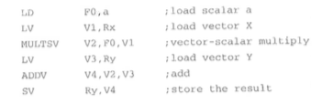
- First, modify the code above to handle vectors with 96 elements. Your code must be vectorized.
LD | F0, a
LV | V1, Rx
MULTSV | V2, F0, V1
LV | V3, Ry
ADDV | V4, V2, V3
SV | Ry, V4
ADDI | Rx, Rx, #512
ADDI | Ry, Ry, #512
SUBI | VL, VL, #32
LV | V1, Rx
MULTSV | V2, F0, V1
LV | V3, Ry
ADDV | V4, V2, V3
SV | Ry, V4
ADDI | VL, VL, #32

After operating on the first 64 elements, we set the Rx, Ry to 64*8=512, to get the remaining 96-64=32 elements start. And we set the vector length to 32.

- How many data references are generated by the CPU to execute the modified code ?
There is 1 scalar load operation, and for each element (first 64 elements, then 32 elements) there are 3 data references. So, there are total 1+3*96=289 data references.

- How many instructions references are generated by the CPU to execute the modified code ?
There 15 lines of code, each line of code is equal to one instruction reference. So, there are total 15 instruction references.

Part C: Evaluate the percentage of decrease (in the number of address references) from MIPS to VMIPS for each of the following address references: data, instructions, and total (both data and instruction).
The number of data references for MIPS and VMIPS are both 289. So, there is no decrease from MIPS to VMIPS in terms of data references.
The number of instruction reference for MIPS and VMIPS are 866 and 15, respectively. So, percentage of decrease from MIPS to VMIPS in terms of instruction reference is (866-15)/866=98.3%.
The total number of references for MIPS and VMIPS are (289+866) and (289+15), i.e. 1155 and 304, respectively. Therefore, the percentage of decrease for total references is (1155-304)/1155=73.7%

Based on progress, additional exercises may be added.
What to turn in INDIVIDUALLY?
Electronic copy of your exercises. Use Microsoft Word or PDF.

IMPORTANT:
A late submission will get a 50% penalty if submitted after 9:00pm on the due day. After 9:00pm the next day, the submission will be worthless.

