# **Usability short** **comings** in “Page Object” section of SWD Page Recorder

1. We can not copy **one page objects onto other pages**, i.e. an Item of .pox file can not be copied to another .pox file.

**Example:** My application has A, B etc.. pages. A page has objects Start Date(id: A_startDate) and End Date(id: A_EndDate), which B also has like Start Date(id: B_startDate) and End Date(id: B_EndDate). So, I would like to copy the objects from A to B, in this case I just need to change the ids, rest things can be the same.

1. The object on which we are currently working on Locators tab, are not **highlighted** in Page Objects tab, due to which user have to read the objects list to see on which object we are currently making the changes.  
   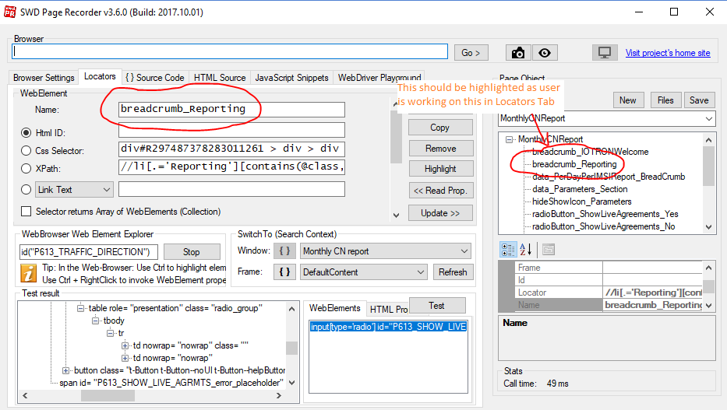
2. We need to **double click** on an Object to bring it in **“Locators Tab”**, It causes lot of confusion while Removing and creating copy of elements
3. We can not select **multiple objects** to perform,” Remove”, “Copy” actions
4. Also if possible, It would be great if we can edit the “xpath” and view element hierarchy on the [ctrl + right click] popup itself
5. Please Enable keyboard shortcut keys to perform actions like (Save – ctrl + s) and also put the Copy, Remove actions on a popup which displays when we select object and right click on it.
6. Also it would be great, if instead of showing a dropdown of created pages,   
   we can have them in tree like view like as shown below  
     
   This will improve the usability and speed in copying and pasting the same kind of Objects from one page to other.