HTK with Neural Network
Hybrid-tandem-bottleneck

Ann neural network for htk

Renal 2015
Output nn, state hmm → hybrid …
Slide p. 5 of 18: Using neural networks for acoustic modeling

@todo How calculate ann output cost function …?
Must check logout probability like IDoutp() that concern with ann

@todo, Why 351x1000x100
Read ann dnn in detail …

@todo genphy …
GenInitDNN.py is copied by RMHTK/step-15 and RMHTK/step-16
And called by RMHTK/scripts/pretrain

Backup projects and research
12/21/2017 2:07:48 PM
/media/joesmart/sda5/BACKUP_001/

Scripts sequence

Monophone

Createlabs.sh
Preparemfc.sh

This will create monophone on hmm7
Makehmm.sh

@todo, Test monophone
Must test accuracy for monophones ….. so we can judge result of ANN Laters.
monophone_test.sh show good result for 64 bit ..

./monophone_test.sh ../../htk/datas/confusable/b.wav
12/22/2017 12:17:18 PM
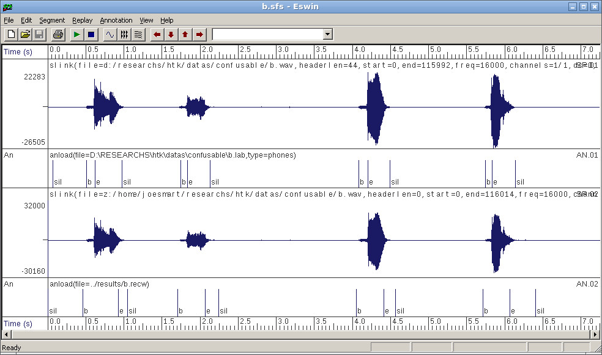
Good result of monophone_test.sh

Hmm nn hybrid

Creating initial structure
initdnn.sh

Creating aligned label with score
step_1_p65_frame_al.sh
connecting hmm7 to dnn3/ini
step_2_p67.sh

Calculating mean variance normalization
step_3_p68.sh

Discriminative pretraining stage
step_3_p68_dps.sh
add layer 4
step_3_p69_addlayer4.sh
fine tuning
step_3_p70_finetun.sh

@todo, hybrid hmm/nnTesting
Using MFCC_D_A_0_Z
hybrid_test_01.sh ../../htk/datas/confusable/b.wav

result is worse than hmm7
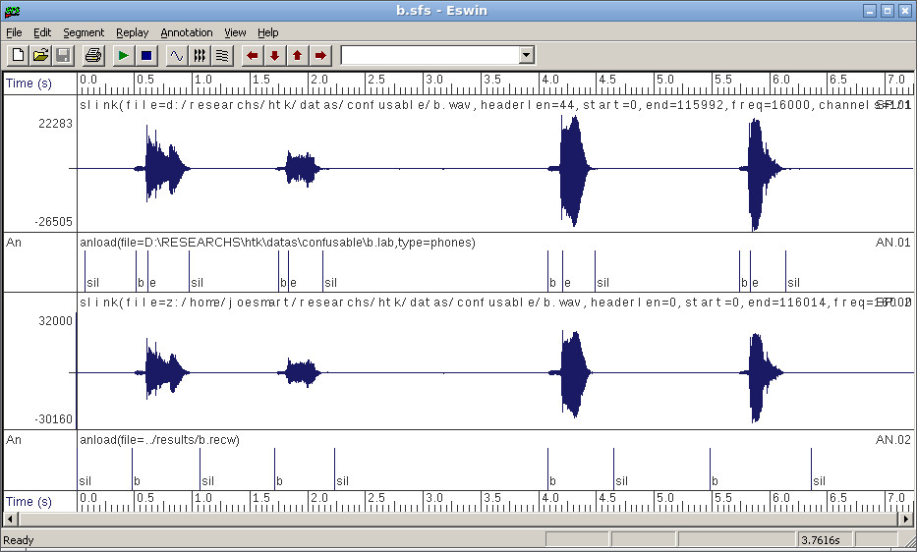
@todo, bad Hybrid nn –result

Why ? bad alignment data ?

Sfs data for neural network

/home/joesmart/sda5/RESEARCHS/htk/datas/confusable

Sfs installed
wine32.sh sfs-4.8.1.exe
wine32.sh ~/.wine/drive_c/htk/SFS/Program/SFSwin.exe

Htk compiled

Gcc -m32 mean 32 bit compilation
Install
Htk is compiled against 32 bit architecture ...

htk 3 5 ...
Copy override over htk_3.4
Hmath.c:4224
Makefile
CFLAGS +=-std=c99
CFLAGS +=-std=gnu99
well it's better cp MakefileCPU intu Makefile in HTKLib and HTKTools directory.

@todo htk 3 5 ...
MakefileCPU contains flag -m64 which suggest 64 bit math ... calculations ...

GITHUB

Steps
$pwd
/home/joesmart/sda5/RESEARCHS/neural_network/
$git init

To restart repository, ie deleting all just remove .git dir.
rm –rf .git

to add directory or file
git add dir or file ..

to see included files

git status | less

git remote add origin https://github.com/dzhatala/neural_network.git
change url
git remote set-url origin https://github.com/dzhatala/confusable.git

Steps

