HTK with Neural Network
Hybrid-tandem-bottleneck

Database speech htk/datas

english labeled data
2/14/2018 4:26:01 AM
There exist 42 English phoneme

pwd
htk/datas/cmu/packed
cat bdl_*/lab/*.lab | cut –f 3 –d “ ” | sort | uniq | wc –l
42

Lab dir is in ……/lab
Word lab is in ………../etc/t1.data or …../etc/txt.done.data

converting cmu/ESPS into htk using hled
esps format can be converted into htk format using –G SOURCELABEL
HLed –G ESPS edcmdfile.ed –l htklabdir cmu/packed/.. ./lab/*.lab
cd

cmu label format into sfswin as ESPS
cmu/packed/…./lab/*.lab can be imported into

@todo, htk how to embed shmm into htk to fix duration model
…

hmm vs shmm generative process
from [oestendorf, 1995] Figure1, hmm ‘generate’ single frame, while shmm ‘generate’ number of frames.

@todo HInit, viterbi training per data calculation verification
3/1/2018 9:00:47 PM
Move to logbook_hinit_calculation_verification.doc.

@todo, loglikelihood per frame ?

where is baum Welch in htk …

Baum welch is implemented in htk/HTKTools/HRest.c, htk/HTKTools/HERest.c using htk/HTKLib/HFB.c

Different between HRest vs HERest
HRest : isolated training, using single iteration update corresepoding phone/subword

HERest : embedded training update all hmm, using embedded Baum Welch algorithm htk3.5book, section 8.8.

@todo, readings

Parallel distributed processing from hinton, william 1986 vol I dan vol 2

Ann neural network for htk

Htk ann
Layerout of ann link to hmm ‘~ ?’ state , this because state can emit phonems.

~s "silst"
<TARGETSOURCE> ~L "layerout"
<TARGETINDEX> 7
<TARGETPENALTY> 0.000000e+00
~h "b"
<BEGINHMM>
<NUMSTATES> 5
<STATE> 2
<TARGETSOURCE> ~L "layerout"
<TARGETINDEX> 1
<TARGETPENALTY> 0.000000e+00
<STATE> 3
<TARGETSOURCE> ~L "layerout"
<TARGETINDEX> 2
<TARGETPENALTY> 0.000000e+00
<STATE> 4
<TARGETSOURCE> ~L "layerout"
<TARGETINDEX> 3
<TARGETPENALTY> 0.000000e+00
<TRANSP> 5
0.000000e+00 1.000000e+00 0.000000e+00 0.000000e+00 0.000000e+00
0.000000e+00 7.278844e-01 2.721157e-01 0.000000e+00 0.000000e+00
0.000000e+00 0.000000e+00 9.097071e-01 9.029292e-02 0.000000e+00
0.000000e+00 0.000000e+00 0.000000e+00 9.582705e-01 4.172954e-02
0.000000e+00 0.000000e+00 0.000000e+00 0.000000e+00 0.000000e+00
<ENDHMM>

Math

Ann for feature , ann as probability …
Cost function MSE criterion:
 | 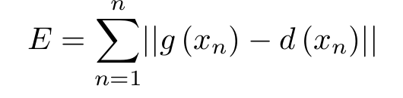 | (6)

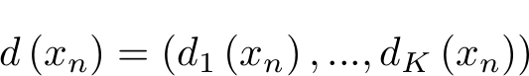 : desired output,
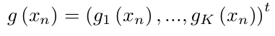: observed output
Reading :
9

10,
27
66, richard, lippmann, Neural network classifiers estimate Bayesian a posteriori probability, 1991

@todo, why train ann per state ?
In dps and finetune we need labeled utterance with full states infos to train ann.

priori vs aposteriori
in pattern recognition prior or prior probability of class w_{k} p(w_{k}) is the.probability without knowing any data. If the feature x is available and then the class probility conditioned on this data is called posterior probability p(w_{k}|x) (Bourlard & Morgan, 1994).

Another probability is called feature/data likelihood p(x|w_{k}).

ann as emission probabilities
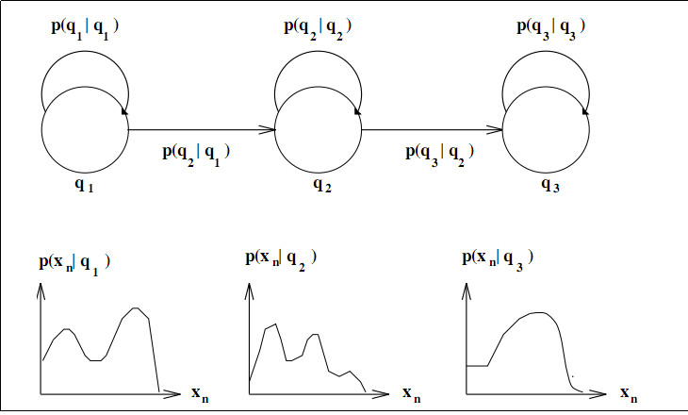

Figure 2:

ANN can be trained to produce posterior probability p(q_{k}|x_{n}), probability of state given acoustic vector.

Renal 2015
Output nn, state hmm → hybrid …
Slide p. 5 of 18: Using neural networks for acoustic modeling

@todo How calculate ann output cost function …?
Must check logout probability like IDoutp() that concern with ann

@todo, Why 351x1000x100
Read ann dnn in detail …

@todo genphy …
GenInitDNN.py is copied by RMHTK/step-15 and RMHTK/step-16
And called by RMHTK/scripts/pretrain

Backup projects and research
12/21/2017 2:07:48 PM
/media/joesmart/sda5/BACKUP_001/

Scripts sequence

Monophone

Createlabs.sh
Preparemfc.sh

This will create monophone on hmm7
Makehmm.sh

@todo, Test monophone
Must test accuracy for monophones ….. so we can judge result of ANN Laters.
monophone_test.sh show good result for 64 bit ..

./monophone_test.sh ../../htk/datas/confusable/b.wav
12/22/2017 12:17:18 PM
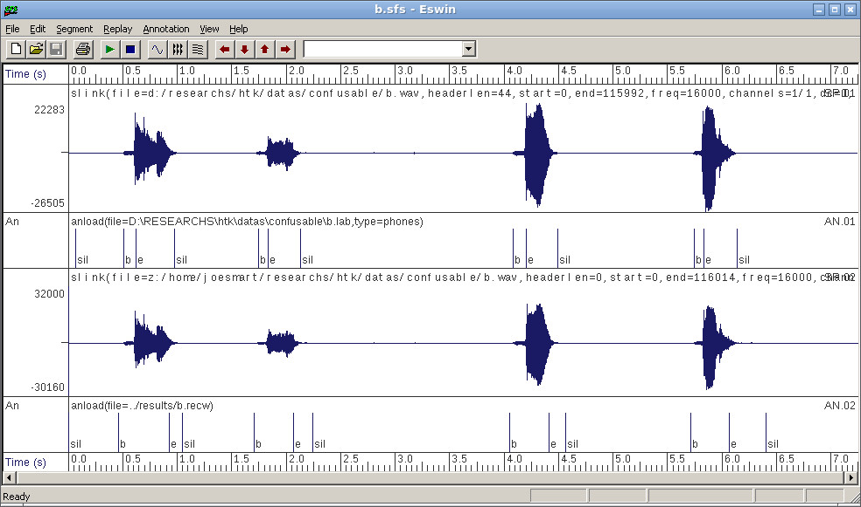
Good result of monophone_test.sh

Hmm nn hybrid

Creating initial structure initdnn.sh results in protonn/work/NMF

Creating aligned label with score
step_1_p65_frame_al.sh
will output trained.mono.aligned.mlf. the aligned mlf label file contain state level definition. For example,

#!MLF!#
"../../htk/datas/confusable/b.lab"
0 1000000 sil[2] -556.032959
1000000 1100000 sil[4] -54.679684
1100000 4400000 sil[2] -1881.822144
4400000 4600000 sil[4] -128.384872

Number ? in bracelet phn?[?], is the state number that generate the phone. For a 3 emitable states of hmm, we have this number could be 2,3,4. And for a single emitable state this number x only have value 2. This state number required by ann (HNTRAINSGD).

connecting hmm7 to dnn3/init
step_2_p67.sh

Calculating mean variance normalization
step_3_p68.sh

Discriminative pretraining stage
step_3_p68_dps.sh
add layer 4
step_3_p69_addlayer4.sh
fine tuning
step_3_p70_finetun.sh

@todo, hybrid hmm/nnTesting
Using MFCC_D_A_0_Z
hybrid_test_01.sh ../../htk/datas/confusable/b.wav

result is worse than hmm7
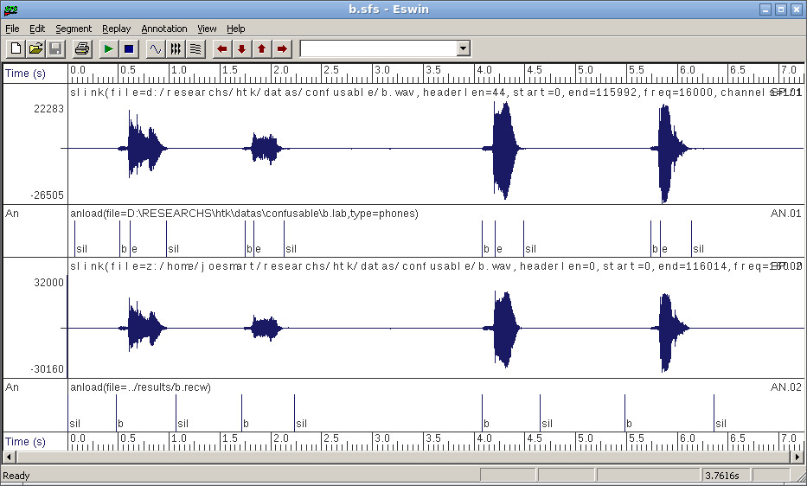
@todo, bad Hybrid nn –result

Why ? bad alignment data ?

Changing structure change validation results …
#initdnn.sh
cmd="python GenInitDNN.py --structure \" 351X700X4\" HTE.dnn.bn protonn/work/NMF"

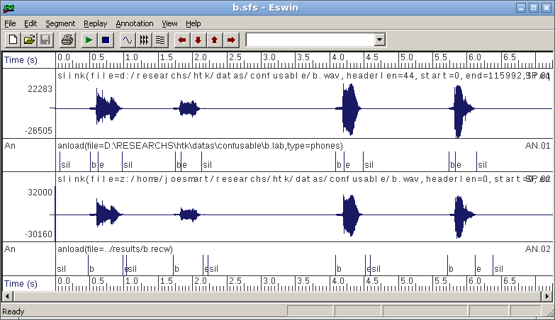
351x700x4

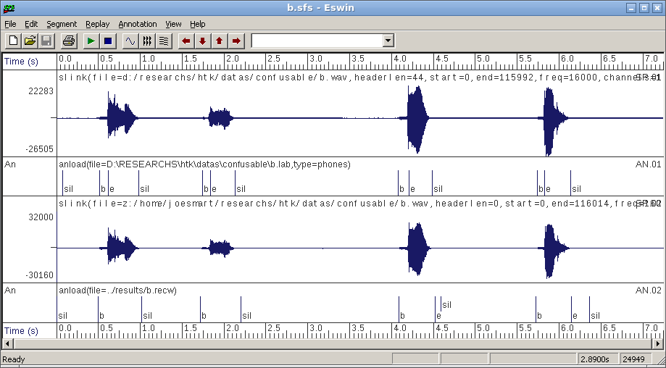
351x702x27

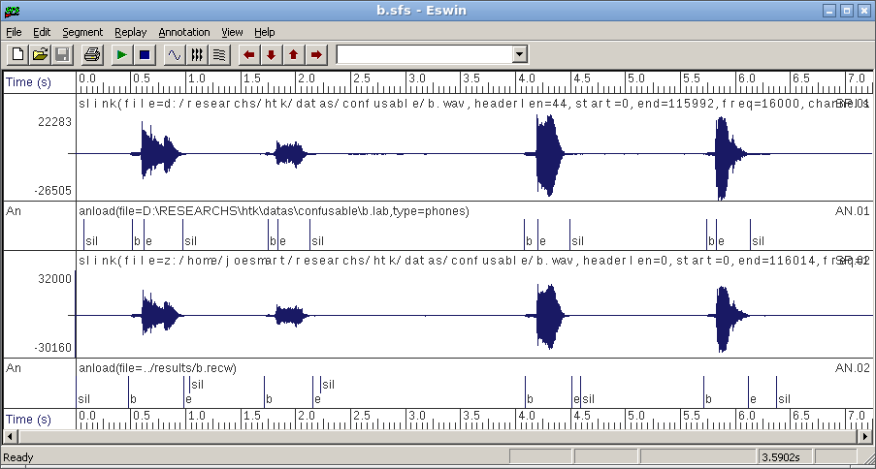
351x700x4

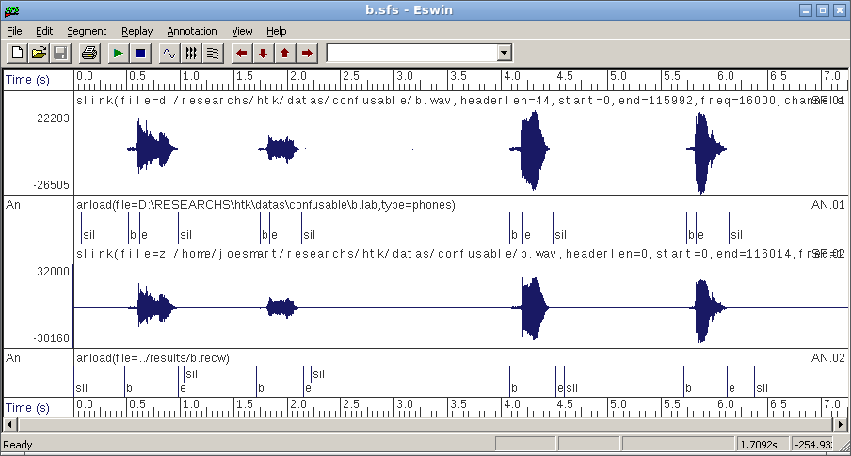
351x700x9

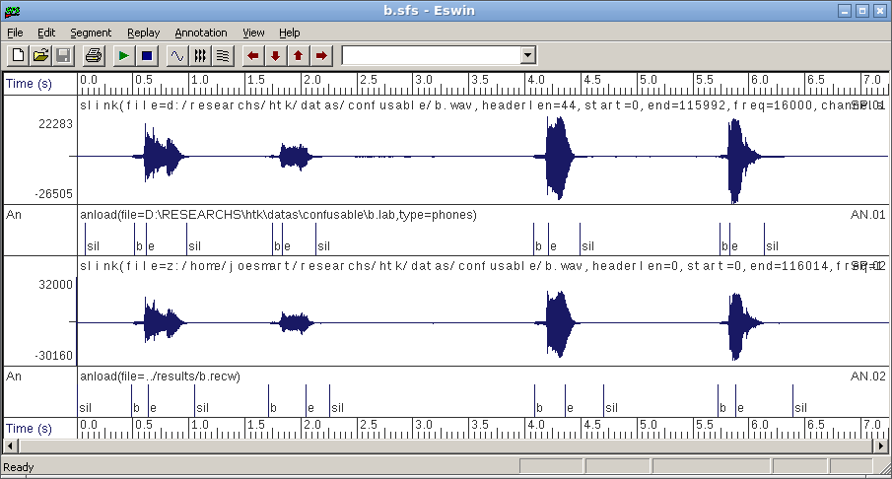
351x351x9
It seems straight mapping will increase in research …

@todo, increasing layer number, more more deep ?
1/7/2018 3:38:43 PM

Sfs data for neural network

/home/joesmart/sda5/RESEARCHS/htk/datas/confusable

Sfs installed
wine32.sh sfs-4.8.1.exe
wine32.sh ~/.wine/drive_c/htk/SFS/Program/SFSwin.exe

Htk compiled

Gcc -m32 mean 32 bit compilation
Install
Htk is compiled against 32 bit architecture ...

htk 3 5 ...
Copy override over htk_3.4
Hmath.c:4224
Makefile
CFLAGS +=-std=c99
CFLAGS +=-std=gnu99
well it's better cp MakefileCPU intu Makefile in HTKLib and HTKTools directory.

@todo htk 3 5 ...
MakefileCPU contains flag -m64 which suggest 64 bit math ... calculations ...

GITHUB

Auto add modified file
#~/bin/gitaddmodified.sh
$for x in `git status | less | sed s/modified// | sed s/:// ` ; do git add $x ; done

Steps
$pwd
/home/joesmart/sda5/RESEARCHS/neural_network/
$git init

To restart repository, ie deleting all just remove .git dir.
#rm –rf .git

git remote add origin https://github.com/dzhatala/neural_network.git

#change url
git remote set-url origin https://github.com/dzhatala/confusable.git

git config –global user.email dzulqarnaenhatala@gmail.com
git config –global user.name Hatala Z

git fetch origin master
git pull

to add directory or file
git add dir or file ..

to see included files

git status | less
git commit –m “Initial commit 002”
git push origin master
#login ; dzhatala
#password : d******z

Latex
- Use notepad== to write equations
- Use pdflatex to create latex
- Use gimp to automatic crop
  - Copy in gimp
- Paste in word2007

References
Bourlard, H., & Morgan, N. (1994). Connectionist speech Recognition : A Hybrid Approach. Kluwer Academic Publisher.

