HTK from HTKBook.pdf to HInit.c Code,

Verification using real data

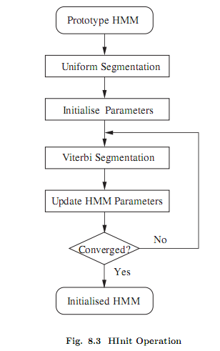

# Hinit

# The basic principle of HInit depends on the concept of a HMM as a generator of speech vectors. Every training example can be viewed as the output of the HMM whose parameters are to be estimated. [HTKBOOK,8.2].

# @todo, read tutorial uniform segmentation, viterbi training at speech.zone

# @todo, viterbi training?

$pwd

/home/joesmart/RESEARCHS/htkbook_to_c_code/scripts

../../neural_network_shmm/htk_35/HTKTools/HInit -T 3 -m 1 -M hinitoutput VOI arctic_a0001.mfc

Initialising HMM VOI . . .

States : 2 3 4 (width)

Mixes s1: 1 1 1 ( 39 )

Num Using: 0 0 0

Parm Kind: MFCC_D_A_Z_0

Number of owners = 1

SegLab : NONE

maxIter : 20

epsilon : 0.000100

minSeg : 1

Updating : Means Variances MixWeights/DProbs TransProbs

- system is PLAIN

322 observations loaded from arctic_a0001.mfc

1 Observation Sequences Loaded

Starting Estimation Process

Iteration 1: Average LogP =-29415.41797

Iteration 2: Average LogP =-29252.76953 Change = 162.64844

Iteration 3: Average LogP =-29247.36133 Change = 5.40820

Iteration 4: Average LogP =-29247.36133 Change = 0.00000

Estimation converged at iteration 5

Output written to directory hinitoutput

## arctic_a0001.wav properties

Dump of "D:\RESEARCHS\htkbook_to_c_code\scripts\arctic_a0001.sfs" on Sat Mar 03 20:39:52 2018

Item 1

Data Type : 1.01 SPEECH

History : slink(file=d:/researchs/htkbook_to_c_code/scripts/arctic_a0001.wav,headerlen=44,start=0,end=51761,freq=16000,channels=1/1,dc=0,mult=0)

Parameters :

Process Date : Fri Mar 02 21:10:51 2018

Format : 2 byte integer

Frame size : 1 Frame count : 51761

Total Length : 512 Frame Duration : 6.25e-005 (16000 Hz)

Window size : 1 Overlap : 0

Offset : 0 Last Position : 0

Comment :

Linked item :

Filename : d:/researchs/htkbook_to_c_code/scripts/arctic_a0001.wav

Filepath :

Filetype : 0

Item no. : 0.00

Offset : 44

Multiplex : 0

Byte swap : no

DC offset : 0

Bit shift : 0

Date : Fri Mar 02 21:08:58 2018

lab_match: out of date labels file 'C:\htk\SFS/data/labels'

file time=1513586305 internal time=1288920030

Total time = 51761 x 6.25e-6 = 3.24

## @todo 322 observations ?

arctic_a0001.wav

configcopy.txt;TARGETRATE =100 000 =1e5

target rate in s = 1e5x1e-7 = 1e-2 s=10 mili seconds;

jumlah frame = 3.24 s / 1e-2 = 3.24 x 1e2 = 324 obs – 2 (first and last ) = 322 obs.

2 observations is thrown out because of windowing …250

## @todo how htk count Average LogP

# Installation setup

## Eclipse cdt installed over eclipse

No debugger in eclipse indigo …

Sudo apt-get install eclipse-cdt

Now create project htk_35

## Octave and gnuplot installed, ron htk matlab downloaded

## Initial

3/2/2018 9:41:21 PM

htkbook_to_c_code/scripts/all.sh

3/1/2018 10:13:29 PM  
Project dir. Created ~/RESEARCHS/htkbook_to_c_code/  
HInit.c