htkbook_to_c_code/htk_normalization_adaptation/
logbook_htk_energy_normalization.doc

to investigate the effect of sound volume level on the performance of

@Todo urgent

@todo 0_D_A vs E_0_D_A?

@todo, continous version

@todo can HTK only use specific dimension of mfcc
Can mfcc 39 , compressesd using pca n <mfcc used in hinit and herest ? if we can than we can avoid implementating ‘token passing’ algorithm.

39 → read by matlab → perform pca

@todo, matlab read kind → convert to user
Change kind in .mfc file and convert it to ‘user’

@todo, Initial_PCA
Unknown symbol USER, ANON ??? whats the hmm base for user specified ...

Set in ‘initial_PCA’, USER type
~o <VecSize> 39 <USER>
~h "initial_PCA"
<BeginHMM>
<NumStates> 5
Set in ‘config_train_pca.txt'
TARGETKIND = USER
SOURCEKIND = USER
Execute baum_viterbi_init_cyg_pca.sh

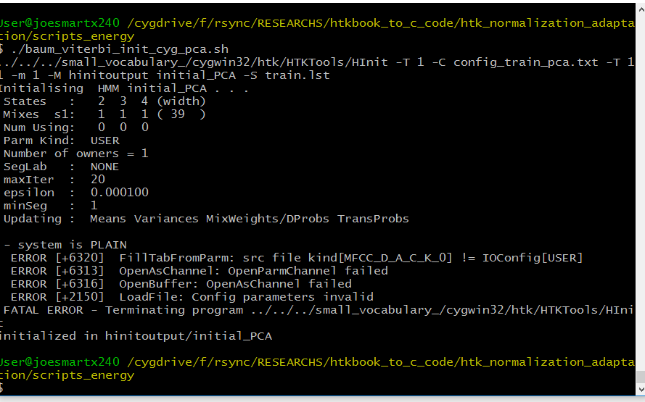

../../../small_vocabulary_/cygwin32/htk/HTKTools/HInit -T 1 -C config_train_pca.txt -T 11 -m 1 -M hinitoutput initial_PCA -S train.lst

Htkbook 3.5 alpha , where 39 come from
This number, 39, is computed from the length of the
parameterised static vector (MFCC_0 = 13) plus the delta coefficients (+13) plus the acceleration coefficients (+13).

@todo baum_viterbi_init_cyg_pca.sh
Train_pca.lst, for
mfc_to_pca_01.m for konverting
makehmm_cyg_pca.sh ..
monotest_cyg.sh ...
05/02/2019 23.54.26
It seems USEr vs MFCC_0_D_A agrees each other.

@todo, PCA pc pursuite 2018 hung jun wu

Solved 2002 smith lindsay tutorial on pca …..

Solved, live hvite win 10 windows command prompt
Is htk ready to a live .. with win 10 ? yes it’s compiled visual studio 2008. you can find the project in RESEARCHS/small_vocabulary_/vs2008/projec_vs2008

pca

trang
based on covariance matrix ?

@todo, how to calcualte cov. Matrix from sample data

Scripts cygwin
F:\rsync\RESEARCHS\htkbook_to_c_code\htk_normalization_adaptation\scripts_energy

Maketrain_lst.sh
This script will prepare train.st and htk2_mfcc_lst.w32.

Prepare_mfc.bat

Wav2mfcc_lst.w32

Htk2_mfcc_lst.w32

Configcopy.txt

Configcopy_htk_mfcc.txt
To copy from HSLAB/htk format into mfcc format

Env.bat

baum_viterbi_init_cyg.sh

train.lst
Using relative addressing can be used in cygwin and aspire (real ubuntu)

env_cygwin.sh

initial_XXX??
For v8 mfcc_e_D_0_z is bad, so we replace with mfcc_0_d_a

makehmm_cygwin.sh
@todo FAILEd to remove #13 from hmmdefs ...? to remove #13 from labs file, just open every labs file with notepad++ and perform EOL conversion → unix.

Sp mode removed
Sp mode removed till the last end of hmm making ... this silst cause error recognition such as ‘back data or bad prunning’

Train.lst
Using relative addressing can be used in cygwin and aspire (real ubuntu)

Error multiple use of hmm
This error because the phonems.lst not uniq. In cygwin this mainly because .lab files not in EOL unix. So the phonems with 0dh cr is considered different by uniq program.

monotest_cyg.sh

test.lst
using relative addressing can be used ini cygwin and aspire (ubuntu real)

monoperf_cyg.sh

@todo monoperf1.lst
Monophone phone recognition without ‘sil’. @TODO remove sil in calculation of monophones performances ....

mktrilab_cyg.sh

maketriph_cyg.sh

train.lst mfc_triph.scp

triphones1

@todo wtriphtest_cyg.sh
@todo

wgram_cont.txt

ctest.lst

cdict.txt
do not write continuous dictionary in triphones format, just write in monophones format, for example
NUM_2 d uw ah
NUM_3 t ih g ah
SILSP sil

wtriph_perf_cyg.sh

recw.mlf
this is the result for last script wtriphtest_cyg.sh

$wlab_dir
Copy from lab dir .. and change lab without time intervals...
#filename NUM_3_iso_0001.lab
SILSP
NUM_3
SILSP
NUM_3
SILSP
NUM_3
SILSP
NUM_3
SILSP

The result
The result is in sent and word levels.

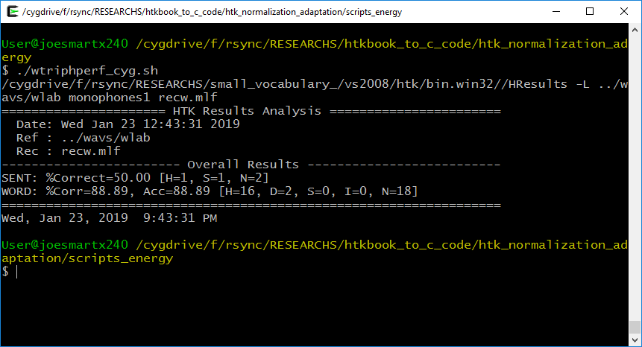

Sent: 50% mean, total sentences correct is 50%
Word : 88,89 mean, total percentages of correct word.

@todo wtriphtest_live.bat
Need to perform live test on windows command prompt ?

wtriphtest_htk_cyg.sh
single file HTK test. To test htk directly without converting into mfcc. Use this to perform immediate test after relabelling especially for correction from single real data from replaybuffer of Hvite –g.

Scripts_aspire.sh
Using this method if htk is worked from acer aspire through mounted samba bin/mountx240sambat.sh

F:\rsync\RESEARCHS\htkbook_to_c_code\htk_normalization_adaptation\scripts_energy → /media/joesmart/x240rsync/RESEARCHS\htkbook_to_c_code\htk_normalization_adaptation\scripts_energy

Wav2mfcc_lst.w32

Configcopy.txt

Env.bat

Prepare_mfc.bat

Env.bat

Train_lst.w32

baum_viterbi_init.bat

env.bat

makehmm_aspire.sh
Since cygwin lead /r/13 in hmmdefs its better to run all scripts in unix pure env aspire.sh

env.sh

train.lst

testing

monotest.sh

test.lst

configtrain.txt (configtest.xt)

phone1.dic

monophones1

@todo, monotest_xxx.sh results ….
Need spectral refinement … care analysis
.. need to analyse the mean and variance for all acoustic model ??

@todo, why MFCC_0_D_A outperform MFCC_E_D_A_Z_0
It seems that options ‘_E_’ or ‘_Z_’ degrade recognition rate. N

Sampling frequency

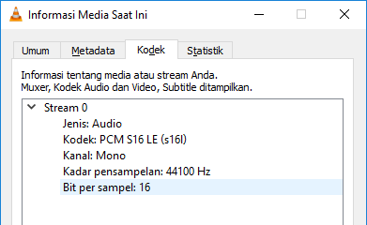
Frequency sampling shown by VLC media lan player

To change the sampling fdquency of the wav file set in audacity project rate at the left bottom panel

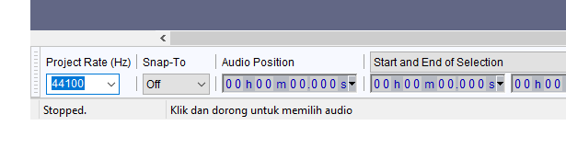
Project rate determine the output of wav exported sampling frequency

did htk perform energy normalization?

Configcopy.txt
ENORMALIZE = T

@TODO how HTK ENORMALIZE
HParm.c:835
case ENORMALISE: p->eNormalise = GB(s); break;

HParm.c:835:
NormaliseLogEnergy(fp1 + cf->nUsed-1, pbuf->qen-pbuf->qst+1,
cf->nCols, cf->silFloor, cf->eScale);

HTKBOOK 5.8 energy measures
Live audio is INCOMPATIBLE with energy normalization ? … show how to adapt two different mic input ? is energy normalization … ?

What’s the relationship between energy c0 and other coeffs in …
What’s the effect of
Energy in mfcc is calculated in c0. so if it not normalized then off course there should be a difference. As in c0 is the energy
https://www.researchgate.net/post/Is_there_any_effect_of_speech_signals_volume_on_the_performance_of_speaker_recognition_systems

Measure sil

Data recording …

Two numbers num_2 num_3 audacity v8
This is the first room condition, in the morning near the beach of rumah tiga ambon

Microphone v8: 100%
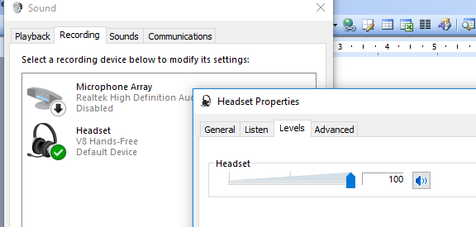

Audacity silence measurement

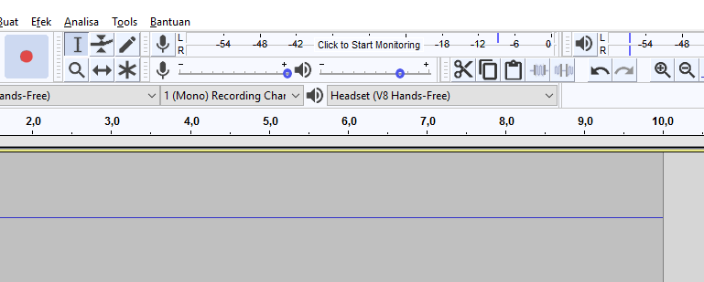

The silence average energy is shown in above picture fall before -54. at different noise level it should be different.
The trainer, num_2 and num_3 is choosen because of the similarities. These two numbers contain 2 consonant and 2 vocals.

Duwa duwa duwa duwa
Tiga tiga tiga tiga

It seems that v8 reduces accuracy of \t\ in num_3 data. This is a common drawback of cheap affordable microphone… the proof is by replacing the recorded num_3 in computer, the word 'tiga’ is heared to become ‘iga’ that is missing its \t\ phone.

@todo, Missing /t/ need to download high resolution wav Indonesian digit from youtube ……? Or internet ?

datas/vas…/mp3/youtube_3.wav

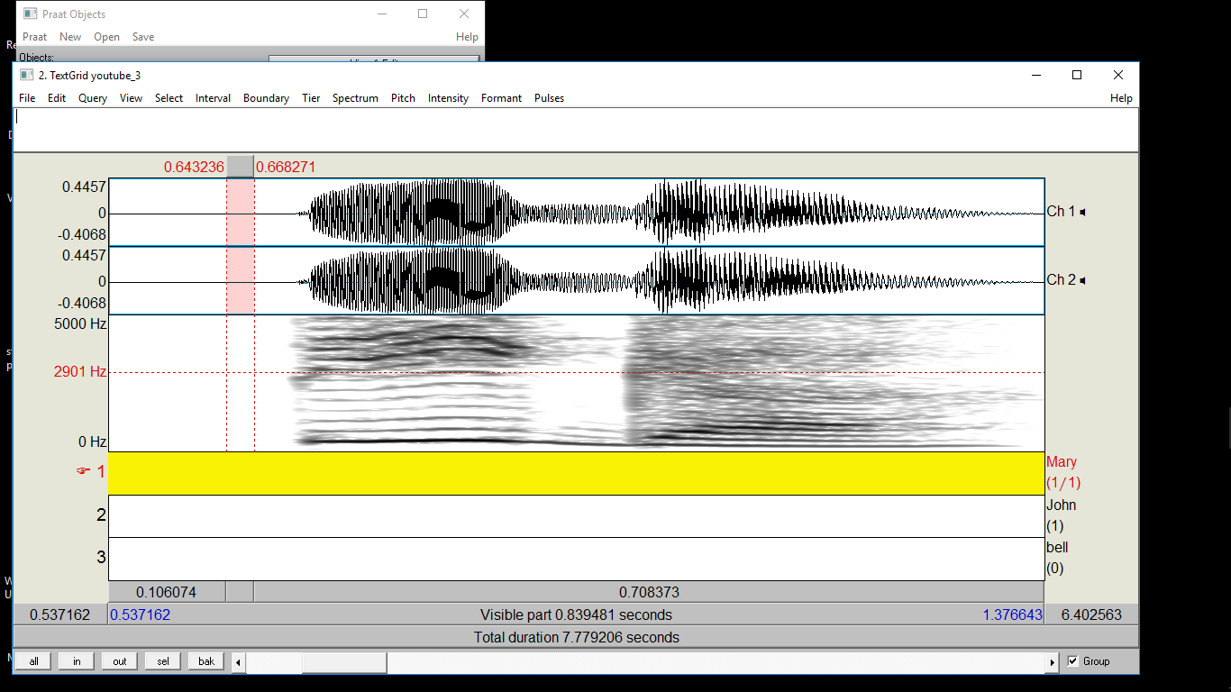

T onset time in num_3 ‘tiga’

T onset time “2006 voice onset time turkish fatih akif engin10.1016%2Fj.specom.2006.02.003.pdf”
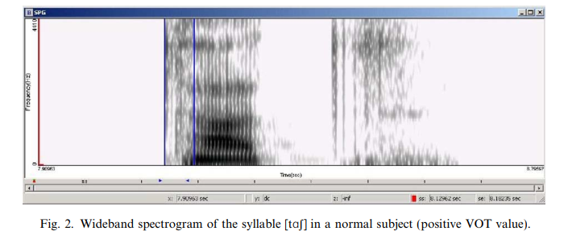

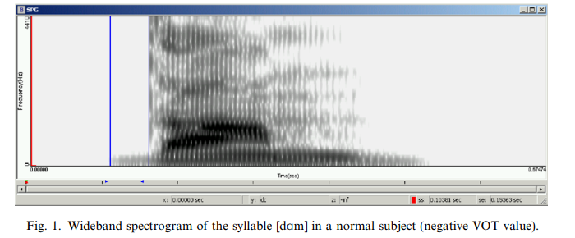

@todo, how to labelled stop consonant by arctic database

http://www.speech.zone/exercises/build-a-unit-selection-voice/the-recording-script/the-utts-data-file/

arctic lab file in
cmu_us_bdl_arctic/lab/acrtic_00001.lab while its utterance/prompt/sentence file in
_bld_arctic/fectival/utts/acrtic_0001.utt
Its fragment

Features max_id 184 ; type Text ; iform "\"Author of the danger trail, Philip Steels, etc.\"" ; fileid arctic_a0001 ;

Arctic cmu label in ESPS format which can be loaded by SFS automatically. Arctic label is in Arpabet format which has counterpart version of Internation Phonetic Association (IPA) format.

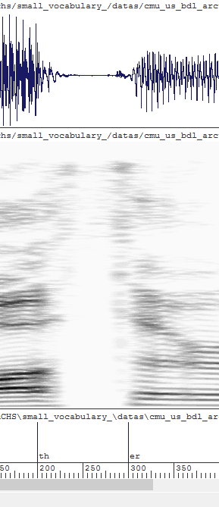

Fig : stop conconant th and t labelled by arctic ….

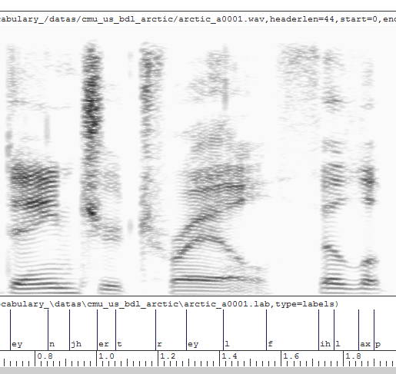
@todo Arctic in cmu format HTK –G ???

@todo list arpabet labelling bt arctic or timit ….

@todo TIMIT database ….
Lee hon 1989 , using phone like this

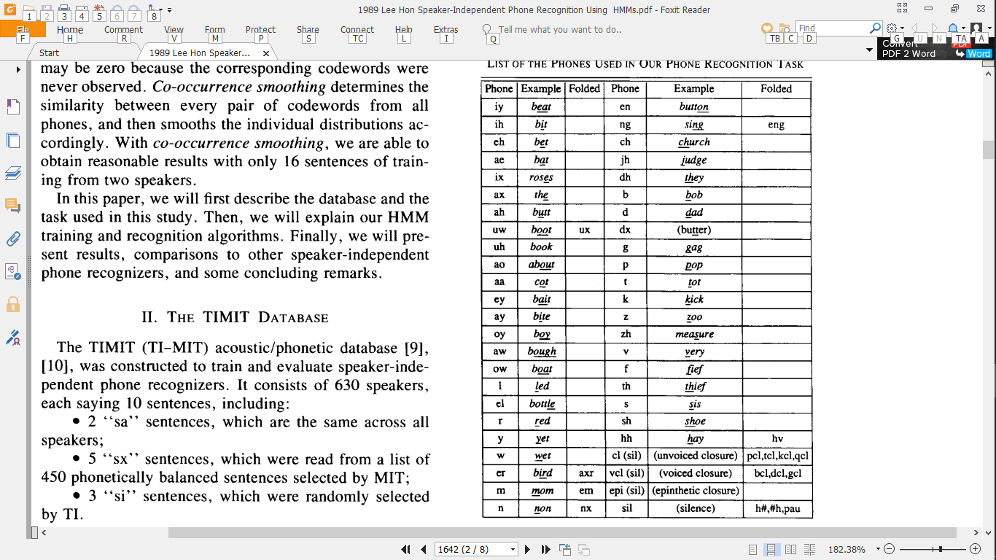

NUM_2 NUM_3

Recording wav using audacity
Label using praat, save as (long) text file ...
Create new sfs, Import praat (long) format into SFS format
Export into htk, open in notepad ➔ EOL conversion ➔unix format
Train ...

NUM_4
We have stop consonant a-t at the end of word. How to label it? According to TI-MIT ? according to cmu ?

did htk perform energy normalization?

did htk perform energy

normalization?

did htk perform energy normalization?

Print

ip chart hon lee

the books, steps

recording

periksa frekuensi sampling

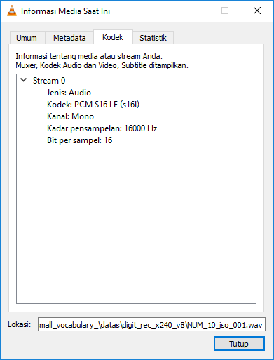

Or you can check the bit rate, if 256 kbps than its in 16000 hz.
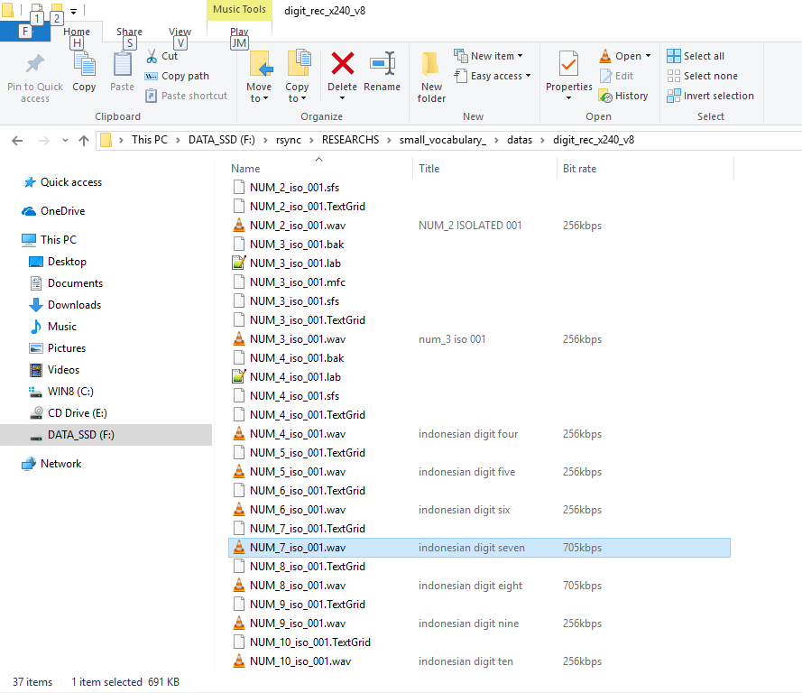

labelling or annotating ..

Praat useful shortcut
Ctrl+o open file
Ctrl+i zoom in while annotating
Ctrl+o zoom out while ann.

annotating with praat
click open long sound menu
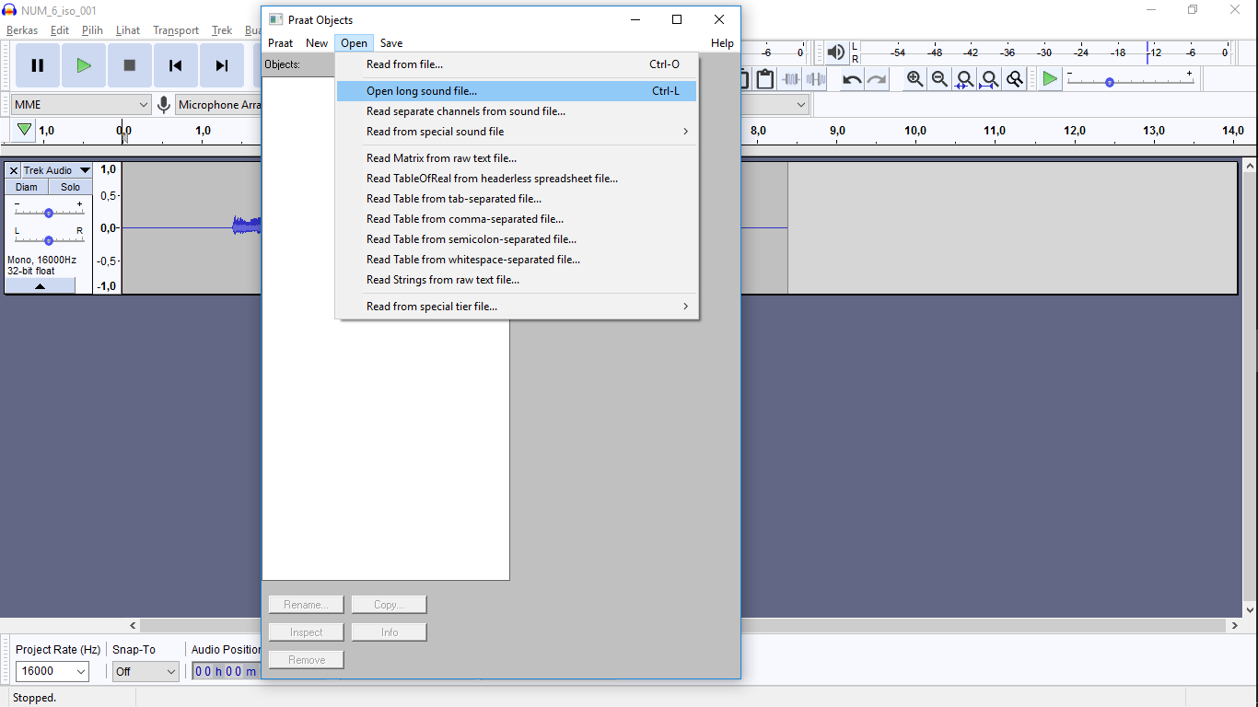

Choose the file from the chooser
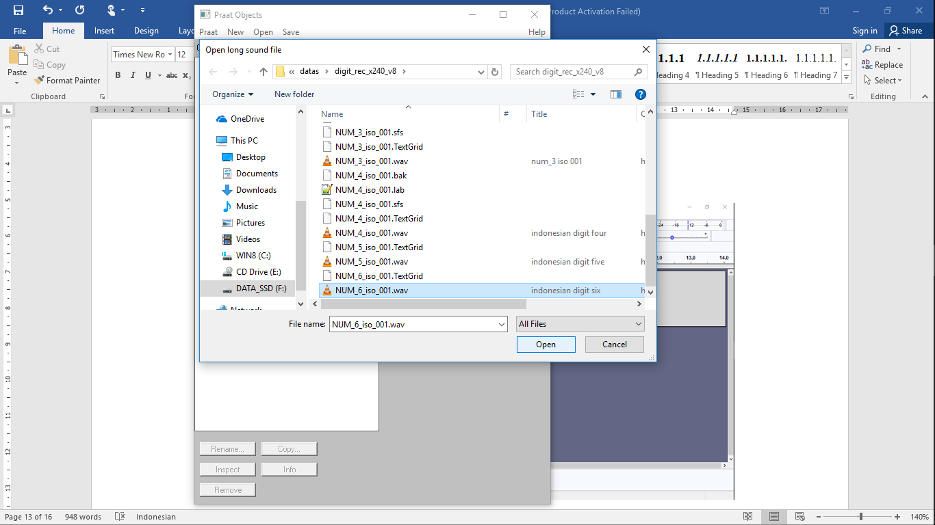

The file is ready on left pane of praat
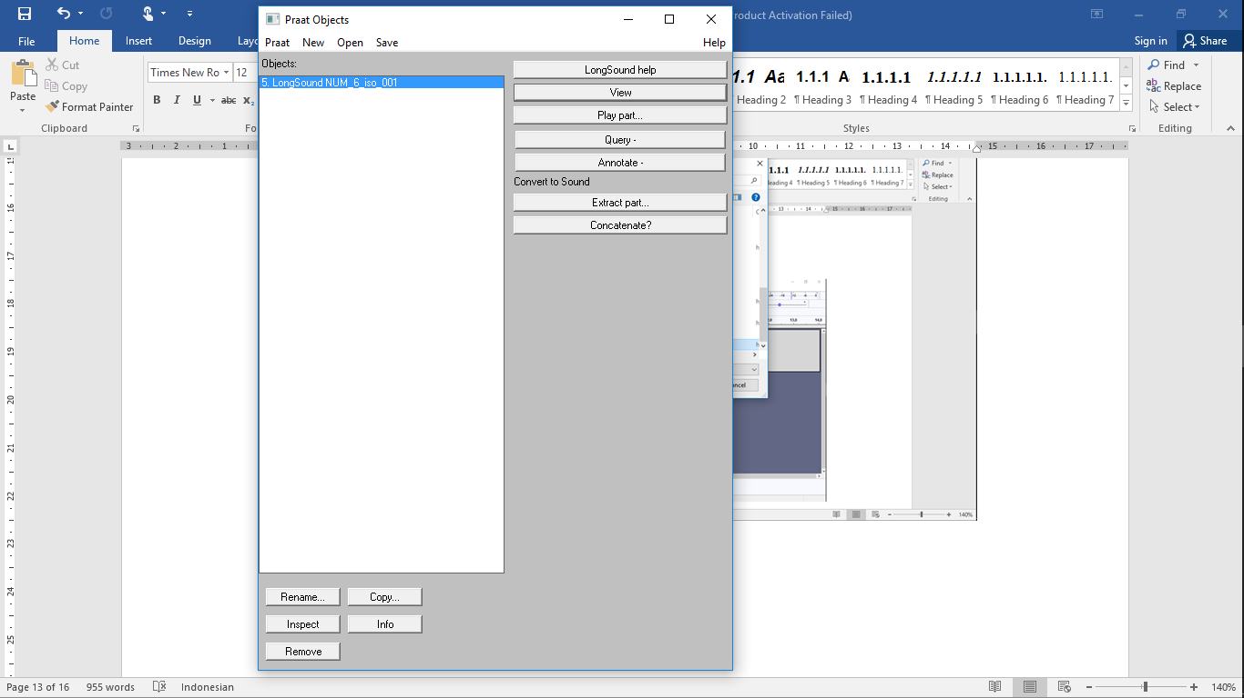

Select the file on the right, it will turn blue and annotate button enable in the right
Now click annotate button

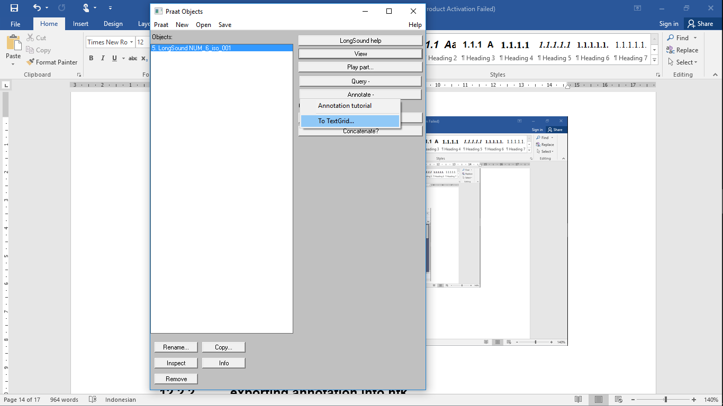

Click to text grid

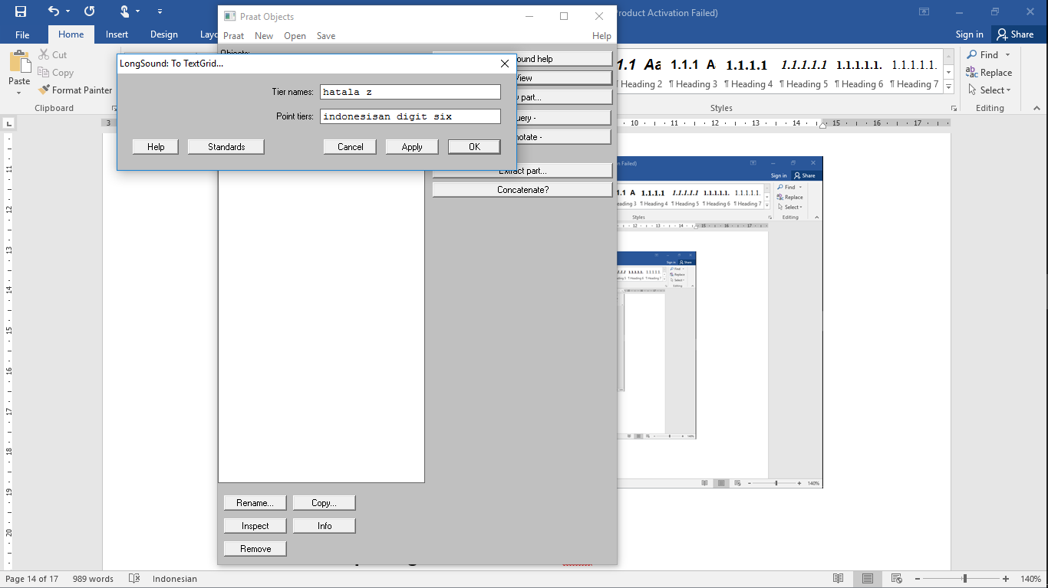
Fill the fields ‘tier name; and ‘point tier’ and the click ok

Now select both the wav and the annotation until them turn into blue ...
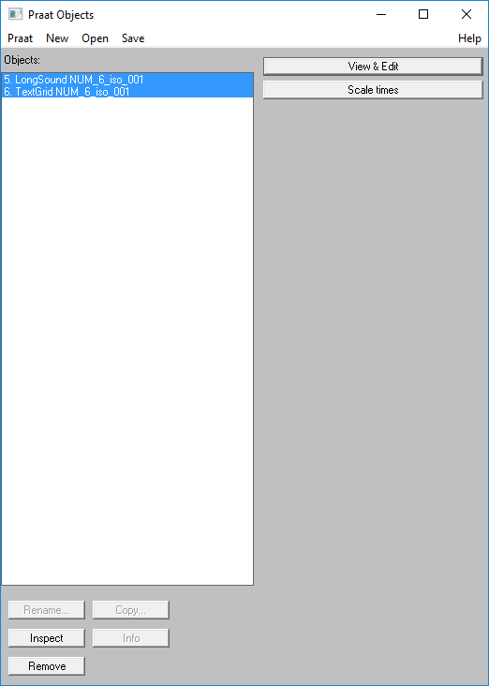

The view and edit button appear on the right. Click the button the annotaiton window appear.

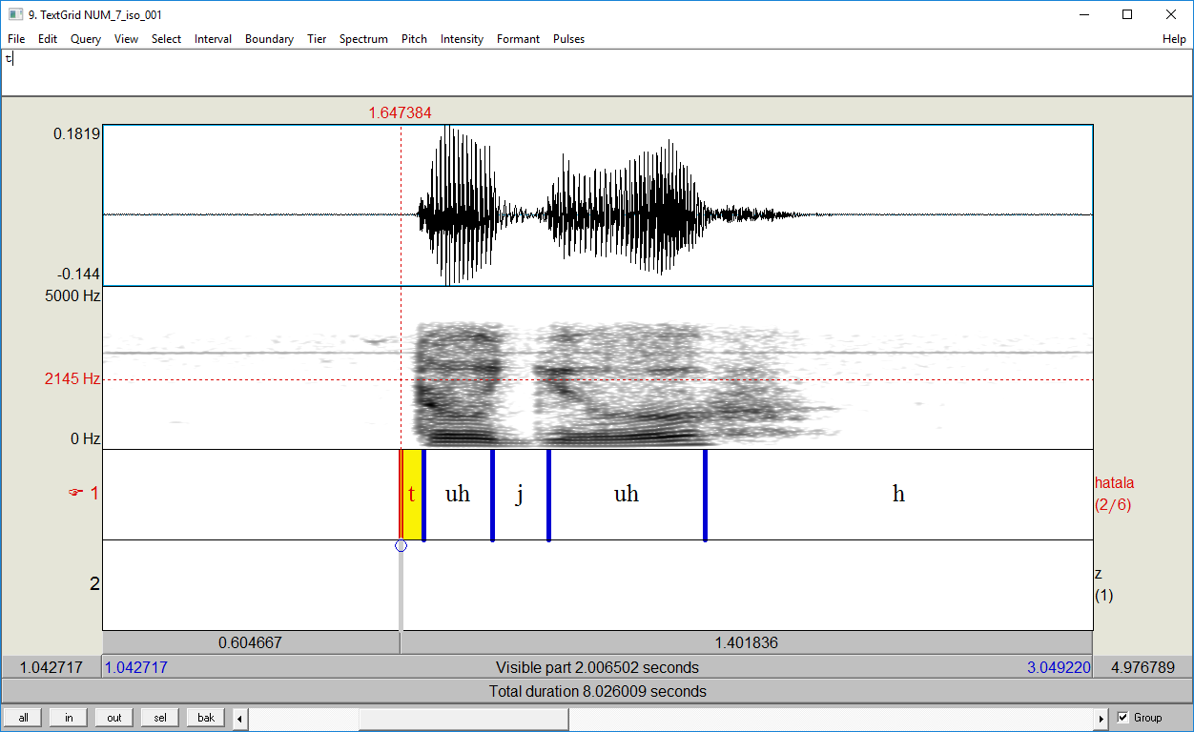

To annotate :
Click to a left boundary of the phonem. Note that in praat you only concern on the left boundary. Right boundary is created automatically when you create next adjacent left phone boundary. After you click the left bounday, the red dashed-line will be appear you the boundary. Now press/type ENTER, the bold blue line will be shown, that means the boundary is created and ready to accept the label. Now type the label on the text field LEFT UP. After finish click another boundary to commit this label change. Every time we want to change the label of the phones click on the blue line. And to change the position of the boundary (left or right) just click, hold and drag the bold blue line.

After finishing you can open another pair wav – text grid, with or without removing the old pair. Just use the ‘remove’ button on the left bottom.

exporting annotation into htk

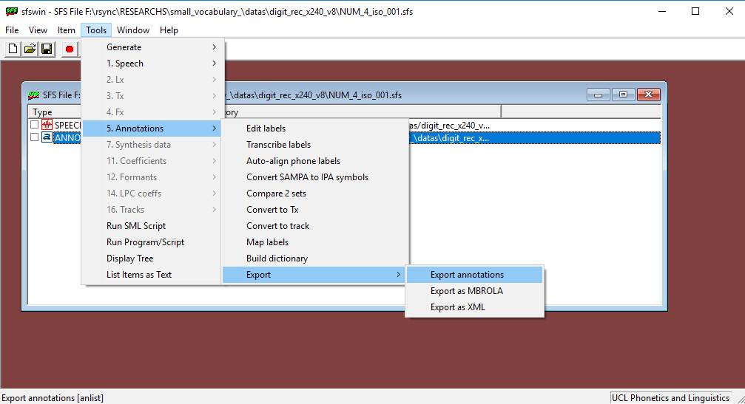

Now choose HTK as target format and browse to file
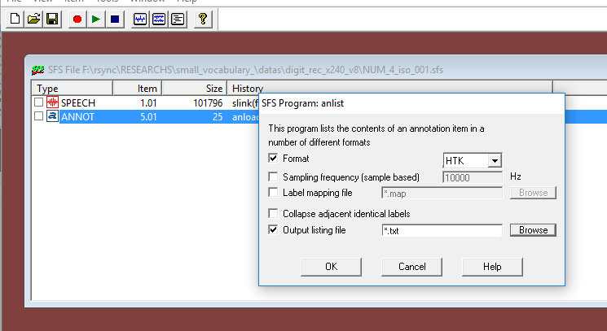

After push browse button now select correct directory and type correct name with .lab HTK standard extension for label file.

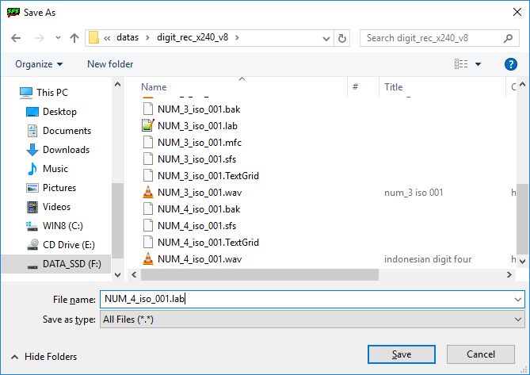

After you click save the file choose will close and you’ll be returned to annotation export form but with ‘output listing file filled’. Now click ok and HTK file will be generated

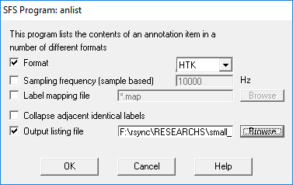

Now open the lab file using notepad++ and convert its eol to unix

