Very low bandwith CCTV replacement with android phone as a camera

`
Android phone
Google drive
Sleeping child
Disabled person
Monitoring
laptop
Camera_shot_007.jpg
Camera_shot_007.jpg

@todo java application oauth

Create oauth 2.0 client id

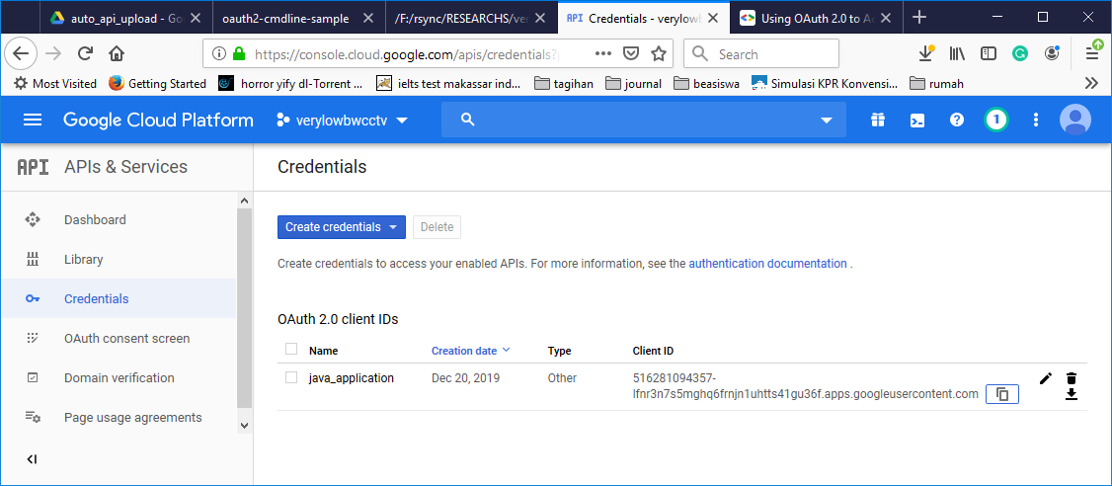

@todo java application google drive download

Google Drive (Zulkarnaen Hatala)→ My Drive → auto_api_upload

Folder file id
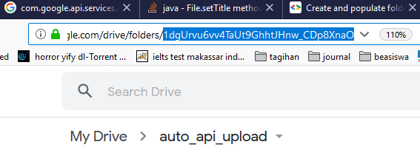

Download with search specific files

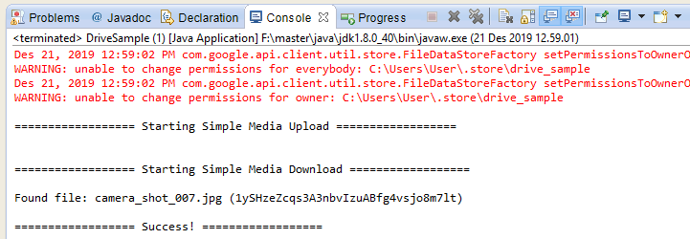

@todo use auto sync google drive …

@todo check settings
5 menit interval
Connection : internet, wifi, mobile
Upload only : set on (toggle to right)
Changes we’re detected, this will instantly sync to google drive …

@todo android java oauth 2.0 api
Creating new workspace
F:\rsync\RESEARCHS\very_low_bandwith_cctv_android\andr_eclipse_wspace

Creating new project, THEME → NONE

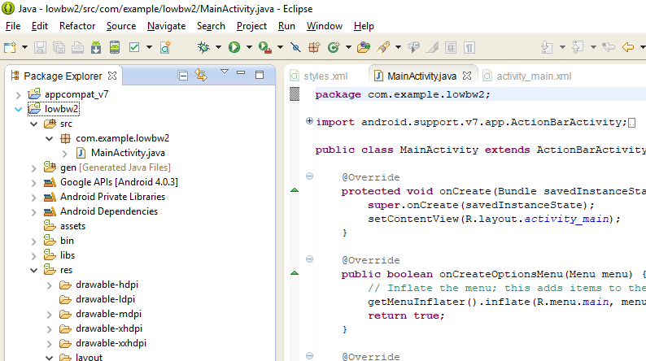

Appv7 compat issue, manifest objects/view not detected/resolved
Just clean the projects , it will generate R …

@todo android google drive api
Just use autosync google drive :

