Logbook-ubuntu

Course total not shown in gradebook setup → view report
1/4/2018 10:45:44 AM
Collapse the - + □ until course total shown … ( - is shown)
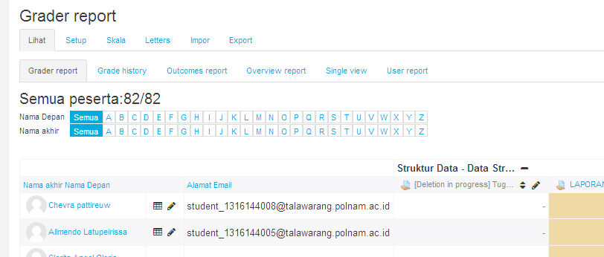

@todo, remove permanently “activity deletion in progress” in assignments, gradebook , and grade report …

Cd /var/lib/mysql
Tar –cp mysql > mysql.tar
Gzip -9 mysql.tar

Login phpmyadmin ..... deleting from mdl_assign .. still not work ….
Activate recycle bin from site administration →plugins →admin tool → recycle bin ..
But recycle bin say , not deleted item … ☹

Compressing files
#ZIP
zip –r nilai_akhir.zip nilai_akhir
unzip nilai_akhir.zip

#TAR GZ
tar –c nilai_akhir > nilai_akhir.tar
gzip -9 nilai_akhir.tar

#RAR
rar a nilai_akhir.rar nilai_akhir
unrar x nilai_akhir.rar

#7ZIP
7z a nilai_akhir.7z nilai_akhir
7z x nilai_akhir.7z

apt-get install p7zip-full

Creating db_007 and mysql user ‘007’ ….
Create database db_007 ;
Localhost//Phpmyadmin -- >
Import sda5/poltek/…./nos/code/db_007.sql

CREATE user '007'@'localhost'

grant select on db_007.* to '007'@'localhost' identified by '007';
FLUSH PRIVILEGES;

@todo, insert all zero into never unattended lab error …. In my.php
1/3/2018 2:31:01 PM

@todo, protect st_jmbond_007 DELETE/UPDATE access into mysql, someone can DELETE PROBLEMS …

1/3/2018 1:23:33 PM

@uas mysql problems

SELECT u.id AS userid, u.username AS studentid, gi.id AS itemid, c.shortname AS courseshortname, gi.itemname AS itemname, gi.grademax AS itemgrademax, gi.aggregationcoef AS itemaggregation, g.finalgrade AS finalgrade FROM mdl_user u JOIN mdl_grade_grades g ON g.userid = u.id JOIN mdl_grade_items gi ON g.itemid = gi.id JOIN mdl_course c ON c.id = gi.courseid WHERE gi.courseid = 6 AND u.username = "007"

Creating db_007 and user_007 on mysql ….
Mysql>create database db_007 ;

@todo revoke update insert on db_007 for user 007 …

Passwords in xiaomi notes
1/2/2018 10:42:13 AM

Accessing/resetting admin user in moodle db:s
1/2/2018 10:42:05 AM
Get md5 for empty string

Echo –n “” | md5sum

d41d8cd98f00b204e9800998ecf8427e

mysql –u root –p
mysql>use moodle;

mysql> select * from mdl_user where username='admin';

mysql>update mdl_user where username="admin" set password="d41d8cd98f00b204e9800998ecf8427e";

