Logbook-ubuntu

Ubuntu installs

Powerdesigner
Powerdesigner 12 seems ok …. Floating pallet for not shown, but you can add directly from drop down menu …

Torrent
Vuze crash on ubuntu
Using Tixatin instead, ~/bin/torrent_tixati

@dv3 battery problem, Dv3 combo bat ---
Dv3 will blink at 10.4V on batinfo.sh …..
This is where we should recharge/reclibrate batter ? actually it’s better to 11.1 (3.7x3)

Just monitor voltage and energy … seems … ic error for energy full
From 48wh t0 640wh. Two still corrects params is voltage and energy …
Which is shown/calculated low to

SOLVED, kabel kuning putus/tinggal satu urat, menyebabkan blinking dan tidak bisa mencash

Disable auto shutdown
Kill upower daemon
Systemctl stop upower
Watch –n10 ps ax \| grep upower

Long life battery save hemat energy
Execute
watch –n2 lowcpu1

Reset/recalibrate 9 cell ubuntu:
Charge a cell above 3.7V. Empty others (>3.7) in bios, grub, or shell mode of ubuntu 14. Until nothing left but voltage above 11.1 . Recharge

Openbox Tint2 laucher shortcut
To add item into tint2 launcher …
Nano ~/.config/tint2/tint2rc

Look for … launcher_app = /usr/share/applications/…….xxx.desktop.

Camera monitoring poltek ---

Te15/Mi max/Android
Ipwebcam
Portable hotspot on
192.168.43.1:8080/
uas:uas
Te15/Ubuntu-dv3
Wifi on zhmimax
~/bin/webcam_server
~/.motion/motion.conf
192.168.43.102:8081/
Nopassword?

zhmimax

Te16
Wifi on zhmimax
Open two pages browsers

Ssh server dv3
Sudo service ssh restart, its different from ubuntu lab server

Systemctl restart sshd ?

dpkg-deb build and rebuild .deb package
Using –R and target dir …
Dpkg-deb –R cnij*common*deb common
Gedit common/DEBIAN/control

Gnome unity control center

Using unity-control-center …

@todo, print pdf not working …cups

@todo, openbox screentshot printscreen

Using gimp, file → screenshot … grab single window, delay … seconds

@todo, ldm/unity synaptic not working
In system settings → mouse ..
Tap to click ok, but scrolling still not working …………….

@todo mi max, sdcard
Should using mtp ….
Already detected in ldm … unity desktop

Execute command mount MTP mimax into
jmtpfs ~/mtps/mnt

Ls ~/mtps/mtn

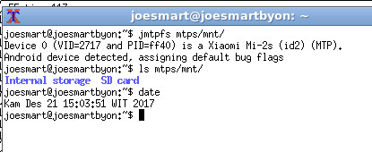

Or running nautilus … but wait while loading ….

@todo printer

Epson l220
Lsusb -v
Using Epson l210

ip 1980
using ppa inameiname/stable
lsusb- v

driver version should be 3.90

#cups management
http://localhost:631/printers/

#restart cups
Systemctl restart cups

@todo, Hdmi on dv3
Ldm, fn+f4 but no sounds
Openbox lxrandr – choose/tick hdmi 1024x768…apply

Hdmi,e
Connect hdmi cable …
Unity-control-center → sound →hdmi →unmute

Speaker
Unity control center → allow louder than 100%

Word 2007 manage data source
Manage data source

@todo, install canon 1980 epson l220, syslog only after #lsusb -v

Plug usb cable
Tailf /var/log/syslog
do root mode

#lsusb -v
now monitor syslog message

epson l220 using l210 driver
Currently l210 can use l210 driver on ubuntu 16.04 .... and it's working fine....
still using lsusb -v to refresh the kernel finding usb ....

@todo screenshot ubuntu

@todo, install epson l220
Dpkg -i /var/cache/..../epson.....deb
apt-get install -f
gnome-control-center

using l210 driver works

@todo wine installs for office word 2003
Still not sukses install microsoft office 2003. so i'm using libre office now

Misc
Apt-get install firefox

Moving archives to ntfs
ln –s /media/joesmart/sda5

Install nvidia driver vga dv3
12/10/2017 5:53:21 AM
Apt-get install nvidia-340
Apt-get install Plymouth-hamara
Apt-get install Plymouth-label

Securing database mysql - moodle config.php
chown www-data.www-data /var/www/html/moodle_33/config.php
chmod o-rwx /var/www/html/moodle_33/config.php

git

@todo fix git_add_modified.sh
Fix for spaced file name, error in bash looping for …

Upload single file .. from lab to github …
1/4/2018 11:21:51 AM

No need to fetch if just to modify single file from lab … using http://github.com.

@todo, not known if remote repository is updated from command line ….

@todo, moodle

@todo moodle, creating cohort

Site administration → users → cohort → add new cohort → context “system”

Add/assign cohort to course
Manage course categories → click a course → users → enrolled users → enroll users → browse cohort…

@todo, mirror moodle talawarang dv3

Course total not shown in gradebook setup → view report
1/4/2018 10:45:44 AM
Collapse the - + □ until course total shown … ( - is shown)

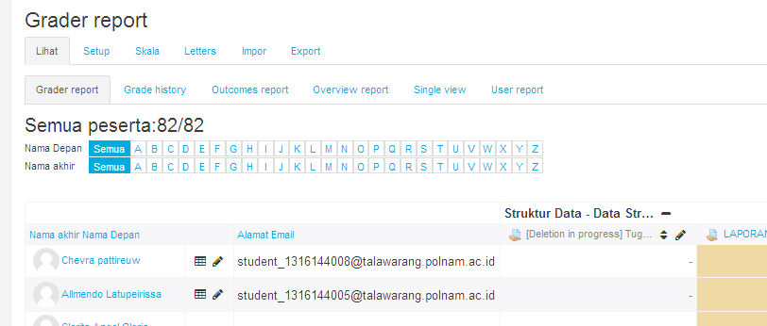

@solved, remove permanently “activity deletion in progress” in assignments, gradebook , and grade report …
Goto site administration → development → purge all caches …. untul got messages ‘all caches purged’. Then go back to grabebook setup, now for an assignment to be deleted permanently, under ‘action’ tab, there is ‘delete’ together with ‘edit settings’ and ‘hide’

----------
Cd /var/lib/mysql
Tar –cp mysql > mysql.tar
Gzip -9 mysql.tar

Login phpmyadmin ..... deleting from mdl_assign .. still not work ….
Activate recycle bin from site administration →plugins →admin tool → recycle bin ..
But recycle bin say , not deleted item … ☹

Moodle on dv3
Moodle 3.4 or later requires at least PHP 7.0.0 (currently using version 5.6.31-1~ubuntu16.04.1+deb.sury.org+1). Some servers may have multiple PHP versions installed, are you using the correct executable?

Downgrading to moodle_33
Moodle data directory : /var/www/moodledata
Mkdir /var/www/moodledata
Chown www-data.www-data /var/www/moodledata

#copy paste Create manually /var/www/html/moodle/config.php …

#password
admin:same_as_lab_admin_xxxBx

Debugging php
moodle_33/course/lib.php:1334
function course_modules_pending_deletion
just return true/false;
…
throw new Exception("Error Processing Request", 1);
…

exception 'Exception' with message 'Error Processing Request' in /var/www/html/moodle_33/course/lib.php:1339 Stack trace: #0 /var/www/html/moodle_33/grade/lib.php(985): course_modules_pending_deletion('2') #1 /var/www/html/moodle_33/grade/report/grader/index.php(129): print_grade_page_head('2', 'report', 'grader', 'Grader report', false, Object(single_button)) #2 {main}

lib/modinfolib.php:2075
function get_fast_modinfo($courseorid, $userid = 0, $resetonly = false) {
function get_fast_modinfo($courseorid, $userid = 0, $resetonly = false) {

in grabooksetup
http://localhost/moodle_33/grade/edit/tree/index.php?id=2
we got trace
exception 'Exception' with message 'Error Processing Request' in /var/www/html/moodle_33/course/lib.php:1339 Stack trace: #0 /var/www/html/moodle_33/grade/lib.php(985): course_modules_pending_deletion(2) #1 /var/www/html/moodle_33/grade/edit/tree/index.php(235): print_grade_page_head(2, 'settings', 'setup', 'Gradebook setup') #2 {main}

lib/modinfolib.php:759
class cm_info implements IteratorAggregate {

Compressing files
#ZIP
zip –r nilai_akhir.zip nilai_akhir
unzip nilai_akhir.zip

#TAR GZ
tar –c nilai_akhir > nilai_akhir.tar
gzip -9 nilai_akhir.tar

#RAR
rar a nilai_akhir.rar nilai_akhir
unrar x nilai_akhir.rar

#7ZIP
7z a nilai_akhir.7z nilai_akhir
7z x nilai_akhir.7z

apt-get install p7zip-full

Creating db_007 and mysql user ‘007’ ….
Create database db_007 ;
Localhost//Phpmyadmin -- >
Import sda5/poltek/…./nos/code/db_007.sql

CREATE user '007'@'localhost'

grant select on db_007.* to '007'@'localhost' identified by '007';
FLUSH PRIVILEGES;

@todo, insert all zero into never unattended lab error …. In my.php
1/3/2018 2:31:01 PM

@todo, protect st_jmbond_007 DELETE/UPDATE access into mysql, someone can DELETE PROBLEMS …

1/3/2018 1:23:33 PM

@uas mysql problems

SELECT u.id AS userid, u.username AS studentid, gi.id AS itemid, c.shortname AS courseshortname, gi.itemname AS itemname, gi.grademax AS itemgrademax, gi.aggregationcoef AS itemaggregation, g.finalgrade AS finalgrade FROM mdl_user u JOIN mdl_grade_grades g ON g.userid = u.id JOIN mdl_grade_items gi ON g.itemid = gi.id JOIN mdl_course c ON c.id = gi.courseid WHERE gi.courseid = 6 AND u.username = "007"

Creating db_007 and user_007 on mysql ….
Mysql>create database db_007 ;

@todo revoke update insert on db_007 for user 007 …

Passwords in xiaomi notes
1/2/2018 10:42:13 AM

Accessing/resetting admin user in moodle db:s
1/2/2018 10:42:05 AM
Get md5 for empty string

Echo –n “” | md5sum

d41d8cd98f00b204e9800998ecf8427e

mysql –u root –p
mysql>use moodle;

mysql> select * from mdl_user where username='admin';

mysql>update mdl_user where username="admin" set password="d41d8cd98f00b204e9800998ecf8427e";

