X240:f://research/silex_windows/logbook_silex_windows.doc

Mendeley jurnal

References not seen on other computer/pc while seen in other pc
Sync FIRST to .. seeing computer .. and only after then sync on the not seeing computer …

Prevent uploading/downloading file, takes long time
To prevent mendeley from downloading/uploading file. Uncheck synchronize attached files …

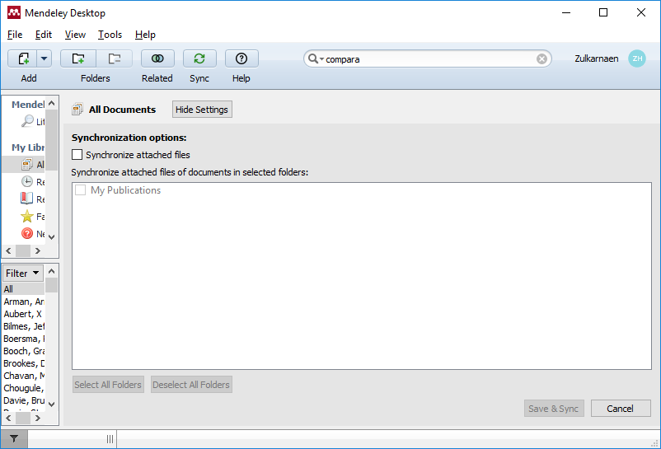

Installing crud admin jonseg ori

Creating apache alias
Download original from jonseg site
First we create alias entry in c:/xampp/apache/conf/extra/httpd-xamp.conf

Alias /dbgenerator "F:/RESEARCHS/silex_windows_/composers/simpledbgenerator"
<Directory "F:/RESEARCHS/silex_windows_/composers/simpledbgenerator">
AllowOverride AuthConfig
Require local
ErrorDocument 403 /error/XAMPP_FORBIDDEN.html.var
</Directory>

Test with simpledbgenerator/index.html …
Error in apache/logs/error.log ➔ php_flag is not allowed here …Server error caused by .htaccess, uncomment all entries in .htaccess .. its worked. Create simpledbgenerator/test.php get Phpinfo(); phpversion is 5.6.39. So… the ‘is not allowed here’ error is caused by missing of ‘AllowOverride All’.

Executing console generate:admin

Generating sql from power designer. Create tables in database by Executing sql from phpmyadmin → import, choose registration.sql. do not forget to uncheck “Enable foreign key checks” in phpmyadmin import view.
If u still got error drop table foreign key exist to fix, must drop table with fk first, than drop table referenced later. Fix auto increment id using fix_sybase_mysql.php
@todo, error alter for auto increment need to be unreferenced, so .. alter for auto increment must be performed before referrer table be created.
User_login_id must be altered for auto increment before user_role created ? a simple wise not solution is to disable foreign key check temporary
SET FOREIGN_KEY_CHECKS=0/1;

Fix database,username, password in src/app.pp
Opening http://localhost/dbgenerator/web/index.php error no route to host, …… ???? this is because silex must working with apache httpd
To solve this error .. Create entry in c:\windows\system32\drivers\etc\hosts

127.0.0.1 dbgenerator.local

Now you must be able to ping dbgenerator.local from cmd.
Create c:\xampp\apache\conf\extras\httpd-vhosts.conf

<VirtualHost *:80>
##ServerAdmin webmaster@dummy-host2.example.com
DocumentRoot "F:\RESEARCHS\silex_windows_\composers\simpledbgenerator\web"
ServerName dbgenerator.local
##ErrorLog "logs/dummy-host2.example.com-error.log"
##CustomLog "logs/dummy-host2.example.com-access.log" common
</VirtualHost>

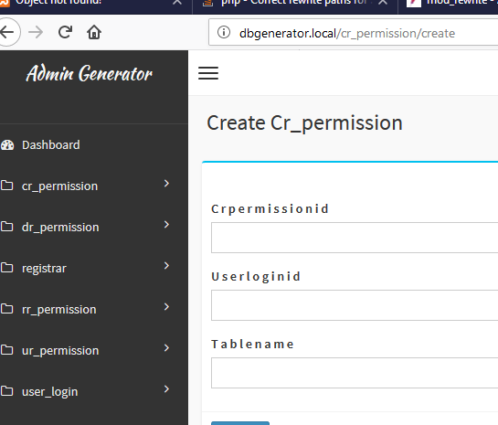

This is the result of pure jonseg crud-admin-generator.

@todo, USER_LEVEL strings (1)
This error is because, miss configuration in

Fixing permissions and login …

We’re using permission from phpSecurePages,
First create two roles …
Insert itu …

Fixing lookup …
To be lookup

Installation crud-admin windows simlitabmas copy

- copy jurnal_01 into F:\RESEARCHS\silex_windows_\composers
- create entry vhost

- now in file web/index.php
  - change www_root_uri …
$GLOBALS['$www_root_uri'] = "/" ; /** set with ***/

- database configuration
  - check web/vendor_01/phpSecurePages/config.php. direct database of psp into same database with application to prevent multi db access. Tune appropriate field, login, password, id …

  - src/app.php, this is the database of crud-admin
'dbs.options' => array(
'db' => array(
'driver' => 'pdo_mysql',
'dbname' => 'registration',
'host' => '127.0.0.1',
'user' => 'root',
'password' => '156354',
'charset' => 'utf8',
),
)

- phpSecurePages configuration also in web/index.php

$minUserLevel = 100;
$requiredUserLevel = array(1,3,100);

- fixing session in vendor/symfony/http-foundation/Session/Storage/NativeSessionStorage.php

if($phpSecurePages & FALSE)
if (\PHP_VERSION_ID >= 50400 && \PHP_SESSION_ACTIVE === session_status()) {
throw new \RuntimeException('Failed to start the session: already started by PHP.');
}

if($phpSecurePages & FALSE)
if (\PHP_VERSION_ID < 50400 && !$this->closed && isset($_SESSION) && session_id()) {
// not 100% fool-proof, but is the most reliable way to determine if a session is active in PHP 5.3
throw new \RuntimeException('Failed to start the session: already started by PHP ($_SESSION is set).');
}

- adding new route
  - src/app.php
    - add silex match here

- another configs
  - src/app.php, lot of var here …

Hello

Xampp

conf files for aliases
it seems vhost not activated by default, the config file for is in
c:/xampp/apache/conf/extra/httpd-xamp.conf

Composer download once, using cache next

Installation silex winds

Install xampp
Install composer
Run cmd → type composer … ok

Installing monolog

Create composer.json file

And issue

Composers>composer install

Composer with install parameter, is how to install from computer.json file
- composer require monolog/monolog

Now

Ubuntu version for references only:

GIT github
22/12/2018 13:06:41
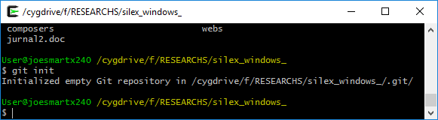

Git undo deleting directory
To restore a directory or file u can use git checkout -- ..for example to restore a directory jurnal_01, when I was wrong deleted dirs…

$pwd
/cygdrive/f/RESEARCHS/silex_windows_
$Git checkout – composers/jurnal_01

Git version

@todo stable 0.1 stable_01
Must coded until user can change password ….
Role → Registered, user that has a login and password
: able to change password, email, phone , etc …

@todo stable 0.2 stable_02
Role → StudentApplicant
: able to change student application datas, address, courses intended …

Using git

…or create a new repository on the command line
echo "# simpledbappgenerator" >> README.md
git init
git add README.md
git commit -m "first commit"
git remote add origin https://github.com/dzhatala/simpledbappgenerator.git
git push -u origin master

…or push an existing repository from the command line
git remote add origin https://github.com/dzhatala/simpledbappgenerator.git
git push -u origin master

…or import code from another repository
You can initialize this repository with code from a Subversion, Mercurial, or TFS project.

logbook_crud_admin_generator_Umb jurnal version
2018-2019/penelitian/

Git commands
Git add –u # add all changes but not committed

Installation crud-admin linux ubuntu

- copy directory into apache documents … htdocs or /var/www/html
- now in file web/index.php
  - change www_root_uri …
$GLOBALS['$www_root_uri'] = "/jurnal_01/web" ; /** set with ***/

- database configuration
  - check web/vendor_01/phpSecurePages/config.php. direct database of psp into same database with application to prevent multi db access. Tune appropriate field, login, password, id …
  - src/app.php, this is the database of crud-admin
'dbs.options' => array(
'db' => array(
'driver' => 'pdo_mysql',
'dbname' => registraion,
'host' => '127.0.0.1',
'user' => 'root',
'password' => '156354',
'charset' => 'utf8',
),
)

- adding new route
  - src/app.php
    - add silex match here

- another configs
  - src/app.php, lot of var here …

crud-admin

search tabular is case sensitive
to search for Guest may show different result with guest.

Lookup for foreign key is supported as long as foreign already has value
Fill values in foreigners before open form containing references …

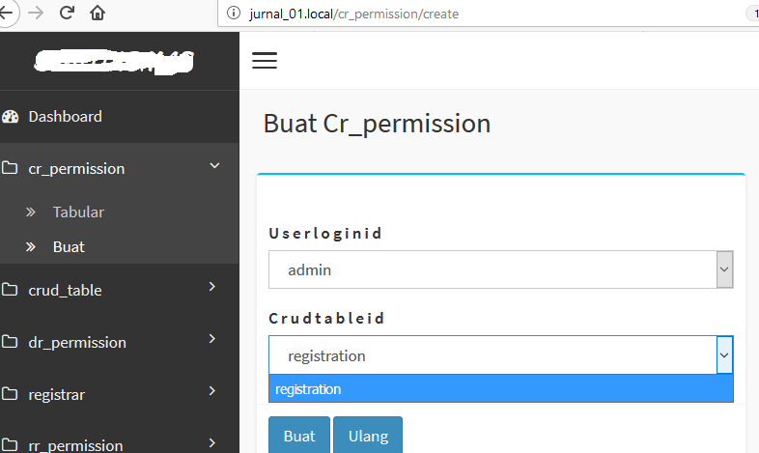

@todo, routing based on roles
When a user login, where he will be directed to ?
For crud admin ….

We can say , ….. for a blong we have this roles/group

- Administrator
- Guest
- Registered users

@todo, Silex routing for non generated page
For non generated pages, we need to maintained MVC components manually. In src/app.php, Register silex routing with with app→match …

@todo, Permissions

Very simple crud permission: Java functions

User id → AddCreateRecordPermission(tablename, userid)
AddReadRecordPermission(userid,tablename, recordnumber []);
AddUpdateRecordpermission(userid, tablename, recordnumber[]);
AddDeleteRecordpermission(userid, tablename, recordnumber[]);

Permissions tables
Create_Record_Permission
Id | Userid | Tablename
1 | Mhs01 | Registration
1 | Mhs02 | Registration
UserId is the index/primary key in user table

Read_Record_Permission
Id | Userid | Tablename | RecordId
1 | Mhs01 | Registration | 001
1 | Mhs02 | Registration | 007

Delete Record Permission
Id | Userid | Tablename | RecordId
1 | Mhs01 | Registration | 001
1 | Mhs02 | Registration | 007

Update Record Permission
Id | Userid | Tablename | RecordId
1 | Mhs01 | Registration | 001
1 | Mhs02 | Registration | 007

The recorded is the UniqID(auto increment) in table Tablename. For example if Student is allowed to delete.

Power designer
File → new model → information → conceptual data model

Php auth silex
In web/vendor_01/auth.php is_CRUD_authorized($login, $uri) will check is user with login $login is permitted…

TO_CRUD_info ($uri)
This function will explode $uri into … path component.
Testing function
F:\RESEARCHS\silex_windows_\composers\jurnal_01>php test\test_uri_auth_01.php

@todo how in silex? routing check all permissionstables
Actually no need to do in silex, since phpsecurepages is called first.

web/Index.php
Required Web/vendor_01/auth.php

Is_authorized()
src/app.php

So a permission module is completed in one single file web/vendor_01/auth.php.

Shared symlinks in samba to win10, Samba fix /var/www/html/jurnal_01

Chown –R joesmart.root /var/www/html/jurnal_01

#### WIN 7 compatibility #####
ntlm auth = no
lanman auth = no
client ntlmv2 auth = yes

follow symlinks = yes
wide links = yes
unix extensions = no

restart samba …..
systemctl restart smbd ….

Power designer general
2018-2019/penelitian/crud-admin-generator/power_designer/ws_main_001.sws
………………………………………………………………../main_01.cdm
………………………………………………………………../main_01.pdm

UNIQUE, INDEX ON MORE THAN 3 FIELDS
INDEX can be designed in physical data model. On table properties. Just click indexes, type index, click apply, and click add columns.

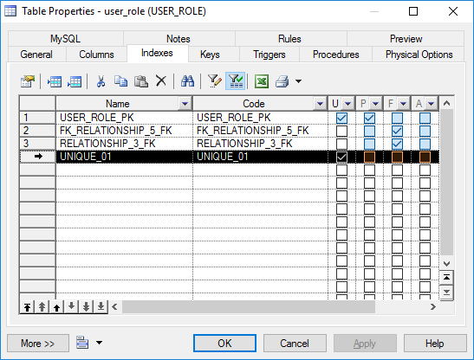
1

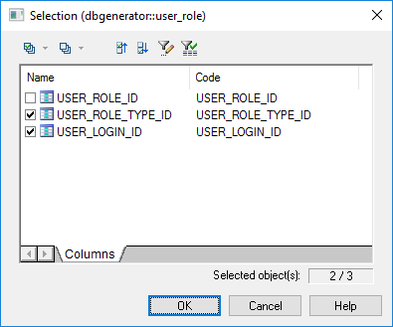

Power designer fix auto increment
Use power_designer/fix_sybase_mysql.php
Or set in physical data model like this:

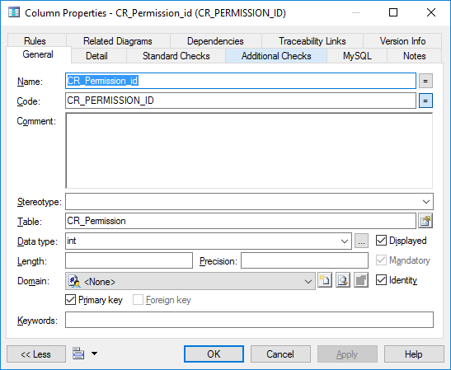

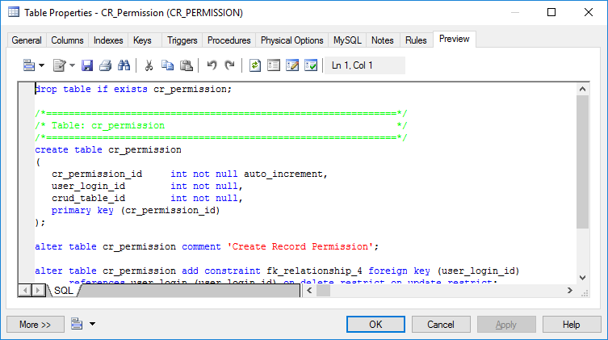

Power designer mysql null default null
This very weird for mandatory field in cdm. Myql will be generated as null default not null.
Now just in notepad++ replace :
not null default null,
With :
not null

Mysql

@todo, Mysql, not null but still insert with null
Not null in mysql, mandatory in power designer, but why still can be inserted without value ?.
Current solution is replace with notepad++

console.php, silex, twig, symfony, phpSecurePages

@todo, twig, console.php advanced form fields checking …
How to implement custom javascript check in twig ??? like tdatetime .. and so on …. ….

advanced complicated fields date, upload

@todo, date or datetime for datepicker ??

@todo, upload file form path_
all fields/column with prefix “path_” in lower case will be treated as an uploader field ….. for example path_file_preview, path_proposal_upload_.....

@todo not uploading now …. @todo see linux implementation …
In src/console.php file upload handlers not yet to be generated for all entities, only for table usulan …

// file upload handlers
if($stb=="usulan"){
/**0.check if file uploaded
1.
**/
$__BEFORE_EXECUTE__UPDATE_CREATE__.="\n".
"\t\t\tif(\$data['PATH_PROPOSAL_UPLOAD']){\n".
"\t\t\t \$forig=\$app['credentials']['userlogin_id'].\"__\".date(\"Y_m_d_h_m_s__\").\$data['PATH_PROPOSAL_UPLOAD']->getClientOriginalName();\n".
"\t\t\t \$data['PATH_PROPOSAL_UPLOAD']->move(\$app['uploaded_dir'].\"/\".\$app['userlogin_id']['login'],\$forig);\n".
"\t\t\t \$data['PATH_PROPOSAL']=\$forig ; \n".
"\t\t\t}";

So this must be fix!! @TODO. First we have to know where file is uploaded is defined, its in src/app.php

$app['uploaded_dir']="/media/uploaded/simlitabmas";

Since we’re in windows should be changed to …
$app['uploaded_dir']="f:/RESEARCHS/silex_windows_/uploads/jurnal_01";

Now the name format for file should be … :
Table_name/pk/date_time/original_file_name
But since pk is not available when creating first record, so we need login information for this. By this assumption we also assume that who upload already logged in. This is so the file can be traced easily, if it’s linked to which form it’s uploaded from.
Table_name/pk/date_time/original_file_name

Now in src/app.php
$app['www_root'] = $_SERVER['SERVER_NAME']; /** symfony web dir on browsers address **/
$app['uploaded_dir']="f:/RESEARCHS/silex_windows_/uploads/jurnal_01"; /** permanent client uploaded files location **/
$app['www_uploaded']="/getfile_jurnal_01"; /** temporary directory to download by client ...
this directory must be created in doc root apache
***/

Now we still get error for route not found
NotFoundHttpException in RouterListener.php line 144: No route found for "GET /tempdownloaded/jurnal_01/admin/admin__2018_12_25_10_12_38__README.MD" (from "http://jurnal_01.local/applicant/edit/1")

So we need to handle this in controller … to copy to the temporary accessible web url right before files transfer begin …. @todo how simlitabmas implement this ?

Put this in src/app.php
$app->match($app['www_uploaded'].'/{f1}/{f2}', function ($f1,$f2) use ($app) {

$filename=$app['uploaded_dir']."/".$f1."/".$f2;
//echo "request to get file "."$f1 $f2 ==> $filename" ; die;
if(file_exists($filename)){
$response= new Symfony\Component\HttpFoundation\BinaryFileResponse($filename);
$response->setContentDisposition(Symfony\Component\HttpFoundation\ResponseHeaderBag::DISPOSITION_ATTACHMENT);
return $response;
} else {
throw new NotFoundHttpException("file $f2 not found !");

}
})
->bind('getfile_jurnal_01');

@todo silex, phpsecurepages, php
remove dependency on $_SERVER[‘HTTP_HOST’];

CRUD silex twig

@todo, console.php miss

@todo missing tabular field for user role
If not shown in drop down or in tabular, check if the field is right in controller. For example we’re missing user_login_id.login in all table referencing user_login table. Actually It’s not missing , but it’s foreign is EMAIL instead of login, email which hasnot been filled yet off course shown empty in tabular. So you have to change it LOGIN, which can be done in console.php, try remove key ‘e?mail’ from search_names_foreigner_key array.

//console.php line : 435
$external_select_field = false;
//$search_names_foreigner_key = array('name','title','e?mail','username');
$search_names_foreigner_key = array('login','name');

if(!empty($app['usr_search_names_foreigner_key'])){

@todo role demonstration, customization
Registered role demonstration. Each user that has a login and password has minimal role Registered. Registered user can change their profile password, email and phone.
- Only user can update his record
- can not update primary key
- can not update login name

@TODO limiting field/column level akses in controller and views

Some FOLLOW UP table need to keep its primary key unchanged. For example registrar table which reference userlogin create can’t be change it’s primary key and its foreign key to userlogin table.

@TODO, $cfgIndexpage from silex remove $_SERVER[‘HTTP_HOST’]
How to passing value from silex to phpsecurepages ???
$cfgIndexpage can’t be set from silex to be used on interface.php in phpsecurepages. Currently we use globar php variable $_SERVER[‘HTTP_HOST’]

Silex security, login , url

Authorization stages/priority …

Web/Vendor_01/Auth.php
$cfgDefaultPolicy=TRUE ; // TRUE/1/ACCEPT, FALSE/0=DENY

DEFAULT DENY
  - block unless at least one rules is match with policy is ACCEPT/1

DEFAULT ACCEPT
  - ACCEPT unless one rules is matched to policy DENY/0

Authorization steps/prirority …

Called is_crud_authorized() ; …
Called is _role_authorized(); ….
Called is_URI_authorized(); ……

@todo admin url for post ? can silex form be faked …

@todo silex, phpsecurepages login url, login using phpsecurepages NOT working …
All url is converted/directed into index.php.

In src/app.php declare
$app['login_url']="/?do_login" ;
This will be used by twig/template for example in web/views/ag_header.html

In web/index.php
if(isset($_GET['do_login']) | strlen($_SERVER['REQUEST_URI'])>1)
{
1 include($cfgProgDir . "secure.php");
2 require_once __DIR__.'/vendor_01/auth.php';
}
Above two lines 1,2 in curl braces when called user/role appeared $app['credential'] filled as userlogin. But if not called $app['credential'] reset even user has logged in. the credential will be resetted to Guest. The solution is to change the code in web/index.php to check wether a user is logged in is by checking the session value $_SESSION[‘login’] which is set by phpsecurepages in objects/checklogin.php

if(isset($_GET['do_login']) | strlen($_SERVER['REQUEST_URI'] >1 | isset($_SESSION['login']) ))
{
include($cfgProgDir . "secure.php");
require_once __DIR__.'/vendor_01/auth.php';
}
Above still can work because SESSION might have been suspended, so you need to RESUME session using session_start(). So the completed code is …

if(!isset($_SESSION)) session_start();
if(isset($_GET['do_login']) | isset($_SESSION['login']) |strlen($_SERVER['REQUEST_URI'])>1 )
{
//var_dump($_SESSION);
//var_dump($_SESSION['login']); die;

include($cfgProgDir . "secure.php");
require_once __DIR__.'/vendor_01/auth.php';
}

@TODO, check session_start () in checklogin.php preventing warning session already start.

@todo controller/silex crud-admin creating credentials ?
Where credentials are created ? all variables is binding into ‘app’ in src/app.php. guest/no login credentials is created

@todo, twig silex available roles
Ag_header not rendering roles correctly … or generally. Still rendering roles for simlitabmas. So twig must get something like available_roles from $app

@Creating guest role, guest account
First we have to create guest role … a role that no need to authenticate … this mean to @todo provide guest credential for twig, by default and remove login screen by default.

Remove default login screen, protecting web site to go to securepages login screen in web/index.php :

//@TODO fix this .. after login ???
if (1==0){
include($cfgProgDir . "secure.php");
require_once __DIR__.'/vendor_01/auth.php';
}

Provide default credential in src/app.php

$app['translator']=$translator;

if (!isset($app['credentials']))
{
$credentials=array();
$roles=array();
array_push($roles,"Guest");
$credentials['login']="guest";
$credentials['userlogin_id']=-1;//admin id always 1

/*f*@TODO, cek for requesting roles here .....*/
//error_log("@TODO, assign current role without, checking requesting roles ...");

$credentials['current_role']=$roles[0];
$credentials['roles']=$roles;
$app['credentials']=$credentials;
}

return $app;

Registered role

For a user that has login/password the role is registered. Registered user should can change their password and login, email … etc. Actually this information is keep in single table user_login, but we need to differentiate its interface and controller from admin form user_login.html.twig …

The very first thing is to create a menu on left sidebar …

{% if (app['credentials']['current_role']=="Registered" )%}

<li class="treeview active">
<a href="#">
<i class="fa fa-folder-o"></i>
<span>Profile</span>
<i class="fa pull-right fa-angle-right"></i>
</a>

<ul class="treeview-menu" style="display: none;">
<li {% if 1 %}class="active"{% endif %}><a href="{{ path('profile_edit', {'login': $app[‘user_login’]} ) }}" style="margin-left: 10px;"><i class="fa fa-angle-double-right"></i>Edit</a></li>
</ul>

</li>
{%endif%}
You got error “Unable to generate a URL for the named route "profile_edit" as such route does not exist.”. this is because the route is not set up in controllers. Now since user profile is assumed to be user login, password that not so much differ to user_login table, we copy the views and the controller from user_login dir. And rename it to user_profile …. This is better than modify the user login directly ….
So we have now 2 new dirs. Which is copied from 2 generated dirs.
Web/controllers/user_profile
Web/views/user_profile

Uncomment all match routes except for user_login/edit/{id}. This is the master we want to modify….Now open in notepad++ replace match('/user_login_edit?????? With .. match('/profile_edit … and off course with its bind(‘user_login_edit ., replace with bind(‘profile_edit\\, and in url generator, ['url_generator']->generate('profile_edit'))

@todo, user_profile/??? .. not updated in database … this is because some sql, $id need to be fixed

So the complete changes is in in web/controllers/user_profile/index.php Replace the match with

$app->match('/profile_edit', function () use ($app) {

And the first two lines in the file
$id=$app['credentials']['login'];
$find_sql = "SELECT * FROM `user_login` WHERE `login` = ?";
Go on to enable text fields ..
//if($app['credentials']['current_role']=="Administrator"){
if(TRUE){
unset($field_default_ro['disabled']);
}
$form = $form->add('plain_password', 'text', array_merge(array('required' => false),$field_default_ro));
And for updating into mysql, the query should be fix …..
$update_query = "UPDATE `user_login` SET `plain_password` = ?, `email` = ?, `phone` = ? WHERE `login` = ?";
$app['db']->executeUpdate($update_query, array($data['plain_password'], $data['email'], $data['phone'], $id));

In vendor_01/auth.php add this to enable registered user to access:
& !( isset($login)& startsWith($uri,'/profile_edit') ) /** login exist that must be Registered role***/

Finally to be included in base.php, put these line in src/console.php

$BASE_INCLUDES .= "require_once __DIR__.'/" . "user_profile" . "/index.php';" . "\n";

Now test regenerate to make sure everything is ok.
Php concole generate:admin

silex where app is binding into twig
in src/app.php

search is case sensitive
in tabular view

external enabler …
is to search a table includes its foreign information ….
For example when search on user_role, it means searching on user_login.login and user_role_type.role_name ….

Set app name/title
Must change all ‘simlitabmas appearance’ do it in
Top left appearance → src/app.php, web/views/ag_base.html

Initial hardware

15/12/2018 12:15:01

Acer aspire one 725 as server
Thinkpad x240 as client
Hotspot creation on x240
X24::f\researchs\windows\hotspot.bat

