Installation
1. install from cygwin _ git
$git init
$git clone https://github.com/dzhatala/simpledbappgenerator.git

2. Create entry in c:\windows\system32\drivers\etc\hosts

127.0.0.1 dbgenerator.local
Now you must be able to ping dbgenerator.local from cmd.

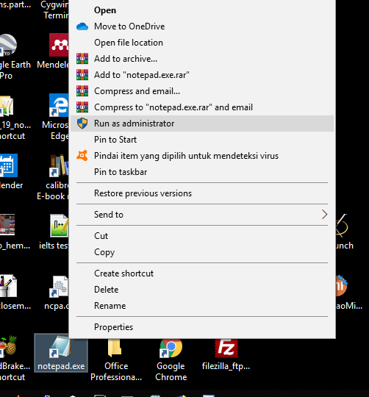

3. create virtual host entry in apache/conf for jurnal_01/web

<VirtualHost *:80>
DocumentRoot "F:\rsync\RESEARCHS\silex_windows_\composers\jurnal_01\web"
ServerName jurnal_01.local
</VirtualHost>

<Directory "F:/rsync/RESEARCHS/silex_windows_/composers/jurnal_01/web">
AllowOverride All
Require local
ErrorDocument 403 /error/XAMPP_FORBIDDEN.html.var
</Directory>

Updating git
$Git add –u
$git commit –m “”
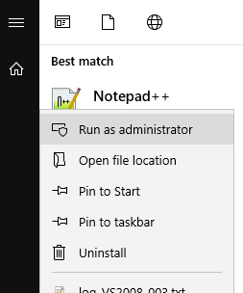

4. execute registration.sql into your mysql client/phpmyadmin to create tables
4. check user passwords in table 'user_login'
5. now test login from your browser.

