JOB2 – IT SERVICES

Technical Report

LOGBOOK 9/29/2019 2:38:42 PM

Aplikasi Web Pelaporan Lampu rusak
Zulkarnaen Hatala
dzulqarnaenhatala@gmail.com

Implementation summary

Story_board
Ui. prototyping

Database design
Xampp server installation
Web RAD
Web prototyping
Web refining

Story board

Form laporan jalan rusak (actor: pelapor)

create_report.php

joe@smart.com
Email pelapor
JMP. Lampu no. 3 di sisi kiri jalan dari arah MCM
Alamat kerusakan :
Alamat google map
https://www.google.com/maps/@-3.6661735,128.1981407,95m/data=!3m1!1e3
Tambah Foto
Kirim laporan
Keterangan rusak
Baterai tidak ada, kemungkinan di curi

hapus

hapus

konfirmasi.php

TERIMA KASIH j...@...rt.com
Laporan Anda sudah tercatat dengan nomor 0x0sdf01, Anda bisa melihat laporan ini di alamat url :
HYPERLINK "https://laporan.jalan/?id=lap_0x0sdf01"
https://laporan.jalan/?id=lap_0x0sdf01

view_report.php
j…@...rt.com
Email pelapor
JMP. Lampu no. 3 di sisi kiri jalan dari arah MCM
Alamat kerusakan :
Alamat google map
https://www.google.com/maps/@-3.6661735,128.1981407,95m/data=!3m1!1e3
< Sebelum berikut >
Keterangan rusak
Baterai tidak ada, kemungkinan di curi
Foto

hapus

hapus

Mysql Tables:

TABLE lamp_fault_report

Column Name | Column Type | Description
lamp_fault_report_id | PK, SPD: MPD Integer | Must Table_name_id
reporter_email | Varchar
fault_street_address | Text
google_map_address | Varchar
fault_detail | Text
report_date | Datetime
Follow_up | Text

TABLE fault_picture

Column Name | Column Type | Description
fault_picture_id | PK, SPD: MPD Integer | Must Table_name_id
lamp_fault_report_id | FK : lamp_fault_report | Associated lamp_fault_report_id
path_picture | Varchar | Silex uploading file server path_?? Do not set mandatory in P.desg, se null in mysql
gps_info_exist | Boolean | Is gps info exist ?
gps_info | Varchar

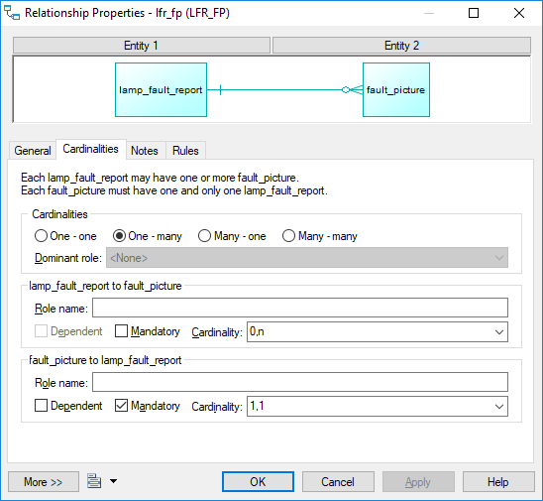

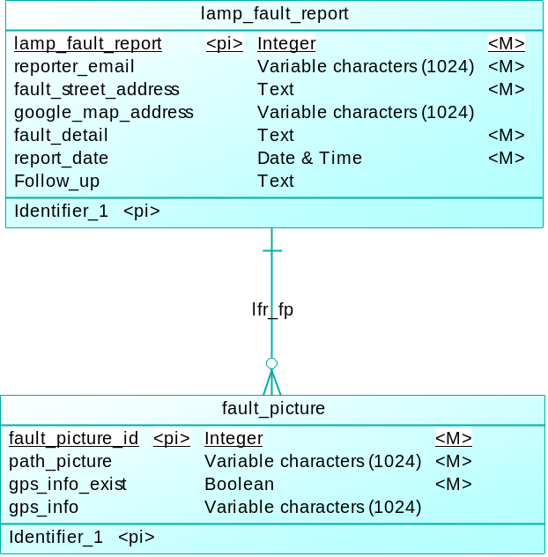

IMPLEMENTASI

Copy jurnal_01 and regenerate test

Copy and do not link vendor
For some system like linux/ubuntu, we may able to link vendor which is take hundreds MB of space, but windows/php/xamp doesn’t permit such method.

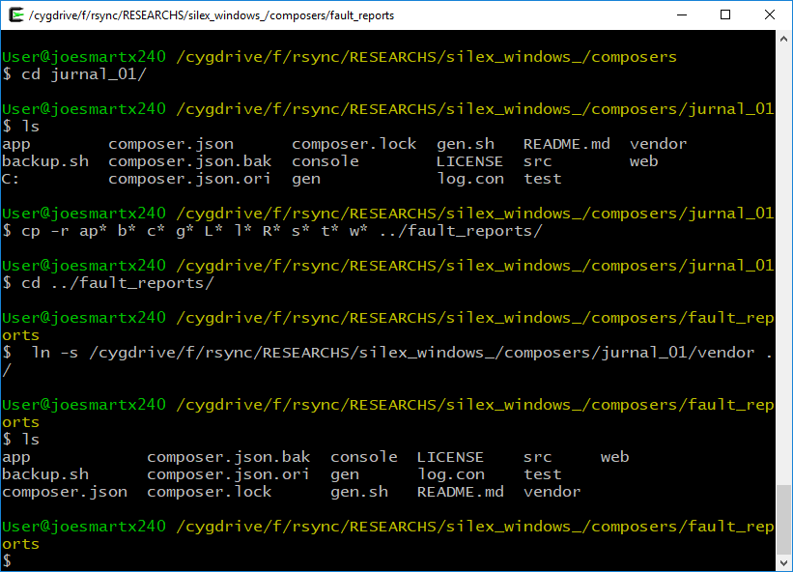

DO not link vendor in xampp windows, it doesn’t work, recopy vendor instead.

Edit host file to create new hostname
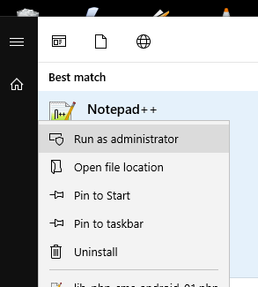

#c:\windows\system32\drivers\etc\hosts
127.0.0.1 lamp_report.local

And ping the address
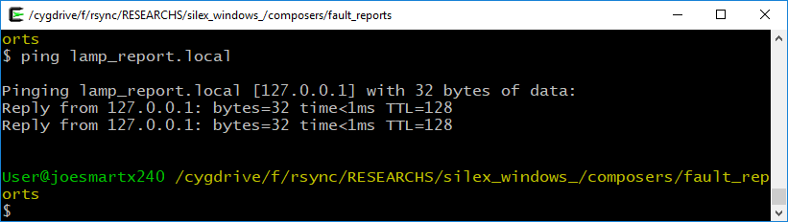

#C:\xampp\apache\conf\extra\httpd-vhosts.conf
<VirtualHost *:80>
DocumentRoot "F:\rsync\RESEARCHS\silex_windows_\composers\fault_reports\web"
ServerName lamp_report.local
</VirtualHost>

<Directory "F:/rsync/RESEARCHS/silex_windows_/composers/fault_reports/web">
AllowOverride All
Require local
ErrorDocument 403 /error/XAMPP_FORBIDDEN.html.var
</Directory>

Restart xampp apache
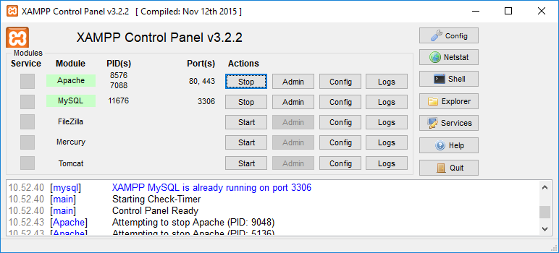
Testing copied results

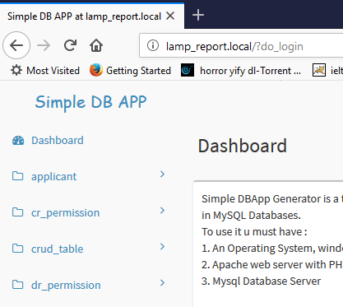

Testing regeneration:
Use php5.6 of xampp

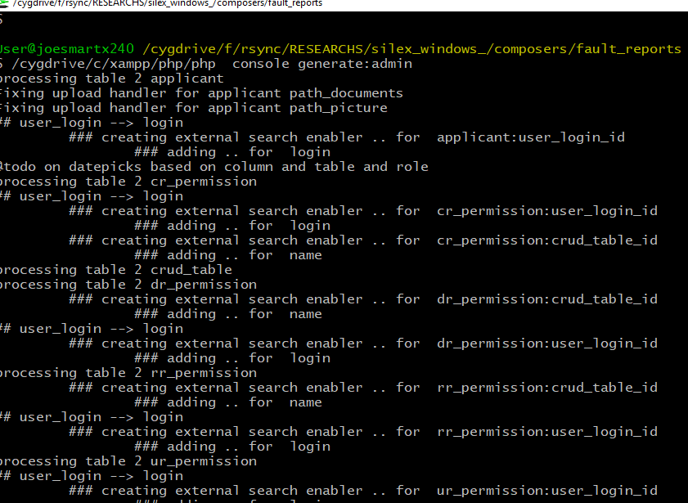

Create new database “lamp_reporting”
Import registration2.sql

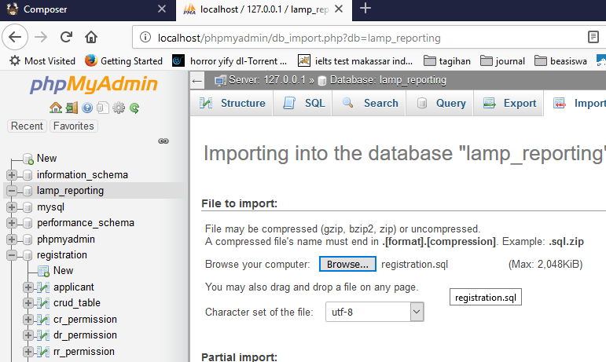

Src/app.php
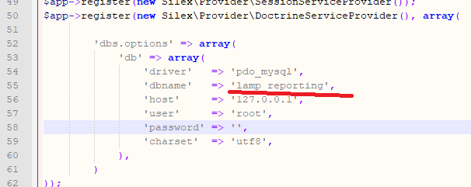

phpSecurePages/config.php
$cfgDbDatabase = 'lamp_reporting'; // MySQL database name containing phpSecurePages table

<?php
//Power_designer/fix_sybase_mysql.php
//fixing auto increment from sybase generated

$mysql_hostname="localhost";
$mysql_user = "root";
$mysql_password = "";
$mysql_database = "lamp_reporting";

#using php5.6 from xampp to fill default values
$/cygdrive/c/xampp/php/php ../../power_designer/fix_sybase_mysql.php

Extending new view for new role

Generating default view tables for admin

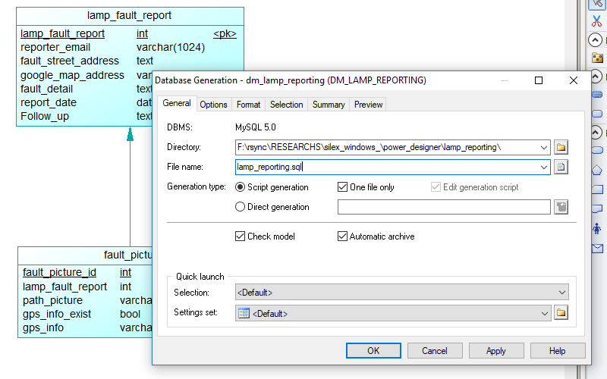

import it into phpmyadmin
Fix auto_inc and insert default values :

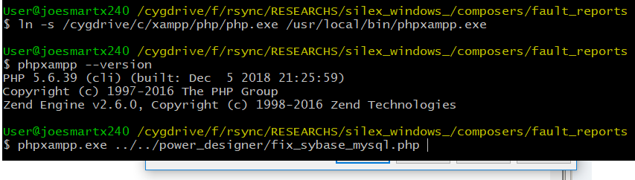

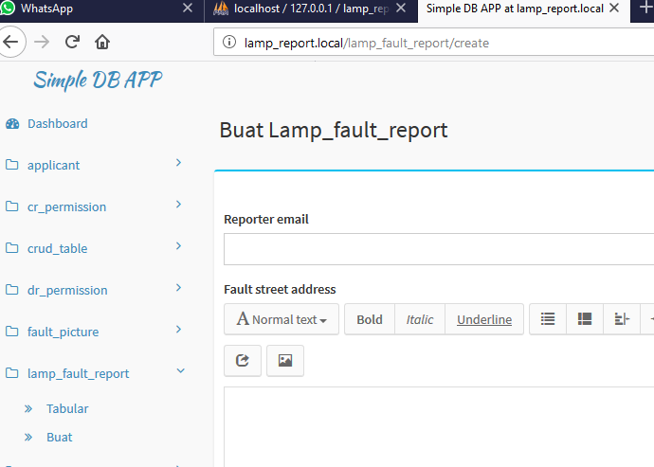

@todo fix lookup

@todo coding report view for admin
If we see clearly a new view for admin is actually concatenated or joined from two default generated forms.

/fault_report/edit{id}

/fault_picture/list

- Now create two dirs, copy from lamp_fault_report:
web/view/lamp_fault_report → web/view/one2many_lfr_fp
web/controllers/lamp_fault_report → web/controllers/one2many_lfr_fp

- Include controllers controllers/one2many_lfr_fp in controllers/base.php by editing
Fault_reports/src/console.php

// Fault_reports/src/console.php

//non generated bases controllers ...
$BASE_INCLUDES = "//require_once __DIR__.'/" . "custom" . "/test_001.php';" . "\n";
$BASE_INCLUDES .= "require_once __DIR__.'/" . "user_profile" . "/index.php';" . "\n";
$BASE_INCLUDES .= "require_once __DIR__.'/" . "one2many_lfr_fp" . "/index.php';" . "\n";

- Now test regenerate to make sure everything is ok.
User@joesmartx240 /cygdrive/f/rsync/RESEARCHS/silex_windows_/composers/fault_reports
$ pwd
/cygdrive/f/rsync/RESEARCHS/silex_windows_/composers/fault_reports
User@joesmartx240 /cygdrive/f/rsync/RESEARCHS/silex_windows_/composers/fault_reports
$ /cygdrive/c/xampp/php/php console generate:admin

Test the controller inclusion by put this line web/controllers/one2many_lfr_fp

echo "I'm included , error "; die; // using this to test the inclusion ;

If the controller is included then you can see in browser

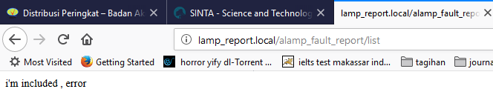

- If everything ok, now change the silex routing.
In web/controllers/one2many_lfr_fp/index.php change both ->match, -generate , and ->bind to match new routing:

//$app->match('/lamp_fault_report/edit/{id}', function ($id) use ($app) {
$app->match('/one2many_lfr_fp/edit/{id}', function ($id) use ($app) {
….
return $app->redirect($app['url_generator']->generate('one2many_lfr_fp_edit', array("id" => $id)));
…
->bind('one2many_lfr_fp_edit');
//->bind('alamp_fault_report_edit');

- @todo append picture list for current reports ….
To append pictures which refer to a report we need to modify one2many_lfr_fp/edit.html.twig
  - append tabular template
Add tabular datatables template. Copy from web/views/fault_picture/list.html.twig. Add datatables custom renderer in java script block:
"render": function ( data, type, row, meta ) {
var splitted = data.split('__');
return splitted[0]+'<img src="/getfile_jurnal_01/'+
splitted[0]+'/fault_picture/'+data+'" />';
}

  - @todo create silex/binding in index.php
  - @todo: Change controller ajax location to absolute if may
Absolute: ajax: '/fault_picture/list',
Relative: ajax: 'fault_picture/list'
Absolute vs relative will become problem because
Relative will call http://lamp_report.local/one2many_lfr_fp/edit/1/fault_picture/list instead which is wrong.

@todo coding report view for user
Same as for admin just fix view permissions

References
X240:f://research/silex_windows/logbook_silex_windows.doc
X240:f://research/silex_windows/logbook_sdbapp_install_x240_generator.doc

