htk/small_vocabulary_/logbook_small_vocabulary.odt

summary

Performance grade by stop consonant
Many times, hmm failed to model stop consonant ...

steps in htk/small_vocabulary_/megasync_003/scripts

Record data see ‘Data recordings below’

Annotate data see ‘Using praat to annotate’

Edit env.sh

Edit configcopy.txt

Edit wav2mfcc.lst
This file contain wav to mfc files mapping.
Since phone labelled in _ph suffix, for easiness the target mfcc list is _ph suffix also.

Execute prepare_mfc.sh
This will create all mfc from wav described in wav2mfcc.lst

Edit proto ??

Edit train.lst

Execute baum_viterbi_init.sh
This will average hmm model and put into single hmm initial model.

Exec makehmm.sh

hmm0

hmm1

hmm2

hmm3

hmm4

hmm5

hmm6

Hmm7

HEREST warning/ERROR, no use of variance in [sil], because sp not fix ...

Monophone phonems recognition

Exec monotest.sh

Exec monoperf.sh
Cek master/references lab. File in ./lab
Only 40% performance
60%

Monophone word recognition

Edit wgram_isol.txt

Edit wdict.txt

@todo, Edit all words master lab in wavs/wlab/????_ph.lab
Word labs file to be in another dir. For easines of word recognition performance and comparison .. since HResults can recognize labs. directory but not between prefix/suffix. _ph suffix for label file is Hresults can work correctly, but the contain is word sequence NOT phones sequence

wtest.lst
Limit mfc file here, for example you only want to test mfc that have Word label annotated to be analyzed using Hresult.

Exec wmonotest.sh

@todo, Exec wmonoperf.sh
Put master world level annotations in wavs/wlab/…...ph.lab. The suffix _ph
so we can’t use the mfc generated previously when test on phonems rec. performance.
This is the performance of single file monophone word recognition
/home/joesmart/RESEARCHS/neural_network_shmm/htk_35/HTKTools/HParse wgram_isol.txt words.net
/home/joesmart/RESEARCHS/neural_network_shmm/htk_35/HTKTools/HVite -l ../../wavs/results -y recw -T 1 -w words.net -C configtrain.txt -H hmm7/hmmdefs -o S -S wtest.lst wdict.txt monophones1
Read 22 physical / 22 logical HMMs
Processing data directly from the input filesRead lattice with 5 nodes / 5 arcs
Created network with 17 nodes / 17 links
File: ../../wavs/isolated_0001_9_ph.mfc
SILSP NUM_9 SILSP NUM_9 SILSP NUM_9 SILSP NUM_9 SILSP NUM_9 SILSP == [809 frames] -52.8027 [Ac=-42717.4 LM=0.0] (Act=14.7)
/home/joesmart/RESEARCHS/neural_network_shmm/htk_35/HTKTools/HVite -i recw.mlf -T 1 -w words.net -C configtrain.txt -H hmm7/hmmdefs -o S -S wtest.lst wdict.txt monophones1
Read 22 physical / 22 logical HMMs
Processing data directly from the input filesRead lattice with 5 nodes / 5 arcs
Created network with 17 nodes / 17 links
File: ../../wavs/isolated_0001_9_ph.mfc
SILSP NUM_9 SILSP NUM_9 SILSP NUM_9 SILSP NUM_9 SILSP NUM_9 SILSP == [809 frames] -52.8027 [Ac=-42717.4 LM=0.0] (Act=14.7)
/home/joesmart/RESEARCHS/neural_network_shmm/htk_35/HTKTools/HResults -L ../../wavs/wlab monophones1 recw.mlf
====================== HTK Results Analysis =======================
Date: Sun Oct 21 17:36:43 2018
Ref : ../../wavs/wlab
Rec : recw.mlf
------------------------ Overall Results --------------------------
SENT: %Correct=0.00 [H=0, S=1, N=1]
WORD: %Corr=100.00, Acc=77.78 [H=9, D=0, S=0, I=2, N=9]

@todo, Exec wmonolive.sh
Live isolated mono test need to recompile HTK with sound support ...

Semi align new sentences

nlabforwav.sh
This align is bad when hmm7 (monophones using isolated is used) … so we’re continuing using triphone continuous version ….

making and testing triphones ...

mktrilab.sh
This script will create triphone annotations from monophone’s. Also list the triphones in triphones1

maketriph.sh
This will create triphones version in saved into hmm12

wtriphtest.sh
Just a slight modification of wmonotest.sh by changing the phone list and hmm directory.

@TODO, Cdict.txt
We should include all possible triphone pronounciation
Cut -f 3 -d “ “ trilab/?.lab > cdict.txt

@TODO, tied state to recognized from all same middle/left/right context ???
IS NOT POSSIBLE to write all possible context in a cdict.txt . so we must construct tied state …

wgram_cont.txt

@TODO, Result error different volumen recording ...
Bad error, continuous not success, seems from volume level …. NEED to rerecord and relabel … it can be proof if , isolated samples is removed … SO VOLUME IS ABIG PROBLEMS...

wtriphperf.sh

Incremental learning
For a novice, with little knowledge of phonetics Its better to create database incrementally. Do not add database if it’s not correctly identified. Treat unmatched sample as bad samples and throw away.

Train
test

in real live situation, the model is perfected by test samples
perfected_samples = initial_samples+test_samples

Data recordings on ubuntu dv3

Audacity preparation

$pactl list sinks
$pactl list sources

#The sink for v8 is the second (1). The first is 0

$pactl set-default-sink 1 #v8 active port headset-output
$pactl set-default-source 3 #v8 active ports headset-input

#in case multiple bluetooth devices, for ex. Existing of b102 instead of v8
$pactl set-default-sink 2 #v8 active port headset-output inc. by 1
$pactl set-default-source 4 #v8 active ports headset-input inc by 1

$ audacity &

$pavucontrol # input devices, 100% #or volume.sh

V8 dv3 + fan output too loud, set to 30%
V8 recording too loud and hmm output is crash …. maybe because of v8 auto shutdown, so if want to use 100% make sure input devices is monitoring ….

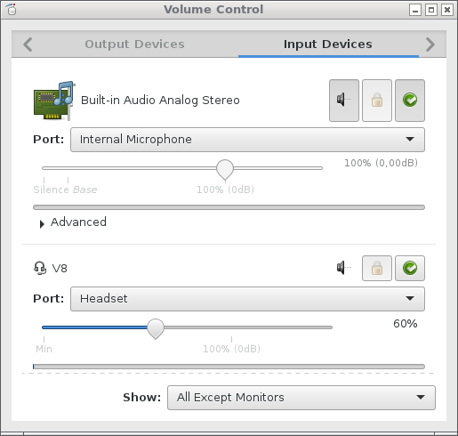

omit except overloud recording

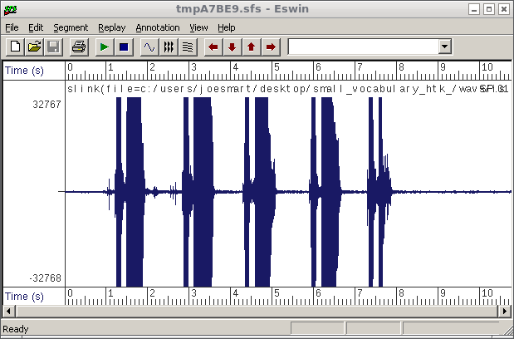

figure: over loud recording level 100% dv3 v8

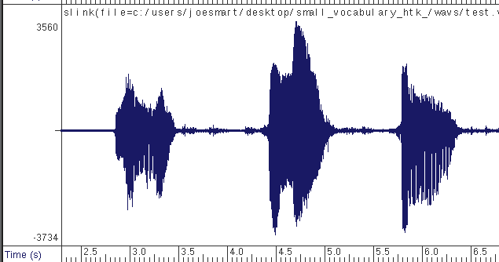

figure: 30% v8 dv3

smaller vocabulary incremental verification checking …
For a single short sentence training could be verified by using monophone performance. When you have finish record new sentence, this new labelled can be verified by using this sentence as a training and also a test sentence. See the performance of monophone recognition results.
/home/joesmart/RESEARCHS/neural_network_shmm/htk_35/HTKTools/HResults -L ../../wavs/lab monophones1 recph.mlf
====================== HTK Results Analysis =======================
Date: Sat Oct 20 19:49:43 2018
Ref : ../../wavs/lab
Rec : recph.mlf
------------------------ Overall Results --------------------------
SENT: %Correct=0.00 [H=0, S=1, N=1]
WORD: %Corr=84.00, Acc=84.00 [H=21, D=4, S=0, I=0, N=25]
===================================================================
Sab Okt 20 19:49:43 WIT 2018
#!MLF!#
"../../wavs/isolated_0001_0_ph.recph"

until hmm7, to check indivudal check 2 files need to change:
train.lst and test.lst

if mfc not created wav2mfcc need to be added also

Ubuntu pavu control – input output volume level Data recording

Pavucontrol:configuration:v8 profile -→Headset Head Unit (microphone need)
pavucontrol:input devices: v8 heaset → 30% (otherwise, audio too loud) with 30%, even with
iron fan running …
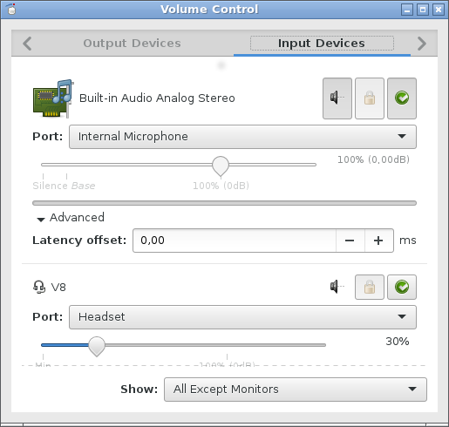

Set project source to mono 8000Hz (or later choos 16 bit PCM), since we’re doing in noisy environment.
Set volume.sh e
output device to 100 %,
input device: - build In mute
- v8 100%
vlc
100%

0 0 0 0 → a_iops/wavs/isolated_0001_0.wav (RIFF wav microsofts tag file)
a_iops/wavs/isolated_0001_0.aup

1 1 1 1 → isolated_0001_1.wav
9 9 9 9 → isolated_0001_9.wav
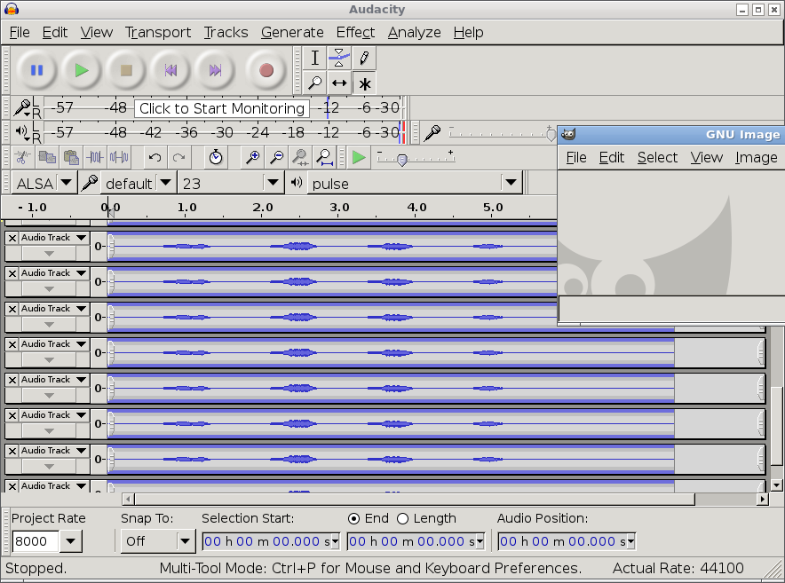

Hz frequency vs bit
Choose 16 bit pcm, this is 8000Hz standard

the data pattern for phone dialler or digit recognition

Filename | Transcription
isolated_0001.wav | 0 0 0 1 1 1 2 2 2 3 3 3 4 4 4 5 5 5 6 6 6 7 7 7 8 8 8 9 9 9
Figure-?: isolated number for training sentence
Above pattern in Figure-? Actually could be neglected since contained in patterns below in figure-?. But a point to be stressed here that we need to label it first is because the result will be used to automatically align the following monophone patterns.

Filename | Transcription
cont_0.wav | 0000 0101010 0202020 0303030 0404040 0505050 0606060 0707070 0808080 0909090
cont_1.wav | 1111 1212121 1313131 1414141 1515151 16161611717171 1818181 1919191
cont_2.wav | 2222 2323232 2424242 2525252 2626262 2727272 2828282 2929292
cont_3.wav | 3333 3434343 3535353 3636363 3737373 3838383 3939393
cont_4.wav | 4444 4545454 4646464 4747474 4848484 4949494
cont_5.wav | 5555 5656565 5757575 5858585 5959595
cont_6.wav | 6666 6767676 6868686 6969696
cont_7.wav | 7777 7878787 . 7979797
cont_8.wav | 8888 8989898

dfd

RECORDING FROM DB WE CAN’T INFER REAL LEVEL OF SOUND
https://stackoverflow.com/questions/2445756/how-can-i-calculate-audio-db-level/9812267#9812267

isolated data recording

@todo, Hresults error segmentation fault

@todo, cpu time need on intel, android, arduino ...

sdfa

@todo, memory needed …

@todo effect of window on recognition …

@todo effect of number of state on recognition …
Duration model of ...

Using praat to annotate
06/02/2018 13:28:31

create annotation
Open long sound file, click annotate
Create tier name ‘phonems’
now select both sound and text grid (use shit+ctrl+click), click ‘view and edit’
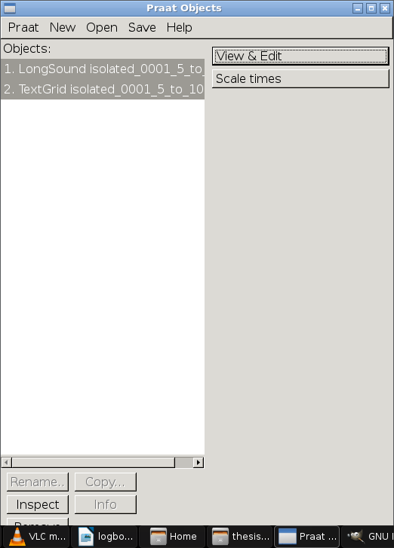

label/note/marking interval/boundary

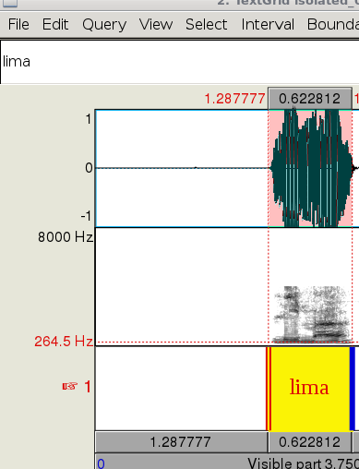

right click to select ‘begin interval’, now press enter to confirm, the blue line will be created, to annotate click this blue line (it will turn into two red lines), after click then type, you will see the phone change.
Best practice : mark all intervals at first, then type labels later.

Delete boundary/interval
To delete use menu boundary → remove (alt+backspace)

error
Group error by short_to_htk label,
delete/remove this label, recreate annotation, make sure “phonems” and “bell”

save praat collections
To save all praat file information, you need to save praat collections.
Now select all objects (using shift + ctrl+click), and click save → to binary and enter collection locations.

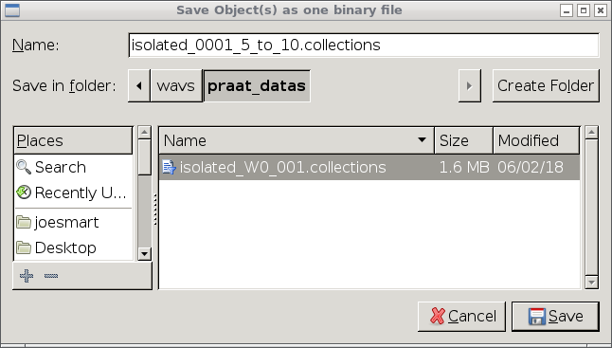
Gambar: praat collections

sometime long sound can’t be save. In this case save only annotations/tiers and open each one by one manually latter when work with Praat again.

Htk save
Save to text short_version use patterns below under wavs dir.;
praat_datas/isolated_0001_0_ph_short.TextGrid
praat_datas/isolated_0001_0_ph_long.TextGrid
praat_datas/isolated_0001_0_wd_short.TextGrid
praat_datas/isolated_0001_0_wd_long.TextGrid
praat_datas/isolated_0001_0.wav
praat_datas/isolated_0001_0.Collections
praat_out/isolated_0001_0_ph_short.sed
lab/isolated_0001_0_ph.lab
sfs/isolated_0001_0.sfs or wine dir f:\htk\small_\wavs\isolated…...sfs
and for world level lab file …
lab/isolated_0001_0_ph.lab
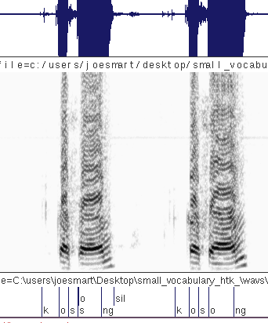

picture : tampilan sfs ….

editing
Zoom out/in ctrl+o, ctrl+i moving , using button bellow

@todo, how to play only selected interval …
Mark begin intervals with left click, end interval with right click … then click the grey bar
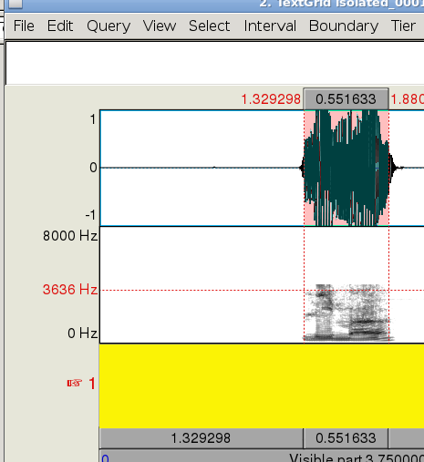

@todo understand praat plugin

@todo, how to insert annotation into praat
How to insert annotation into praat automatically. For example after aligned by HTK and need to be refined. Is there any ‘import ’ from HTK into praat.
https://github.com/CShulby/plugin_htklabel

using spectogram settings ..
Why using praat over sfs is because in praat, spectrogram… is customizable …

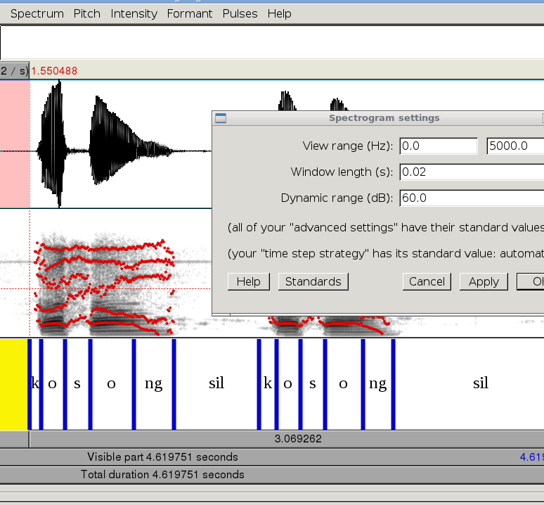

convert from praat format to HTK format
Use short version of textgrid. On Praat save to short version. Be sure tier names in short file match in python script short_to_htk_label.py for example “phonems” is different form “phones”.
wav$./sedder.sh praat_datas/isolated_0001_0_ph_short.TextGrid > praat_out/isolated_0001_0_ph_short.sed
wav$short_to_htk_label.py praat_out/isolated_0001_0_ph_short.sed > lab/isolated_0001_0_ph.lab

To verify labs file created, load HTK lab into SFS. This is since SFS understand HTK label format. To import sound into SFS, using menu import --> sound. To import HTK label import-->annotation -->HTK. When import, remember to uncheck sampling frequency.

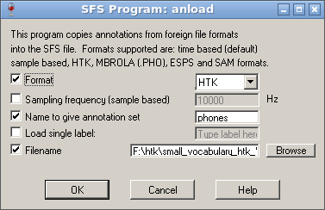

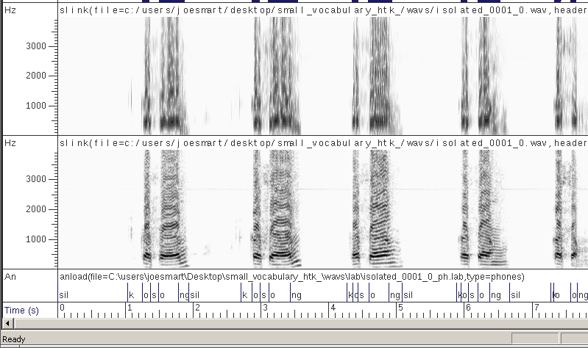

Download kylebgorman python ann lib into a_iop/soft_tools

@todo how to extract text grid from collections
Using gui : save to text files …
using bash?

@todo extract xxx.collections into xxx.tg_short or xxx.tg_long
How to Extract annotations from collections into tg_short and tg_long …

using praat scripts
http://phonetics.linguistics.ucla.edu/facilities/acoustic/praat.html
praat –open praat_datas/isolated_0001.collections
? extract ...

@todo, how to extract and import praat annotations into and from htk format
There is a module on phyton ?
https://github.com/kylebgorman/textgrid/blob/master/tests.py
using this module, we got assertion on python3 use python2 instead … test ok.

two formats of praat text labels ..
it seems there are two formats text grids on python … long format (praat objects → select text grid → menu save as text ...)
and short format (praat objects → select text grid → menu save as short text file…)
An example is here:
a_iops/soft_tools/textgrid-master/zoel.py
ready to use
a_iops/wavs/sedder.sh
a_iops/wavs/short_to_htk_label.py
for examples:
wav$./sedder.sh isolated_W0_0001.tg_short > isolated_W0_0001.sed
wav$short_to_htk_label.py isolated_W0_0001.sed > isolated_W0_0001.sed.lab

sedder.sh fix broken parsing from kyledgorman, which praat version match
#praat --version
praat version Praat 6.0.04 (November 1, 2015)
#dpkg -l | grep praat
ii praat 6.0.4-2ubuntu1 amd64 program for speech analysis and synthesis

@todo different short annotations between kylebgorman tests/data vs praat output…

Praat output:
File type = "ooTextFile"
Object class = "TextGrid"

0
4.6197505668934244
<exists>

kylebgorman version of short:
File type = "ooTextFile short"
"TextGrid"

1358.8925
1422.5525
<exists>
4

solutions: change first two lines praat to match kylebgorman
File type = "ooTextFile"
Object class = "TextGrid"
0
4.6197505668934244
<exists>

well this can be solved using sed command twice see a_iops/wavs/sedder.sh
#a_iops/wavs/sedder.sh
cat $1 | sed 's/"ooTextFile\"/"ooTextFile short"/' | sed 's/Object class = //'

@todo, how about multiple labels ex. Phones and words
not tested using multiple annotations in praats and save to long/short format.

Journal writing : Mendeley
It seems permissions is crashed for joesmart .. use sudo mendeleydesktop instead for the first time, creating dir. Structures and caches ..

Recording with v8 bluetooth headset
Bluetooth v8
Pactl list sinks
Pactl list sources

#The sink for v8 is the second (1). The first is 0

Pactl set-default-sink 1 #v8
Pactl set-default-source 3 #v8 active ports headset-input

Run audacity

