megasync_003/phonems_labelling_guide.odt

Phonems Labelling/annotation Guide

Number 9 of Indonesian
In the following figure, the marker of el ‘l’ is an ascending … around 2400 Hz

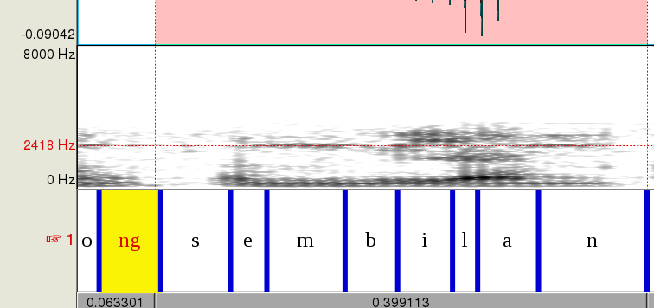
Figure-? : marker

