X240::/f://researchs/small_vocabulary/logbook_x240_sm_voc.doc

@todo, energy normalization …
How htk normalize energy, is MFCC normalized ….
htkbook_to_c_code/logbook_htk_energy_normalization.doc/logbook_htk_energy_normalization.doc

https://github.com/dzhatala/htk_norm_adapt

@todo, Htk algorithm?
When hvite running live, it measure signal/silent for cablibration ….that mean energy is normalized in htk.. but @todo what is the algorithm ???

2008 jakovjevic
Cmn, cvn
Hamming window → aid to lesser variation in the twi edges and strengthen variantion in the central of the frame

Current very important failed

@todo replay buf → to wav → ????
Only silsp, OFF COURSE because HSLAb rendering still wrong …. ? all replay buffered render in HSLAB over amplitudes ???
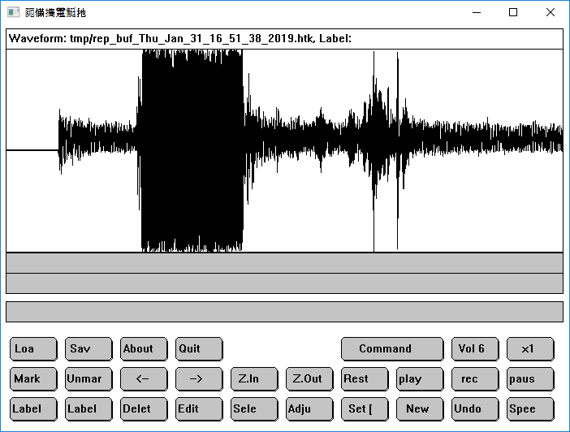

@TODO, fix replay buffer recording ….

This is why HVIte –g is always silent ?????

@todo replay buff without to wav failed with htk row failed …

@todo, confusable terms

@todo VOT voice onset time

@todo formant transitions …
What is format transitions …

@Spectral characteristics …

@todo dynamic time warping dtw

@todo Htk dsp
Is htk doing preemphasis ?
In configcopy.txt
PREEMCOEF = 0.97

Matlab htk
The matlab version of hinit researchs/htk/mscripts/hinit_arctic.m

Log_confusable
Specially focus on confusable set

Megasync03/scripts_confusable

preparemfc.bat
Convert wav file into MFCC format. Read configcopy.txt and wav2mfcc_lst.w32 . This step prepare

@todo, mfcc matlab vs mfcc htk

@todo, plat 3d view of confusable consonants
F:\RESEARCHS\small_vocabulary_\megasync_003\matlab_htk-master\plot_mfcc.m
Run (F5) → tools → rotate3d

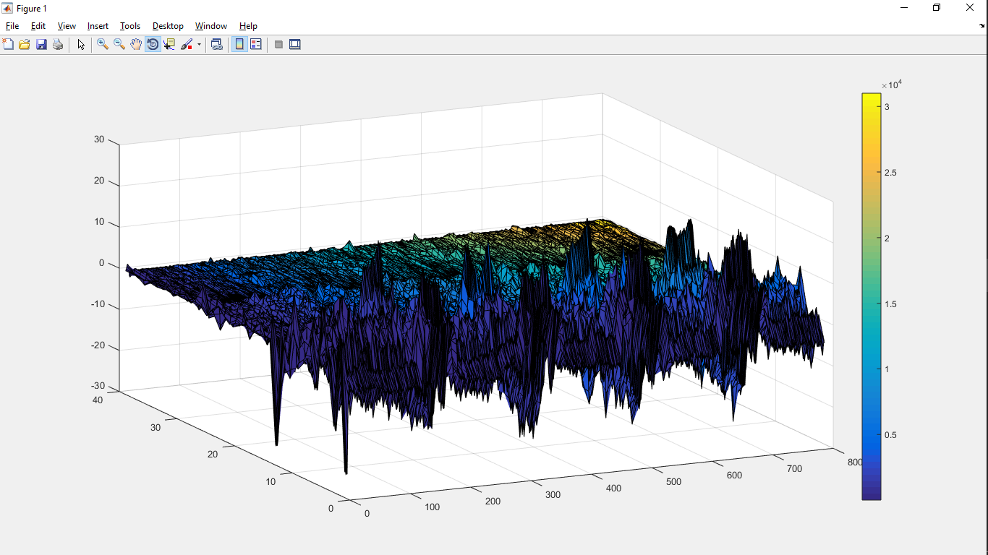

Recording

cooledit working on windows 10

win10_x240_okCool.Edit.Pro.2.+.2.1.+.serial.+.pdf.manuals.rar
run registration_crack.exe, ➔ marco heidmer …

Audacity is better on noise than sfs
Since like audacity has better noise than sfs ….?

Creating git github
27/12/2018 06:09:12

…or create a new repository on the command line
echo "# sm_win" >> README.md
git init
git add README.md
git commit -m "first commit"
git remote add origin https://github.com/dzhatala/sm_win.git
git push -u origin master

…or push an existing repository from the command line
git remote add origin https://github.com/dzhatala/sm_win.git
git push -u origin master

…or import code from another repository
You can initialize this repository with code from a Subversion, Mercurial, or TFS project.

Git on cygwin32 bad switch to cygwin64
27/12/2018 06:42:49
Cygwin32 has problem with windows 10 64, so we’reusing cygwin64 for giting …

Internet sharing and dns
30/12/2018 13:11:21
Just run ncpa.cpl and click sharing on wifi connection …
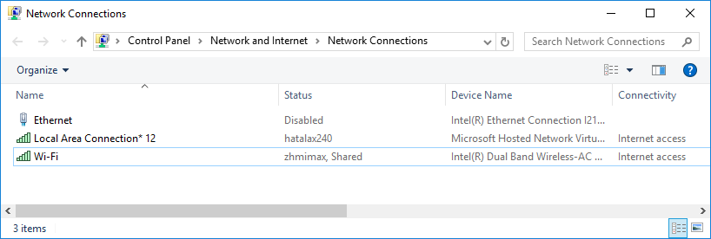

Cygwin live audio recognition windows
To enable live audio in cygwin32 bit compilaiton

Change in HAudio.c
#ifdef USS_AUDIO
#define OSS_AUDIO
#endif
#define WIN32_AUDIO
#if !defined NO_AUDIO && !defined SGI_AUDIO && !defined SUN16_AUDIO && !defined SOLARIS16_AUDIO && !defined HPUX_AUDIO && !defined RS6000_AUDIO && !defined WIN95_AUDIO && !defined OSS_AUDIO && !defined HPRAW_AUDIO && !defined DEC_AUDIO && !defined WIN32_AUDIO && !defined EXT_FD_AUDIO
#define NO_AUDIO
#endif

Use –lwinmm in HTKtools/Makefile LDFLAG

Compiled version in :

$ pwd
/cygdrive/f/rsync/RESEARCHS/small_vocabulary_/cygwin32/htk/HTKTools

Exit live recognition
Use CTRL+C.

Installing for windows 32 bit
Adding visual studio 32bit path into system properties F:\Program Files (x86)\Microsoft Visual Studio 9.0\VC\bin
Following installation procedure from http://htk.eng.cam.ac.uk/docs/inst-win.shtml
file:///F:/rsync/RESEARCHS/small_vocabulary_/webs/HTK%20Speech%20Recognition%20Toolkit-windows%20compile.htm

Everything works fine.

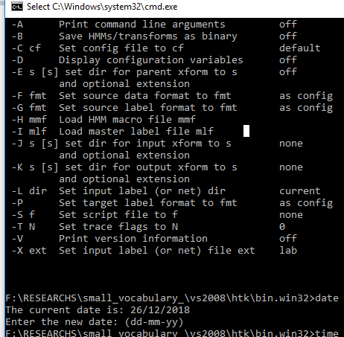

Debugging preparation of htk in visual studio
You can debug htk since it’s pure ansi written.

- Create new solution → new project from existing project – console application →
- specify debug options (copy from /D “win32” HTKLib/htk_htklib_nt.mkf)

alt+f7 (configuration properties) → configuration → c/c++ → preprocessors → pre-processor definition

include subfolder htklib/htktools

- cp HGraf.null.c → HGraf.c
- remove HTKTools/*.c except one single file with main(), for example HVite.c otherwise you got error something like

__??? Already defined ..

FIXING missing variable in signal.c

#define ARCH "WIN32"
This is because vstudio can’t recognized /D flag with value supplied
/D ARCH=”win32” .

Now you should got error free, and lunch program like this picture
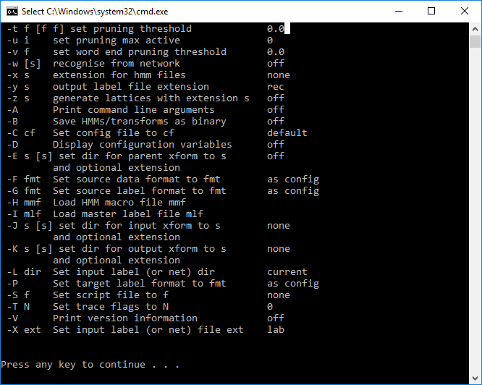

The conclusion is that htk is ready to be debugged in vs studio 2008

opening solution htk solutions …
open solutions in …
F:\RESEARCHS\small_vocabulary_\vs2008\projecs_vs2008

debugging hvite on trained set and hmm definitions
change project properties …
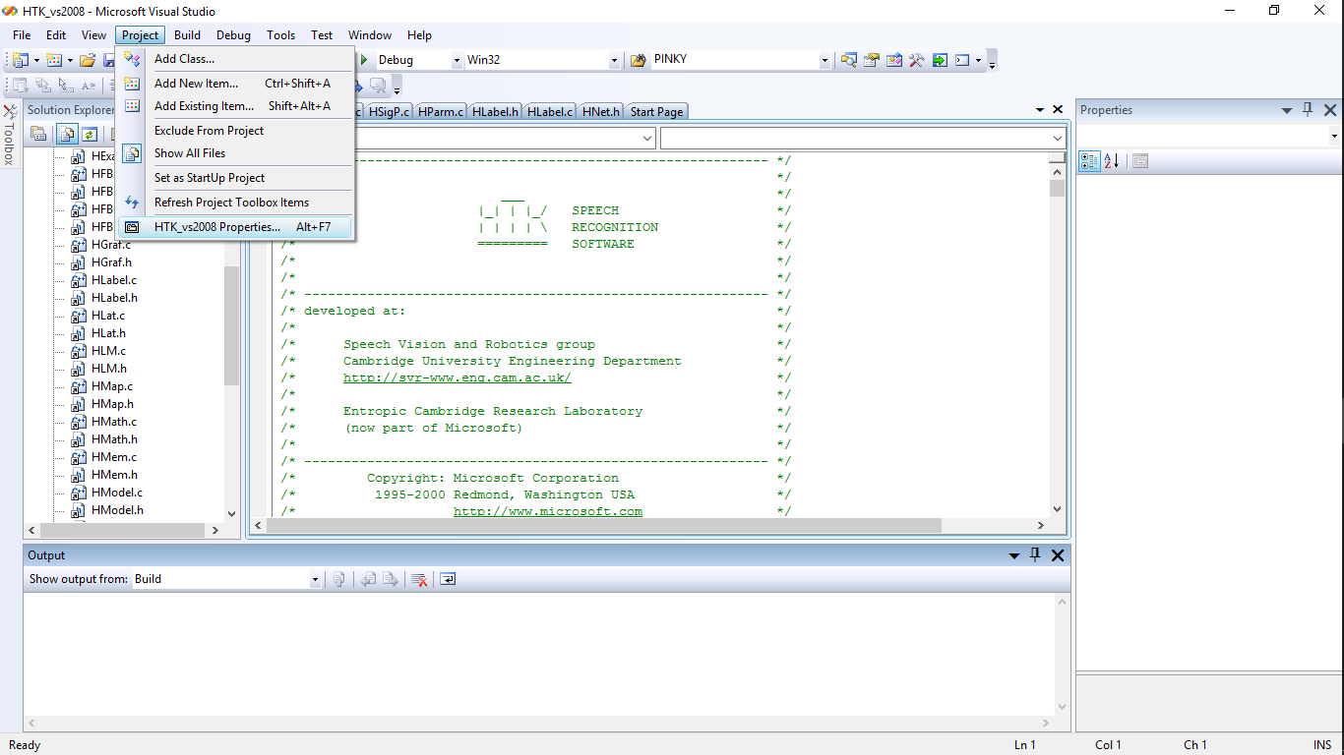

Now change configuration → debugging → working directory and argument

Argument for Hvite should be:
-T 1 -g -w cwords.net -C configlive.txt -H hmm12\hmmdefs -o S cdict.txt triphones1_srtd

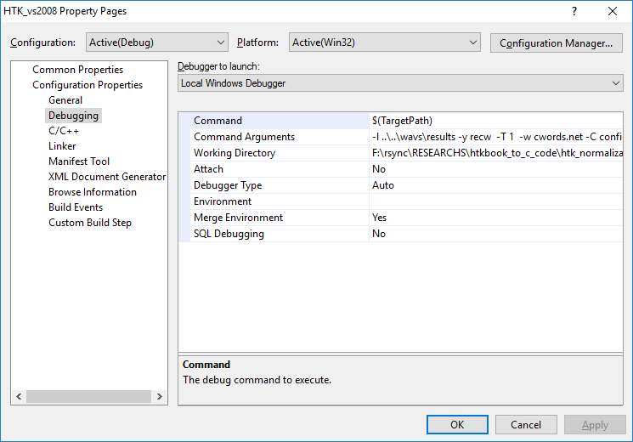

@TODO , live audio htk on command prompt ?
Don’t forget to set correct params, see example in configlive.txt. content of this configuration must match configuration in configcopy.txt

# Coding parameters
SOURCEKIND=HAUDIO
SOURCEFORMAT=HTK
#625 ns = 62.5 us === 16000 Hz
SOURCERATE=625.0
TARGETKIND = MFCC_0_D_A
TARGETRATE = 100000.0
WINDOWSIZE = 250000.0
USEHAMMING = T
PREEMCOEF = 0.97
NUMCHANS = 26
CEPLIFTER = 22
NUMCEPS = 12

USESILDET=T
MEASURESIL=F
OUTSILWARN=T
ENORMALISE=F

MEASURESIL=F, for only once measurement, if set to T, measurement is performed every time.

@todo, bad performance bad recording shown in HSLab ….. over amplitude

This mean very bad recording …

@todo maximum live audio recording long
Need to adjut maximum time live audio before in finish sentences

HVite.c:
if (pbinfo.a != NULL && replay) AttachReplayBuf(pbinfo.a, (int) (3*(1.0E+07/pbinfo.srcSampRate)));

change 3 in above line for buffer long in seconds

Solved, Mmsystem waveingetdev() Can’t read audio name, bad character … shown wchar_t
Set pre-processor UNICODE active. Wchar will turn into CHAR. waveingetdevsW will changeto waveingetdevsA. See pre-processor set WIN32, WIN32_AUDIO, UNICODE .. etc in vsual studio 2008 project F:\rsync\RESEARCHS\small_vocabulary_\vs2008\projecs_vs2008\HTK_vs2008.vcproj

@todo, Switch microphone … or choose recording device
Waveinopen receive udevice id ??? which is default to WAVE_MAPPEr= -1 … default ?

Solved, bad performance single word/phone for long sentences with closured grammar...Disable laptop mic enable only v8 bluetooth mic

For htk testing surety just disable laptop mic leave v8 online ….
Sometime bad performance shown as single word/phonem even for very long sentences. In long sentences we hove to see a sequences of phones or words. But unfortunate only a word/a phone shown in recognitiion grammar. One reason of this to happen is because mismatch input devicess. In our case data that which is trained with V8 bluetooth accidentaly recognized laptop array mic on and default. In this case worng input device (mic array)

@todo bad performance htk live versus cmmand only …

@todo, verification of HSLAB against Hvite –g

Need to verify if online recognition Hvite –g matched against offline (HSLab/ReplayBUffer). After this verification we’re completely sure that there is no bias acoustic treatment of this two HTK builtin product. This is because it’s experienced that Audacity and Hvite –g treat the recoding differently. Well this is slightly complicated since Hvite –g waveform is different from rep buffer. Because of replay buffer overriding policy. The wave in the replay buffer could contain wav from previous recognition sentences.

@todo bad performance seem _Z is main factor ...
Different treat of hslab vs audicity is in Zero mean ... it seem that hslab do not perform zero mean ... while audacity perfoms. But new problem arise that htk lize can’t perform zero mean ???
Can’t zero mean in buffer ?

So what’s the different between _Z vs ZMEANSOURCE ? _Z is for static coefficient ...

@todo bad performance, re-record from HSLAB
It could be Audacity recording different from htk live recording .. so the experiment need to be redone using HSLab recording ...

@todo backup replay buffer to file for further analysis
It’s considered better to backup in HAudio.c:playAudio, since this audio is header created. But actually when HSLab play audio by clicked button? This become a messy solution.

The function PlayAudio is simple enough, there is a pointer to short datas and nSamples …

/* PlayAudio: play nSamples from buf thru output device a */
static void PlayAudio(AudioOut a, short *buf, int nSamples)

PlayAudio(ao,ai->rbuf.data+ai->rbuf.outx,ai->rbuf.size - ai->rbuf.outx);

So thes mean rbuf.data is the beginning, ai->rbuf.outx is the available form input. This mean our backup buffer must be the same exactly …

After backup from live hvite we got conclusion that audacity and htk recording is missing something ….

Say X is raw from hvite live , and Y is raw from hvite live converted using audacity, then
The recognition is different … does audacity alter something ?

@todo, data size calculation SHORT ? 16 bit PCM ?

Editing raw data from replaybuffer using audacity
From audacity → import →data row , change rate to 16000 Hz

lajdssad

Port audio installed
F:\rsync\RESEARCHS\small_vocabulary_\vs2008\pa_stable_v190600_20161030\portaudio

Configuring port audio for visual studio 2008
Working : ./pa_stable_v190600_20161030/portaudio/src/vs2008_portaudio_src.vcproj

Create project from existing source …

Don’t forget c/c++> pre-processor → use_wmme=1
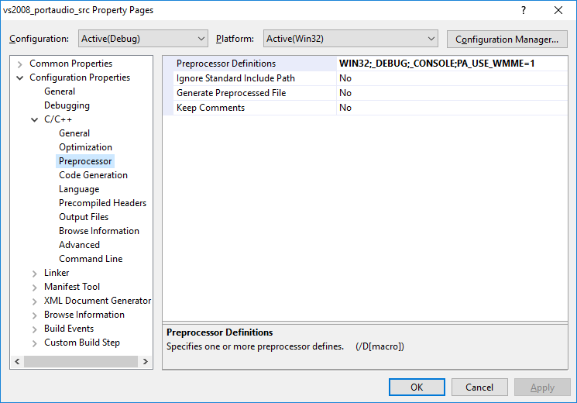

Port audio ok but why ?

Port audio waveincaps different than htk
Port audio not shown strange character and shown char type for .szPname field, this is because UNICODE pre-processor is set.

visual studio 2008

Solved, compiling many tools or programs Hvite, Hslab
To compiled a tool/program in VS just ‘add existing’ HSLab.c/Hvite.c and remove exclude from project‘’ the old one ‘hslab.c/hVite.c’. this will prevent compilation error ‘function .. already defined’ for example ‘main already defined'.

include directory
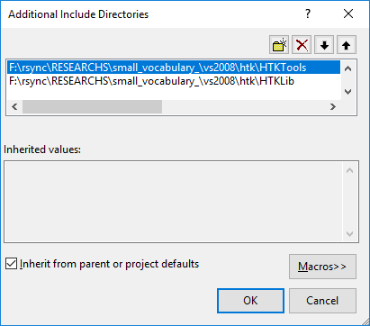

include mmsystem multimedia sound library to compile htk live on windows
as in
https://social.msdn.microsoft.com/Forums/vstudio/en-US/dff0c5e3-007c-430f-a4d3-350dbfce969f/error-lnk2019-unresolved-external-symbol-impplaysoundw12?forum=vcgeneral

file:///F:/rsync/RESEARCHS/small_vocabulary_/vs2008/webs/error%20LNK2019%20%20unresolved%20external%20symbol%20__imp__PlaySoundW@12.htm

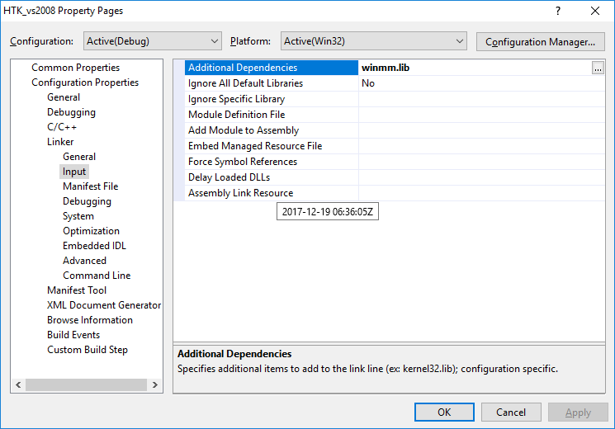

visual studio shortcuts

f12 goto definition, ctrl -, go back
ctrl+f4 close current file

Object browser
Shortcut | Description
Alt-F12 | Displays the Find Symbol dialog
Ctrl-F12 | Displays the declaration of the selected symbol in the code
F12 | Displays the definition for the selected symbol in code
Ctrl-Alt-F12 | Displays the Find Symbol Results window
Ctrl-Alt-J | Displays the Object Browser to view the classes, properties, methods, events, and constants defined either in your project or by components and type libraries referenced by your project
Alt-+ | Moves back to the previously selected object in the selection history of the object browser
Shift-Alt-+ | Moves forward to the next object in the selection history of the object browser

dsfdsafa

Htk source code

Include mmsystem.h
C:\Program Files\Microsoft SDKs\Windows\v6.0A\Include\mmsytem.h

Hgraf_win32.c

This hgraf version can be used on compilation by visual studio 2008
/* EXPORT->InitGraf: initialise memory and configuration parameters */
#define TextOut TextOutA /*** zoel ***/
void InitGraf(void)

HSLab.c
Some function need to localized for properly compilation on visual studio

static void LoadLabs(void) /**add static by zoel for compilation on visual studio **/
static void LoadData(void) /** add statiac by zoel for compilaaion in vs2008 ***/

Haudio.c

Win32 mmsystem
Define UNICODE in pre-processor if dealing with wchar … for example to print waveInCaps type

Haudio.c:backupreplaybuffer

@todo, using htk header ...
Hcopy can’t convert raw htk yet ...need to put htkheader info ..

Solved, fopen() error in haudio.c:backupreplaybuffer, invalid argument
This is because the filename contain \n or \r. fopen can’t create file name contain more than one line for a filename. So fopen () will return NULL and perror will print “Invalid Argument”

@todo, Haudio.c backupreplaybuffer
There is a buffer of short and n samples, but we need to know how many short per samples. Even we have to write header … for (WAV or HTK)?

HError() for debugging
For direct debugging while coding use HError with -1 first argument, it will become warning and printed guaranteed…

