How to use , user manual

Install sdk
Install appropriate zktech sdk the best mached one. ZKFinger_SDK_2017_07_20_okwin8_win10_64.rar

Copy folders
release folder contain executable.
master folder contain fingerprint templates …
downloaded folder will contain new registered templates. Model the content of download folder to master/ to confirm the selection.

Install moodle tables
This application link to mysql database of moodle e-learning library.

@todo, java word sound (javaws)
Edit project using eclipse browse to javaws/eclipse_32_ws

execute javaws/eclipse_32_ws/javaws/run.bat

@see examples at user21 lab. mulmed

Install espeak and puth in system/user path
F:\rsync\RESEARCHS\fingerprint\github_x240\zk4500biotime\javaws\espeak_installed\command_line

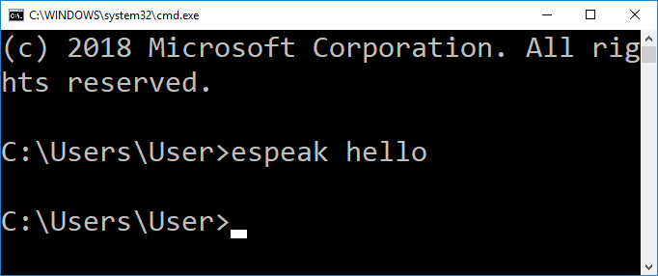

Install mbrola id1
Download from wget http://www.tcts.fpms.ac.be/synthesis/mbrola/dba/id1/id1-001010.zip

Copy the id1 phone into mbrole_ph directory. Now query this voice using espeak

prompt>espeak --voices=id
Pty Language Age/Gender VoiceName File Other Languages
5 id M indonesian asia\id

Edit and fix vlcwin.bat
Make sure vlcwin.bat refer to correct path of vlc installation.

Install mbrola id ?
F:\rsync\RESEARCHS\fingerprint\github_x240\zk4500biotime\javaws\espeak_installed\espeak-data\mbrola_ph

x240 database mysql migration
a new database “absensi” is created in x240/win10 mysql/xampp.

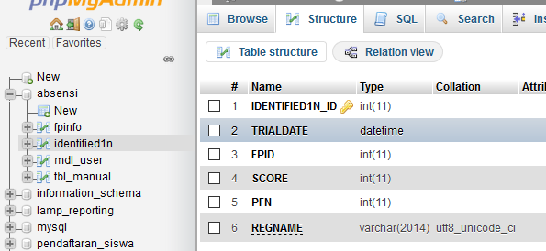

In moodle database instance (‘absensi’) create more two tables fpinfo and identified1n. fpinfo contain finger registration for a person in moodle mdl_user table. Identified1n contain log of attendances.

@todo visual studio 2008
Demo.exe can’t be run, must install sdk first in directory ZKFinger_SDK_2017_07_20_okwin8_win10_64

@todo, std:string error different from password.h , loadconfigfromfile, connecttest()
//error coding not be carefull
password1.clear() it should be database1.clear() .. so password is always cleared

@todo using text files for configuration and password
14/03/2020 19:36:22
Algorithm:
Use line by line reading .. us sscanf

Underscore not read for server and database in mysql
server localhost_txt
username joesmart_txt
password password_txt
database absensi_txt

mysql will assume server is localhost (without underscore) and database is absensi (also underscore ignored)

@todo check download folder when exit and set warning!
14/03/2020 07:48:30
When register new fingerprints the content ‘download’ folder must be moved into master when exit.

Function and Object declaration
/*Demodlg.h*/
void CheckDownloadFolder();

Warning show message information box msgbox
MessageBox(“”);

Solved, combo drop down only show one row

https://social.msdn.microsoft.com/Forums/vstudio/en-US/63ab73b5-08e2-4c5c-85d7-4cbfbd7ccf52/comboboxs-dropdown-list-only-show-one-item-at-a-time-with-scroll-bar?forum=vclanguage

click demo.rc2 on design view click combo, then click combo drop down(while in design view) → now resize the square …

Solved, adding finger? It’s missing just using array to scroll down ….

The combo Is ready but no selection …. For example left_thumb, left_ring, left_middle, left_index, left_little.

This function works ….. using ccombobox functions
((CComboBox*)GetDlgItem(IDC_COMBO1))->AddString("MyString");

@todo, adding attendance type and title
14/03/2020 07:47
Need to add event type for example, job1_enter, job2_exit. A new field “REGNAME”is added to absensi:identified1n. Anew EditControl editRegName is added to resource Demo.rc.

Initialization on open:
//DemoDlg.cpp
BOOL CDemoDlg::OnInitDialog()
SetDlgItemText(editRegName,"REG?_JOBX_ACT?");
..

To get the value we need to get handle and get its length. The common ERROR is to get dialog handle using GetActiveWindow() which is wrong. We must convert dialog to its window handle using its properties m_hWnd.

//Demodlg.cpp::pr1()
HWND handle=GetDlgItem(dlg->m_hWnd, editRegName);
int len = SendMessage(handle, WM_GETTEXTLENGTH, 0, 0);

SendMessage(handle, WM_GETTEXT, (WPARAM)len+1, (LPARAM)sb);

Save it for further use field of class CDemoDlg
//Demodlg.h
char reg_event_name [30] ; //NOS_JOB1_IN

@todo InsertIntoMysql:

@todo get a string text from edit text control ?

Win32_api

Read file line by line
https://www.systutorials.com/how-to-process-a-file-line-by-line-in-c/

MessageBox
Very important to show mes

Sprintf()
Sprintf doesn’t append string, it put string from 0 index.

getCurrentDirectory()
get current directory

get executable file
GetModuleFilename()

@todo Git
14/01/2019 21:58:26
Checkout from github since github date is 8 april while sda5/…/vec_..new date on 1 april 2018. so we clone from github first.
$pwd
RESEARCHS/fingerprint/github_x240
$git clone https://github.com/dzhatala/zk4500biotime

Creating new branch x240 …
Git checkout –b x240

Make sure we’re already in x240 …

$ git branch
master
*x240

$git push origin x240

$ pwd
/cygdrive/f/rsync/RESEARCHS/fingerprint/github_x240/zk4500biotime
$git status

To issue Git command must inside correct direktori ‘zk4500biotime’

User@joesmartx240 /cygdrive/f/rsync/RESEARCHS/fingerprint/github_x240/zk4500biotime
$ pwd
/cygdrive/f/rsync/RESEARCHS/fingerprint/github_x240/zk4500biotime

User@joesmartx240 /cygdrive/f/rsync/RESEARCHS/fingerprint/github_x240/zk4500biotime
$ cd ..

User@joesmartx240 /cygdrive/f/rsync/RESEARCHS/fingerprint/github_x240

$ pwd
/cygdrive/f/rsync/RESEARCHS/fingerprint/github_x240

$ ls .git
ls: cannot access '.git': No such file or directory

User@joesmartx240 /cygdrive/f/rsync/RESEARCHS/fingerprint/github_x240
$ git status
fatal: Not a git repository (or any parent up to mount point /cygdrive)
Stopping at filesystem boundary (GIT_DISCOVERY_ACROSS_FILESYSTEM not set).

