logbook_zkfinger_java
latest update : 3/22/2020 6:52:49 AM

Installation directory
Location of driver and sdk master installation
F:\master\driver\zkteco

Working driver windows 10 64 java and visual c++ application
F:\rsync\RESEARCHS\fingerprint\github_x240\zk4500biotime\drivers\ OK_win1064_java_fingerprint_mfc_5.3.0.30.rar

Install new driver and test on zk4500 success
Wed Mar 6 22:17:02 WIT 2024
G:\rsync\RESEARCHS\fingerprint\github_x240\zk4500biotime\javaws\eclipse_32_ws\zkfinger_elerning\run.bat

3/22/2020 6:15:40 AM
F:\master\driver\zkteco\ZKFingerSDK_Windows_ZK10_Standard\ZKFingerSDK_Windows_ZK10_Standard\driver\5.3.0.30\setup.exe
This will remove the zkonline 2.x.x version, after installation zk4500 will not beep anymore on usb plug. This is okay … just run
F:\rsync\RESEARCHS\fingerprint\github_x240\zk4500biotime\javaws\eclipse_32_ws\test.but

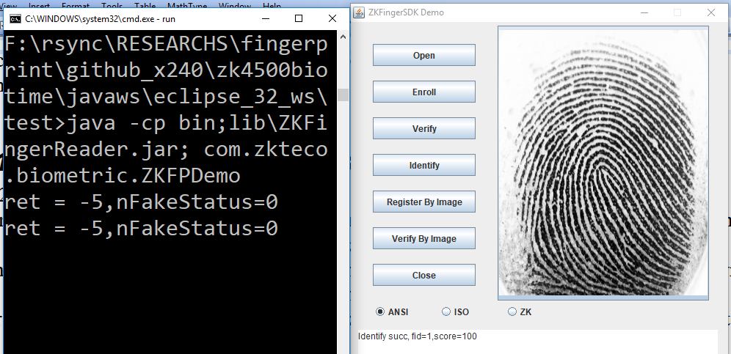

Old MFC applications can still be run …

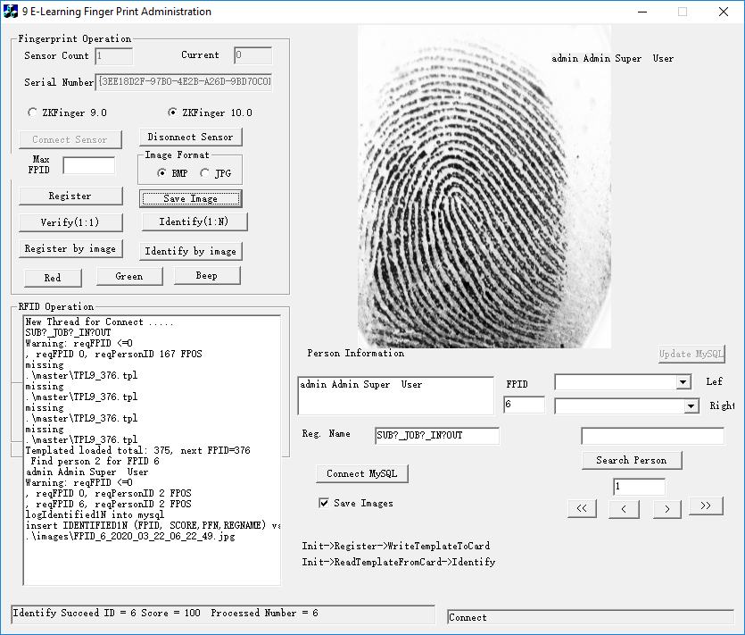

Register by template files version 10
Moodle_att_https/src/test/ZPFDemo001.java

@todo test register by image function on new SDK
Is not practical use register by template files version 10

register by fingerprint.bmp ok
F:\rsync\RESEARCHS\fingerprint\github_x240\zk4500biotime\javaws\eclipse_32_ws\test

register by jpeg/jpg file from zk4500 also ok … ".\\FPID_6_2018_09_19_08_05_06.jpg"

@todo test all moodle/absensi templates/images in java app ….

Limitation Limited number of person maximum number of fp 1:N, maximum N
Enroll is not effected. To recognize 1: N .. only ‘load’ a subset of stored finger.

Migration from All/Complete to subset directory based
Moodle_att_https/sql/find_fpid_group_mhs.sql

SELECT mdl_user.username, FPINFO.* FROM `fpinfo`, mdl_user where PERSON_ID=mdl_user.id and username like '1321%' ORDER BY `FPINFO_ID` ASC;

Load templates from directory
Z:\remove_programs\yogacopy\javaws

Enroll template into directory

Cygwin
Cygwin Programs used:
Espeak
lsusb

Usb cable disconnect detection

When cable disconnect, setparam() all functions calling are normal …
But the message is not forwarded to device and no RETURN can detect.
The ‘ret’ in this line always returned 0 even the usb is disconnect (the led doesn\t respond)

ret=FingerprintSensorEx.SetParameters(mhDevice, 102,changeByte(1), 4);

to detect we parse output of cygwin →lsusb?

Maven

Group : org.cpintar.attendance
Artifact : Kalesang

//todo Release-executable launch4j-running program

Launch4j
Kalesang-Jar + jre =>kalesang.exe

Release-executable launch4j-running program

Cygwin : lsusb, espeak, //todo dll ?

