Logbook-zk4500
axioo
D:\researchs\fingerprint\logbook.doc

@todo reporting mysql

Absen today
In good.sql
select IDENTIFIED1N.*,fpinfo.person_id,mdl_user.username,mdl_user.username,mdl_user.firstname,mdl_user.lastname from IDENTIFIED1N, fpinfo,mdl_user where ((IDENTIFIED1N.fpid=fpinfo.RIGHT_INDEX) OR
(IDENTIFIED1N.fpid=fpinfo.RIGHT_THUMB)OR
(IDENTIFIED1N.fpid=fpinfo.RIGHT_INDEX)OR
(IDENTIFIED1N.fpid=fpinfo.RIGHT_MIDDLE)OR
(IDENTIFIED1N.fpid=fpinfo.RIGHT_RING)OR
(IDENTIFIED1N.fpid=fpinfo.RIGHT_PINKY)OR
(IDENTIFIED1N.fpid=fpinfo.LEFT_THUMB)OR
(IDENTIFIED1N.fpid=fpinfo.LEFT_INDEX)OR
(IDENTIFIED1N.fpid=fpinfo.LEFT_MIDDLE)OR
(IDENTIFIED1N.fpid=fpinfo.LEFT_RING)OR
(IDENTIFIED1N.fpid=fpinfo.LEFT_PINKY)OR
0) AND person_id=mdl_user.id order by trialdate;

@todo, vs2008 , still can’t save datas images templates that already enrolled before …
Compile and running ok, all functions work except .. register by image, unknown jpeg/bmp format. Extract failed or not using standard version of sdk

@todo Tcp server visual c++
This tcp server is still need, since c# is not working …
So the server in c++ and , the client will be in java ….

Mysql LAN login from axio into dv3 ok using mysql front

@todo Mysql

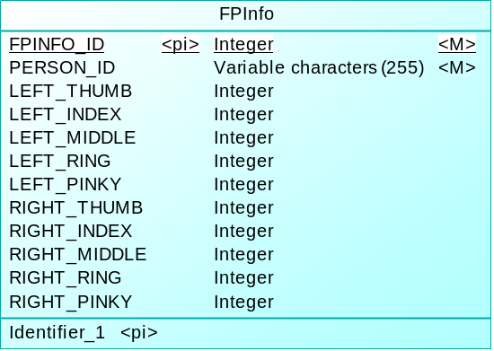

Mysql boost visual c++
Must copy string from resultSet->getString(?) into a buffer in axf/dialog

@todo, boost ok for console program,need integration to vc_fe_tp10_new
3/18/2018 2:35:50 AM
Fingerprint/testboost/Release/testboost.exe ok standalone, but not integrated to vc_??
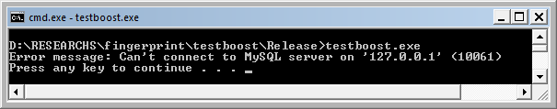

3/18/2018 5:31:52 AM
It’s working we got access denied on static text ..

logging
DemoDlg.h
afx_msg void appendLog(CString text);

@todo connecting fp to database or client
3/14/2018 10:28:48 PM
Fingerprint/VC_EF_TCP_SERVER

FP TCP Server functionality
Server messages:
→EVENT_LOGIN_SUCCESSFULL(SESS_ID)
→EVENT_FP_IDENTIFY_SUCCESS(FPID)

→EVENT_FP_IDENTIFY_FAILURE
A user stick finger but not identified
→EVENT_FP_ENROLL_WAIT (NEED_N)
Need a user to stick finger, NEED_N=0 mean completed but not guarantying successful enrolling process.

→EVENT_FP_ENROLL_SUCCESS(FPID)
→EVENT_FP_ENROLL_CANCEL(FPID)

Client messages:
→REQ_LOGIN(USER, PASSWORD)
→REQ_LOGOUT(SESS_ID)
→REQ_KEEP_LIVE(SESS_ID)

All functions above must accomadate nature of tcp comms. For example
→ if socket disconnected SESSION must be deleted ….
→

@todo load ok fingerprint

3/14/2018 9:27:10 AM

Solved, Fingerprint\vc_file_enroll but quality is bad
3/14/2018 9:26:27 AM
This is because v9 ???? can v10 be saved ? is v10 templates is better ????
See fingerprint/vc_enroll_file the performance is BAD comparing to original version in fingerprint/VC .

3/14/2018 5:38:02 PM
Tested ok It’s better to using v10 tmplate in file loading as seen in fingerprint\vc_enroll_file_10

@todo, testing register with template file ?
3/13/2018 8:35:12 AM
Cv_edited originally using templatestr to register into fpcache db, can we use template file ?
It seems work ….

$ git push origin master
Username for 'https://github.com':
Password for 'https://dzhatala@github.com':
Counting objects: 11, done.
Delta compression using up to 2 threads.
Compressing objects: 100% (11/11), done.
Writing objects: 100% (11/11), 91.68 KiB | 77.00 KiB/s, done.
Total 11 (delta 9), reused 0 (delta 0)
remote: Resolving deltas: 100% (9/9), completed with 9 local objects.
To https://github.com/dzhatala/zk4500biotime.git
e2f9fa8..b7b9b1f master -> master

mamaxioaero@mamaxioaero-PC /cygdrive/d/RESEARCHS/fingerprint
$ date
Tue, Mar 13, 2018 9:06:28 AM

Fingerprint\vc_edited compiled success on visual studio 2008
3/13/2018 8:25:53 AM

Compiled success but need to reinstall sdk 7.20,other wise program not working …

Using form/dialog in win 32
We can use form designer Win32 project type visual studio ……….
In dir. fingerprint/VC_../demo.sln… double click demo2.rc .. double click the dialog ….

Problem, converting win32 sdk samples/vs into clr failed
Must coding windows/form manually can’t use mfc/toolbox ….

@todo, must find how to save/persistent finger datas into disk in win32 samples/VC env/source

@todo, Downloading visual studio 2008

Problem not working, after install visual studio 2008
Solution : Reinstall sdk 7.20 , restart computers ….

Activex ocx is syswow64/biokey.ocx

Good example but not working must modified
http://www.azamshaikh.com/?p=5
in c#
not working for some events …

solved, zk4500 beep from c# active x

@todo, System.Runtime.InteropServices.COMException (0x80040202): Exception from HRESULT: 0x80040202
This event is not supported by server , ?????

@todo, only c# oncapture event is working need libfprint open source sdk
Need to integrate with another finger print library….. such as libfprint ….
Images (training, vs test) will be input to libfprint …..
Zkteco active x is lack of documentation ……

3/20/2018 4:03:18 AM

Well actually we must

Working/solved …
Example in github.com/dzhatala/zk4500…
On capture

For saving, previous file must exist before ….

@todo, empty all event class ….
So far on capture is working …

Running error active x class factory 80040154
Need target x86, since registry is 32bit active x, but visual studio build 64bit.

Using corflags.exe
https://stackoverflow.com/questions/1381968/setting-32-bit-x86-build-target-in-visual-c-sharp-2008-express-edition

D:\RESEARCHS\fingerprint\zktime_csharp_0002\zktime_csharp_0002\bin\Release>\RESE
ARCHS\fingerprint\corflags.exe /32BIT+ zktime_csharp_0002.exe
Microsoft (R) .NET Framework CorFlags Conversion Tool. Version 2.0.50727.42
Copyright (c) Microsoft Corporation. All rights reserved.

Downloaded corflags.exe form
https://stackoverflow.com/questions/242304/where-should-i-download-corflags-exe-from

running ok

Git local repo created, remote in github/dzhatala

mamaxioaero@mamaxioaero-PC /cygdrive/d/RESEARCHS/fingerprint
$ pwd
/cygdrive/d/RESEARCHS/fingerprint

mamaxioaero@mamaxioaero-PC /cygdrive/d/RESEARCHS/fingerprint
$ git status

$ git push origin master

Using zk4500 active x in visual studio express
On solution explorer → right click →(add) References …

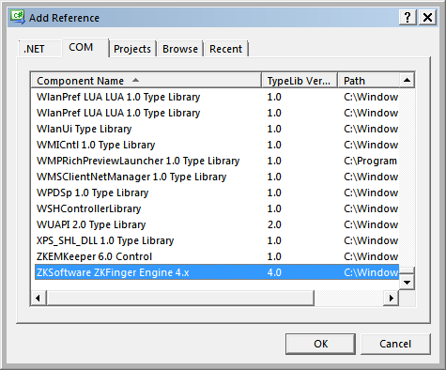

Failed, Generating wrapper

D:\RESEARCHS\fingerprint\tmp>"c:\Program Files\Microsoft SDKs\Windows\v6.0A\bin\

AxImp.exe" /source ZKOnline.ocx

Generated Source: D:\RESEARCHS\fingerprint\tmp\Axzkonline.cs

Generated Assembly: D:\RESEARCHS\fingerprint\tmp\zkonline.dll

Generated Assembly: D:\RESEARCHS\fingerprint\tmp\Axzkonline.dll

Zk4500 active x control already registered in registry(regedit.xe)
3/10/2018 5:58:21 AM
HKEY_LOCAL_MACHINE/Software/Classes/CLSID/CA69969C-????

….
static CLSID const clsid
= { 0xCA69969C, 0x2F27, 0x41D3, { 0x95, 0x4D, 0xA4, 0x8B, 0x94, 0x1C, 0x3B, 0xA7 } };
return clsid;
……….

