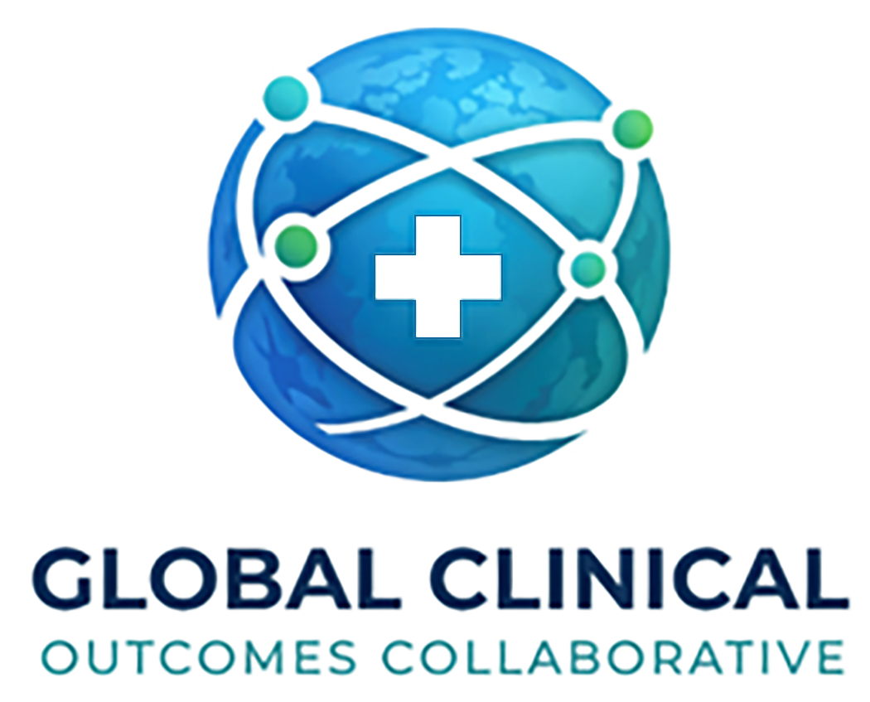
GLOBAL CLINICAL OUTCOMES COLLABORATIVE
Brand Identity Guide
Better Recovery Begins with Better Evidence.
Version 1.1 • Bellevue, WA

What GCOC Stands For
Recovery is one of the most important phases of care. Yet today, it remains one of the least consistently measured, least transparently compared, and least collaboratively governed.
Global Clinical Outcomes Collaborative (GCOC) exists to close that gap. As an independent nonprofit, GCOC provides a trusted framework for multicenter outcomes research, responsible data stewardship, and patient-centered benchmarking across spine and musculoskeletal care.
By bringing together surgeons, hospitals, universities, and researchers, GCOC turns real-world recovery into actionable evidence — so that better care is guided not by isolated experience alone, but by shared learning in the public interest.
Better Recovery Begins with Better Evidence.

Core Values
Three principles guide every project, partnership, and publication GCOC takes on.
TRUST  Independent governance and responsible stewardship of collaborative clinical data. | RIGOR  Scientifically grounded outcomes research, transparent methods, and meaningful benchmarking. | TOGETHER  Cross-institutional collaboration that turns real-world experience into better care for future patients.

Brand Colors
The GCOC palette emphasizes scientific credibility, neutrality, and collaborative trust. Midnight Navy and Deep Teal are intentionally shared with AcureonHealthcare to signal a related ecosystem, while Bright Aqua and Collaborative Green give GCOC its own more open, public-interest identity.
Midnight Navy  #0E2A5A  Primary anchor  Headlines, primary fields | Deep Teal  #0E6B6E  Secondary trust tone  Subheads, supporting fields | Bright Aqua  #22A7C7  Signal accent  Use sparingly for emphasis | Collaborative Green  #45BE6A  Growth accent  Calls-to-action, charts | Clinical Slate  #5A6E73  Neutral text  Body copy on light backgrounds | Soft Mist  #EFF6F7  Background field  Section backgrounds

Usage hierarchy
- Primary: Midnight Navy and Deep Teal carry roughly 80% of brand surface area — logo, headers, primary fields.
- Accent: Bright Aqua and Collaborative Green are reserved for emphasis, calls-to-action, and data visualization. Use sparingly to preserve impact.
- Neutral: Clinical Slate and Soft Mist support body text, dividers, and quiet backgrounds.

Accessibility
All foreground/background pairings used for body text must meet WCAG AA contrast (4.5:1). Clinical Slate on Soft Mist is suitable for headings and labels but should not be used for long-form body copy; use Midnight Navy or near-black on Soft Mist instead.

Logo Usage
The GCOC logo is the most visible expression of the brand. Treat it consistently across every touchpoint.
DO  - Maintain clear space equal to the height of the “G” in GCOC on all sides.  - Use a minimum print width of 1.0 inch (or 96 px on screen).  - Place on white, Soft Mist, or Midnight Navy backgrounds for maximum legibility.  - Use the approved color logo whenever possible; reverse-out (white) on dark fields. | DON’T  - Don’t stretch, skew, rotate, or recolor the logo.  - Don’t place the logo on busy photography or low-contrast backgrounds.  - Don’t add drop shadows, outlines, or other effects.  - Don’t lock up the logo with other marks without brand approval.

Clear space and minimum size
- Clear space: maintain padding equal to the height of the “G” in GCOC around all sides of the mark.
- Minimum print size: 1.0 inch wide. Minimum digital size: 96 px wide.
- On dark backgrounds, use the reverse (white) version of the logo.

Typography
Arial is the GCOC system font — universally available, accessible, and neutral. It signals scientific clarity rather than design style, which is intentional for a nonprofit research collaborative.
Role | Typeface | Used for
Display / Headlines | Arial Bold (or Helvetica Neue Bold) | H1 titles, section headers, major callouts
Body | Arial Regular | Paragraph text, long-form copy
Captions / Metadata | Arial Italic, 9–10pt | Image captions, footnotes, color codes
Web fallback | system-ui, -apple-system, Segoe UI, sans-serif | Web only, when Arial unavailable

Approved Messaging
Three phrases carry GCOC’s voice across donor, institutional, and translational contexts. Use the one that fits the audience; do not invent variants.

1. Tagline (primary)
Better Recovery Begins with Better Evidence.
The core promise: patient recovery should be studied rigorously and improved systematically.

2. Institutional line
Independent Data Stewardship for Patient-Centered Care.
For governance, donor, and hospital-facing materials where neutrality and trust are paramount.

3. Translational line
Turning Clinical Experience into Evidence for the Public Good.
For grants, press, and public-interest communications that connect day-to-day care to scientific learning.

Relationship to AcureonHealthcare
GCOC is an independent 501(c)(3) nonprofit. It is not owned, controlled, or directed by AcureonHealthcare or any commercial entity. The two organizations share visual elements (Midnight Navy and Deep Teal) to signal a related ecosystem and shared origin, but they operate under separate governance, separate boards, and separate funding structures.
In external communications:
- Always describe GCOC as an “independent nonprofit research and data-governance organization.”
- If the AcureonHealthcare relationship is relevant, describe it as a “related ecosystem brand” — not a parent, subsidiary, or affiliate.
- Do not co-brand GCOC and AcureonHealthcare materials without explicit written approval from GCOC governance.

Standard Boilerplate
For press releases, partner agreements, and the closing block of formal communications, use the following paragraph verbatim.
About GCOC — Global Clinical Outcomes Collaborative is an independent nonprofit research and data-governance organization based in Bellevue, WA. GCOC provides a trusted framework for multicenter outcomes research, responsible data stewardship, and patient-centered benchmarking across spine and musculoskeletal care. By bringing together surgeons, hospitals, universities, and researchers, GCOC turns real-world recovery into actionable evidence in the public interest.

Global Clinical Outcomes Collaborative
Independent nonprofit research and data-governance organization
Bellevue, WA • Related ecosystem brand to AcureonHealthcare

