The Impact of Inflation and Housing Costs on Social Inequality in the UK
Day 7 Final Report | April 2026

1. Executive Summary
This project examines the UK cost-of-living shock through inflation, housing costs, interest rates, unemployment, and income distribution. The strongest result is distributional rather than predictive: the same housing-cost shock absorbs a much larger share of income for lower-income deciles.
The Day 6 stylised burden calculation applies one £2,013 annual mortgage-cost benchmark across deciles. It represents 18.8% of Decile 1 income versus 1.9% of Decile 10 income. This illustrates regressivity, not a literal payment increase faced by every household.
The modelling pipeline is reproducible and leakage-aware, but holdout performance is weak: Linear Regression $R^{2}$ = -28.506 and Random Forest $R^{2}$ = -7.386. The models should therefore be presented as descriptive association tools, not reliable forecasters.

2. Research Question and Hypotheses
Research question: How do inflation and housing-cost pressures affect the purchasing power and economic vulnerability of different income groups in the UK, and how much short-term housing signal can be extracted from lagged macroeconomic variables?
- H1: Higher inflation is associated with larger real-income pressure for lower-income deciles.
- H2: Housing-cost pressure is regressive because fixed or similar cash costs absorb a larger income share for lower-income households.
- H3: Lagged macro variables may contain short-term signal for the House Price Index, but this must be tested on a chronological holdout.

3. Data and Preprocessing
The Day 2 pipeline uses official UK sources and keeps raw files unchanged in data/raw/. Cleaned datasets are written to data/processed/ with consistent Day 2 names. The current monthly macro table covers March 2021 to January 2026 with 59 rows.
- Inflation: ONS CPIH annual rate, used because it includes owner-occupiers' housing costs.
- Housing: GOV.UK UK House Price Index, represented by the monthly HPI index.
- Bank Rate: Bank of England policy rate, converted to a monthly snapshot.
- Unemployment: ONS unemployment rate, used as a labour-market context variable.
- Income: ONS income by decile, annual and kept separate from the monthly macro file.
Annual income covers March 2020 to March 2024 with 50 rows. It is not mechanically expanded into monthly data. The March year_month value is a reference anchor only, and income_expanded_flag remains False to avoid false precision.
The monthly macro file retains 1 structural missing unemployment value because the macro window extends beyond the latest published unemployment month. It is not hidden through imputation.

4. Exploratory Analysis
Day 3 is exploratory analysis, not causal proof. This exploratory stage sits against a genuine macroeconomic shock: CPI inflation reached 11.1% in October 2022, while Bank Rate later reached 5.25% in August 2023, so the project is analysing an unusually severe cost-of-living period rather than a normal macroeconomic backdrop. It uses the cleaned Day 2 outputs to describe the macro context, affordability patterns, and distributional pressure.
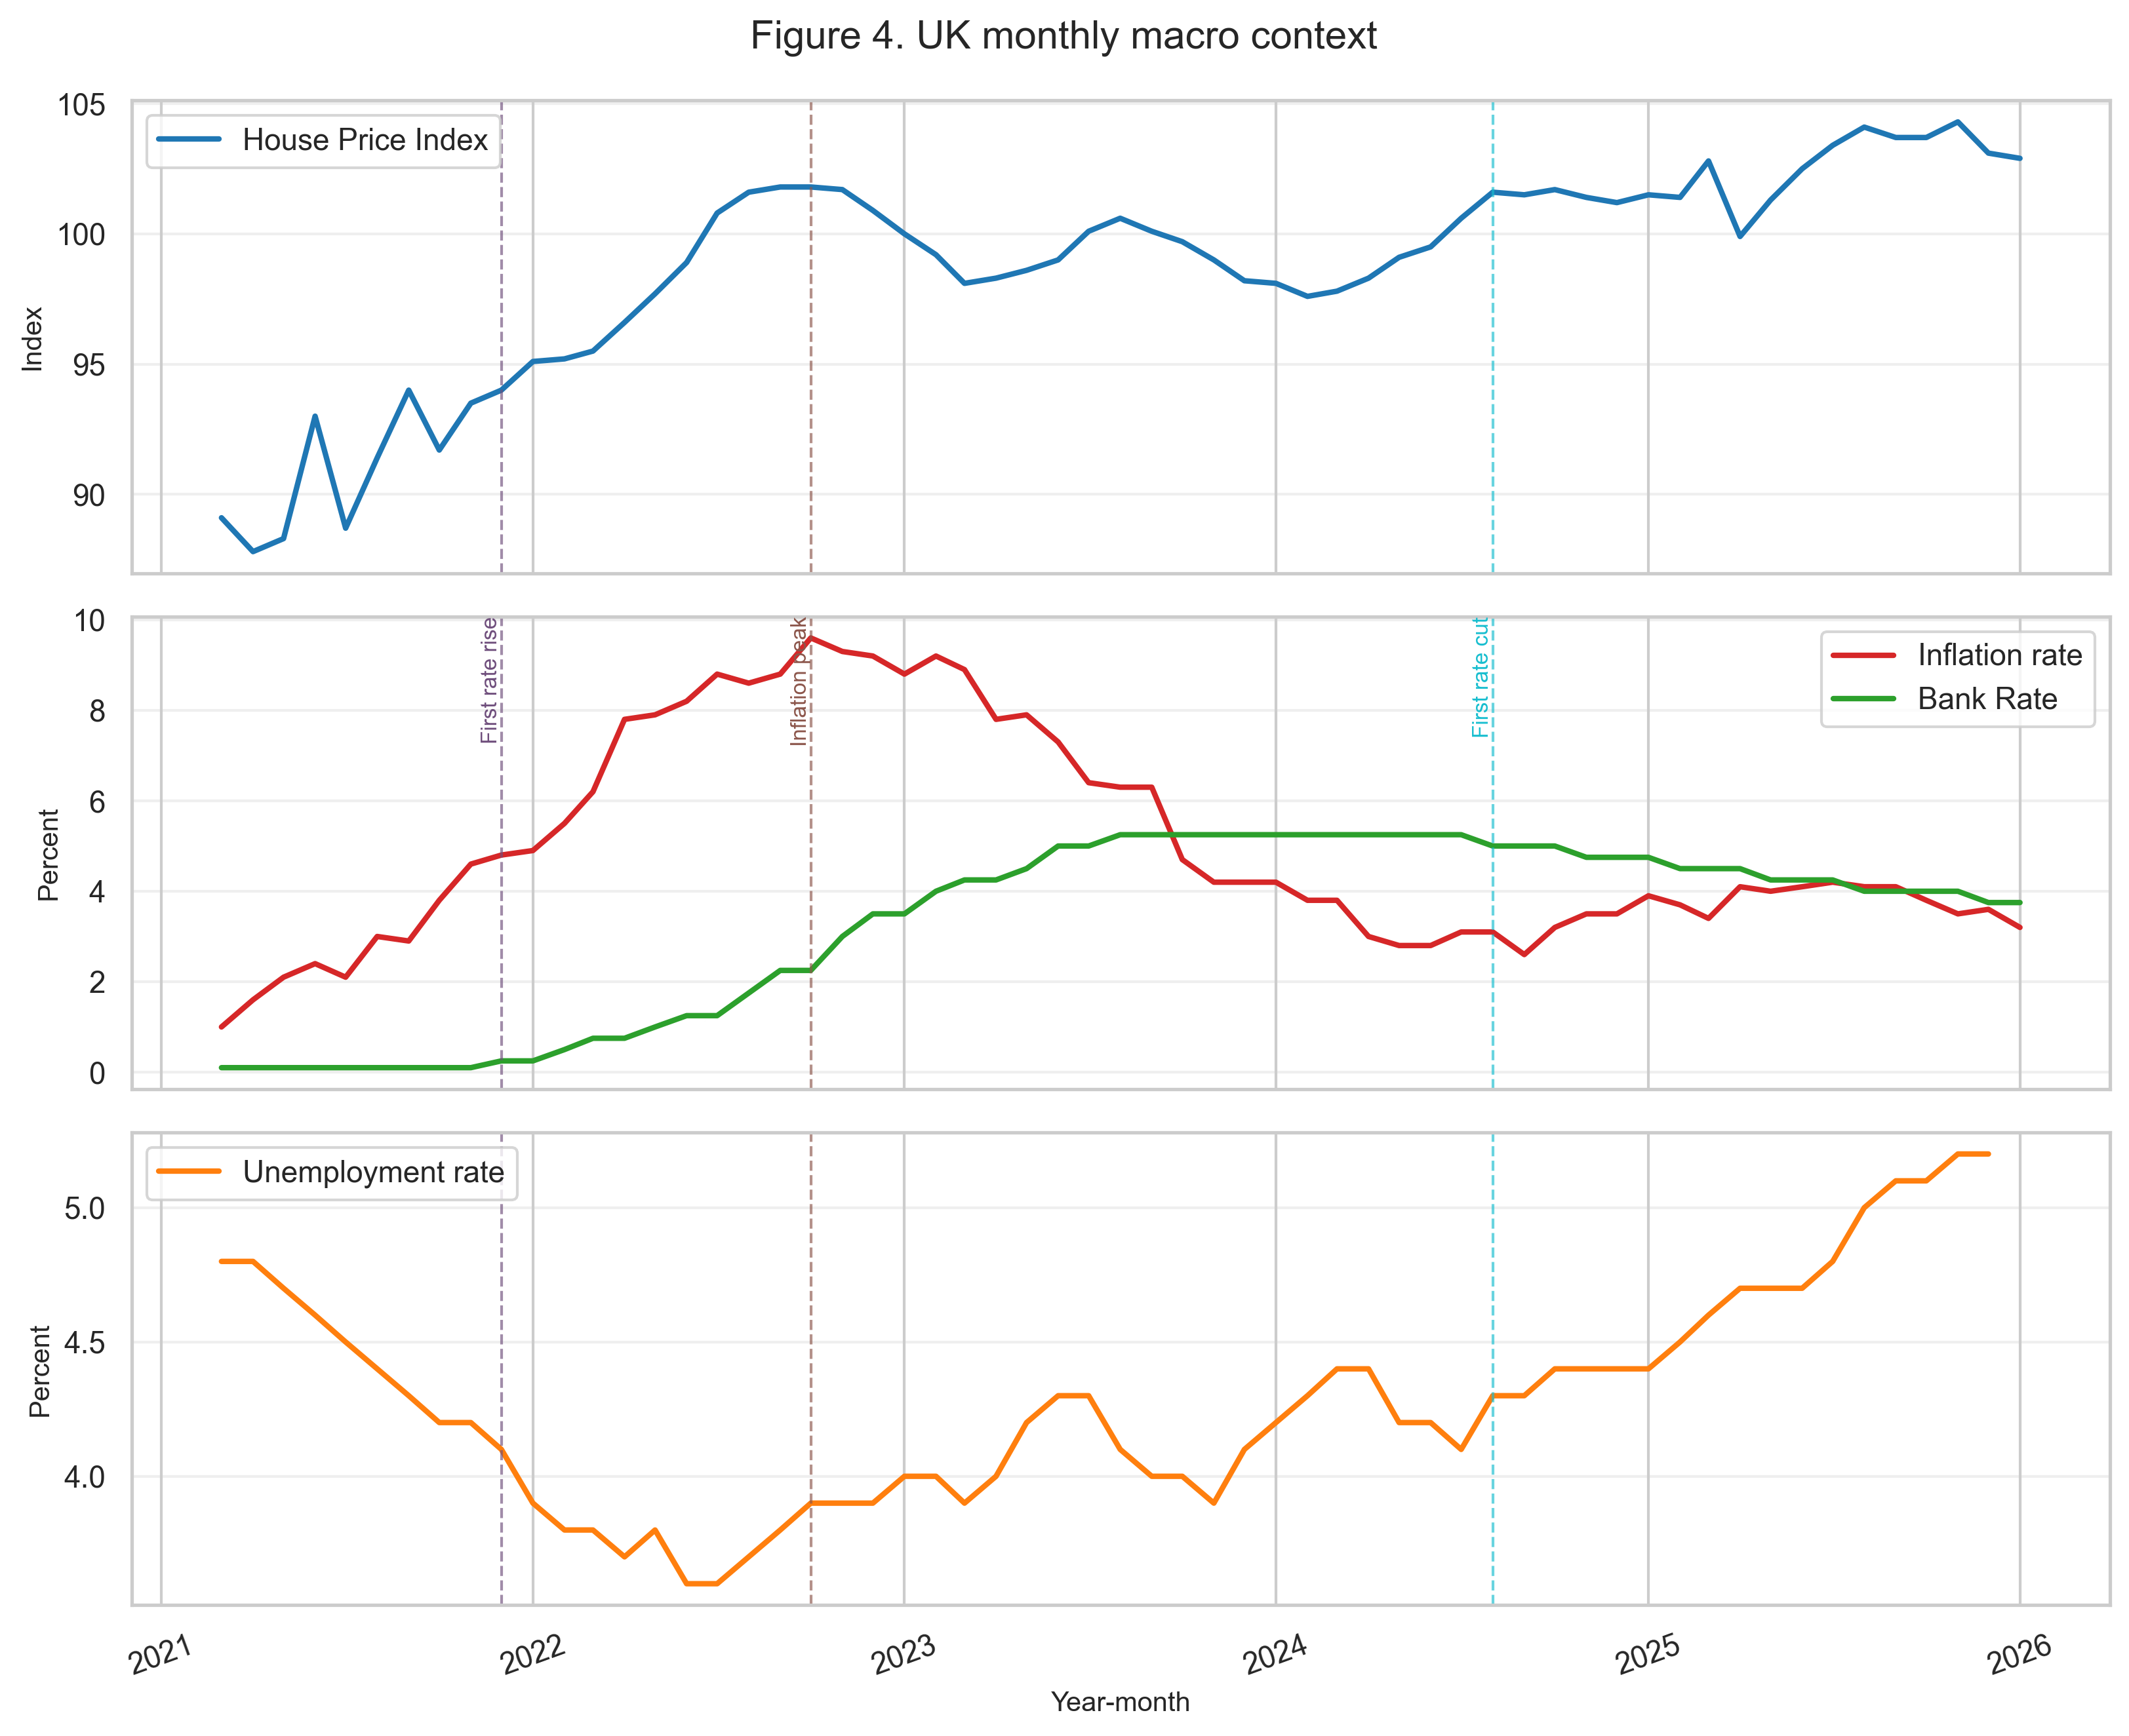
Figure 1. Macro context: CPIH inflation, House Price Index, Bank Rate, and unemployment.
The EDA shows the recent inflation shock, the Bank Rate tightening cycle, and a housing market that did not move in a simple one-for-one way with interest rates. Correlations are informative but unstable in a short macro window.
The social-pressure analysis supports the broad affordability concern, but the decile proxy is treated cautiously. It does not prove a perfect monotonic 1-to-10 gradient in every measure; instead, it shows that affordability pressure is significant and uneven across income groups.

5. Model Setup
The Day 4 modelling target is monthly house_price_index. The model-ready dataset covers June 2021 to January 2026 with 56 usable rows after lag creation.
- Features: inflation_rate_lag1, unemployment_rate_lag1, bank_rate_lag1, and bank_rate_lag3.
- Split: chronological 80/20 with 44 training rows and 12 holdout rows.
- Baseline: Linear Regression, chosen for interpretability.
- Comparison: Random Forest, included only as a simple nonlinear comparison without tuning.
- Leakage prevention: only lagged predictors are used; no random shuffling or test-set preprocessing is used.

6. Model Evaluation
Day 5 evaluates the frozen Day 4 holdout set without retraining. Metrics measure generalisation only; they do not establish causal relationships.
Model | Role | MAE | RMSE | $$R^{2}$$
Linear Regression | Baseline | 6.377 | 6.783 | -28.506
Random Forest | Comparison | 3.371 | 3.616 | -7.386
Both holdout $R^{2}$ values are negative, so neither model beats a naive mean prediction on unseen data. Random Forest has lower MAE and RMSE than Linear Regression, but it is still not a strong forecasting tool.
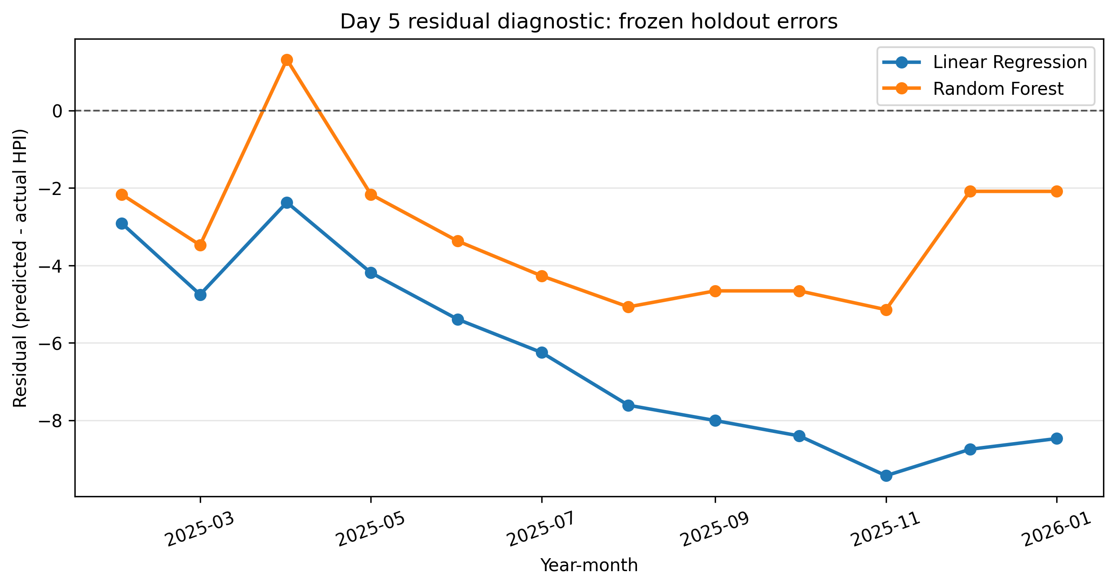
Figure 2. Day 5 residual diagnostic: model errors on the frozen holdout set.
The BBC sentiment sample contains 23 negative, 14 neutral, and 13 positive classifications. This is qualitative media context only, not proof of household welfare or a causal economic mechanism.

7. Day 6 Scenario and Policy Interpretation
Day 6 applies a +1 percentage point Bank Rate shock to bank_rate_lag1 and bank_rate_lag3. The scenario delta is scenario prediction minus baseline prediction.
Model | Mean HPI delta | Relative change
Linear Regression | +1.074 | 1.098%
Random Forest | +1.144 | 1.161%
The small positive scenario result is internally consistent with the fitted model, but it is not a causal estimate and does not imply that higher rates raise house prices. It reflects the short 2021-2026 window and the fitted lag structure, where Bank Rate and HPI co-moved during part of the tightening cycle.
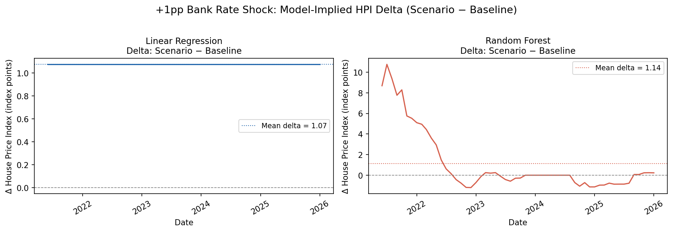
Figure 3. +1pp Bank Rate scenario: model-implied HPI delta, scenario minus baseline.
The linear-regression line is nearly flat because the same +1pp shock is applied to the same lagged features in every row and the model uses fixed coefficients. The Random Forest allows more nonlinear variation across months.
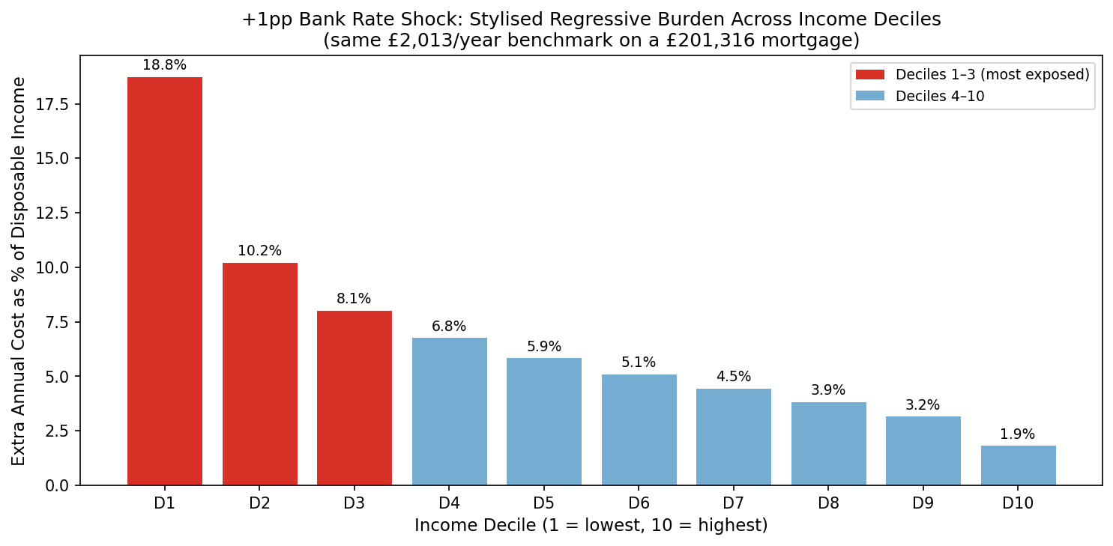
Figure 4. Stylised distributional burden across income deciles.
The distributional burden chart applies the same annual mortgage-cost benchmark across deciles. It illustrates regressivity, not the exact payment change faced by every household. Tenure, debt size, fixed-rate status, and landlord pass-through all vary in reality.
Policy recommendation: targeted rent subsidy for renters in income deciles 1-3 is preferred over broad rent controls. The recommendation is strong but conditional: subsidy incidence and fiscal cost are real risks, and supply-side reform is needed to reduce long-run affordability pressure.

8. Limitations
- Negative holdout $R^{2}$ means the Day 4/5 models are not reliable forecasting tools.
- The 56-row model-ready window covers one unusual tightening cycle, limiting generalisability.
- Annual income data limits month-level distributional analysis.
- The modelling target is HPI, not a rent-specific price index, even though renters are central to the policy concern.
- No causal identification strategy is used; coefficients and scenario outputs are associations.
- BBC sentiment is qualitative media context, not economic measurement or welfare evidence.
- CPIH is applied uniformly across deciles, which may understate real pressure on lower-income households.

9. Conclusion
The project is strongest as a coherent, reproducible account of distributional pressure during the UK cost-of-living shock. H1 is supported descriptively: real-income erosion is visible across deciles, and the evidence suggests stronger pressure on lower-income households, although decile-specific inflation exposure is approximated rather than directly observed. H2 is supported by the stylised burden calculation: the same £2,013 annual housing-cost shock absorbs about 18.8% of Decile 1 income but only 1.9% of Decile 10 income, showing a strongly regressive burden structure. H3 is only partially supported descriptively: lagged macro variables contain some in-sample association with the House Price Index, but the negative holdout R² means they do not deliver reliable short-run forecasting performance in this setup.
The final policy message is disciplined: support should be targeted toward households most exposed to the income-housing gap, especially lower-income renters, while acknowledging that stronger evidence would require rent-specific data, regional analysis, household microdata, and causal research designs.

10. References and Source Notes
- ONS Consumer Price Inflation / MM23: CPIH inflation rate.
- GOV.UK UK House Price Index: monthly UK HPI, published from official UK house price sources.
- Bank of England: official Bank Rate time series.
- ONS Labour Market Statistics: unemployment rate.
- ONS Effects of Taxes and Benefits: annual income by decile.
- BBC News headlines: qualitative text context scored with VADER sentiment.
- Full extraction, cleaning, and frequency decisions are documented in docs/day2_data_log.md.

11. Reproducibility and Final Package
The final package includes README.md, requirements.txt, notebooks for Days 2-6, scripts in src/, outputs/day7_key_messages.txt, outputs/day7_submission_checklist.txt, and the presentation-ready outputs/day7_asset_pack/ folder. To rebuild the analytical pipeline, run python run_all.py from the project root.

