**Laboratory work #1**

**Task 1. Inputs and Outputs**

1.1 The popular TV series "Stay Alive" used a sequence of numbers 4 8 15 16 23 42, which brought the heroes good luck and helped to hit the jackpot in the lottery. Write a code snippet that outputs a given sequence of numbers with one space between them. **[ 5 point ]**

**Sample Output:**

4 8 15 16 23 42

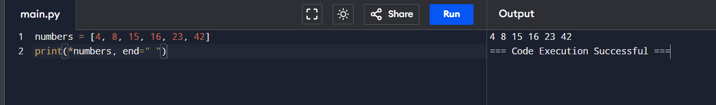

1.2 Change the previous code so that each number of the sequence 4 8 15 16 23 42 is printed on a separate line. **[ 5 point ]**

**Sample Output:**

4

8

15

16

23

42

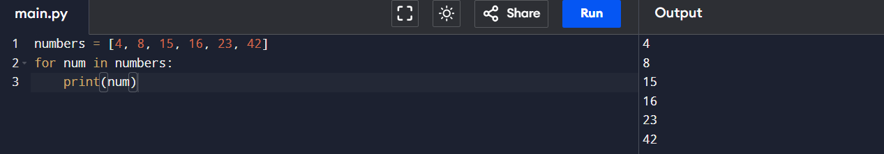

1.3 Write a code to display three consecutive numbers, each on a separate line. The first number is entered by the user, the remaining numbers are calculated in the code. **[ 5 point ]**

**Sample Input 1:**

8

**Sample Output 1:**

8

9

10

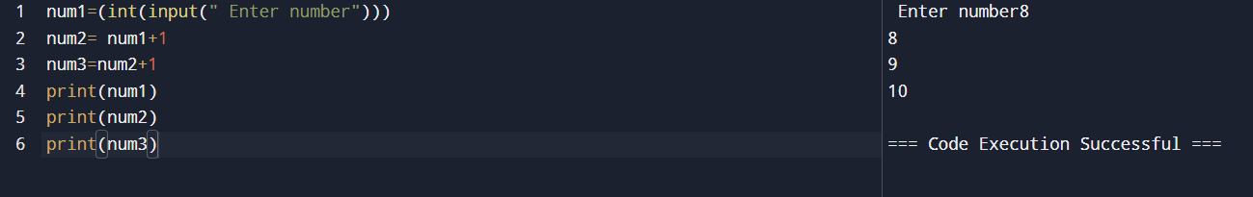

1.4 Write a code that reads three integers and displays their sum on the screen. Each number is written in a separate line. **[ 5 point ]**

**Sample Input 1:**

9

11

2

**Sample Output 1:**

22

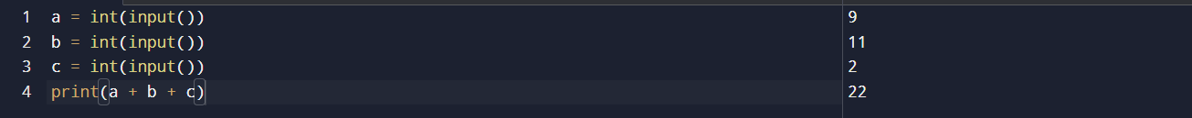

1.5 Write a code that calculates the volume of a cube and the area of its full surface, based on the entered value of the edge length. **[ 10 point ]**

**Sample Input 1:**

25

**Sample Output 1:**

Volume = 15625

Total surface area = 3750

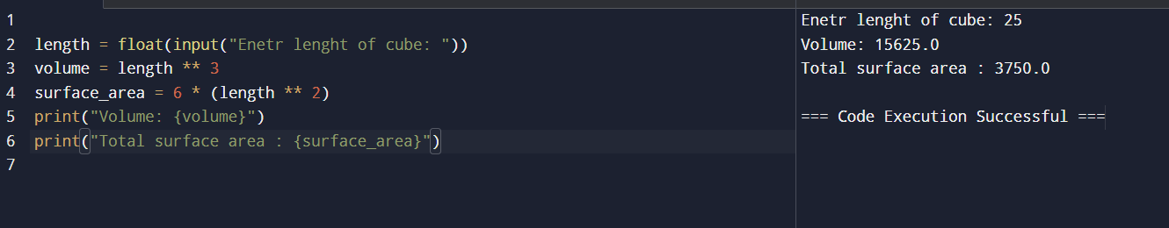

**Task 2. Arithmetic, logic.**

2.1 N schoolchildren divide K tangerines equally, the non-dividing remainder remains in the basket. How many whole tangerines will each student get? How many whole tangerines will remain in the basket? **[ 5 point ]**

**Sample Input 1:**

3

6

**Sample Output 1:**

2

0

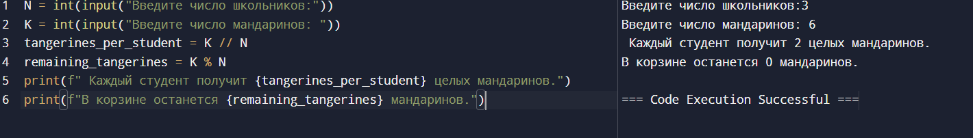

2.2 Write a program to find the digits of a four-digit number. **[ 10 point ]**

**Sample Input 1:**

3281

**Sample Output 1:**

The digit in the thousands position is 3

The number in the hundreds position is 2

The digit in the tens position is 8

The digit in the position of units is 1

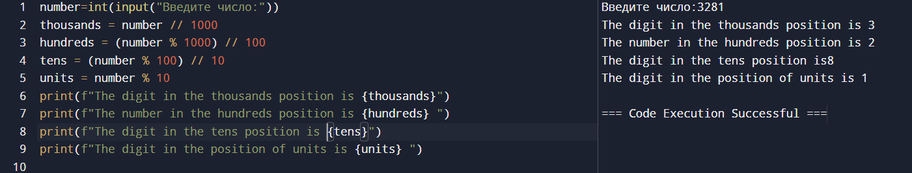

2.3 The mad titan Thanos has collected all 6 infinity stones and intends to destroy half the population of the universe at the click of his fingers. At the same time, if the population of the universe is an odd number, then Titan will show mercy and round up the number of survivors. Help the Avengers count the number of survivors. **[ 10 point ]**

**Sample Input 1:**

99

**Sample Output 1:**

50

