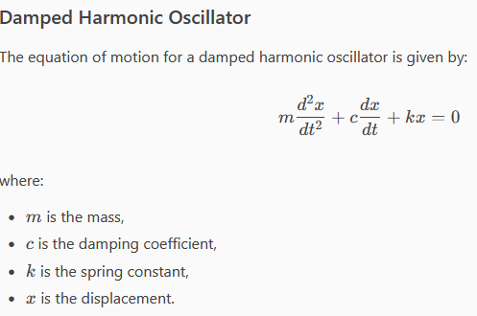

$$m\ddot{x}=-c\dot{x}-kx$$

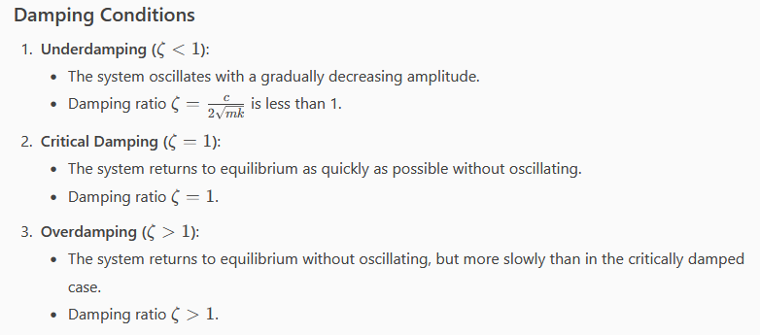

% Define the damping coefficient and spring constant

m = 1; % mass

k = 1; % spring constant

% Define the damping conditions

underdamped = @(x, y) deal(y, -k/m * x - 0.5/m * y); % Underdamped

critically_damped = @(x, y) deal(y, -k/m * x - 2/m * y); % Critically damped

overdamped = @(x, y) deal(y, -k/m * x - 5/m * y); % Overdamped