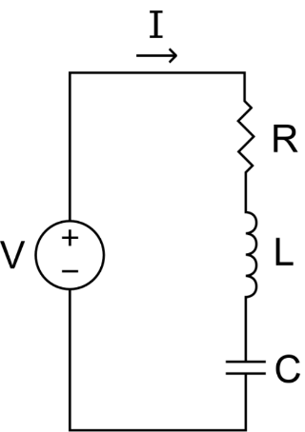**Governing Differential Equation**

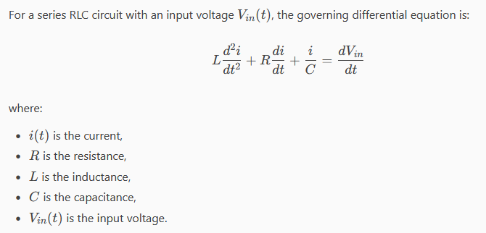

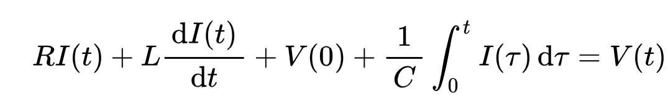

**Numerical Solution Using RK4**

We'll use the RK4 method to solve this differential equation numerically. We'll also plot the current and the voltage drop across the resistor.

**Main Script**

% Main script

dt = 0.01; % Time step

numSteps = 1000; % Number of steps

R = 1; % Resistance in ohms

L = 1; % Inductance in henries

C = 1; % Capacitance in farads

% Define the input voltage as a function of time

Vin = @(t) sin(2 * pi * 50 * t); % Example: 50 Hz sine wave

% Define the vector field for the RLC circuit

rlcField = @(t, y) [y(2); (Vin(t) - R * y(2) - y(1) / C) / L];

% Initial conditions

initialConditions = [0; 0]; % Initial current and its derivative

% Solve the differential equation using RK4

[t, y] = rk4Solver(rlcField, initialConditions, dt, numSteps);

% Extract the current and voltage drop across the resistor

current = y(:, 1);

voltageDropR = R * y(:, 2);

% Plot the results

figure;

subplot(2, 1, 1);

plot(t, current);

title('Current in the RLC Circuit');

xlabel('Time (s)');

ylabel('Current (A)');

grid on;

subplot(2, 1, 2);

plot(t, voltageDropR);

title('Voltage Drop Across the Resistor');

xlabel('Time (s)');

ylabel('Voltage (V)');

grid on;

**RK4 Solver (rk4Solver.m)**

function [t, y] = rk4Solver(vectorField, initialConditions, dt, numSteps)

t = (0:numSteps-1) * dt;

y = zeros(numSteps, length(initialConditions));

y(1, :) = initialConditions;

for i = 1:numSteps-1

k1 = vectorField(t(i), y(i, :)') * dt;

k2 = vectorField(t(i) + dt/2, y(i, :)' + k1/2) * dt;

k3 = vectorField(t(i) + dt/2, y(i, :)' + k2/2) * dt;

k4 = vectorField(t(i) + dt, y(i, :)' + k3) * dt;

y(i+1, :) = y(i, :) + (k1' + 2*k2' + 2*k3' + k4') / 6;

end

end

**Explanation:**

1. **Main Script**:
   * Defines the time step and number of steps.
   * Sets the resistance, inductance, and capacitance values.
   * Defines the input voltage as a function of time.
   * Defines the vector field for the RLC circuit.
   * Sets the initial conditions for the current and its derivative.
   * Solves the differential equation using the RK4 solver.
   * Extracts the current and voltage drop across the resistor.
   * Plots the results.
2. **RK4 Solver**:
   * Implements the RK4 method to solve the differential equation.
   * Returns the time vector and the solution matrix.

This implementation allows you to study the behavior of an RLC filter by numerically solving the governing differential equation and analyzing the current and voltage drop across the resistor.

If you have any more questions or need further assistance, feel free to ask! 😊