**TABLE OF CONTENTS**

CONTENTS

TITLE PAGE

CERTIFICATION

DEDICATION

ACKNOWLEDGEMENT

ABSTRACT

TABLE OF CONTENTS

**CHAPTER ONE: GENERAL INTRODUCTION**

* 1. INTRODUCTION
  2. AIMS AND OBJECTIVES
  3. SIGNIFICANCE OF THE STUDY
  4. SCOPE OF THE STUDY
  5. ORGANISATION OF THE PROJECT

**CHAPTER TWO**

* 1. HISTORICAL BACKGROUND
  2. REVIEW OF RELEVANT LITERATURE
  3. DEFINITIONS, ACRONYMS, AND ABBREVIATIONS

**CHAPTER THREE**

* 1. METHOD OF DATA COLLECTION
  2. ANALYSIS OF DATA AND THE EXISTING SYSTEM
  3. PROBLEMS OF THE EXISTING SYSTEM
  4. DESCRIPTION OF THE PROPOSED SYSTEM
  5. ADVANTAGES OF THE PROPOSED SYSTEM
  6. DESIGN AND IMPLEMENTATION METHODOLOGIES

**CHAPTER FOUR: DESIGN, IMPLEMENTATION AND DOCUMENTATION OF THE SYSTEM**

* 1. DESIGN OF THE SYSTEM
     1. OUTPUT DESIGN
     2. INPUT DESIGN
     3. DATABASE DESIGN
     4. PROCEDURE DESIGN
  2. IMPLEMENTATION OF THE SYSTEM
     1. HARDWARE SUPPORT
     2. SOFTWARE SUPPORT
  3. DOCUMENTATION OF THE SYSTEM
     1. PROGRAM DOCUMENTATION
     2. OPERATING THE SYSTEM
     3. MAINTAINING THE SYSTEM

**CHAPTER FIVE: SUMMARY, CONCLUSION AND RECOMMENDATION**

* 1. SUMMARY
  2. EXPERIENCED GAINED
  3. CONCLUSION
  4. RECOMMENDATION

REFERENCES

APPENDICES

1. System flowchart
2. Program flowchart
3. Source listing
4. Computer output

**CHAPTER ONE**

**1.1 GENERAL INTRODUCTION**

Library is defined as a place in which books, manuscripts, recordings, films, or reference materials are kept for private or public uses. Typically, a library must be able to handle some housekeeping information such as acquisition, interlibrary loan, cataloging, circulation, serials management, statistical reports and references. A library management system software package is designed especially to handle such housekeeping tasks. A rapidly growing of information technology adds some features to library management system software packages such as features to handle digital media, e-book, e-journals, online public access catalog (OPAC), a feature to connect and exchange information with a digital library system, an ability to connect with networks of libraries, machine-readable cataloging (MARC) standard support and Z39.50 standard support.

Integrated library system have been part of colleges and universities computing system since the early 1980’s and part of mainframe based system. Today Library Management system is a multi function web and desktop based multimedia content information management system, generally built on a standard relational database structure. While the system architecture remains grounded in bibliographical citations presented via structured indexes.

**1.2 AIMS AND OBJECTIVES**

(a) To improve control over collection of books in the library

(b) To have an effective control over the entire operation.

(c) To improve the existing services.

(d) To share effectively the resources among various libraries in a region.

(e) To avoid duplication of work.

(f) To use the services of the existing staff effectively.

**1.3 SIGNIFICANCE OF THE STUDY**

This project aims at presenting a simple and clear indefatigable method of running a library which administers every activities of the library in simple and best alternatives. It serves to administer the system in plain and simple method of report generation needed for all the administrative task by the library staff.

**1.4 SCOPE OF THE STUDY**

The project product to be produced is a Library Management System which will automate the major library operations. The first subsystem is the registration of the users (staff and students) to the system to keep track of authorized users to the system. The second subsystem is the registration of new books into the library management system to know when new books are brought into the library. The third subsystem is a borrower and return of books which is the major area needed by the user. These three subsystems’ functionality will be described in detail in chapter 3 – Description of the proposed system.

There are three end users for the Library Management System. The end users are the library staff, school staff and student.

**1.5 LIMITATION OF THE STUDY**

The set back of the system is that all details of the system resides on a system which is the administrator (librarian) although information from such system can be transported into another system as a means of back up for keeping the record on a long term basis.

**1.6 ORGANISATION OF THE PROJECT**

This project is segmented into five distinct chapters. Chapter one describes the introduction, aims and objectives, significance of the study, research methodology, scope and limitation as well as the organization of the report.

The second chapter talks about the literature review, historical background, Definitions, Acronyms, Abbreviation and review of related project.

The third chapter deals with the analysis of the existing system, problems of the existing system, description and the advantages of the proposed system.

The second to the last chapter deals with the design of the system which entails the output. Input, database and procedure design of the system, the implementation comprises of the hardware and software support while the documentation comprises of how to use the system and the system maintenance.

The last chapter deals with the summary experienced gained, conclusion and recommendation.

**CHAPTER TWO**

**2.1 HISTORICAL BACKGROUND**

According to Oxford Dictionary a Library is defined as a building or room containing collections of books, periodicals, and sometimes films and recorded music for people to read, borrow, or refer to.

A library is a large collection of books, periodicals, films or other information sources including digital. The collections can be of print, audio, and visual materials in numerous formats, including [maps](http://en.wikipedia.org/wiki/Map_collection), [prints](http://en.wikipedia.org/wiki/Print_room), [documents](http://en.wikipedia.org/wiki/Document), [microform](http://en.wikipedia.org/wiki/Microform) (e.g. microfilm/microfiche), [CDs](http://en.wikipedia.org/wiki/Compact_disc), [cassettes](http://en.wikipedia.org/wiki/Compact_cassette), [videotapes](http://en.wikipedia.org/wiki/Videotape), [DVDs](http://en.wikipedia.org/wiki/DVD), [video games](http://en.wikipedia.org/wiki/Video_game), [e-books](http://en.wikipedia.org/wiki/E-books), [audio books](http://en.wikipedia.org/wiki/Audiobooks) and many other types of electronic resource. The places where this material is stored include [public libraries](http://en.wikipedia.org/wiki/Public_libraries), [subscription libraries](http://en.wikipedia.org/wiki/Subscription_libraries), and private libraries, and material can also be in digital form, stored on computers or accessible over the Internet.

The first libraries consisted of [archives](http://en.wikipedia.org/wiki/Archive) of the [earliest form of writing](http://en.wikipedia.org/wiki/Writing#The_beginning_of_writing) - the [clay tablets](http://en.wikipedia.org/wiki/Clay_tablet) in [cuneiform script](http://en.wikipedia.org/wiki/Cuneiform_script) discovered in temple rooms in [Sumer](http://en.wikipedia.org/wiki/Sumer), some dating back to 2600 BC. These archives, which mainly consisted of the records of commercial transactions or inventories, mark the end of [prehistory](http://en.wikipedia.org/wiki/Prehistory) and the start of [history](http://en.wikipedia.org/wiki/History).

Things were much the same in the government and temple records on [papyrus](http://en.wikipedia.org/wiki/Papyrus) of [Ancient Egypt](http://en.wikipedia.org/wiki/Ancient_Egypt). The earliest discovered private archives were kept at [Ugarit](http://en.wikipedia.org/wiki/Ugarit); besides correspondence and inventories, texts of myths may have been standardized practice-texts for teaching new scribes. There is also evidence of libraries at [Nippur](http://en.wikipedia.org/wiki/Nippur) about 1900 BC and those at [Nineveh](http://en.wikipedia.org/wiki/Nineveh) about 700 BC showing a [library classification](http://en.wikipedia.org/wiki/Library_classification) system. http://en.wikipedia.org/wiki/Library#Early_libraries_.282600_BC_.E2.80.93_800BC.29

Over 30,000 clay tablets from the [Library of Ashurbanipal](http://en.wikipedia.org/wiki/Library_of_Ashurbanipal) have been discovered at Nineveh,[[8]](http://en.wikipedia.org/wiki/Library#cite_note-7) providing modern scholars with an amazing wealth of Mesopotamian literary, religious and administrative work. Among the findings were the [Enuma Elish](http://en.wikipedia.org/wiki/Enuma_Elish), also known as *the Epic of Creation,* which depicts a traditional Babylonian view of creation, the [Epic of Gilgamesh](http://en.wikipedia.org/wiki/Epic_of_Gilgamesh),[[10]](http://en.wikipedia.org/wiki/Library#cite_note-9) a large selection of "omen texts" including *Enuma Anu Enlil* which "contained omens dealing with the moon, its visibility, eclipses, and conjunction with planets and fixed stars, the sun, its corona, spots, and eclipses, the weather, namely lightning, thunder, and clouds, and the planets and their visibility, appearance, and stations", and astronomic/astrological texts, as well as standard lists used by scribes and scholars such as word lists, bilingual vocabularies, lists of signs and synonyms, and lists of medical diagnoses. http://en.wikipedia.org/wiki/Library#Early_libraries_.282600_BC_.E2.80.93_800BC.29

[Han Chinese](http://en.wikipedia.org/wiki/Han_Chinese) scholar [Liu Xiang](http://en.wikipedia.org/wiki/Liu_Xiang_%28scholar%29) established the first library classification system during the [Han Dynasty](http://en.wikipedia.org/wiki/Han_Dynasty), and the first book notation system. At this time the library catalogue was written on scrolls of fine [silk](http://en.wikipedia.org/wiki/Silk) and stored in silk bags. http://en.wikipedia.org/wiki/Library#Early_libraries_.282600_BC_.E2.80.93_800BC.29

**2.2 REVIEW OF RELEVANT LITERATURE**

Before the advent of computer in modern age there are different methods of keeping records in the library. Records are kept in the library on shelves and each shelf are labeled in an alphabetical or numerical order, in which the categories of books available are arranged on different position on the shelves and as well are recorded on the library manuscript and when any book is to be referenced the manuscript is being referred to, to know the position of such required book by the person that requested for the book.

After the invention of computer different researchers have carried out various approach on an automated library management system in which this project is as well all about.

The first library management system to be reviewed is the KOHA library management system. Since the original implementation in 1999, Koha functionality has been adopted by thousands of libraries world wide, each adding features and functions, deepening the capability of the system. With the 3.0 release in 2005, and the integration of the powerful Zebra indexing engine, Koha became a viable, scalable solution for libraries of all kinds. LibLime Koha is built on this foundation. With its advanced feature set, LibLime Koha is the most functionally advanced open source ILS on the market today. The major set back of this library management system is that it is a web based and as a result it is not security conscious because hackers could have the database hacked and access or modify the information of such user. ([www.koha.org](http://www.koha.org))

## Another Library Management System is the Capita’s library software with the following benefits Increases support available for staff and users in any modern library service , Integrated, innovative system saves your library time, Improves the user experience. The setback of this library management system is the cost of purchase and information generated from the software can not be easily exported to be used in another system in case there is a system failure. (<http://www.capita-softwareandmanagedservices.co.uk>)

The set of researcher to be reviewed on an automated library system is a project carried out by Bhupendra, Singh Baghela, Shraddha Panwar, Vijay Vaishnav during as a partial fulfillment of the requirement for the System Design Project of Masters of Computer Application IV Semester, of the Rajasthan Technical University, Kota. The purpose of the application is for automation of library management. The system comprises of two sets of users an operator and admin

Operator: Can enter details related to a particular book.

Can provide membership to members.

Administrator: Can read and write information about any member.

Can update, create, delete the record of membership as per requirement

and implementation plants.

Scope: The different areas where we can use this application are

Any education institute can make use of it for providing information about author, content of the available books.

It can be used in offices and modifications can be easily done according to

requirements.

Technology Used: Front End : Servlets, HTML, Java script.

Back End : MS Access, Apache Tomcat server.

**2.3 DEFINITIONS, ACRONYMS, AND ABBREVIATIONS**

1. Archive(s): Collection(s) of permanently valuable historical records documenting a particular subject or activity or transaction. Also the repository where such a collection is kept.
2. Bibliography: A list of resources used in writing a research paper or other document that appears at the end of the document. See also: Citation, Reference.
3. CaMS: Cataloging and Metadata Services. Part of Technical Services.
4. Circulation: The circulation desk is the place in the library where you check out, renew, and return library materials. You may also place a hold, or report an item missing from the shelves.
5. Citation: A reference or footnote to a book, a magazine or journal article, or another source. It contains all the information necessary to identify and locate the work, including author, title(s), publisher, date, volume, issue number, and pages.
6. DCRM(B): Descriptive Cataloging of Rare Materials (Books), the updated "successor" to DCRB (Descriptive Cataloging of Books), meant to update the older guide and bring it into accord with international standards; also the first in an ongoing series of cataloging guides for special collection items covering maps, serials, graphic materials, and other special collections items beyond books alone.
7. Entry: Refers to the data in a catalog record by which it is retrieved, for example, an author entry. Also called a “heading.” Standardized forms of author names and subjects are used in catalog records to facilitate sorting and retrieval.
8. ISBN: International Standard Book Number. The ISBN is a unique machine-readable identification number, which marks any book unmistakably. First implemented in the U.K. in 1967, the ISBN is now used in 159 countries and territories.
9. ISSN: International Standard Serial Number. Eight-digit number which identifies periodical publications, including electronic serials. Created in the 1970’s, the ISSN Network has assigned more than one million ISSN numbers. There are 75 national ISSN centers coordinated by an international center based in Paris; the U.S. center is managed by the National Serials Data Program at the Library of Congress.
10. LISSC: The Library Integrated Systems Steering Committee. The group that reviews policies and procedures that relate to the Integrated Library System.
11. Manuscripts: Handwritten or unpublished documents, such as correspondence, notes, and drafts of articles or books.
12. MARC Record: MARC - MAchine-Readable Cataloging. Standard format for machine-readable bibliographic records. “http://libserv5.princeton.edu/letc/glossary”

**CHAPTER THREE**

* 1. **METHOD OF DATA COLLECTION**

The library is a major means of data gathering and as well a case study for the proposed system. In line with this the major method of information gathering for the system is the library and observation method via observing the staff and operation of the library.

* 1. **ANALYSIS OF THE EXISTING SYSTEM**

The existing system of library management system involves lots and lots of paper work. The system involves that all library user details will be taken on a white and black method. To borrow book from a library a borrower ticket is issued to every registered user and collected from each user when a borrower is made by such user to be collected back when return of the book is completed. A ticket is only allowed to be used for one transaction (borrowing book) only.

* 1. **PROBLEMS OF THE EXISTING SYSTEM**

Having have the overview knowledge of the existing system, the following are its problem

1. LOSS OF DATA: a lot of paper works are needed for the safe keeping of the details of books borrowed by a registered user.
2. TIME WASTING: user time are wasted as a result of searching for a bookd that has been borrowed by a user whose record can not be traced on the paper records.
3. ERROR PRONE: the existing system of operation is prone to error.
4. TEDIOUS: it is tedious because it must take a routine
5. PROCESSING SPEED: the processing speed is very low resulting into low output.
   1. **DESCRIPTION OF THE PROPOSED SYSTEM**

The library management system is a desktop based application system used by an administrator (Librarian) as an alternative means of record keeping of the books stored in the library. It has the following features.

1. The administrator registers the applicant with their name as the username and give a system generated code to each individual.
2. An applicant is allowed to log into the system with his name and generated password which is given at the point of registration, if information supplied is incorrect for three attempts the user is directed to contact the administrator to log in.
3. The administrator goes into the report to view the details of a particular user.
4. The question of the system can be added or remove from the system before the commencement of the test.
5. It consists of stipulated timing per courses treated.
6. The scores of each course can be viewed by the applicant immediately after answering the question and the administrator can view the overall result.
   1. **ADVANTAGES OF THE PROPOSED SYSTEM**

Certain merits have been associated with the proposed system which enhances the design of the system. Some of which are stated below:

* 1. It eliminates the presence of the audience or fellow colleague who can whisper the result to their friends.
  2. It is free from biasness (all users are served equally).
  3. It provides an immediate form of response to every user.
  4. It facilitates easy learning.

**3.6 DESIGN AND IMPLEMENTATION METHODOLOGY**

The design methodology used in the proposed system is parallel as a result of the fact that parallel methods support the use of the proposed system side by side with the existing system in order to test for the system efficiency. Top down approach is used as well in the design because it allows the analysis of the system to be carried out one after the other.

**CHAPTER FOUR**

**DESIGN, IMPLEMENTATION AND DOCUMENTATION OF THE SYSTEM**

* 1. **DESIGN OF THE SYSTEM**

The proposed system is designed in modules with each modules working together to perform the goal of library management system in order to enhance the performance of the existing system as earlier discussed in chapter three.

The ability to analyze and give focus to the system is explained in the following formats which are output design, input design, database design and procedure design.

* + 1. **OUTPUT DESIGN**

The output to be extracted from the proposed system are as shown below

1. Home Page

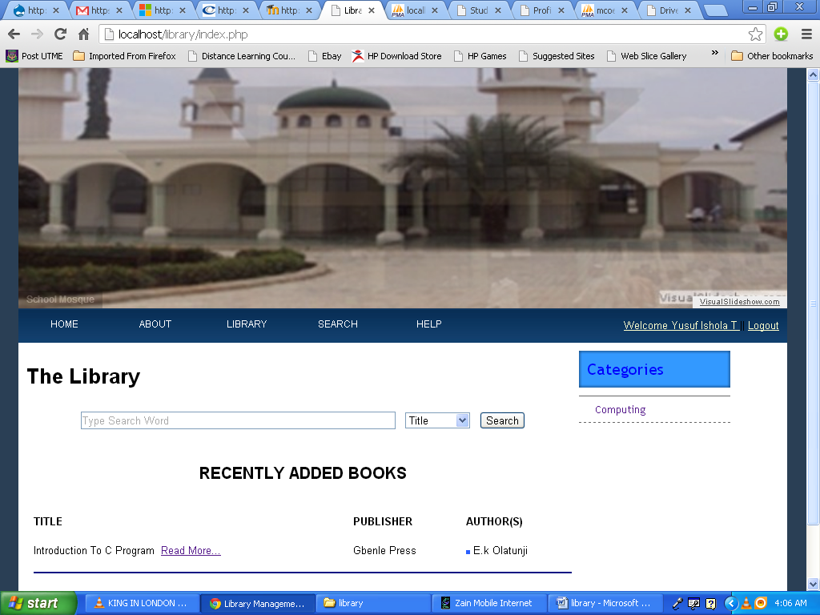

1. Help Page

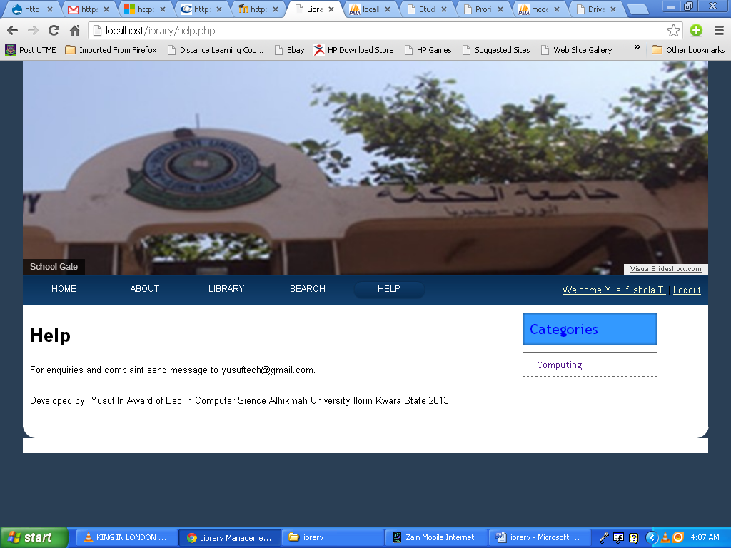

1. Search Book

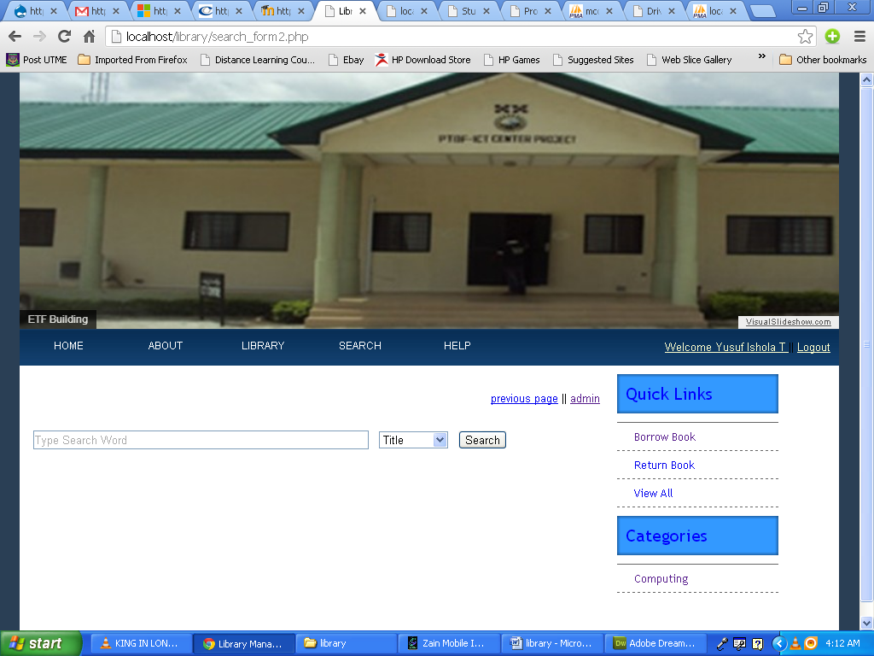

* + 1. **INPUT DESIGN**

The input to be extracted from the proposed system is as shown below

1. Add User

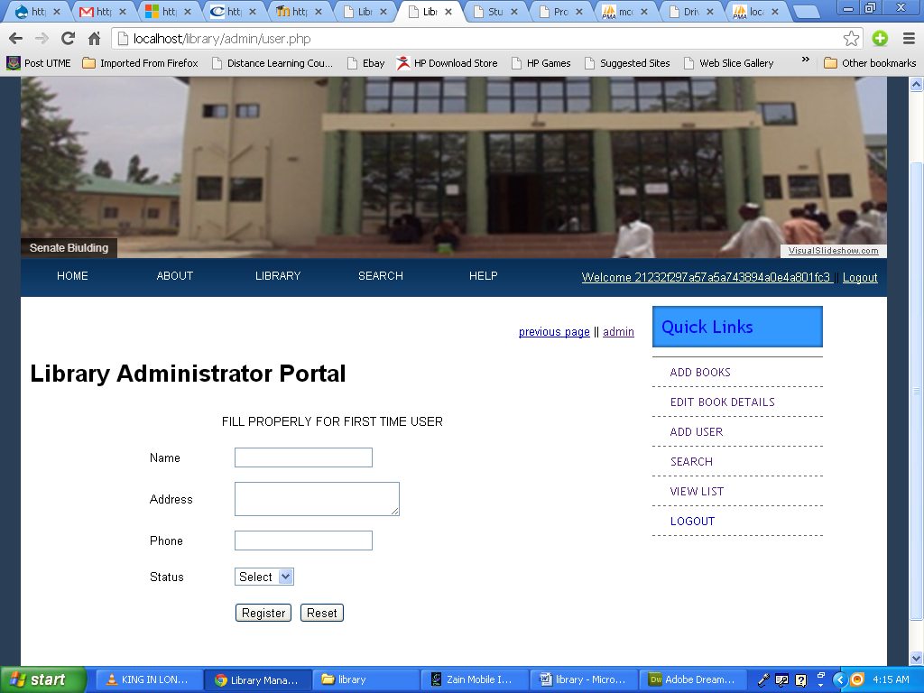

1. Add Book Details

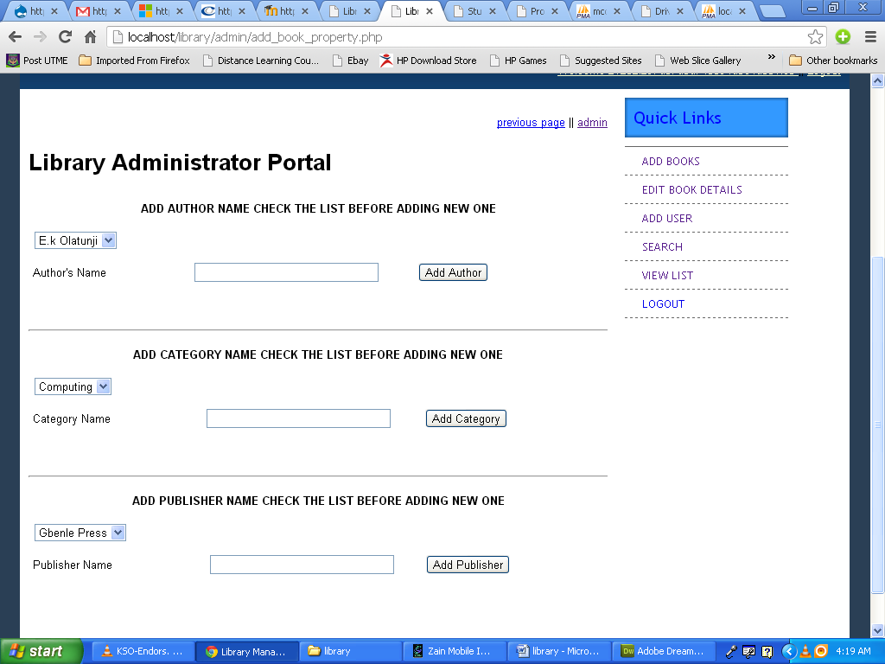

1. Add Book

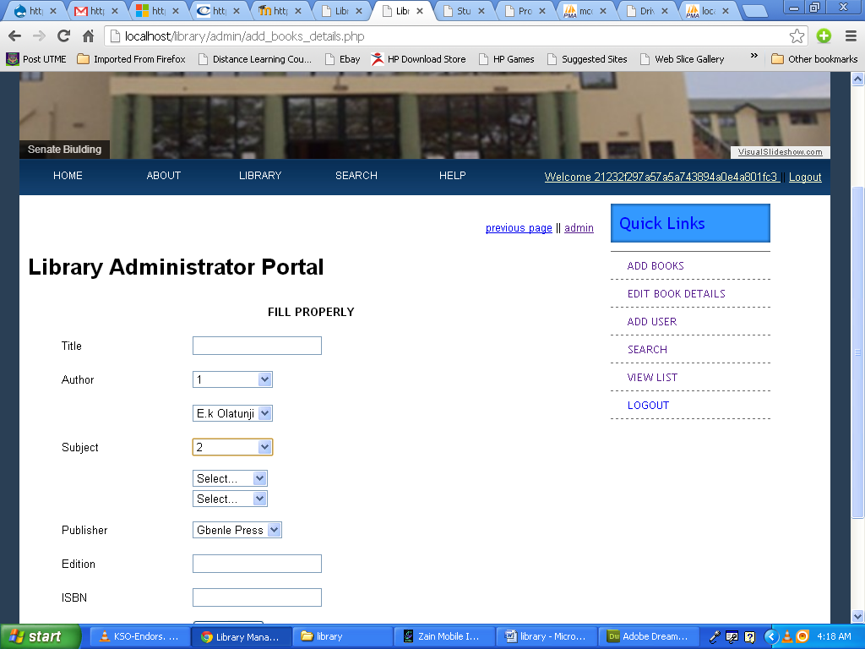

1. Modify Book

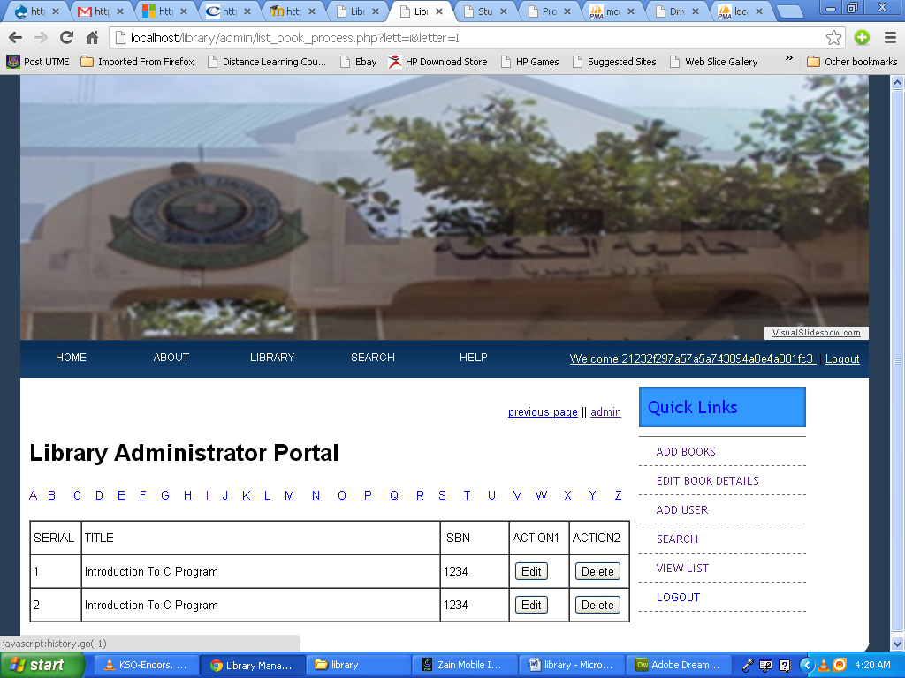

**4.1.3 DATABASE DESIGN**

This refers to the tables used in the proposed system. The database design for the proposed system is as shown below

1. Admin table

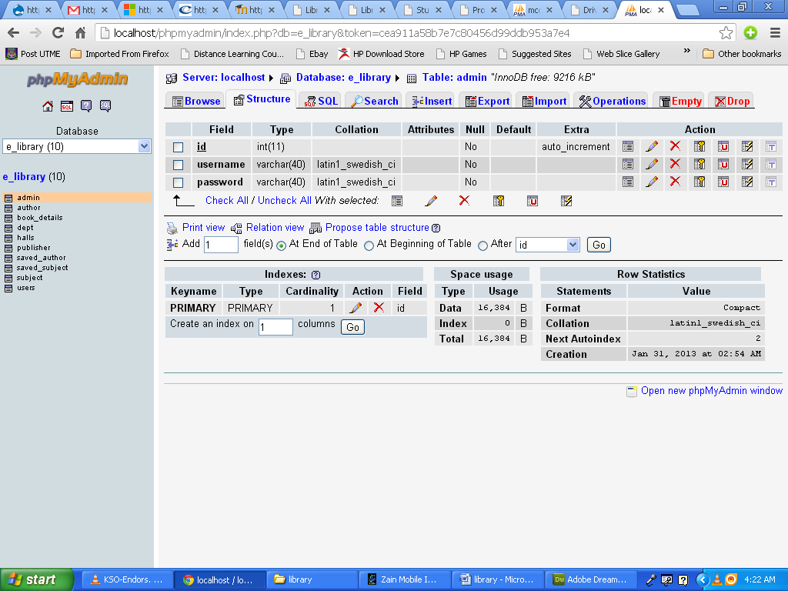

1. Author Details

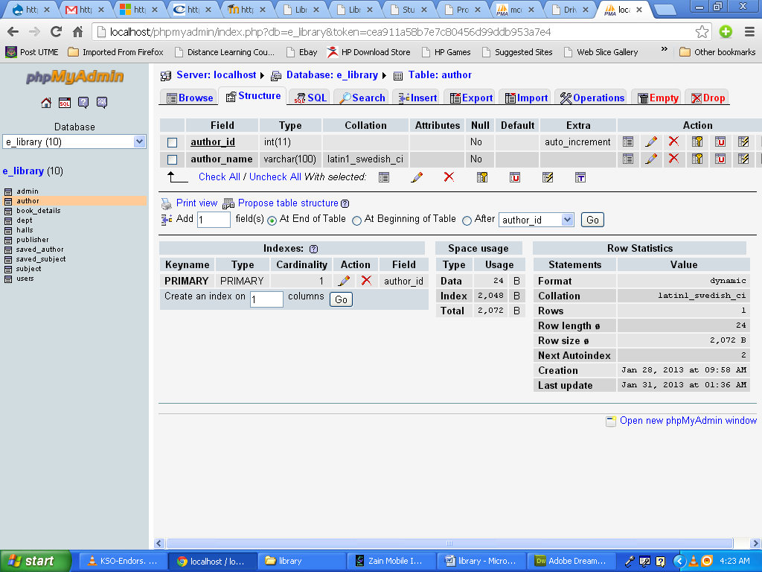

1. Book details

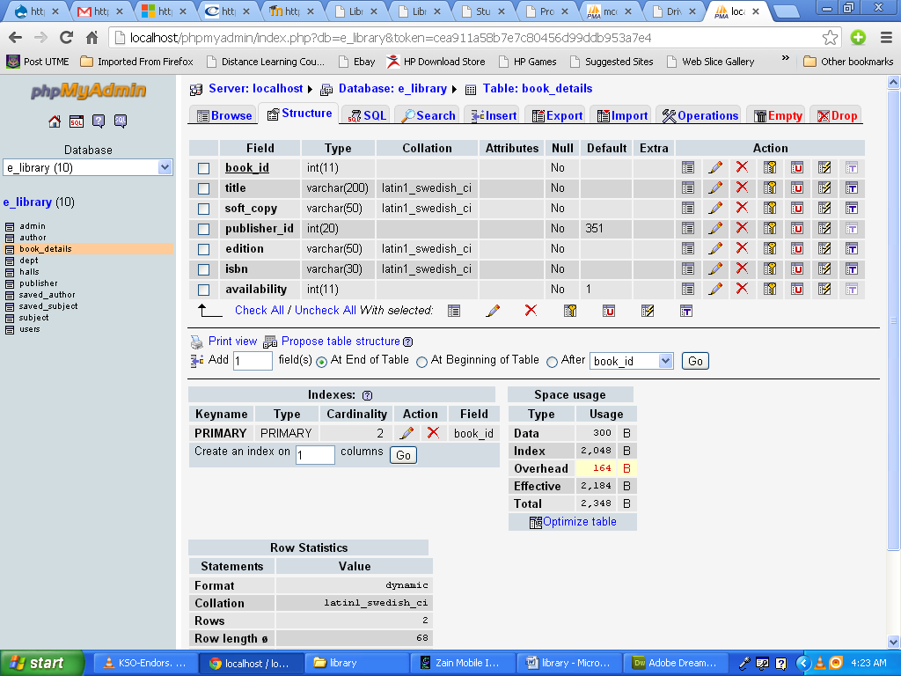

1. Publisher Details

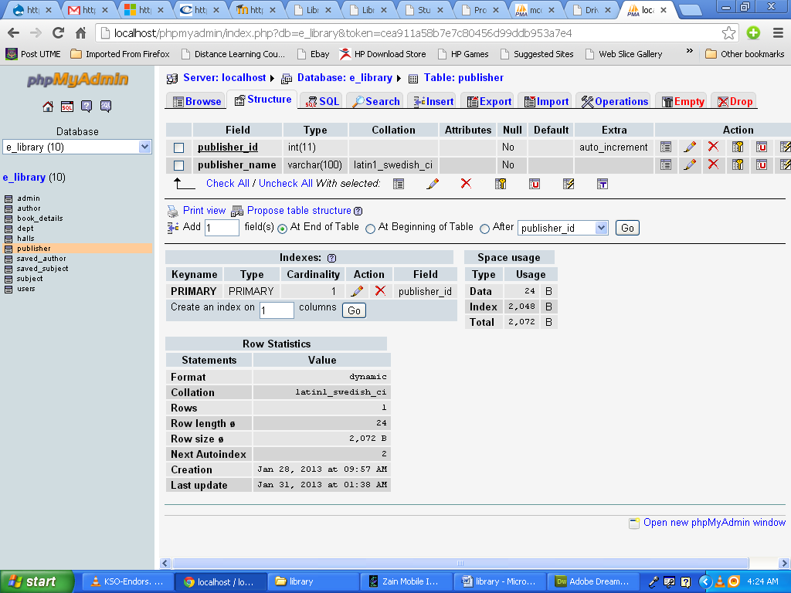

1. Saved Author

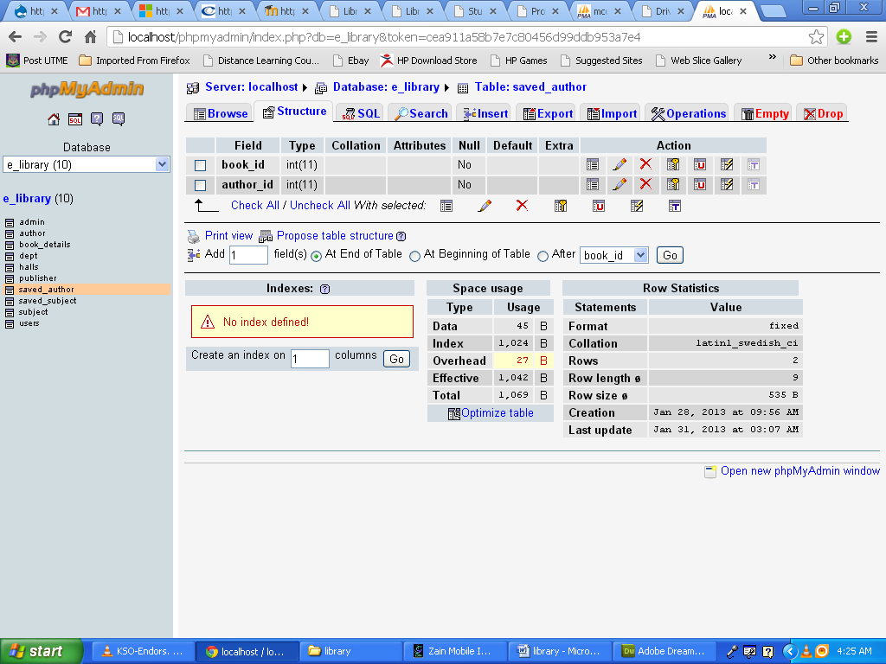

1. Saved Subject

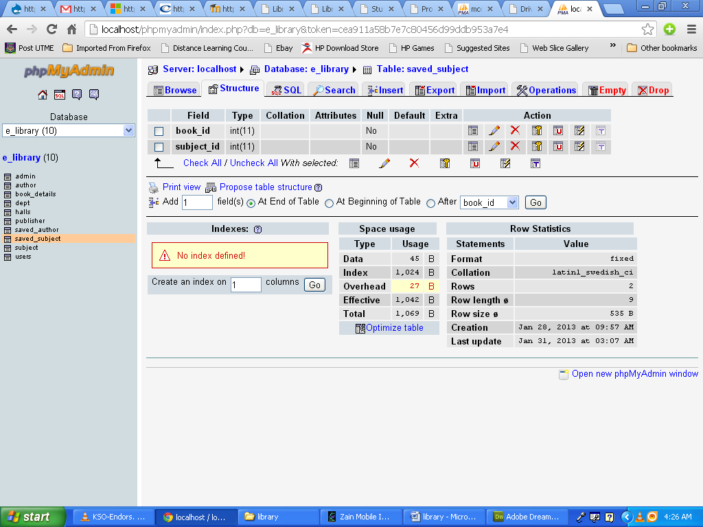

1. Subject Details

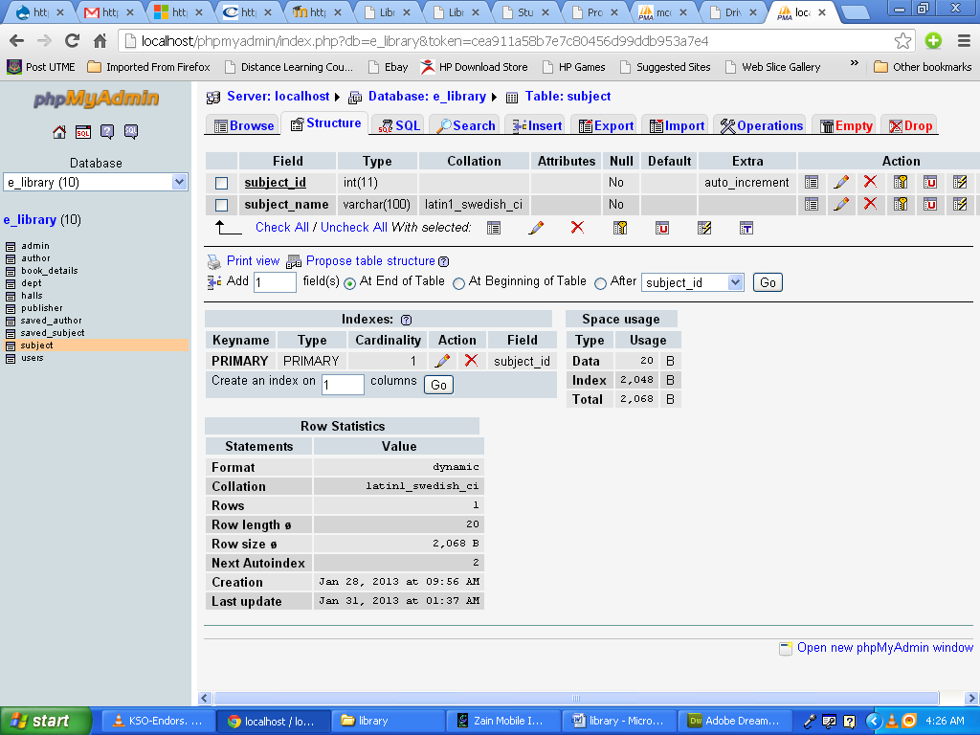

1. User Details

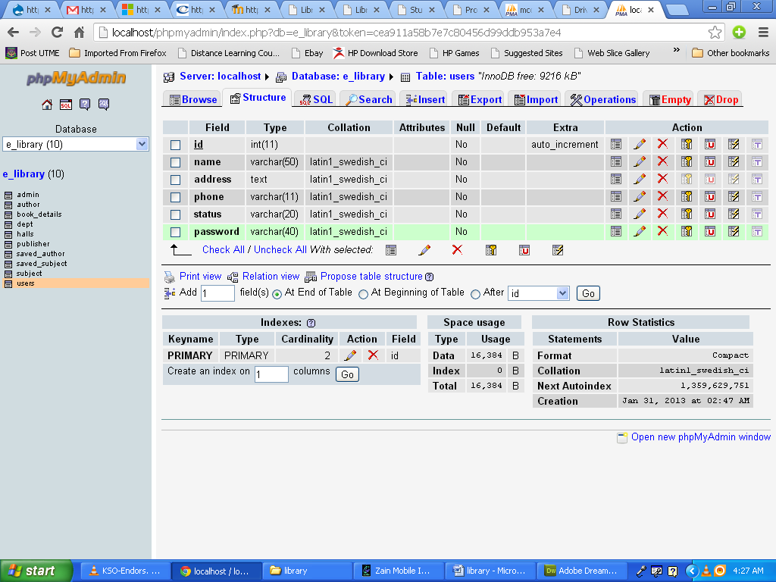

* + 1. **PROCEDURE DESIGN**

This refers to the step by step method of using the proposed system. The proposed system comprises of Administrator and the general user environment. The steps to use the proposed system are as follows

1. On the address bar of any browser type <http://localhost/e-library/index.php>
2. You are prompted to supply the username and password this verifies that you are a registered user and has the privileged to use the e-library system otherwise you can only view the books without inability to read the document or download any material.
3. If the username and password supplied are correct as that of a user you are prompted with the home page with the list of available document which you can read and donloa based on choice.
4. The username and password are in two formats as an administrator as well as a user.
5. As an administrator you are to type <http://localhost/e-library/admin/index.php> on the address bar.
6. As an administrator you are prompted with the administrator page where the back end of the e-library exercise is carried out.
   1. **IMPLEMENTATION OF THE SYSTEM**

**4.2.1 HARDWARE SUPPORT**

The hardware that is required in the successful completion of this project include monitor, CPU, keyboard, mouse, printer and an uninterrupted power supply (UPS).

* + 1. **SOFTWARE SUPPORT**

The software support for the design of the proposed system involves operating system, Macromedia dreamweaver, WAMP server and an internet access as well as an anti virus software which prevents the system from being infected by virus.

* 1. **DOCUMENTATION OF THE SYSTEM**
     1. **PROGRAM DOCUMENTATION**

In order for the proposed system to be used on any computer system it takes the following ways

1. Boot the system
2. Copy the folder to www inside wamp folder of the drive C: after WAMP server is installed onto the system.
3. Open any browser on the system (Microsoft internet Explorer, Mozilla Firefox, Netscape Navigator, Opera, Flock, Safari e.t.c)
4. Type <http://localhost/e-library/index.php> on the address bar and press the return key or enter key.
   * 1. **OPERATING THE SYSTEM**

In order for the proposed system to be used on any computer system it takes the following ways

1. Boot the system
2. Copy the folder to www inside wamp folder of the drive C: after WAMP server is installed onto the system.
3. Open any browser on the system (Microsoft internet Explorer, Mozilla Firefox, Netscape Navigator, Opera, Flock, Safari e.t.c)
4. Type <http://localhost/elibrary/index.php> on the address bar and press the return key or enter key.

**4.3.3 MAINTAINING THE SYSTEM**

The system is flexible enough to entertain any future amendment which might be required when the need arise.

**CHAPTER FIVE**

**SUMMARY, CONCLUSION AND RECOMMENDATION**

* 1. SUMMARY
  2. EXPERIENCED GAINED
  3. CONCLUSION
  4. RECOMMENDATION

**OUTPUT**

**WELCOME SCREEN**

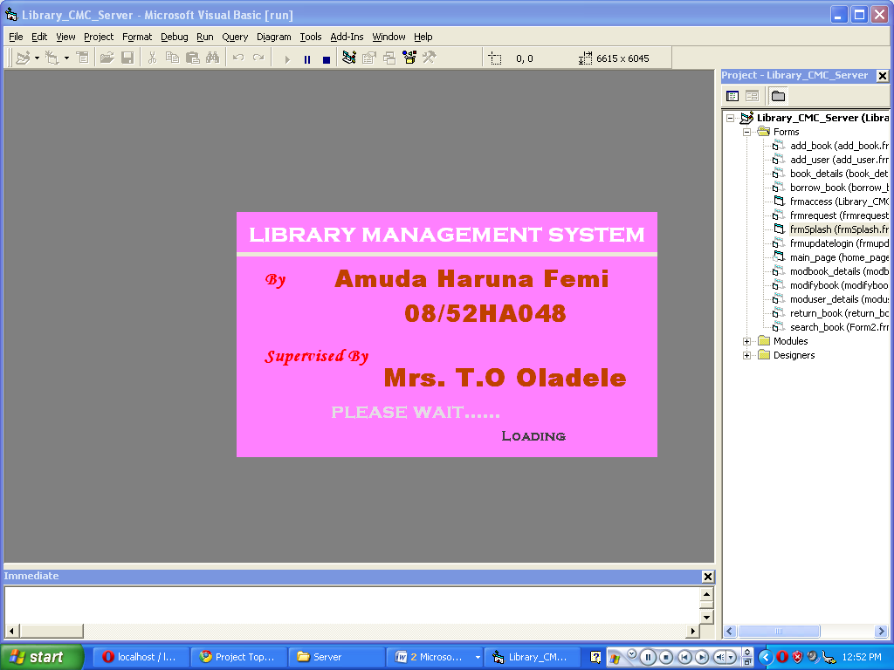

**LOGIN PAGE**

