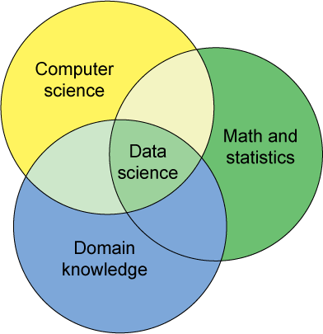
Introduction to Data Science
CMPSC-310
Summer 2015

Instructor Information
Name | Dmitry Dem-MEE-TREE Zinoviev, also known as  “Professor,” “Professor Zinoviev,” and “Professor Dmitry”
E-mail | dzinoviev@gmail.com (preferred), dzinoviev@suffolk.edu (official)
Phone | x1985 (please use e-mail whenever possible)
Office Hours and Location | After class.  73 Tremont Street, Rm 8093 (8th floor)

Course Information
Meeting Times | MW 5:30–7:30PM
Location | Archer 349
Catalog Description | The field of data science is emerging at the intersection of the fields of social science and statistics, information and computer science, and design. Data science involves using automated methods to analyze massive amounts of data and to extract knowledge from them. This course serves as a project-based introduction to data science in Python, covering data organization, retrieval, statistical data processing, and data visualization.
Prerequisites | CMPSC-F132 (in Python; required), MATH-134, MATH-165, MATH-255 or STAT-250 (at least one course required)
Credit Hours | Four credit hours. This course follows the Federal Government’s Credit Hour definition.
Recommended Textbooks | Practical Data Science with R by N.Zumel & J.Mount, Manning Publications, 2014; Python for Data Analysis: Data Wrangling with Pandas, NumPy, and IPython by W.MacKinney, O'Reilly Media, 2012
Software | 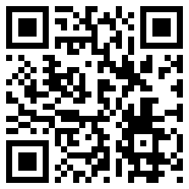  We will use Python (version 3.4 and above) in the course. You will also need a personal laptop or desktop computer with Linux, Windows or MacOS (I regret to restrict my technical advice mostly to Linux and possibly Windows users) and Anaconda—a Python 3.4 distribution that includes Python interpreter, an iPython console, Python modules (such as numpy, networkx, and matplotlib) and Spyder, an integrated development environment. You can download Anaconda from https://store.continuum.io/cshop/anaconda/. Choose Anaconda for Python 3.4, not 2.7.

Course Goals and Objectives
Goals | Objectives | Assessments
Upon successful completion of the course, students should be able to:
...understand how to recognize, extract, and organize quantitative data by incorporating best practices in data management. | ...recognize quantitative data in various formats and communicate the meaning of the data. | HW 1, 2, 3; midterm; final
 | ...develop software that reads, tokenizes, and normalizes plain-text and HTML data, reads structured data (XML, JSON, CSV), and stores processed data to, and retrieves data from, relational databases. | HW 2; midterm; final
...know how to process data by logically manipulating and joining the underlying raw data into a new representation and package. | ...determine and use appropriate data science methods to solve application problems. | final
 | ...develop software that calculates data statistics and dependencies (such as frequency analysis; distributions; correlations; regressions; complex data networks), using NumPy, networkx, and other Python modules. | HW 4, 5, 6; final
 | ...accurately interpret the results of data analysis and assess results for reasonableness. | HW 5, 6; final
...know how to deliver data ensuring that the message the data has is being accessed by those that need to hear it. | ...determine appropriate visualization methods for scalar, vector, and network data. | HW 4, 5, 6; final
 | ...develop software for simple data visualization, using matplotlib. | HW 5; final
 | ...use data visualization tools, such as Gephi, for advanced network data analysis and presentation. | HW 6; final

Course Calendar
The schedule, policies, procedures, and assignments in this course are subject to change in the event of extenuating circumstances, by mutual agreement, or to ensure better student learning.

Lecture Dates and Topics
Week | Topic
05/18 | Summer Module 3 begins
1 | Review of Python file and string methods. Regular expressions
2 | Text Data. Tokenization and stemming. Structured text data formats (CSV, XML, JSON)
3 | Matplotlib. Relational databases. PyMySQL
4 | Midterm. Numeric data. NumPy
5 | Data frames. Pandas
6 | Statistics. Frequency distributions
7 | Correlations and regressions. Least square fit method. Data independence test
8 | Network data. Complex networks. Clustering
9 | Building and analyzing data networks with networkx and Gephi.
9½ | Review
 | Final exam on 07/22 (5:30–8:10PM)

University Closings
5/25 | Memorial Day; make-up class on 5/29
7/04 | Independence Day

Course Withdrawal Deadlines
6/02 | The last day students can withdraw from a course without receiving a grade of W. The course will be completely removed from the student's transcript. Students may do this online via MySuffolk.
7/02 | The last day students can withdraw from a course without receiving a grade of F. They will receive a W on their transcript instead. Students may do this online via MySuffolk.  Students may not withdraw from courses after this date unless they have serious extenuating circumstances and documentation. Students should contact the Student Affairs Office at 617-573-8239 or at studentaffairs@suffolk.edu to request a late course withdrawal.

Assessment

Homework
There are eight group-based project in Python. The complete solutions must be submitted to BlackBoard for rubric-based grading.
You are responsible for your homework. All homework must be done independently or in the pre-assigned teams. A close similarity of homework papers or programs submitted by different students is a sufficient cause not to grade all of them.
Select assignments in this course may be used by our accreditation team for institutional assessment purposes and will be handled confidentially.

Tests
All tests must be taken on BlackBoard.
There are eight take-home quizzes, given approximately once a week.
There is one midterm exam and the final exam. The exams are closed book, closed notes, but you can bring a letter-size cheat sheet. The exams are proctored and must be taken in the classroom (not at home).
The University policy requires that to request a make-up final exam, you have to write a petition to the Dean of Students.

Grading and Evaluation
I do not accept late papers, quizzes, and programs, unless a serious medical condition prevented you from submitting them on time.
The estimation of your course grade is calculated using the following weights:
Take-home quizzes—10%.
Projects—40%.
Midterm—25%.
Final exam—25%.
Your grades will be posted at BlackBoard. Please consider the online gradebook as a courtesy to you, subject to errors given various upgrades and shifts in the software. I reserve the right to make gradebook corrections to keep it consistent with the syllabus so that your grade reflects true performance, not software or user error. If you see something that doesn’t make sense, please alert me! Thanks so much for your help.

Course Policies

Disability Accommodations
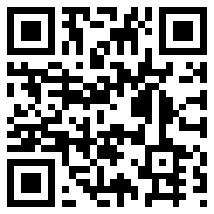
If you determine that you need formal, disability-related accommodations, it is very important that you register with the Office of Disability Services (located at 73 Tremont Street, 7th floor, 617-994-6820, disabilityservices@suffolk.edu) and notify me of your eligibility for reasonable accommodations. We can then plan how best to implement your accommodations. For more information, look here: www.suffolk.edu/disability.

Attendance Policy
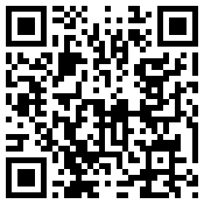
I expect all students to attend all classes. You will not pass the course if you attend fewer than 80% of classes. It is the students' responsibility to make up for any missing material. Under other equal circumstances, students with good attendance will be assigned higher final grades than students with poor attendance. Students should contact the Student Affairs Office at 617-573-8239 or at studentaffairs@suffolk.edu if they expect to be absent for a period of a week or more. See http://www.suffolk.edu/studenthandbook/19864.php for more information.

Academic Integrity Policy
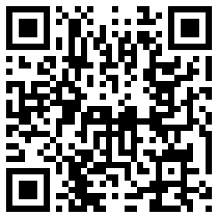
When you submit work to me with your name on it, it must be your own best quality work. Talking with your classmates and colleagues about the ideas, problems, and techniques that we cover in class is desirable and is an important part of the learning process. But, when you prepare homework for submission you must not submit the work of others. Ultimately, you will have to personally and privately demonstrate your mastery of the course material on the exams that I give. I use my exams as reality checks on the homework. If a student submits excellent homework programs but performs poorly on my exams then I can only conclude that the homework was the work of someone else. If I conclude that you have tried to pass off someone else's work as your own then I will respond quite punitively. I try my best to protect the interests of students who do not cheat.

Bottom line: if you let other people help you too much then you deprive yourself of the opportunity to learn, and eventually master, the course material and you will do poorly in my course. Honestly doing your own work is the best academic survival strategy. See http://www.suffolk.edu/studenthandbook/19863.php for more information.

Student Resources

Student Support/Mental Health
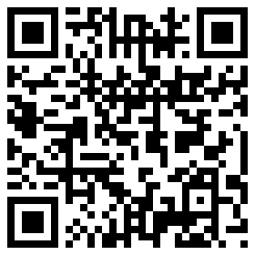
A range of issues can cause barriers to learning, such as strained relationships, increased anxiety, health issues, alcohol/drug problems, feeling down, difficulty concentrating, lack of motivation, or feeling ill. These concerns or other stressful events may lead to diminished academic performance or may reduce your ability to participate in daily activities. University resources can help you address these and other concerns you may have. You can learn more about Suffolk’s broad range of confidential medical and mental health services at http://www.suffolk.edu/campuslife/2752.php.

Early Alert Statement
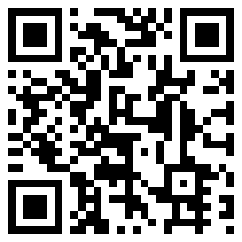
The Early Alert Project is a university-wide collaborative effort designed to support student learning by identifying and warning students who may be in danger of failing one or more courses.
After the first month of the semester, faculty are asked to identify undergraduate students in their classes who may be in danger of failing as well as the reason for their concern. Alerts may be issued for excessive absences, trouble with subject matter, not completing assignments, and writing deficiencies. See http://www.suffolk.edu/academics/3057.php for more information.

Center for Learning and Academic Success
The Center for Learning and Academic Success (CLAS) is a one-stop shop for student support. At the CLAS, you can find tutoring, study groups, academic coaching, and academic skills workshops. The CLAS also has math and statistics drop-in sessions as well as assistance for students whose primary language is not English.

