|  |  |  |  |  |  |  |
| --- | --- | --- | --- | --- | --- | --- |
| VILNIAUS KOLEGIJA  UNIVERSITY OF APPLIED SCIENCES  FACULTY OF ELECTRONICS AND INFORMATICS  Image result for viko logo | | |  | | | VILNIUS COLLEGE  Image result for viko logoFACULTY OF ELECTRONICS AND INFORMATICS |
|  | | |  | | |  |
| **DATABASE DESIGN** | | |  | | | **INTRODUCTION TO INFORMATICS** |
| PRACTICAL ASSIGNMENT  TASK3  6531BX028 PI18E | | |  | | | PRACTICAL ASSIGNMENT  SPOTIFY USER MANUAL  6531BX028 PI18E |
| STUDENT | DŽIUGAS PEČIULEVIČIUS | STUDENT | | DŽIUGAS PEČIULEVIČIUS |
| (SIGNATURE)  10/23/2019 | | |  | | | LECTURER |
| LECTURER | JUSTINAS ZAILSKAS | (SIGNATURE)  10/17/2018 | | VIRGILIJUS KUKLIERIUS |
| (SIGNATURE)  10/23/2019 | | |  | | | 2018 |

2019

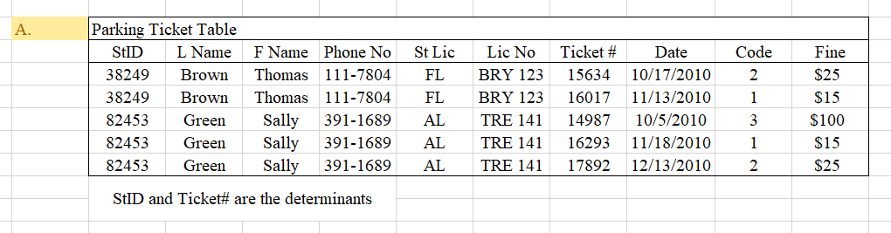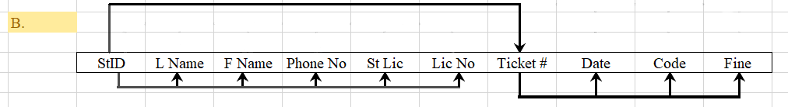

Anomalies:

1. Deletion anomaly – if student leaves school, all information will also be deleted.
2. Insertion anomaly – we have to enter new information which can be messy.

