|  |  |  |  |  |  |  |
| --- | --- | --- | --- | --- | --- | --- |
| VILNIAUS KOLEGIJA  UNIVERSITY OF APPLIED SCIENCES  FACULTY OF ELECTRONICS AND INFORMATICS  Image result for viko logo | | |  | | | VILNIUS COLLEGE  Image result for viko logoFACULTY OF ELECTRONICS AND INFORMATICS |
|  | | |  | | |  |
| **DATABASE DESIGN** | | |  | | | **INTRODUCTION TO INFORMATICS** |
| PRACTICAL ASSIGNMENT  TASK4  6531BX028 PI18E | | |  | | | PRACTICAL ASSIGNMENT  SPOTIFY USER MANUAL  6531BX028 PI18E |
| STUDENT | DŽIUGAS PEČIULEVIČIUS | STUDENT | | DŽIUGAS PEČIULEVIČIUS |
| (SIGNATURE)  11/8/2019 | | |  | | | LECTURER |
| LECTURER | JUSTINAS ZAILSKAS | (SIGNATURE)  10/17/2018 | | VIRGILIJUS KUKLIERIUS |
| (SIGNATURE)  11/8/2019 | | |  | | | 2018 |

2019

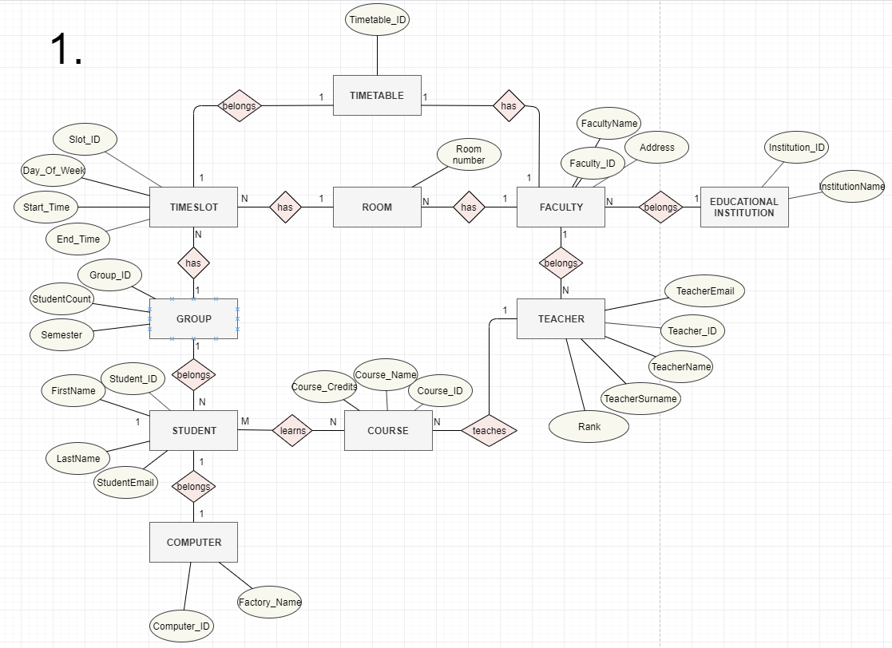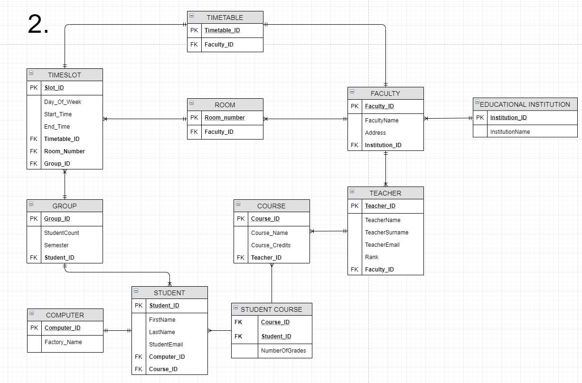

1. Basically one student has one computer so it’s a one-to-one ratio.
2. Since student has a computer, so computer number is in student table.
3. Many students belong to one group.
4. Many students have many courses at a time, so another table is created because of many-to-many relation.
5. One teacher can lecture many courses.
6. Each group basically has many timeslots for each subject. Many subjects = many time slots.
7. Each room has many timeslots also.
8. One room belongs to a faculty, but faculty can have many rooms.
9. Educational institution can have many faculties
10. Each faculty has one timetable, and each timeslot also has one timetable.

**3.**

