**Injection**

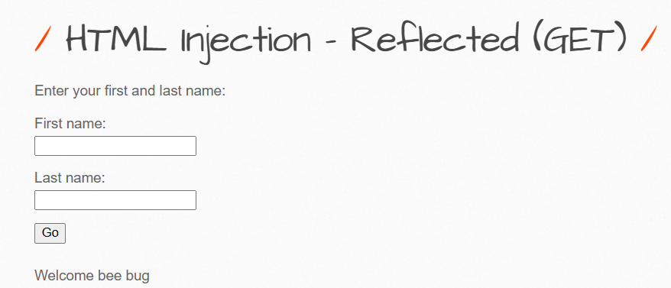

**HTML injection – Stored**

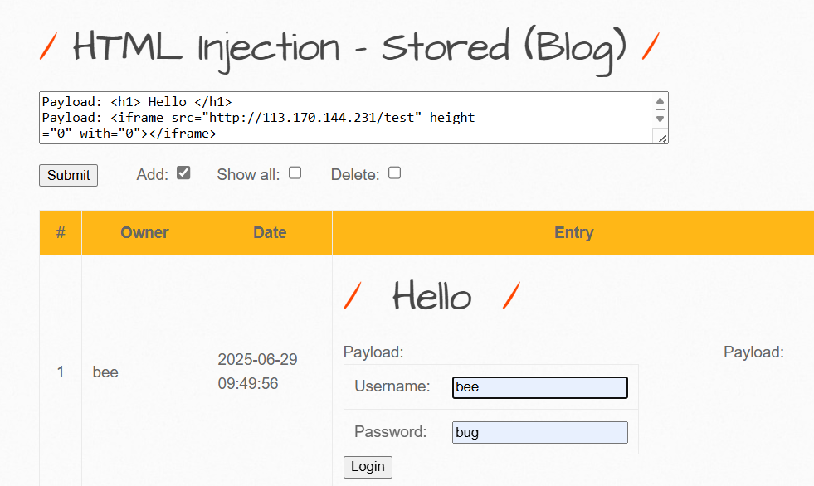

**PHP code injection**



**OS Command injection**



**SQL injection (Get/Search)**

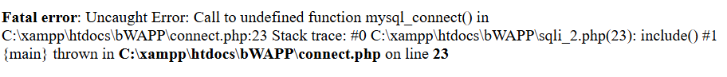

**SQL injection (Get/Select)**

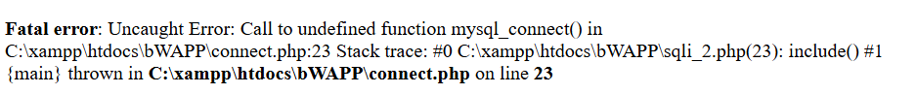

**SQL injection (Post/Search)**



**SQL injection (Post/Select)**



**SQL injection (Captcha)**



**SQL injection (Login Form/Hero)**



**SQL injection - Stored (Blog)**



**SQL injection - Stored (User-Agent)**

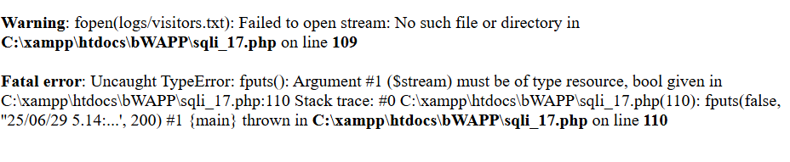

**SQL BỊ LỖI NÊN EM LƯỚT PHẦN SQL NHA THẦY**

**XML/XPath injection (Login Form)**

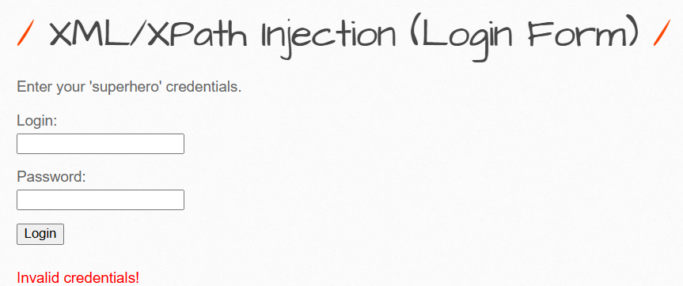

**XML/XPath injection (Search)**

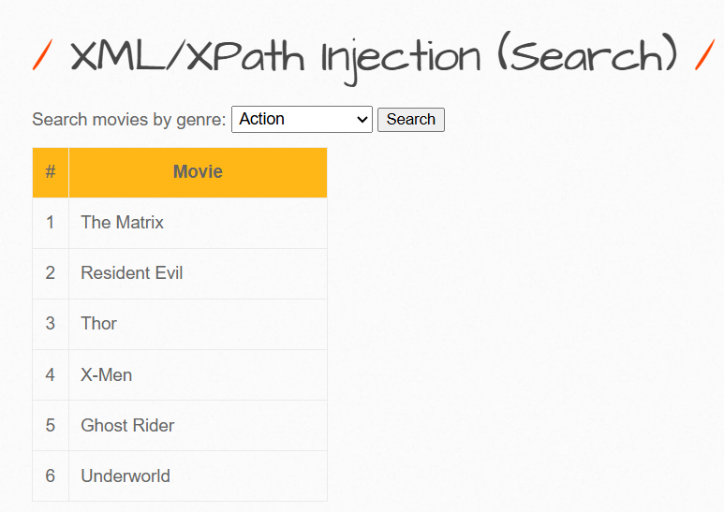

**Broken Authentication**

**“”**

**Broken Authentication - Insecure Login Forms**

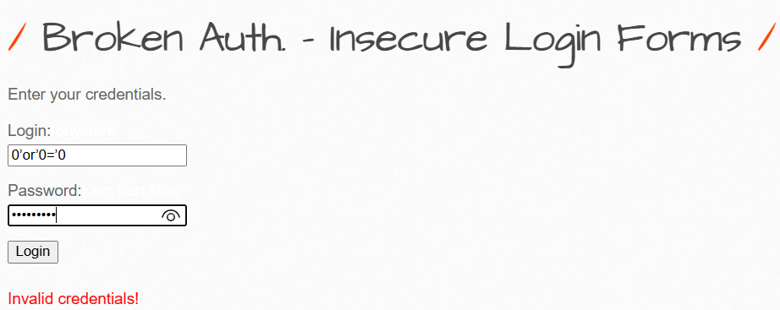

**Session Management - Administrative Portals**



**Broken Authentication - Insecure Login Forms**

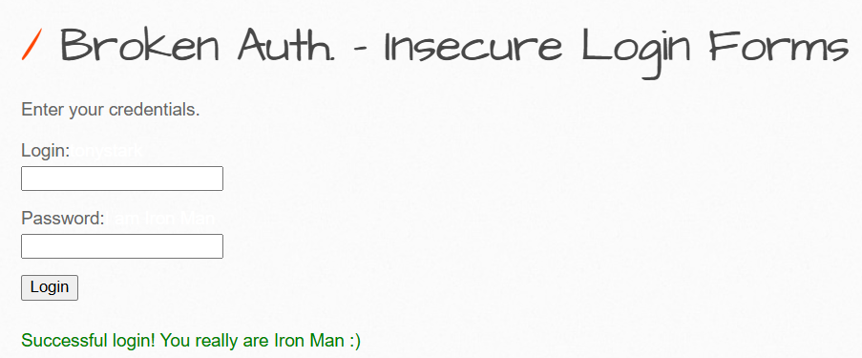

**Broken Auth. - Password Attacks**

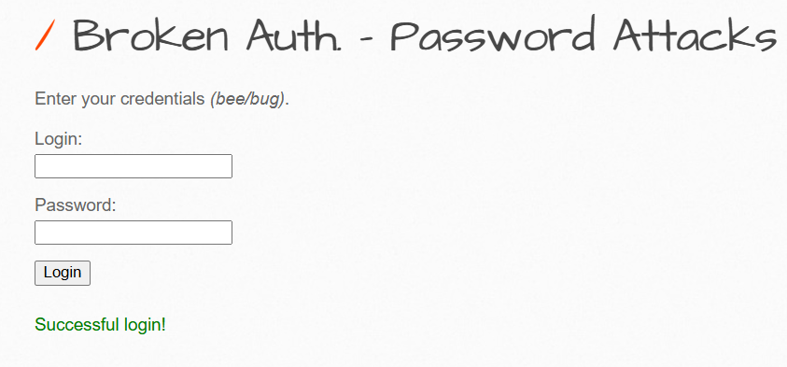

**HTML5 Web Storage (Secret)**

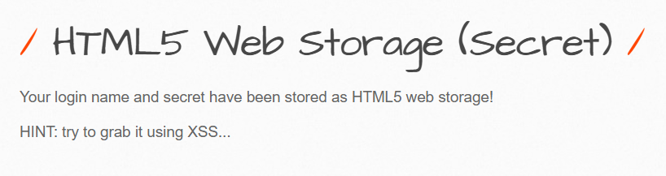

**Cross-Site Request Forgery (CSRF)**

**CMD**